Name: Lauren Garraghan
Entrepreneurship BMIH5001
business Plan for: ECO Haven Boutique Hotel

Lecturer: | Ben Chong
Date: | 20/04/2024
Team members: | Lauren Garraghan 2212964  22
Business plan contents
Executive Summary…………………………………………………………………………………………………………….3
1 Executive summary 3
2 Business details 4
3 Key personnel 5
Vision 6
4 The business idea 6
5 Business goals 6
6 What the business does 7
7 What makes the business different 7
8 Legal requirements 7
Marketing 8
9 Market research 8
10 Profiling customers 8
11 Profiling competitors 9
12 Managing market risks 9
13 Pricing 9
14 Promotion and advertising 10
Running the business 11
15 Staff 11
16 Premises 11
17 Suppliers 11
18 Equipment 12
19 Managing operational risks 12
Finance 13
20 Start-up costs 13
21 Profit and loss forecast 15
22 Sourcing finance 16
23 Managing financial risks 16
24 Cash flow forecast 17

1 Executive summary

The Eco Haven Boutique Hotel aims to redefine luxury hospitality in Cornwall by offering upscale, eco-friendly accommodations to environmentally conscious travelers. Its key features include modern architecture, attentive service, and a commitment to sustainability. With a management team comprising experienced professionals, Eco Haven is poised to meet the increasing demand for eco-friendly lodging options in line with the growing global trend towards sustainable tourism (UNWTO, 2022). By targeting specific client segments such as eco-conscious travellers, business leaders, couples, and families, Eco Haven plans to capture a significant portion of the Cornwall tourist market. Financial forecasts indicate promising growth prospects, supported by government subsidies, bank loans, and equity investments. With a robust financial plan, strategic marketing approach, and clear vision, Eco Haven aims to lead the way in environmentally conscious luxury travel.

2 Business details

Company name:

Eco haven boutique hotel

Address:

Eco Haven Boutique Hotel
22 Seahorse Way
St. Brioc
Cornwall, CR1 2EH
United Kingdom

Primary contact method
Telephone: 0189079870
Email: Ecohaven@gmail.co.uk

###

The business will: (Provide a brief description of what your business will do)

The Eco Haven Boutique Hotel business plan presents a well-thought-out strategy for starting a high-end hospitality enterprise in Cornwall that has an emphasis on environmental responsibility and sustainability. Under the direction of a seasoned management group with a wealth of hospitality sector experience, Eco Haven strives to provide guests luxurious yet environmentally responsible lodging.
By means of rigorous market research and analysis, the enterprise discerns pivotal customer categories and customises its product offerings to suit their requirements. Personalised service, modern design, and organic food that is sourced locally are how Eco Haven differentiates itself from other businesses in the industry. Based on a combination of government grants for sustainable initiatives, bank loans, and private investment, financial estimates show positive development over the first three years. Through leveraging the increasing demand for environmentally conscious travel experiences, Eco Haven hopes to become a pioneer in sustainable luxury hospitality.

3 Key personnel

Details of owner(s):
Name: Lauren Garraghan
Position/main responsibilities: Founder & CEO
Experience and knowledge of our industry: Over 15 years of experience in the hospitality industry, specializing in sustainable practices.
Previous employment: General manager at Green Valley Resorts
Key skills brought to the business: leadership, sustainability expertise
Business experience and any training undertaken: Batchelors degree in hospitality management
Academic/professional qualifications: diploma International Hotel Management
Salary expectations £ 80,000 per Anum

Name: Nancy Johnson
Position/main responsibilities: Operational Manager
Experience and knowledge of our industry: Extensive experience in hotel management focused on sustainability
Previous employment: Operations Manager at ECO luxury Resorts
Key skills brought to the business: Operations manager, sustainability implementation
Business experience and any training undertaken: Diploma in hotel management
Academic/professional qualifications: hotel management

Salary expectations £ 60,000 per Anum

Name: Jennifer Banks
Position/main responsabilités: Head chef
Experience and knowledge of our industry: Extensive culinary experience in upscale restaurants with a passion for using locally sourced, organic ingredients.
Previous employment: Head Chef at Farm-to-Table Restaurant, recognized for implementing sustainable cooking practices
Key skills brought to the business: Culinary expertise, menu development, sourcing sustainable ingredients.
Business experience and any training undertaken: Completed courses in sustainable cooking and food sourcing
Academic/professional qualifications: Culinary Arts Degree
Salary expectations £ 50,000
Name: Michael Brown
Position/main responsibilities: Head of Marketing
Experience and knowledge of our industry: Extensive background in marketing and branding, with a focus on promoting sustainable businesses
Previous employment: Marketing Manager at Greentech Solutions, where he spearheaded campaigns to raise awareness of eco-friendly products
Key skills brought to the business: Marketing strategy development, digital marketing, brand management.
Business experience and any training undertaken: Completed courses in sustainable marketing and digital advertising.
Academic/professional qualifications: Batchelors degree in marketing
Salary expectations £ 70,000

Vision

4 The business idea

Sum up your business idea:

At Eco Haven Boutique Hotel, our vision is to redefine the hospitality landscape by seamlessly integrating luxury with sustainability. Inspired by the principles of the Business Model Canvas (Osterwalder & Pigneur, 2010), our vision encompasses every aspect of our business, from customer segments to key resources, channels, and revenue streams.

Customer Segments:
Our vision begins with a deep understanding of our customer segments. We aim to attract eco-conscious travellers, business professionals, couples, and families seeking luxurious yet environmentally responsible accommodation experiences (Boswijk, Thijssen, & Peelen, 2007).

Value Proposition:
Central to our vision is our unique value proposition. By offering luxury amenities and personalized service while prioritizing sustainability, Eco Haven provides guests with an unparalleled experience that aligns with their values (Pine & Gilmore, 1999).

Channels:
Our vision extends to the channels through which we reach our target audience. Leveraging digital marketing, social media platforms, eco-friendly travel agencies, and partnerships with sustainable tourism organizations, we aim to connect with environmentally conscious travellers worldwide (Hudson, 2008).

Customer Relationships:
Building long-lasting relationships with our guests is a fundamental aspect of our vision. We strive to cultivate a sense of community and belonging through exceptional service, personalized experiences, and ongoing engagement with our guests (Kotler, Bowen, & Makens, 2010).

Revenue Streams:
Our vision for revenue generation is multifaceted. In addition to room bookings, Eco Haven will offer supplementary services such as spa treatments, guided eco-tours, and organic dining experiences to diversify our revenue streams and enhance guest satisfaction (Mason & Alamdari, 2007).

Key Resources:
To realize our vision, we recognize the importance of key resources such as our physical location, sustainable infrastructure, talented staff, and partnerships with local suppliers and artisans (Demangeot & Broderick, 2010).

Key Activities:
Our vision drives our key activities, which include maintaining eco-friendly practices, delivering exceptional service, fostering community engagement, and continuously innovating to meet the evolving needs of our guests (Lusch & Vargo, 2014).

5 Business goals
- What do you want to achieve in your first year of business? (for example, turnover of £100,000 or trading at breakeven) (SMART Target as the basis)
- .In the first year of operation, Eco Haven Boutique Hotel aims to achieve a turnover of £500,000. This target aligns with the SMART criteria, ensuring that our goal is Specific, Measurable, Achievable, Relevant, and Time-bound (Doran, 1981). By setting a specific turnover target, we provide a clear focus for our efforts and establish a measurable benchmark for success. Achieving a turnover of £500,000 in our inaugural year will demonstrate the viability and market demand for our sustainable luxury accommodation concept (Klofsten, 2000). Furthermore, reaching this milestone will position Eco Haven for continued growth and success in the competitive hospitality industry.

- Where do you see your business in 3-5 years’ time?
- As envisioned through Klofsten’ s business platform, Eco Haven Boutique Hotel aims to establish itself as a leading sustainable luxury accommodation provider in Cornwall within the next 3-5 years. Klofsten’ s platform emphasises the importance of long-term vision and strategic planning for business growth and development (Klofsten, 2000).
Our vision for Eco Haven includes expanding our operations to incorporate additional eco-friendly services and amenities, such as eco-conscious spa treatments, nature excursions, and sustainable event hosting. By leveraging our reputation for excellence in sustainability and guest experience, we aim to attract a loyal customer base and become a preferred destination for eco-conscious travellers seeking luxury experiences.
Furthermore, we envision forging partnerships with local environmental organizations and community initiatives to further enhance our sustainability efforts and contribute positively to the local ecosystem. Through continuous innovation and adaptation to changing market trends, Eco Haven strives to remain at the forefront of sustainable tourism and set new standards for environmentally responsible hospitality in the region.

6 What the business does

Product/service | Features | Benefits
- Luxury accommodation | - Energy-efficient design | - Reduced carbon footprint for guests
- Quality food | - Locally sourced organic cuisine | - Fresher, healthier dining options
- Accessible showers and baths | - Eco-friendly toiletries | - Reduced environmental impact
- Trained guest services staff | - Personalised service | - Enhanced guest experience
- Luxury beds | - High-quality linens and bedding | - Comfortable and restful sleep
- Exceptional rooms and suites | - Sustainable architecture | - Unique and visually appealing design
- 40 Acre land | - Green landscaping | - Beautiful outdoor spaces

7 What makes the business different (Value Proposition)
Your product/service is unique or different compared with the competition because:
- According to a report by Nielsen (2022) there is a substantial demand from customers for environmentally friendly goods and services, with 73% of respondents worldwide saying they would be ready to pay more for sustainable solutions. In response to this trend, Eco Haven offers visitors a guilt-free pleasure in luxury with eco-friendly amenities, energy-efficient construction, and locally sourced organic cuisine. Our dedication to sustainability benefits the local community and environment in addition to improving the visitor experience. Travellers looking for a balance between pleasure and environmental stewardship will find Eco Haven intriguing since it prioritises responsible practices without sacrificing comfort or flair, unlike traditional luxury hotels that may disregard sustainability in favour of magnificence.

8 Legal requirements (including regulations and licences particular to your business)
The legal and insurance requirements that apply in your business are:
- Eco Haven’s Business Registration and Regulations
- Obtaining a business license to operate as a hotel in [Tourist Destination].
- Compliance with building codes and regulations for safety and structural integrity.
- Adherence to health and safety regulations for guest and staff well-being.
- Compliance with environmental regulations related to waste management, energy efficiency, and conservation efforts.
- Comprehensive insurance coverage for property, liability, and business interruption risks.
- Compliance with employment laws and regulations for fair treatment of employees and adherence to labour standards.
You will meet your legal and insurance requirements by:
- Eco Haven Boutique Hotel Compliance Measures
- Engage legal counsel for compliance with local regulations and licenses.
- Partner with insurance providers for comprehensive coverage.
- Implement robust health and safety protocols.
- Implement eco-friendly practices and sustainable initiatives.
- Establish human resources management policies for compliance with employment laws and workplace safety.

Marketing

9 Market research

How you know this: (Provide examples with references)

Trends:
movement in favour of environmentally friendly travel experiences. Recent data from Sustainable Travel International (STI) indicates that eco-friendly lodging and experiences are becoming more and more popular among travellers (STI, 2022). Younger people, such as millennials and Gen Z, have a significant desire for travel options that are environmentally responsible, making this trend especially noticeable among them (UNWTO, 2021). In addition, a Mintel survey found that more than 70% of participants would be ready to pay extra for environmentally friendly lodging options, suggesting that the hospitality industry is becoming more and more conscious of sustainability (Mintel, 2023).

10 Profiling customers
- The customer groups you will be selling to are: (4 x Customer profiles minimum)
- Eco-Conscious Travellers: These people look for lodging that is consistent with their ideals and give sustainability first priority when planning a trip. Customers are prepared to spend more for environmentally friendly services and attractions.
- Business Travellers: A sizable portion of our clientele consists of business travellers who are looking for elegant accommodations with practical amenities and attentive service. Even though comfort and convenience may come first, people still value environmentally friendly products that uphold corporate social responsibility.
- Seekers of Romantic Getaways:
Intimate and romantic environments appeal to couples and honeymooners who value seclusion, elegance, and customised experiences. They look for lodgings that provide amenities and unique packages designed for romance vacations.
- Family travellers: Families seeking educational travel opportunities that are ecologically conscious. They like lodgings that provide amenities for families, family-friendly events, and sustainable education possibilities.

Your customer research has shown what your customers want is:
- Surveys, focus groups, and an examination of internet evaluations and comments from prior visitors were all used in our customer research. The findings showed that guests strongly prefer lodgings that put sustainability first. They also showed interest in eco-friendly features like waste reduction programmes, locally produced organic food, and energy-efficient architecture. Furthermore, an examination of reservation trends showed an increase in the desire for eco-friendly travel experiences, especially from younger audiences.

How you know this:
- Survey responses highlighting preferences for eco-friendly accommodations.
- Analysis of online reviews praising sustainability initiatives.
- Booking data indicating an increase in demand for eco-friendly options.
- This customer profiling and research provide valuable insights into the preferences and expectations of our target market, allowing us to tailor our offerings to meet their needs effectively.

Number of customers you expect to win in each group and what they might pay:
Group | Number of customers | Price they might pay per unit
Eco-Conscious Travelers | 500 | £200
Business Travelers | 300 | £250
Romantic Getaway Seekers | 200 | £300
Family Travelers | 400 | £180
 |  | £
 |  | £
 |  | £
 |  | £
 |  | £
 |  | £

11 Profiling competitors

Competitor name | Strengths | Weaknesses
Green Valley Resort | - Established brand reputation | - Limited focus on sustainability
 | - Wide range of amenities | - Higher prices
 | - Experienced staff | - Lack of differentiation
Eco Luxury Resorts | - Strong commitment to luxury | - Limited emphasis on sustainability
 | - Exclusive partnerships | - Higher price point
 | - Premium location | - Less flexibility in pricing
Oceanview Eco Retreat | - Focus on sustainability | - Smaller scale
 | - Unique eco-friendly accommodations | - Limited marketing
 | - Community and environmental initiatives | - Less diverse range of amenities

How you can improve on their offer and/or price(s) unique offerings:
Focus on Sustainability: Eco Haven will lead the way in sustainability by utilising green technologies and procuring locally to have the least possible negative effects on the environment.
Personalised Service: To provide unforgettable experiences, our team will receive training on how to offer personalised hospitality.
Value-Based Pricing: By providing free environmentally friendly amenities and adding value, you can draw in eco-aware tourists.
The Eco Haven Boutique Hotel will establish itself as the premier option for opulent, environmentally friendly lodging thanks to these tactics.

12 Managing market risks

Write down the risks you have identified:
- The recession has an impact on travel patterns.
- competition from well-established hotels that have more money for marketing.
- Consumer tastes in sustainability are evolving.

How will you manage these risks so that they become less of a threat:
- Eco Haven’s price policy will be commensurate with those of other upscale establishments in the vicinity, taking into account the value addition of our eco-friendly facilities and individualised attention.

13 Pricing

How you can calculate your prices:
- To reach our target demographic, our marketing strategies will include social media campaigns, collaborations with environmentally concerned travel firms, and focused web advertising.

How your prices compare with the competition:
Product/service | Your price(s) | Range of competitor prices (per unit)
Luxury Room | £200 | £180 - £250
Eco-Friendly Package | £50 | £40 - £60
Organic Dining Option | £30 | £25 - £35
Personalised Concierge | £20 | £15 - £25
Sustainable Amenities | £10 | £8 - £12

Reasons for the difference between your price(s) and your competitors’ price(s):

• Unique Offerings: Eco-friendly amenities and personalized services justify higher prices.
• Quality and Exclusivity: Premium luxury rooms and spa treatments justify higher prices.
• Sustainability Investment: Prices reflect investment in sustainability initiatives.
• Personalized Service: Personalized concierge services and guided eco-tours justify higher prices.
• Brand Differentiation: Eco Haven’s reputation as a sustainable luxury hotel provides a slight premium over competitors.

14 Promotion and advertising

How and where will you promote your product/service?
Eco Haven Boutique Hotel's Promotion and Advertising Strategy
Online Promotion:
• Optimize website for SEO for a seamless user experience.
• Engage with audience on social media platforms like Instagram, Facebook, and Twitter.
• Implement email marketing strategy to send newsletters and promotional offers.
• Partner with Online Travel Agencies (OTAs) like Booking.com and Expedia to attract bookings.
Offline Promotion:
• Place advertisements in travel magazines, eco-friendly publications, and local newspapers.
• Form partnerships with local businesses, tour operators, and environmental organizations.
• Participate in eco-friendly events, trade shows, and community initiatives.

Running the business

15 Staff

Role | Total cost | Necessary experience | Specialist skills and/or qualifications
General Manager | £40,000 | - Extensive experience in hospitality management | - Strong leadership and decision-making skills
 |  | - Proven track record in hotel operations | - Excellent communication and interpersonal skills
 |  | - Understanding of sustainability practices | - Bachelor's degree in Hospitality Management or related field
Front Desk Receptionist | £25,000 | - Previous experience in customer service | - Proficiency in reservation software and POS systems
 |  | - Ability to multitask in a fast-paced environment | - Excellent communication and problem-solving skills
Housekeeping Supervisor | £30,000 | - Supervisory experience in housekeeping | - Knowledge of cleaning protocols and eco-friendly practices
 |  | - Attention to detail and organizational skills | - Leadership and team management abilities
 |  | - Understanding of sustainability initiatives | - High school diploma or equivalent education
Head Chef | £45,000 | - Culinary degree or equivalent experience | - Creativity and innovation in menu development
 |  | - Experience in fine dining establishments | - Knowledge of locally sourced and sustainable ingredients
 |  | - Ability to lead a kitchen team effectively | - Food safety certification (e.g., SERV Safe)
 |  | - Passion for sustainable and organic cuisine
Environmental Officer | £35,000 | - Background in environmental science or related field | - Understanding of sustainability principles and practices
 |  | - Experience in implementing eco-friendly initiatives | - Ability to conduct environmental audits and assessments
 |  | - Familiarity with relevant regulations and certifications | - Strong analytical and problem-solving skills

16 Premises

 | Cost £
Premises required at start-up: | £300,000
Premises required in the future (if different): | £500,000

17 Suppliers

Your key suppliers and their credit terms
Supplier | What you’ll buy from them | Number of days’ credit
Eco-Friendly Products Co. | - Sustainable cleaning supplies | - 30 days
- Local Organic Farm | - Locally sourced produce | - 15 days
- Renewable Energy Solutions Ltd. | - Solar panels and energy-efficient systems | - 60 days
- Green Building Materials Inc. | - Eco-friendly construction materials | - 45 days
- Eco-Friendly Furniture Ltd. | - Sustainable furniture and decor | - 30 days
- Sustainable Textiles Co. | - Organic linens and bedding | - 30 days

18 Equipment
Resource | How funded | Cost £ per unit | Investment
- Eco-Friendly Cleaning Tools | - Cash | - £100 | £2,000
- Energy-Efficient Appliances | - Loan | - £500 | £10,000
- Solar Panels | - Grant | - £5,000 | £50,000
- Eco-Friendly Building Materials | - Cash | - £1,000 | £20,000
- Sustainable Furniture | - Cash | - £300 | £6,000
- Organic Bedding and Linens | - Cash | - £50 | £1,000
- Recycling Bins | - Cash | - £20 | £400
- Energy-Efficient Lighting | - Cash | - £50 | £1,000
- Water-Saving Fixtures | - Cash | - £100 | £2,000

19 Managing operational risks

Risk | Solution
Staff  - Staff shortages are a risk. | - Implementing cross-training programs to ensure staff members can perform multiple roles in case of absences.  - Maintaining a pool of part-time or temporary staff to fill in during peak periods or staff shortages.
Suppliers  - Supplier Unreliability | - Establishing relationships with multiple suppliers to reduce dependency on a single source.  Regularly reviewing supplier performance and seeking feedback from other businesses to identify potential issues early.

Finance
Please double click in the table below to access the embedded Microsoft Excel sheets to input your figures, Microsoft Excel will automatically update the total for you. If you do not have access to Microsoft Excel you can use the link below this table and save the file onto your PC. You can then use Open Source Software such as Google Docs or OpenOffice to access the information by uploading the file into this software. Please note that all tables can be customised and additional rows and categories can be added.

20 Start-up costs

Calculate how much money you need before you start trading

* Total from here should be used in 22 Sourcing finance below

21 Profit and loss forecast

22 Sourcing finance

Total borrowing requirement for the business

23 Managing financial risks (such as, sales are less than forecasted or start-up finance takes three months longer to obtain)

The risks that you have identified for your financial forecast are:
Sales are less than forecasted.
Start-up finance takes three months longer to obtain than expected.

How you will minimise their impact:

keep a close eye on consumer feedback and market developments to make quick adjustments to our marketing and sales tactics, reducing the chance that sales may fall short of expectations. Furthermore, by keeping our budget flexible, we'll be able to reallocate funds as needed to take advantage of new opportunities.
We shall promptly notify prospective lenders and investors in the event that start-up funding is delayed in order to allay any worries and hasten the fundraising procedure. In addition, we intend to investigate substitute funding avenues and enhance our cash flow management strategies to maintain operations throughout the interim period.
These steps will ensure the stability and expansion of our company endeavour by assisting in the mitigation of potential financial risks.

24 Cash flow forecast (Click on the tabs within the Microsoft Excel sheet to view the second 6 months and summary)

25 Conclusion.

The business plan outlines a strategy for establishing and growing a hospitality venture. It focuses on sustainability, customer satisfaction, and innovation to differentiate from competitors and establish a strong brand presence. The plan includes a robust marketing strategy, effective promotional activities, and customer profiling to ensure steady revenue and growth. The plan also identifies potential risks and devises mitigation strategies to minimize their impact. With realistic financial forecasts and prudent resource management, the plan is confident in achieving business goals and delivering value to stakeholders. The plan reflects the commitment to creating a sustainable and viable venture that meets and exceeds customer, investor, and community expectations.

26

Reference list
Boswijk, A., Thijssen, T., & Peelen, E. (2007). The experience economy: A new perspective. Pearson Education.
Chernev, A. (2018). Strategic Marketing Management. Cerebellum Press.
Demangeot, C., & Broderick, A. J. (2010). Exploring the experiential intensity of online shopping environments. Qualitative Market Research: An International Journal, 13(4), 394-416.
Doran, G. T. (1981). There's a S.M.A.R.T. way to write management's goals and objectives. Management Review, 70(11), 35-36.
Guide, S. (2016). 13 Eco-Friendly Hotels Blending Luxury & Sustainability. [online] The Good Trade. Available at: https://www.thegoodtrade.com/features/13-eco-friendly-hotels-blending-sustainability-luxury/ [Accessed 20 Apr. 2024].
Hill, C. W., & Jones, G. R. (2012). Strategic management theory: An integrated approach. Cengage Learning.
Hudson, S. (2008). Tourism and hospitality marketing: A global perspective. Sage
Klofsten, M. (2000). The business platform: developing entrepreneurial ventures in a global network. London: Routledge.
Klofsten, M. (2000). The development of new business ventures: a comparison of U.S. and Swedish incubator practices. Journal of Small Business Management, 38(2), 45-53.
Kotler, P., Bowen, J. T., & Makens, J. C. (2010). Marketing for hospitality and tourism. Pearson Education.
Kotler, P., Kartajaya, H., & Setiawan, I. (2020). Marketing 4.0: Moving from Traditional to Digital. John Wiley & Sons.
Lusch, R. F., & Vargo, S. L. (2014). Service-dominant logic: Premises, perspectives, possibilities. Cambridge University Press.
Mason, P., & Alamdari, F. (2007). Strategic management for tourism, hospitality, and events. CABI.
Mintel group (2020). UK Hotels Market Report (Updated 2020). [online] store.mintel.com. Available at: https://store.mintel.com/report/uk-hotels-market-report.
Nielsen (2022). Environmental, Social and Governance (ESG) Report. [online] Nielsen. Available at: https://www.nielsen.com/about-us/responsibility-and-sustainability/esg-report/.
Osterwalder, A., & Pigneur, Y. (2010). Business Model Generation: A Handbook for Visionaries, Game Changers, and Challengers. John Wiley & Sons.
Pine, B. J., & Gilmore, J. H. (1999). The experience economy: Work is theatre & every business a stage. Harvard Business Press.
Ryans, A. B. (2008). Sustainable strategic management. CRC Press.
Sustainable Travel International (2020). Sustainable Travel International. [online] Sustainable Travel International. Available at: https://sustainabletravel.org/.
UN tourism (2021). UNWTO World Tourism Barometer and Statistical Annex, May 2021. UNWTO World Tourism Barometer, 19(3), pp.1–42. doi:https://doi.org/10.18111/wtobarometereng.2021.19.1.3.

27 Appendix
(An appendix comes at the end (after the reference list) of a report, research project, or dissertation and contains any additional information such as raw data, tables, and supporting information such as screenshots, and additional evidence. The information in the appendices is relevant but is too long or too detailed to include in the main body of your work.)

Pestle analysis
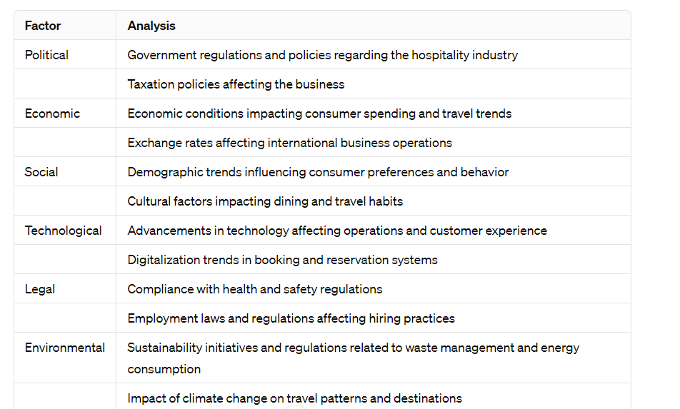

Swot analysis

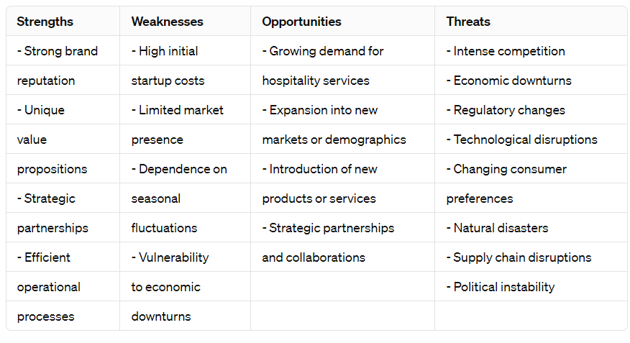
The vison


