How individuals’ beliefs, attitudes and values impact on workplace behaviour

Name: Sara Al Hashidi
Student ID: 1919947
Name of university: University Of Wales Trinity Saint David
Name of lecturer: Obinna Nkwocha
Module code: BMSW5101
Module name: Developing workplace critical thinking
Assignment title: How individuals’ beliefs, attitudes and values impact on workplace behaviour
Table of content
Introduction………………………………………………………..…………………....1
Description of believes and its origin…………………………………..…....2
Discussion about 5 identified beliefs and how they impact on
workplace behaviour……………………………………………………………...…3
Explain on how to reduce the negative impact of beliefs in the
workplace………………………………………………………………………………….4
Conclusion……………………………………………………………………………...…5
Reference list…………………………………………………………………………….6
Critical reflection
Introduction..................................................................................6
Review on learning module outcome………………………………………..7
Discuss how various topics shaped my critical thinking abilities…8
Explanation on how I used critical thinking gained to inform future
engagement……………………………………………………………………………..9
part 1 Introduction
In this assignment I will aim to demonstrate and discuss how individuals’ beliefs, attitudes and values impact on workplace behaviour. I will describe believes and discuss its origin. I will also identify 5 beliefs and discuss each of them as well as how they will impact on workplace behaviour. I am going to provide recommendations and an explanation on how to reduce the negative impact of beliefs in the workplace. I will then summarise the key findings which will include all the important components I discussed in this report. In this report I will aim to write about the theory of kolb’s reflective model and I will provide some examples of my own experiences (Midtools.com.2021). However, by taking the step to cover this key points, we should be able to gain knowledge of the different beliefs and how it can impact on the workplace behaviour. We will also develop critical thinking and understand attitudes and values and how to manage them by taking the appropriate steps to reduce negative impact in the workplace behaviour. Personal beliefs, attitudes and values are the foundation stage that build up individuals’ behaviour and personal concept. It can also affect the way we think and observe different things and how we deal with them as well as background, upbringing , relationships and experiences (2021). It is important to realise those beliefs and attitudes to avoid negative impacts and to be able to work with others when taking positive attitudes and beliefs into account.

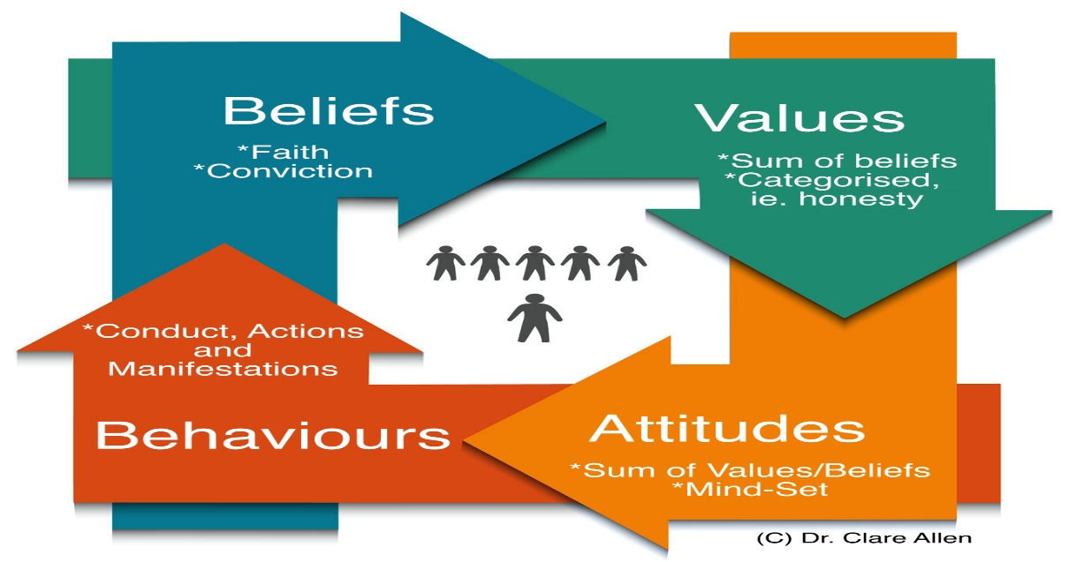

Beliefs and its origin
Normally, every individual have his own beliefs, attitudes and values. Beliefs are the things that we always assume and think is true. Beliefs come from previous life experience and builds up as the individual grow during the time and by the different things that occurs to the individual. Beliefs is not always the reality and truthfulness of different factors, it is how, where, when and the way we observe them differently. Beliefs can include, perspectives, religion, culture and moral (The Balance Careers.2021) . However, beliefs are very precious because they reflect on our personalities, attitudes and values. It is important to consider and promote each and everyone’s beliefs to know how others think and their knowledge and concepts of beliefs ( Faulkner.2021). Also to have the opportunity to understand each other in the workplace and maintain a productive and effective work environment and good relationships within the organisation. Beliefs can affect the organisation either negatively or positively by identifying the most important strategies to be able to work together as a team to build the organisation appropriately (Mindtools.com.2021). Also to be able to achieve a successful targeted workplace environment.
Personal beliefs can greatly influence individual’s ability to think critically as people always seek out ideas that corresponds to their own beliefs. Several factors that can drive the person to act inappropriately in critical thinking are personal bias, misconceptions, assumptions which can lead to wrong directions (Mindtools.com.2021). Despite, sometimes even judgements can be caused by incorrect personal beliefs and misconceptions in certain topics. When talking about beliefs in the workplace, it is important to follow certain regulations for everyone to feel good when dealing with each other (Understanding Workplace Values,2021). Respect should be taking into account and every employee in the organisation should feel valued and respected. It is not important that each and every individual of the employees agree with the other person but, it is essential to understand and respect other perspectives, different opinions and beliefs (UnionLeader.com.2021). It is obvious that there will be a variety of beliefs and point of views from different types of employees. However, personal beliefs can be positively impacting on others and persuasive, just when there are discussions and engagement in conversations with good conducting behaviours. (2021)
Attitudes is the way we express ourselves in thoughts, words and actions. An attitude is an evaluation of an attitude object, ranging from extremely negative to extremely positive. Most perspectives and personal beliefs on attitudes that allow individuals to stick with one point of view which cause conflicts towards an object and between people (2021). Although, attitudes involves mindset, beliefs, viewpoint etc. This basic elements adds up to our personality and our skills on facing different challenges and move to hold a particular shaped attitude. There are three types of attitudes which includes behavioural , cognitive and emotional attitudes which drives us to perform in a certain way and all this is linked to beliefs and values (Spirtual.Ray.2021). Values is what we as individuals believe and think is more important than anything else. Personal values determines priorities, family, friends, daily life responsibilities and what we pay more or less time to consume. (Mindtools.2021)

5 different personal beliefs and the impact on workplace behaviour

Educational beliefs are a very essential topic that each and everyone should know and have an understanding on the different aspects of them. Which could include all the advantages of believing in the importance of education and the disadvantages. Believing in education and the importance of it can vary from person to another (Radcliff,2021). Even though it has a positive impact on any individual that educate further in the educational process, there will still be some that disagree that education is important. However, lack of education has a huge negative impact on individuals that does not pay attention to it until late (2021). This can then lead to lack of efficiency in the workplace, poor knowledge on the overall work and personal concepts, less personal skills, no previous experience on related fields and work commitment. All these affects and influence workplace behaviour and the way the individual produce commitments to the organisation. (The Critical Thinking Skills In The Nursing Practice, 2021)

Financial beliefs, there are many people that believe money is the most important part in life. However, financial beliefs always cover just some aspects of life but it can never cover all of them. Money can enable people afford food, drink, shelter, rent cost and many more. But, it can not change the reality, it is impossible to buy happiness because there will still be issues that can not be charged or funded by paying money. Financial beliefs can impact on the workplace bahaviour in several ways. For example, in the workplace commitment, engagement and motivation is required by the employees to be able to achieve the goals of the organisation (Personal.finance.for.beginners,2021). Employees should be attached to the work itself , they need to have an attention to the benefits of the company reputation, the quality of products, high standard of performance, well trained staff that contributes with customers by encouraging them to involve (Radcliff,2021). These strategies needs to be met to achieve the target and in the other hand salaries will still be provided by the organisation when satisfied. Workplace behaviour is important for employees as this can impact on them as individuals and their workplace condition. (2021)

Equality and diversity beliefs: equality is to ensure that each individual has an equal opportunity to work, speak, be respected, and to be treated as anyone else. Diversity is when the people look at the differentiate between themselves and discriminate each other (2021). There are lots of diversity beliefs that individuals may have towards another such as race, disability, language, ethics, gender, qualification. In the workplace, there are several topics that needs to be completed by working together and even by dealing with the customers of the organisation. Having the opportunity to feel treated equally, there must be an understanding of different beliefs and the differentiate between people (Equalityhumanrights.com.2021). To have the knowledge of the variety of individuals and how to deal with everybody equally. Believing in the difference of people is essential in the workplace environment and in life overall (Personal beliefs, values, attitudes and behaviour,2021). Making the most of the organisation and maintaining a high standard of performance requires the difference between people and the outcome from everyone to put their own skills and experience into practice. These goals can only be achieved by working together as a whole and delivering of personal knowledge and personal skills and talents. However, diversity beliefs can have a negative impact on the workplace. For example; discrimination often plays a role when accessing a job or training opportunities (Styles.at.life.2021). These are based on negative stereotypes and perception and expectations on what people are able to do and unable to do. This can lead to profit loss and costumer decrease and many more reductions of the workplace behaviour and the organisation itself.
Friendship: beliefs of friendship and personal relationship is important aspect of life. Having a social life full with friends and known personalities can be in the workplace environment, schools, online, outside and anywhere. But, making friends is not easy for everyone to have or believe on. Friends can shape who we are and how we think critically, our beliefs, values and attitudes can impact by their perspectives (Sielearning.tafensw.edu.2021). Friends can convince and persuade us how to behave in certain ways, conduct, interact with people and it can also impact on the way we look at different things. Dealing with friends in the workplace environment can be challenging and difficult sometimes (Care,2021). Workplace behaviour has limits and rules in regards on how to implement organisational issues and dealing with different kind of customers (2021). Therefore, friendship is a positive relationship but, it can negatively affect the workplace behaviour if not treated accurately with situations such as, working with other staff that you might not know and having to discuss topics withing the workplace. This requires critical thinking and the ability to understand others perspectives other than friends point of view. In addition to a high standard of positive attitude and behaviour and to value each others point of view in a respective way. (2021)

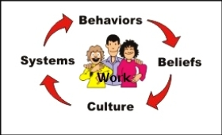
How to reduce the negative impact of beliefs in the workplace
It is very important to know what the actual issue is to enable the staff and the manager of the organisation prevent any upcoming negative beliefs or attitudes before it occurs. Therefore, whatever the cause of the negativity in the workplace is, we need to address the actual problem (Pdfs.semanticscholar.org.2021). However negative impact of beliefs or any other attitudes or issues can occur in any workplace environment. But, when the organisation decide to reduce the impact immediately, this is what makes it successful company and achieve it’s goals. There are several recommendations on how to reduce the negative impact of beliefs in the workplace;
Provide opportunities to express opinions; when the organisation provides opportunities for employees and even customers to express their different opinions about workplace policies and procedures. As well as taking the opportunity to feel free when talking and making suggestions. Individuals has to be provided with sufficient time to discuss different perspectives and to get proactive responses to questions and concerns. (2021)

Use consistent fair treatment; each individual in the workplace need to be treated fairly and avoiding favouritism by applying the same standard of accountability and system on rewards on all employees. It is important to develop workplace policies and procedure that organise efficiency. (Equalityhumanrights.com.2021)
Target punishment and rules; minimize directing rules of behaviour towards adults in the workplace, this will met their expectations of believing in themselves.
Provide trust and respect; In the workplace environment, it is important to believe, trust and respect each employees within the workplace. This has a huge positive impact on individuals as this reduce the impact of beliefs (Care, 2021). Each and everyone will feel valued, trusted and believed in. However, maintaining a high standard of performance in the workplace increase work productiveness and achievements. (Dsdweb.co.uk.2021)
Be incusive; support everyone to feel included, valued and respected. This helps promote confidence.
Give recognition; treat individuals equally and avoid discriminating anyone. Recognise each employees hard work and contribution. (2021)

Conclusion
In conclusion, beliefs are the assumptions we make about ourselves and others. When people discuss whether certain belief is a fact or an opinion, they will never end up with one decision and perspective. Therefore, in the workplace it is very important to avoid persuading someone of the same belief or point of view. However, as employees there need to be an acceptance of other point of views, attitudes, difference and way of thinking. There must be a target for everyone to met and achieve as a team with a high standard of performance, value, respect (2021). The organisation builds up with different perspectives and the differentiate between beliefs and attitudes but, in a positive way. Moreover, each individual has different skills which benefit the organisation as a whole and make it grow faster when thinking critically. (2021)

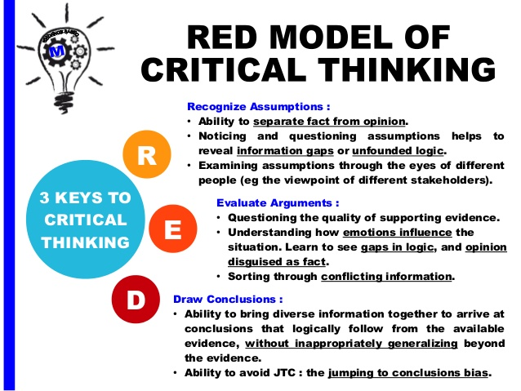

Reference list ( Part 1 )
- Care, A., 2021. [online] Activesocialcare.com. Available at: <https://activesocialcare.com/handbook/understanding-your-role/personal-values-attitudes-and-beliefs> [Accessed 27 June 2021].

- Dsdweb.co.uk. 2021. Describe how your own values, beliefs and personal experiences might affect your working practice. – ANSWERS FOR HEALTH AND SOCIAL CARE. [online] Available at: <https://dsdweb.co.uk/2017/11/01/describe-how-your-own-values-beliefs-and-personal-experiences-might-affect-your-working-practice/> [Accessed 27 June 2021].

- Equalityhumanrights.com. 2021. [online] Available at: <https://www.equalityhumanrights.com/sites/default/files/gd.12.411-2_religion_belief_workplace_employers_26-03-14b.pdf> [Accessed 27 June 2021].

- Faulkner, J., 2021. How your personal values and beliefs affect your decisions and behaviour. [online] Australasian Sustainable Wellness Academy. Available at: <https://aswa.net.au/understand-personal-values-beliefs-affect-decisions-behaviour/> [Accessed 27 June 2021].

- Immigration Advisers Authority. 2021. Personal beliefs, values, attitudes and behaviour - Immigration Advisers Authority. [online] Available at: <https://www.iaa.govt.nz/for-advisers/adviser-tools/ethics-toolkit/personal-beliefs-values-attitudes-and-behaviour/> [Accessed 27 June 2021].

- Mindtools.com. 2021. Understanding Workplace Values: ― Finding the Best Cultural Fit. [online] Available at: <https://www.mindtools.com/pages/article/understanding-workplace-values.htm> [Accessed 27 June 2021].

- Mindtools.com. 2021. What Are Your Values?: – Deciding What's Most Important in Life. [online] Available at: <https://www.mindtools.com/pages/article/newTED_85.htm> [Accessed 27 June 2021].

- Owlcation. 2021. The Relationship Between Beliefs, Values, Attitudes and Behaviours. [online] Available at: <https://owlcation.com/social-sciences/Teaching-and-Assessing-Attitudes> [Accessed 27 June 2021].

- Pdfs.semanticscholar.org. 2021. [online] Available at: <https://pdfs.semanticscholar.org/b6de/ee21f5afee8b64f89b266c46c2aad5d631f9.pdf> [Accessed 27 June 2021].

- Personal Finance for Beginners. 2021. 9 Questions That Will Help You Discover Your Financial Values. [online] Available at: <https://www.personalfinanceforbeginners.com/financial-values-questions/> [Accessed 27 June 2021].

- Radcliff, D., 2021. My Beliefs on Education! - Dianna Radcliff. [online] Dianna Radcliff. Available at: <https://www.sassysavvysimpleteaching.com/2014/07/my-beliefs-on-education-2/> [Accessed 27 June 2021].

- RNspeak | Nursing Journal. 2021. The Critical Thinking Skills In The Nursing Practice. [online] Available at: <https://rnspeak.com/critical-thinking-in-nursing/> [Accessed 27 June 2021].

- Sielearning.tafensw.edu.au. 2021. Personal values, belief and attitudes - Personal values, belief and attitudes. [online] Available at: <https://sielearning.tafensw.edu.au/MCS/CHCAOD402A/chcaod402a_csw/knowledge/values/values.htm> [Accessed 27 June 2021].

- Spiritual Ray. 2021. We Explain to You What Beliefs are and Why They are So Important. [online] Available at: <https://spiritualray.com/why-are-beliefs-so-important> [Accessed 27 June 2021].
- Styles At Life. 2021. 4 Different Types of Attitudes of People As Per Psychology. [online] Available at: <https://stylesatlife.com/articles/types-of-attitudes/> [Accessed 27 June 2021].

- The Balance Careers. 2021. You Can Counter Negativity in the Workplace With These 9 Tips. [online] Available at: <https://www.thebalancecareers.com/tips-for-minimizing-workplace-negativity-1919384> [Accessed 27 June 2021].

- UnionLeader.com. 2021. unionleader.com | 'There is nothing so powerful as truth' - Daniel Webster. [online] Available at: <https://www.unionleader.com/> [Accessed 27 June 2021].

- WiseStep. 2021. Effects of Positive and Negative Attitudes in the Workplace - WiseStep. [online] Available at: <https://content.wisestep.com/effects-positive-negative-attitudes-workplace/> [Accessed 27 June 2021].
- 2021. [online] Available at: <https://www.thedailymeditation.com/how-beliefs-affect-your-life-changing-your-perception-of-reality> [Accessed 27 June 2021].
Part 2 Critical reflection

Introduction
As part of this module, for the second part of this report I will be using my own reflection to discuss how my critical thinking skills has developed over the period I learnt throughout completing critical thinking skills module. However, whilst I have been listening to each lesson we had, I have obtained the keys of how critical thinking, beliefs, attitudes and values can be dealt with in the workplace. Therefore, to be able to develop my concepts on this topic, I will apply kolb’s reflective module. Kolb’s reflective cycle consists of four stages which refers to the experimental learning process. (Kolb Reflective Model, 2021).

The experimental learning cycle
Kolb’s reflective cycle

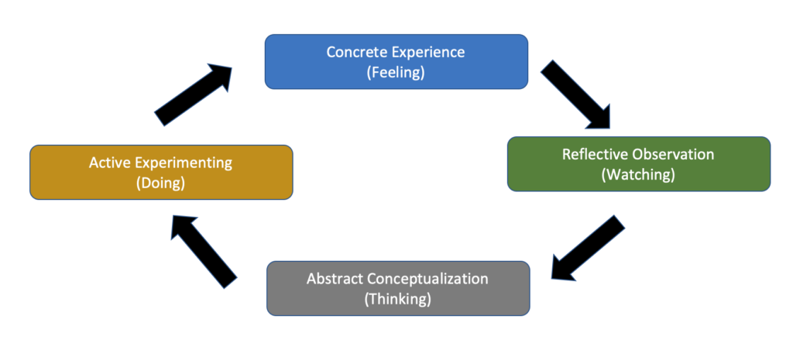

Concrete Experience
By starting with this module, the lecturer introduced the different concepts of beliefs, attitudes and values and how different perspectives can make beliefs of thinking something is true. I learnt that each belief and point of view must not be the truth but, in the case of various sources such as personal experiences, cultures, traditions, backgrounds. On reflection, we were engaged to provide our own beliefs whether we agree or disagree with this statement “marriage should be forever”. However, I gained knowledge on how each of us as students have had different view on this statement. Even though we have been though together in the same course, each one of us still have their opinion on whether marriage should be forever or not and the reason behind it. And that is because everyone of us might have been going through different experience and personal thoughts. Therefore, my own opinion somehow do not correspond other student’s opinion but, each one of us accepts other beliefs. I have also developed my understanding on the connections between beliefs, attitudes and values. As well as how we require to perform in the workplace getting to respect each others belief, provide a high standard of attitude and behaviours and treat individuals equally in such way we make everyone feel valued. (Kolb and Kolb, 2005)

Reflective Observation
At this stage, reflecting on how my personal knowledge developed, I have improved on my critical thinking and the way I interact with different minds. I have always respected other opinions but, I have been looking for people that has the same way of observing things as I do. However, I understood the aspects and the purposes behind each belief and ways of thinking. Therefore, I stopped to attempt individuals perspective and different opinions. I focused on how I could deal with a variety of beliefs, attitudes and values. At the same time to aim for a better workplace environment were personalities and beliefs has no impact on the organisation. I also obtained the target of being different than others as each and everyone has his or her own skills and knowledge which could benefit the organisation productivity as a whole. It is important for each employee to develop upon this and to understand each other and to aim to achieve workplace goals. (Litarian.2021)

Abstract Conceptualisation
Reflecting on my experiences and conclusion involving strategies and input. This part of the cycle transformations has a huge impact on how we should have obtained the learning module. This transforms our expectations on all the topics we covered until now, our understanding and personal knowledge improved, what we took as an evidence from this module to convert into practice. On reflection, we then identified all the important skills and structures of building critical thinking, we completed different activities that promoted my own learning and maintained good quality and mindful process of thinking critically. The lecturer aimed to provide us with different sources to get the best understanding of the module. We covered critical thinking models, pearson’s RED critical thinking model which stands for Recognise assumptions, evaluate arguments and draw conclusion. This helped me to link every aspects of this topic together. Where recognise assumptions involves the ability to separate facts from personal opinions. (Kolb Reflective Model,2021) This developed my understanding to know whether the content, belief or assumptions are facts or just opinion by applying this specific model. As well as addressing if the information is inductive or deductive reasoning and link them between logical reasoning. This is achieved by noticing and questioning assumptions and unproven information which provide us to reveal gaps and unfounded logic. In addition to evaluating argument by getting to know the quality of evidence. This helped me to understand how emotions influence the different situations that I could face later on and the way I could prevent that from occurring. And finally drawing conclusion, which is the ability to bring diverse information together to arrive at conclusion that realistically and logically directs the available evidence. This made me aware of judgement and how I could be provided with the appropriate information to draw conclusion without jumping and missing some important information.

Active Experimenting
At this final stage, I have been provided and supported with all the different learning materials, sources and models which, helped me to gain confidence towards this module and increased my understanding on every component that I have been taught with. However, I have the ability to uphold my beliefs, attitudes and values. I can understand others , the purpose behind each individuals’ beliefs, how it become like that, and what could be done to reduce any negative impact of beliefs in the workplace. Even if any general situations related to this aspects occurs, it can be avoided and I will be able to use my own skills and knowledge developed throughout this module to decrease the negative impact of beliefs. Critical thinking module have covered most of the important issues that arise in any workplace, therefore I have gained more skills than I expected as there were lots of informative conversation going through which build up my logical thinking and relationship within the workplace. On top of the sustainable benefit of getting to know the link between beliefs, attitudes and values and how to deal with those effectively. This module were introduced perfectly within the timeline addressing the different factors that could help students succeed in their learning as I have learned how to use critical thinking skills gained to inform future engagement. (2021)
Reference list (part 2)
- Essaywritingserviceuk.co.uk. 2021. Kolb Reflective Model. [online] Available at: <https://essaywritingserviceuk.co.uk/advice-and-guidance/kolb-reflective-model> [Accessed 27 June 2021].

- Kolb, A. and Kolb, D., 2005. Learning Styles and Learning Spaces: Enhancing Experiential Learning in Higher Education. Academy of Management Learning & Education, 4(2), pp.193-212.

- Leedsscp.org.uk. 2021. [online] Available at: <https://www.leedsscp.org.uk/LSCB/media/Images/pdfs/Kolb-learning-cycle.pdf> [Accessed 27 June 2021].

- Litairian. 2021. What is Belief? How Belief Impacts Us? What are Limiting Beliefs? How to Change Limiting Beliefs? - Litairian. [online] Available at: <https://litairian.com/what-is-belief-how-belief-impact-us-what-are-limiting-beliefs-how-to-change-limiting-beliefs/> [Accessed 27 June 2021].

- Mike, V., 2021. What are the Four Key Processes of Kolb's Reflective Learning Cycle?. [online] Online Assignment Expert. Available at: <https://www.onlineassignmentexpert.com/blog/four-key-processes-of-kolbs-reflective-learning-cycle/> [Accessed 27 June 2021].

