UWTSD

(ACCA4023)
Student Name: Leonardo Iwasaki
Student ID: 2531571
Submission Date: 14/08/2026
INTRODUCTION TO WEB AND DATABASE CONCEPTS
HTML & CSS Web Development
Assessment 2

Table of Contents

Contents
Table of Contents 1
1. Introduction 2
2. Requirements 2
3. Implementation 2
Validation results (HTML & CSS). - errors and fixes. 11
4. Evaluation 14
a) Research: 14
SEO 14
Usability 14
Accessibility 15
b) Website Evaluation: 16
Usability & Utility 17
SEOS Techniques 18
Accessibility (WCAG 2.1) 20
c) Website Comparison 21
Usability 21
Accessibility 23
SEO 25
Mobile Friendliness 27
Conclusion 28
5. Conclusion 29
6. References (IEEE Format) 30
7. Appendices 30

1. Introduction

This assessment will provide a study and practice introduction to web page development using HTML and CSS. For this assignment, an e-commerce website will be created to demonstrate the use of HyperText Markup Language (HTML) and the use of Cascading Style Sheets (CSS).
HTML is a most base structural language to create webpages. It provides elements and attributes to model a webpage intuitively and semantically, which means it is easy to code and visualize.
CSS is a language to stylish web pages, where is possible to set the visual and appearance.
It will be used elements as tables, images, links, and visual effects to demonstrate a functional layout of a webpage.

2. Requirements
This webpage contains the basic and pure HTML language, as the CSS files and can be navigated in system folder environment.
One resource for visual stylish and standardization is the use of the website bootstrap - https://getbootstrap.com/. An internet connection is required to correct load elements.

3. Implementation

The implementation of the website was built in a local static page’s environment, using language HTML v5 and CSS v3. To ensure agility in layout development and full responsiveness on mobile devices, the Bootstrap 5 framework was integrated via Content Delivery Network (CDN). Since this is a frontend prototype without server communication, the navigation flow — including product display, search products, and shopping add list — was simulated through the interconnection of independent local HTML files stored in a standardized directory structure.
A website for e-commerce named E-store will be the case of this study. It contains 7 HTML pages. 1 sitemap, 2 folder of images and 1 CSS file.
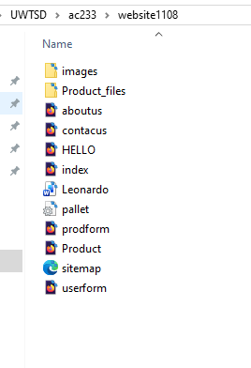
Files

The IDE used is the Visual Studio Code. The VS Code is an open-source code editor developed by Microsoft. It is available for Windows, Mac and Linux. It is built using Electron, a tool created by GitHub that enables the development of desktop software using HTML, CSS and JavaScript. [1]
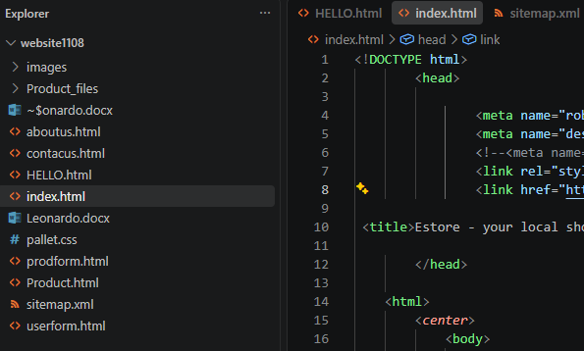
Visual Studio Code – IDE

To demonstrate graphicaly the layout of website, the followed print screens show how each page is design.
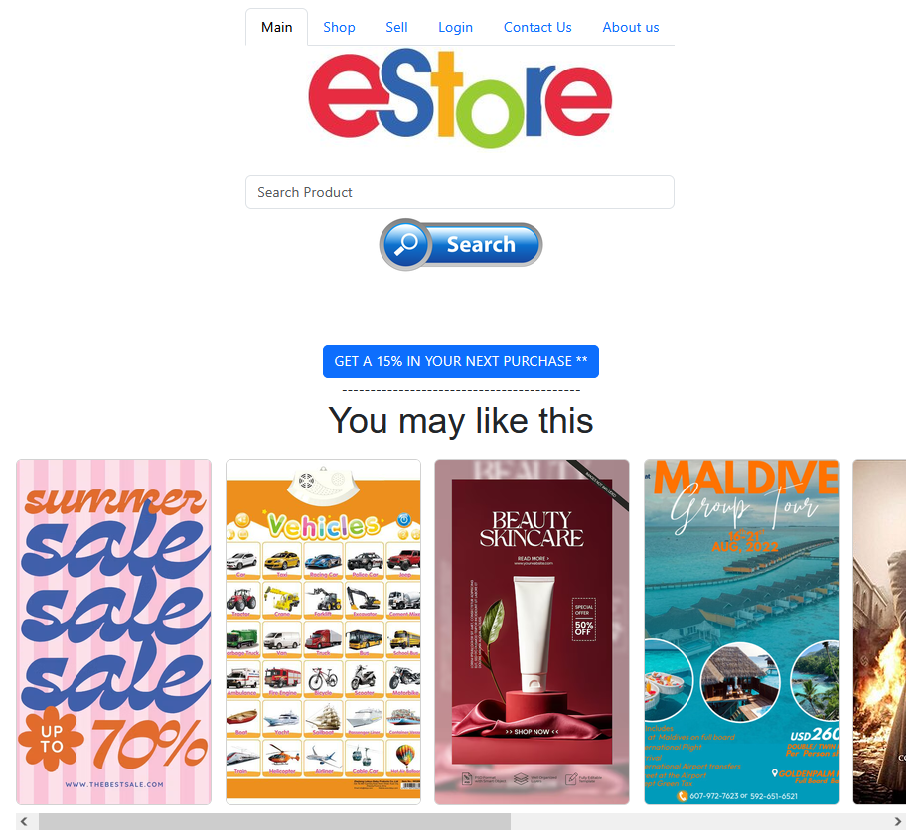
Index page – index.html

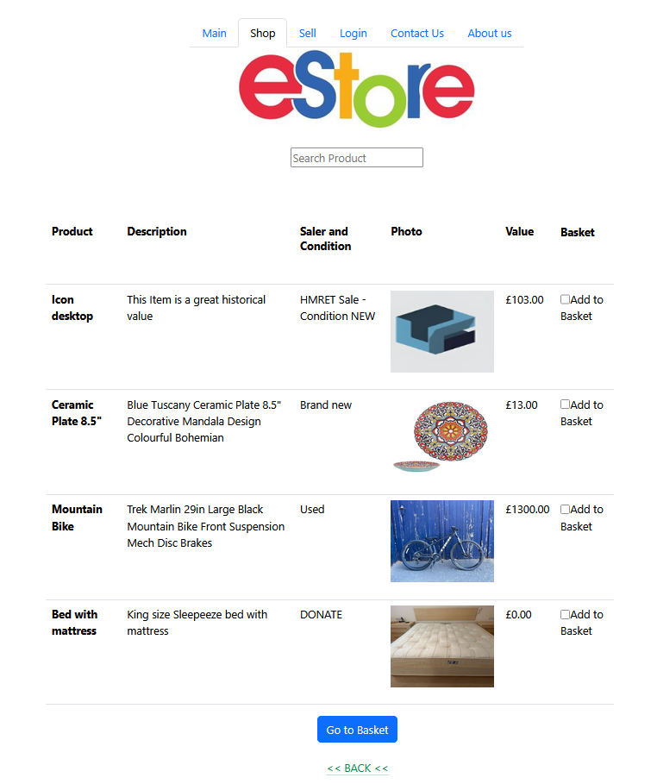
Products List – Product.html

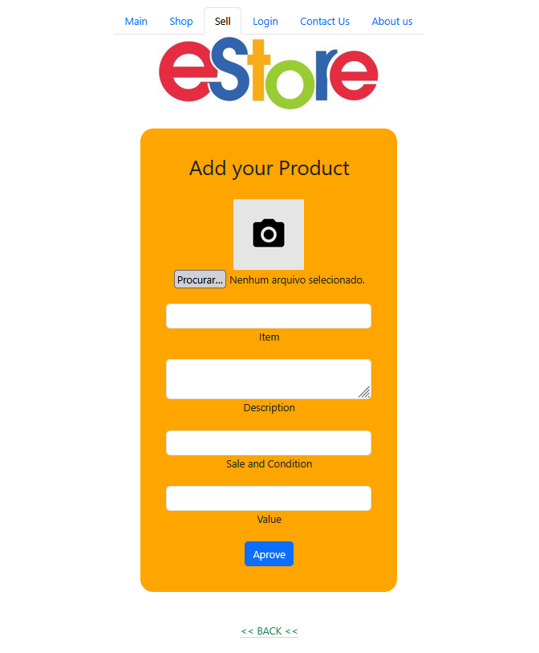
Product Add Sell Form – prodform.html

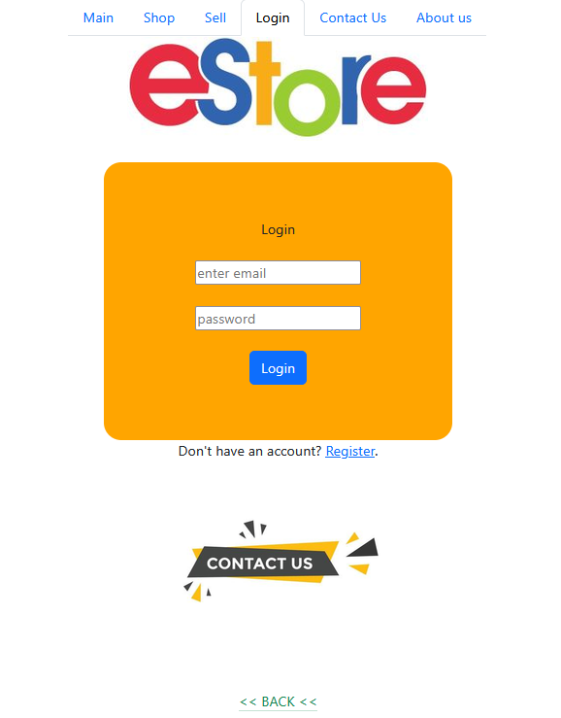
Login form – HELLO.html

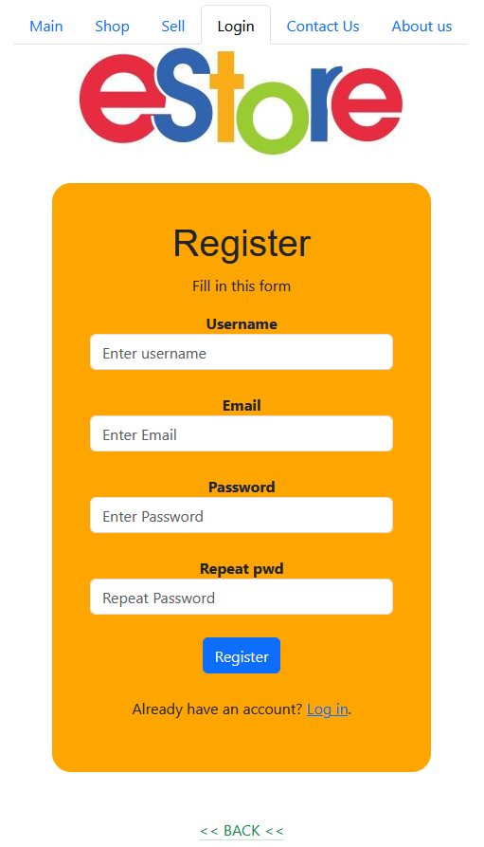
User Register from – userform.html

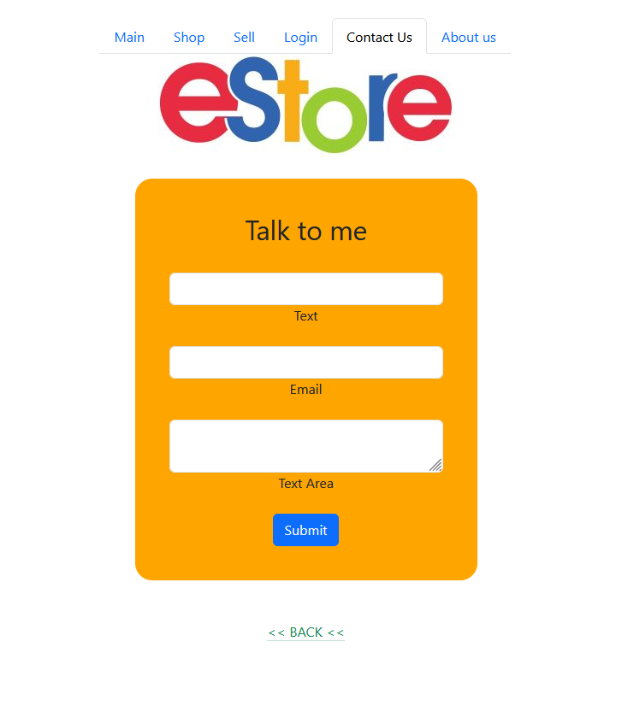
Contact Form – contactus.html

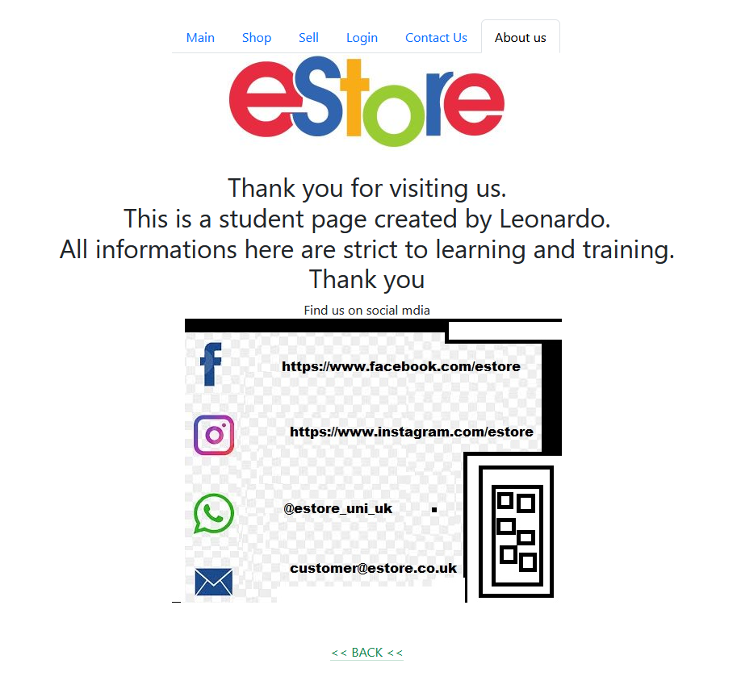
About us and social media – aboutus.html

Validation results (HTML & CSS). - errors and fixes.

For validate the content of this website the online tool (https://validator.w3.org) will be used to check for error in HTML (https://validator.w3.org/) and CSS Files (https://jigsaw.w3.org/css-validator/) . The errors found will be explained and sorted as the tool recommended.

pallet.css

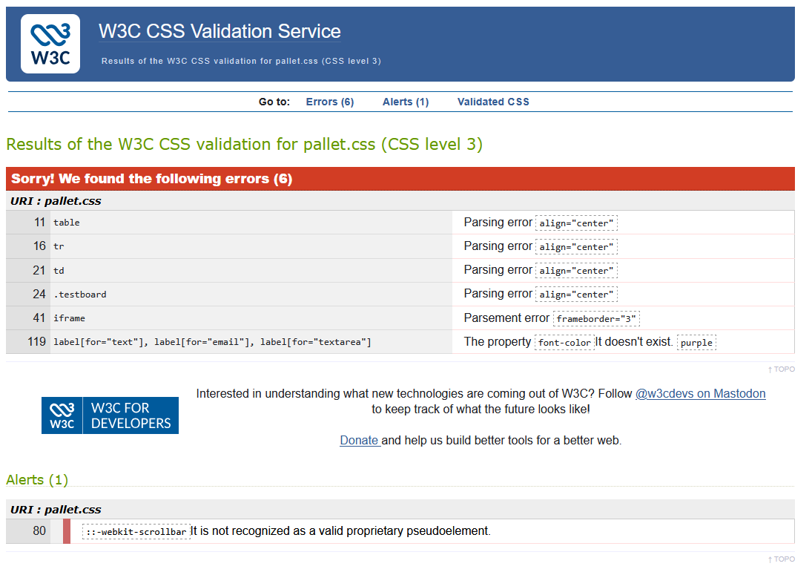
- Error 11,16,21,24,41. Are syntax errors and they are not recognized, these entries were added for test.
\_ To Fix these errors they were deleted from CSS file as it is not being in use.

- Error 119. It doesn’t recognize the color “purple” in that attribute.
\_ To Fix the error this was deleted from CSS file as it is not being in use.

- Alert 80. It doesn’t recognize the entry webkit-scroolbar, this entry was added as a test.
\_ After searching apparently is a bug not fixed. Deleted as is not used.

Result
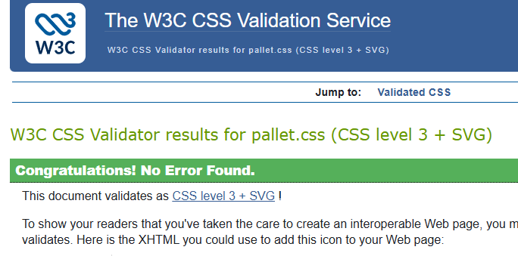

Index.html
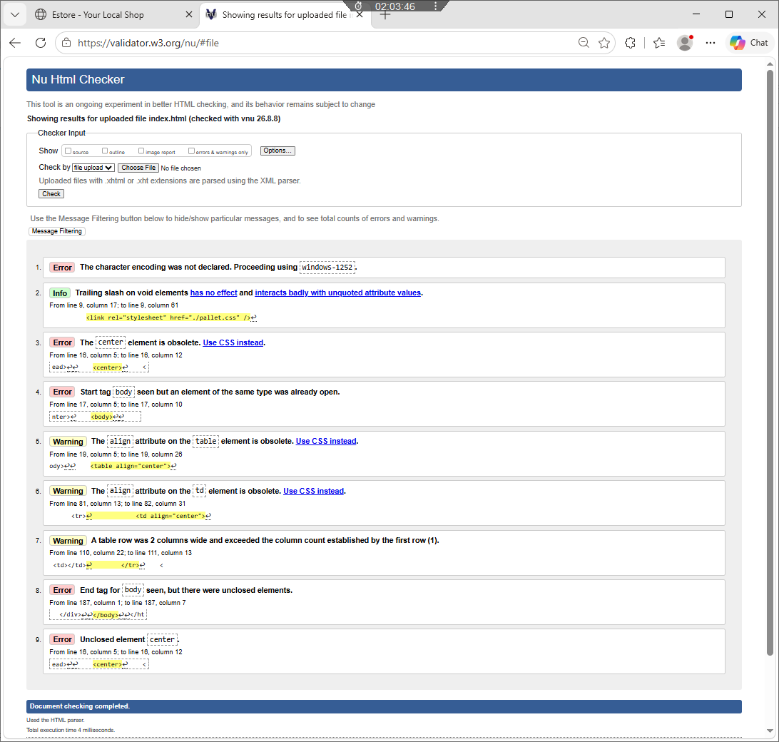

Error 3 The center element is obsolete.
\_ remove the tag and add to CSS file
Error 4 Start tag [body] seen but an element of the same type was already open.
\_ remove tag body
Error 9 Unclosed element [center]
\_ add the open element missing
Warning 5,6 – obsolete attribute
\_ removed and added to CSS file
Info 2 - Trailing slash on void elements
\_ remove character

Result
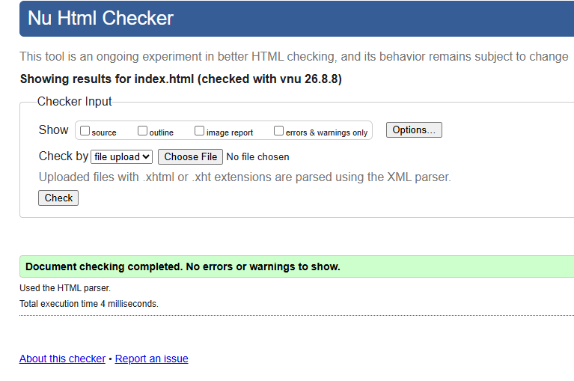

Product.html

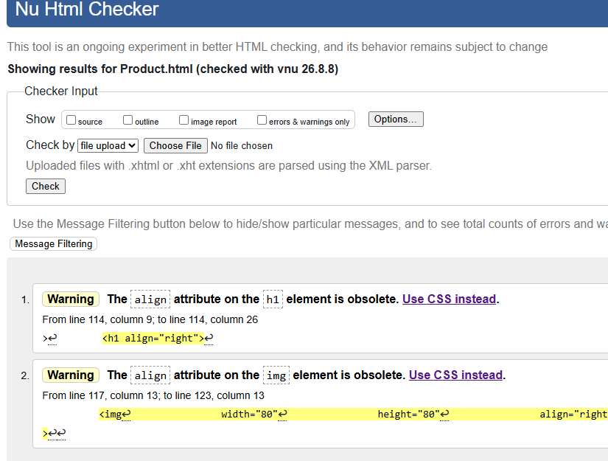

Warning 1,2 – Element Obsolete
\_ remove the attribute as is no need

Result
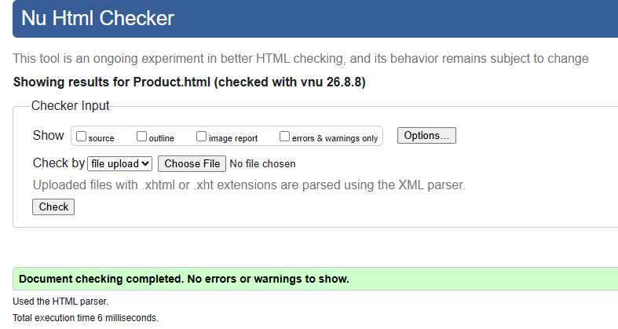

prodform.html

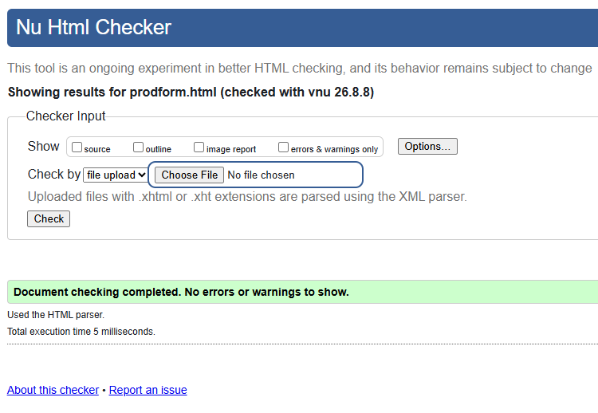

HELLO.html

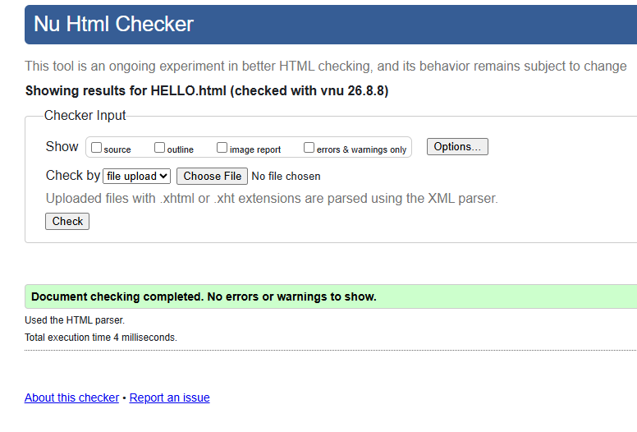

userform.html

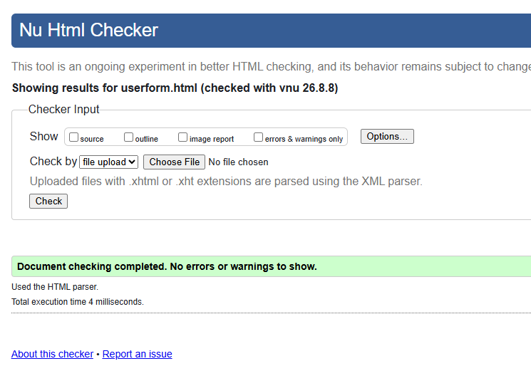

contactus.html

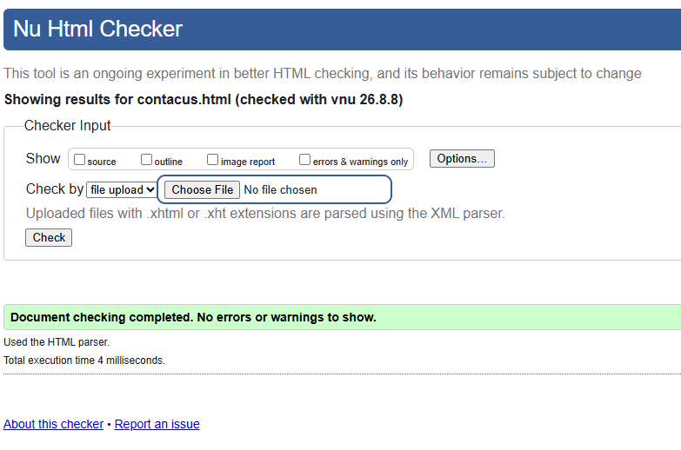

aboutus.html

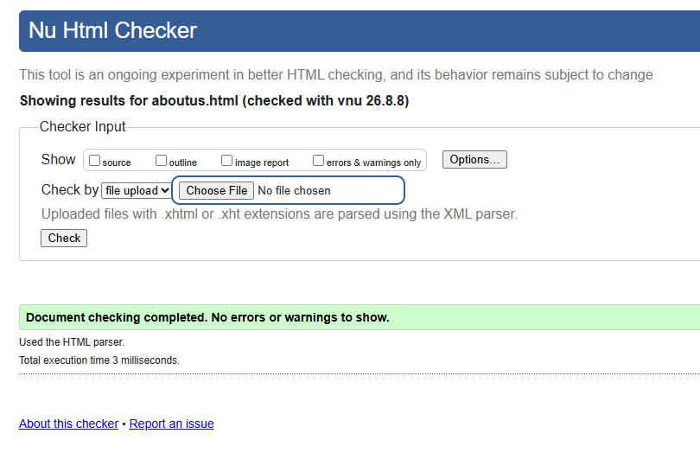

4. Evaluation

a) Research:
SEO
Keyword research or Search Engines Optimization is an analysis of terms, words, questions and behavior of people’s search. When people use sites like Google or Yahoo or Bing to search anything these engines look in websites contents, tags and information to result in a ranking search for the user. [2]
Taking that as considered, this web site was created based on some specs to be faster and get better rank when these engines look for results.
Usability
After the website was developed, the next step was the research for usability as it is very important in the user perspective and for SEO.
For the user, we make clean and direct pages. This helps the user to get on the website and see right away what is looking for, without must search in many contents and paragraphs.
In SEO perspective, a search engine can run through the website and collect all information needed faster as all information as condescend, which helps to rank higher in users search results.

Accessibility
Search Engine are like reader robots in the web. So as clean and direct to point the webpage is, more it tends to rank better in a search. In this case, the user accessibility and the SEO was considered to create a totally intuitive website. With large and self-explained elements and less required information. This helps all kinds of users to use the website without expertise or disability.
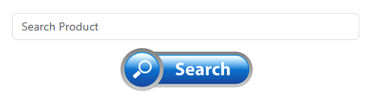
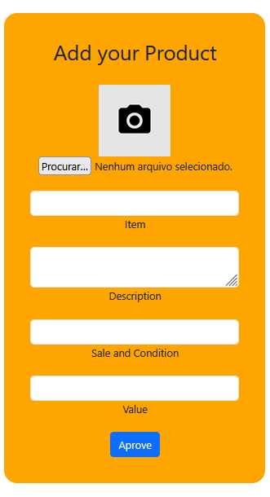
Clean and Intuitive interface

b) Website Evaluation:
Evaluating a website takes into consideration many aspects of how the site will be presented. Aspects of quality of contents, effectiveness, accuracy, and timelessness are important to pass credibility. Content must be well written, updated, and easy navigation. [3]
Taking this specificity, this website was built carefully to be fast and to users and engine find the information faster.
When the website is reached, the main page contains the proposal of the website, which in this case is an e-commerce for different vendors.

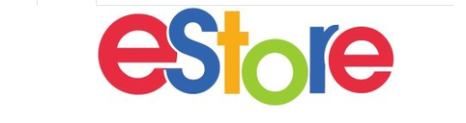
Main proposal of website

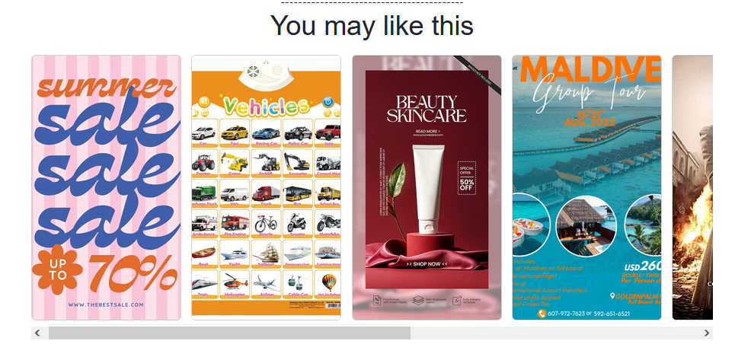
Vendors Announces

Usability & Utility
Since people are more likely to use easy and clean structures, this website was created in a way that is very user friendly and intuitive, without complex commands and texts. With easy navigation and a simple layout to facility the user experience.
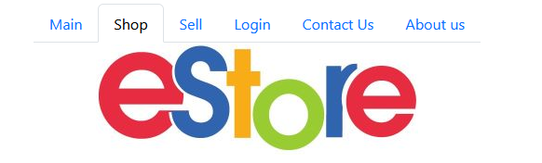
Example of easy navigation menu

SEO Techniques

Image optimization. All images are designed to be self explained with labels and comments
Meta tags are HTML tags that are used to provide additional information about a page to search engines and other customers. Clients process meta tags and ignore those that are not supported. Meta tags are added to the <head> section of the HTML page and typically look like this:
<meta name="description" content="Easy to use E-Store">
<meta charset="utf-8">
<meta name="robots" content="noindex,nofollow"> <!-- meta tag for search engines -->

A sitemap is a map of a website—a file that lists and catalogues all the pages on a website that we want to index on Google and other search engines.
A sitemap can be thought of as a website’s table of contents, like a book’s table of contents. In fact, the sitemap provides an overview of the content structure to make it easier for users and search engines to find topics. [4]
An example of a site to be created and distributed to search engine is:
<?xml version="1.0" encoding="UTF-8"?>
<urlset xmlns="http://www.sitemaps.org/schemas/sitemap/0.9">
<url>
<loc>https://www.estore.com/main.html</loc>
<lastmod>2026-08-12</lastmod>
<changefreq>monthly</changefreq>
<priority>0.5</priority>
</url>
<url>
<loc>https://www.estore.com/Product.html</loc>
<lastmod>2026-08-12</lastmod>
<changefreq>monthly</changefreq>
<priority>0.5</priority>
</url>
<loc>https://www.estore.com/prodform.html</loc>
<lastmod>2026-08-12</lastmod>
<changefreq>monthly</changefreq>
<priority>0.5</priority>
</url>
<url>
<loc>https://www.estore.com/userform.html</loc>
<lastmod>2026-08-12</lastmod>
<changefreq>monthly</changefreq>
<priority>0.5</priority>
</url>
<url>
<loc>https://www.estore.com/aboutus.html</loc>
<lastmod>2026-08-12</lastmod>
<changefreq>monthly</changefreq>
<priority>0.5</priority>
</url>
<url>
<loc>https://www.estore.com/HELLO.html</loc>
<lastmod>2026-08-12</lastmod>
<changefreq>monthly</changefreq>
<priority>0.5</priority>
</url>
<url>
<loc>https://www.estore.com/contactus.html</loc>
<lastmod>2026-08-12</lastmod>
<changefreq>monthly</changefreq>
<priority>0.5</priority>
</url>
</urlset>

Accessibility (WCAG 2.1)
Accessibility was taking in considering when size fonts and images – to help user to understand the needs, layout display – clean and fast to help the navigation experience, and HTML semantic Headers (h1) - distinguish main relevant information texts.

Examples of accessibility

Important information relevant size of fonts e images.

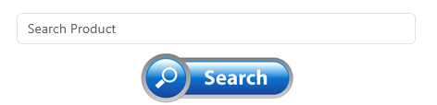
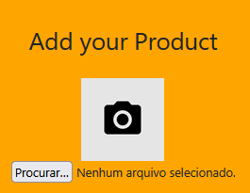
Well format, standard layout and relevant images.

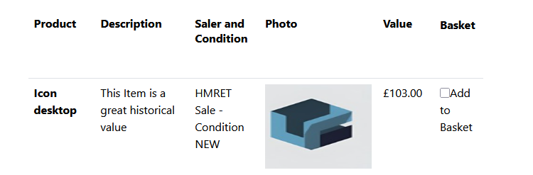
Well defined content and clean enviorament.

c) Website Comparison
A good practice of SEO comparative is evaluating the content against similar competitors. The competitor’s analysis may show GAPs strategics or benchmark the site’s keyword ranking. [5]
In this study, we are only going to compare layout, accessibility and Usability as the website is not online, and don’t to have sufficient data.
Usability
Comparing competitor’s websites, it’s possible to see that our project has a similar usability in manners of structures and elements position. Another parameter to compare is how the website looks easy and pleasant to use.

A clean and focus main page, help the user to get all important informations to his profile and search direct for a product. The Estore mix part of sites like ebay and google to create a more effient experience. In comparating the index page is similar to ebay page where there is a main bar to search for products.

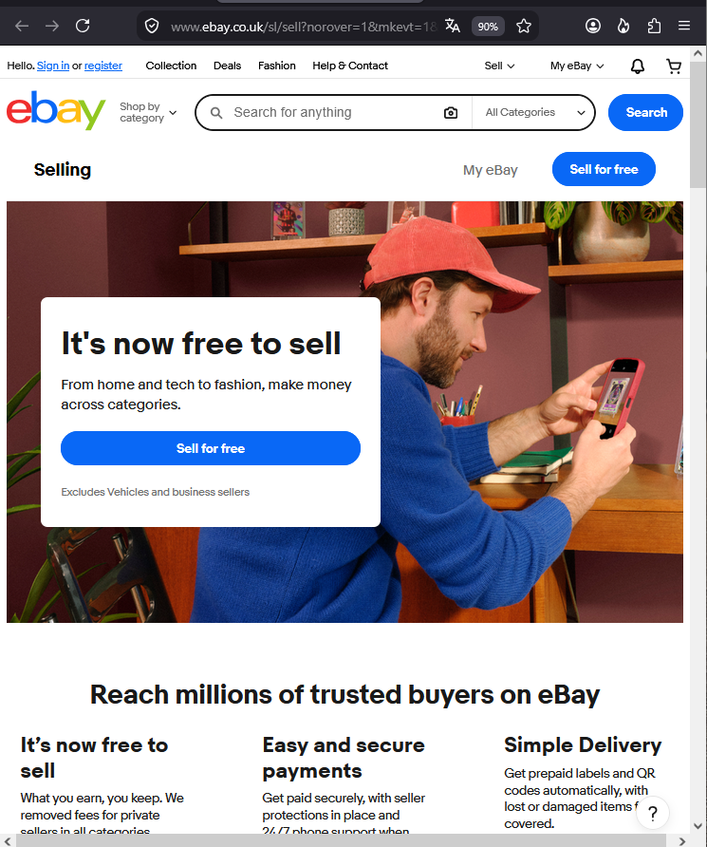 | 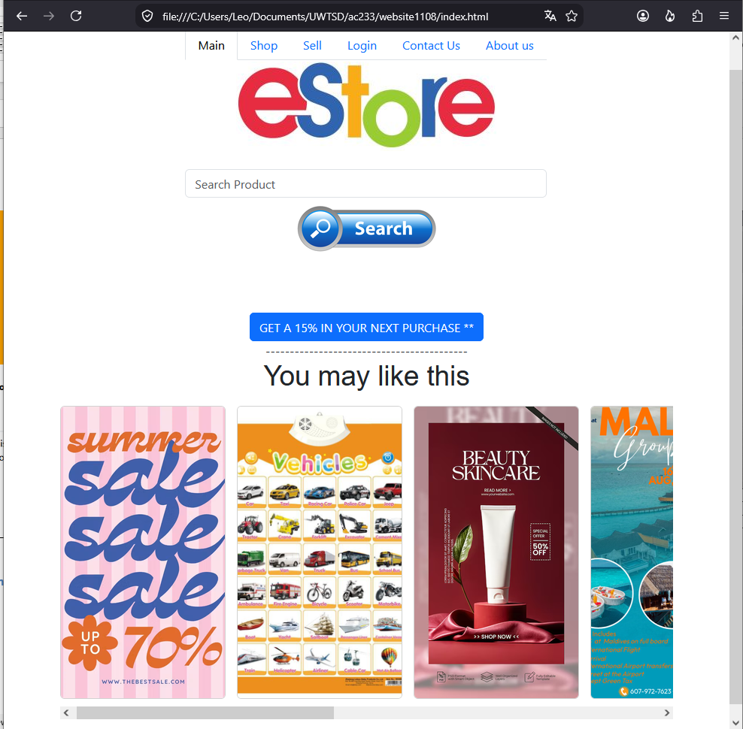
In amazon.com the serch results come in a list with photo and descriptions. Sponsored vendor come in first place and the other sellers follow filter and relevant informatinos to ranking products for user.
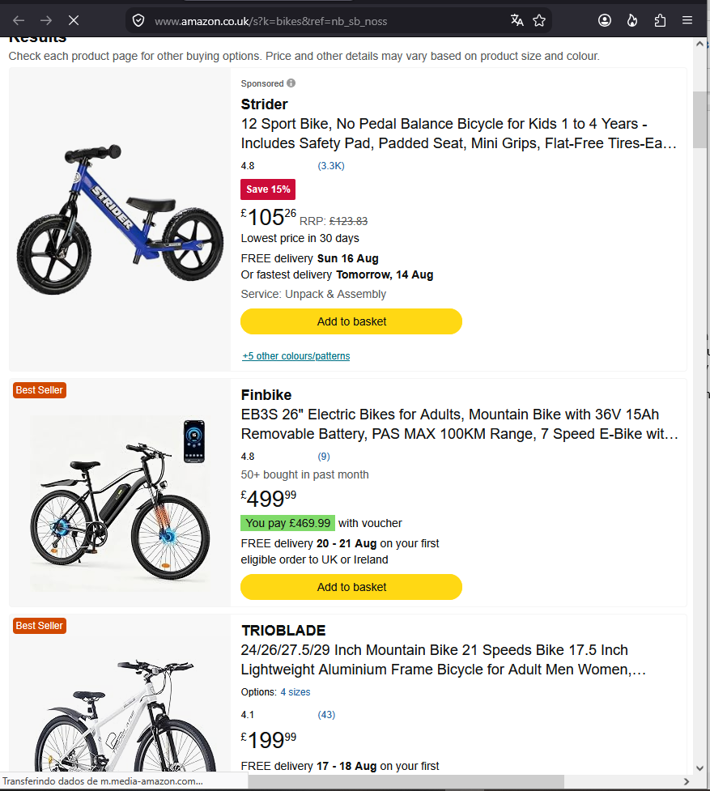 | 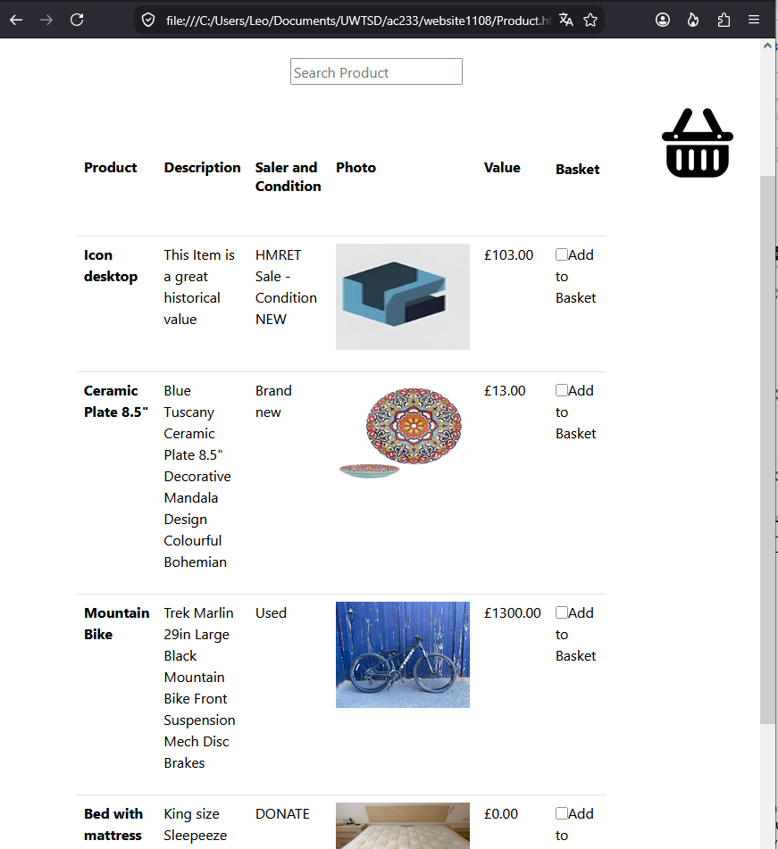
To keep the simplicty of add new products to list, the comparation application was the OLIO mobile aplciation, which in just a few clicks its possible to submit a product to be avaliated and added to sell. In OLIO aplication, a good resource that is good to mention is the advent of AI feature, helping to fill a description and some information automatically taking a picture of an object.

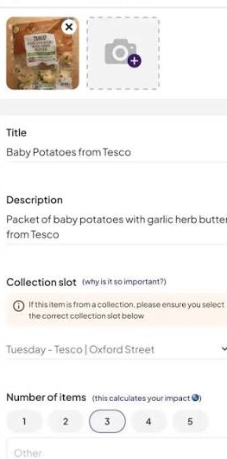 | 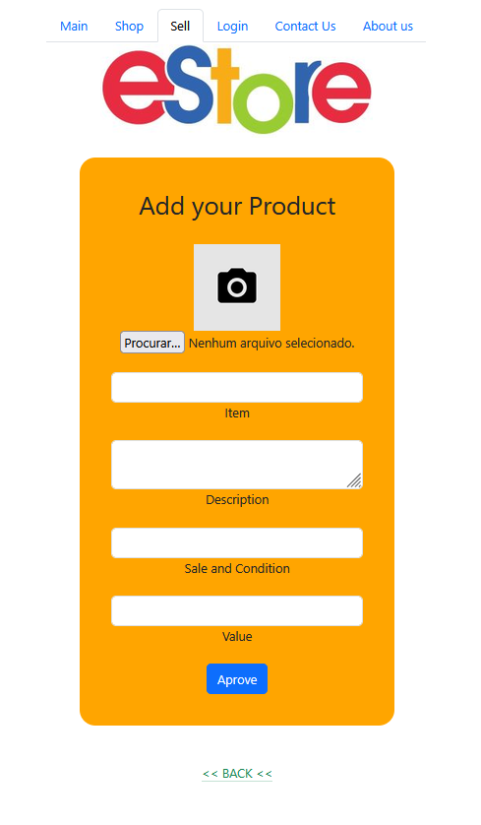

Accessibility

Accessibility is a key feature for major big company’s website. Every is thinking in a manner that the user and engines don’t have difficulty navigating. By well structured the product content internal algorithms and readers can track, indexes and interpret text and images effectively.
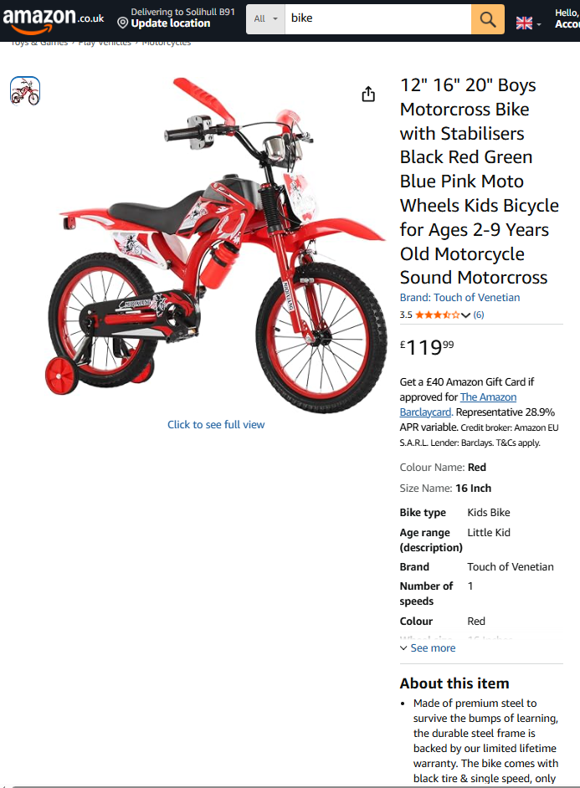
Amazon web site – information indexed, “about item” detailed, user`s rating of product

Another part of this study is the facility to access information about a product. Search engines and user screens should easily identify images and text on websites. In case of products most relevant search results come in priority and necessary fields are self-explained leaving no doubts about what, where to go, how to buy it and what’s is the best option.
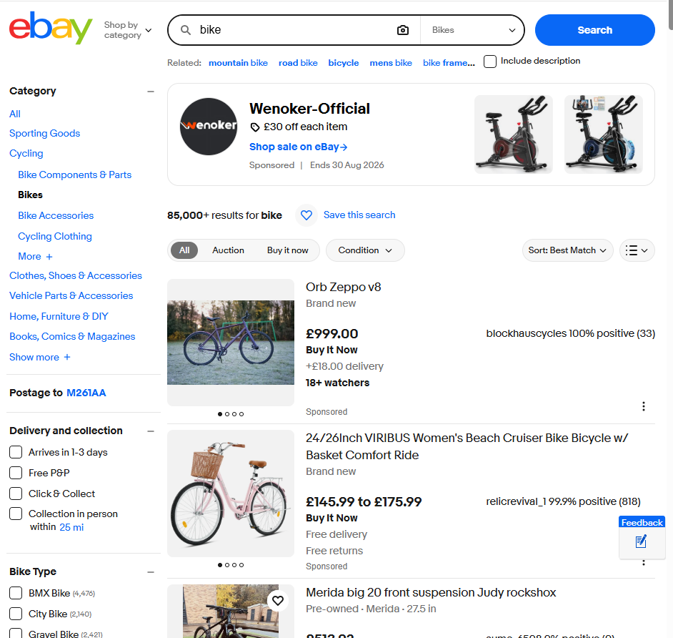
eBay website - Images are well defined with labels and different header fonts

SEO

External and internal search engines use content of search results to rank and show a list of a user`s query. For example, google search for data in websites to list, index and show a list of results order by relevant data reached or eBay uses its internal search engine to show a list of results ranked with most relevant data. Using SEO techniques, a website or a product to be distinguished in the list and get more relevant ranking by using tag or metatags, proper e trustful images, well written content and clear information about it.

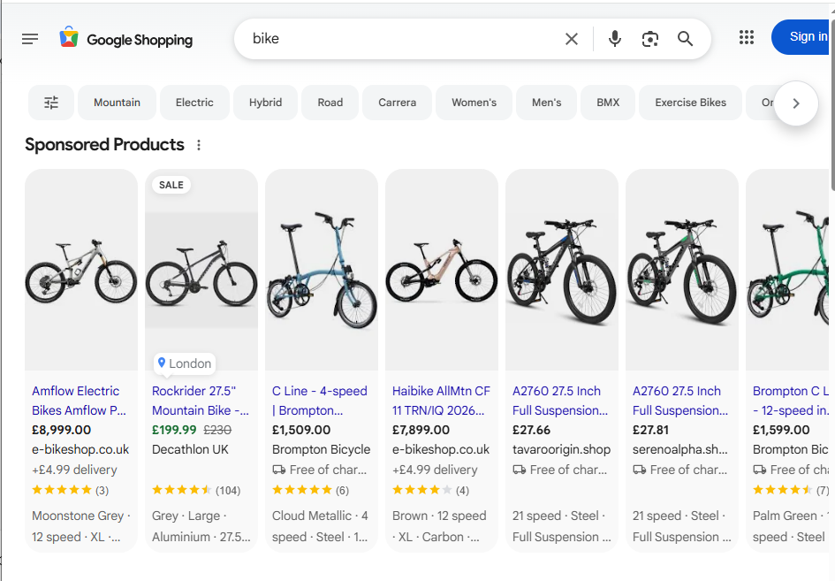
Google website – generic query order by most relevant data found by google engines.

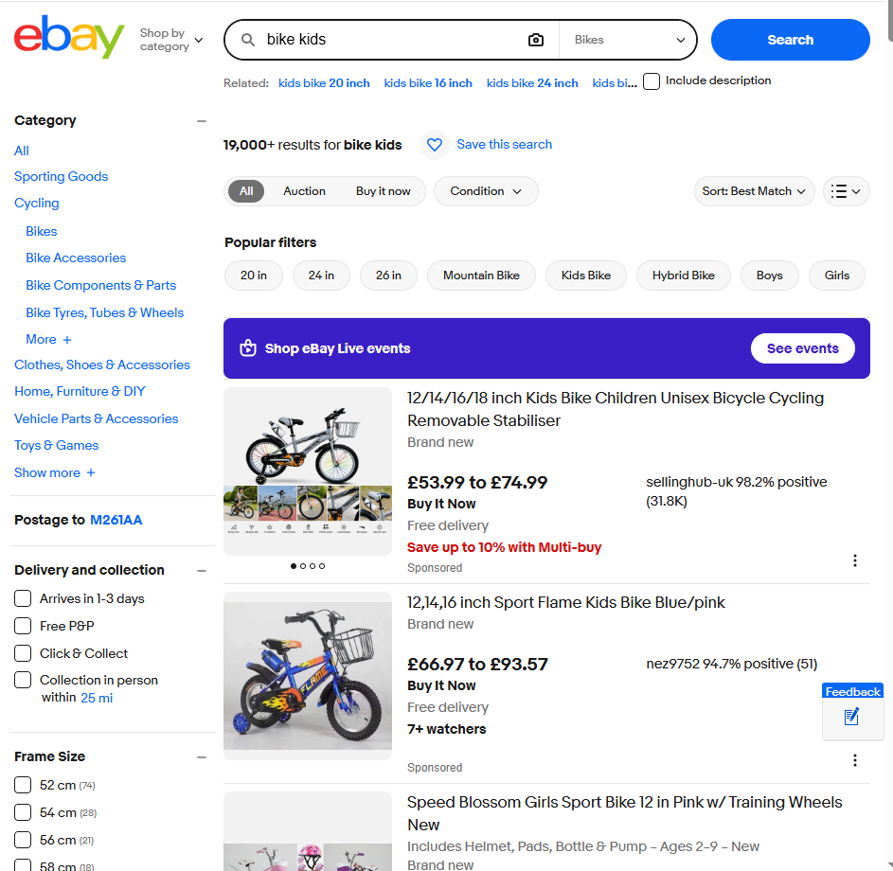
eBay website – internal search engine listing most relevant results

Mobile Friendliness

Using the resource of inspection on browser it’s possible to see the layout and scheme of the website in mobiles architectures. Aspects like size and colors and click and fields to fill were set up to have a friendly experience.
Compared to similar websites, this website was more intuitive and cleaner with focus on one business idea.

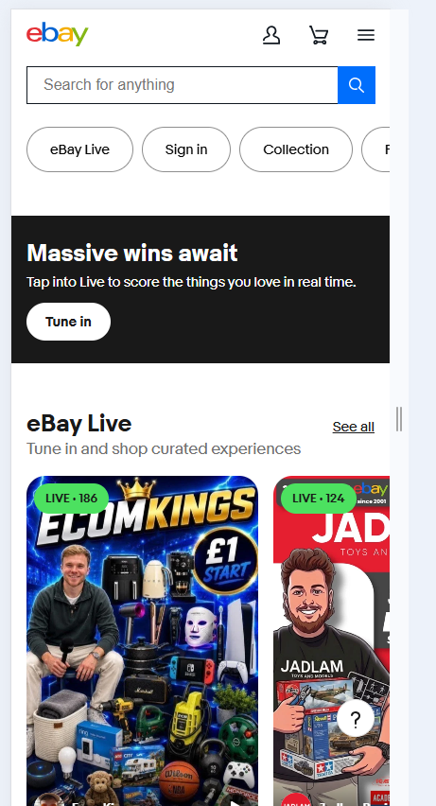 | 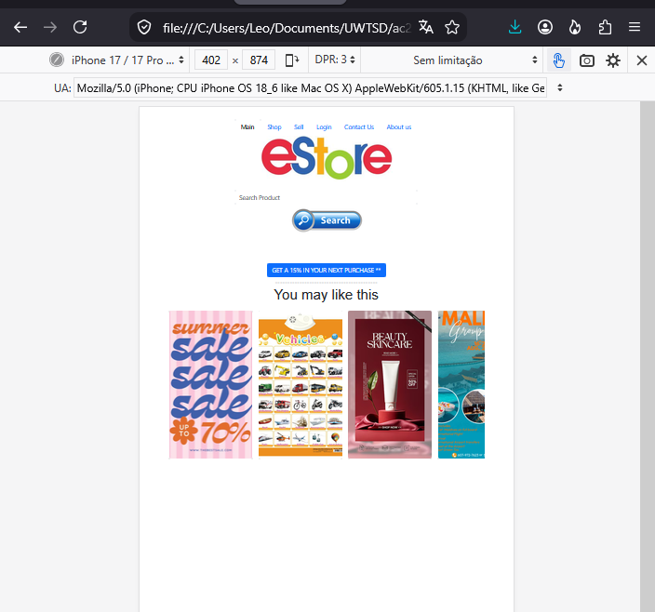
Mobile View – eBay vs index page

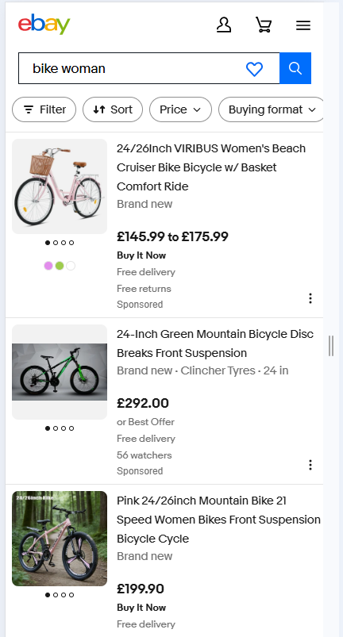 | 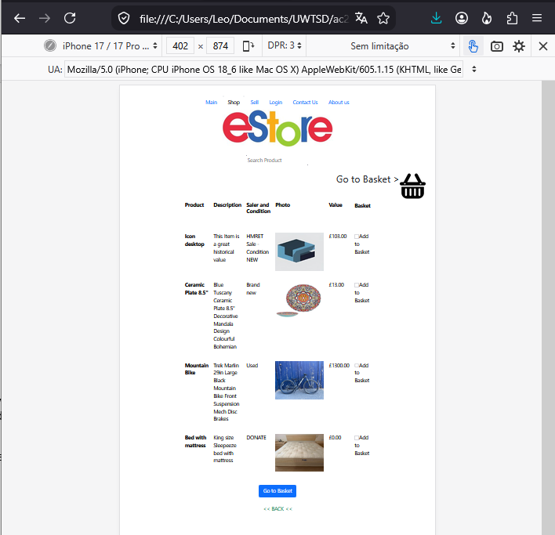
Mobile View – List of products page eBay vs product.html

Conclusion

In comparation the major websites of same segment, it’s possible to understand how the SEO works to rank and development a better website. How code is written and how the, for example, meta tags are used defines a better relevance in search engine. Organized and keyworks in text and images make the differential as a good accessibility to contents, internal and external.

5. Conclusion

This assessment had to introduce the HTML language and CSS in practical and professional development. Learning how the structures and navigation of web pages are, it was possible to understand how to build an efficient website.
Using tools to check and validate codes, and understanding the concept of Search Engines Optimization, it was possible to create more professional pages for engines like google or yahoo as to be more user friendly to people.
To create this website, many factors were considered and the option to choose this theme was the necessity of creating something that could join the facility of layout as google with the functionality of ecommerce.
Outthought the simplicity of it was created and the style of webpages it was possible to study all aspects of classes of this module.

6. References (IEEE Format)

[1] | A. Hanashiro, "treinaweb," treinaweb, 2021. [Online]. Available: https://www.treinaweb.com.br/blog/vs-code-o-que-e-e-por-que-voce-deve-usar. [Accessed 10 07 2026].
[2] | Google, "developers.google.com," Google, [Online]. Available: https://developers.google.com/search/docs/fundamentals/seo-starter-guide. [Accessed 07 2026].
[3] | G. Kowalewski, "https://www.expre.co.uk/," expre.co.uk, 18 11 2025. [Online]. Available: https://www.expre.co.uk/how-to-evaluate-a-website/. [Accessed 10 07 2026].
[4] | A. Lindley, "semrush.com," semrush, 05 01 2026. [Online]. Available: https://www.semrush.com/blog/xml-sitemap/?g_acctid=152-012-3634&g_adid=676232816874&g_adgroupid=149553966170&g_network=g&g_adtype=search&g_keyword=&g_keywordid=dsa-2185834088336&g_campaignid=18352326857&g_campaign=UK_SRCH_DSA_Blog_EN&kw=&cmp=UK_SRCH_DSA_B. [Accessed 20026 08 10].

7. Appendices

index.html

<!DOCTYPE html>

<html lang="en">
<head>
<meta charset="UTF-8">
<meta name="robots" content="noindex,nofollow"> <!-- meta tag for search -->
<meta name="description" content="Easy to use E-Store">
<!--<meta name="viewport" content="width=device-width, initial-scale=1"> --><!-- bootstrap for mobile*/ -->
<link rel="stylesheet" href="./pallet.css">
<link href="https://cdn.jsdelivr.net/npm/bootstrap@5.3.8/dist/css/bootstrap.min.css" rel="stylesheet" integrity="sha384-sRIl4kxILFvY47J16cr9ZwB07vP4J8+LH7qKQnuqkuIAvNWLzeN8tE5YBujZqJLB" crossorigin="anonymous">

<title>Estore - your local shop</title>

</head>

<table>
<tr>
<td>
<ul class="nav nav-tabs">
<li class="nav-item">
<a
class="nav-link active"
aria-current="page"
href="./index.html"
>
Main
</a>
</li>

<li class="nav-item">
<a
class="nav-link"
href="./Product.html"
>
Shop
</a>
</li>

<li class="nav-item">
<a
class="nav-link"
href="./prodform.html"
>
Sell
</a>
</li>

<li class="nav-item">
<a
class="nav-link"
href="./HELLO.html"
>
Login
</a>
</li>

<li class="nav-item">
<a
class="nav-link"
href="./contacus.html"
>
Contact Us
</a>
</li>

<li class="nav-item">
<a
class="nav-link"
href="./aboutus.html"
>
About Us
</a>
</li>
</ul>
</td>
</tr>

<tr>
<td>
<img
src="./images/store.jpg"
alt="eStore"
>

<br>
<br>

<input
type="text"
class="form-control"
aria-label="Search product"
aria-describedby="inputGroup-sizing-default"
placeholder="Search Product"
>

<a href="./Product.html">
<img
src="./images/search.jpg"
alt="Search"
height="80"
>
</a>

<br>
</td>

</tr>
</table>

<br>
<br>
<br>

<!-- Button trigger modal -->
<button
type="button"
class="btn btn-primary"
data-bs-toggle="modal"
data-bs-target="#exampleModal"
>
GET A 15% IN YOUR NEXT PURCHASE **
</button>

<br>

<hr>

<h1>You may like this</h1>

<div class="carrossel">

<div class="card">
<img
src="./images/foto1.jpg"
alt="Imagem 1"
>
</div>

<div class="card">
<img
src="./images/foto2.jpg"
alt="Imagem 2"
>
</div>

<div class="card">
<img
src="./images/foto3.jpg"
alt="Imagem 3"
>
</div>

<div class="card">
<img
src="./images/foto4.jpg"
alt="Imagem 4"
>
</div>

<div class="card">
<img
src="./images/foto5.jpg"
alt="Imagem 5"
>
</div>

<div class="card">
<img
src="./images/foto6.jpg"
alt="Imagem 6"
>
</div>

<div class="card">
<img
src="./images/foto7.jpg"
alt="Imagem 7"
>
</div>

</div>

</html>

Product.html
<!DOCTYPE html>
<html lang="en">

<head>
<meta charset="UTF-8">

<link rel="stylesheet" href="./pallet.css">

<link
href="https://cdn.jsdelivr.net/npm/bootstrap@5.3.8/dist/css/bootstrap.min.css"
rel="stylesheet"
integrity="sha384-sRIl4kxILFvY47J16cr9ZwB07vP4J8+LH7qKQnuqkuIAvNWLzeN8tE5YBujZqJLB"
crossorigin="anonymous"
>

<title>Estore - Your Local Shop</title>
</head>

<body>

<table>
<tr>
<td>
<ul class="nav nav-tabs">

<li class="nav-item">
<a
class="nav-link"
href="./index.html"
>
Main
</a>
</li>

<li class="nav-item">
<a
class="nav-link active"
href="./Product.html"
aria-current="page"
>
Shop
</a>
</li>

<li class="nav-item">
<a
class="nav-link"
href="./prodform.html"
>
Sell
</a>
</li>

<li class="nav-item">
<a
class="nav-link"
href="./HELLO.html"
>
Login
</a>
</li>

<li class="nav-item">
<a
class="nav-link"
href="./contacus.html"
>
Contact Us
</a>
</li>

<li class="nav-item">
<!--<a class="nav-link disabled" aria-disabled="true">Disabled</a>-->

<a
class="nav-link"
href="./aboutus.html"
>
About Us
</a>
</li>

</ul>
</td>
</tr>

<tr>
<td>

<a href="./index.html">
<img
src="./images/store.jpg"
alt="eStore"
>

<br>
<br>
</a>

<input
type="text"
placeholder="Search Product"
>

<br>
<br>

</td>
</tr>
</table>

<div>
<h1>
Go to Basket >

<img
width="80"
height="80"

src="./images/75623.png"
alt="Basket"
>

<br>
<br>
</h1>
</div>

<table
class="table"
style="width: 60%;"
>

<tr>
<td>
<p style="margin-bottom: 1cm; line-height: normal;">
<b>Product</b>
</p>
</td>

<td>
<p style="margin-bottom: 1cm; line-height: normal;">
<b>Description</b>
</p>
</td>

<td>
<p style="margin-bottom: 1cm; line-height: normal;">
<b>Seller and Condition</b>
</p>
</td>

<td>
<p style="margin-bottom: 1cm; line-height: normal;">
<b>Photo</b>
</p>
</td>

<td>
<p style="margin-bottom: 1cm; line-height: normal;">
<b>Value</b>
</p>
</td>

<td>
<b>Basket</b>
</td>
</tr>

<tr>
<td>
<p>
<b>Icon desktop</b>
</p>
</td>

<td>
<p>
This Item is a great historical value
</p>
</td>

<td>
<p>
HMRET Sale - Condition NEW
</p>
</td>

<td>
<p>
<img
width="150"
height="119"
src="Product_files/image001.png"
alt="Icon desktop"
>
</p>
</td>

<td>
<p>
£103.00
</p>
</td>

<td>
<p>
<input
type="checkbox"
id="buy1"
name="basket"
value="1"
>
Add to Basket
</p>
</td>
</tr>

<tr>
<td>
<p>
<b>Ceramic Plate 8.5"</b>
</p>
</td>

<td>
<p>
Blue Tuscany Ceramic Plate 8.5"
Decorative Mandala Design
Colourful Bohemian
</p>
</td>

<td>
<p>
Brand new
</p>
</td>

<td>
<p>
<img
width="150"
height="119"
src="Product_files/s-l9602.webp"
alt="Ceramic Plate"
>
</p>
</td>

<td>
<p>
£13.00
</p>
</td>

<td>
<p>
<input
type="checkbox"
id="buy2"
name="basket"
value="12"
>
Add to Basket
</p>
</td>
</tr>

<tr>
<td>
<p>
<b>Mountain Bike</b>
</p>
</td>

<td>
<p>
Trek Marlin 29in Large Black Mountain Bike
Front Suspension Mech Disc Brakes
</p>
</td>

<td>
<p>
Used
</p>
</td>

<td>
<p>
<img
width="150"
height="119"
src="Product_files/s-l9604.jpg"
alt="Mountain Bike"
>
</p>
</td>

<td>
<p>
£1300.00
</p>
</td>

<td>
<p>
<input
type="checkbox"
id="buy3"
name="basket"
value="13"
>
Add to Basket
</p>
</td>
</tr>

<tr>
<td>
<p>
<b>Bed with mattress</b>
</p>
</td>

<td>
<p>
King size Sleepeeze bed with mattress
</p>
</td>

<td>
<p>
DONATE
</p>
</td>

<td>
<p>
<img
width="150"
height="119"
src="Product_files/s-l500.jpg"
alt="Bed with mattress"
>
</p>
</td>

<td>
<p>
£0.00
</p>
</td>

<td>
<p>
<input
type="checkbox"
id="buy4"
name="basket"
value="14"
>
Add to Basket
</p>
</td>
</tr>

</table>

<div>

<button
type="button"
class="btn btn-primary"
data-bs-toggle="modal"
data-bs-target="#exampleModal"
>
Go to Basket
</button>

<br>
<br>

<a
class="link-success link-offset-2 link-underline-opacity-25 link-underline-opacity-100-hover"
href="./index.html"
>
&lt;&lt; BACK &lt;&lt;
</a>

</div>

</body>

</html>

prodform.html
<!DOCTYPE html>
<html lang="en">

<head>
<meta charset="UTF-8">

<link rel="stylesheet" href="./pallet.css">

<link
href="https://cdn.jsdelivr.net/npm/bootstrap@5.3.8/dist/css/bootstrap.min.css"
rel="stylesheet"
integrity="sha384-sRIl4kxILFvY47J16cr9ZwB07vP4J8+LH7qKQnuqkuIAvNWLzeN8tE5YBujZqJLB"
crossorigin="anonymous"
>

<title>Estore - Your Local Shop</title>
</head>

<body>

<table>
<tr>
<td>
<ul class="nav nav-tabs">

<li class="nav-item">
<a
class="nav-link"
aria-current="page"
href="./index.html"
>
Main
</a>
</li>

<li class="nav-item">
<a
class="nav-link"
aria-current="page"
href="./Product.html"
>
Shop
</a>
</li>

<li class="nav-item">
<a
class="nav-link active"
aria-current="page"
href="./prodform.html"
>
Sell
</a>
</li>

<li class="nav-item">
<a
class="nav-link"
href="./HELLO.html"
>
Login
</a>
</li>

<li class="nav-item">
<a
class="nav-link"
href="./contacus.html"
>
Contact Us
</a>
</li>

<li class="nav-item">
<a
class="nav-link"
href="./aboutus.html"
>
About Us
</a>
</li>

</ul>
</td>
</tr>

<tr>
<td>

<a href="./index.html">
<img
src="./images/store.jpg"
alt="eStore"
>

<br>
<br>
</a>

</td>

</tr>
</table>

<div class="form-container">

<form>

<h1>Add Your Product</h1>

<br>

<img
src="images/photo.png"
alt="Upload photo"
>

<input
accept="image/*"
type="file"
id="imageFile"
>

<br>
<br>

<input
class="form-control"
aria-label="Product name"
aria-describedby="inputGroup-sizing-default"
type="text"
id="item"
name="item"
required
>

<label for="item">
Item
</label>

<br>
<br>

<textarea
class="form-control"
aria-label="Product description"
aria-describedby="inputGroup-sizing-lg"
id="description"
name="description"
required
></textarea>

<label for="description">
Description
</label>

<br>
<br>

<input
class="form-control"
aria-label="Sale and condition"
aria-describedby="inputGroup-sizing-default"
type="text"
id="condition"
name="condition"
required
>

<label for="condition">
Sale and Condition
</label>

<br>
<br>

<input
class="form-control"
aria-label="Product value"
aria-describedby="inputGroup-sizing-default"
type="text"
id="value"
name="value"
required
>

<label for="value">
Value
</label>

<br>
<br>

<button
type="submit"
class="btn btn-primary"
data-bs-toggle="modal"
data-bs-target="#exampleModal"
>
Approve
</button>

</form>

</div>

<br>
<br>

<a
class="link-success link-offset-2 link-underline-opacity-25 link-underline-opacity-100-hover"
href="./index.html"
>
&lt;&lt; BACK &lt;&lt;
</a>

</body>

</html>

HELLO.html
<!DOCTYPE html>
<html lang="en">

<head>
<meta charset="UTF-8">

<link rel="stylesheet" href="./pallet.css">

<link
href="https://cdn.jsdelivr.net/npm/bootstrap@5.3.8/dist/css/bootstrap.min.css"
rel="stylesheet"
integrity="sha384-sRIl4kxILFvY47J16cr9ZwB07vP4J8+LH7qKQnuqkuIAvNWLzeN8tE5YBujZqJLB"
crossorigin="anonymous"
>

<title>Estore - Your Local Shop</title>
</head>

<body>

<table>
<tr>
<td>
<ul class="nav nav-tabs">

<li class="nav-item">
<a
class="nav-link"
aria-current="page"
href="./index.html"
>
Main
</a>
</li>

<li class="nav-item">
<a
class="nav-link"
aria-current="page"
href="./Product.html"
>
Shop
</a>
</li>

<li class="nav-item">
<a
class="nav-link"
aria-current="page"
href="./prodform.html"
>
Sell
</a>
</li>

<li class="nav-item">
<a
class="nav-link active"
href="./HELLO.html"
>
Login
</a>
</li>

<li class="nav-item">
<a
class="nav-link"
href="./contacus.html"
>
Contact Us
</a>
</li>

<li class="nav-item">
<!--<a class="nav-link disabled" aria-disabled="true">Disabled</a>-->

<a
class="nav-link"
href="./aboutus.html"
>
About Us
</a>
</li>

</ul>
</td>
</tr>

<tr>
<td>

<a href="./index.html">
<img
src="./images/store.jpg"
alt="eStore"
>

<br>
<br>
</a>

</td>

</tr>
</table>

<div class="form-container">

<div>
<br>

Login

<br>
<br>

<input
type="text"
placeholder="enter email"
>

<br>
<br>

<input
type="password"
placeholder="password"
>

<br>
<br>

<button
class="btn btn-primary"
type="button"
>
Login
</button>

<br>
<br>
</div>

</div>

<div>
<br>

<p>
Don't have an account?
<a href="userform.html">
Register
</a>.
</p>
</div>

<div>
<a href="./contacus.html">
<img
src="./images/contact.png"
alt="Contact Us"
height="200"
>
<br>
</a>
</div>

<br>
<br>

<a
class="link-success link-offset-2 link-underline-opacity-25 link-underline-opacity-100-hover"
href="./index.html"
>
&lt;&lt; BACK &lt;&lt;
</a>

</body>

</html>

Userform.html
<!DOCTYPE html>
<html lang="en">

<head>
<meta charset="UTF-8">

<link rel="stylesheet" href="./pallet.css">

<link
href="https://cdn.jsdelivr.net/npm/bootstrap@5.3.8/dist/css/bootstrap.min.css"
rel="stylesheet"
integrity="sha384-sRIl4kxILFvY47J16cr9ZwB07vP4J8+LH7qKQnuqkuIAvNWLzeN8tE5YBujZqJLB"
crossorigin="anonymous"
>

<title>Estore - Your Local Shop</title>
</head>

<body>

<table>
<tr>
<td>
<ul class="nav nav-tabs">

<li class="nav-item">
<a
class="nav-link"
href="./index.html"
>
Main
</a>
</li>

<li class="nav-item">
<a
class="nav-link"
href="./Product.html"
>
Shop
</a>
</li>

<li class="nav-item">
<a
class="nav-link"
href="./prodform.html"
>
Sell
</a>
</li>

<li class="nav-item">
<a
class="nav-link active"
href="./HELLO.html"
>
Login
</a>
</li>

<li class="nav-item">
<a
class="nav-link"
href="./contacus.html"
>
Contact Us
</a>
</li>

<li class="nav-item">
<!--<a class="nav-link disabled" aria-disabled="true">Disabled</a>-->

<a
class="nav-link"
href="./aboutus.html"
>
About Us
</a>
</li>

</ul>
</td>
</tr>

<tr>
<td>

<a href="./index.html">
<img
src="./images/store.jpg"
alt="eStore"
>

<br>
<br>
</a>

</td>

</tr>
</table>

<div class="form-container">

<form>

<div>

<h1>Register</h1>

<p>Fill in this form</p>

<label for="username">
<b>Username</b>
</label>

<input
type="text"
placeholder="Enter username"
name="username"
id="username"
class="form-control"
aria-label="Username"
aria-describedby="inputGroup-sizing-default"
required
>

<br>

<label for="email">
<b>Email</b>
</label>

<input
type="email"
placeholder="Enter Email"
name="email"
id="email"
class="form-control"
aria-label="Email"
aria-describedby="inputGroup-sizing-default"
required
>

<br>

<label for="pwd">
<b>Password</b>
</label>

<input
type="password"
placeholder="Enter Password"
name="pwd"
id="pwd"
class="form-control"
aria-label="Password"
aria-describedby="inputGroup-sizing-default"
required
>

<br>

<label for="pwd-repeat">
<b>Repeat Password</b>
</label>

<input
type="password"
placeholder="Repeat Password"
name="pwd-repeat"
id="pwd-repeat"
class="form-control"
aria-label="Repeat Password"
aria-describedby="inputGroup-sizing-default"
required
>

<br>

<button
type="submit"
class="btn btn-primary"
data-bs-toggle="modal"
data-bs-target="#exampleModal"
>
Register
</button>

</div>

<div>

<br>

<p>
Already have an account?
<a href="HELLO.html">
Log in
</a>.
</p>

</div>

</form>

</div>

<br>
<br>

<a
class="link-success link-offset-2 link-underline-opacity-25 link-underline-opacity-100-hover"
href="./index.html"
>
&lt;&lt; BACK &lt;&lt;
</a>

</body>

</html>

Contactus.html
<!DOCTYPE html>
<html lang="en">

<head>
<meta charset="UTF-8">

<link rel="stylesheet" href="./pallet.css">

<link
href="https://cdn.jsdelivr.net/npm/bootstrap@5.3.8/dist/css/bootstrap.min.css"
rel="stylesheet"
integrity="sha384-sRIl4kxILFvY47J16cr9ZwB07vP4J8+LH7qKQnuqkuIAvNWLzeN8tE5YBujZqJLB"
crossorigin="anonymous"
>

<title>Estore - Your Local Shop</title>
</head>

<body>

<table>
<tr>
<td>
<ul class="nav nav-tabs">

<li class="nav-item">
<a
class="nav-link"
aria-current="page"
href="./index.html"
>
Main
</a>
</li>

<li class="nav-item">
<a
class="nav-link"
aria-current="page"
href="./Product.html"
>
Shop
</a>
</li>

<li class="nav-item">
<a
class="nav-link"
aria-current="page"
href="./prodform.html"
>
Sell
</a>
</li>

<li class="nav-item">
<a
class="nav-link"
href="./HELLO.html"
>
Login
</a>
</li>

<li class="nav-item">
<a
class="nav-link active"
href="./contacus.html"
>
Contact Us
</a>
</li>

<li class="nav-item">
<!--<a class="nav-link disabled" aria-disabled="true">Disabled</a>-->

<a
class="nav-link"
href="./aboutus.html"
>
About Us
</a>
</li>

</ul>
</td>
</tr>

<tr>
<td>

<a href="./index.html">
<img
src="./images/store.jpg"
alt="eStore"
>

<br>
<br>
</a>

</td>

</tr>
</table>

<div class="form-container">

<form>

<h1>Talk to me</h1>

<br>

<input
class="form-control"
aria-label="Sizing example input"
aria-describedby="inputGroup-sizing-default"
type="text"
id="text"
name="text"
required
>

<label for="text">
Text
</label>

<br>
<br>

<input
class="form-control"
aria-label="Sizing example input"
aria-describedby="inputGroup-sizing-default"
type="email"
id="email"
name="email"
required
>

<label for="email">
Email
</label>

<br>
<br>

<textarea
class="form-control"
aria-label="Sizing example input"
aria-describedby="inputGroup-sizing-lg"
id="textarea"
name="textarea"
required
></textarea>

<label for="textarea">
Text Area
</label>

<br>
<br>

<button
type="submit"
class="btn btn-primary"
data-bs-toggle="modal"
data-bs-target="#exampleModal"
>
Submit
</button>

</form>

</div>

<br>
<br>

<a
class="link-success link-offset-2 link-underline-opacity-25 link-underline-opacity-100-hover"
href="./index.html"
>
&lt;&lt; BACK &lt;&lt;
</a>
</body>

</html>

aboutus.html
<!DOCTYPE html>
<html lang="en">

<head>
<meta charset="UTF-8">

<link rel="stylesheet" href="./pallet.css">

<link
href="https://cdn.jsdelivr.net/npm/bootstrap@5.3.8/dist/css/bootstrap.min.css"
rel="stylesheet"
integrity="sha384-sRIl4kxILFvY47J16cr9ZwB07vP4J8+LH7qKQnuqkuIAvNWLzeN8tE5YBujZqJLB"
crossorigin="anonymous"
>

<title>Estore - Your Local Shop</title>
</head>

<body>

<table>
<tr>
<td>
<ul class="nav nav-tabs">

<li class="nav-item">
<a
class="nav-link"
aria-current="page"
href="./index.html"
>
Main
</a>
</li>

<li class="nav-item">
<a
class="nav-link"
aria-current="page"
href="./Product.html"
>
Shop
</a>
</li>

<li class="nav-item">
<a
class="nav-link"
aria-current="page"
href="./prodform.html"
>
Sell
</a>
</li>

<li class="nav-item">
<a
class="nav-link"
href="./HELLO.html"
>
Login
</a>
</li>

<li class="nav-item">
<a
class="nav-link"
href="./contacus.html"
>
Contact Us
</a>
</li>

<li class="nav-item">
<a
class="nav-link active"
href="./aboutus.html"
>
About Us
</a>
</li>

</ul>
</td>
</tr>

<tr>
<td>

<a href="./index.html">
<img
src="./images/store.jpg"
alt="eStore"
>

<br>
<br>
</a>

</td>

</tr>
</table>

<div>
<h1>
Thank you for visiting us.
<br>

This is a student page created by Leonardo.
<br>

All informations here are strict to learning and training.
<br>

Thank you
</h1>
</div>

<div>
Find us on social media
<br>

<img
src="./images/socialm.jfif"
alt="Social media"
>
</div>

<div>
<br>
<br>

<a
class="link-success link-offset-2 link-underline-opacity-25 link-underline-opacity-100-hover"
href="./index.html"
>
&lt;&lt; BACK &lt;&lt;
</a>
</div>

</body>

</html>

