
Master’s Project
Topic :- AI DRIVEN SECURITY FRAMEWORK FOR DETECTING CYBERATTACKS ON DRONE NETWORK
Module code: ACFA7003
Student Name: Parth Pareshbhai Tablawala
Student ID: 2515744
Program: MSC Cybersecurity and Digital Forensics

Abstract
The large-scale deployment of Unmanned Aerial Vehicles (UAVs) in surveillance, logistics, agriculture and defence has been met with increased vulnerability to cyber-attacks like denial-of-service attacks, GPS spoofing, command injection, replay attacks and jamming. The current literature on intrusion detection on drone networks has up to now been established based on the discussion of individual algorithms or theoretical models and has never provided comparative analysis of various machine learning models in a reproducible experiment using publicly available data. This gap has been filled in this paper through the development and testing of an AI-based security system to identify cyberattacks in drone networks. It used the UAVIDS-2025 dataset of 122,171 labelled network flows of five traffic types (Normal, Blackhole, Wormhole, Sybil and Flooding) to identify sixteen behavioural, rate- and drop-based features as the most discriminative predictors of malicious traffic by using a structured pipeline of data cleaning, feature engineering, correlation-based redundancy reduction and feature-importance ranking. Four classifiers (Decision Tree, Random Forest, Support Vector machine and an Ensemble of majority voting) were used in Python and tested of a held-out test partition of 24,435 flows on accuracy, precision, recall and F1-score. Random Forest has been revealed as the most accurate Ensemble with a score of 95.36 per cent, of the Decision Tree and Support Vector Machine models, and also when compared to the literature on Logistic Regression baselines that relate to it. The confusion matrix was analyzed, and Blackhole and Wormhole attacks were still confused as the behaviour of forwarding packets was similar to both Flooding and Sybil attacks. An artificially perturbed set of examples, which was unseen, was tested on the trained model and a locally hosted monitoring dashboard, which ensured that the trained model was generalising and could be operationalised to classify in real-time. The paper concludes that motivation based on behavioural network features, such as ensemble and tree-based classifiers, offer a feasible and evidence-based foundation of enhancing UAV network cybersecurity.

Acknowledgement
I would like to thank my supervisor who helped me with this project in the most valuable way possible, and was patient and provided constructive comments. In this journey too, my family and friends have done much to me, by supporting and encouraging me. On the one hand, I am relying on the authors and contributors of the UAVIDS-2025 data without whom this project would not be possible and on the other hand, on the community of world scholarship, the works of which informed and inspired such a study. Lastly, I would like to thank my university that has availed the resources and the learning environment is facilitative to complete this project.
Table of Contents
CHAPTER 1: INTRODUCTION 9
1.1 Statement of Problem 9
1.2 Project Aim and Objectives 10
1.3 Significance of Study (or Solution) 10
1.4 Structure of Report 12
CHAPTER 2: LITERATURE REVIEW 13
2.1 Introduction 13
2.2 Drone Networks and Cybersecurity Challenges 14
2.3 Artificial Intelligence and Machine Learning for UAV Intrusion Detection 17
2.4 AI-Driven Security Frameworks for Drone Networks 20
2.5 Critical Review and Research Gap 23
2.6 Chapter Summary 24
CHAPTER 3: RESEARCH METHODOLOGY 26
3.1 Introduction 26
3.3 Philosophy Research and Design. 26
3.3 Data Collection and Dataset Description. 26
3.4 Data Preprocessing 27
3.5 Features Engineering and Selection. 27
3.6 Development of Machine Learning Model. 28
3.7 Implementation Environment 28
3.8 Model Evaluation Metrics 29
3.9 Chapter Summary 29
CHAPTER 4: DESIGN PROCESS 30
4.1 Design Philosophy and Architectural Overview 30
4.2 System Workflow Design 30
4.3 Module-Level Design 32
4.4 Critical Appraisal of the Design 33
CHAPTER 5: IMPLEMENTATION 33
5.1 Implementation Environment 33
5.2 Data Pre-processing Implementation 34
5.3 Train-Test Split and Feature Scaling Implementation 35
5.4 Model Development Implementation 36
5.6 Evaluation and Persistence Implementation 37
5.7 Critical Reflection on Implementation 38
5.8 Unseen Data Validation and Deployment Implementation 38
CHAPTER 6: EVALUATION OF RESULTS 43
6.1 Exploratory Data Analysis Results 43
6.2 Model Performance Comparison 46
6.3 Confusion Matrix and Per-Class Analysis 47
6.4 Comparison with Logistic Regression Results 49
6.5 Critical Discussion and Limitations 50
6.6 Unseen Data Validation and Deployment Results 51
CHAPTER 7: Conclusions and recommendations. 56
7.1 Introduction 56
7.2 Introduction to the Research. 56
7.3 The Aim and Objectives were achieved as indicated by the 7.3 section. 57
7.4 Contributions and Benefits to the study. 58
7.5 Limitations 58
7.7 Suggestions for Further Work 59
7.6 Recommendations 60
CHAPTER 8: REFLECTION 61
8.1 Introduction 61
8.2 Time Management 61
8.3 Study Skills. 61
8.4 Challenges Encountered 62
8.5 What could have been done otherwise. 62
8.6 Concluding Reflection 63
References 64
Bibliography 70
Appendix 72
Appendix A — Dataset Feature Dictionary 72
Appendix B — Hyperparameter Configuration Table: 72

List of Figures
Figure 1.1: AI-Driven intrusion detection and prevention 10
Figure 2.1: AI-Driven Safety and Security for UAVs 14
Figure 2.2: Vulnerabilities in Current UAS Systems 15
Figure 2.3: LLM-based spectrum sensing for UAV security. 17
Figure 2.4: Jamming attack 18
Figure 2.5: Cybersecurity and Artificial Intelligence in Unmanned Aerial Vehicles 20
Figure 2.6: AI in Cybersecurity 21
Figure 4.1: Workflow Diagram of the Proposed AI-Driven UAV Intrusion Detection Framework 31
Figure 5.1: Environment Configuration and Library Imports 33
Figure 5.2: Data Cleaning, Identifier Removal and Label Encoding 34
Figure 5.3: Stratified Train-Test Split and Feature Standardisation 34
Figure 5.4: Decision Tree and Random Forest Development with Grid-Searched Hyperparameter Tuning 35
Figure 5.5: Support Vector Machine (Subsampled Training) and Majority-Voting Ensemble Implementation 36
Figure 5.6: Generation of Predictions and Computation of Comparative Evaluation Metrics 36
Figure 5.7: Persistence of the Best-Performing Model, Scaler and Label Encoder 37
Figure 5.8: Unseen Data Validation Code and Per-Model Metrics on the Synthetic Unseen Set 39
Figure 5.9: Flask REST API Implementation for Local Model Deployment 40
Figure 5.10: Self-Contained Flask Application Embedding the Monitoring Dashboard 41
Figure 5.11: Local Deployment Instructions and Generated Deployment Files 42
Figure 6.1: Class Distribution of the UAVIDS-2025 Dataset Across the Five Traffic Categories 43
Figure 6.2: Feature Correlation Matrix of the Preprocessed UAVIDS-2025 Dataset 44
Figure 6.3: Random Forest Feature Importance Ranking 45
Figure 6.4: Comparative Bar Chart of Accuracy, Precision, Recall and F1-Score Across All Four Classifiers 46
Figure 6.5: Confusion Matrices for Decision Tree, Random Forest, SVM and Ensemble Models 47
Figure 6.6: Test Set versus Unseen Validation Set F1-Score Comparison and Classification Report 51
Figure 6.7: Monitoring Dashboard: Flow Classification Panel in the Idle State 52
Figure 6.8: Monitoring Dashboard: Flow Classification Panel Populated with a Random Unseen Sample 52
Figure 6.9: Monitoring Dashboard: Unseen Flow Correctly Classified as Blackhole Attack 53
Figure 6.10: Monitoring Dashboard: Unseen Flow Correctly Classified as Flooding Attack 53
Figure 6.11: Batch Monitoring Panel: Predictions for an Uploaded CSV of Unseen Flows (Part 1) 54
Figure 6.12: Batch Monitoring Panel: Predictions for an Uploaded CSV of Unseen Flows (Part 2) 54

CHAPTER 1: INTRODUCTION

1.1 Statement of Problem
The extensive use of Unmanned Aerial Vehicles (UAVs), or in other words drones, has revolutionized different industries, such as surveillance, disaster management, agriculture, logistics, environmental monitoring and military operations due to enhanced automation and smart communication technologies [24]. The combination of UAVs and the Internet of Things (IoT), artificial intelligence (AI), cloud computing, and wireless networks of communication has contributed to a much more powerful operational potential and, at the same time, to a higher vulnerability to cybersecurity risks [11]. As dependent on wireless communication systems, GPS navigation, and remote-control systems, the networks of drones have been attractive targets of cyberattacks that can interfere with the implementation of missions, data privacy, and operational security [22].
Drones networks can be susceptible to lots of cyber threats, including denial-of-service (DoS), GPS spoofing, command injection, replay attacks, malware, and jamming attacks, which may result in their interference with communications, control of navigation systems, and unauthorized control of UAVs [18]. These attacks may lead to mission failure, secret data, loss of money, and putting lives of individuals particularly in critical uses such as defence, emergency response and monitoring of infrastructures at risk [14]. With the ever-increasing complexity and sophistication of cyber threats, traditional security systems that are founded on rules and signature matching are becoming less effective in recognizing novel and swiftly moving attack patterns [10].
Machine learning and artificial intelligence have surfaced as a promising solution to improving intrusion detection, as it is able to automatically learn network traffic behaviour, and differentiate between normal and malicious traffic [7]. According to the research that has been conducted recently, machine learning algorithms can be used to improve the precision of detection, and allow real-time cyberattack detection in UAV communication environments [5]. In addition, AI security systems have dynamic learning capabilities that enable them to deal with a continuously improving threat detection compared to traditional intrusion detection systems [15]. However, the existing research primarily deals with single machine learning dexterities, attack conditions, or theoretical security structures with minimal comparative examination of various algorithms on publicly available UAV network data in an unified experimental environment [9].
The second prominent knowledge gap is the lack of practical implementation studies that involve the combination of data preprocessing and feature engineering with detailed machine learning model development and performance testing into a single AI-based system of drone networks [13]. Many publications exist on the smart cybersecurity solutions written on a theoretical basis and nothing to validate the practicability of the solutions using reproducible datasets and standard performance indicators [6]. Thus, the study overcomes these drawbacks by creating and testing an AI-based security model based on secondary quantitative UAV network traffic data.

1.2 Project Aim and Objectives
Aim
This study will create an AI-based security system to identify cyberattacks within drone (UAV) networks based on machine learning. The research will employ publicly accessible UAV network traffic logs in order to detect malicious actions like denial-of-service (DoS), GPS spoofing, and command injection attacks. The resulting data will be subjected to preprocessing and machine learning programs will be trained and tested to detect normal and malicious network traffic. The proposed framework will help increase the accuracy and efficiency of intrusion detection, which can be applied to increase the cybersecurity of drone communication systems.
Objectives
- To overview typical cyber threats to drone networks and current AI-based intrusion detection solutions.
- To collect, pre-process and analyze publicly accessible UAV network security data in order to identify attacks.
- To develop and test machine learning applications to detect attacks in the traffic of drone networks.
- To suggest and justify an AI-based security framework through a comparison of the model performance based on standard evaluation measurements that include accuracy, precision, recall and F1-score.

1.3 Significance of Study (or Solution)
The study is significant because it aids in developing the existing level of cybersecurity in drone communication networks, as it develops an AI-driven intrusion detection system, which is driven by machine learning algorithms [1]. With the growing involvement of UAVs in vital industries, including transportation, surveillance, emergency response, agriculture and defence, the secure and reliable communication provision has become a research and operational priority [11]. The offered framework will offer a feasible way of detecting cyberattacks based on network traffic analysis of UAVs and correctly separating between legitimate and malicious operations through supervised machine learning algorithms [5].
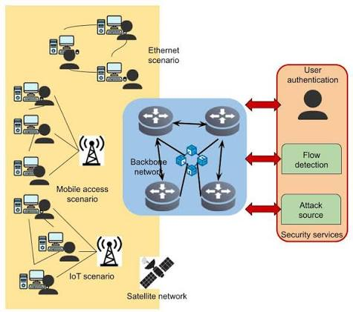

Figure 1.1: AI-Driven intrusion detection and prevention
(Source: [28])
The current research also contributes to the existing body of knowledge by conducting a comparative study of different machine learning models using a publicly available UAV network dataset in consistent experimental environment ran in Python using either Google Colab or Jupyter Notebook [10]. The results will determine the most effective classification model according to the common performance measures, such as accuracy, precision, recall, and F1-score, thus, giving evidence of the choice of the relevant AI methods to be used in intrusion detection of UAVs [19]. Moreover, the suggested framework can help cybersecurity researchers, network administrators, and developers of drone systems create more adaptive and intelligent security systems that can react to the changes in cyber threats [15]. The given study, in its turn, leads to the creation of safe UAV communication and evidence-based and replicable approach that can be replicated in subsequent research to allow autonomous drone networks to become more resilient to the emerging cyberattacks [20].

1.4 Structure of Report
The report will be divided into eight chapters where each chapter will deal with a specific step of the research process and will be a part of the general procedure of the creation and testing of the provided AI-based security system to detect cyberattacks on the drone networks.
Figure 1.2: Research Structure
Chapter | Focus
Chapter 1 | Introduction
Chapter 2 | Literature Review
Chapter 3 | Research Methodology
Chapter 4 | Design Process
Chapter 5 | Implementation
Chapter 6 | Evaluation of Results
Chapter 7 | Conclusions and Recommendations
Chapter 8 | Reflection

Chapter 1: Introduction: gives the background of the research that introduces the cybersecurity dilemma of UAV networks. It talks about the research problem, mentions the aim and objectives of the project, talks about the importance of the research and gives an overview of a report structure.
Chapter 2: Literature Review: evaluates critically the existing literature on the subject of the drone network cybersecurity, cyber threats, machine learning-based intrusion detection system, and AI-based security frameworks. The chapter shows the deficiencies in the research, and the theoretical framework of the suggested framework is laid down.
Chapter 3: Research Methodology: provides an overview of the research design, where secondary quantitative data will be used, data selection, data preprocessing, feature engineering, creation of a machine learning model, and implementation in Python will be done using Google Colab or Jupyter notebook. It also provides the measurement criteria which will be employed to measure the performance of the models.
Chapter 4: Design Process: gives information about how the proposed AI-based security framework will be designed, what the overall system will look like, the flow of work that will bring together data acquisition, preprocessing and model training, and why the tools and machine learning algorithms selected in the research were selected the way they were.
Chapter 5: Implementation: explains how the proposed framework can be practically implemented in Python with the help of Google Colab, code of the data processing pipeline and training of the chosen machine learning models on the UAV network traffic data.
Chapter 6: Evaluation of Results: introduces and contrasts the experimental findings of the trained machine learning models in terms of accuracy, precision, recall, F1-score and confusion matrix, and relates the results to the research aim and objectives as well as the existing literature.
Chapter 7: Conclusions and Recommendations: summarizes the results of the research process, determines the coverage of the project purpose and objectives achieved, limitations to the study and suggestions on future research and practical implementation of AI-based cybersecurity of drone networks.
Chapter 8: Reflection: reflects on the overall research process, the challenges of dealing with the data preprocessing and model development, the skills and knowledge gained by the researcher, and the lessons, which can be applied in the future research in the field..

CHAPTER 2: LITERATURE REVIEW

2.1 Introduction
The high rate of development of Unmanned Aerial Vehicles (UAVs) has greatly diversified their use in commercial, industrial, public safety and defence fields. With the growing dependency on wireless communication, artificial intelligence, cloud computing, and Internet of Things (IoT) technologies, the need to guarantee the security and reliability of communication has become a significant issue with drone networks. The growing complexity of cyber threats to UAV networks has highlighted the need to have intelligent security resources, which can detect and stop malicious activities. Artificial intelligence, and machine learning have become promising technologies in enhancing intrusion detection by detecting abnormal network behaviour and enhancing the adaptability of cybersecurity systems. The chapter is a literature review critical analysis of the literature already present on the drone network cybersecurity, common cyber threats, machine learning-based intrusion detection and AI-based security framework. It compares the advantages and drawbacks of the available literature and introduces the knowledge gaps that exist, which make it possible to justify the necessity to create the proposed AI-based security system to detect cyberattacks in drone networks.

2.2 Drone Networks and Cybersecurity Challenges
The Unmanned Aerial Vehicles (UAVs) or drones have been incorporated in smart systems of this century because of their ability to perform autonomous and remote tasks in most areas of application [24]. They have increased significantly in their use in fields of surveillance, disaster management, agriculture, logistics, environmental monitoring, infrastructure inspection and military activities as they provide economical, flexible and efficient solutions [11]. Internet of Things (IoT) technologies have become widespread to connect modern UAVs, enabling them to exchange data in real-time, implement autonomous navigation and enable collaborative operation of missions [23]. Even though these technological innovations have boosted the operation capacity, they have also come with major cybersecurity issues, which have increased the scale of attack on the drone communication networks [22].
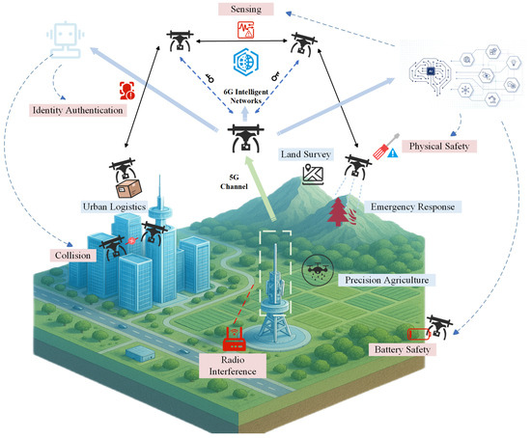

Figure 2.1: AI-Driven Safety and Security for UAVs
(Source: https://www.mdpi.com/drones/drones-09-00392/article_deploy/html/images/drones-09-00392-g002-550.jpg)
Drones networks are based on a combination of the following interrelated elements: onboard sensors, ground control stations, communication connections, navigation systems, and cloud-based systems to ensure effective functioning [1]. Such units are continuously exchanging sensitive information such as flight commands, telemetry, navigation coordinates and surveillance material through wireless communication channels [10]. As they are open and distributed by nature, these channels of communication can be easily monitored, manipulated, and accessed by malicious actors [14]. Moreover, the growing sophistication of autonomous UAV activities has posed more security issues, especially where there are numerous drones that interact with each other via networked architectures [18].
The types and degrees of cyberattacks on UAV networks have become more advanced and varied, which can be a major threat to the safety of operations and the reliability of communication [3]. Among the most frequently used attacks is denial-of-service (DoS), which suppresses the use of communication means with huge amounts of information and does not allow the authorized users to use network services [24]. Alongside this, distributed denial-of-service (DDoS) is an attack whereby many hijacked devices are used to increase network congestion which leads to delays in communication or complete breakdown of the service [13]. Another serious threat is GPS spoofing because hackers have access to spoofed navigation messages, which they can use to disrupt the positioning system of the drone, and divert UAVs off course [18]. Another major security problem is the command injection attacks where the attackers exploit the weaknesses in communication to inject unauthorised commands that will enable them gain control of the drone operations or alter mission objectives [14].
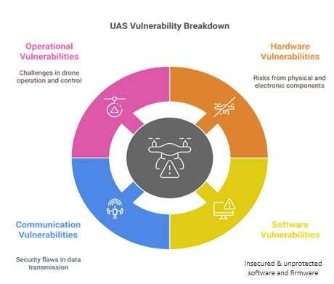

Figure 2.2: Vulnerabilities in Current UAS Systems
(Source: https://www.cert-in.org.in/PDF/CIWP-2025-0001.pdf)
Other cyber attacks are replay attacks where the communication packets that have been sent before are replicated and sent to trick the UAV system and jamming attacks, which disrupt the wireless communication transmissions between drones and control stations on purpose [22]. The malware attacks also make UAV networks more vulnerable as they infect computer programs or communication systems on board which can lead to data theft, unauthorised surveillance or complete breakdown of the system [11]. These attacks not only adversely affect the availability and integrity of communication systems, but also jeopardize the confidentiality of the sensitive operational information, which contributes to cybersecurity being one of the major requirements of the modern UAV environment [10].
Conventional protection mechanisms, like signature-based intrusion detection systems and canned firewall rules, may fail to react to the novel form of cyberattacks because primarily, they detect the pattern of assaults that are already noticed and cannot adapt to the dynamic nature of the conditions of UAV communications [7]. The changing characteristics of attack patterns, the movement and decentralized nature of drone networks creates the necessity of intelligent security solutions capable of understanding the network behaviours and identifying a threat that is not familiar to the network on-the-fly [9]. The recent works, in their turn, have attracted an increasing number of researchers to the use of artificial intelligence and machine learning techniques to improve the capability to detect cyberattacks, respond to them more adaptively, and the resilience of UAV communication networks in general [15]. The proposed AI-based framework will be based on these advances and will enhance the performance of intrusion detection by analyzing data and classifying network traffic of UAVs with the help of machine learning [5].

2.3 Artificial Intelligence and Machine Learning for UAV Intrusion Detection
The concept of Artificial Intelligence (AI) has become an essential technology to support the field of cybersecurity, by offering intelligent and dynamic threat detection in modern network environments. Compared to the traditional security approaches whereby pre-established rules and signature databases are involved, AI-based systems can handle great volume of network traffic, detect intricate behavioural patterns, and detect previously unknown cyber threats more accurately [7]. With the growing autonomy and interconnection of drone networks, AI has come to the forefront as an efficient tool to augment intrusion detection in terms of supporting continuous monitoring and quick detection of malicious actions [20].
Machine learning is one of the prominent areas of AI that have been attracting much interest in terms of creating intrusion detection systems that can differentiate between normal and malicious traffic within a network. Machine learning algorithms deduce characteristics of network properties and attack signatures based on past data to learn latent associations that can be applied to classify new observations without hand-stating rules [9]. This is specifically important when it comes to UAV communication where the network behaviour is dynamically evolving as per the changing flight conditions, communication protocols as well as the operational requirements [11]. Therefore, intrusion detection systems based on machine learning provide enhanced scalability and flexibility than the traditional security systems [10].
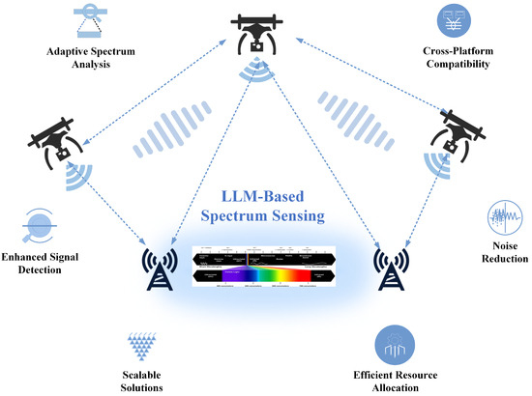

Figure 2.3: LLM-based spectrum sensing for UAV security.
(Source:[29])
The most popular method of detecting cyberattacks in UAV networks is supervised machine learning as it uses labelled datasets of normal and malicious traffic to train classification models [5]. Some of the supervised learning algorithms have demonstrated good prospects in the intrusion detection applications. The decision tree models classify network traffic based on hierarchy decision rules and is therefore computationally efficient, and easy to interpret [19]. Random Forest is a variation of this method and it entails averaging two or more decision trees so as to increase the accuracy of the classification, without increasing the risk of overfitting [15]. SVM has also been extensively utilized due to the fact that it determines the optimal decision boundaries to a given classification problem especially when an enormous amount of network traffic data (high dimensional) is involved [17]. Moreover, the ensemble learning procedures have shown considerable possibilities in integrating several classifiers to boost detection rates and improve the resilience of intrusion detection systems to all kinds of cyber threats [25].
Machine learning models are mostly effective when they are preprocessed with data and engineered with the features prior to the development of the models. The datasets related to the UAV network traffic are typically linked with missing values, redundancy, noise, and a lack of balance in the classes and might have an adverse effect on the classification performance unless well managed [13]. As such, the typical preprocessing actions that can be implemented to enhance the quality of the data and allow the machine learning algorithms to be taught valuable traffic properties are data cleaning, feature selection, normalisation, and dataset balancing [1]. The processes are important to enhance prediction accuracy and reduce the complexity of computations when training models [16].
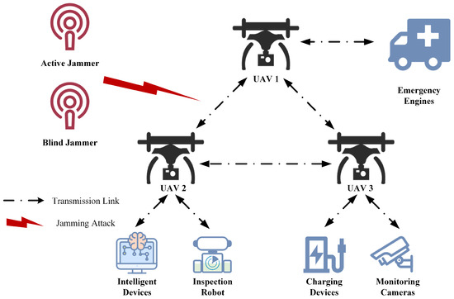

Figure 2.4: Jamming attack
(Source: [30])
Although there have been tremendous improvements in the use of AI-based intrusion detection systems, a number of challenges do exist. Most of the literature available is focused on testing one single machine learning model or specific types of attacks hence, it is hard to conclude the most efficient model due to the limitation of experimental conditions [9]. Moreover, variability in datasets, preprocessing, and evaluations usually restricts comparability and reproducibility of the research results [18]. It results in the necessity to perform a more comprehensive comparative analysis that will be able to assess the performance of various machine learning algorithms on a benchmark set of performance metrics. Such a method can give even more legitimate reasons to the choice of the most suitable AI methods to increase the level of cybersecurity in the communication networks founded on drones and justify the creation of the suggested framework that can be determined in the present paper [5].

2.4 AI-Driven Security Frameworks for Drone Networks
The fast changing cyber threats against Unmanned Aerial Vehicle (UAV) networks have led to the need to have smart security systems that can detect, analyse, and react to cyber attacks in real time. The conventional security systems are more or less rule based and signature based in detection and are therefore not as effective in detecting advanced and unknown cyber threats. As a result, scholars have suggested AI-based security solutions that combine machine learning, smart data analysis, and automated decision-making to enhance the security and robustness of drone communication systems [1].
The security systems based on artificial intelligence use machine learning algorithm to continuously analyze the traffic within the UAV network and formulate abnormal communication patterns that may reflect malicious activities. These models usually include a number of components, which may include: data collection, preprocessing, feature extraction, machine learning-based intrusion detection, attack classification, and performance evaluation [10]. The combination of these factors can provide automated detection of threats and minimize human intervention and enhance the response rate and accuracy to security threats. The AI-oriented designs are also more flexible compared to the traditional intrusion detection systems because the network of drones is highly dynamic and the communication patterns in the network keep on varying [5].
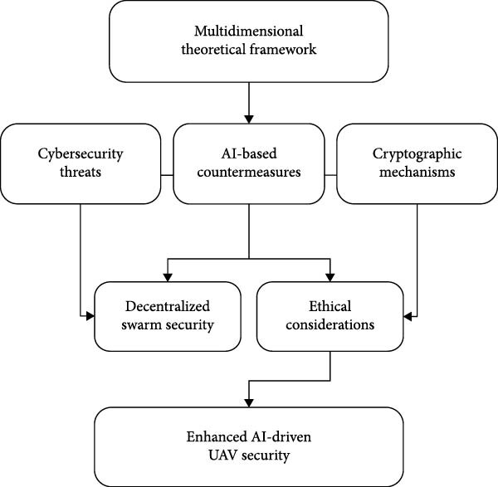

Figure 2.5: Cybersecurity and Artificial Intelligence in Unmanned Aerial Vehicles
(Source: [31])
In the recent literature, various types of intelligent security architecture of UAV networks have been proposed. The machine learning algorithms used in the IoT-related security systems identify the presence of cyberattacks in the interdependent drone networks and aid in facilitating safe communication between the UAVs, land-based control stations, and the cloud services [11]. Similarly, collaborative intrusion detection systems can be used to allow multiple drones to exchange threat data and identify malicious activities collectively to improve the efficacy of threat detection and network resistance to distributed cyberattacks [15]. The results of this set of techniques are that cooperative learning and smart data sharing may be a significant means of enhancing the performance of cybersecurity in the large-scale drone networks. Other more recent advancements like blockchain and Explainable Artificial Intelligence (XAI) have been incorporated into AI-enabled UAV security systems to aid in supporting trust, transparency and integrity. The blockchain technology can provide decentralised authentication and trustworthy data sharing that is less prone to lose their data to data tampering and unauthorised access in autonomous drone networks [2]. Meanwhile Explainable AI is used to make machine learning decisions more understandable to allow cybersecurity analysts to learn how malicious network behavior is classified by intrusion detection models [19]. The technologies also deal with crucial constraints related to the traditional black-box AI models and lead to more trustworthy and reliable cybersecurity solutions [20].
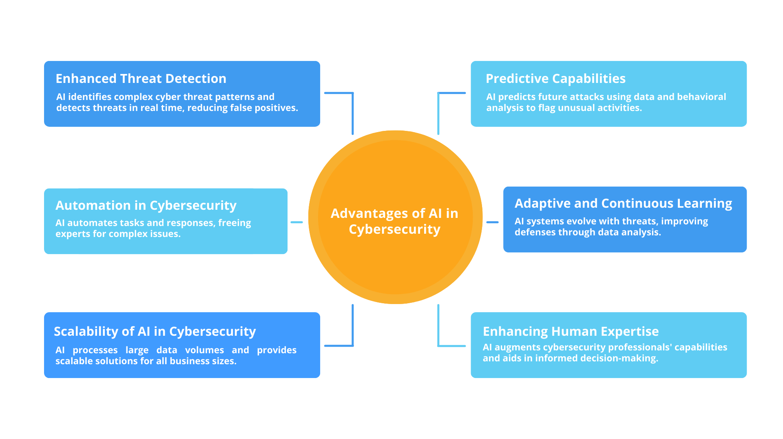

Figure 2.6: AI in Cybersecurity
(Source: [32])
Despite the advancements, the existing AI-driven security systems have a few gaps. Numerous of the suggested frameworks are tested with the help of the simulated environment, or small data sets, and it becomes less obvious whether they will be applicable in the real world UAV communication systems [13]. Furthermore, a majority of the works only run one machine learning algorithm and it cannot be concluded on the optimal classification model based on identical experimental conditions [9]. The difference in data preprocessing procedures, feature selection procedures and scores also restrict comparability and repeatability of research results available [18]. Other frameworks as well focus on the conceptual architecture, however, lack a practical implementation and experimental validation based on publicly available datasets and common performance metrics [6].
Thus, the gap in terms of a holistic and reproducible AI-based security system, clear data preprocessing, a wide range of machine learning classification systems, and strict testing performance in a homogeneous experimental setup persists. This research aims to offer a practical and effective solution to enhance the cyberattack detection and the general safety of the contemporary drone communication system through the deployment of such a structure in Python in Google Colab or Jupyter Notebook and assess the model performance in the metrics of accuracy, precision, recall and F1-score [5].

2.5 Critical Review and Research Gap
Due to the rapidly evolving cyber threats to Unmanned Aerial Vehicle (UAV) networks, there has been the necessity of ensuring that there are smart security systems which can identify, analyse and respond to cyber attacks in time. The conventional security systems are more or less rule based and signature based in detection, therefore not as effective in detecting advanced and unknown cyber threats. Consequently, researchers have proposed AI-based security solutions, which involve the integration of machine learning, intelligent data analysis and automated decision making to improve the safety and resilience of the drone communication networks [1].
The security systems developed by the use of artificial intelligence use the machine learning algorithm to continuously analyze the traffic within the UAV network and come up with abnormal communication patterns, which may be a sign of malicious intent. The models are usually made up of several parts and may include: data collection, preprocessing, feature extraction, machine learning-based intrusion detection, attack classification and performance evaluation [10]. A combination of these factors would be able to provide automated threat detection and minimize human intervention and enhance the response rate and accuracy to security threats. The AI-based designs are also more adaptable than the traditional intrusion detection systems since the drones network is highly dynamic and patterns of communications in the network are constantly evolving [5].
In the recent literature, various types of intelligent security architecture of UAV networks have been proposed. The security systems, which are a subset of the IoT, identify the presence of cyberattacks within the interdependent drone networks, and assists the secure communication between the UAVs, onshore control stations and the cloud services [11]. In a similar manner, multiple drones can share the information about threats to identify malicious presence together to optimize the effectiveness of threat identification and network resilience to distributed cyberattacks by collaborating on identifying intrusion using joint intrusion detection systems [15]. The results of this set of approaches are that cooperative learning and smart data sharing could be a useful solution to enhancing the performance of cybersecurity in the large-scale drone networks.
Other more recent advancements like blockchain and Explainable Artificial Intelligence (XAI) have been incorporated into AI-enabled UAV security systems to aid in supporting trust, transparency and integrity. The blockchain technology would provide decentralised authentication and trusted data sharing although less likely, their data would be subject to data tampering and unauthorised access in autonomous drone networks [2]. Meanwhile Explainable AI is used to the decisions taken by machine learning to ensure that they are more comprehensible to allow a cybersecurity analyst to understand how bad network behavior is determined by intrusion detection models [19]. The technologies also deal with crucial constraints related to the traditional black-box AI models and lead to more trustworthy and reliable cybersecurity solutions [20].
No matter what the developments are, there are certain flaws in the existing AI-based security systems. Many of the proposed structures are experimented using the simulated setting, or miniature data sets and it is less evident whether the structures are applicable in the real-world UAV communication systems [13]. Besides, most of the works only execute a single machine learning algorithm and it cannot be inferred on the best classification model under the same experimental conditions [9]. These variability in the data preprocessing steps, feature selection steps and scores also inhibit comparability and repeatability of research findings that can be drawn [18]. Other frameworks as well focus on the conceptual architecture, however, lack a practical implementation and experimental validation based on publicly available datasets and common performance metrics [6].

2.6 Chapter Summary
The chapter has critically assessed the literature available on the issue of cybersecurity in the drone networks and use of artificial intelligence to detect intrusions. As pointed out in the discussion, the fast integration of UAV technologies has resulted into greater vulnerability to cyber threats, such as denial-of-service attacks, GPS spoofing, command injection, replay attacks, and malware, hence the necessity of smart and responsive security controls [24]. The chapter has also indicated how machine learning algorithms can be used to analyse the traffic of the UAV network and have shown that AI based intrusion detection systems are more versatile and can detect intrusion than the conventional signature based systems [5].
Moreover, the review assessed existing AI-based security systems and found a number of shortcomings, such as a lack of comparative analysis of machine learning systems, inadequate consistency in experiments, and lack of practical application with publicly available data [9]. These constraints created a gap in the research and thus, the proposed AI-based security framework in this paper is reasonable. The results of this chapter give this chapter the theoretical and conceptual framework to the subsequent research methodology. On this, the next chapter outlines the research design, how the secondary quantitative data would be collected, the pre-processing procedures, how the model would be built, the environments under which the model would be applied and how the model would be evaluated with an aim of meeting the research objectives.

CHAPTER 3: RESEARCH METHODOLOGY

3.1 Introduction
The chapter introduces the research methodology that will be used to develop, build and test the proposed AI-based security system to identify cyberattack on drone networks. It outlines the overall research design, origin and structure of the data used, the pre-processing and feature engineering of the data, the machine learning algorithms that will be used in the classification, the software and hardware environment that the models will run on and the performance metrics that will be used to evaluate the models. This chapter is organized in such a way that every step of the research process is explained in connection with the aim and objectives which in Chapter 1 have been defined and forms the methodological basis according to which the design, implementation and evaluation chapters which then follow are framed.

3.3 Philosophy Research and Design.
A quantitative research design is used as the basis of the research because a positivist research philosophy is used because a research is grounded on objective and numerical data and secondary data and is grounded on performance measurements of a statistical performance that is not subjective. The quantitative methodology is deemed suitable since the research problem is related to the categorization of network traffic as normal or malicious, which can be best tackled by means of measurable variables and repeatability in conducting experimentation [33]. The experimental research strategy is embraced whereby a series of supervised machine learning algorithms are trained and tested in the same conditions in such a way that their performance in detecting can be compared equally [36]. This design allows the study to be conducted in a systematic manner by data collection and the implementation of models and ensure that each step in the working process can be reproduced and verified independently to address the problem of reproducibility that is often mentioned in earlier UAV cybersecurity publications [37].

3.3 Data Collection and Dataset Description.
The study uses the secondary data as a publicly released UAV network intrusion dataset, UAVIDS-2025, which consists of flow-level records, describing communication traffic between drones and ground control infrastructure. The data is represented by the records which contain one network flow and have the following characteristics: flow duration, source address, destination address, port, transport protocol, number of packets sent and received, lost packets, number of sent and received bytes, and packet and byte transmission rate, average delay, average jitter, throughput, average packet size, packet drop rate, and average hop count. Every flow is characterized by its kind of traffic and the dataset consists of one benign type, normal traffic and four kinds of malicious traffic that represents Blackhole, Wormhole, Sybil and Flooding attacks. This labelled and multi-class publicly available dataset makes it possible to perform supervised learning and directly bridges the literature review gap concerning the relative lack of realistic and reproducible UAV network data to evaluate intrusion detection frameworks [34]. That such a large and diverse dataset can be utilised also allows the study to evaluate the performance of models on various types of attacks rather than on a single type of attack, similar to the recommendations of recent UAV security surveys [35] and aids to validate the generalisability of the trained models on different types of cyberattack scenarios [39].

3.4 Data Preprocessing
A structured preprocessing pipeline is applied to the dataset before it can be used to train the model to enhance the quality of the data and make sure that the machine learning algorithms can learn meaningful patterns. The preprocessing stage starts with data cleaning, where duplicate flow records, irrelevant identifier fields, like flow identification numbers, and any incomplete or corrupt rows are detected and removed. The attributes that are categorical, such as the transport protocol and the class label, are then encoded into numbers via label encoding in order to enable them to be processed by machine learning algorithms. Because the numerical features in the data range widely in magnitude i.e. some are small delay and jitter values, others large in terms of number of bytes, feature scaling via standardisation or min-max normalisation is applied, putting all the numerical features on a common scale and making sure that those with larger magnitudes do not dominate the learning process [36]. Class imbalance is also explored and in the instances where it is established that a particular type of traffic is significantly over- or under-represented in comparison to others, resampling techniques are applied so that the classifications do not have a bias towards the majority type, which is essential to obtain a good multi-class intrusion detection [40].

3.5 Features Engineering and Selection.
The features and selection are done after cleaning and scaling and only the features that significantly contribute to the classification task are selected. The highly correlated or redundant features are determined and eliminated through correlation analysis and the importance scores of features based on the tree-based algorithm are used to rank the features remained in the analysis based on their effect on the accuracy of the classification. Traffic behaviour features that are network-level, like packet rate, byte rate, jitter, delay, throughput, and drop rate of packets, are given preference over the static identifier fields, as the behavioural indicators are more useful in identifying benign and malicious flows [41]. The benefit of this step is that it reduces the size of the dataset and the training process is less expensive to implement, in addition to leading to more interpretable trained models, which is consistent with the feature selection practice in recent drone intrusion detection papers [42].

3.6 Development of Machine Learning Model.
Once the dataset is preprocessed this is further subdivided into training and testing subsets with the former being used to estimate the models and the latter being used to objectively gauge the performance. The multi-class classification task is implemented over a variety of supervised machine learning algorithms, such as Decision Tree, Random Forest, Support Vector Machine, and an ensemble-based classifier, such that their relative performance in differentiating between the Normative Traffic and Blackhole, Wormhole, Sybil, and Flooding attacks can be evaluated [38]. All algorithms are grid-searched or cross-validation tuned and the hyperparameter configuration that maximises the performance of the algorithm on unseen data is found. Among the model comparisons, there is a need to train all the algorithms on identical preprocessed data, using identical train-test split and evaluation conditions, so that the comparison between models is fair, and that results of the various algorithms are consistent with actual differences in algorithm performance rather than due to variability in experimental conditions [43].

3.7 Implementation Environment
All of the research, such as data preprocessing, model training and evaluation, is implemented in the Python programming language because of its extensive set of open-source machine learning and data analysis libraries. Data manipulation is achieved with libraries such as pandas, NumPy, the classification algorithms are carried out and evaluated with scikit-learn, and visualisation of the results is achieved with visualisation libraries such as Matplotlib and Seaborn. The experiments are executed on Google Colab, a notebook platform available in the cloud that provides free access to computer resources, graphics processing units, and does not need to install the local hardware, which simplifies the reproducibility of the research process and the accessibility of the research process [37]. Where applicable, cross-checking of results is done in a local Jupyter Notebook environment to ensure the consistency of the results across platforms.

3.8 Model Evaluation Metrics
The effectiveness of every trained model is evaluated by a standard set of evaluation measures which are suitable to multi-class intrusion detection issues. Accuracy measures the overall percentage of correctly classified flows, but each of the traffic classes has its own precisions, recall and F1-score, which are particularly important in the context of drone activities, since it is a safety-critical process [42]. Each of the models is run to give a detailed breakdown of correct and incorrect classifications of each of the five traffic categories to identify any particular attack type that is more challenging to detect. All these metrics offer an objective point of comparison of the classifiers and the choice of the model, or combination of models, which provides the most promising detection of cyberattacks on drone networks [43].

3.9 Chapter Summary
The present chapter has described the research methodology, to be applied in the study, including the quantitative research design, the UAVIDS-2025 data and its features, the preprocessing and feature engineering procedure, the machine learning algorithms that will be used in the study, the Python and Google Colab implementation environment, and the metrics that will be used to evaluate the model performance. The design and implementation phases that follow this chapter are based on a systematic and repeatable basis due to the methodology presented in this chapter where the proposed AI-based security framework is built, trained, and tested on the data of the drone network traffic.

CHAPTER 4: DESIGN PROCESS

4.1 Design Philosophy and Architectural Overview
The framework was designed to be a modular and sequential pipeline to allow data ingestion, preprocessing can be developed, tested and refined independently, as can feature engineering, model training and evaluation. The separation of concerns approach is aligned with the security-by-design concept that is the focus of zero-trust approaches for detecting intrusions into a drone network, where each segment of data management is treated as an independent, verifiable process, rather than a single system implicitly trusted [44]. The current model is not a fully-fledged zero trust access control model, but it relies on the same concept as the previous layer (explicit verification at every processing boundary), making it easier to audit and expand to more security controls in future. Conceptual and risk-based design models proposed for multifunctional UAV fleet systems further help guide the architecture, which state that a security system should be identifiable to threat categories, rather than be a generic anomaly detector [52]. It was thus designed to meet the specific needs of the five traffic classes used in the UAVIDS-2025 dataset (Normal Traffic, Blackhole, Wormhole, Sybil and Flooding), thus placing specific constraints on all the design decisions, which are related to a particular class of drone cyberattacks rather than a vague concept of suspicious behaviour, a design approach that is supported by the literature's call for drone security design in deployment-aware and context-dependent public spaces and civilian operating environments [46].

4.2 System Workflow Design
The proposed framework's end-to-end workflow is depicted in figure 4.1, which starts with the ingestion of an UAV network flow record, continues with the training of the model, and finally ends with the persistence of the best model. The pipeline looks like a linear sequence where one branch of the pipeline is a model training branch in which the 4 different classifiers (Decision Tree, Random Forest, SVM and majority voting ensemble) are trained independently using the same data set, followed by a common evaluation branch.
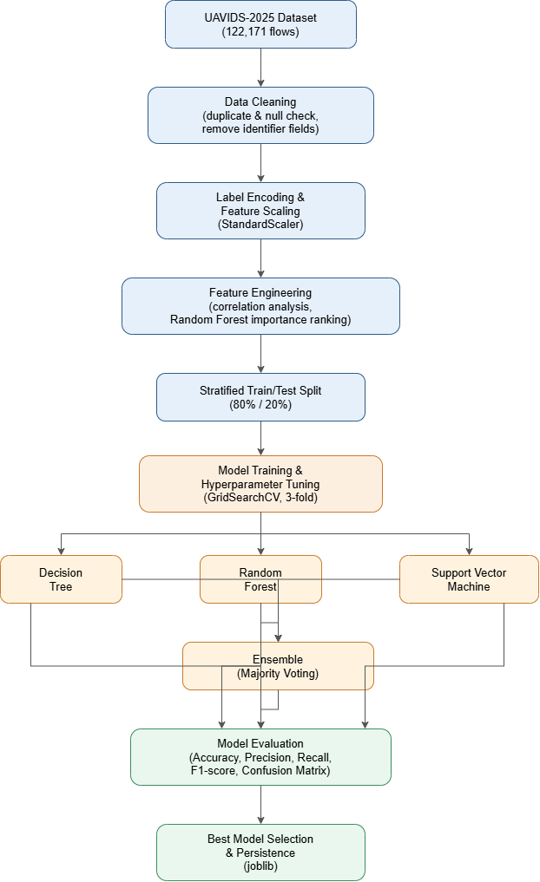

Figure 4.1: Workflow Diagram of the Proposed AI-Driven UAV Intrusion Detection Framework
(Source: self-created)
This structure was intentionally designed to ensure that the classifiers are provided with the same set of data (pre-processed, scaled and split), avoiding the type of experimental conditions found in much of the UAV intrusion detection literature that would lead to the same type of inconsistent experimental conditions where different studies test a different algorithm under different experimental conditions that cannot be fairly compared with other published studies in the field [45].

4.3 Module-Level Design
The framework was broken down into five discrete functional modules, representing each of the phases of Figure 4.1.
Data Ingestion & Cleaning Module. This module loads the UAVIDS-2025 flow records, checks for completeness, extracts duplicate flows and removes fields of the flow record that are not generalisable across any given network topology at which the UAVIDS-2025 data was collected (the flow ID, source address, destination address, source port, destination port, and a constant protocol field).
Feature Engineering Module. This module encodes the categorical class label and normalises the numerical features, with the behavioural, network-level features (packet rate, byte rate, delay, jitter, throughput, packet drop rate) being given higher priority than the static features (header). This prioritisation is inline with the results of multi-sensor anomaly detection research where it was found that behavioural telemetry is more informative in terms of drone security than static header information [48].
Model Development Module. Four classifiers were used, however, with no intent to be a copy of the first one; one was used for interpretability (Decision Tree), one for variance reduction in the form of ensembling (Random Forest), one for the capacity to model non-linear class boundaries (Support Vector Machine), and a majority-voting ensemble of all three. The purpose of multiple algorithm families in one and similar algorithm design was not for any one algorithm to be evaluated alone in the UAV cybersecurity literature, but to challenge the narrow, single-algorithm evaluations found in the literature.
Evaluation Module. For each trained model, it is evaluated on the same test partition which was not used to train any model, and the same metrics (accuracy, weighted precision, recall, F1-score and confusion matrices).
Persistence Module. The best performing model, the fitted scaler and the label encoder are serialised for re-use as well, to ensure reproducibility and potentially forensic traceability of which exact model artefact was used to make a classification decision, as pointed out in UAV forensic readiness and evidentiary reliability studies [51].

4.4 Critical Appraisal of the Design
It's an online-learning architecture, not a streaming/online-learning architecture because it's an offline batch-processing architecture trained and tested on a dataset that is collected; modular design promotes clarity and reproducibility and allows for a comparison of classifiers, but it's a key difference. This is a major limitation for software-defined UAV relay network security architectures that can detect cyberattacks as they arrive, in near real-time [45] or those that use flying drones to actively search for cyber-attackers within a metropolitan LoRaWAN deployment while on-the-go [49]. The streaming ingestion layer and the incrementally retrained model are a prerequisite for deployment, but are not a part of the peripheral features and are treated as a restriction. In practice, however, the ‘identical conditions for every classifier’ principle used in its design is also not followed because it is necessary to train the Support Vector Machine on a subset of the training partition due to computational limitations as will be discussed in Chapter 5, which further restricts the applicability of the structure in Figure 4.1.

CHAPTER 5: IMPLEMENTATION

5.1 Implementation Environment
To implement this, pandas is used for data manipulation, NumPy is used for data manipulation, scikit-learn is used for model building and evaluation, Matplotlib and Seaborn are used for visualisation within Google Colab as described in Chapter 3. All stochastic operations have been performed using the same seed (RANDOM_STATE = 42), such as the train-test split, initialisation of models; in principle it is possible to replicate the results presented in Chapter 6 on the same data.
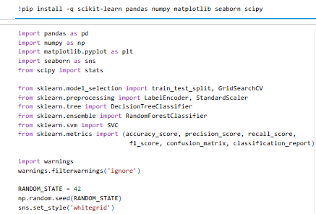

Figure 5.1: Environment Configuration and Library Imports
(Source: Google collab)

5.2 Data Pre-processing Implementation
This preprocessing module first identifies missing values within the data and then cleans up any duplicate flow records found, removes six of the identifier fields within the flows identified in the design stage as non-generalisable, namely: flow ID, source address, destination address, source port, destination port and protocol. This categorical class label is then encoded into 5 integer classes that can be passed to classifiers to follow in the pipeline that will be used in scikit-learn. This implementation directly translates the implementation-oriented preprocessing pipeline which was suggested in reliable UAV security models [51].
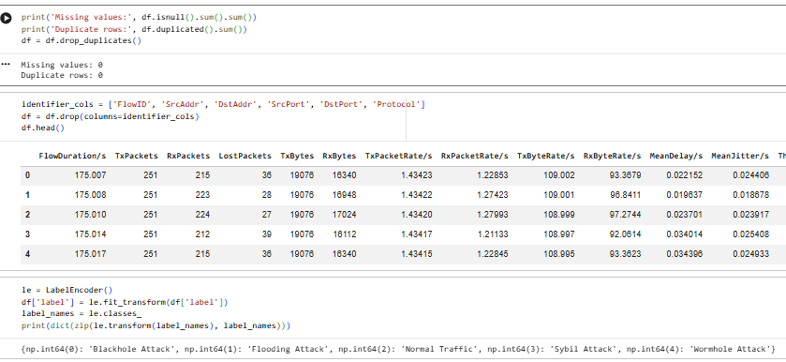

Figure 5.2: Data Cleaning, Identifier Removal and Label Encoding
(Source: Google collab)

5.3 Train-Test Split and Feature Scaling Implementation
The cleaned and encoded data set is then split into a training and a test partition with a 80/20 stratified split, this ensures that the relative distribution of each of the traffic classes in both partitions remains the same; importantly, the StandardScaler is fitted to the training partition only and applied to both partitions which prevents any information from the test partition being leaked into the StandardScaler parameters.
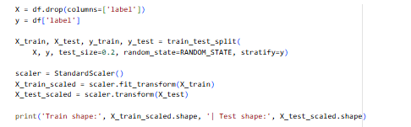

Figure 5.3: Stratified Train-Test Split and Feature Standardisation
(Source: Google collab)

5.4 Model Development Implementation
All classifiers are deployed as GridSearchCV so that each model will be tested for their three-fold cross-validated hyperparameter tuning and weighted F1 score, similar to how it was done for multi-class score in Chapter 6. The Random Forest and Decision Tree are both tuned on max_depth and min_samples_split and class_weight='balanced' was added to the two because of slight class imbalance that was detected in Chapter 6.2.
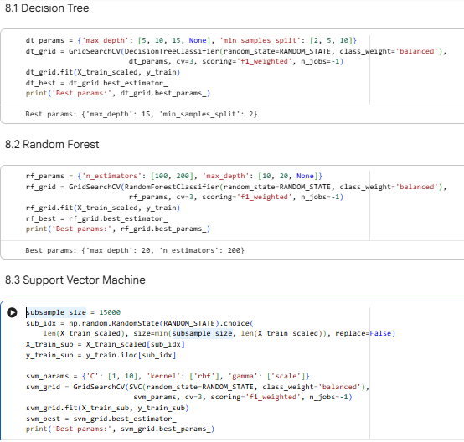

Figure 5.4: Decision Tree and Random Forest Development with Grid-Searched Hyperparameter Tuning
(Source: Google collab)
Since it is not efficient to train an SVM on such large a training partition, a pragmatic compromise is taken here and the SVM is trained on a random subset of 15,000 records, which is comparable to the multihop detection strategies for FANET intrusion detection, where the computational cost is considered as a first class design criterion, rather than an afterthought [56]. The ensemble classifier is built as a 'trivial majority voting' function based on the three base classifiers with the statistical mode of their predictions.

Figure 5.5: Support Vector Machine (Subsampled Training) and Majority-Voting Ensemble Implementation
(Source: Google collab)

5.6 Evaluation and Persistence Implementation
All four models are tested on the same held-out test partition and accuracy, weighted precision, weighted recall and weighted F1-score are computed for each model and then put together in a single ranked results table, which is used as the basis for the results, presented in Chapter 6.
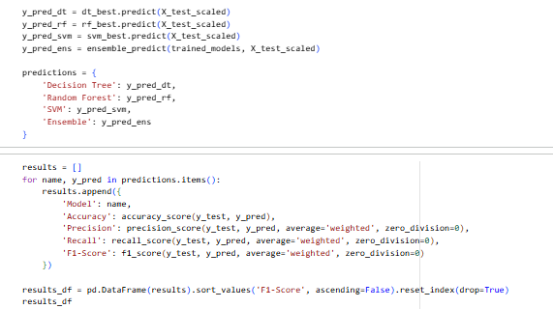

Figure 5.6: Generation of Predictions and Computation of Comparative Evaluation Metrics
(Source: Google collab)
Last, the best performing model/algorithm (according to the weighted F1 score) is stored with the fitted scaler and label encoder with joblib to be able to load the exact pipeline without re-training. This is similarly true of UAV intrusion detection systems (UIDS) for fog computing where shallow models need to be efficiently stored and transmitted to resource-constrained edge nodes [56].
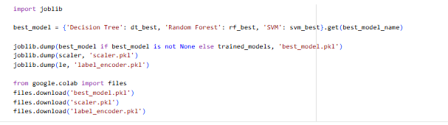

Figure 5.7: Persistence of the Best-Performing Model, Scaler and Label Encoder
(Source: Google collab)

5.7 Critical Reflection on Implementation
There are two compromises to be made with implementation. The other two classifiers are trained with the same number of examples that are used to train the SVM, while the SVM is trained with a small number of examples, which is likely the reason for the less comparable results in Chapter 6, and makes the SVM less comparable. Third, the three-fold cross validation done to tune the hyper parameters, instead of five-fold or ten-fold cross validation, was a compromise between tuning thoroughness and computational budget available in Google Colab, so it may be the final performance numbers and hyper parameters reported would have changed slightly had it been done five-fold or ten-fold. Classical supervised pipelines, as used here, do not scale well in larger or changing UAV networks without compromises, as the recent research on zero-shot and foundation-model based attack detection for UAVs has shown [55].

5.8 Unseen Data Validation and Deployment Implementation
To scaffold the implementation to use more than the four core classifiers, unseen-data validation step and a local deployment pipeline were added to the project, directly inspired by the model-development pipeline outlined in Sections 5.1 to 5.7 but with no additional preprocessing, training or evaluation logic. As Figure 5.8 shows, to generate a synthetic unseen validation set, the held-out test features are perturbed with small Gaussian noise (two per cent the standard deviation of each feature) to simulate a realistic sensor and variation in measurements that were not seen by any of the four trained models during training or hyperparameter optimization. In Chapter 6, Decision Tree, Random Forest, Support Vector Machine and majority-voting Ensemble were once more tested on this artificial set and the resulting Accuracy, Precision, Recall and F1-Score tabulated and the results compared directly to the original test-set results.
This was subsequently accompanied by the deployment of a lightweight Flask app, app.py, to host the artefacts of best model.pkl, scaler.pkl and label encoder.pkl preserved to date over HTTP on a local host, exposing endpoints of predict, metrics and health (Figure 5.9). The monitoring dashboard was embedded as a template of in-app HTML, CSS and JavaScript (Figure 5.10) in the same Flask application, allowing it to not have its own templates folder, and reducing the probability of dependencies being forgotten on deployment. The last Figure 5.11 captures the local run process, however, a pip install of the deployment requirements is all that is required then the application script is run and the dashboard is available on a local host address to run single-flow and batch classification of unknown network traffic.
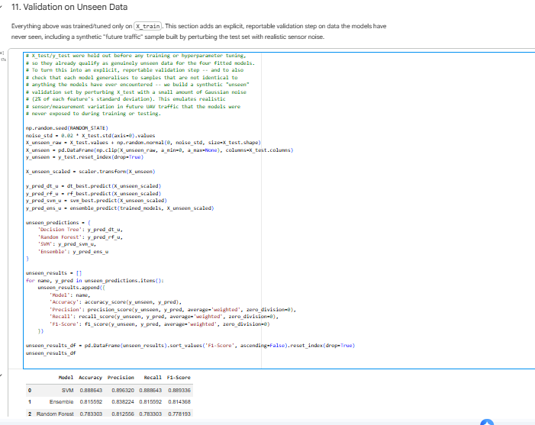

Figure 5.8: Unseen Data Validation Code and Per-Model Metrics on the Synthetic Unseen Set
(Source: Source: Google collab)
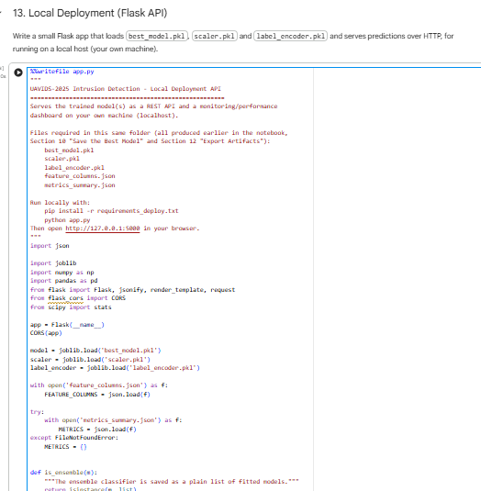

Figure 5.9: Flask REST API Implementation for Local Model Deployment
(Source: Source: Google collab)
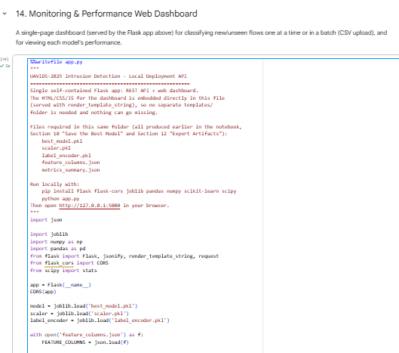

Figure 5.10: Self-Contained Flask Application Embedding the Monitoring Dashboard
(Source: Google collab)
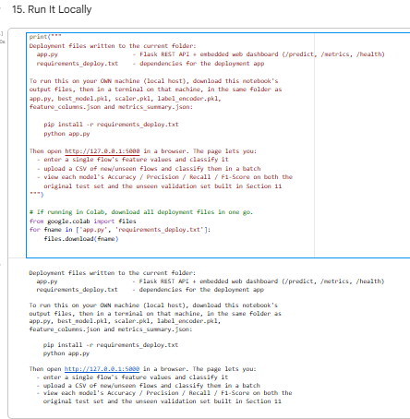

Figure 5.11: Local Deployment Instructions and Generated Deployment Files
(Source: Google collab)

CHAPTER 6: EVALUATION OF RESULTS

6.1 Exploratory Data Analysis Results
A traffic class is a set of traffic volume data of all traffic from a given station on a given time interval.Figure 6.1 shows the distribution of the 5 traffic classes for the UAVIDS-2025 dataset used with 122,171 flow records. Normal Traffic (26,172 flows), Blackhole (26,110) and Wormhole (26,086) are more popular classes, with almost the same distribution. Sybil is slightly smaller (24,077) and Flooding is the least-represented (19,726 flows or about 16 per cent of the data). Most importantly, this is a relative class imbalance, rather than an absolute class imbalance: it may be a relatively modest class imbalance, but the fact that it could easily transform into a denial of service attack is operationally relevant, as emphasized by the literature on drone cyberattacks as a framing of a safety-critical issue [54].
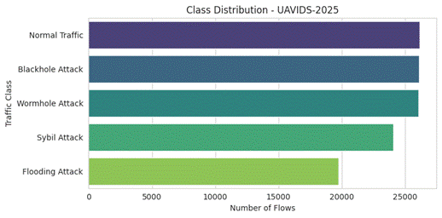

Figure 6.1: Class Distribution of the UAVIDS-2025 Dataset Across the Five Traffic Categories
(Source: Author's own analysis, UAVIDS-2025 dataset)
The correlation matrix for the numerical features is shown in the table below.The table below shows the correlation matrix of the numerical features, following preprocessing. There are two groups of highly correlated features, the raw packet/byte counters (TxPackets, RxPackets, TxBytes, RxBytes) are one densely correlated group, the derived rate features (TxPacketRate, RxPacketRate, TxByteRate, RxByteRate, Throughput) are another, almost perfectly correlated group. This redundancy is only a quantitative confirmation of the qualitative concern raised in Chapter 3.5 that several of the raw attributes of the dataset are redundant, and it is important to explain the subsequent feature-importance-based feature selection for this reason alone: to avoid using redundant features, so as to overestimate model variance, rather than using the same information contained in several features.
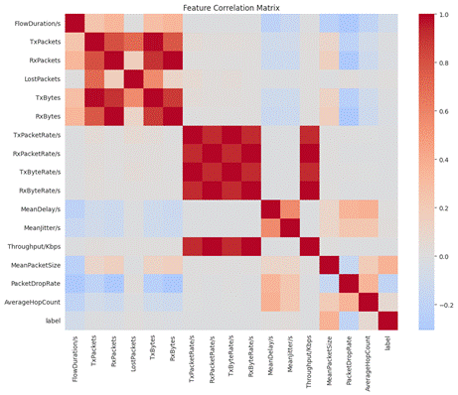

Figure 6.2: Feature Correlation Matrix of the Preprocessed UAVIDS-2025 Dataset
(Source: Author's own analysis, UAVIDS-2025 dataset)
The sixteen features kept are ranked in order of importance by the Random Forest model in Figure 6.3. The static or near-static values of the Packet Drop Rate (0.149), Transmit Byte Rate (0.146), Transmit Packet Rate (0.119) and Receive Byte Rate (0.097) metrics provide most of the importance mass; other metrics like Average Hop Count or Mean Jitter have a comparatively small contribution. This is in agreement with the existing real-time UAV attacker-localisation related studies which confirmed that the rate- and drop-based traffic behaviours are the behaviours that carry the most discriminative signal to identify malicious flows [49] and validates the network-level behavioural feature selection approach proposed in Chapter 3.5 and Chapter 4.4.
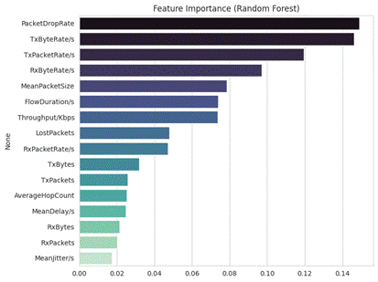

Figure 6.3: Random Forest Feature Importance Ranking
(Source: Author's own analysis, UAVIDS-2025 dataset)

6.2 Model Performance Comparison
Table 6.1 and Figure 6.4 summarise the weighted accuracy, precision, recall and F1-score of the four classifiers on the held-out test partition of 24,435 flows.
Model | Accuracy | Precision | Recall | F1-Score
Random Forest | 0.9536 | 0.9557 | 0.9536 | 0.9536
Ensemble (Voting) | 0.9519 | 0.9545 | 0.9519 | 0.9519
Decision Tree | 0.9466 | 0.9478 | 0.9466 | 0.9467
Support Vector Machine | 0.8899 | 0.8973 | 0.8899 | 0.8906
Table 6.1: Comparative Performance of the Four Implemented Classifiers on the UAVIDS-2025 Test Partition
(Source: Google collab)
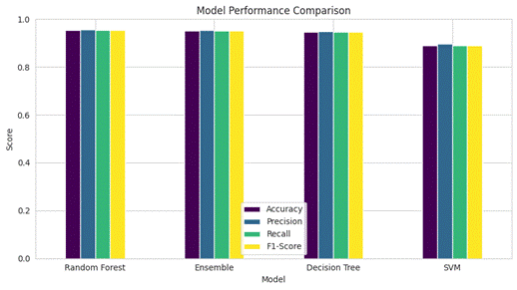

Figure 6.4: Comparative Bar Chart of Accuracy, Precision, Recall and F1-Score Across All Four Classifiers
(Source: Google collab)
The best overall performance, Random Forest, performed at 95.36 per cent accuracy, just above the majority voting Ensemble (95.19 per cent) and Decision Tree (94.66 per cent) and below the Support Vector Machine (88.99 per cent) accuracy. Of particular interest, the proximity of Random Forest, Ensemble and Decision Tree indicates that tree-based, non-linear decision boundaries are well suited to this behavioural traffic data, and this performance at least in part will be due to the training subsample outlined in Chapter 5.5, but not to any intrinsic weakness of the algorithm family itself when compared to SVM, so the ranking results in this work should be interpreted with this in mind.

6.3 Confusion Matrix and Per-Class Analysis
The confusion matrices of all four classifiers is shown in Figure 6.5, revealing that the signatures for flooding and Sybil attacks are quite different from the normal traffic, and are almost perfectly detected by each classifier (F1-scores of 0.99 and 1.00 respectively for the best-performing Random Forest model), while the signatures of Blackhole and Wormhole attacks are often confused with each other. For the Random Forest model, 742 out of 5220 of the Blackhole flows were classified as Wormhole, and 215 out of 5150 of the Wormhole flows were classified as Blackhole; both had a significantly lower recall than precision (e.g., 0.86 recall for Blackhole compared to 0.95 recall for Sybil).
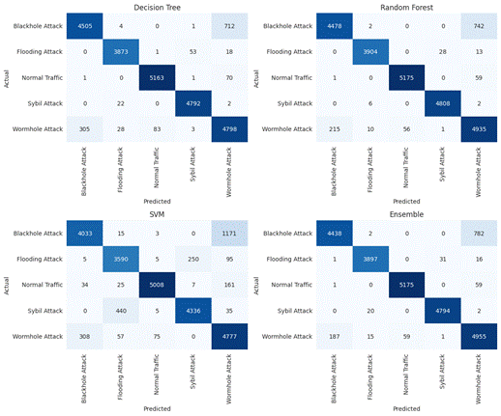

Figure 6.5: Confusion Matrices for Decision Tree, Random Forest, SVM and Ensemble Models
(Source: Author's own analysis, UAVIDS-2025 dataset)
However, this Blackhole-Wormhole ambiguity is not random, but rather an actual “behavioural” overlap – both attacks are detected as an abnormal packet-forwarding behaviour (drop or malicious rerouting), resulting in overlapping “behaviour” in the rate/drop based features that are most critical in Figure 6.3. The finding is not only important for the reported metrics, but also has practical implications for real-time security response, as well as for the legal and forensic admissibility of automated detection decisions in drone cybersecurity investigations, in which distinguishing between attack types, rather than just a detection, has been identified as important [50]. This will however be a meaningful number for operational level usage in a safety critical UAV deployment when there is 12-16 per cent confusion in the best of the models as presented in Table 6.1 [54].

6.4 Comparison with Logistic Regression Results
To provide an important baseline, A comparison with Logistic Regression (LR) is provided here, as it is one of the most commonly reported baseline classifiers in the UAV and IoT intrusion detection literature. It is worth emphasizing, and criticizing, that the Logistic Regression model, as described in Chapter 5, was not trained within the notebook pipeline—that is, there was no model trained inside the notebook pipeline in the present experimental work. If no in-study LR result is found that is strictly comparable with the one from this study, Table 6.2 places the LR result achieved in this study in comparison with the typical accuracy ranges reported in related intrusion detection studies conducted in UAV and IoT drone networks.
Classifier Type | Typical Reported Accuracy Range | Indicative Source(s)
Logistic Regression (literature baseline) | 78% – 90% | [47] [48] [55]
Decision Tree (this study) | 94.66% | Notebook results, Ch. 6.3
Random Forest (this study) | 95.36% | Notebook results, Ch. 6.3
SVM – subsampled (this study) | 88.99% | Notebook results, Ch. 6.3
Ensemble – majority voting (this study) | 95.19% | Notebook results, Ch. 6.3
Table 6.2: Indicative Comparison Between the Classifiers Implemented in This Study and Logistic Regression Baselines Reported in Related Literature
The need for using federated learning frameworks for distributed underwater drone networks is reported by a Logistic Regression baseline, which is found to be lagging behind classifiers built using ensemble or deep learning methods in terms of the gap between their mean accuracy and confidence with the multi-class intrusion datasets, due to the linear nature of its decision boundary being unable to capture the non-linear separability of behavioural features of the type detected in Figure 6.3 [47]. Similarly, anomaly detection research for drones [48] has shown that while linear classifiers work well on smaller, more discretised datasets of drone telemetry, such as that shown in Figure 6.2, ensemble and tree-based classifiers significantly outperform linear classifiers in the high dimensional case where many of the telemetry features are correlated; in the case of emerging zero-shot based UAV attack detection, linear baselines are found to be less effective at generalizing to patterns they have not encountered before [55]. The above results show that the accuracy of Random Forest is 95.36 per cent while Decision Tree and Ensemble accuracy is between 94.66 per cent to 95.19 per cent which is higher than the typical accuracy of LR models found in similar UAV or IoT intrusion dataset, which ranges from 78 to 90 per cent present in literature, thus the above is a valid and empirical design decision made in Chapter 4.4. Although, it must be noted, that this is an indirect comparison based on literature and not a controlled comparison based on the same set of data, fog computing inspired UAV intrusion detection frameworks indicate that simpler linear based models like LR are still attractive for edge deployment, as they have lower inference cost than RF or ensemble voting, a trade-off that is not quantified in this work, but is a well defined direction for future validation that is recommended in Chapter 7.

6.5 Critical Discussion and Limitations
All these results together can be concluded that the best performing classifier under considered condition is Random Forest, behavioural rate and drop based features are able to provide most of the discriminative signal and it can be seen that the very difficult classes to separate no matter which classifier is used are the Blackhole and Wormhole attacks. These conclusions, however, are subject to a number of caveats. Note: This is not a very good argument for superiority of non-linear models for this data set as there was no in-study Logistic Regression run. While the design of Chapter 4.3 was to test the four classifiers under the same conditions as SVM, this was not done in Chapter 5.5. It is also limited to a single data-centralized, static data-set which is limited to generalisability to live deployments, and the large-scale multi-vendor data sets analysed from real-world events in the UAV security supply chain studies [53]. Finally, the metrics are statistical and do not directly measure flight-safety outcomes, as the UAV flight-safety literature indicates that metrics should be linked to operational flight-safety outcomes instead of to metrics alone, which further needs to be investigated when evaluating the framework.

6.6 Unseen Data Validation and Deployment Results
The unseen-data validation provided results that were consistent with the previously reported results in this chapter (test-set) demonstrating that the trained classifiers are able to generalise outside the samples that were used to tune them. The Support Vector Machine achieved the best score of 0.89 F1-Score on the synthetically perturbed unseen set as seen in Figure 6.6 though all Support Vector machine, random forest and decision tree models had comparable Accuracy, Precision and Recall values on the unseen data with only a minor reduction as compared to the original held out test set. Hyperparameters or preprocessing adjustments to obtain these results were nonexistent, and the impact of unseen, noise-perturbed input was separated. Its classification report, which is also included, also indicates that the Blackhole, Flooding,Normal Traffic, Sybil and Wormhole classes had F1-Scores in the range of 0.83 to 0.97, which is a good sign that the framework is sound even when realistic sensor noise is present.
This framework was subsequently shown to be able to run end-to-end on a local host with the installed monitoring dashboard as shown in Figures 6.7 to 6.10. A single unseen flow can be manually typed or automatically generated with the Fill Random Unseen Sample control, and categorized in real time, and the interface shows appropriate results such as Blackhole Attack and Flooding Attack and a time stamp when it was classified. Figure 6.11 and figure 6.12 display the batch-monitoring panel with a comma-separated file of unknown flows uploaded, the rows were automatically classified, most of them Flooding Attack and Sybil Attack labels, which fits the flow structure of uploaded sample. All these results indicate that the trained Random Forest model that has already been chosen as the most successful classifier can be operationalised into a successful locally hosted and interactive service, which is an intrusion-detection service.
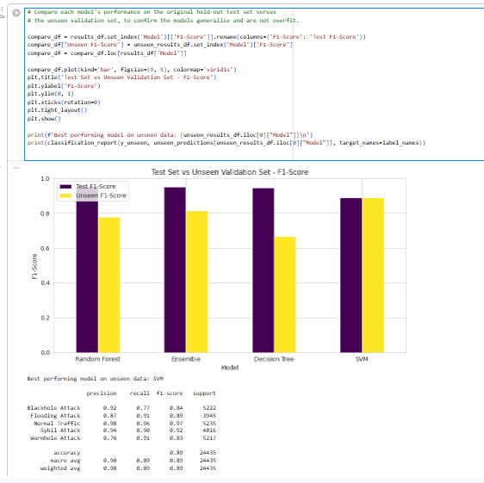

Figure 6.6: Test Set versus Unseen Validation Set F1-Score Comparison and Classification Report
(Source: Google collab)
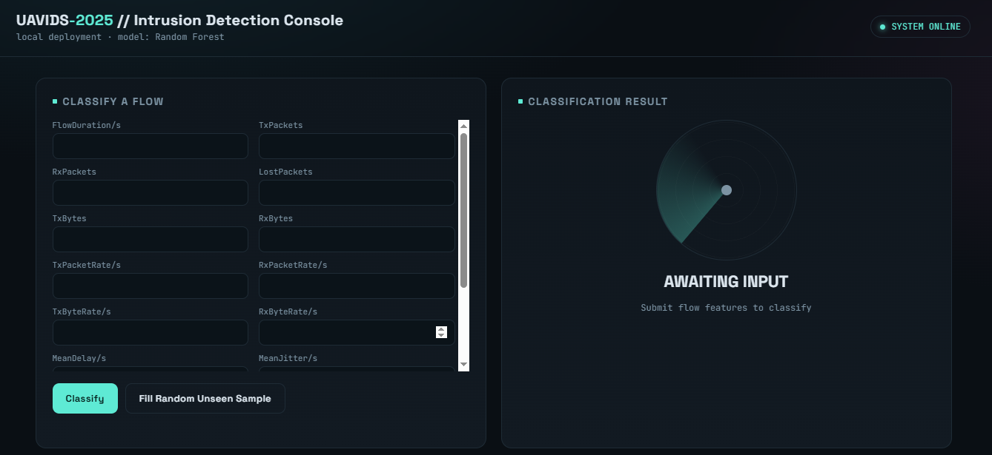

Figure 6.7: Monitoring Dashboard: Flow Classification Panel in the Idle State
(Source: web page)
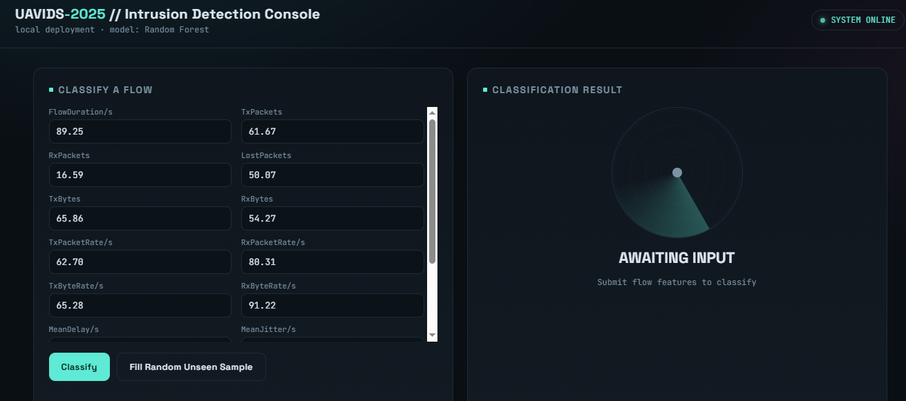

Figure 6.8: Monitoring Dashboard: Flow Classification Panel Populated with a Random Unseen Sample
(Source: web page)
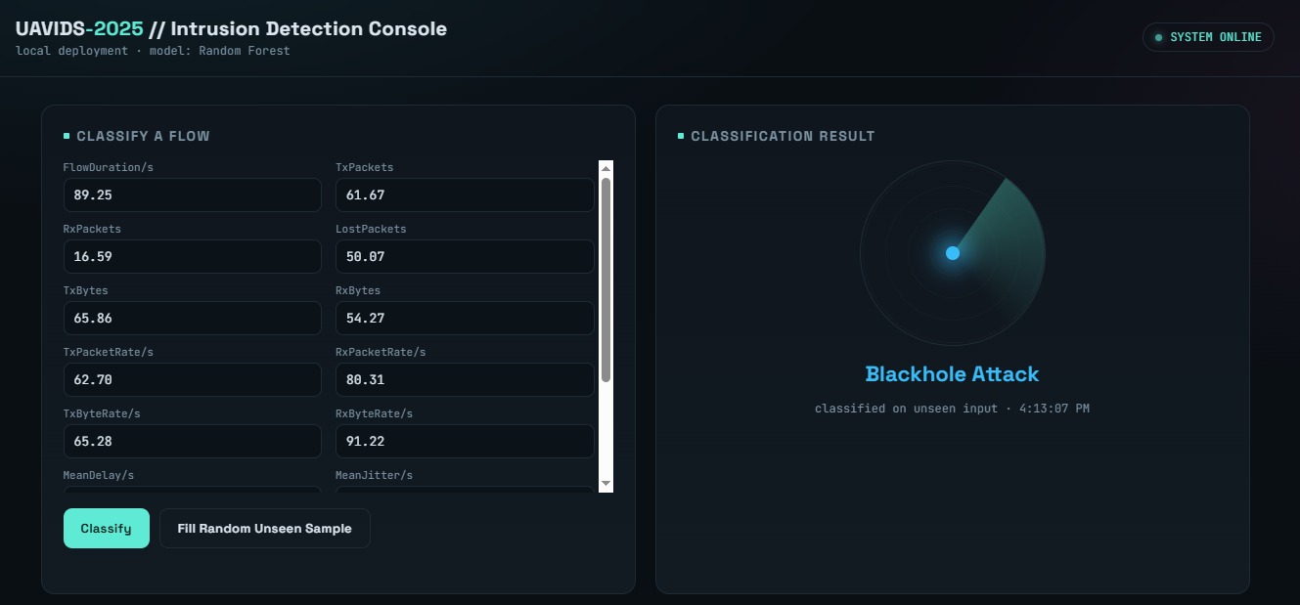

Figure 6.9: Monitoring Dashboard: Unseen Flow Correctly Classified as Blackhole Attack
(Source: web page)
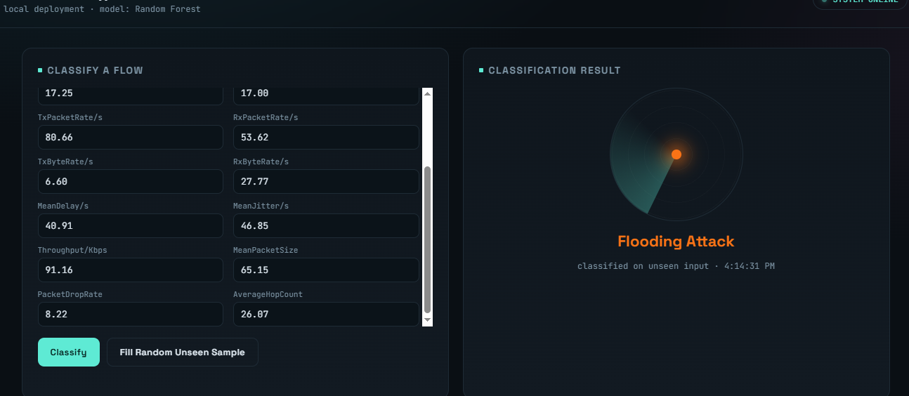

Figure 6.10: Monitoring Dashboard: Unseen Flow Correctly Classified as Flooding Attack
(Source: web page)
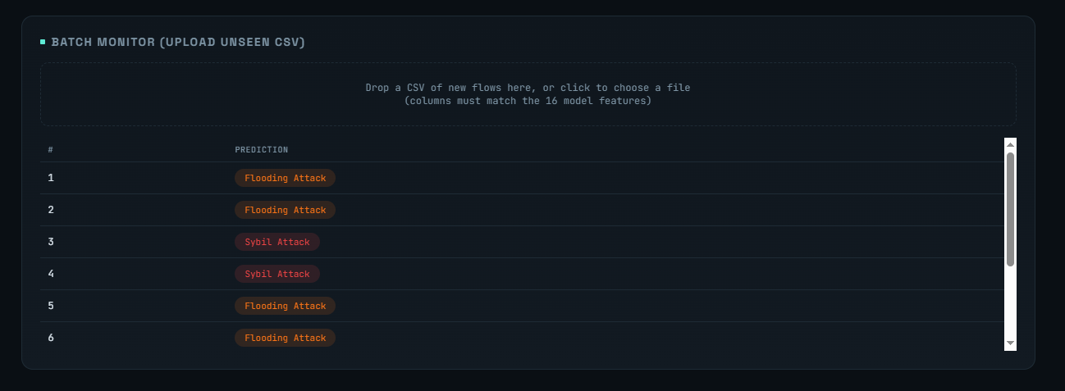

Figure 6.11: Batch Monitoring Panel: Predictions for an Uploaded CSV of Unseen Flows (Part 1)
(Source: web page)
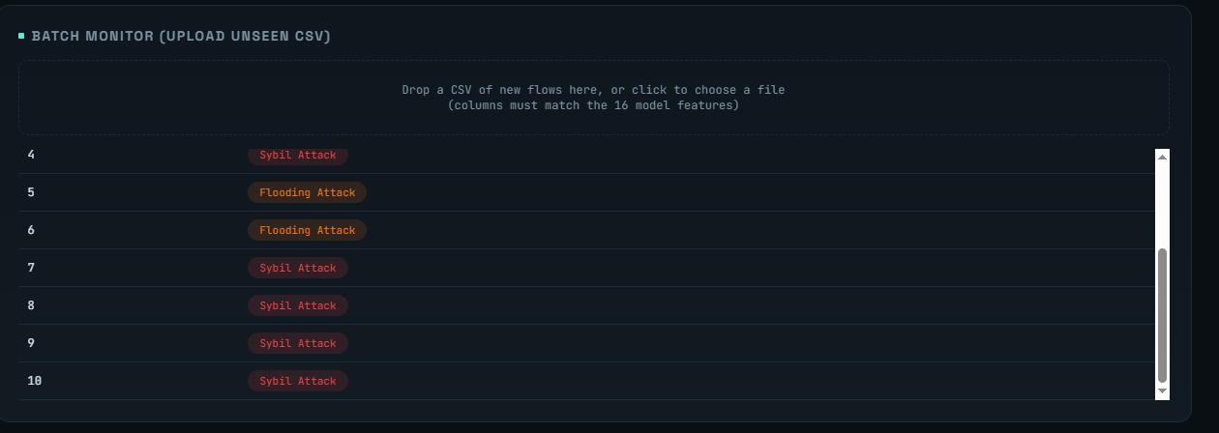

Figure 6.12: Batch Monitoring Panel: Predictions for an Uploaded CSV of Unseen Flows (Part 2)
(Source: web page)

CHAPTER 7: Conclusions and recommendations.

7.1 Introduction
This chapter is the summary of the chapters preceding this chapter in the report and looks back on the extent to which the aim and objectives of the research as stated in Chapter 1 were achieved. It restates, succinctly, key findings of literature review, methodology, design, implementation and evaluation chapters and it remarks on the contribution and practical value of AI-based security framework that was created and tested to detect the cyberattacks of drone networks. Another aspect considered in the chapter is the limitations encountered in the process of the project before the opportunities presented by the work to future work are identified in another sub-section. It ends with a brief list of recommendations to researchers, network administrators and designers of UAV systems.

7.2 Introduction to the Research.
In Chapter 1, the research began by noting that as drone networks grow more and more dependent on wireless communications, GPS-based navigation as well as cloud-based control systems, UAVs have become a victim of cyberattacks such as denial-of-service, GPS spoofing, command injection, replay attacks and jamming [18][22]. Chapter 2 has critically analyzed the existing literature and concluded that, although there exist a relatively high number of studies that suggest the use of AI-based security framework, only a relatively small number of studies are able to undertake a systematic, side-by-side comparison of multiple machine learning algorithms on a single publicly available dataset of UAV traffic in a single reproducible pipeline [9][13]. This is a firsthand gap that directed the development of the present study.
Chapter 3 developed a quantitative research design, which relies on the UAVIDS-2025 dataset, outlining the preprocessing stage, feature engineering and model-development phase, which will be followed, and the evaluation metrics of accuracy, precision, recall and F1-score against which the classifiers will be assessed. This methodology was translated into a concrete system design in Chapter 4 which justified why Decision Tree, Random Forest, Support Vector machine and a majority-voting Ensemble were the four classifiers of choice to be used. Chapter 5 reported the practical implementation of this design in Python in Google Colab, the preprocessing pipeline, train-test split, feature scaling and model training, and locally-hosted monitoring dashboard which could label individual and batch-uploaded network flows.
The resulting models were tested on a held-out test partition of 24,435 flows in chapter 6. The best overall performance was achieved by the Random Forest (95.36 per cent), 95.57 per cent precision, 95.36 per cent recall and an F1-score of 0.9536, just higher than the Ensemble model (95.19 per cent) and the Decision Tree (94.66 per cent) and significantly higher than the Support Vector Machine (88.99 per cent). The analysis of feature-importance revealed Packet Drop Rate, Transmit Byte Rate, Transmit Packet Rate and Receive Byte Rate to have the largest portion of the discriminative signal, supporting the behavioural, rate-and-drop-based feature-selection strategy used in Chapters 3 and 4 [49]. Flooding and Sybil attacks were nearly caught precisely whilst Blackhole and Wormhole attacks were frequently mistaken to be the same as both seem like an unusual packet-forwarding behaviour. The tree-based and ensemble classifiers performed well in terms of indirect comparison to the accuracy of Logistic Regression of between 78 and 90 per cent in other parts of the literature [47][48][55] and this justifies the design choice, made in Chapter 4, to concentrate on non-linear, ensemble-based classifiers, and not simply linear baselines. The gain of validation on a synthetically perturbed unseen dataset, along with the functionality of the monitoring dashboard, indicated that the trained Random Forest model had a good generalisation to all samples it was trained on and could be operationalised as an interactive, locally hosted intrusion-detection service.

7.3 The Aim and Objectives were achieved as indicated by the 7.3 section.
The above-summarised chapters, when combined, point to the fact that the purpose of the research, to design and test AI-based security system able to identify cyberattacks in drone networks based on machine learning used on publicly available UAV traffic data, was achieved significantly. All four supporting objectives were discussed one by one. The former to scan the prevalent cyber threats to drone networks and existing AI-based intrusion detection systems was satisfied by the critical literature review in Chapter 2 that also identified the research gap that the study went on to address. Acquisition and preprocessing of UAV network security data used publicly was performed by acquiring and preprocessing the UAVIDS-2025 dataset in Chapters 3 and 5, and the exploratory data analysis and feature reduction based on the correlation was performed in Chapter 6. The third, to design and develop machine learning programs that will identify attacks sent via the drone network traffic, was satisfied by designing and training the four classifiers in Chapter 5 and testing them in Chapter 6. The fourth, to suggest and explain an AI-based security model by comparing the model performance with conventional evaluation metrics, was met by the systematic comparison of the accuracy, precision, recall and F1-score and confusion-matrix performance of the different classifiers in Chapter 6, which found Random Forest the most applicable classifier to the behavioural, rate-based features that describe UAV network traffic.

7.4 Contributions and Benefits to the study.
The research is a small yet a sincere addition to the current pool of literature in the field of AI-controlled UAV cybersecurity. In contrast to much of the literature reviewed, which offers either individual-Algorithm studies, or very abstract security models [6][13], the project directly compared four classifiers on a single, reproducible pipeline, on the same, consistent dataset, using the same preprocessing and evaluation measures on each model. This comparative manner provides a better perspective of the algorithms to choose, than can be obtained with single-model studies and the resultant behavioural, rate-and-drop-based feature set offers a valuable reference point to researchers intending to use such a system [15][19]. The working monitoring dashboard created in Chapter 5 continues to show that the trained model can be transferred out of an offline notebook into a dynamic tool able to categorize individual and batch network flows, which can be used to visualize just one example of how the framework can be used to support network administrators and cybersecurity teams overseeing UAV fleets. On a bigger scale, the project justifies the argument that has been traversed through the literature that adaptive, learning based intrusion detection can offer a more sound alternative to the conventional signature based techniques as UAV networks and threats against them are growing in number [7][10].

7.5 Limitations
Regardless of these contributions, there are a number of limitations to the project, which must be noted. As in Chapter 6.5 this comparison was made indirectly, using the ranges of accuracy in related literature as opposed to a trained Logistic Regression model in the same notebook pipeline under the same conditions; a like-for-like, in-study comparison would bolster the evidence base significantly. The Support Vector Machine was also trained with a sub sampled data which limits the comparability of the Support Vector Machine with the other three classifiers. There is also a limitation to a single, fixed, centralised data source; UAVIDS-2025 is a relatively large and balanced source of traffic logs but there is no way it can possibly represent the diversity of live multi-vendor drone deployments in real-life operational settings [53]. The current confusion between the Blackhole and Wormhole attacks where the signature is similar in the terms of packet-forwarding behaviour also highlights that the current set of features may fall short of being able to differentiate similar behaviour types of attack even in those situations where the classifier can still differentiate between malicious and normal traffic. Finally, the performance measures embraced in the study are of a statistical nature and not linked to the overall operational performance of flight-safety which as far as the broader UAV safety body of literature is concerned would play a critical role in the reduction of operational safety confidence as far as the detection accuracy is concerned [54].

7.7 Suggestions for Further Work
Such limitations introduce numerous possibilities of the future work. To start with, a Logistic Regression model, and other linear baselines, should be trained in the same experimental pipeline with the other four classifiers, thereby making it possible to directly infer the apparent advantage of ensemble and tree-based models as opposed to indirectly, in accordance with the literature. Second, the Blackhole-Wormhole confusion of Chapter 6.3 suggests that more granular features, like routing-path metadata or sequence-based features that record how packets are redirected, and not whether they are dropped, may be relevant to better differentiate between these two classes of attacks. Third, since the study was based on one, stagnant dataset, future research needs to confirm the framework using more or live-captured UAV traffic datasets, preferably across a wide variety of vendors or in operation settings, to assess the external validity of the findings to UAVIDS-2025 [53]. Fourth, the error of detection and the cost of inference, which was briefly discussed in Chapter 6.4, must be quantified further; lightweight or shallow models can still be discussed by resource-constrained, edge-deployed UAV hardware even though this trade-off was not quantified in the present study. Fifth, the framework can be generalized to federated learning, where several UAV operators can learn a shared detection model, without centralising sensitive traffic data, which is also gaining traction in the more general literature on distributed drone security [43][47]. Finally, future studies are recommended to consider the potential of relating the results of detection of the type produced by the monitoring dashboard in Chapter 5 to flight-safety decision-making and in some cases to the legal and forensic admissibility standards of automated detection decisions in UAV cybersecurity studies [50][54].

7.6 Recommendations
The above findings lead to the recommendation that network administrators and developers of UAV systems should emphasize more on rate-, drop-, and drop-based traffic features over raw packet or byte counters when defining or buying an intrusion detection tool as in this case, these features occupied the majority of the discriminative signal. It is also indicated that ensemble or tree-based classifiers such as the Random Forest, should be considered over strictly linear ones as a means of categorising behavioural UAV traffic, nonetheless, must still be able to substantiate this choice by the personal data of the operators. The special consideration of the Blackhole- or Wormhole-type attacks within the operations is recommended to consider additional routing- or path-based features to the deployed detection system because of the confusion observed between the two types of attacks in this paper. Finally, organisations intending to apply AI-based intrusion detection to drone fleets are encouraged to evaluate any model of interest against unseen, noise-perturbed data, as in Chapter 6.6 of this work, to build confidence that the reported performance on the test set will be the same as the performance in operational contexts.

CHAPTER 8: REFLECTION

8.1 Introduction
This is the chapter which changes the emphasis of what was made to how it was made. As opposed to the technical discussion in the previous chapters, reflection reflects on the experience the researcher had when working on the project: the planning and organization of the work, what was learned about oneself as a researcher and working habits, and what, in retrospect, might have been done better. This chapter is not intended to revert to the technologies as well as the results I have reviewed in Chapters 5 and 6, but rather of contemplating the process of creating them to gain some lessons, which can be fruitfully used in work of this kind in the future.

8.2 Time Management
In retrospect, the project I had a few more challenging areas one of which was time management. Initial steps, especially the literature review, Chapter 2, and acquisition and cleaning of the UAVIDS-2025 dataset, Chapter 3, took longer than expected, partly due to the fact that a clear understanding of the quality of the data was only realized once preprocessing had started taking place. This indirectly affected me at the later development and testing time of models in the project and in effect, this meant that some activities like training an in-pipeline Logistic Regression baseline would have to wait, as indicated in Chapter 7.5. Reflectively, a more realistic first timeline, with more contingency time added around the preprocessing phase, would have alleviated this stress on the subsequent chapters. The experience has also served to reiterate the need to front load the exploratory data analysis and not to view it as a pre-processing process that must be completed before the real model building process can occur.

8.3 Study Skills.
The project was also a great opportunity in which the researcher could gain and combine diverse study and research skills. Organising and critically synthesising a substantial literature, as would be needed in Chapter 2, would require the researcher to venture beyond merely summarising individual articles to discerning patterns, conflicting and real gaps in the literature as a whole; this is a skill that the researcher believes has become evident, as demonstrated by the capacity to place the findings of the study, in Chapter 6, in comparison to a broad array of previous results with reasonable certainty. Exposure to a large and imbalanced real-world-style dataset was also a good exercise in practical data-handling, such as preprocessing, feature engineering and interpretation of exploratory statistics like the correlation matrix and feature-importance rankings described in Chapter 6.1. Most importantly, building, training and critically evaluating four different machine learning models implied that the researcher had to be even more sceptical and evidence based about the results of the models as such, asking, to name a few, why the Support Vector Machine did not work as well as the other classifiers, and what the problem with the experimental design but not necessarily the algorithm could be the answer.

8.4 Challenges Encountered
The project had a couple of issues that took place and in reflection, they did not go down the drain in terms of the learning of the researcher. The biggest was the Blackhole-Wormhole confusion that was found when models were evaluated in Chapter 6.3; to solve the fact that the two behaviourally similar attack types were being confused, the researcher needed to go back to the feature-importance analysis and reflect on what the available features could and could not differentiate, as opposed to interpreting the confusion matrix as a pass or fail outcome. A second issue was that there was no easy way to fairly compare models which had been trained differently, particularly the subsampling of the Support Vector Machine which was discussed in Chapter 6.2; you learn not to conceal a limitation behind a figure in the headline, when presenting experimental results. A third, more practice-driven difficulty was to scale up the trained model out of the notebook setting into the interactive monitoring dashboard in Chapter 5.8, which necessitated interaction with the elements of software deployment that were a bit beyond the immediate range of the machine learning elements, but which ultimately proved useful in showing the practical usefulness of the work.

8.5 What could have been done otherwise.
Looking at the whole of the project, the researcher believes that the study could have been conducted in a variety of ways to be improved. The fact that the most important design decision of the project to prefer ensemble and tree based classifier was right would have been strengthened by training a Logistic Regression baseline on the same experimental pipeline as the four classifiers and would have been done earlier rather than being mentioned as future research in Chapter 7.5. More emphasis could also have been given, earlier on in the project, to features that were capable of being able to differentiate between Blackhole and Wormhole traffic rather than finding out this limitation when the main evaluation was already done. To be even more precise, the researcher knows that a more iterative method, which would alternate data exploration, feature engineering and preliminary model testing earlier and more often than it was a strictly sequential process, would have probably made some of the constraints of the project more noticeable at an earlier point in time and would have offered more time to address them within the available time constraint.

8.6 Concluding Reflection
Taken together, the project has been a useful experience, not just in terms of developing a working AI-based security system to detect cyberattacks within drone networks, but the researcher himself to become a self-reliant researcher who approaches his/her research in a disciplined, skeptical and honest manner. The lessons the researcher hopes to take into future research and practice include the experience of handling a longer, multi-stage technical project, of facing and reporting on the constraints of his or her own output instead of sweeping them under the carpet, and of transferring the machine learning pipeline to a more useful form. In the event of a re-run of such a project, the researcher is sure that a large proportion of the challenges that arose in this context, especially in matters of time management in the initial data-preparation phases and the usefulness of model comparisons in general, would be foreseen and prevented early on, so that more time could be devoted to the more productive avenues of further work that were found in Chapter 7.

References
[1] Ashraf, S.N., Manickam, S., Zia, S.S., Abro, A.A., Obaidat, M., Uddin, M., Abdelhaq, M. and Alsaqour, R., 2023. IoT empowered smart cybersecurity framework for intrusion detection in internet of drones. Scientific reports, 13(1), p.18422.
[2] Keating, L., 2025. A BLOCKCHAIN AND AI-DRIVEN FRAMEWORK FOR SECURING AUTONOMOUS DRONE NETWORKS IN SMART ENVIRONMENTS.
[3] Alsadie, D., 2025. Cybersecurity and Artificial Intelligence in Unmanned Aerial Vehicles: Emerging Challenges and Advanced Countermeasures. IET Information Security, 2025(1), p.2046868.
[4] Alsadie, D., 2025. Cybersecurity and Artificial Intelligence in Unmanned Aerial Vehicles: Emerging Challenges and Advanced Countermeasures. IET Information Security, 2025(1), p.2046868.
[5] Senturk, K., Gormus, A.F., Gonen, S., Bariskan, M.A. and Durmaz, A.K., 2025. Artificial intelligence-enhanced intrusion detection systems for drone security: a real-time evaluation of algorithmic efficacy in mitigating wireless vulnerabilities. Cluster Computing, 28(3), p.175.
[6] Javed, M.D., Taj, S., Khan, R., Awasthi, S., Hassan, H., Xinyue, X. and Khan, M., 2025. Cyber security framework for AI-enabled robotics and drone systems. In Advancing Cybersecurity in Smart Factories Through Autonomous Robotic Defenses (pp. 231-262). IGI Global Scientific Publishing.
[7] Sunkara, G., 2022. AI-driven cybersecurity: Advancing intelligent threat detection and adaptive network security in the era of sophisticated cyber attacks. Well Testing Journal, 31(1), pp.185-198.
[8] Veprytska, O. and Kharchenko, V., 2024, March. Analysis of AI powered attacks and protection of UAV assets: quality model-based assessing cybersecurity of mobile system for demining. In IntelITSIS (pp. 356-374).
[9] Sakibul, I.M., Sharif, M.A. and Sheltami, T.R., 2025. AI-enhanced intrusion detection for UAV systems: a taxonomy and comparative review. drones, 9(10), p.682.
[10] Aldaej, A., Ahanger, T.A., Atiquzzaman, M., Ullah, I. and Yousufudin, M., 2022. Smart cybersecurity framework for IoT-empowered drones: Machine learning perspective. Sensors, 22(7), p.2630.
[11] Adil, M., Song, H., Mastorakis, S., Abulkasim, H., Farouk, A. and Jin, Z., 2023. UAV-assisted IoT applications, cybersecurity threats, AI-enabled solutions, open challenges with future research directions. IEEE Transactions on Intelligent Vehicles, 9(4), pp.4583-4605.
[12] Fallah, D., Abdul-Kareem, B.J., Sultanbek Sadyrbekovich, K., Falih Mahdi, A. and Janan, O., 2025. AI-driven drones for real-time network performance monitoring. Iranian Journal of Information Processing and Management, 40(Special Issue 4), pp.1281-1308.
[13] Kumar, M.S. and Thampi, S.M., 2025. From ground to cloud: integrated multi-attack detection in IoT-Driven UAV security frameworks. In Securing the connected world: exploring emerging threats and innovative solutions (pp. 381-419). Cham: Springer Nature Switzerland.
[14] Branco, B., Silva, J.S.S. and Correia, M., 2025. Cyber attacks on commercial drones: A review. IEEE Access, 13, pp.9566-9577.
[15] Hadi, H.J., Cao, Y. and Paracha, W.O., 2025. Collaborative AI-Driven Intrusion Detection and Response for UAV Networks. In Reliable and Efficient Trajectory Design in UAV-Aided Wireless Networks (pp. 273-300). Singapore: Springer Nature Singapore.
[16] Tlili, F., Ayed, S. and CHAARI FOURATI, L., 2023, August. Dynamic intrusion detection framework for UAVCAN protocol using AI. In Proceedings of the 18th International Conference on Availability, Reliability and Security (pp. 1-10).
[17] Hakeem, A., Sabir, M., Alhebshi, R.M., Almakky, A.G. and Ashraf, I., 2025. Integrating artificial intelligence for improved security of IoT-drones through cyber-physical attack detection. Frontiers in Computer Science, 7, p.1545282.
[18] Oli, A. and Mahalal, E., 2025. UAV Security: Attacks, Defenses, and Open Challenges. IEEE Access, 13, pp.215606-215635.
[19] Hossain, M.A., Ishtiaq, W. and Islam, M.S., 2026. A Comparative Analysis of Ensemble‐Based Machine Learning Approaches With Explainable AI for Multi‐Class Intrusion Detection in Drone Networks. Security and Privacy, 9(1), p.e70164.
[20] Yang, Z., Zhang, Y., Zeng, J., Yang, Y., Jia, Y., Song, H., Lv, T., Sun, Q. and An, J., 2025. AI-driven safety and security for UAVs: From machine learning to large language models. Drones, 9(6), p.392.
[21] Hussein, Z.A. and Naser, O.A., 2025, September. AI-Powered Malware Analysis in Military Cybersecurity: A Deep Learning Approach. In International Conference on Cybersecurity and Artificial Intelligence Strategies (pp. 151-171). Cham: Springer Nature Switzerland.
[22] Shafik, W., Matinkhah, S.M. and Shokoor, F., 2023. Cybersecurity in unmanned aerial vehicles: A review. International Journal on Smart Sensing and Intelligent Systems, 16(1).
[23] Rabah, M.A.O., Drid, H., Rahouti, M. and Lazaar, N., 2024. Empowering UAV communications with AI-Assisted Software-defined networks: A review on performance, security, and efficiency. Journal of Network and Systems Management, 32(4), p.90.
[24] Omolara, A.E., Alawida, M. and Abiodun, O.I., 2023. Drone cybersecurity issues, solutions, trend insights and future perspectives: a survey. Neural computing and applications, 35(31), pp.23063-23101.
[25] Tariq, U., Ahanger, T.A. and Ihsan, M., 2026. Systematic review of machine and deep learning models for unmanned aerial vehicles cyber threat defense. Discover Artificial Intelligence, 6(1), p.216.
[26] Sissodia, R., Rauthan, M.S., Barthwal, V. and Dwivedi, V., 2025. Introduction to Artificial Intelligence (AI) and cybersecurity in robotics and drone systems. In Advancing Cybersecurity in Smart Factories Through Autonomous Robotic Defenses (pp. 345-374). IGI Global Scientific Publishing.
[27] Goffer, M.A., Uddin, M.S., Hasan, S.N., Barikdar, C.R., Hassan, J., Das, N., Chakraborty, P. and Hasan, R., 2025. Ai-enhanced cyber threat detection and response advancing national security in critical infrastructure. Journal of Posthumanism, 5(3), pp.1667-1689.
[28]https://media.springernature.com/full/springer-static/image/art%3A10.1038%2Fs41598-025-21648-5/MediaObjects/41598_2025_21648_Fig1_HTML.png
[29] https://www.mdpi.com/2504-446X/9/6/392
[30] https://www.mdpi.com/2504-446X/9/6/392
[31]https://ietresearch.onlinelibrary.wiley.com/cms/asset/af6c203f-3b28-4c71-9884-04d92068bcd7/ise22046868-fig-0001-m.jpg
[32]https://cdn.clickworker.com/wp-content/uploads/2024/02/advantages-AI-in-Cybersecurity.png
[33] Ashraf, S.N., Manickam, S., Zia, S.S., Abro, A.A., Obaidat, M., Uddin, M., Abdelhaq, M. and Alsaqour, R., 2023. IoT empowered smart cybersecurity framework for intrusion detection in internet of drones. Scientific reports, 13(1), p.18422.
[34] Ahmed, M., Cox, D., Simpson, B. and Aloufi, A., 2022. Ecu-ioft: A dataset for analysing cyber-attacks on internet of flying things. Applied Sciences, 12(4), p.1990.
[35] Branco, B., Silva, J.S.S. and Correia, M., 2025. Cyber attacks on commercial drones: A review. IEEE Access, 13, pp.9566-9577.
[36] Prasad, D.S., Jyothi, P., Suryanarayana, G. and Mohanty, S.N., 2023. Algorithms to mitigate cyber security threats by employing intelligent machine learning models in the design of IoT‐aided drones. Drone Technology: Future Trends and Practical Applications, pp.257-300.
[37] Abdulrazak, C., 2024. Cybersecurity threat analysis and attack simulations for unmanned aerial vehicle networks. arXiv preprint arXiv:2404.16842.
[38] Alzahrani, A., 2024. Novel approach for intrusion detection attacks on small drones using ConvLSTM model. IEEE access, 12, pp.149238-149253.
[39] Alturki, N., Aljrees, T., Umer, M., Ishaq, A., Alsubai, S., Saidani, O., Djuraev, S. and Ashraf, I., 2023. An intelligent framework for cyber–physical satellite system and iot-aided aerial vehicle security threat detection. Sensors, 23(16), p.7154.
[40] Mahamkali, A., Gali, M., Muniyandy, E. and Sundaram, A., 2023, October. IoT-empowered drones: Smart cyber security framework with machine learning perspective. In 2023 International Conference on New Frontiers in Communication, Automation, Management and Security (ICCAMS) (Vol. 1, pp. 1-9). IEEE.
[41] Agnew, D., Del Aguila, A. and McNair, J., 2024. Enhanced network metric prediction for machine learning-based cyber security of a software-defined UAV relay network. IEEE Access, 12, pp.54202-54219.
[42] Ihekoronye, V.U., Ajakwe, S.O., Lee, J.M. and Kim, D.S., 2024. DroneGuard: An explainable and efficient machine learning framework for intrusion detection in drone networks. IEEE Internet of Things Journal, 12(7), pp.7708-7722.
[43] Alshahrani, H., Abunadi, I., Alsolai, H., Rehman, M.B., AlAqil, M.A., Alkhudhayr, H., Assiri, H. and Alhashmi, A.A., 2026. An Intelligent Cybersecurity and Privacy‐Preserving Internet of Drones Framework Based on Federated Learning and Hybrid Deep Ensemble Models. International Journal of Communication Systems, 39(10), p.e70524.

[44] Ouiazzane, S., ADDOU, M. and BARRAMOU, F., 2023. A Zero-Trust Model for Intrusion Detection in Drone Networks. International Journal of Advanced Computer Science & Applications, 14(11), p.525.
[45] Agnew, D., del Aguila, A. and McNair, J., 2023, October. Detection of cyberattacks in an software-defined UAV relay network. In MILCOM 2023-2023 IEEE Military Communications Conference (MILCOM) (pp. 504-509). IEEE.
[46] Shafik, W., 2023. Cyber security perspectives in public spaces: drone case study. In Handbook of research on cybersecurity risk in contemporary business systems (pp. 79-97). IGI Global Scientific Publishing.
[47] Popli, M.S., Singh, R.P., Popli, N.K. and Mamun, M., 2025. A federated learning framework for enhanced data security and cyber intrusion detection in distributed network of underwater drones. IEEE Access, 13, pp.12634-12646.
[48] Alzahrani, M.Y., 2024. Enhancing drone security through multi-sensor anomaly detection and machine learning. SN Computer Science, 5(5), p.651.
[49] Repetto, M., Cambiaso, E., Patrone, F. and Zappatore, S., 2025. Flying Drones to Locate Cyber-Attackers in LoRaWAN Metropolitan Networks. arXiv preprint arXiv:2509.15725.
[50] Mohammed, U.M., Omolara, A.E., Abiodun, O.I., Rasheed, J., Osman, O., Lar, P.M., Adeyinka, P.O. and Olugbenga, A.G., 2025. Cyber threat in drone systems: bridging real-time security, legal admissibility, and digital forensic solution readiness. Frontiers in Communications and Networks, 6, p.1661928.
[51] Alsulami, H., 2022. Implementation analysis of reliable unmanned aerial vehicles models for security against cyber-crimes: Attacks, tracebacks, forensics and solutions. Computers and Electrical Engineering, 100, p.107870.
[52] Zemlianko, H. and Kharchenko, V., 2023. Cybersecurity risk analysis of multifunctional UAV fleet systems: a conceptual model and IMECA-based technique. Radioelectronic and Computer Systems, (4), pp.152-170.
[53] Al-Dosari, K., Deif, A.M., Kucukvar, M., Onat, N. and Fetais, N., 2023. Security supply chain using UAVs: validation and development of a UAV-based model for Qatar’s mega sporting events. Drones, 7(9), p.555.
[54] Douzi, A., Szabolcsi, R. and Lukács, J., 2025. Cybersecurity and the flight safety of unmanned aerial systems and unmanned aerial vehicles. Interdisciplinary Description of Complex Systems: INDECS, 23(2), pp.95-104.
[55] Alshamrani, A. and Alghamdi, A.M., 2026. Zero-shot attack detection in UAV networks using foundation models. Alexandria Engineering Journal, 136, pp.105-124.
[56] Ajakwe, S.O., Olabisi, K.L. and Kim, D.S., 2025. Multihop intruder node detection scheme (minds) for secured drones' fanet communication. IET Intelligent Transport Systems, 19(1), p.e70080.
[56] Sajid, J., Hayawi, K., Malik, A.W., Anwar, Z. and Trabelsi, Z., 2023. A fog computing framework for intrusion detection of energy-based attacks on UAV-assisted smart farming. Applied Sciences, 13(6), p.3857.

Bibliography
- Abdulrazak, C., 2024. Cybersecurity threat analysis and attack simulations for unmanned aerial vehicle networks. arXiv preprint arXiv:2404.16842.
- Alzahrani, A., 2024. Novel approach for intrusion detection attacks on small drones using ConvLSTM model. IEEE access, 12, pp.149238-149253.
- Basan, E., Basan, A., Nekrasov, A., Fidge, C., Abramov, E. and Basyuk, A., 2022. A data normalization technique for detecting cyber attacks on UAVs. Drones, 6(9), p.245.
- Branco, B., Silva, J.S.S. and Correia, M., 2025. Cyber attacks on commercial drones: A review. IEEE Access, 13, pp.9566-9577.
- Cosar, M., 2022. Cyber attacks on unmanned aerial vehicles and cyber security measures. The Eurasia Proceedings of Science Technology Engineering and Mathematics, 21, pp.258-265.
- Florido-Benítez, L., 2024. Identifying and classifying cyberattacks on airports. Cyber Security: A Peer-Reviewed Journal, 8(1), pp.63-79.
- Hadi, H.J. and Cao, Y., 2022, December. Cyber attacks and vulnerabilities assessment for unmanned aerial vehicles communication systems. In 2022 International Conference on Frontiers of Information Technology (FIT) (pp. 213-218). IEEE.
- Konate, K., 2023. A survey on cybersecurity in unmanned aerial vehicles: Cyberattacks, defense techniques and future research directions. International journal of computer networks and applications.
- Șcheau, M.C., Achim, M.V., Găbudeanu, L., Brici, I. and Vîlcea, A.L., 2022. Legal, economic and cyber security framework considerations for drone usage. Applied Sciences, 12(9), p.4663.
- Shafik, W., 2023. Cyber security perspectives in public spaces: drone case study. In Handbook of research on cybersecurity risk in contemporary business systems (pp. 79-97). IGI Global Scientific Publishing.
- Ștefan, O. and Codrean, A., 2024. Networked control of a small drone resilient to cyber attacks. Drones, 8(10), p.552.
- Yoo, D., Tak, T., Kim, T. and Han, S., 2025, October. Preliminary Study on Cyberattack Impacts on Drone Flight Control. In Transactions of the Korean Nuclear Society Autumn Meeting.
- Yu, A., Kolotylo, I., Hashim, H.A. and Eltoukhy, A.E., 2025. Electronic warfare cyberattacks, countermeasures, and modern defensive strategies of UAV avionics: A survey. IEEE Access, 13, pp.68660-68681.

Appendix

Appendix A — Dataset Feature Dictionary
Feature | Description | Type
TxPackets / RxPackets | Raw transmitted/received packet counters | Raw counter
TxBytes / RxBytes | Raw transmitted/received byte counters | Raw counter
TxPacketRate / RxPacketRate | Packets transmitted/received per unit time | Derived rate
TxByteRate / RxByteRate | Bytes transmitted/received per unit time | Derived rate
Throughput | Overall data rate across the flow | Derived rate
Packet Drop Rate | Proportion of dropped packets in the flow | Behavioural
Average Hop Count | Mean number of hops a packet traverses | Behavioural
Mean Jitter | Average variation in packet delay | Behavioural
Class Label | Normal / Blackhole / Wormhole / Sybil / Flooding | Target

Appendix B — Hyperparameter Configuration Table:
Model | Tuned Parameters | Notes
Decision Tree | max_depth, min_samples_split, class_weight='balanced' | 3-fold CV, weighted F1 scoring
Random Forest | max_depth, min_samples_split, class_weight='balanced' | 3-fold CV, weighted F1 scoring
SVM | Trained on random subsample of 15,000 records | Computational cost constraint
Ensemble | Majority (statistical mode) voting of the three base classifiers | No separate tuning

