Name – Declan Thomas

Student Number – 1908075

Course – HND in Quantity Surveying

Assignment Title – Construction Detailing


Module – Fundamentals of Construction Technology

Table of Contents
Introduction 3
Ground Floor 4
First Floor 6
External Walls 7
Openings 9
Eaves detailing and roof covering 11
The Main Roof Structure 13
Appendix A – Annotated Sketches 15
Conclusion 22
Bibliography 23

Introduction
Within this assignment, I shall provide a detailed construction for a two-storey domestic building with a loft room. The proposed site is to be built upon a level area that has a 450mm of topsoil above firm subsoil, also the proposed site is above a water table. I shall produce detailed drawings to show the materials and methods used. Also, including step by step descriptions on how the elements have been built and with solutions to how its been adopted to avoid humidity because of rain, thermal bridging, and condensation. I shall also ensure that the construction method shows how the design will meet the current building regulations for a new build and will including and specify these within the drawings.
Provided Construction Details:
- The ground floor construction, detailing and junctions with external wall
- The first-floor construction, detailing, junctions with external walls and restraints
- Openings details and solutions for lintels, sills and jambs
- Eaves Detailing and Roof Coverings
- The Main Roof Structure

Ground Floor
Suspended Timber Floors
Construction
A Timber suspended ground floor will consist of a timber floorboards being fixed to the floor joist. That have which been suspended above the subfloor of the foundations. The sleeper wall will then raise the floor joist above the subfloor as the sleeper wall acts as the supporting wall. Following this, a wall plate will then be attached on the top of the sleeper wall which the floor joist will rest on. Also, there will be a damp proof course that separates the wall plates from the sleeper wall, this will prevent rising moisture and there will be a gap in the block work of the sleeper wall which will ensure air circulation. Vents shall be installed in the external wall which will then allow air to the timber to keep the timber dry and prevent decay. Insulation is key, this ensures the floor is thermally insulated and the insulation will be placed between the floor joists. A seen in Appendix A.
Building Regulations
A must building regulation for the suspended timber floor is that the structure shall be protected against the growth of weeds and other plant life. The ground should have a layer of concrete poured with a ventilated gap of at least 150mm between the underside of the timbers and the concrete. This is to prevent moisture and affect the joists. Also, the timber joist is to be sized correctly to depend on their span and to be laid across the shortest span from wall to wall with a gap beneath. Damp proof course is to be placed between the wall and timber and insulation to be placed between the joists. Additionally, Air vents to be placed beneath to provide ventilation and allow air to travel from one side of the building to the other.
(Planning Portal, n.d.)
(Construction Studies Q1, n.d.)

First Floor
Traditional solid timber with tongue and grove soft wood flooring
Construction
Tongue and groove flooring are a type of hardwood flooring that has a tongue and groove fitting system. Meaning that each plank of flooring has tongue on one end and a grove the other, meaning all planks will fit together and grooves together for a tight and snug fit.
The flooring shall sit on joists which will be supported by internal and external walls. These shall be hung by joist hangers. Joist hangers shall allow no break into the inner skin of the wall, which would allow no thermal loss and prevent moisture penetration. Following this, bracing or strutting is installed, this shall reduce any movement. Correctly sized insulation sheets shall then be added between the joist to ensure good thermal bridging and to prevent heat and sound loss. Also, to protect the floor from any moisture a DPC shall be added. The flooring is the be installed by screws or glue.
(Ambience Flooring, n.d.)

External Walls
Construction
The cavity wall construction entails a double skin created by two walls and a cavity in between, the main purpose of the cavity wall is for weather protection, thermal insulation, and noise attenuation. Between the double skin walls, I have chosen to use polyurethane foam 25mm of insulation within the cavity. This insulation acts as a seamless insulation without thermal bridging. Also, this material will stay in its place without sagging and is moisture resistance. Additionally, an excellent insulator.
The construction of the double skin wall shall include, constructing the inner skin of the wall to a certain amount then insulating the cavity, then constructing the outer skin of the wall. This construction technique will then keep going until reached to the wall plate of the dwelling. Also, included within the cavity wall there be weep holes, wall ties and flashing as shown within the detailed drawing. The weep holes will act as a ventilation and drainage, these shall help reduce prevention of damp and rot within the walls. If there is no ventilation it could reduce the performance of the materials used such as the wall ties and insulation. The flashing will prevent any water penetration getting into the walls. The flashing normally extends from the interior wall through to the outer wall and a weep hole will then allow the water to drain. Wall ties are added to as it helps keep the structure safe and secure. As well as tying both walls together the wall ties also prevent water transfer from the outer to the inner leaf of the wall. Also, a damp proof course (DPC) is included within the wall, which acts as a barrier which is formed by a membrane that’s is built within the wall. This is essentials as it prevents raising damp through the walls and prevents groundwater from being absorbed by capillarity action in the walls.
Building Regulation
Within the cavity wall, where both leaves are 90mm or thicker there shall be a minimum of 2.5 ties per square meter. Also, a maximum horizontal spacing of 900mm and a maximum vertical spacing of 450mm. Wall ties shall be evenly distributed over the wall area with a staggered pattern but not around openings.
(Ancon, n.d.)
(Designing Buildings Wiki, 2019)

Openings
Lintels
Construction
A lintel is a horizontal structural support used to span an opening in a wall. Mostly used for windows and doors. Also, another key purpose of a lintel is to spread the load bearing. Lintels are important as they can prevent heat loss from the property and prevent the occurrence of damp and condensation. Also, the design and construction of the lintel must be careful to avoid thermal bridging.
I have decided to use a steel lintel for all openings within this dwelling. The lintel is to be placed directly above an opening which is to be placed on top of both skins of walls. When constructing a lintel is must include a cavity tray or a damp proof membrane to allow the water to be directed into the weep holes. Also, the lintel must incorporate a stop ends at either end of the lintel. This will prevent any water flowing back into the lintel and into the cavity, if water shall get into the cavity it will cause damp within the wall. Lintel shall also be insulated to decrease thermal bridging issues.
(Designing Buildings Wiki, 2019)
Building regulations
As we are using a steel lintel the damp proof course must be at least 140mm deep and to be manufactured from stainless steel or galvanised steel to suit the building regulations. A correct lintel installation is vital to the lintels performance as it must comply with the building regulation. Also, when installing the lintel, a 150mm end bearing must be provided and. Additionally, the steel lintel shall be up to 60 minutes of fire resistance.
(LABC, 2017)

Eaves detailing and roof covering
Eaves
Eaves are a combination of a fascia and soffit that overhangs of a roof. The eave acts as protection from rain, debris and acts as aesthetic functions that create a distance between the roof and the wall. The eaves will also prevent any leaking or damage to the façade of the property.
The eaves will include vents to ventilate the roof. This will prevent moisture within the roof structure and roof space and reduces condensation forming. Additionally, the eave will include a guttering, this will allow water to run from the roof down into the guttering which acts as a drainage system.
Roof Covering
The roof covering chosen by the developer is a slate covering. Slate coverings are most used on pitched roof with pitches angling from 20 degrees to 45 degrees. Slate is a very strong materials with good weather resistance as well as low water absorption. This means the material will withstand cold temperatures.
Construction
Firstly, install a breathable membrane over the roof trusses. The breathable membrane will act as an additional layer of protection to the roof which will prevent any water or debris accessing the property. As the membrane is breathable it will allow air through the membrane to allow air to circulate and discourage any mould and rot. This must comply with the building regulations. Next, the batten will be fixed. This is to be fixed at every 600mm centres. The Batten is to be fixed by nails or screws.
When fixing the slate, it must double lapped and every slate to be fixed to the battens by centre and head nailing. It’s crucial that the slate is fixed in the centre and head of the tile as extreme weather such as high winds can lift the slate, also thermal expansion can also cause the slate to lift. Also, it’s crucial that the tile will have a minimum of 100mm overlap on each tile that will allow water to run off the tile.
Once the roof covering is installed, the soffit and fascia’s is to be installed. The soffit and fascia will act as a protection as it will stop any debris entering the dwelling and will give aesthetic functions. As seen in Appendix A.
Building Regulation
Ventilation must be provided to the roof. Without this it could causes condensation within the roof which then leads to damaged timber. Ventilated soffit boards are installed to allow ventilation to the roof and to reduce moisture damage.
(Planning Portal, n.d.)

The Main Roof Structure
The functions of a roof is it can resist extreme weathers and to have strength and stability to withstand the weathers. The roof structure must be built as light as possible to allow the imposed loads on the supporting walls to minimum as possible. A very important function of the roof is that is must be fire protected to reduce the spread of a fire. The aesthetics of the roof is also a main function of the roof.
I have chosen to use a purlin roof structure but with a queen post truss. I have chosen this because it has a lot of roof space and can be used for living space. The plan for the dwelling is to include a room within the loft.
A queen post is a truss that can span longer openings than a king post truss. A queen post will use two supporting post whereas a king post will use one, this will allow more space to create a loft conversion.
Construction
Firstly, the queen post trusses are to be designed on constructed off site then delivered to site. When the trusses are being designed, the trusses will have a correct loadings for the dwelling which have been calculated by the timber specialists. These calculation will have to be complied with the building regulation. Once delivered to site, the trusses are to be fixed to the wall plates of the dwelling. The wall plate will then spread the load of the roof structure down through the walls without creating pressure points where each rafter will meet the wall. The insulation will then be installed between the trusses.

Also, included within the queen post truss structure there will be a ridge board, purlin Cleat, purlins, strut as seen in Appendix A.
Ridge Board
A ridge board is a horizontal board under the ridge of the roof that allows the top of the rafters to be fixed too.
Purlin cleat
A purlin cleat is a hidden bracket that will fix the purlin to the rafters, this shall help resist wind uplift.
Purlins
The purlins are used for structural support. These are horizontal beams that will support rafters and allow the rafters to be lighter and not as heavy. Allowing the roof structure to be lighter. Also allowing a larger spans.
Struts
Shall stop the rafters from sagging and offers support to the rafters.
(Designing Buildings Wiki, 2019)
(DIY Data, n.d.)
Building Regulation
Certain conditions must be met when a loft is turned into a living space. Regulations shall ensure that the floor is to be structurally stable, the roof is to be stable, reasonable sound insulation and a safe exit in case of a fire.
(Designing Buildings Wiki, 2019)

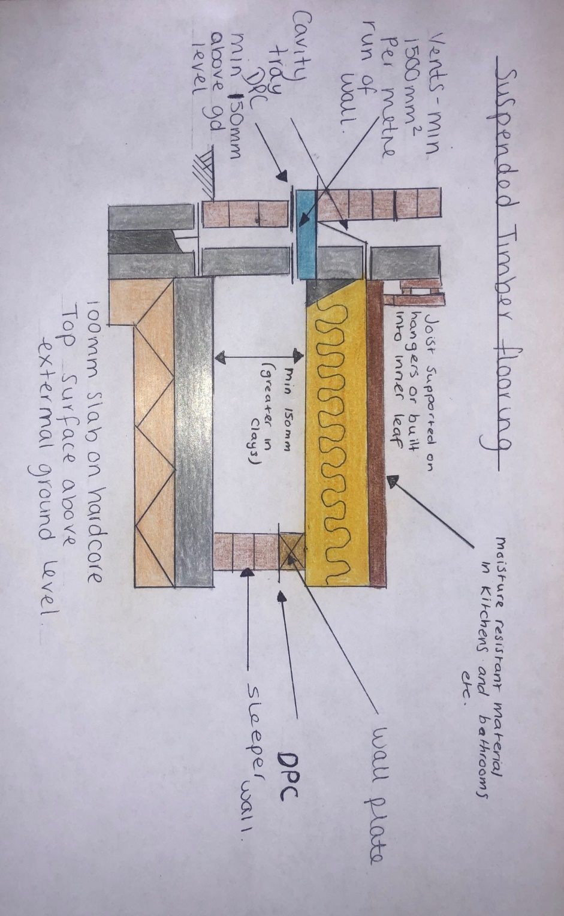
Appendix A – Annotated Sketches

(Suspended Timber Floor Sketch)

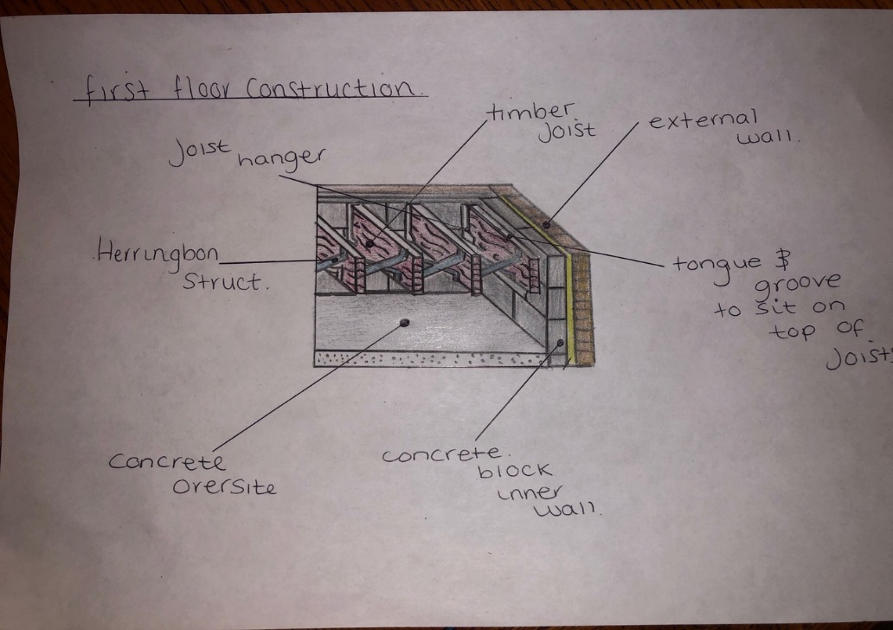

(First Floor Construction Sketch)

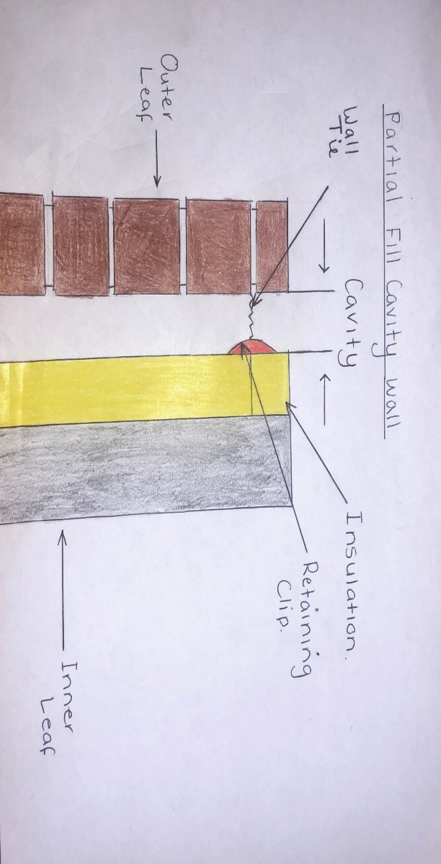
(Cavity Wall Sketch)
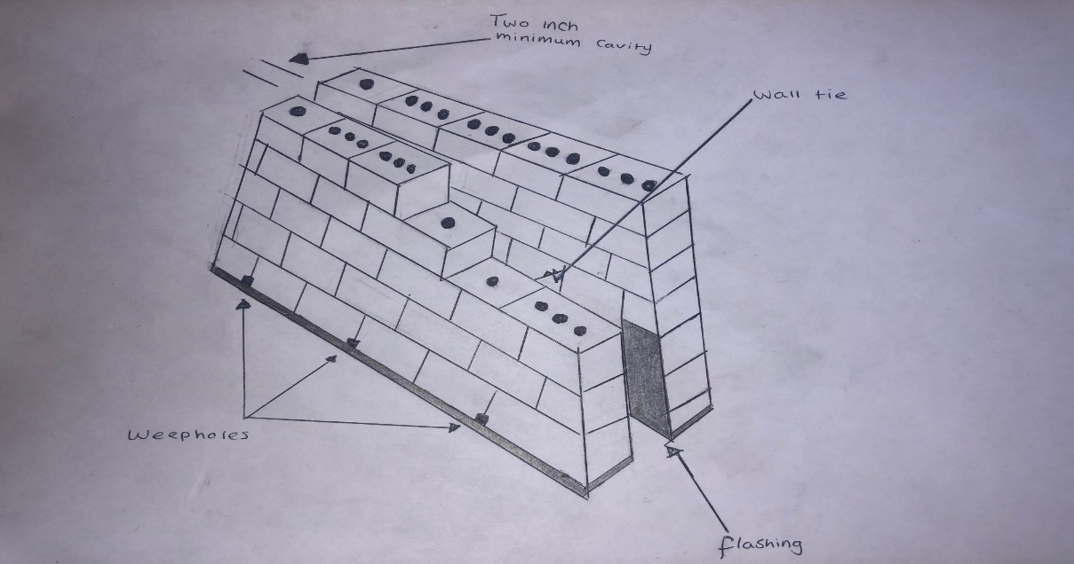

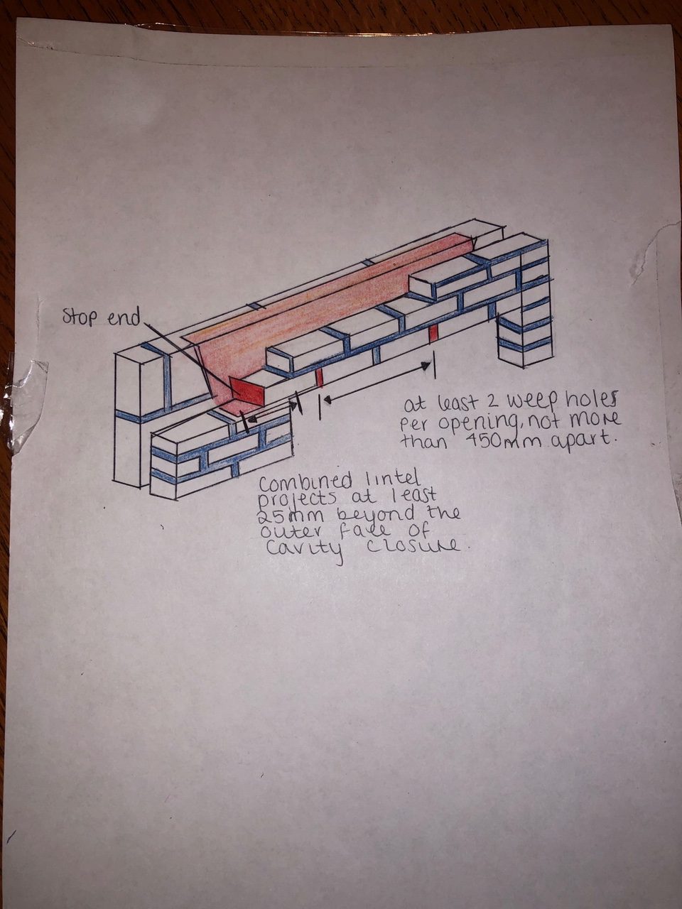
(Steel Lintel Sketch)

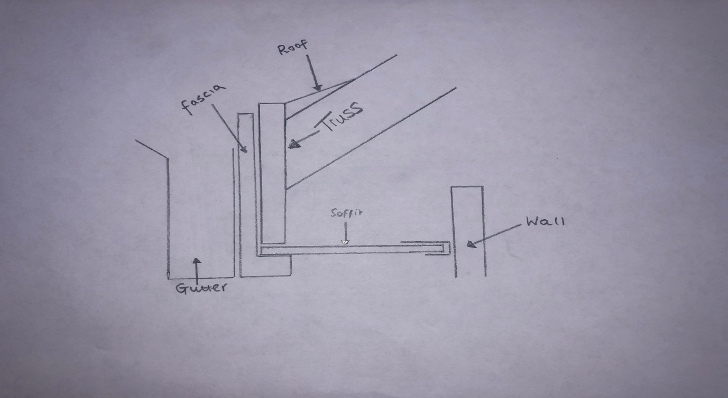
(Eaves Sketch)

(Wall Plate included as seen in below detail)
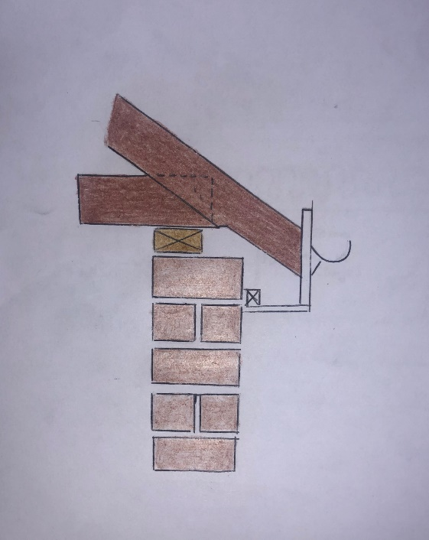

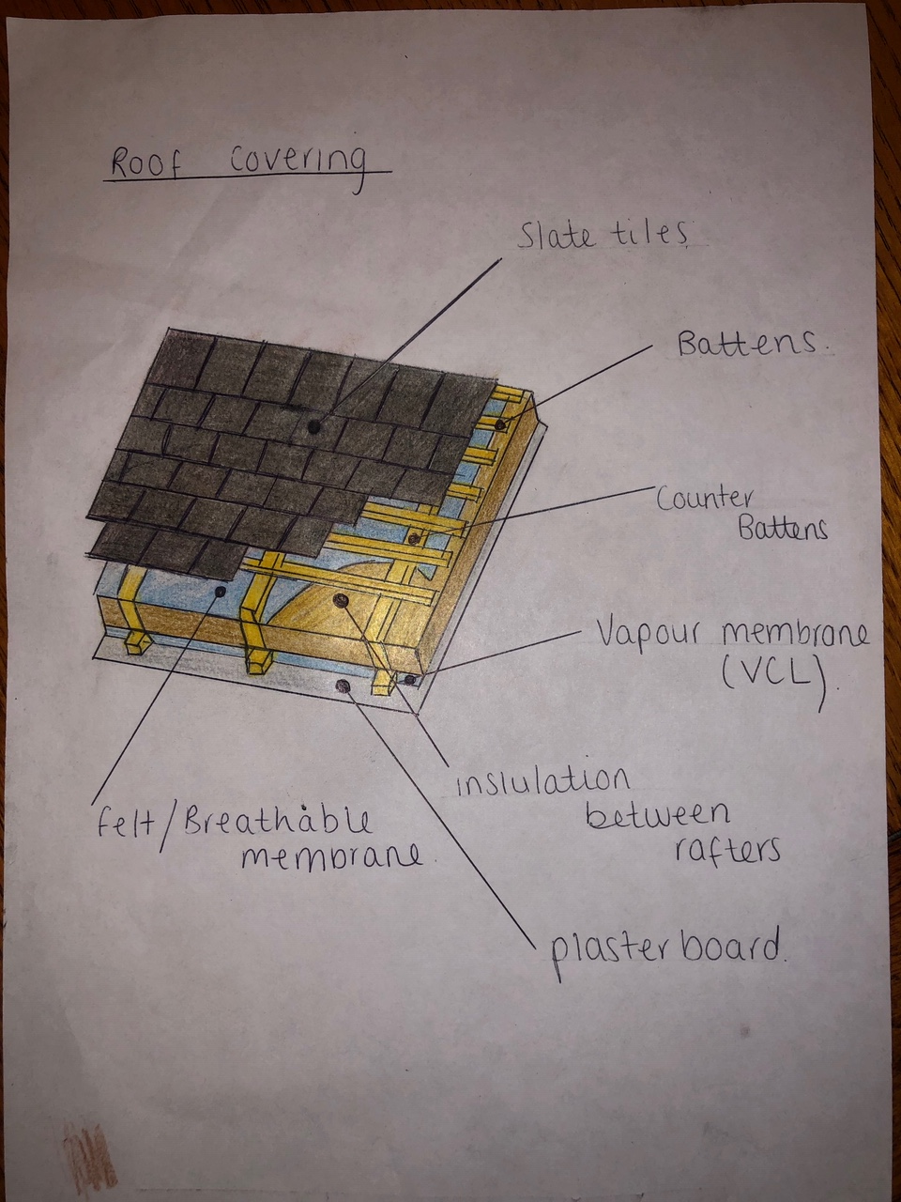
(Roof Covering Sketch)

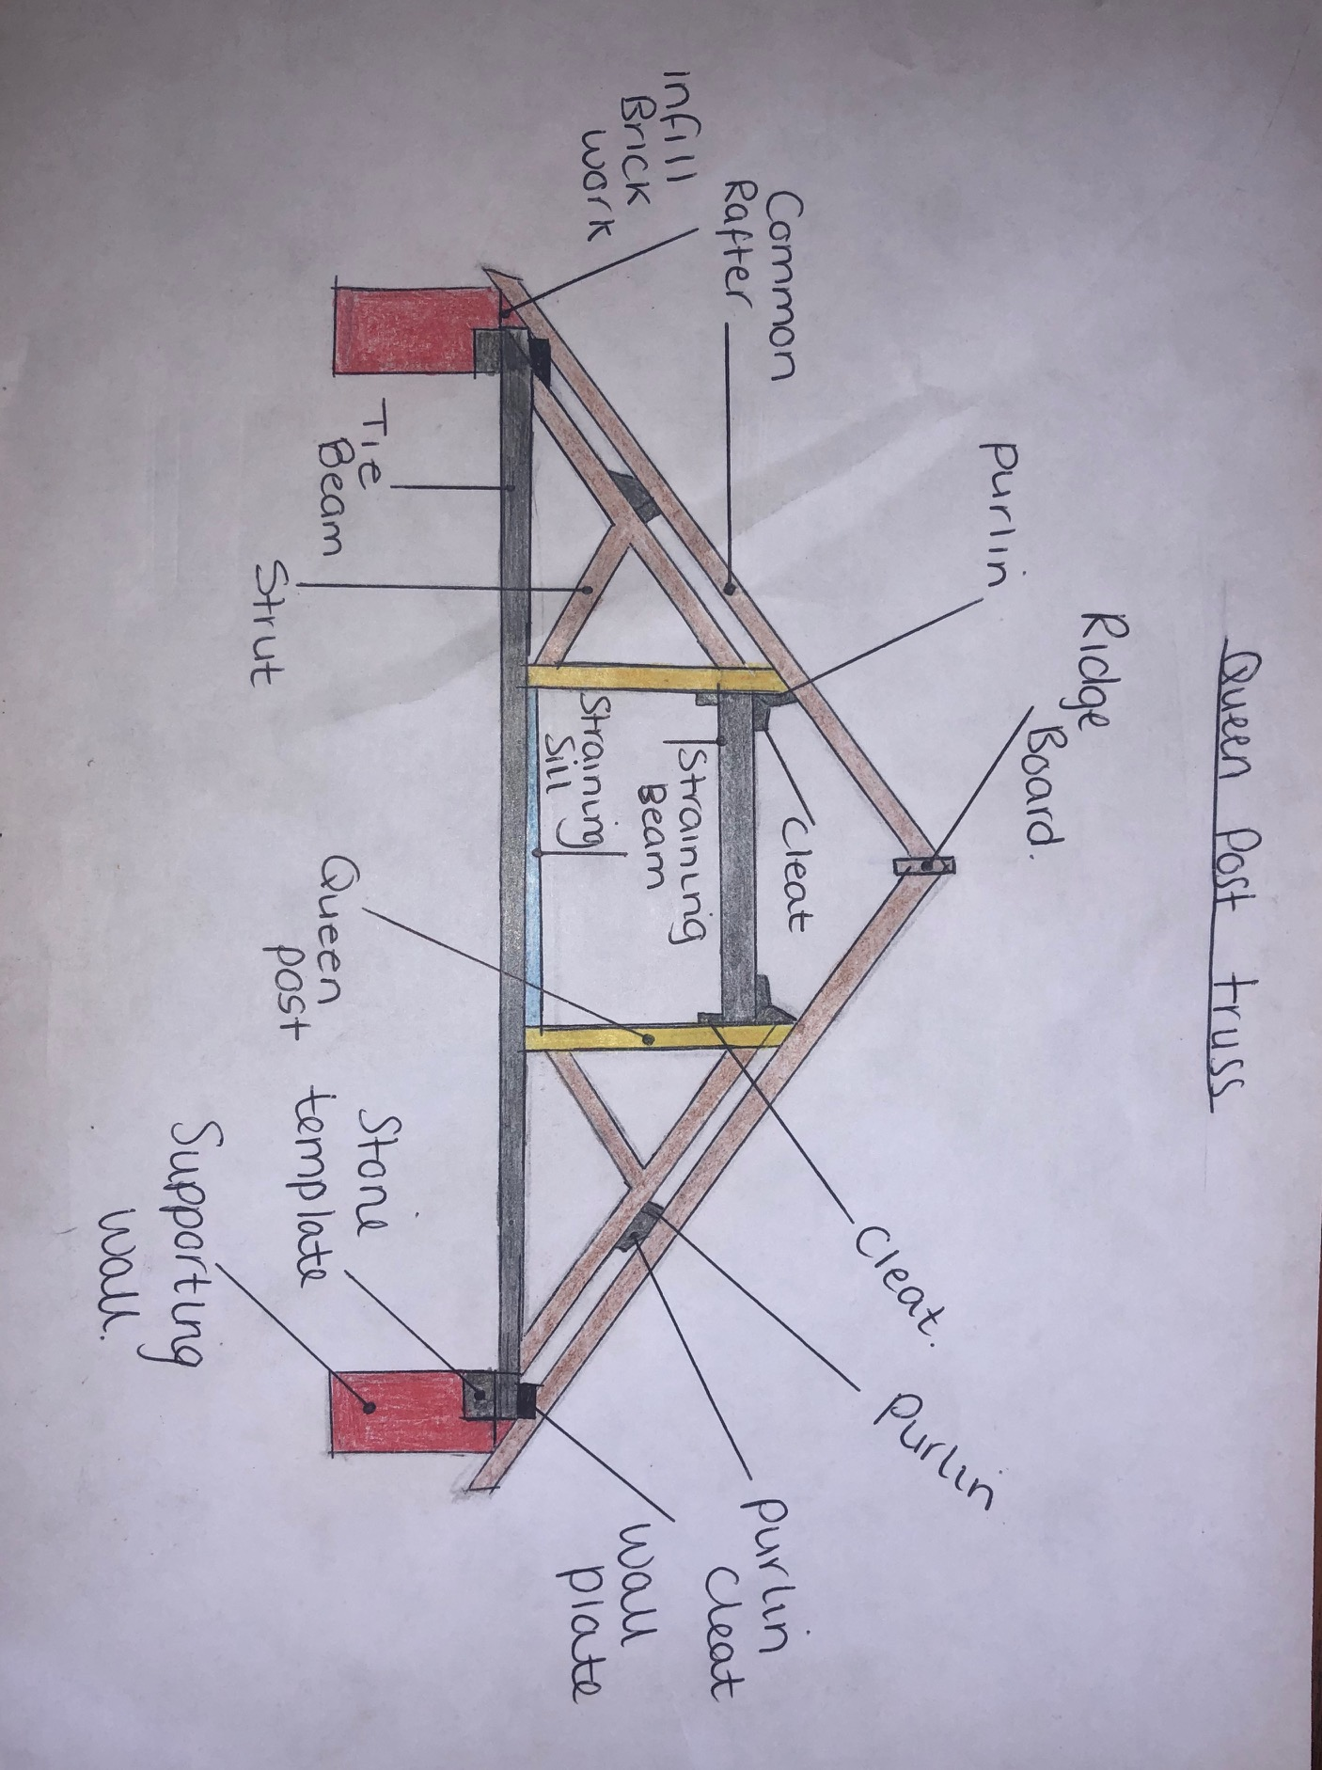
(Main Roof Structure Sketch)

Conclusion

To conclude this report, I would use CAD to design the drawings as it makes the report look more professional and detailed. This would drastically make the report look more presentable and neater.

Bibliography

Ambience Flooring. (n.d.). Tongue and Groove Flooring. Retrieved from Ambience Flooring: https://www.ambiencehard+woodflooring.co.uk/wood-flooring-guide/the-benefits-of-tongue-and-groove-flooring/
Ancon. (n.d.). Cavity Wall Tie Spacing and Appropriate Tie Lengths. Retrieved from Ancon: https://www.ancon.co.uk/blog/cavity-wall-tie-spacing-and-appropriate-tie-lengths
Construction Studies Q1. (n.d.). Suspended Timber Floor. Retrieved from Construction Studies Q1: http://constructionstudiesq1.weebly.com/suspended-timber-floor.html
Designing Buildings Wiki. (2019). Domestic Roofs. Retrieved from Designing buildings: https://www.designingbuildings.co.uk/wiki/Loft_conversion
Designing Buildings Wiki. (2019). Domestic Roofs. Retrieved from Designing Buildings Wiki: https://www.designingbuildings.co.uk/wiki/Domestic_roofs
Designing Buildings Wiki. (2019). DPC. Retrieved from Designing Buildings Wiki: https://www.designingbuildings.co.uk/wiki/Damp-proof_course_DPC
Designing Buildings Wiki. (2019). Lintels. Retrieved from Designing Buildings Wiki: https://www.designingbuildings.co.uk/wiki/Lintel
DIY Data. (n.d.). Roof Construction. Retrieved from DIY Data: https://www.diydata.com/general_building/roof_construction/roof_construction.php
LABC. (2017). Steel Lintels. Retrieved from LABC: https://www.labc.co.uk/news/what-you-need-know-about-steel-lintels
Planning Portal. (n.d.). common projects. Retrieved from Planning Portal: https://www.planningportal.co.uk/info/200130/common_projects/19/fascias/2
Planning Portal. (n.d.). Common Projects. Retrieved from Planning Portal: https://www.planningportal.co.uk/info/200130/common_projects/17/extensions/4

