Cory Tyzack
1301015
Build, deploy, configure and manage a type 2 hypervisor based Virtualised network
Worksheet 2
Network Operating Systems and Services
ACCA5023

Table of Contents
Introduction 3
Part 1 : Practical Work 3
Part 2: Observational Task 6
DNS 6
Two critical roles of enterprise network 7
DHCP 7
Remote Desktop Services 7
Importance of different levels of access/roles within the built in network user account groups (Domain Admins, DHCP Admins) 8
Share your ideas in-detail on Microsoft’s recommendations on AGDLP and AGUDLP for assigning permissions. How do you view them in a perspective of a system admin in strategizing and implementing within your network. 8
Summary 9

Introduction
This task is split up into two parts with Active Directory Install and testing on one network in part one followed by observational work in part 2 where by elements such as DNS, critical roles and Active Directory features were researched and explained.

Part 1 : Practical Work
Active Directory is a crucial part of any network, it allows network administrators to create and manage domains, users and objects within a network. It allows the admins to create a group for users and give them specific access to the required resources. [1]

The first part of the install was completing the pre-requisite task. This involved renaming Server 1 from its default name to DC1-NWT as it will now act as the domain controller on the network to manage network resources.

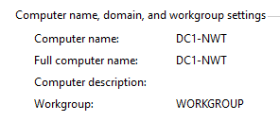

The next part was to deploy Active Directory to the server. It was added through the Server Manager dashboard by using the Add roles and feature option. The Active Directory was deployed to DC1-NWT with the default options.

Once complete the forest for the network was set up and names “nwtraders.msft”. DNS was enables along with the Global Catalog option. Once complete the server restarted and the machine was successfully configured as a domain controller and then it was verified that it was in the Domain Controllers container.
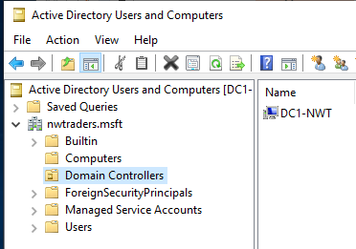
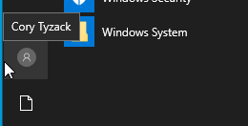

Next user accounts were created. The first account created was a domain admin account (NWT-CT). Creating this account allows the admin of the network to control and manage accounts and also to log into the server, this is the highest level privilege group. In the domain admins group there is two administrators now. This is done in case the Administrator account gets hacked or the password lost/changed.

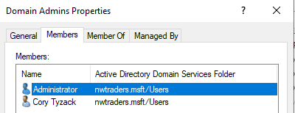

Another user (Dave Smith) was then set up as a standard user, this user will be using PC1 so that some attributes could be changed to run in line with the organisational opening times.
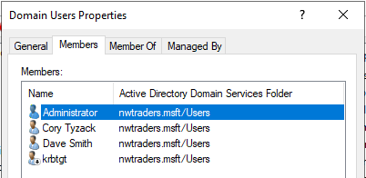

Object attributes help optimise the management of objects in an Active Directory. It is a way of enforcing network policy options and better controls on objects. In this case the logon hours were changed for the user. This was done in the properties of the user account. There was an amendment in the log on hours as they did not make sense in the scenario, they were set to 8am to 5pm Monday to Friday, Lunch breaks between 1pm and 2pm were also implemented, this was done this way to prevent unauthorised log ons outside of business hours. Another change made was restricting the change of the password of the user as this is usually a security measure enforced at Network Admin level.
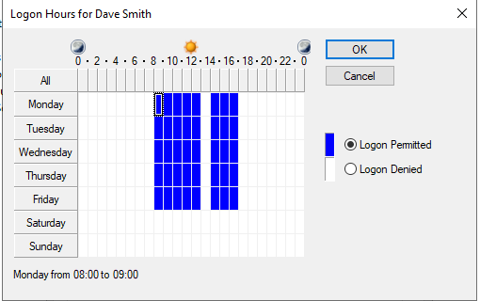
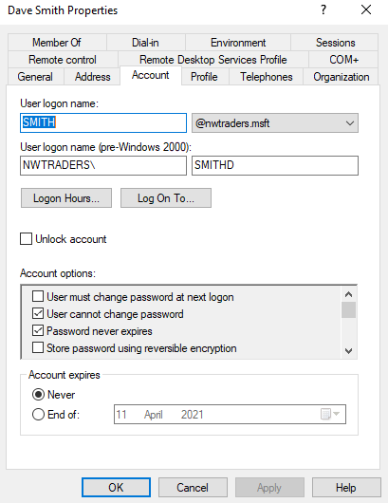

The last task in the completion of the Active Directory deployment is to add computers to the domain to allow the domain users to log in successfully. In this scenario the computer is added into the computer container of AD then the workstation is required to be domain joined on the actual workstation.
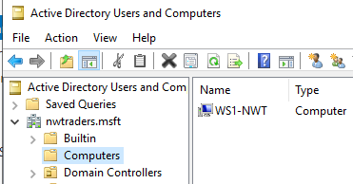

On the client machine the computer name is changed to WS1-NWT to match the name in the Active Directory Container group then the PC is restarted. The PC Name is now amended, in order for the workstation to connect to the DNS server running on Server 1 some IP configurations were made.

The preferred DNS server was set to 192.168.1.100 at the start but it was not contactable, changing this to 192.168.100.1 which is the DNS of the PrivateNet resolved the issue. Making this change allows the PC to contact the Domain controller so the computer can now be added to the domain.

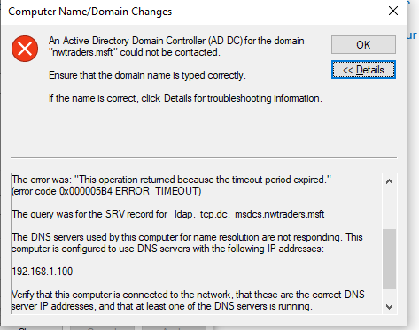

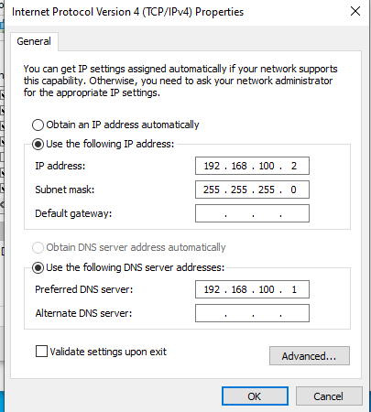

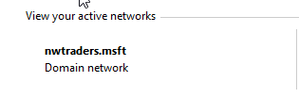

To test this has worked correctly the standard user account created tried logging into the machine, which was successful.

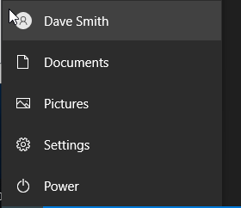

To complete the testing of the deployment the standard user account is tested against the server VM which isn’t an admin account so it shouldn’t be able to log in. This was also successful, the user is greeted with an unsuccessful log in message. This is put in place as an organisation would only want the network admins to have access to the server, it can be a dangerous place for a standard user if they change or delete settings which is a critical security risk



Part 2: Observational Task

DNS
The Domain Name System (DNS) is a directory of names that match with IP addresses, which computers use to communicate with each other. It matches human-readable domain names such as google.co.uk with its unique IP address 216.58.211.163. [2]

Domain names were invented to solve the problem of remembering IP addresses, it is much harder to remember Googles IP address than it is to remember the domain name. DNS translates the domain name into the IP and points the device in the right direction. A domain name and its matching IP is known as a “DNS record”.[2]

The image below shows steps from 1 to 5 on how using a domain name instead of an IP works.
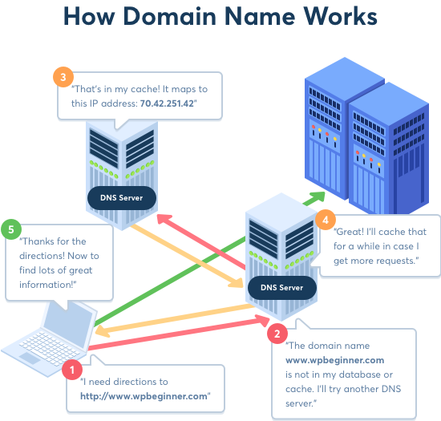
Figure 1. How a Domain Works[2]

DNS is a feature automatically installed when Active Directory forest and domain is installed on a Server. Active Directory uses DNS as its domain controller location mechanism. When any operations are performed such as authentication, updating, searching, computers use DNS to locate the AD domain controller.

The DNS Client service is included in all Windows operating systems installs on client and server. It can be used to resolve computer names to IPs and also queries the DNS server to discover domain controllers when TCP/IP network connections are configured[3]

Two critical roles of enterprise network

DHCP
Dynamic Host Configuration Protocol (DHCP) Server enables the organisation to centrally configure, manage, and provide temporary IP addresses and related information for client computers. It is used to automate the process of configuring devices on an IP network and allows them to use network services such as DNS. [4]

With a DHCP server dynamically assigning IP addresses and other network configuration parameters to each device on a network it allows the devices to communicate with other IP networks. [4]

Remote Desktop Services
Remote Desktop Services enables the business to access virtual desktops, session-based desktops, and RemoteApp programs. The current versions of RDS provide the ability to deploy an application or a full desktop to end users without having to install the application on the end users’ device. Using this method ensures there is no security or compatibility issues and essentially eliminates the need to manage the end users device and application.[5]

Importance of different levels of access/roles within the built in network user account groups (Domain Admins, DHCP Admins)
In any organisation employees particularly in the IT department have different responsibilities when it comes to accessing the network. Some may be responsible for supporting computers and servers, others may be responsible for creating and updating configuration items others may only require read only access. Using different levels of security in security groups allows the person to access what they need to corresponding to their role. [6]

Security groups are used to collect user accounts into manageable units. There are several in-built accounts and security groups which are preconfigured with the appropriate rights and permissions to perform specific tasks. They are an efficient way to assign access to resources on the network and by using them the business can delegate domain-wide administrative roles [7]

It saves the Domain administrators time as they will not have to set permissions for every user, they will be able to manage them effectively by adding them to the correct group. In the same respect the business would only want the right people to access the right resources. They would not want an end user to be able to make changes to the domain. They may get read only access to certain things but the business would not want them to make any accidental or intentional system-wide changes.[7]

All in all the main benefit of using these groups is control and manageability of users. Another benefit of using these groups is the ability to monitor and audit. The IT professionals can continuously monitor and audit to change or remove permissions where necessary to make sure nobody has more security access than they need. This also helps keep the domain secure as it reduces the chance of malicious activity. [8]

Share your ideas in-detail on Microsoft’s recommendations on AGDLP and AGUDLP for assigning permissions. How do you view them in a perspective of a system admin in strategizing and implementing within your network.
AGDLP is an abbreviation of Account, global, domain local and permission. It is the recommended procedure for implementing role-based access control within a Windows domain. Using this helps maintain access control and permissions to particular resources.

Using this makes it simpler to implement user and group authorisations through membership in the domain local group, assuming that the relevant groups for each resource exist permissions for groups can easily be changed and changes will affect every user inside the group rather than changing permissions on a per user basis which could take a long time. [9]

One disadvantage of using AGLDP is that a structure for the organisation must be created manually. This means it’s very intensive in terms of labour and expense and can be prone to human error. [9]

AGUDLP on the other hand is the multi domain version of AGDLP. The one difference between the two is a universal group being added to the nesting chain. In this version an organisation can use the universal groups to all role groups from other domains without much effort. [10]

In an big organisation that already has a structure in place this is a good way to manage different departments. The ability to add users to appropriate groups streamlines the set-up of accounts and makes the whole structure clearer to see if a user is unable to access a particular resource the IT administrators will be able to check which groups the account is in and amended as required. It can also be helpful in audits.

For a business that hasn’t got a structure set up, it may still be worth it in the long run as it helps keep accounts organised, although the expense may outweigh the business goals in some cases.

Summary
The task as a whole was successful, there was one minor issue that was documented and rectified in order for PC1 to join the domain. The Active Directory is correctly deployed and the user accounts were created correctly to allow the correct access as they would need to be in an organisation. This sort of feature is critical in an organisation to help manage and control users and computers, it ensures with the help of network admins that users have the correct permissions and cannot access resources they should not be able to. This enhances security.

References
[1]"Active Directory Definition", Techterms.com, 2017. [Online]. Available: https://techterms.com/definition/active_directory. [Accessed: 09- Mar- 2021].
[2]"What is DNS and How does DNS Work?", Wpbeginner.com. [Online]. Available: https://www.wpbeginner.com/glossary/dns/. [Accessed: 09- Mar- 2021].
[3]"Domain Name System (DNS)", Docs.microsoft.com, 2020. [Online]. Available: https://docs.microsoft.com/en-us/windows-server/networking/dns/dns-top. [Accessed: 12- Mar- 2021].
[4]"What is DHCP and why is it important? | EfficientIP", EfficientIP. [Online]. Available: https://www.efficientip.com/what-is-dhcp-and-why-is-it-important/. [Accessed: 09- Mar- 2021].
[5]R. Waggoner, "5 Benefits of Using Remote Desktop Services (RDS)", Blog.mycloudit.com. [Online]. Available: https://blog.mycloudit.com/5-benefits-of-using-remote-desktop-services. [Accessed: 09- Mar- 2021].
[6]"Manage user roles", Docs.microsoft.com. [Online]. Available: https://docs.microsoft.com/en-us/system-center/scsm/user-roles?view=sc-sm-2019. [Accessed: 09- Mar- 2021].
[7]"Active Directory Security Groups (Windows 10) - Microsoft 365 Security", Docs.microsoft.com. [Online]. Available: https://docs.microsoft.com/en-us/windows/security/identity-protection/access-control/active-directory-security-groups. [Accessed: 10- Mar- 2021].
[8]"Top 6 Active Directory Security Groups Best Practices - DNSstuff", Software Reviews, Opinions, and Tips - DNSstuff, 2019. [Online]. Available: https://www.dnsstuff.com/active-directory-security-groups. [Accessed: 10- Mar- 2021].
[9]"AGDLP | tenfold", tenfold Security. [Online]. Available: https://www.tenfold-security.com/en/wiki/agdlp/. [Accessed: 12- Mar- 2021].
[10]A. Bertram, "Active Directory nesting groups strategy and implementation", SearchWindowsServer, 2020. [Online]. Available: https://searchwindowsserver.techtarget.com/tip/Active-Directory-nesting-groups-strategy-and-implementation. [Accessed: 11- Mar- 2021].

