WORKPLACE CULTURE AND ITS IMPACT ON
ORGANISATIONAL EFFICIENCY
Student id: 1713914
Student name: Gherga Blaj Elisabeta Ionica
Lecturer name: Hussam Helmi
Module code: BMSW5005_LON

Table of Contents
Introduction 1
Case Study 2
External Environment Analysis 3
Internal Environment Analysis 6
Stakeholder Analysis 8
Culture and Ethics 9
Recommendations 13
Conclusion 14
Reference 15

Introduction
Organizational Culture and workplace ethics are a very important aspect in every business organization and operation. The business organizations are developed and maintained surrounding these aspects and the organizational values are developed accordingly. The leadership style an organization follows is also an important aspect to consider in this regard as the employee satisfaction and the employee involvement is also ensured by that (Blessinger and Hrycaj, 2013). This assessment will discuss about the corporate culture, leadership and ethics of Apple, the corporate analysis of Apple through internal and external environment analysis, stakeholder analysis and finally the recommendations will be provided according to the discussions and the findings of the assessment. The company selected in this regard for the assessment is Apple Inc. Apple in the present is one of the greatest if not the greatest association culture change pattern ace, in a previous couple of years apple as being in its light thoroughly see virtuoso methods for completing things in an alternate way. Apples corporate culture is always showing signs of change because of changes to its authority/CEO now and again. To pick up a top to bottom comprehension of this we should stay into apple chronicled foundation, its upsides and downsides, and the likelihood of future administration. In this manner, the exact inquiry would be what the way of life of Apple is.

Case Study
Apple is one of the mostly renowned companies in the world with the reputation of most famous of the most famous brand as well. It serves a large customer base by providing hardware, software and networking related solutions mainly. The company has significantly expanded its business operations in North and south America, European countries, China, and a most of the Asian countries as well. With a very rich portfolio, some of the products which define the organization’s brands are iPhone, Mac, iPod, iPad etc. and also a lot of software products like iOS, watchOS. Apple also provide software-based services through iTunes and Apple store, cloud-based service with iCloud as well. By the change of time the mission statement of Apple has formed up a several times and taken a fully different form from the beginning (O'Grady, 2019). Apple is a company which has always been dynamic and adapted according to the change of market preferences and customer’s choices. In the mission statement of the company this change is defined through the rich and necessary portfolio of products to the customers. Apple provides an overall soothing technology experience and the main mission of Apple is keep doing so by being dynamic and adapting towards the changes and key preferences of the customers as well. Apple promises to provide an all-round best customer experience through the combination of innovative and world-class hardware and software. Apple’s vision statement is much more related to the company’s core values and ethics. The company promises to make a valuable contribution in the lives of the users by adding significant value. Apple promises to continuously improve product’s user experiences and services provided by innovation and dedication. Established in 1976 by Steve Jobs and Steve Wozniak, Apple now comprises of more than 100 thousand employees in more than 24 countries. Apple always fosters creativity and innovation in every aspect. Apple is one of the largest companies in the world, despite having so many employees Apple believes in democratic style of leadership. It gives value to the decision-making ability of the employees and takes the valuable comments in to consideration in every aspect of decision making. Apple maintain a certain organizational culture of secrecy (Scott, 2018). For which not many information breaches out of the company which gives the company a competitive advantage. Apple believes in its own culture and believes that the culture is top notch. The employees also tend to believe this which makes it an amazing working environment in Apple for the employees

External Environment Analysis
For the external environment analysis of Apple, the help of PESTLE analysis framework is taken. PESTLE defines the initials of the first letters of each of the elements of the external environment which are – Political, Economic, Social, Technological, Legal and Environmental elements which overall define every single business entity’s external business environment and the environment shapes many activities and forms of the business. This analysis for apple is conducted below to understand the external environment in a systematic and better way.
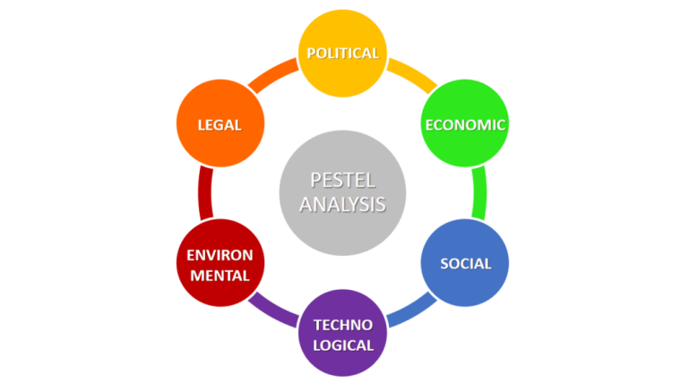
Figure: PESTEL Analysis
Source: (Baron, 2010)
Political Factors: Political factors of any business entity includes the government patronization and interference in a certain field of business, legal policies, tax policies, foreign trade policies etc. It can also include the government and political stability of a certain region and the factors like corruption, education system, infrastructure etc. Apple is also affected by these political factors in every region it conducts business in. The dispute between US and China can have a bitter impact on the operations of Apple as raw materials and production of products are conducted in China (Blessinger and Hrycaj, 2013). As there is political unrest going on between two countries, it may have an adverse impact on the company. Again, due to the legal and taxation policies in the US, Apple has to face a lot of tax issues which hinders the general operation of the company. In 2015 Apple had to pay a lot of amount for cash which is due to the adverse political affect in the US. Recent dispute on Huawei issue has initiated a hatred on Apple products in China which is completely a political dispute among the two countries.
Economic Factors: Economy is one of the main elements of external environment as one has to survive in the business world having to be in the economic conditions and design plans and activities accordingly. Economic factors include inflation, exchange rates of a country, the expending and purchasing abilities of the consumer and business opportunity and growth as well. In Apple, it has to abide by the economic conditions and the situations ongoing in a certain country or a region. Thus, it is affected by the economic decisions and situations as well. For example, the labour costs in China are relatively low and Apple can conduct business by providing the products from China (Scott, 2018). But if the costs raised higher, Apple would either have to redesign the revenue model or look for alternative cheaper production faculties in order to continue production and business activities.
Social Factors: Social factors are depended on the country or regions demographics. It is mainly concentrated around the culture, the lifestyle, population growth rate, age, income of people etc. This can also include language, consciousness and awareness of the people on certain topics etc. Also, the local labour force falls under the social factor as well and their willingness to serve in a certain industry. Apple serves high end products to the customers which is often luxury than daily necessity. Thus, people below the desired income range cannot afford to purchase and use Apple products, which can create a sense of discrimination and decrease apple products sales as well. Again, culturally the people of a certain region have to accept the product and believe that it’s the product of their culture. Whereas Apple has production facilities in China which might not be appreciated by some people from US. This can also impact the business of Apple.
Technological Factors: Being a technology-based company, this is the most important external environmental element for Apple. This element includes the technological advancement and acceptance of a certain region, the use of technology in day to day life as well as production and other activities, also the technological awareness of the common mass is also involved in the process as well (Waddington, Badger and Bull, 2016). The technological market is expanding and Apple has more competitors than ever before. Now there are many companies which have more value for money than apple which are for technological innovation and growth. This affects the business of Apple and forces them to conduct more innovative technological changes in the products to provide more value to the customers.
Legal Factors: Legal factors are related to the country’s law and legislations such as the discrimination law, equality law, employment law, legal resections in terms of business and commerce activities etc. These are very important because a business can face serious consequences if it conducts any breach in any of the legislations stated in the law books and can also face extermination. Apple faces problems in doing business in some Asian countries due to not acceptance of Apple pay, the payment service of Apple (Blessinger and Hrycaj, 2013). Again, the intellectual property that Apple conducts business in is highly risky and there can be a lot of legal and copyright restrictions which has to be maintained and followed very carefully.
Environmental Factors: Environmental factors include the natural environment of the certain country or region. It shapes up the natural resources available in a certain region, how appropriate it is to conduct business in a certain country in terms of natural conditions etc. The greenhouse effect is a serious environmental concern now a days which also affect the production of Apple. Apple production houses can emit a lot of harmful gases which ultimately contribute to the greenhouse effect. Apple has been investing money to stop this emission and gain more reputation from the environmental sector which it has been successful to do so in the past years.

Internal Environment Analysis
After conducting the discussion on the external environment, the internal environment analysis will be conducted of Apple. This will bring light upon the inside of the Apple Inc. and how it is stronger than other companies and also what might be the possible weaknesses and threats of the organization. To conduct this analysis, the help of SWOT analysis will be taken. SWOT depicts the Strength, Weakness, Opportunities and Threats of a certain organization which depict the total inner environment of the workplace. It indicates what the organization can capitalize on and what it should be careful about as well.
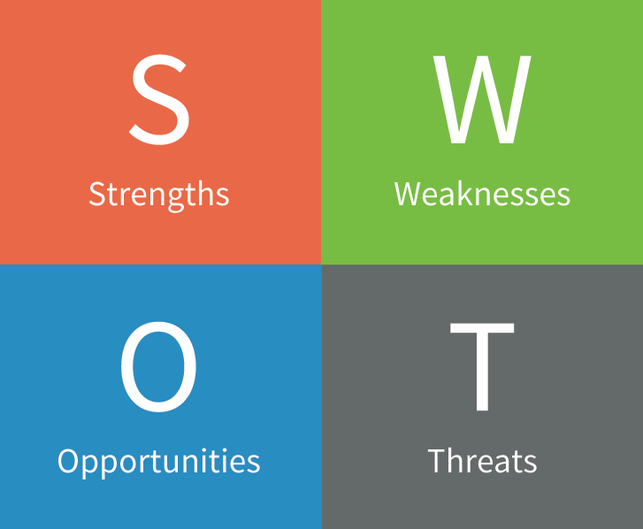
Figure: SWOT analysis
Source: (Devlin et al., 2016)
Strength: Strength defines the most important aspect that an organization has which gives it the competitive advantage over its competitors. It can also be the Unique Selling Proposition or the USP of an organization as well. Apple can be stated as the market leader for the technological products and services it provides. Specially in the smartphone and laptop market. This company gained 700 billion dollars in 2014 in term of revenue which defines the success of this company. Another core strength of Apple is its innovative capability and brand value. People are fond of the exclusive design and technology that are visible in every product in the Apple product line.
Weakness: Weakness is the matters of concern of the organization or company. It shows the area of improvement which a company has in terms of the operations and management. Apple has some weaknesses as well which it needs to be careful about. In the market of technology, Apple faces a lot of legislations as well as copyright related regulations from the competitors (O'Grady, 2019). Apple products are also inclusive meaning that they have lesser compatibility with other technological devices. This can create issue for the company to lose market share.
Opportunities: Opportunities are the external factors of an organization which it can capitalize upon. Such as the changes that are occurring affecting the organization’s operations and business policy. Also, the trends that are constantly being formed up surrounding the organization etc. Apple is looking forward to expand in the automobile market from the technology sector which can be a new era for the organization to operate in. Apple has many products in the lines which are not that much popular but have the potential to serve the customers more significantly such as Apple watch, Apple TV etc.
Threats: There are always some external factors from the competitors and other parties related with the business organizations which possess certain hindrances from which the organization has to be careful about. Apple is facing a tough competition from competitors and also lower end price category devices which offer more value for money than Apple. Then again, Apple’s success is defined on the success of a few products rather the competitors have a huge product depth and breadth (Blessinger and Hrycaj, 2013). This can cause a possible threat to Apple if it loses market share in the tech industry.

Stakeholder Analysis
Stakeholders are the entities which are involved in the overall process of business operation of a certain organization directly or indirectly. In easy words the term defines to the people who have a stake in the organization. It is not only the owner or the shareholders of the organization rather the customers, employees, regulatory bodies and even competitors fall under the category (Kelly, 2016). The organization affects these stakeholders thus it has to keep them in mind while operation in the business. The stakeholder analysis is thus conducted in order to identify the stakeholders of an organization and finding out how the stakeholders can be dealt with tactfully. Apple has thus many of the stake holders who have a significant impact on the company’s operations and activities. These stakeholders are:
Consumers or Customers: This is the most important stakeholder for Apple as they are the primary source of revenue for Apple. Apple has to take the consumers are the number one in the priority list of Apples. Thus, the products and services provided by Apple are developed and designed keeping in mind the needs and wants of the customers and also to satisfy the growing demands Apple’s theme is continuous improvement through innovation. Although the higher price points of Apple is still a matter of concern for the customers, the services provided by Apple can be made up to the price point. The CSR activities that Apple conducts also keep a good impression in the minds of the consumers about the products and the services.
Investors: Investors or shareholders are mainly the owners of the company. Apple is a profit-making organization and at the end of the day it has to provide profit and benefit to the investors as well otherwise the investors will not be able to earn the investments and therefore fall out of business (Johri, 2010). The financial management and reporting thus has to be proper in order to keep the investors updated and informed about the ins and outs of the company and also the organization has to conduct business activities properly in order to maintain the revenue model as well.
Employees: Employees are one of the core concerns of any organization. Employees are the ones who actually operate and manage the resources to develop the business activities and earn revenue. Thus, Apple gives special consideration to the employees of the company and the employees are also involved in the process of learning as well as innovation. Employees are also given priority in terms of decision making in the company as well.

Culture and Ethics
Leadership Style
Apple is one of the leading brands as well as company in terms of technology and software service. It has been possible for the creative mind of Steve Jobs and Steve Wozniak who were prompt to identify the lacking in the technology market and used innovation and diversity as the main tool for success in this field. Apple Inc. believes in innovation at its best. Apple has been maintaining secrecy in the operation and which has produced the amazing results for Apple. Apple has and had in the past, some of the world’s renowned leaders like Steve Jobs whose unique leadership abilities defined the total organization and brought upon its success as well. Steve Jobs leadership style was like the more of a Autocratic style but with a great sense of business and management (Scott, 2018). There are many forms of leadership styles and the Autocratic Style is one of the. It is mostly the basic style of leadership where leaders decide every process of the organization. Leaders do not tend to involve employees in the decision-making process and the leader’s decisions are followed by the employees. Steve Jobs was this kind of autocratic leader but with a situational mindset. Steve Jobs had a clear vision about what he wanted to achieve, what are the values to be provided to the customer and have no compromises in the values provided what so ever. In this regard, he alone used to take the decision and others would implement them. The leadership value followed by Steve cannot be implemented by everyone. The autocratic style of leadership is said to be mostly effective in military perspectives and not appropriate in corporate or organizational teams. Because, here the leaders need to take the employees in to consideration and develop understanding and a good relationship with the employees.
However, if a leader has a clear vision of what he or she wants to achieve and how to achieve that than this style of leadership can be most fruitful. As Steve Jobs was one of the most visionary leaders of all time, he had the idea of what he was doing in the field and he also had clear knowledge about the facts and all the ins and outs of his business. Thus, he never hesitated in making any decision and took decisions based on own observation, experience and the vision. For these reasons, the employees were not that much involved in the decision-making process, rather mostly followed the order of Steve which actually resulted very much beneficial for the company as well (Gupta, 2017). This leadership style has some adverse effect as well. When an employee’s decision is not given priority, he or she might feel demotivated and even leave the organization due to workplace dissatisfaction. Steve had the possession over the employees but did not discourage innovation and creativity whatsoever. This is another success point in his leadership style that the employees were very much allowed to be creative in the task and bring out creative solutions as well (Waddington, Badger and Bull, 2016). This made him one of the best leaders in the history and formed the greatest company of all time as well.
Theoretically, the leadership style of Jobs can be named as autocratic leader but in reality, his leadership style was situational and very calculated. But this affected the relationship between the leader and the employees and the leaders could not develop the employees as a proper themselves in the organizational process as well.
Organizational Culture
The organizational culture of Apple Inc. can be described using the Edgar Schein model of organizational culture. Born in 1928, Edgar was a professor in MIT who has several experiences in the field of managing and business. He developed a model consisting of three components which can define the organizational culture and the whole organization’s perceived value as well.
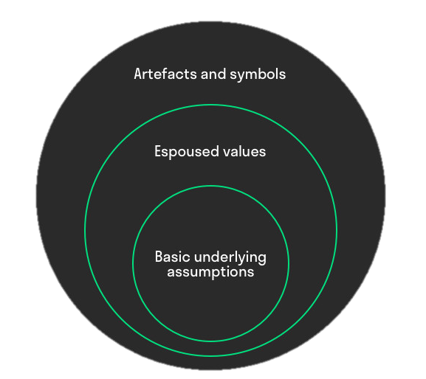
Figure: Edgar Organizational Culture Model
Source: (Devlin et al., 2016)
These three components define the organization’s operations and policies. The Artefacts and Symbols are the basic visible marks of the organization. Like the logo of the organization, strategies, products, promotional activities, employees, clothing materials and also the processes and structures of the organization fall under this category. The logo of Apple and the brand equity carries this aspect of the organizational culture and the leadership styles of the top management also shapes up this Artefacts. These are the clear facts that are visible to the stakeholders and these are very important in shaping up the further organizational culture as well.
The second stage in the organizational culture model is the exposed values which are the values rules and code of conduct set up by the management of the company and objectives and philosophies too developed by the top management (Baron, 2010). Apple has built up these values and practices of theories and there is certain code of conducts for the employees in the company. Each individual employee falls under this process and codes and everyone has to keep in mind and also abide by these rules to uphold the organizational structure and process.
The last and the core part of the organizational culture is the concepts of the employees and the people working in the organization. It is the core part and there is less force of the organization on this aspect rather this is the perceived idea of the employees about the organization itself. Apple employees individually shape up some ideas and thoughts about the organization which are according to their own external and internal environment as well as culture, values and perceptions. The organizational cannot affect this however the organization can change this through behaviour and the help towards the employees.
Ethics
Organizational ethics is very important for the growth and prosperity. Ethics need to be defined by the organization clearly and maintained properly by the management of the organization in order to develop a proper sense of development in this scenario. Apple has always been maintaining a strict corporate ethics to promote solidarity and equality among the customers and also to provide the best services to the customers as well. Bu their haze bean some allegations against Apple in terms of production and pollution in the production plants. Apple has been using much harmful materials in production without proper caution and decomposing method thus contributed to environmental pollution as well (Blessinger and Hrycaj, 2013). These aspects fall under ethics and Apple has been prompt to deal with these facts. Apple has provided training to the facilities in China and lessen the amount of pollution and emission. Also, there were some corporate ethical misconduct against Apple in 2016 due to the avoiding of Tax payments. This is not expected from one of the major and the top most companies in the world and thus Apple has tried to properly maintain the corporate ethics as well.

Recommendations
After the discussion on the total scenario of Apple some recommendations can be suggested in terms of the development and the improvement of the company. At first, the attention has to be drawn in to the short and concise product line of Apple. Apple has only been production technological products of which some of are no longer even in the market. The market of technology is highly changing and there is a huge risk factor in this scenario. Thus, Apple can expand its business operations in other sectors. Apple is already looking to expand in the Automobile sector which is promising because the organization has also addressed the expansion of the market and hopefully the brand value of Apple can be maintained in the field as well.
There are some issues regarding the team management and leadership styles of Apple (Carlberg., 2014). Although being one of the largest companies in the world, Apple provides lesser job satisfaction to the employees due to lack of job satisfaction and the not participation in proper aspects of decision making of the employees the employees should be properly handled and the relationship between the leaders and the employees should also be strengthened to develop a good and satisfactory working environment for the employees as well.
The ethical issues in Apple should be dealt in more organized way. The ethical misconducts should not be allowed to continue and to maintain the proper reputation in the market, Apple should develop a very good monitoring and evaluation process in this regard. This will help the company to maintain a proper relation with the company as well as develop in a proper manner as a organization as a whole.

Conclusion
As the conclusion of the report, it can be deduced that that Apple Inc. is one of the most important company with innovation on the planet. At the point when Apple presented and propelled its very own item, for example, iPhone, iPad, iPod, iMac, etc, it's certainly give an astonishing impact to their clients. It is all around clearly that Steve Jobs are confronting the test from the other contender whereby their core rivals are from the Samsung, Sony and Nokia. However, Apple Inc. some of the time have done some misstep on it. The duty of the top management will be do develop more recommendations as well as according to the recommendations provide in this assessment and also develop a very good workplace for employees and a great company in the minds of the customers as well.

Reference
Baron, D. (2010). Business and its environment. Upper Saddle River (N.J.): Prentice Hall.
Blessinger, K. and Hrycaj, P. (2013). Workplace culture in academic libraries. Oxford: Chandos Publishing.
Carlberg. (2014). Business Analysis. Pearson India.
Devlin, E., Emerson, C., Jr, L. and Desman, M. (2016). Business Resumption Planning. Hoboken: Taylor & Francis Ltd.
Gupta, P. (2017). Six Sigma Busines Scorecard. Blacklick, USA: McGraw-Hill Professional Publishing.
Johri, A. (2010). Business analysis. Mumbai [India]: Himalaya Pub. House.
Kelly (2016). Business environment. Amsterdam: Elsevier/Pergamon Flexible Learning.
O'Grady, J. (2019). Apple Inc.. Westport, Conn.: Greenwood Press.
Scott, M. (2018). Apple, inc. Westport: Greenwood.
Waddington, P., Badger, D. and Bull, R. (2016). The violent workplace. Cullompton, UK: Willan.

