Student Name | Jose M. Lopete
Student Number | 1808701
Lecturer Name | Rexon Nting
Module Title | Managing Enterprise in The 21st Century
Module Code | BMSK4006

INTRODUCTION
In this report we will be explain my experience during Term1 module assignment, consisting in team work and design a Business Plan. The aim of this report is to highlight the importance of analytical writing skill as well as understand the necessary of team work skill and presentation skills with PowerPoint.
Basically, I will be describing all the experience through a reflective writing, aditionally I will be mention all the proses from went we form the group work until we handed the task to the lecture. moreover I will be using the five concept of stages of team working performans; Forming, Storming, Norming, performing and transforming (Tuckman B. 1965)
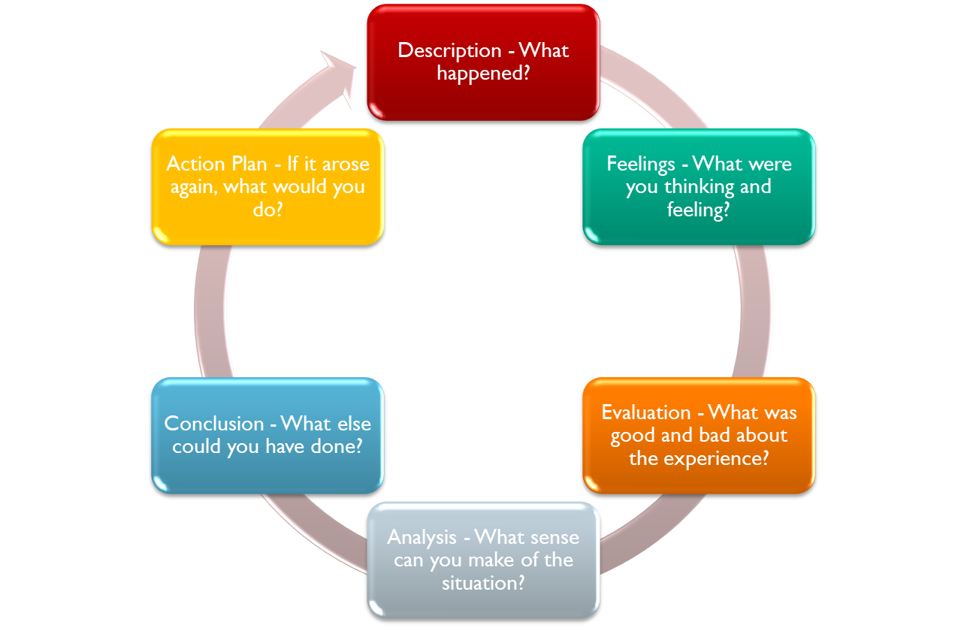

although we were facing the issue of build a team working, I implement few skills and learned some stuff that I will explain in the present report overall in order to explain my experience I will use few teams working concept in order to explain all proses occur in the team work task. furthermore, in order to explain the event experience and feeling and find answered to what, why, who, how to set the events I will be using reflection in action writing methodology

MAIN BODY
In term one module, Managing Enterprise in 21st Century in order to pass the module the lecture give us a task consisted in created a team of four or five member and designing and planning a business plan, additionally, after form a team work and writing a business plan in power point format the next thing is to make a twenty minute presentation into a classroom in front of the classmates and any team member should have 5 minute of presentation.
Clearly, from the begging we assumed that the expectation and aim of Term 1 module assignment involve the necessary of learning and put in practice your abilities working in group team like; communication, presentation, team working, problem solving as well as leadership.
In order to share this experience through a reflective writing methology I will be mention two concepts in term of team working design, in one hand, the group group development theory………Tuckman……Belbin and in the other hand different rule of in team member…...

First Stage
At the beginning “Forming” we focus on configurate the team group however this were bit confused because most of my classmates was unknow and did not know with who I should face the challenger of built a group of people whom willing to start this journey with me. Katzenbach & Smith (1993) suggested that “a team is a small number of people with complementary skills who are committed to a common purpose, performance goal, and approach for which they hold themselves”.

basically, my first though was to start with my close mate the one who seating close to my thus we were fried already and we had been shared few common though in the past. The next, were to check for more people to join us like I mention above, we need to form group of fourth or five members. I suggested my classmate to find someone not necessary somebody with team design skills but can also bring confidence and experience in design and written a business plan so, we approach our next team members whom were people bit mature and we though they will help hugely in term created the future business.
Basically/thus, the first stage is the categorize with a high level of relaxation and socialization, it was the kick-off day, the green light for the work project, establishes initial behaviours for performance, is went we meet and get to know who is who and share past experience working in group of people, is went we created the communication platform to aloud us get in touch like whatsappgroup, Facebook and email address. although, despite members still feel that the deadline for the project is far in the future, I encourage all members regarding time running out and focus on task deadline, so, we set the rota for the weeks ahead until the completion day.
Second Stage
Week two, ,known as “storming” the group of four members has been formed and the level of activity is little high, the week start little more dynamic in sense of problems are confronted between members, criticisms about the task or group start to be taken seriously. Additionally, we set our goal and our business plan concept. “group members become hostile toward one another and toward a therapist or trainer as a means of expressing their individual and resisting the formation of group structure”(Tuckman, B., 1965) different behaviour emerges and they start undermine and complaining each other, at this point we begin assembling team members duty and we decide how our business plan will be focus in term of name and different sections as well as presentation through power point format.
Personally, in this second stage I start digging and as the result of that we discovered what is presentation skill in term of communication, body language, PowerPoint presentation format. Hence, we learned how to deal with different behaviour in group task, as well as what is business plan in term of all sections involves in this matter like why we need to write a business plan before pursuing any idea, the purpose of writing a document describing your business idea.
Third Stage
Week tree and four, know as norming, in this phase I found members behaviour a bit positive, we begin understanding the group`s norms in a sense of starting work together and taking things more serious. Graham, B. (2003) by citing Tuckman he points out that, any group development theories has some type of norming phase, also he adds that norming stage is very important because it make members of the group`s performance release themselves and accept new behaviour within the team. Additionally, we discover that group with different background like gender, age, personality and value benefit the team as a whole and help individual member to interact with the group.
Personally, in this phase I learned some key employability skills like conflict management, negotiation, listening and work under pressure. Citation CV

Fourth Stage
Week four, entitle as performing it’s the most productive stage. In comparation with all stages above I will say in this phase we were in our honey moon. We feel like the team has all skills, talent and resource needed to accomplish any challenge. So, all team members were thinking about task deadline surprisingly, we increase the level of productivity in order to accomplish our goals.
Moreover, we understand that working together as a whole not only will benefit our group assignment overall will open the door for both employability and personal ability. (Clarke, A., 1997) point out that even in high special job position employers give more value to both core skills and generic ability rather than highly technical skill and knowledge.

Fifth Stage
Week fifth, know as transforming. At this phase there is no rust for closure as the job as been done. The next step will be the presentation day in front of all class mate.
Nowsday is important to have all the employability skills mentioned above as will help hugely in term of job experience. According to York, M. (2006) “set of achievement that make graduate more likely to gain employment and be useful in their chosen occupations, which benefits themselves, the workforce, the community and the economy. In this stage every team member recognises their abilities example, we find out who was the team leader or project manager, we notice who was god with communications skill and god with problem solving.

Conclusion
This project I feel like I highlight my habilities as well as improve some skills that I did not have enough confidents.
Team work its essential ability or skill to any graduate in a sense of work in an organization.

REFERENCE LIST
Clarke, A. (1997). `Survey on Employability`. Industrial and Commercial Training. 26(6), pp.177-183.
Graham, C. R. (2003). `A Model of Norm Development for Computer-Mediated Teamwork`. Small Group Research, 34(3), pp.322-352.
Morgan, P. (2016). The Business Student`s Guide to Study and Employability. Sage Publications.
Tuckman, B. W. (1965). `Development Sequence in Small Group`. Psychological Bulletin, 63(6), pp.384-399.
Katzenbach, JR. & Smith, DK. (1993). The Wisdom of Teams: Creating the High-Performance Organization, Harper Business, New York. pp-54.
Yorke, M. (2006). Employability in Higher Education: What it is what it is not. York: Higher Education Academy.

