Digital Skills Research Methods

Table of Contents
Introduction 1
1. Literature review 2
2. Methodology 4
3. Data analysis and results 5
Conclusion 9
Reference 10
Appendix 11

Figure 1: Percentage of learners benefitting from VLE 5
Figure 2: Most convenient aspect of VLE 5
Figure 3: Experience using VLE 6
Figure 4: Student engagement in VLEs 6
Figure 5: Impact of the shift to VLE 7

Introduction
Online education has become highly mainstream following the recent Covid-19 pandemic, as physical classes were halted and social distancing guidelines were introduced. In this case, learners have been required to use online learning tools and platforms, with VLEs being most commonly used (World Economic Forum, 2021). However, the concepts of online education and VLEs date back to many years prior, as many studeis have been conducted regarding the effectiveness of online education as a whole. With the rapid growth of technology, digitalisation of education can certainly be deemed inevitable. Concerning VLEs, there seem to be mixed opinions on the use of such digital tool as part of education (Hawkins, 2019). This report aims to analyse responses, primarily from the students of UWTSD, and form a conclusion as to how students perceive VLEs. Information will be derived from collected data using statistical graphs. Secondary data from existing literature will also help form a strong basis for conducting this research.

1. Literature review
A virtual learning environment or VLE can be defined as online arrangements created to aid teaching and learning practices (Webster, 2015). Typically, a wide range of digital tools and software are used as part of a VLE. Here, similar to traditional education conducted in physical classrooms, assessment tools, teaching and learning resources are available. Learners can access the learning resources and assessment tests from any location, generally with password protected IDs (Mroz, 2014). The use of VLE has become quite relevant during the recent pandemic, as educational institutions were forced to remain closed. Therefore, while the concept of VLE was previously established, the use of VLE has become highly mainstream during the Covid-19 pandemic. In this case, many reseaches and studies conducted on learners, as well as educators, from different educational institutions reveal the effect of the shift to online education as a whole, and the effectiveness of online learning. For the most part, both positive and negative aspects have been discovered (Miller Juvé et al., 2020). The positive effects of VLE pertain mostly to tech savvy teachers and students. In this case, leaners and teachers who are unfamiliar with technology have faced challenges in effectively using VLE platforms. However, for learners that have been able to use such platforms, sample responses convey that VLEs are highly meaningful. Again, a study conducted in 1996 reveals that students tend to perform well when technology is incorporated as part of education (Nahai and Kenkel, 2020). Students who may generally feel uncomfortable in communicating their issues in a certain subject topic may prefer online methods of communication with teachers. In general, the use of VLE’s largely enable students to incorproate the approach of self-reflection into their studies. This provides the opportunity to reflect on their learning capabilities, progress and needs, which is quite beneficial in improving academic performance (Thomas, 2013). In other words, learners themselves can take initiatives to academically perform well and increase the scoper of learning. Another key benefit to VLE’s is that learners can access learning materials and resources at any time. Not to mention, online education as a whole, expose learners to a wide range of learning resources that are available on the internet. This can also encourage independent learning and thinking in part of students. The most prominent argument against the use of VLEs pertain to the lack of student engagement that can usually be achieved in offline education (CNBC, 2021). Students who are unfamiliar with the concept of online education may feel less engaged in online classroom activities. In this context, people have argued that VLEs encourages an institution-led approach to education, rather than a teacher-led approach that is necessary. This can be attributed to the core reason of less student engagement as part of online education.

2. Methodology
This study uses both primary and secondary data to form a complete understanding as to the effectiveness on online education and the impact it has on students. In terms of the method used for the study, quantitative method has been used. Following this method allows for using the available as well as collected data to form an inference about the entire population (Vogt, 2011). For this study, the population would be all learners of the University of Wales Trinity Saint David London Campus. Due to the large number of students in the institution, only a handful of respondents have been used as the representative sample for the study. The sample consists of 23 students who were randomly selected from different academic backgrounds. Here, primary data collection process pertains to the use of a questionnaire consisting of 20 questions. These questions are aimed at assessing learners’ motivation level during online learning and the level to which learners have benefitted from online classes and lectures. Due to the current circumstances created by the pandemic, the questionnaire has been distributed through online platforms. In this case, the use of online tools has allowed the researcher to record and summarise the responses from all respondents. The data collected has been provided in the appendix section of the report, along with the questionnaire that has been used.
A key aspect of the data collection process relates to maintaining ethics. In this case, the respondents were provided with the option to opt out from filling the questionnaire should they desire to do so. Again, the questionnaire, in its entirety, excludes any questions that might require personal information of the respondents. This allowed the researcher to maintain the confidentiality of each respondent, while assuring the respondents that their responses would not cause any problems academically and that they could maintaing the highest level of honesty in answering each question.

3. Data analysis and results
The collection of data is followed by the process of proper and comprehensive analysis of the data to create comprehensible information. In this case, the responses for specific questions have been summarised into pie charts. The use of pie charts allows for easy interpretation of the responses from the students from UWTSD.
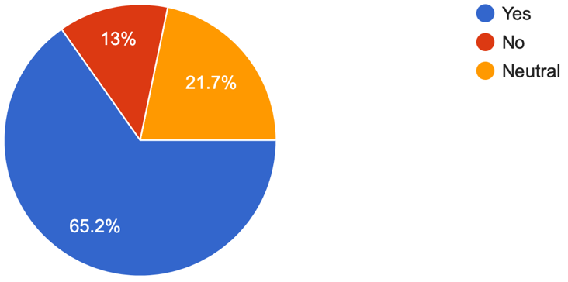
Figure 1: Percentage of learners benefitting from VLE
Similar to what secondary data suggests, the primary data collected for this study also suggests a variety of perceptions concerning VLE. Among the respondents, however, a majority have stated that they have benefitted from the use of the VLE provied by UWTSD. From the pie chart, this percentage is shown to be about 65.2%, with 13% stating that they have not found the VLE to be useful. Again, the respondents have described several aspects of the institution’s VLE that they have found to be most convenient. These mostly include accessing and sharing resources, maintaining communication with teachers, receiving important academic announcements, and submitting assignments.
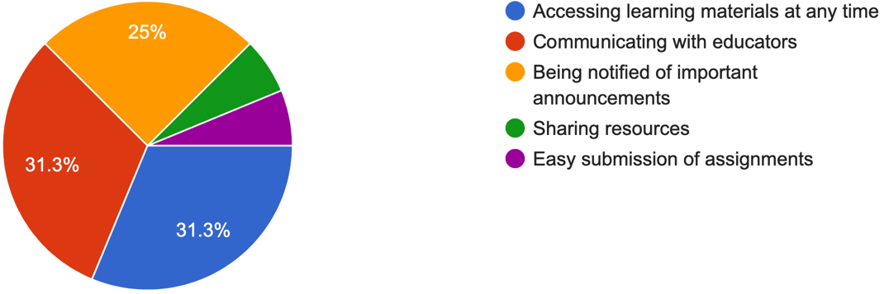
Figure 2: Most convenient aspect of VLE
Pertaining to the question of experience using the institutional VLE, about 60% of the respondents have had a positive experience, with about 10% having a negative experience. In this case, previous inexperience in addition to a lack of prior training can be considered as the underlying reasons. Again, there have been a few cases of technical difficulties faced by students, which has also hindered the overall experience in using the VLE.
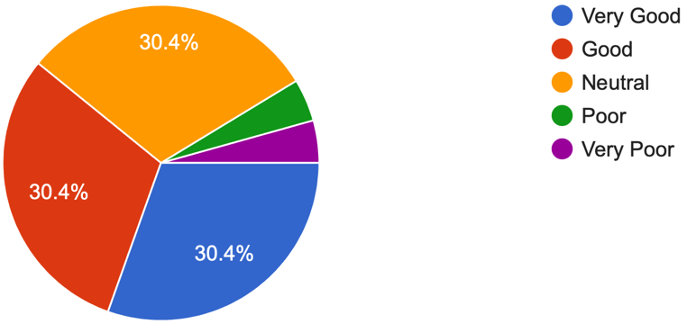
Figure 3: Experience using VLE

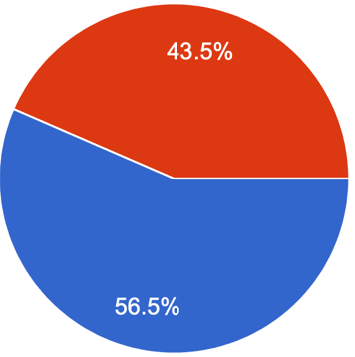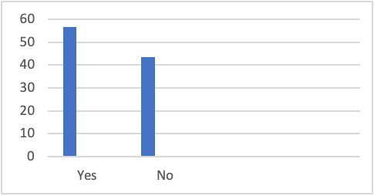
Figure 4: Student engagement in VLEs
The data analysis process has prioritised the questions and subsequent responses that are most relevant to the study and those that can be summarised using graphical representations. The overall responses from respondents state a positive impact of the VLE on student learning, despite many students facing some issues initially in using the platform. However, many students have conveyed that they prefer a combination of both the VLE and offline classes as part of their education. This response can be attributed to the factor that many students do not feel as engaged in the learning process while using VLE, in comparison to attending physical classes and lectures. This concern is quite widely expressed in secondary data sources and literature as well. Student engagement and motivation is, therefore, an aspect to be focued on in improving the institution’s VLE.
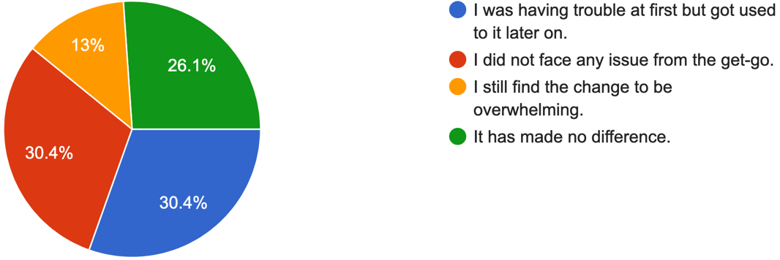
Figure 5: Impact of the shift to VLE
Concerning this study, the impact of the recent and abrupt shift to VLE must be closely considered. From the responses of different students of the institution, many students were unfamiliar with VLEs in general prior to the pandemic. Many students were provided no training as to how to navigate through the institution’s VLE, contributing to initial difficulties for some students. Here, about 30.4% students did face difficulties initially, with 30.4% students facing no difficulties at all. 13% of the respondents still face issues in using the VLE, conveying the need for proper and generalised training for all the students of the institution. As mentioned, difficulties and issues faced by students can harm the experience in using VLEs, ultimately taking away from the learning experience. Meaning, despite the range of benefits that the VLE can provide, it is of paramount importance that educators take initiatives to familiarise all learners with the concept of VLE and how to effectively use it as part of education. Regardless, for the most part, students have found the availability and use of VLE to be quite convenient during the recent circumstances caused by the Covid-19 pandemic.
In terms of the benefits of VLE, several aspects have been identified and confirmed, following the primary data collection process. Given the availability of different resources, the use of VLE has enabled students to be more efficient in the learning process. Also, learners can share different materials with their classmates, allowing a group-oriented approach to education, helpful in facilitating engagement. Another key positive aspect is that students have received the opportunity to commuicate with teachers throught the VLE, allowing them to resolve any issue or confusion regarding any subject topic or concept. In this case, the opportunity is especially helpful for students that face difficulties in speaking out in the classroom. However, following the responses, some students have stated room for improvement when it comes to VLEs. This mostly pertain to expediting further engagement on part of students, which may be difficult concerning students with different learning needs, such as students who are easily bored or who are not used to online classroom environments. In this case, the designing of different teaching and learning materials should follow certain methods such that students find them to be highly informative and appealing at the same time. Here, the use of teaching methods, prioritising different learning styles, should also be considered by the teachers of the institution.

Conclusion
The report concludes that there are many benefits to VLEs for learners, especially during emergencies such as the recent global pandemic. The benefits, in this context, pertain mostly to convenience and efficiency. While it is quite certain that there are challenges associated with replacing the traditional classroom environment with VLE, at present, a combination of both methods seems most viable. Again, as technology advances, it can be assumed with certainty that the entire process of education will be completely digital as the years progress. Of course, it would then be necessary to address the challenges of VLE, concerning student engagement, participation and motivation.

Reference
CNBC. 2021. Virtual school resulted in ‘significant’ academic learning loss, study finds. [online] Available at: <https://www.cnbc.com/2021/03/30/learning-loss-from-virtual-school-due-to-covid-is-significant-.html> [Accessed 4 August 2021].
Hawkins, J., 2019. Learning Online. Hanover, NH: Scribl.
Mroz, A., 2014. 21st Century Virtual Language Learning Environments (VLLEs). Language and Linguistics Compass, 8(8), pp.330-343.
Nahai, F. and Kenkel, J., 2020. Accelerating Education During COVID-19 Through Virtual Learning. Aesthetic Surgery Journal, 40(9), pp.1040-1041.
Thomas, M., 2013. Online learning. Los Angeles: SAGE.
Vogt, W., 2011. SAGE quantitative research methods. London: SAGE.
Webster, R., 2015. Declarative knowledge acquisition in immersive virtual learning environments. Interactive Learning Environments, 24(6), pp.1319-1333.
World Economic Forum. 2021. The COVID-19 pandemic has changed education forever. This is how. [online] Available at: <https://www.weforum.org/agenda/2020/04/coronavirus-education-global-covid19-online-digital-learning/> [Accessed 4 August 2021].
Zuo, L., Dillman, D. and Miller Juvé, A., 2020. Learning at home during COVID‐19: A multi‐institutional virtual learning collaboration. Medical Education, 54(7), pp.664-665.

Appendix
Questionnaire for UWTSD students
1. What are you currently studying at UWTSD?
a) Business Management
b) Health and Social Care
c) Cloud Computing
d) Other
2. Had you been familiar with the concept of Virtual Learning before the Covid-19 pandemic?
a) Yes
b) No
3. If yes on the above question, please state the virtual learning programme(s) you had participated in.

4. Did you receive any form of training as to how to use VLE?
a) Yes
b) No
5. Did your teachers encourage you to incorporate VLE in your learning process?
a) Yes
b) No
c) Sometimes
6. Have you found the VLE of UWTSD to be effective/beneficial?
a) Yes
b) No
7. For the answer yes in the above question, which aspect of VLE did you find to be most effective/convenient?
a) Accessing learning materials at any time
b) Communicating with educators
c) Being notified of important announcements
d) Other

8. How would you describe your experience using the institution’s VLE so far?
a) Very Good
b) Good
c) Neutral
d) Poor
e) Very Poor
9. Did you face any form of difficulty in accessing/using the VLE?
a) Yes
b) No
10. Were there any technical difficulties faced in using the VLE?
a) Yes
b) No
11. How has the shift to VLE impacted your education?
a) I was having trouble at first but got used to it later on.
b) I did not face any issue from the get-go.
c) I still find the change to be overwhelming.
d) It has made no difference.
12. What would you consider as the most beneficial?
a) VLE
b) Offline classes and lectures
c) A combination of both
13. Do you think VLE is effective in facilitating student encouragement?
a) Yes
b) No
14. Do you think that VLE should be made a core component in education?
a) Yes
b) No
15. Do you think that the institution’s VLE can be improved further?
a) Yes, certainly
b) No, I am satisfied with the way it is currently
16. Accessing study materials and resources aided me in my studies.
a) I agree
b) I disagree
17. Submitting assignments and academic projects was a simple process.
a) I agree
b) I disagree
18. I enjoyed the learning process as I used the VLE of UWTSD.
a) I agree
b) I disagree
19. The VLE enabled me to be efficient in my studies.
a) I agree
b) I disagree
20. The VLE has proven to be highly useful in sharing materials and resources with my peers.
a) I agree
b) I disagree

Collected data


