
catherine JONES 2016142
[Document subtitle]

[Date]
[Company name]
[Company address]

Contents
1.0 Introduction 2
2.0 Self Awareness 3
2.1 Johari Window 3
2.2 Studies undertaken 3
3.0 Learning Styles 4
3.1 VARK Learning styles questionnaire 5
3.2 Myers Briggs Personality Test 6
4.0 Employment skill 7
4.1 Gap Analysis 7
5.0 Personal Development Plan 8
5.1 SMART Analysis 8
6.0 Conclusion 9
7.0 References 10
8.0 Appendices 11
8.1 Appendix A- Johari Window 11
8.2 Appendix B-VARK Learning Questionnaire 11
8.3 Appendix C- Myers Briggs Personality Test 15
8.4 Appendix D-Smart Goals 16
8.5 Appendix E-Gap Analysis 16

Introduction
In this assignment I will be talking about my career goals and the steps I need to take to achieve them. This will be done by applying the Johari window, that will help me establish my strengths or weaknesses known to myself and others, as well as the unknown. This illustrates my preferred style of learning. I will accomplish this by completing a Vark questionnaire and applying the results to the way I learn. I will also take a Myers Briggs personality test. Then create a smart goal and gap analysis to set realistic goals that I will achieve over a period of time. All of the above will assist me to create a personal development plan that I will use as a guide to help me close the gap between having no qualifications to setting up my own business. I will be using Swot analysis to find out my strengths and weaknesses, establishing ways to enhance my weaknesses and using my strengths to my advantage.
Furthermore, I will be writing about studies I am currently undertaking to help me gain a better understanding of business and working my way closer to creating my own business. I will gain a better understanding of knowledge on the key skills I do not currently hold. Attaining these will help me further my career after graduating and how I plan to advance these skills. Demonstrating how to apply the smart and gap analysis to achieve a realistic and timely approach I will undertake to gain the qualifications I need to achieve my end goal of opening a business.

Self-Awareness

Johari Window
After completing the Johari Window, it emphasized my self-awareness and what is known or unknown to others and myself. Indicating shared, hidden, blind spot and unknown.
Shared highlighted that I am an organised individual, this is mainly due to my hidden area being OCD. Another shared is being shy and struggling with self-confidence this is emphasised due to anxiety, overcoming this will develop communication skills and nervousness when surrounded with new people.
When asking my daughter to tell me something blind to myself I realised that my unknown is that I should try to have a better work and personal life balance. An additional skill I require to develop is time keeping and not procrastinating. This can be achieved by managing my time more efficiently creating a schedule in order of high to low urgency each day, giving myself a set time to complete each task. Enhancing this skill will decrease stress and increase my productivity. Developing these skills further will assistance me in establishing a successful business.
The Johari window assisted within my personal characteristics, illustrated areas I need to improve within this enhanced my knowledge within my personality (Johari window - Bing, 2020). (Appendix A).

VARK Learning styles questionnaire
According to the VARK version 8.01 questionnaire I completed online indicated that I am a strong kinaesthetic learner. This implies that my preferred way of learning is achieved by doing. I will us this as an advantage and start an internship in retail managers position to gain knowledge and first-hand experience after graduating university.
It highlighted my weakest learning style is reading and writing, I will need to enhance these in order to achieve a Cert HE in business skills for the workplace. This will be accomplished by reading more, leaning how to skim read picking out relevant information and practicing my writing skills. By keeping a diary and writing a descriptive learning log.

Myers Briggs Personality Test
After taking the Myers Briggs personality test, I established that my personality type is ISFJ. Meaning introvert, sensing, feeling, and judging.

The outcome suggests being introvert makes me reserved and shy. I believe this is due to my anxiety. (Johari Window, appendix A). Being introvert can sometimes be construed as unapproachable in a managing position and often mistaken for nervousness. Although another source claims it is and makes a better leadership, introverts tend to be observant and good listeners with tenancies to avoid conflict (Williams, 2019).
The s, sensing means I am good at being reasonable and practical, with attention to detail being important this connected to being kinaesthetic
Feeling stands for being accepting and compassionate to others feelings and values consistency. Highlighting I am a sensitive individual and process feelings and emotions accordingly.

The J means judging this means I am a great at planning being organised and thrive when achieving. (100% Free Personality Test - Discover Yourself, 2020). (Appendix C).

Employment skills I need to develop

Communication
Based on the Myers Briggs personality test highlighting I am an introvert. I concluded that I need to work on my communication skills. It is one of the key skills needed when running or managing a business, poor communication leads to employees being less productive, therefore will result in a loss of income. Improving on this skill will help me develop my chances of running my own successful business, enabling me to improve relationships with employees and clients. I will achieve this by improving my self-confidence by participating in group discussions online and in class. Thinking about what I want to say along with executing my words clearly. (Angelo, n.d.) (Appendix C).

Time Management
Although Myers Briggs and Johari Window both highlighted that organising and planning is a strength. I feel I need to work on my time management skills. I often move from one task to another without prioritising in a relevant and timely manner. I will us self-discipline to work on this key skill by pre-planning my days ahead and sticking to my plan. Categorizing duties from high importance to low importance. Concentrating on one task at a time and completing with a time efficient approach. (Appendix A, B) (Ingram,2020).

Read and Writing
Reading and writing skills scored the lowest on VARK. I feel I will need to improve on these in order to complete assignments to a high standard and graduate with a Cert HE. It is a skill developed over time but there are simple ways I can improve starting with simply reading, writing or keeping a diary. Learning how to effectively scan paragraphs for information relevant to required subject will also enhance this skill, along with practicing different writing styles.(Appendix B) (Dave Landry, 2020).

Studies Undertaken
In September 2020 I started a course at university to gain a cert HE in business. During the last two months I have learnt a greater understanding of what employability skills employers look for in employees. The skills I need to enhance to become more employable.

I have additionally learnt about different leaning styles and ways of setting goals using the Johari window, smart, VARK, Myers Briggs and gap analysis. I have undertaken these online leaning questionnaires along with personality tests to establish best methods of learning suited to me (appendix A, B, C, D).

My studies included how to perform a Smart analysis this highlighted what is specific, measurable, achievable realistic and time bound within my current and future goals. This will increase my goals into becoming more achievable with a professional approach.
I will work to strengthen skills I’ve established as weaknesses to make me successful in my chosen career. Aside applying aspects of what I’ve learnt in, in addition to the other aspects of business I continue to learn over the next academic year to embark on my business venture.

SWOT Analysis
When undertaking the swot analyse this emphasised my strengths, weaknesses, opportunities, and threats this aided towards an understanding of how to apply these to my professional career development. Within the strengths category I established that I am resilient when presented with personal problems. When faced with unexpected situations I adapted to the situation in a correct behaviour.
The Johari Window and swot emphasized that one weakness is self-confidence, working on this will improve my communication skills and leadership skills needed to develop my career. I will achieve this engaging within discussions in lectures. Researching communication skills and how to correctly apply them within studies and my goals (Roadmapping, 2020).

My employment role as a cleaner requires time management skills however, I will need to improve within these skills. Myers Briggs sensing indicated that I am detail oriented with a tendency to focus on tasks that are not high priority. This can be a negative and positive element of my personality. The strengths indicated I am committed to employment completing tasks to a high standard.
Opportunities will develop my weaknesses by completing assignments within university will strengthen my reading and writing skills participating within discussions within lectures build self confidence and develop communication skills. Starting an internship within a mangers position in retail will decrease my weakness enabling an greater understanding on how to establish a successful business.
Unable to improve within the reading and writing skills this will become a threat towards my developing career. Completing assignments to a low standard will result in not obtaining the cert HE at the end of this academic year. Undertaking research relevant to assignment topic and effectively scanning the books to take relevant information will develop my reading. To develop my writing by keeping a journal and practicing different writing styles (Roadmapping, 2020). (Dave Landry, 2020) (appendix G).

SMART Analysis
My specific goal is to accomplish my own organising business in the cleaning industry. To succeed in this I will undertake university graduating with a Cert HE combined with a better insight of how to establish a business.
This progress can be measured by completing all assignments given by my lecturers on time and completing the year. This is attainable providing I learn to manage my time efficiently, attend lectures and research topics for assignments. Attaining a Cert HE is relevant for my future plans of running a successful business within the cleaning industry. I hope to achieve this graduation on the 6/08/2021. Applying the smart analysis to my future goal of succeeding within my business plan will enhance an understanding of how to successfully establish a business.
After university embark on internship to assist in gaining a better knowledge in a manager’s position. Because I am kinaesthetic this will be an advantage to me gaining action orientated experience.

Personal Development Plan
Creating a personal development plan (PDP) will enhance the possibilities to preform a professional career development. Apply learning styles and analysis methods
Within the next year I intend to achieve the cert HE certificate in business studies for the workplace. Undertaking these studies will improve my educational abilities and increase a self-awareness within establishing a successful business. I will accomplish this by attending lectures, managing my time efficiently, completing assignments to the best of my abilities and turning work in on time.
Once graduated I plan to start an internship at a retail store to obtain experience in a managers position to improve my knowledge and skills in leadership. Working at the retail store dealing with customers will build my confidence and communication. Implementing resources I’ve learnt and will continue to learn over the academic year.
Applying smart to the personal development plan with further an understanding of my current and future goals assisting me to focus on my main goal of achieving a profitable business within the industry I desire.
Swot analysis enabled me to recognise my strengths and weaknesses assisting areas needed to improve, that will assist me with my future career goals. Implementing the swot, smart and learning styles will develop a professional career development plan.
After graduating I will apply my educational knowledge in a retail store, gaining first-hand experience in a managers position that will enable me to further my career goal of establishing a successful business within the cleaning and organising industry.

Gap Analysis
Currently working within the cleaning industry, I have the skills to organise. I desire to one day manage my own successful and profitable business organising clients homes. To achieve this I will proceed in higher education attaining a Cert HE in business, ending the academic year with better knowledge and understanding on how to run a business. Utilizing everything I’m taught over the next eight months towards my career applying a professional approach. Using social media platforms to building clientele.
Improving on my self-confidence and key skills I lack such as communication and time management will additionally aid me in furthering my career goals. After undertaking the vark questionnaire it illustrated I am kinesetic. I plan to use this as an advantage by participating in an internship at a retail shop after graduating to gain experience in a manager’s position. (Gap Analysis Template Download, 2020).(Appendix E).

Conclusion
Applying the learning styles and Swot, smart, PDP and gap analysis to my professional career development will increase self-awareness and understanding of my current goals. By doing the swot analysis it has enhanced my knowledge and understand of where I need to gain academic skills to help strengthen my weaknesses. I will apply different learning strategies to aid me in enhancing my weaknesses highlighted throughout this report. Along with using my strengths to an advantage. Being an kinaesthetic learning I plan to use the internship I have attained to my advantage with hands on experience. By applying the analysis and learning styles towards my career development this will assist within an outcome of a professional strategy.
Vark assisted with my understanding of being a kinaesthetic learner this improved on my knowledge of learning hands on. I will apply this to my goals and apply this within my educational preference. I have learnt that I need to improve on the reading and writing skills in order to complete to a high enough standard. I will improve these by undertaking more research and enhancing the academic reading and writing skills. I have learnt I need to improve on confidence In order to become a successful business woman in the industry I have chosen for my career development.

References

VARK - A Guide to Learning Styles. 2020. VARK Learning Style Questionnaire. [online] Available at: <https://vark-learn.com/the-vark-questionnaire/?p=results> [Accessed 22 November 2020].

My Personality Test. 2020. 100% Free Personality Test - Discover Yourself. [online] Available at: <https://my-personality-test.com/results/2911058908924013229/personality-type-indicator> [Accessed 22 November 2020].

Bing.com. 2020. Johari Window - Bing. [online] Available at: <https://ww [Accessed 24 November 2020].
Beautybwb.blogspot.com. 2020. Setting SMART Goals For 2016. [online] Available at: <http://beautybwb.blogspot.com/2016/01/setting-smart-goals-for-2016.html> [Accessed 24 November 2020].
Project Management Templates. 2020. Gap Analysis Template Download. [online] Available at: <https://www.techno-pm.com/2018/04/Gap-Analysis-Template.html> [Accessed 25 November 2020].
Angelo, G., n.d. The 7 Effective Communication Skills. SN & NS Publications.
Ingram, G., 2020. Time Management: A Step By Step Guide To Planning Your Day For Extreme Productivity (How To Plan Your Week, Stay Productive And Motivated The Entire Time).
Perkbox. 2020. The Ultimate Personal Development Plan Guide (+ Free Templates). [online] Available at: https://www.perkbox.com/uk/resources/blog/the-ultimate-personal-development-plan-guide-free-templates.
Dave Landry, J., 2020. How To Improve Reading And Writing Skills With These Easy Steps. [online] Myguruedge.com
Williams, R., 2019. Why Introverts May Be Better Leaders For Our Times. [online] Medium.

Appendices

Appendix A- Johari Window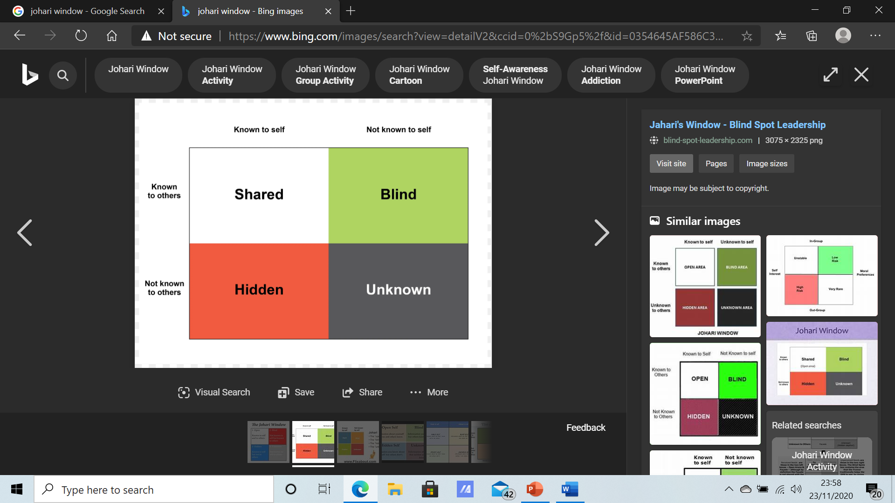

shared | Blind
Organised.  Shy.  Not confident.  Time keeping. | Hard worker.  Procrastinate.  Stress.
Hidden | Unknown
Depression.  Anxiety.  OCD. | Do not balance personal life and work life well.
(Roadmapping, 2020)

Appendix B-VARK Learning Questionnaire
Undertook the VARK Questionnaire version 8.01 online.

My results were:
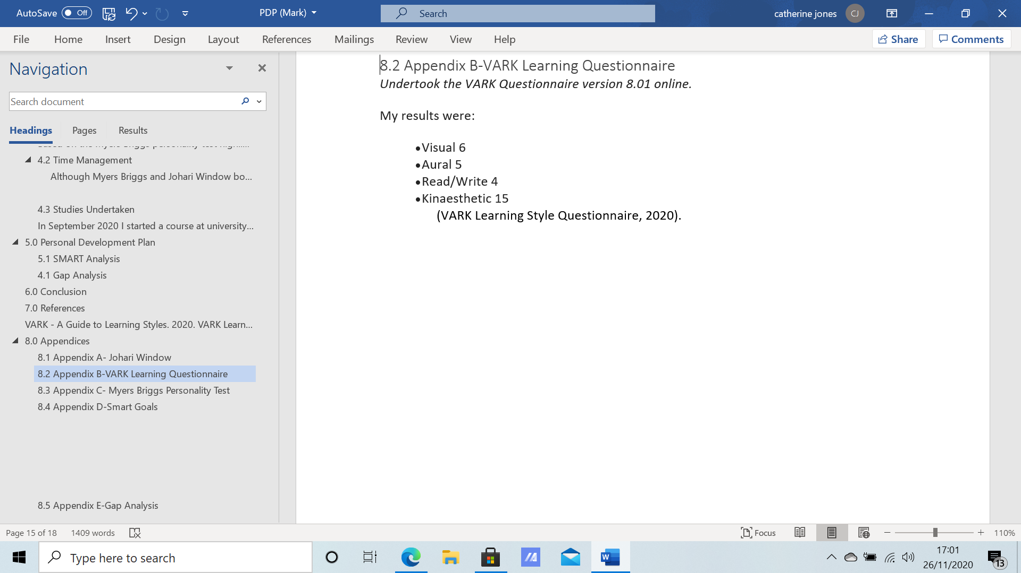

(VARK Learning Style Questionnaire, 2020).

Appendix C- Myers Briggs Personality Test

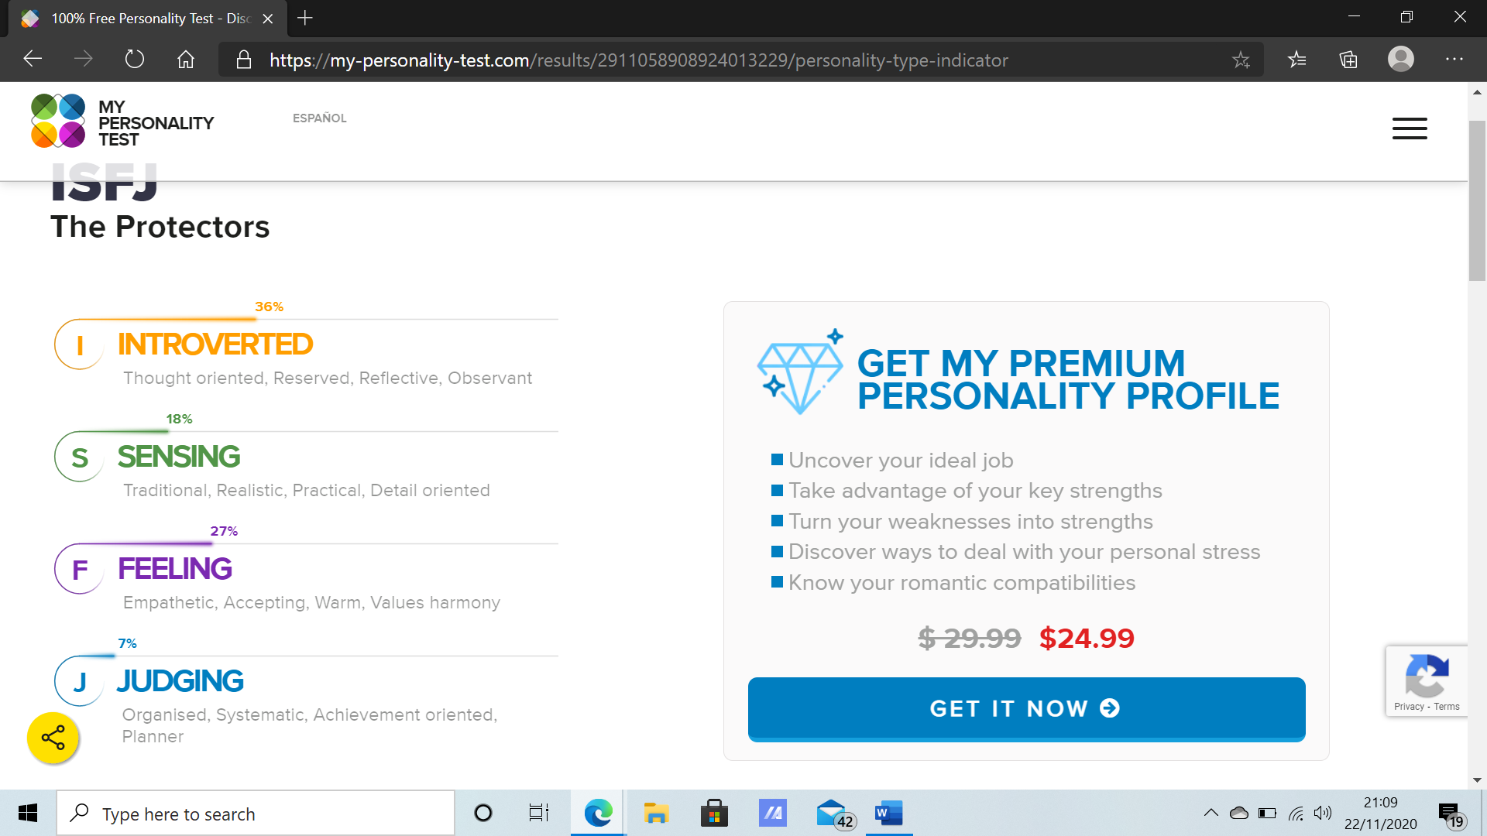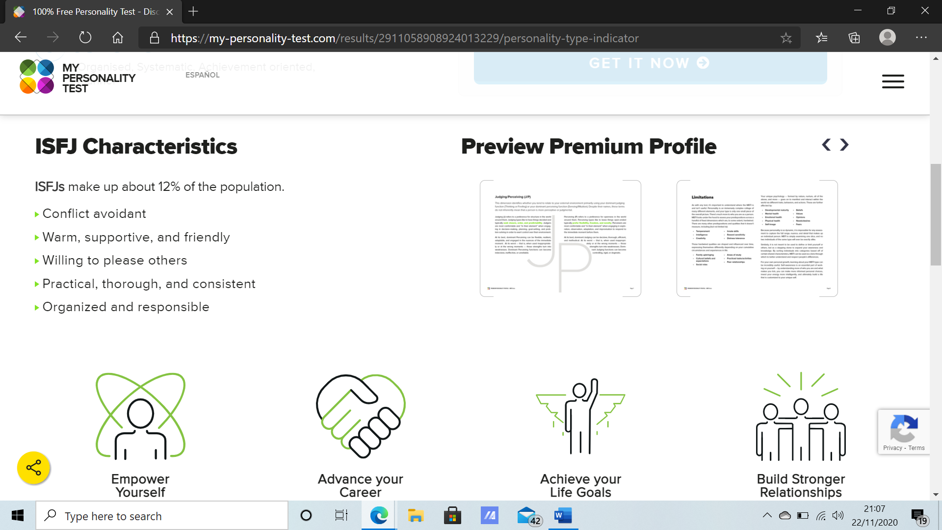 (100% Free Personality Test - Discover Yourself, 2020).

Appendix D-Smart Goals
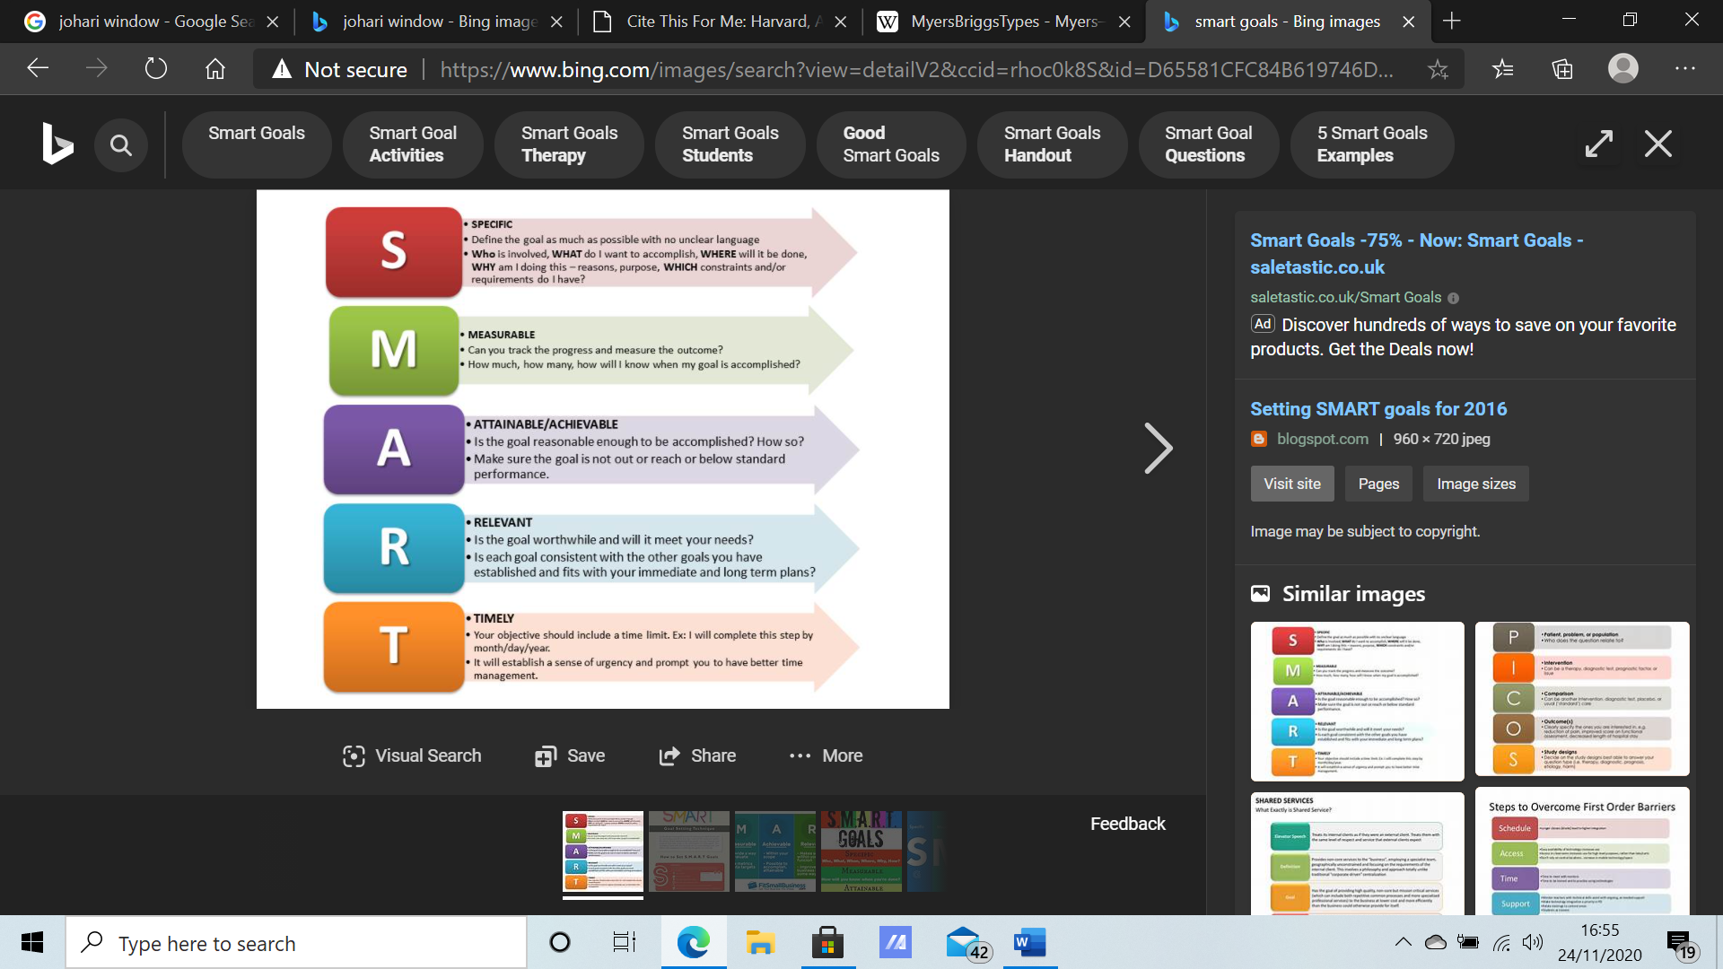
S- Specific | To graduate university and gain a cert HE in business.
M-  Measurable | After I have submitted all my assignments and completed the year.
A-  Attainable | I feel confident this is attainable, providing I manage my time wisely, research and attend my classes online and in university.
R-  Relevant | This is a realistic goal, by applying learning styles I have learnt through the vark questionnaire. Also, by creating a gap analysis plan.
T-  Timed | By applying everything I learn through university this goal is reasonable and I will acquire it within the time frame.
(Setting SMART goals for 2016, 2020)

Appendix E-Personal Development Plan
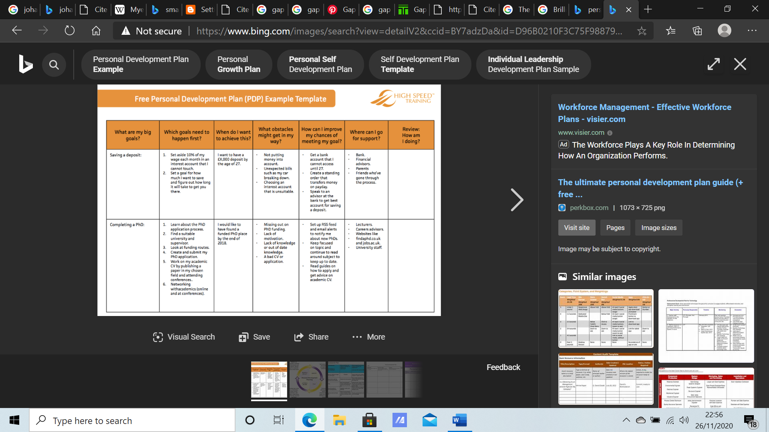
Goals | what happens next | When I will achieve it | Current situation | Time scale | Improve chances of achieving goal
Graduate uni gaining a cert HE | Attend lectures and complete assignments on time | 6th July 2021 | No qualifications | 1 year | By researching and completing assignments to the best of my abilities
Establishing my business | Graduate university  And gain work experience through an internship | Within the next two years | Working towards cert HE | 2 years | By finishing university and gaining knowledge in a managers position through internship at a retail store.
(The ultimate personal development plan guide, 2020)

Appendix F-Gap Analysis
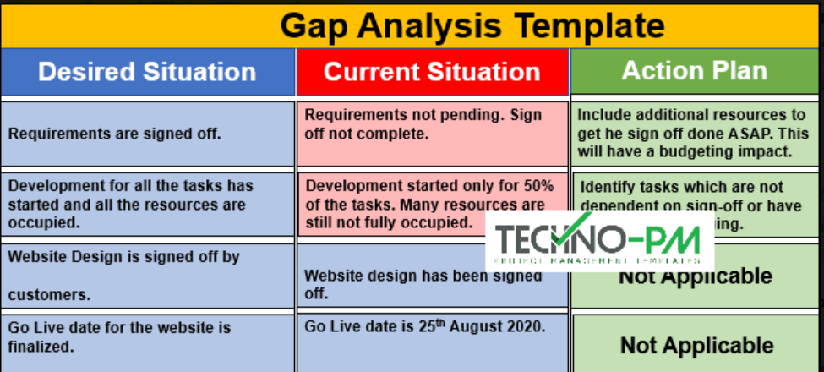
 | Gap Analysis
Desired Situation | Current Situation | Action plan
To successfully run my own business organising client’s homes. | Currently work in the cleaning industry.  I have the skills to organise but not the knowledge on how to run a business.  Currently studying business in university to gain a better understanding of how to run a successful business. | Complete my first year university to gain a Cert HE.  internship  work on skills- communication  Time management  Self-confidence  Start a business  Build up clientele
(Gap Analysis Template Download, 2020)

Appendix G-SWOT Analysis
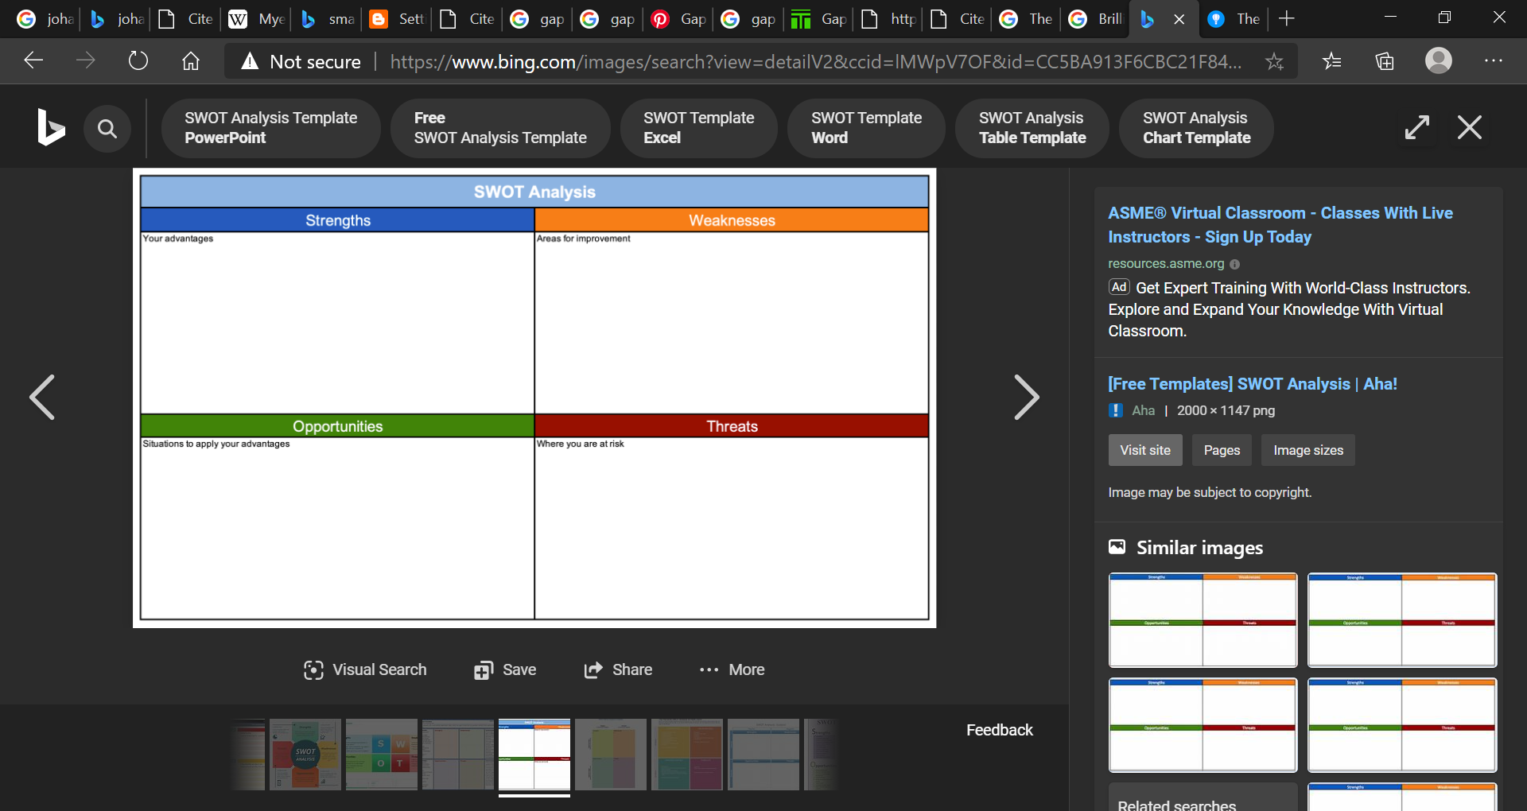

Low self confidence
Time management
Communication
Reading and writing

Resilient with personal problems
Adaptable when faced with unexpected problems
Committed to my employment

Low confidence
Not completing my assignments to a high standard resulting in failing university.
Attending university increasing skills
Internship in managers position

(Roadmapping, 2020)

