DS 1 Assignment

PHOTO 1.
LAPTOP
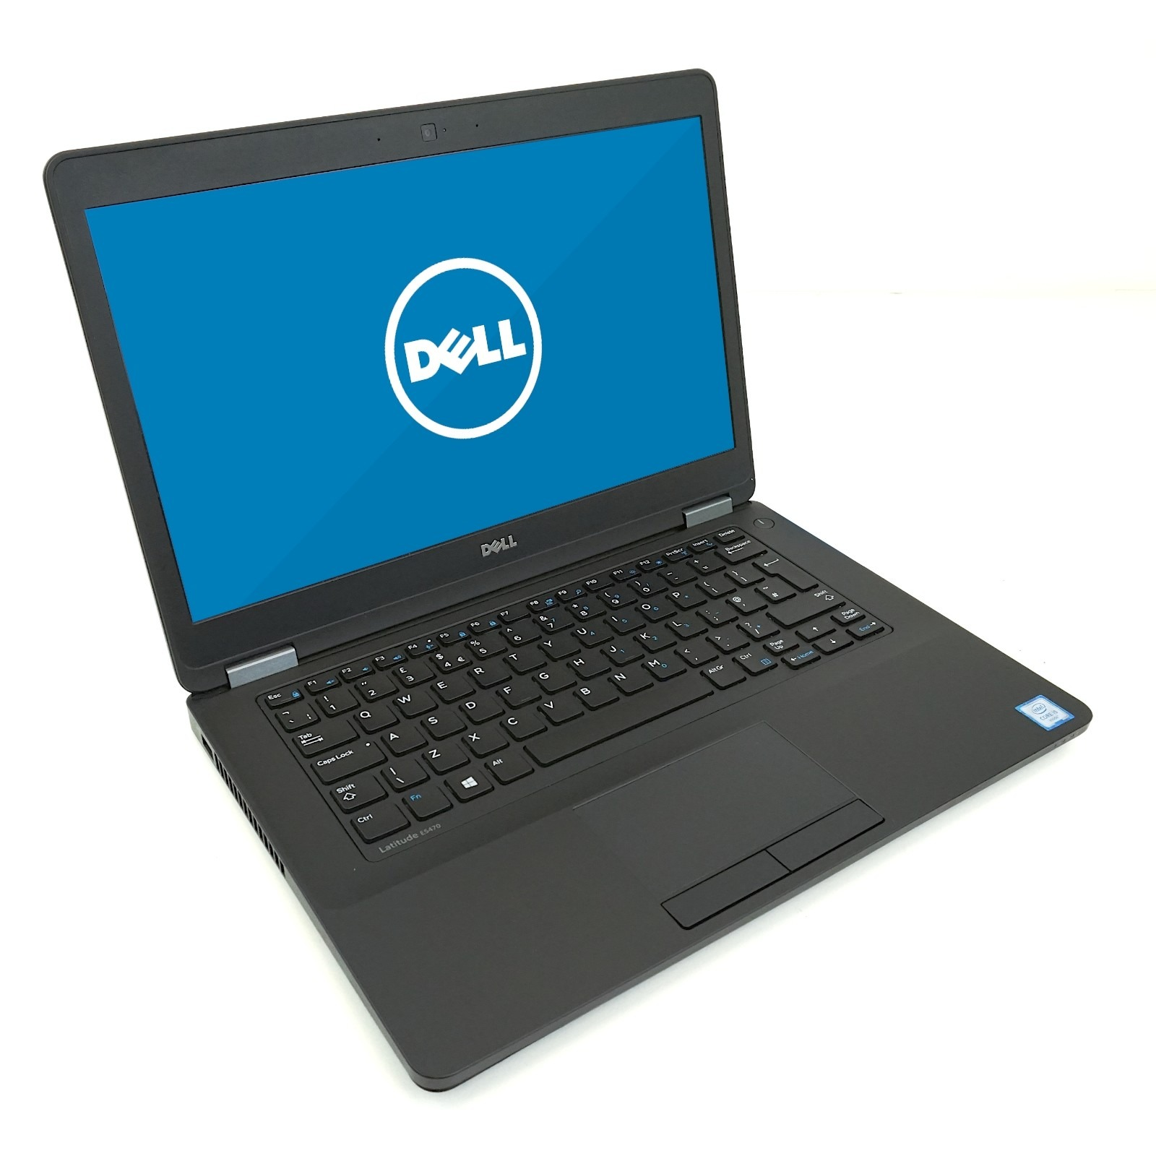
I use my laptops for both educational, businesses and general aspect of my life, it serves as a medium of communication to me.
I do research on internet, online class work, sending emails to my business partners.
I use it for playing games and watching movies and other entertainments.
I also read news on my laptop daily.
Laptops are very important, that hospitals, doctors, students, work environment etc depends on the use of storing data information and it played a major role in our day to activities.

PHOTO 2.

AEROPLANE


Airplane plays a vital role in my business which helps me in connecting my businesses in general.
I travelled on holidays with my family by using aeroplane, without it the aeroplane. This won’t be possible.
DHL PDP Parcel Force all depends on the airplane to deliver cargos, goods to different destinations across the world.
Importance of the Airplane, fast transportation, business activities, Tourism, employment opportunities, connecting people.

Photo 3
MOBILE PHONE

I use my mobile phones as a medium wave of communicating with my family, friends and my business.
I do a lot on my Mobile phones, including school work, checking time tables, reading articles and listening to music.
I called the student finance this morning which saved me a lot of time travelling on bus to achieve what I want.
It has been a digital tool which integrates communication, finance, navigation and entertainment in our daily routines.

PHOTO 4
WhatsApp

Using WhatsApp everyday has play a multi-functional core helping me, this is either by chatting or video calling.
I use WhatsApp to communicate with my course mates everyday,
WhatsApp has played a big role in my business, especially helping the small businesses grow.
In the olden days people relied on sending letters, faxes, which takes long and probably get lost in transit.

REFLECTION
I use mobile phone daily, which has helped in growing my business globally across Africa, I can call anytime I want or chat on WhatsApp anytime.
I feel confident when I call my business partner directly rather than sending a letter across continents.
Learning about digital skill tools is kind of surprised, as I didn’t know how important some of our digital tools are, but which we use on daily basis.
During the digital skills lectures, I had the opportunity to take a photo using my mobile phone and download it on my laptop. I was surprised by how easy the process was, as I had never done this before.
This experience has motivated me to continue learning and gaining more knowledge about digital skills and tools.
I now feel to improve to explore how I can use these tools to meet my daily needs and improve my business activities.
This has also helped me appreciate the importance of digital skills in making everyday tasks easier, faster and more efficient.

