- Introduction

This report is going to cover malware, particularly Ransomware. The author is going to cover a brief overview of what Malware is and the different types that you can be affected by. He will talk about the effects of malware and if there’s anything you can do and how to prevent it in the first place.

- Malware
  - Cryptowall and how it works
The Oxford dictionary definition of malware is a “software that is specifically designed to disrupt, damage, or gain unauthorized access to a computer system.” Malware is commonly used by criminals to gain control over user’s devices and information and use it against them often for financial gain. Some of the other uses of malware are identity theft, stealing credit card information and infecting computers to mine different cryptocurrencies [1]. Malware is the general term for malicious software which targets devices and networks. There are lots of different types of Malwares but the most notable are:
- Viruses - is a kind of malware that attaches itself to another application such as documents and when installed onto a user’s device, can multiply and spread. [2]
- Ransomware - is a kind of malware that threatens to lock down the user’s information or worse if the victim doesn't pay the attacker a ransom fee which can be hundreds or even thousands of pounds. [3]
- Trojans - pretend to be ordinary, harmless programmes to trick users into unsuspectingly installing and using them. Once operational, they are able to steal personal information, crash devices, or spy on a user’s digital activities. [1]
- Spyware - is installed on a computer without the user's permission or knowledge. The term "spyware" refers to the software's main objective, which is to "spy" on the user. Its goal is to take control of the device, collect private data and internet usage information, and then send or sell it to interested third parties. [4]

  - Cryptowall and how it works
One ransomware is cryptowall. Cryptowall is a very dangerous form of ransomware that makes it nearly impossible to recover your data after your device has been affected. This is because it deletes shadow copies of files you have and will try to steal passwords and personal information. [5] As explained on the Varonis website [5], Cryptowall can affect and gain access to your device in multiple different ways. For example, phishing emails, exploit kits and malicious ads. The website also shows the different file types which can be affected by a cryptowall attack. [5]
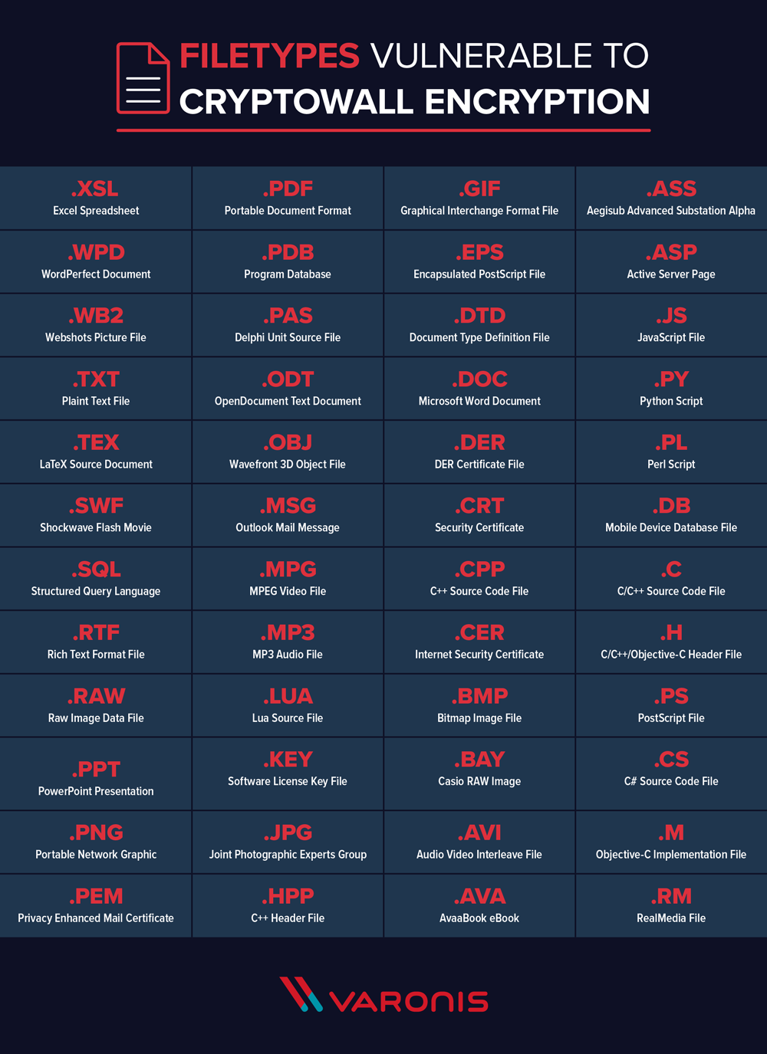
- Effects of cryptowall
Once cryptowall has accessed your device, it will run through all your files on your device such as photos, music, documents and presentations as well as any connected networks such as USB’s and encrypt them so you can’t access them. When these files have been encrypted, you will receive a notification on how to send them payment in return for file decryption. However, most users often do not ever get their files back even after payment [5].
- What to do if you’re affected by cryptowall
If you are affected by cryptowall and it has gained access to your device. There are a few measures suggested by the Varonis website [5] which you can take to attempt to remove it.
- Load up your device using Safe Mode.
- If you have an up-to-date backup system which is free from the malware you can attempt to restore.
- Download and install a malware removal application.
- Run malware removal app and scan all your files.
- Preventing Malware
The best thing to do is protect yourself from cryptowall in the first place, before it accessed your device. There are a few measures you can take to decrease your chances of being attacked by this malicious software, including: making sure your computer software is updated to the most recent version, using an anti-virus scanner and a firewall, be cautious and ensure any links are safe before opening and ensure files are backed up. [5]
- References

References

[1] | “McAfee,” [Online]. Available: https://www.mcafee.com/en-gb/antivirus/malware.html. [Accessed 11 Nov 2024].
[2] | “MalwareBytes,” [Online]. Available: https://www.malwarebytes.com/computer-virus. [Accessed 11 Nov 2024].
[3] | M. Kosinski, “IBM,” [Online]. Available: https://www.ibm.com/topics/ransomware. [Accessed 11 Nov 2024].
[4] | “Proofpoint,” [Online]. Available: https://www.proofpoint.com/uk/threat-reference/spyware. [Accessed 11 Nov 2024].
[5] | M. Buckbee, “Varonis,” [Online]. Available: https://www.varonis.com/blog/cryptowall#how-cryptowall-works. [Accessed 11 Nov 2024].

