Module Title: Managing enterprise
Module Code: BMSW4011
Student Name: Khalil Ullah
Student ID: 2508657

FreshMart Corner Shop
Business Plan and Reflection

Table of Contents
Part A: Business Plan 4
1. Product/Service description 4
2. Company Name 4
2.1 Company Overview 4
2.2 Market Opportunity 4
3. My Story 5
4. Legal status (pros and cons) 5
5. Mission statement/aims / SMART objectives and USP 6
5.1 Business Aim 6
5.2 Mission Statement 6
5.3 SMART objectives 6
5.4 Unique Selling Proposition (USP) 6
6. Location (including Google map) 7
7. Human resources (including organisation chart) 7
7.1 Daily Operations 7
7.2 Human Resources 8
8. Marketing activities 8
9. Market research 9
9.1 Industry Analysis 9
9.2 Customer Segmentation 9
10. Financial resources and cash flow forecast 10
10.1 Start-Up Costs 10
10.2 Sources of Finance 11
10.3 Cash Flow Forecast 11
10.4 Break-Even Discussion 11
11. Competitor analysis 12
12. Critical appraisal 13
Part B: Reflection 14
Existing Entrepreneurial Skills 14
Newly Developed Entrepreneurial Skills 14
Feasibility Analysis and Investment Decision 14
13. Reference list 16
Appendices 18
Appendix A – Customer Questionnaire 18
Appendix B – Survey Results Summary 19
Appendix C – Cash Flow Forecast (12 Months) 20
14. AI statement 21

Part A: Business Plan

Product/Service description
FreshMart Corner Shop is a one-man business convenience grocery store that will be opening in a residential locality of Cardiff, offering everyday food essentials, fresh produce, refrigerated foods, and impulse foods, conveniently located near consumers' homes. Its concept is based on the trend of fewer but larger shopping trips to the store, now replaced by multiple smaller ones in closer proximity, due to the increase in fuel costs and the hectic nature of UK lifestyles. The target market includes locals, senior citizens, students, and busy working professionals who prefer convenience over supermarkets' wide selection. The convenience of the store, extended hours of operation, the availability of locally grown products and the loyalty program would be competitive advantages gained that would be hard for the supermarket chain outside the community to duplicate. The total financing required for the new venture is £60,000, which will include £25,000 in their own money and a bank loan worth £35,000. The expected annual sales income is £150,000, and the breakeven period is estimated to be one year.

Company Name

2.1 Company Overview
FreshMart Corner Shop is a corner shop which sells a variety of fresh goods in a residential neighbourhood. Some of the items that this business will sell are around 2,000 popular items such as bread, milk, eggs, fresh fruits and vegetables, refrigerated and non-refrigerated grocery products, essentials, newspapers and sweets. Parcel delivery and billing facilities will become a part of the services. It will be a narrowly-based and demand-driven offering, giving a typical local family “products” to purchase between visits to the supermarkets and to the fast, reliable local corner store. As per Burns (2022), successful businesses are niche, not size-based.

2.2 Market Opportunity
The convenience retail market is massive and strong in the UK. The market is now larger than £50,500 billion in 2025, and is growing faster than the overall grocery market, with customers increasingly being focused on ‘little and often' purchasing (Statista, 2025). The Office for National Statistics (ONS, 2026) shows the need for the provision of food retail in the community. Mintel (2023) has identified convenience, freshness and localisation as the reasons behind consumers' purchasing behaviours. The growth of Cardiff's residential population is an ideal scenario. Focusing on localisation and value-added services is more appropriate as per Porter's (2008) theory.
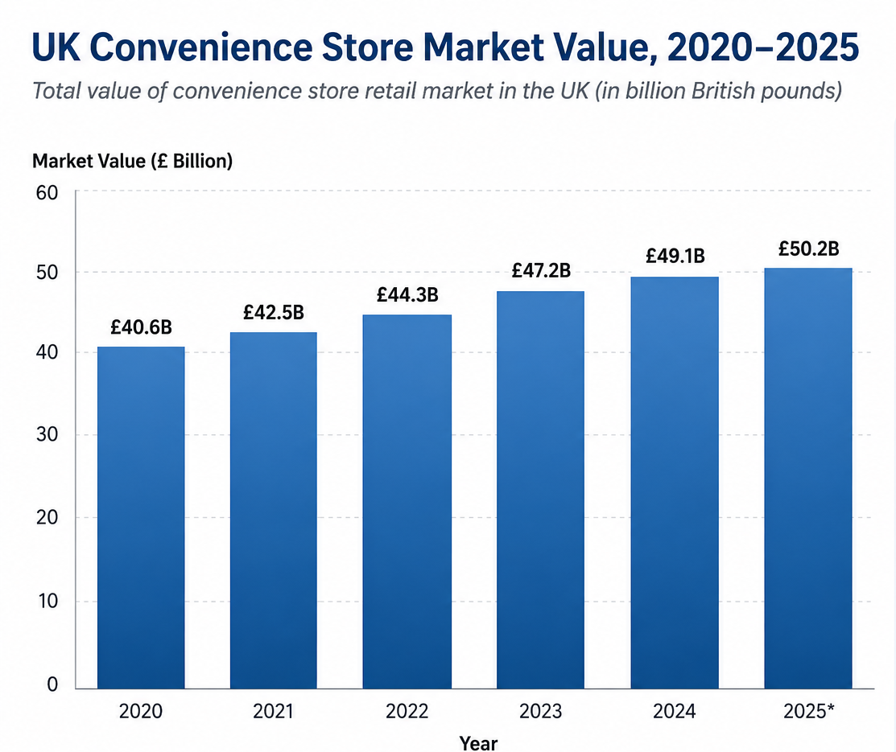
Figure 1: UK convenience store market value, 2020–2025 (Statista, 2025)

My Story
The above proposal was chosen based on my own observations in an underserved residential community in Cardiff, where the nearest full-service supermarket is only accessible by vehicle, putting elderly and less mobile people at a disadvantage. It is motivated by both economic opportunity and social need, which aligns with the theory put forward by Shane and Venkataraman (2000).

Legal status (pros and cons)
Legal form: FreshMart will commence trading as a sole trader.
Advantages | Disadvantages
Easy and inexpensive setup, complete control to the owner, all profits kept and small regulatory filing. | Personal liability is unlimited, financing is more difficult, and growth and continuity of business are limited.
It is important to note that the sole proprietorship form is advantageous for one-site startups that require low capital and a quick decision-making process (Scarborough and Cornwall, 2023). The only disadvantage with the form is no doubt going to be dealt with by suitable business insurance, and plans to change to a private limited company will be made at the proper time.

Mission statement/aims / SMART objectives and USP

5.1 Business Aim
“To become the most trusted neighbourhood convenience retailer in Cardiff.”

5.2 Mission Statement
“To provide fresh, affordable everyday essentials with friendly, fast service at the heart of the local community.”

5.3 SMART objectives
Table 1: SMART strategic objectives
SMART Objective | Detail
Sales | Ensure £150,000 sales annually within Year 1.
Profitability | Break-even within 1 year of operations.
Loyalty | Improve the online community base to 500 online loyalty club members within a year.
Service | Satisfaction rating of 85% or above (survey on quarterly basis).

5.4 Unique Selling Proposition (USP)
“Fresh groceries, everyday essentials, and friendly local service—right in your neighbourhood.”

Location (including Google map)
FreshMart Corner Shop will operate out of a high street in the residential area of Cardiff (Albany Road), within a walkable distance of 0.5 miles from the residential area. The property is situated at the heart of a local transport link, which offers high pedestrian movement, on-site parking, and a bus stop within 100 metres, thus being favourable to older residents and families who are forced to use their cars to visit the nearest big supermarket. There are positive elements regarding the visibility of the shop front, accessibility to deliveries, and the presence of educational institutions around.

Figure 2: Google Maps screenshot of the proposed Cardiff store location

Human resources (including organisation chart)

7.1 Daily Operations
- Inventory management using an EPOS system to track fast-moving lines and minimise waste.
- Supplier relationships with a cash-and-carry wholesaler plus selected local fresh-produce suppliers.
- Stock control through daily perishables counts and weekly ambient replenishment.

7.2 Human Resources
A small group of people will manage the company: the owner, a cashier, and a stocker, who work shifts. The recruitment process is carried out through advertising within the community, while training is conducted in-house.

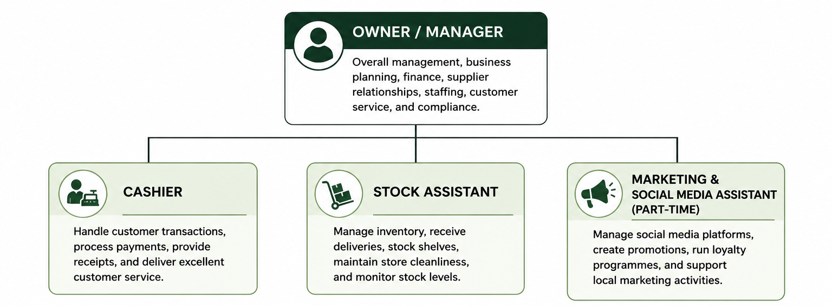Figure 3: FreshMart organisation structure.

Marketing activities
The marketing strategy applies the 7Ps extended marketing mix (Kotler et al., 2015).
Table 2: The 7Ps marketing mix applied to FreshMart Corner Shop.
Element | FreshMart application
Product | Organised daily grocery necessities, fresh produce, chilled lines and local specialities.
Price | Selective promotions with competitive pricing on a daily basis, not lowest cost, but fair value.
Place | Easy accessibility to housing, working long hours.
Promotion | Use of social media marketing, digital loyalty cards, and partnerships within the community.
People | Well-trained staff who are friendly and customer-focused.
Process | Quick and easy checkout and easy access to stock.
Physical Evidence | Well organised, clean and light store atmosphere.
The strategy for promotion involves minimal cost and a local approach, including a launch campaign through community social media networks, an app to encourage repeat customers, and collaborations with local schools and caregivers to promote the community identity.

Market research

9.1 Industry Analysis
The UK convenience sector is well developed but it is a fast-growing sector with tight competition between the symbol group retailers and supermarkets with “local” format stores. Applying the STP concept (Kotler, 1994), FreshMart segments its market area, focuses on the most accessible and loyal segments, and adopts a positioning strategy based on convenience and community rather than pricing.

9.2 Customer Segmentation
Table 3: Customer segmentation across demographic, geographic and behavioural bases.
Basis | Segment characteristics
Demographic | Families with children, elderly residents, students and working professionals.
Geographic | People living within a ~0.5-mile walking distance from the residential streets of Cardiff.
Behavioural | Frequent Top-up and convenience shoppers, impulse and emergency shoppers.

Positioning — Customer Persona
“Sarah, 38”: a working parent who frequents FreshMart thrice or four times per week for forgotten items, favors quick and courteous service, and would be an active participant in the loyalty application. This is the persona used to anchor the targeting process and develop the positioning statement: the quick, courteous, and local substitute for shopping from home in your car.
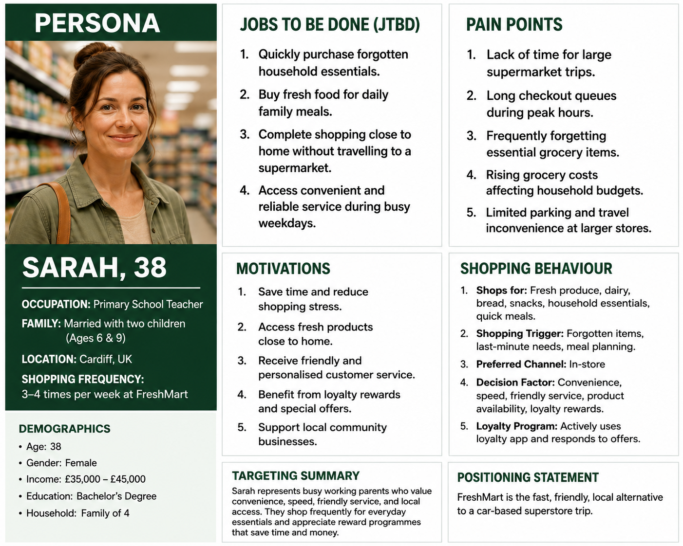
Figure 3: Customer Persona

Financial resources and cash flow forecast

10.1 Start-Up Costs
Table 4: Estimated start-up costs.
Item | Cost (£)
Shop fit-out, shelving and signage | 18,000
EPOS system, security, and equipment | 8,000
Refrigeration units | 9,000
Opening stock | 15,000
Lease deposit and legal fees | 6,000
Working capital/contingency | 4,000
Total start-up requirement | 60,000

10.2 Sources of Finance
- Personal savings: £25,000 (owner equity, demonstrating commitment to lenders).
- Bank loan: £35,000 over five years at a fixed rate, secured against business assets.

10.3 Cash Flow Forecast
The year-ahead forecast shows short-term pressures arising during the launch period, when stocks are being accumulated and customer contacts are being built up, while the final cash position becomes increasingly robust from the high festive trading period onwards. This reinforces the significance of the working capital contingency.
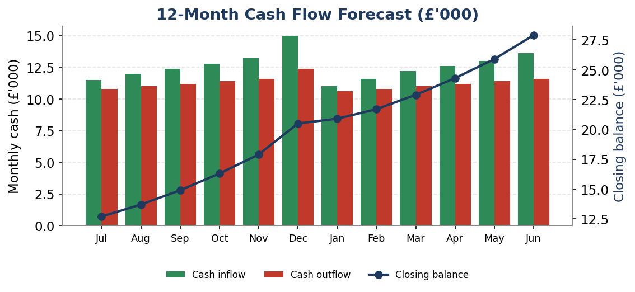
Figure 4: 12-month cash flow forecast (full statement in Appendix C).

10.4 Break-Even Discussion
Taking into account the fixed cost of about £42,000 per annum and the contribution margin of 22%, breakeven shall occur at £191,000 worth of annual sales, meaning that the sales goal for Year 1 of £150,000 is slightly under the breakeven point and will incur some losses until half way through Year 2. It is always best to have realistic expectations rather than overestimate figures (Scarborough and Cornwall, 2023).
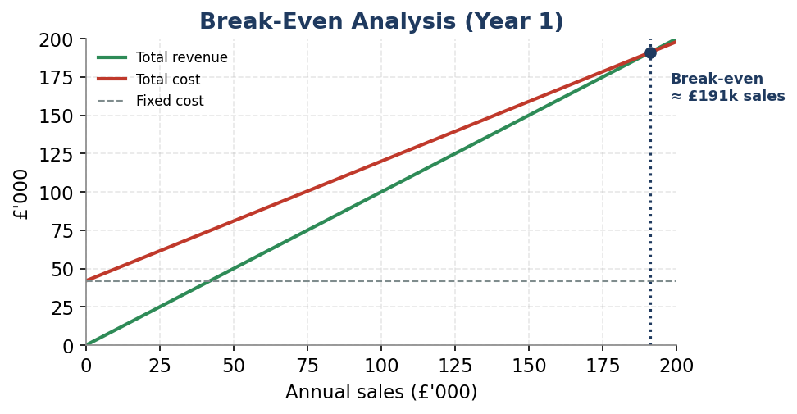
Figure 5: Break-even analysis, Year 1.

Competitor analysis
Table 4: Competitor analysis
Factor | FreshMart Corner Shop | Tesco Express | Co-op
Price | Competitive local pricing with selected promotions and value offers. | Strong pricing power supported by Tesco's national purchasing scale and Clubcard discounts (Davey, 2022) | Generally competitive but often positioned slightly above major supermarkets, supported by Member Prices and personalised offers (White, 2025)
Location | Residential neighbourhood location focused on walk-in customers and community convenience. | Located in high-footfall residential, urban, and transport-linked areas throughout the UK (Tesco, 2026). | Strong presence within local communities and residential neighbourhoods.
Product Range | Around 2,000 items including essentials for groceries, household products, and fresh produce. | A wide variety of products, including groceries, fresh produce, meal solutions, and household products. | Large selection of groceries, fresh produce, meals, and local products.
Loyalty Programme | A loyalty digital card that gives customers points and discount offers. | Tesco Clubcard delivers points, Clubcard prices, vouchers, and rewards from partners. | The Co-op Membership gives members member prices and personalised offers (Co-op, 2024).
Customer Service | Highly personalised, community-focused service and direct customer relationships. | Standardised service model across all stores. | Community-oriented service supported by local membership initiatives.
Competitive Advantage | Personal service, local relationships, flexibility, and community engagement. | National brand strength, purchasing power, extensive product range, and sophisticated loyalty scheme (Whitaker, 2019) | Ethical positioning, member ownership model, and community-focused benefits.
Key risk: competition from supermarket convenience formats and online delivery.
Mitigation: a digital loyalty scheme to ensure repeat patronage, active community involvement for brand affinity development, and low cost for a basic basket relative to multiples so that there is a fair price differential.

12. Critical appraisal
The FreshMart Corner Shop clearly recognises a real and emerging market opportunity in Cardiff's residential areas. The model is feasible in that there is a realistic plan to achieve profitability and a defensible strategy of differentiation and loyalty. Finally, there is a realistic financing strategy that takes into account not only the owner’s commitment but also external capital.

Part B: Reflection
Application of Gibbs' (1988) Reflective Cycle, including description, feelings, evaluation, analysis, conclusions, and action plan on the reflection of the process of developing the business plan.

Existing Entrepreneurial Skills
There were many entrepreneurial and management skills developed through creating the plan. I have learnt techniques for market analysis and have learnt to triangulate second-hand data sources like ONS, Statista and Mintel data with questionnaire responses to prove demand, rather than just assume it. Financial forecasting included estimates of start-up costs, a cash flow forecast and a break-even analysis, which has helped to develop my numerical skills, as well as my understanding of the importance of liquidity, not profitability. The application of various theories, including STP, the 7 Ps and SWOT, has contributed to improving my strategic thinking by allowing my decisions to be based on rational thinking. I had an idea for a reflection exercise based on Gibbs' (1988), but I knew that strategy has to work in conjunction with evidence. Once I'm done with this analysis, I can say this is indeed the essence of strategy.

Newly Developed Entrepreneurial Skills
The process of writing the business plan has enabled me to acquire several new entrepreneurial skills. To begin with, I acquired marketing research skills as I had to examine different industry reports and competitive intelligence for evaluating product demand and target consumers. Secondly, I learned how to develop financial forecasts, including estimating the cost of launching the business as well as forecasting its cash flows and breakeven points. Thirdly, my project involved strategic planning since I was supposed to formulate business goals and strategies. Fourthly, I got acquainted with the skills needed for risk evaluation. Specifically, I considered the risks associated with competition, inflation, and changes in customer behaviour which could hinder the success of my venture. Fifthly, through this project, I was able to master marketing planning skills, namely market segmentation, positioning, and 7P marketing mix.

Feasibility Analysis and Investment Decision
On the basis of the results of this business plan, I would consider that the proposed venture of FreshMart Corner Shop is a viable one and would invest my money into such a business. There is a high demand for convenience stores among customers, and the chosen location also allows attracting enough customers, who prefer convenience in shopping. There are several competitive advantages that allow creating a good reputation and attracting clients: personalised customer service, involvement in community life, and a convenient location.
At the same time, there is a risk of competition between the supermarket convenience and FreshMart Corner Store, growing costs, and also dependence on client loyalty at the initial stage. At the same time, the financial analysis shows a good prospect of the financial development of this business in the long run and the possibility to generate profit after some period of time.
Following Gibbs (1988), my action plan will be to enhance my numerical and financial skills, identify larger sample sizes of data for analysis in the future and practice the ability to turn strategy into measurable objectives. Overall, the learning outcomes of this course have shaped my understanding of business differently, providing me with new insights into planning, setting up and running businesses.

13. Reference list
Burns, P. (2022). Entrepreneurship and Small Business. [online] Bloomsbury. Available at: https://www.bloomsbury.com/us/entrepreneurship-and-small-business-9781352012491/.
Gibbs, G. (1988) Learning by Doing: A Guide to Teaching and Learning Methods. Oxford: Further Education Unit.
Kotler, P. (1994). Reconceptualizing marketing: an Interview with Philip Kotler. European Management Journal, 12(4), pp.353–361. doi:https://doi.org/10.1016/0263-2373(94)90021-3.
Kotler, P., Burton, S., Deans, K., Brown, L. and Armstrong, G. (2015). Marketing. [online] Google Books. Available at: https://books.google.com/books?hl=en&lr=&id=8TjiBAAAQBAJ&oi=fnd&pg=PP1&dq=marketing+mix+(Kotler&ots=jgfukLy4g_&sig=x8baaio7a_RyI-3PfgH0ypAwCL8 [Accessed 10 Jun. 2026].
Mintel (2023). UK Convenience Stores Market Report 2021 | Mintel.com. [online] store.mintel.com. Available at: https://store.mintel.com/report/uk-convenience-stores-market-report.
ONS (2026). Retail sales, Great Britain. [online] Ons.gov.uk. Available at: https://www.ons.gov.uk/businessindustryandtrade/retailindustry/bulletins/retailsales/december2025.
Porter , M. (2008). Competitive advantage: Creating and sustaining superior performance. [online] Google Books. Available at: https://books.google.com/books?hl=en&lr=&id=7UqQXsQ_dj4C&oi=fnd&pg=PT2&dq=Porter.
Scarborough, N. and Cornwall, J. (2023). Entrepreneurship and Small Business Management ninth edition. [online] Available at: https://studentebookhub.com/wp-content/uploads/2024/preview/9780134741086.pdf.
Shane, S. and Venkataraman, S. (2000). The Promise of Entrepreneurship as a Field of Research. Academy of Management Review, 25(1), pp.217–226. doi:https://doi.org/10.5465/amr.2000.2791611.
Statista (2025). Topic: Convenience stores in the United Kingdom (UK). [online] Statista. Available at: https://www.statista.com/topics/9698/convenience-stores-in-the-united-kingdom-uk/?srsltid=AfmBOorcKVeL6xbIcbf2i56CEJX9XOm3HvPrfB9E_8TxHsGfxJvj4sDp [Accessed 10 Jun. 2026].
Co-op (2024). Co-op Membership - Membership That Makes a Difference. [online] Co-op. Available at: https://www.coop.co.uk/membership.
Davey, J. (2022). Loyalty pays off for Tesco as Britons feel the pinch. Reuters. [online] Available at: https://www.reuters.com/business/retail-consumer/loyalty-pays-off-tesco-britons-feel-pinch-2022-02-23/.
Tesco (2026). Tesco Express stores - Tesco Groceries. [online] Tesco.com. Available at: https://www.tesco.com/shop/en-GB/zone/express-stores?srsltid=AfmBOooB4i9QxAGn5iYRS-E9IWYJlKYh-Ciutd7CZSUYFm1AYYyRAqb6 [Accessed 15 Jun. 2026].
Whitaker, E. (2019). The power of customer loyalty: Tesco and healthy eating. [online] Ikano Insight. Available at: https://insight.ikano/news/the-power-of-customer-loyalty-tesco-healthy-eating.
White, K. (2025). How Co-ops Help Businesses Compete in a Globalized Economy. [online] Co-operatives First. Available at: https://cooperativesfirst.com/blog/2025/10/20/how-co-ops-help-businesses-compete-in-a-globalized-economy/ [Accessed 15 Jun. 2026].

Appendices

Appendix A – Customer Questionnaire
A short questionnaire (n = 60) distributed to local residents. Sample questions:
- How often would you use a local convenience shop within walking distance?
- Do you value convenience over price for top-up shopping? (Likert 1–5)
- Would you join a digital loyalty scheme offering points and offers?
- Are you interested in fresh and locally sourced produce?
- How far do you currently travel for everyday grocery items?

Appendix B – Survey Results Summary
Primary research confirmed strong latent demand for a local convenience offer and clear appetite for a loyalty scheme.
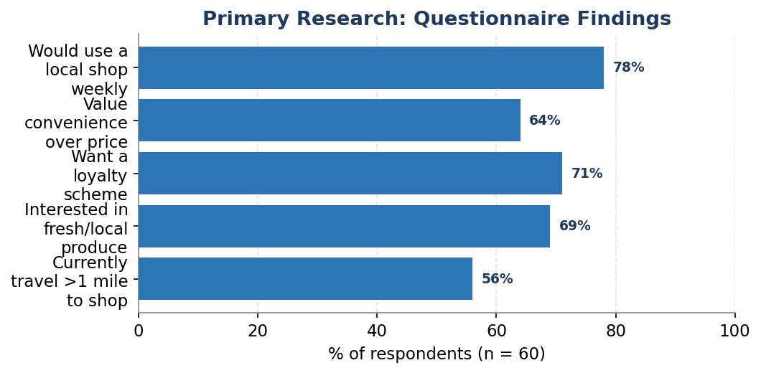
Figure B1: Summary of questionnaire findings (n = 60).

Appendix C – Cash Flow Forecast (12 Months)
Month | Inflow (£k) | Outflow (£k) | Closing bal. (£k)
Jul | 11.5 | 10.8 | 12.7
Aug | 12.0 | 11.0 | 13.7
Sep | 12.4 | 11.2 | 14.9
Oct | 12.8 | 11.4 | 16.3
Nov | 13.2 | 11.6 | 17.9
Dec | 15.0 | 12.4 | 20.5
Jan | 11.0 | 10.6 | 20.9
Feb | 11.6 | 10.8 | 21.7
Mar | 12.2 | 11.0 | 22.9
Apr | 12.6 | 11.2 | 24.3
May | 13.0 | 11.4 | 25.9
Jun | 13.6 | 11.6 | 27.9
Table C1: Monthly cash flow forecast (opening balance £12k). Figures illustrative.

14. AI statement
All research, data interpretation, financial estimates, strategic decisions and conclusions are my own work, based on the sources cited in the reference list. Where AI suggestions were used, I reviewed, edited and verified the content to ensure accuracy and that it reflects my own understanding. No part of this submission was generated and submitted without my own critical input and verification.

