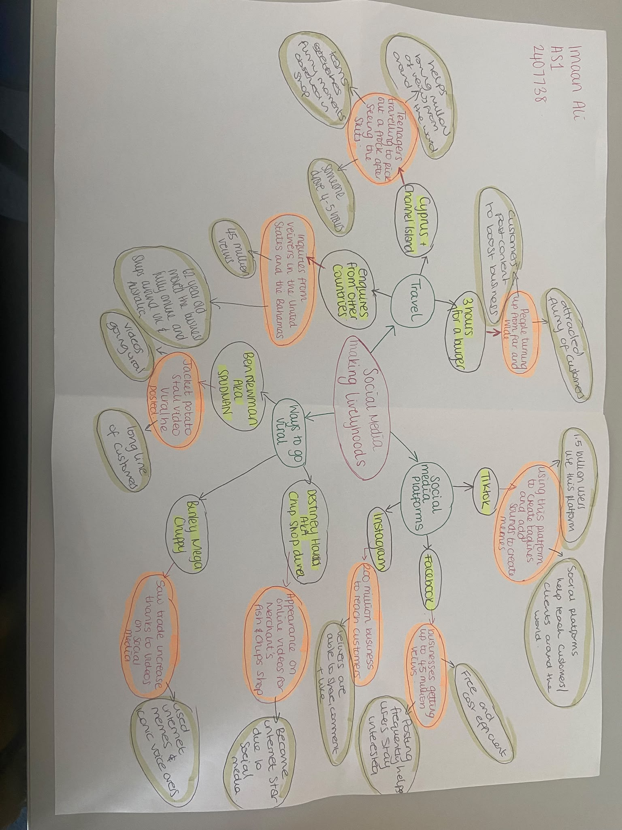
Assessment 1 – Reading Task Template
PART 1: Upload your photo of your A3 in-class notes here:

PART 2:
- Answer every question below in 1-3 full sentences.
- Use your own words. Do not use generative AI to answer these questions.
- Include a specific detail from the text when asked.
REMINDER
- The main idea is the overall message of the whole text.
- A key point helps to explain the main idea.
- A specific detail or example from the text shows that the key point is true.

- What is the main idea of the whole text?
How businesses promote their work on social media platforms to get recognised and grow.

- What is one key point that supports the main idea, and which specific example from the text shows this? “Social media can help businesses reach new customers and increase sales’ this comment shows social media can help a business grow and become more successful.

- What is a different key point that supports the main idea, and which specific example from the text shows this? Social media can help businesses reach a much larger audience and an example of this from the text is where Little Love’s Pampers Bus received around 45 million views in under a year.

- Which part of the text do you think is most important, and why?
The part that important is where the businesses share platforms and how they become known. This is important because it showcases what they used to promote their business and how they gained their target audience from different cities, even countries such as people travelling abroad to try on prom dresses.

Reflection:
- What did you find difficult in this task (including in-class components), and why was it difficult?
I found it difficult to understand how to create the mind map and decide what information is needed to include in each section. At first, I was not sure which points were most important to focus on how to expand on my ideas. I also found it difficult to organise my thoughts clearly and make sure each section of the mind map was completed properly.

- What helped you with this difficulty, and how did it help you?
What helped me with this difficulty was using the title to predict what information I needed to look for the text. I used skimming to get a general idea of what the text was about and scanning to find the main points and important information. These techniques helped me to understand the text more easily and gave me a better idea of what information to include in my mind map.
https://librarysearch.uwtsd.ac.uk/permalink/44WHELF_UWTSD/1bmis16/cdi_doaj_primary_oai_doaj_org_article_12d5bc8c05c147a5997f325903195665

