Coaching and Mentoring Within an Organisational Context

Module: coaching and mentoring
Module code: BMSW6007
Lecturer: Rhiannon Akers
Student name: Aliaa Nabhan Danouni
Student ID:2309830

Contents
Introduction………………………………………………………………………….3
Reflection and Gibbs Reflective Cycle………………………………………….5
Description……………………………………………………………………………6
Feeling…………………………………………………………………………………6
Evaluation……………………………………………………………………………...6
Analysts………………………………………………………………………………..7
Conclusion……………………………………………………………………………..9
Personal development plan………………………………………………………..10
References…………………………………………………………………………….12
Appendix………………………………………………………………………………14

AI disclosure:
I confirm that I have not presented any AI generated text as my work. l confirm I have copies of my draft, notes, and other resources I used before.

Introduction:
In contemporary workplaces, coaching will to be one of the most successful developmental interventions. This is especially in the post-Covid environment, where organisations and employees are still adjusting to uncertainty, higher task demands, as well as changing expectations. Coaching is a carefully planned though flexible conversation, which helps people analyse obstacles, develop self-awareness, also choose potential solutions. In contrast to traditional training, which often focus on transferring knowledge, but coaching concentrates on the aims and reflections of the coachee, making it a highly tailored and successful learning approach. Post-Covid research shows that employees now have multiple possibilities for individualised emotional support, resilience building, and meaningful conversation. These are the needs that coaching exists to address (CIPD, 2024).

Although coaching and mentoring are sometimes mentioned together, each has different goals. In most circumstances, mentoring is a longer-term partnership in which a senior employee offers direction, advice, and business information. In contrast, coaching is indirect; rather than offering solutions, the coach uses active listening, opening questions, and encouraging innovative ideas to help the coachee think more deeply. While mentoring assists in professional development, coaching is particularly helpful in enabling quick shifts in behaviour and thinking, which is something that businesses need increasingly as they deal with ongoing post-Covid issues including a limited budget, working remotely, and the need for flexibility (Blackwell, 2014).
In the education sector, where I work, coaching is not applied yet in professional development frameworks, event hough it being increasingly needed to support teachers, enhance communication, and management of pressures.In post Covid, teachers’ roles expanded, that making coaching a crucial tool for performance and wellbeing (Passmore et al., 2023). I believe that applying a coaching culture would strengthen teacher’s confidence improve decision making, in addition to enhance relationships between educators. This reflection will critically evaluate my performance in a peer coaching exercise with my coachee, Anna, using Gibbs’ Reflective Cycle (1988). Analyses my strengths and weaknesses, also compares the Instant Payoff Model with recognised models such as GROW and OSCAR. Examines the skills, values, and beliefs required to be an effective coach. Concluding with a 6-month Personal Development Plan.

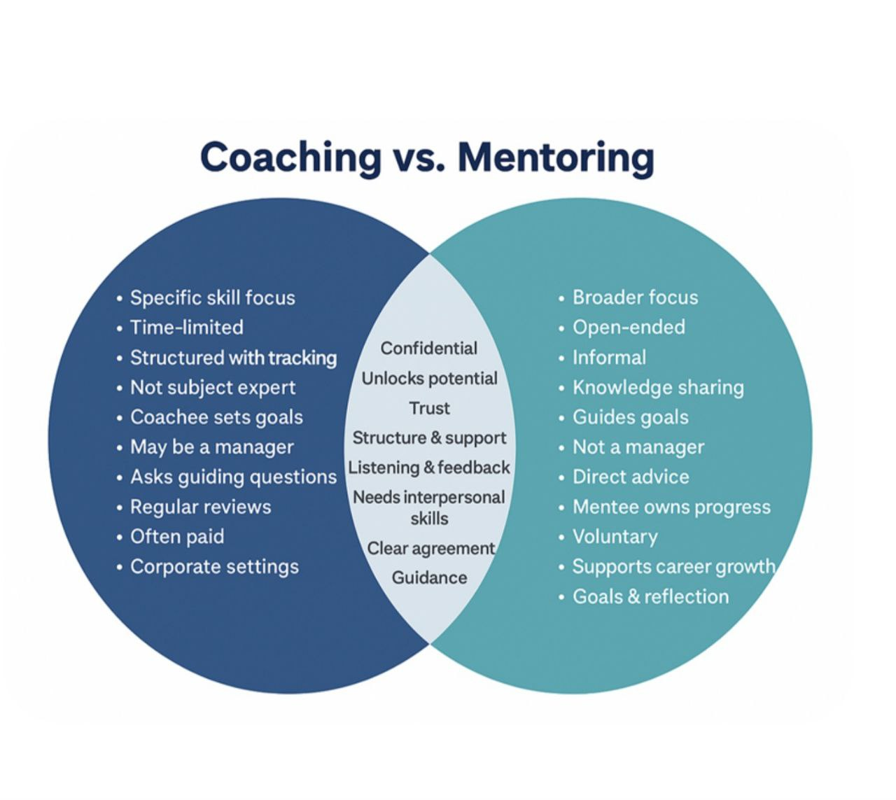
Figure 2: Murray 2025

The Revelation Mode:
The Reflective models are organised structures that help individuals and groups reflect on their experiences. All job responsibilities involve continuous learning and development, which makes these models useful. Reflective models can help in developing a deeper awareness of thoughts, feelings, and behaviours by examining prior events. This leads to both personal and professional development. Additionally, it helps to become more self awareness and critical thinkers, which helps to assess methods, pinpoint areas that need work, and test adjustments (Niada, 2021).

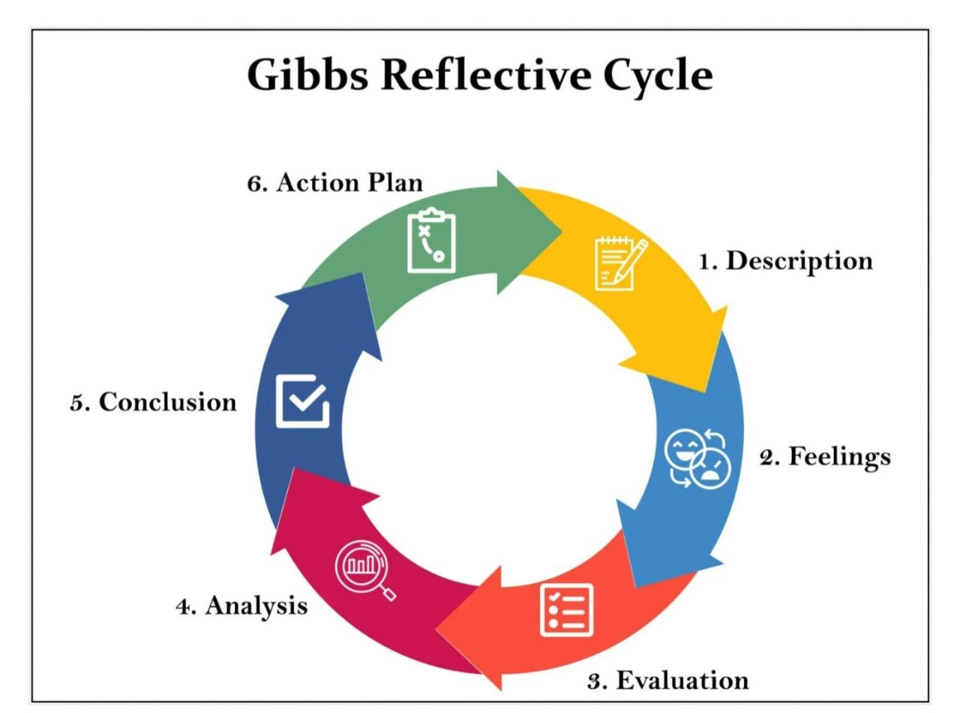
Gibbs Reflective Cycle (1988)
Figure: MCLeod 2025

The Gibbs' Reflective Cycle (1988) is one of the most widely used frameworks as it provides a clear and structured process for analysing experiences. The model consists of six cyclical stages: Description, Feelings, Evaluation, Analysis, Conclusion, and Action Plan, which enabling practitioners to examine both the emotional and factual dimensions of an experience. In each stage contributes to deeper understanding:
Description: What happened?

Feelings: What l felt and emotions?

Evaluation: What went well or not well?

Analysis: Why did events unfold this way? Links to theory.

Conclusion: What I learned?

Action Plan: What will I improve next time?

This structure of the model makes it particularly helpful for coaching, where behavioural changes, critical analysis, and emotional awareness are all necessary to successful practice (McLeod, 2025).

How I Applied the Gibbs Model in My Coaching Practice?

I used Gibbs' Reflective Cycle during my fifteen-minute peer-coaching session with Anna. I was able to break down the session into several parts according to the cycle, which began with a logical description of the conversation and progressed with more significant emotional and analytical reflections (Amir et al., 2023)

Description (Using the Instant Payoff Model):

In the coaching practice, I used the Instant Payoff coaching approach, which designed to apply short, solution-focused coaching sessions. Building empathy and clarifying confidentiality are the first two steps in this model. Next, the problem defined, the desired outcome considered, internal, external, and situational obstacles shown, practical solutions brainstormed, Achievable goals and finally agreeing on specific actions and timing. I ran this process with Anna: she spoke about how difficult it is for her to say "no" in her work environment, which is stressful and overwhelming for her. She gave a recent example, and together we found environmental and personal obstacles. We concluded with three specific activities that she committed to implementing in the next week (Adams, 2022).

Feelings:
In the beginning I was scared and worried about time management and following every step of the model before to the session. I also felt responsible to make sure Anna felt supported and heard. My anxiousness decreased as soon as the session started since Anna participated truthfully. At times, I felt uncertain about whether to allow silence or move the conversation forward. I concerned about interrupting her thoughts process. After the session, I felt a mix of pride and awareness: I was happy that Anna felt better and had more understanding of her goals, but I also need to improve my time management and listening skills. Reflecting on it now, I see that these emotional responses were part of my growth as a developing coach.

Evaluation:
By reflecting on my coaching practice with Anna, several strengths and weaknesses became clear, also noted by the observers. Ones of clear strength was my ability to follow the Instant Payoff Model in a logical order.I began the session by building rapport and clearly identifying Anna’s presenting issue, before guiding her to define her desired outcome and explore the internal, external, and situational obstacles, which impacting her behaviour. This structure aligns with best coaching practice, by emphasises clarity as well as progression through defined stages to support coachee reflection and action planning (CIPD, 2024).

Another strength was using open questions such as “Tell me the issue,” “What happened in the recent example?”, and “How did that make you feel?” These questions encouraged Anna to explore her experience more deeply, reflecting the coaching competency of powerful questioning outlined in professional standards (ICF, 2025). Furthermore, use of positive non-verbal communication such as, eye contact, nods, warm tone that learning to a supportive environment, which important for building trust and psychological safety in coaching relationships (International Coaching Federation, 2019).
However, the evaluation shows several areas that require development. Even though I spoke up the topic of confidentiality, I missed to provide a detailed description of the entire coaching contract. As I did not explain the crucial session structure beforehand. Additionally, even though I gave Anna examples to help, I did not always have her permission beforehand. Even it is minor but its crucial element that might have an impact on the coachee's autonomy and empowerment (CIPD, 2024).

Analysis:

Skills of Effective Coach:
The effective coaching includes specific skills that allow the coach to create safe, empowering, and supporting environment. Active listening, effective questioning, emotional intelligence, non-directive communication, and the ability to organise discussions are all essential abilities. Instead of providing answers, an effective coach should show empathy, be present, and support the coachee to be more independent (Ribeiro, 2020). Several of these skills were applying in my practice when I backed on my conversation with Anna. The clarity and psychological safety enhanced by used an open question, strong eye contact, and an organised use of the Instant Payoff Model. These actions explained my strengths in rapport-building and process management.
Evaluation Of Coaching in the Workplace:
My performance analysis did, however, highlight certain areas that still require improvement. For example, I occasionally made recommendations without getting permission. These actions may cause the coaching to change from suggestions to mentoring, which reduces the coachee's sense of commitment. Increasing the period, I spend in silence during talks and thoughtful pauses will also provide the coachee more room to think more deeply and create novel ideas (Chandler, 2024).

Role of coaching and mentoring need for agility:
The organisational agility has improved by coaching and mentoring, especially in settings where uncertainty and quick change are usual happened. The coaching improves adaptability by promoting critical thinking, problem solving, and ongoing learning, which helps employees react more skilfully to changing demands. Similar to mentoring ,which promotes agility by development of skills and offering support during times of change.Both coaching and mentoring help to create a culture that is adaptable, responsive, and able to sustain performance during change by allowing employees to accept responsibility for their choices and develop resilience (Dayoi and Samuel, 2025).

Critical Comparison: Instant Payoff Model vs. GROW Model

Both the GROW Model and the Instant Payoff Model are organised coaching frameworks that emphasise action, clarity, and problem-solving. They differ, though, particularly in terms of depth, concentration, and the kind of help they provide to the coachee. the evaluating of advantages and disadvantages of the structure, which I applied in my work requires an understanding of this differentiation.
David Rock created the Instant Payoff Model (2006). It is a quick, solution-focused framework designed to help coachee in quickly getting to understand particularly in situations of high stress or short coaching sessions. The approach goes through five stages: defining the existing problem, outlining the desired outcome, investigating internal and external obstacles, producing potential solutions, and agreeing on specific steps of action. Its quickness and simplicity are its strongest points. It enables the coach to quick
direct a person towards practical results. So, instant payoff is especially useful in workplaces when time is essential importance or when the coachee requires immediate clarification to resolve a problem.

However, a critical limitation of IPM is that it may oversimplify of complex behavioural patterns or deeper emotional issues. So, the model is highly outcome driven, it less emphasis on reflection, or developmental learning across time. In practice, I found it useful for helping Anna gain quick clarity, but it did not fully explore the emotional roots of her difficulty with assertiveness.
By contrast, the GROW Model. It originally developed by Sir John Whitmore (2017) as one of the most widely recognised coaching frameworks globally. GROW stands for Goal, Reality, Options, Will, and it encourages deeper exploration. The model begins with showing long-term goals, then moves into a reflective examination of current reality, the barriers involved, and a broad exploration of potential strategies. GROW supports deeper behavioural change because it helps coachee examine patterns, assumptions, and internal motivations (Thipatdee, 2019).
Crucially, compared to IPM, GROW might need more time, emotional depth, and reflective ability. For coachee who need quick results, GROW seems to slow or less structured during brief limited time sessions. But it offers deeper long-term growth, which makes it better suited for showing problems, wellbeing, or leadership coaching (Main, 2023).

When we compare these two models, we see that GROW provides a deeper learning experience, while the Instant Payoff Model is more effective for brief, directly, solution-focused sessions. Instant payoff helped Anna in creating a short, workable strategy during our session, but a GROW based approach might have provided a deeper understanding of the viewpoints that behind her inability to say "no." Therefore, a mixed approach in the following sessions might have greater effect.

Tangible and Intangible Benefits of Coaching:

Coaching offers a range of tangible and intangible benefits that affect directly to individual and organisational performance. Tangible benefits include improved productivity, clearer goal achievement, moreover it enhanced decision-making, and measurable improvements in skills and behaviour as well. These outcomes often translate into better efficiency, reduced errors, and higher quality of work (Knowles,2021).
According to Jorio, Kasmi and Daghri (2019), coaching produces important intangible benefits as enhanced self awareness, improved involvement, better mental health, and increased confidence. These emotional and psychological improvements will improve relationships at work and increase resilience. Thus, when combined, these benefits to create a workforce that is more capable, motivated, and flexible.

Conclusion:

In the reflecting on my coaching session with Anna has deepened on my understanding of the skills and professional standards, which needed for effective coaching. Using Gibbs’ Reflective Cycle ,that allowed me to examine not only what happened during the session, but also the reasoning behind my decisions and the areas where I can improve.The Instant Payoff Model proved useful by providing clarity and structure, also helping Anna to move efficiently from identifying her challenge to developing actual actions.Comparing it with the GROW model highlighted that, while IPM supports quick progress, deeper exploration and long-term development may require a more reflective framework.This reflection helped me to recognise clear strengths, particularly in rapport-building, active listening and using open questions. However, it also highlighted to important development needs by offering a clearer and more formal coaching contract, especially on expectations, boundaries, and confidentiality. Although I briefly mentioned confidentiality, but I did not explain it thoroughly, and strengthening this will help me sustain of ethical standards and psychological safety in future sessions. I also intend to improve my use of silence and strengthen permission that based questioning.
Overall, this experience has enhanced my confidence as a developing coach, in addition to clarify the skills that must improved to ensure a more ethical, structured, and impactful coaching practice.

Personal Development plan

What do I want/need to learn? | What will I do to achieve this? | What resources or support will I need? | What will my success criteria be? | Target dates for review and completion
I need to improve my coaching contracting skills, especially explaining boundaries and confidentiality as I did not mention that clearly to my coachee during the practical exercise (as highlighted by my observer).  I also intend to improve my use of silence and strengthen permission that based questioning  These are important core skills of coaching according to Passmore and Sinclair (2020). | Study ethical  contracting principles  in The Ethical coaching ‘Handbook (Smith el al.,2023).  Review guidance on  confidentiality and  coaching agreements in Becoming a Coach (Passmore & Sinclair, 2020).  I will try out the above techniques with my coachee via a role-play in 2 weeks’ time. | Read more about coaching as read book: “Coaching. The science. The undisputable evidence”  (Seen,2025)  Suggestion to to do a role-play with my colleagues for more supporting practice | I will have positive feedback from my coachee as feeling heard and not rushed  I can confidently  communicate confidentiality, expectations, and structure.  I consistently ask permission before sharing ideas in practice session | Review on 12th December,2026. following the role-play session with my coachee.

Reference List:

Adams, M. (2022) ‘Enable: a solution-focused Coaching Model for Individual and Team Coaching’, Coaching Practiced, 12(1), pp. 285–297. Available at: https://doi.org/10.1002/9781119835714.ch29.

Blackwell, W. (2014) Ho Law the Psychology of Coaching, Mentoring and Learning Second Edition, ISBN 978-1-119-95466-8 (pbk.), p. CM. Available at: https://download.e-bookshelf.de/download/0003/9736/57/L-G-0003973657-0002484685.pdf.

Chandler, A. (2024) The evolution of coaching in the workplace, PeopleManagement. Available at: https://www.peoplemanagement.co.uk/article/1872207/evolution-coaching-workplace? (Accessed: 11 December 2025).

CIPD (2024) Coaching and Mentoring. Available at: https://www.cipd.org/en/knowledge/factsheets/coaching-mentoring-factsheet/ (Accessed: 11 December 2025).

Connor, M. (2017) Coaching and mentoring at work. Third edition. London: Open University Press.

Dayoi, E. and Samuel, A. hertiage (2025) Coaching and Mentoring in Agile Leadership Contexts. ResearchGate. Available at: https://www.researchgate.net/publication/393061696_Coaching_and_Mentoring_in_Agile_Leadership_Contexts (Accessed: 11 December 2025).

Haeril, A. et al. (2023) ‘Enhancing Skill conceptualisation, Critical thinking, and Nursing Knowledge through Reflective Case discussions: a Systematic review.’ PubMed, 16(6), pp. 851–855. Available at: https://pmc.ncbi.nlm.nih.gov/articles/PMC10478664/ (Accessed: 12 December 2025).

International Coaching Federation (2019) ICF Core Competencies | Coaching Standards and Best Practices. Available at: https://coachingfederation.org/credentialing/coaching-competencies/icf-core-competencies/ (Accessed: 11 December 2025).

Jorio, H., Kasmi, S. and Daghri, T. (2019) ‘Emotional intelligence: an intangible capital linked closely to organizational performance as a liability - case of SAHAM Company’, in Economic and Social Development: Book of Proceedings. Varazdin: Varazdin Development and Entrepreneurship Agency (VADEA), pp. 9–16.

Knowles, S. (2021) ‘Benefits of Coaching’, Positive Psychology Coaching, 5, pp. 67–77. Available at: https://doi.org/10.1007/978-3-030-88995-1_5/ (Accessed: 11 December 2025).

Main, P. (2023) GROW Model for Coaching, Structural Learning. Available at: https://share.google/sQ2KJFDO5DgH9S6yK (Accessed: 11 December 2025).

McLeod, S. (2025) Gibbs Reflective Cycle, Simply Psychology. Available at: https://www.simplypsychology.org/gibbs-reflective-cycle.html (Accessed: 10 December 2025).

McLeod, S. (2025) Gibbs Reflective Cycle. Simply Psychology Figure1.

Murry, J. (2025) What is the Difference Between Coaching VS Mentoring Mentoring & Coaching Software Figure 2.

Niada, L. (2021) LibGuides: Reflective Writing: Reflection Models. Available at: https://libguides.westminster.ac.uk/reflectivewriting (Accessed: 10 December 2025).

Parsloe, E. (2022) Coaching and mentoring: practical techniques for developing learning and performance. Fourth edition. London: KoganPage.

Passmore, J. and Sinclair, T. (2020) Becoming a Coach: The Essential ICF Guide. Springer, pp. 139–143.

Passmore, J., Liu, Q., Tee, D. and Tewald, S. (2023) ‘The impact of COVID-19 on coaching practice: Results from a global coach survey’, Coaching: An International Journal of Theory, Research and Practice, 16(2), pp. 1–17. Available at: https://doi.org/10.1080/17521882.2022.2161923

Ribeiro, M. (2020) 28 Coaching Techniques Confident Coaches Use, PositivePsychology.com. Available at: https://positivepsychology.com/coaching-techniques/ (Accessed: 11 December 2025).

Senn, F. (2025) Coaching. The science. The undisputable evidence.: Everything you wanted to know about coaching, but you were afraid to ask. Editorial Neurosoft.

Smith, W.A., Passmore, J., Turner, E., Lai, Y-L., and Clutterbuck, D. (2023) The Ethical Coaches’ Handbook. Taylor & Francis.

The Coaching Academy (2024) How Effective Team Coaching Can Transform Performance. Available at: https://www.the-coaching-academy.com/blog/2024/06/how-effective-team-coaching-can-transform-performance-3599 (Accessed: 11 December 2025).

Thipatdee, G. (2019) ‘The Development of Coaching and Mentoring Skills through the GROW Technique for Student Teachers’, Journal of Education and Learning, 8(5), p. 168. Available at: https://doi.org/10.5539/jel.v8n5p168 (Accessed: 11 December 2025).

Appendix:


Practical Coaching Exercise: marking form
Name: Aliaa Nabih Nabhan Danouni
Feedback by Rhiannon Akers
1. Engagement with Literature Skills
Have they followed the Instant Payoff model in the correct order? YES
- Current issue or problem
- Desired outcome
- List obstacles/blocks (existing in coachee, existing in others, blocks in the situation)
- Jointly brainstorm possible next steps
- Agree an approach, actions and timing
Have they incorporated appropriate elements of other models(e.g. E for engage from ELECTRIC)? YES
Comments and examples:
You opened the session in a friendly, open manner and mentioned the model you would be using.
You clarified the problem, asked what the coachee’s ideal outcome would beand asked about blocks.
You revisited each of the blocks when referring back to solutions and agreed on actions with timings.

2. Knowledge and Understanding Skills
Have they shown an understanding of the Instant Payoff Model? YES
Correct interpretation of each part of the model, including blocks? YES
Appropriate Use of Open, Probing and Closed Questions, appropriate use of pauses, asks permission to make suggestions to the coachee if the coachee is struggling with solutions? YES
Comments and examples:
It could have been useful to explain a coaching contract at the start as well as confidentiality, followed by an explanation of the model.
You utilised a variety of open questions such as “tell me the issue”, “please share a recent example” and “how did that make you feel?”. This demonstrated your ability to probe.
You offered an example when the coachee was struggling to come up with solutions themselves. It could have been useful to gain clearer permission.

3. Cognitive and Intellectual Skills

Have they retained focus throughout, not reading notes, not fiddling with pen or looking distracted? YES
Have they responded appropriately to questions? YES
Have they followed a logical structure? YES
Does the conversation flow well? YES
Comments and examples:
Good eye contact with the coachee throughout
Displayed empathy, showed that you care by nodding an using non-verbal cues

4. Practical Application Skills
Have they used encouraging language, warm and open body language, nods of the head, murmurs of encouragement, appropriate energy levels to match and mirror the coachee? YES
Is there evidence of building rapport? YES
Comments and examples:
Encouraging language and praise, made the coachee feel comfortable.
Displayed active listening.

5. Transferable Skills for Life and Professional Practice
Overall,have they performed well and managed the conversation? YES
Did the coachee domost of the talking and come up with their own solution? YES
Good time management (kept to 15 minutes)? Yes but slightly shorter
Comments and examples:
The session lasted slightly less than 15 minutes butthe conversation flowed well and followed an appropriate structure.



