Jazz and Postmodernism

Though jazz is a movement unto its own, I could not help but notice the similarities between the movement of jazz and postmodernism. They both defy what was previously popular, and focus more on the meaning, the interpretation behind the piece, rather than the overt aesthetic. But first, what is Postmodernism? According to Susan Sontag and Ihab Hassan Postmodernism is (as written in Postmodernism: a very short introduction):
“The work of postmodernists was deliberately less unified, less obviously masterful, More playful or anarchic, more concerned with the process of our understanding than with the pleasures of artistic finish and unity, less inclined to hold a narrative together, and certainly more resistant to a certain interpretation, than much of the art that preceded it.”
In short, it’s the idea that regardless of the look, or the skill behind the piece of work, what truly matters is the thought that went into it. A child may draw stick figures and use green for the sky and blue for the grass, but so long as the child had a reason, one drawn from thought and study, who is to say they are wrong? Since that is their interpretation of the truth.

For my exhibit, I would be holding it at Dempsey’s bar in Cardiff (formerly known as The Four Bars Inn). The bar holds a dear place in the history of welsh jazz, and though my art pieces are not particularly centered around the culture of wales, they are still fundamental in Jazz’ history. The bar was founded by Jed Williams, the man who was, some say, the leading drive behind the creation of the “Brecon Jazz Festival.”
Though I can not get a floor plan of the building, my plan is to have the paintings hang behind along the walls of the stage, as a gentle jazz plays in the background. Near each of the pieces, a small placard would have the name of the piece and a paragraph about the work and the artist behind it. I would not include the ‘meaning’ of the works, as the whole idea is for the viewer to interpret the art for themselves.
My hope would be for the bar setting to create some form of discourse about jazz, thus feeding into the values of postmodernism. That the discussion of the work outways the artistic skill. Also, using a more casual setting such as a bar is atypical of the usual art gallery environment, reinforcing the nonconformity of postmodernity.
414

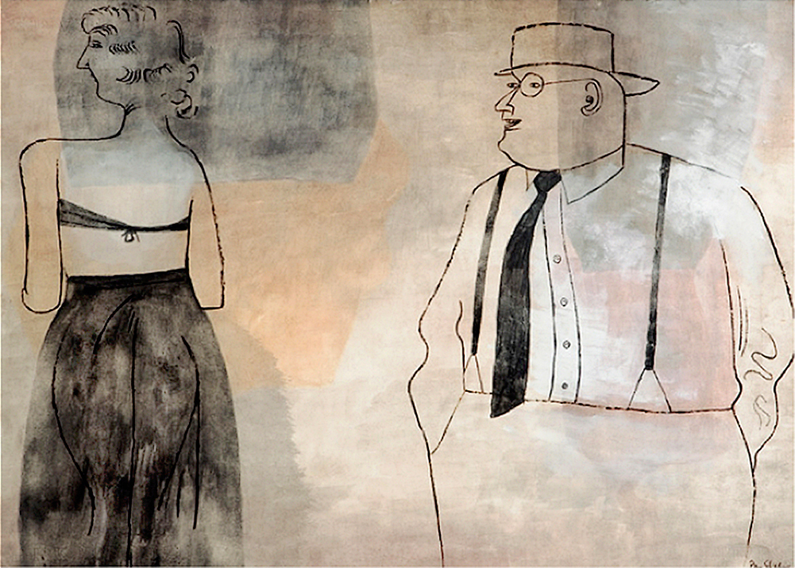
Ben Shahn mixed a great number of different art genres, though his most predominant were realism and surrealism. Politics often fueled his work, and he would often photographed working people to juxtapose against the ever growing industrial landscape. Shahn identified himself as what he called a “communicative artist.” His idea was that, the pre-conventions of art past disconnected the work from it’s audience. He would rather a more intimate relationship with his audience, he would include a large array of symbols into his work, ranging from christianity to pagan deities. His intention was to create social conversation and in turn, social change. As said by John Morse, “Shahn stressed that in art, as in life, the combination of opposing orders is vital for progress.”

I included Ben Shahns work because his work is never the same twice. Above, his work Suzanna and the Elders, 1940-1950, is a good example of his more jazz centric works. Though it is just an ink and wash on coloured paper, with but two figures, it still says a lot. No one is clear on what exactly is going on, if perhaps the man is leering at the woman or if she is playing coy. Taking into context, Shahns social criticism through his artwork, it may take on a whole other meaning.

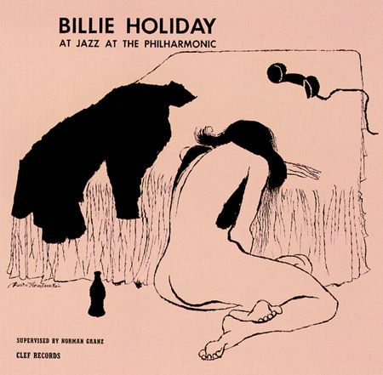
David stone Martin is perhaps an exception. His work was predominantly catered towards Jazz record covers, though he did illustrate the occasional magazine. His work is simplistic, with block colour and the lines fluid. Though the work itself doesn’t tell much of the album or it’s contents, it lays down the tone of the music well. A woman leaning over a table, nude whilst a hand reaches down for a bottle. The image, depending on the audiences personal interpretation could mean a great number of things.
281
https://iotaillustration.posthaven.com/david-stone-martin
His work will be included because no other artist has illustrated as many jazz records as him. He has over four hundred pieces to his name, and has worked on some of the most influential musicians of the jazz era, such as Billie Holiday and jazz at the philharmonic. His influence and style helped shape the jazz music of the 1940’s onwards. Though his work is not particularly postmodern, it still defies the conventions of album illustrations of the past. Albums were predominantly of the singers face, painted to flatter with the name of the record and artist. But the jazz age allowed illustrators the freedom to be expressive, to make the viewer think.

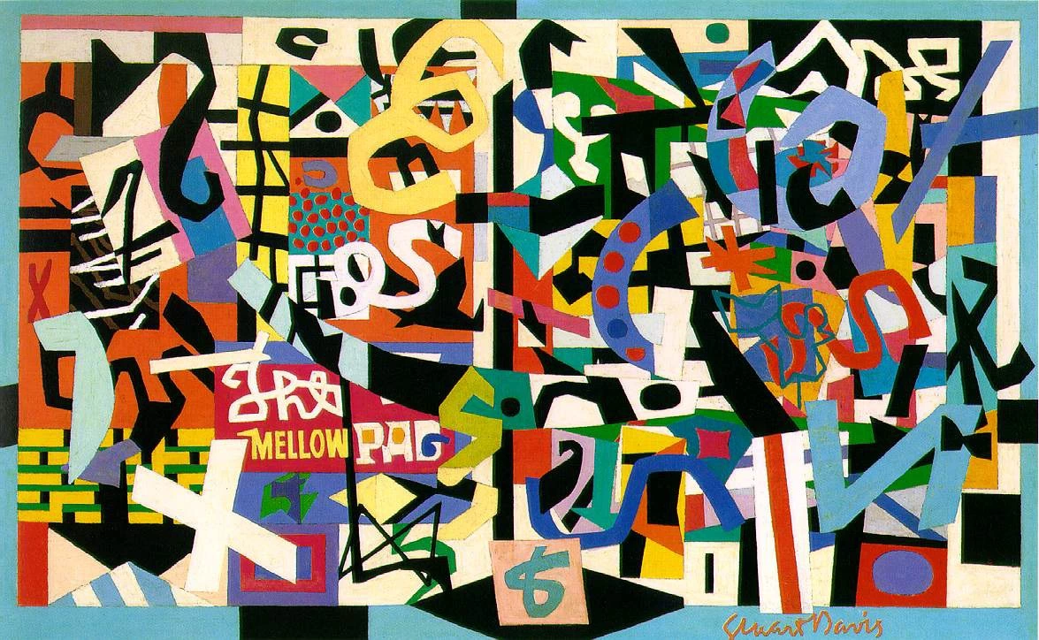

Stuart Davies, like Ben Shahn was a very vocal social critic and became very anti-institutional due to his friendship with John Sloan. Though Davies was in fact a practitioner of the Modern principle way of thinking (something the postmodernists eschew) many of his ideals and thoughts mesh with postmodernity.

His work, as seen left, does not have a structural narrative and is left completely up to the understanding of the one viewing it. Colour plays an important part, something Davies studied in europe whilst trying to improve his work (a trait he prescribed to european modernists). There is an array of numbers and letters, all mixed together forming incoherency, a trait often replicated in the offbeat and often rhythmless music of the age. This mixed with seemingly solid blocks of colour force the eye to create images.
274
https://pelhamcommunications.com/blog/419/

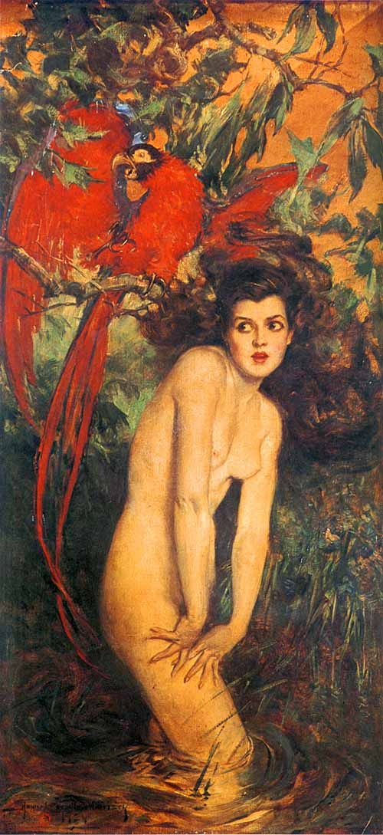
Howard Chandler Christy’s art is different from the others I have chosen.Though he is not connected the music of jazz, he was one of the most prolific painters of the early jazz age ( Though his style is more reminiscent of the impressionist painters. And yet his ideals were so wholly modern, or rather postmodern). His attitudes towards women in his paintings helped transform societal attitudes towards women. It was subtly groundbreaking and often, Christy would be influential enough to create fashion trends amongst the upper gentry.

I have chosen this particular piece though, because the colours and the subject of the piece. Women being depicted as overtly feminine or sexual during the lead up to the jazz age, were seen in a negative light. The colours are earthy and vivid, reminding me of the more earth toned works of both Ben Shahn and David Stone Martin. It’s eye catching, and like the other paintings i have chosen to display, it is without context. It is down to the individual viewer to discern what the painting means.

I believe that through the use of ambiguity in these paintings, that the artist can truly connect to it’s viewers and put their points across without being overt in their symbolism. As Sontag and Hissan said Postmodernism is “resistant to a certain interpretation”. It can not be pushed, it can not be told. It is down to you, the individual to discern what the art means to you.

https://www.pinterest.co.uk/pin/392446555005066789/

Reference:

Epistrophy.fr. (2018). [online] Available at: https://www.epistrophy.fr/IMG/pdf/cfp-epistrophy-jazzandmodernity_.pdf [Accessed 2 April 2018].
245

Nicholson, S. (1999). Everyone his own leader in postmodern jazz. [online] The Independent. Available at: https://www.independent.co.uk/arts-entertainment/music/news/everyone-his-own-leader-in-postmodern-jazz-743837.html [Accessed 2 April 2018].

ArtfixDaily. (2018). The Jazz Age: American Style in the 1920s. [online] Available at: http://www.artfixdaily.com/artwire/release/8860-the-jazz-age-american-style-in-the-1920s [Accessed 1 April 2018].

Voices of East Anglia. (2012). The Art of Jazz - David Stone Martin – Voices of East Anglia. [online] Available at: http://www.voicesofeastanglia.com/2012/04/the-art-of-jazz-david-stone-martin.html [Accessed 1 april 2018].

Tate. (2018). Ben Shahn 1898-1969 | Tate . [online] Available at:

http://www.tate.org.uk/art/artists/ben-shahn-1930 [Accessed 1 April 2018].

Butler, C. (2002). Postmodernism: A Very Short Introduction. Oxford: Oxford University Press.

Head, J. (n.d.). An affair with beauty.

Fordham, J. (2007). Jed Williams was the guiding hand of Welsh jazz. [online] the Guardian. Available at: https://www.theguardian.com/music/musicblog/2007/aug/08/jedwilliamswastheguidingh [Accessed 2 April 2018].

Telegraph.co.uk. (2009). Britain's most important jazz venues - full list of nominees . [online] Available at: https://www.telegraph.co.uk/culture/music/music-news/5966047/Britains-most-important-jazz-venues-full-list-of-nominees.html [Accessed 2 April 2018].

K. Pohl, F. and Shahn, B. (1993). Ben Shahn. Chameleon books.

Morse, John (1972). Ben Shahn. New York: Praeger Publishers Inc.

The Art Story. (2018). Ben Shahn Biography, Art, and Analysis of Works. [online] Available at: http://www.theartstory.org/artist-shahn-ben.htm [Accessed 8 May 2018].

