University of Wales Trinity Saint David

Wales Institute of Science & Art



Structural Design and Fluid Analysis
ACHA6010

Ollie Harrison
2003607
December 2023

Contents:

- Introduction ………………………………………………………………………………………. p3
- Literature Review ……………………………………………………………………………….p4
  - Ansys CAE………………………………………………………………………………………
  - Ansys Granta…………………………………………………………………………………
- Project Scope and Objectives……………………………………………………………… p5
- Methodology…………………………………………………………………………………….. p6
  - Validation examples………………………………………………………………………
    - Bi-metallic Strip……………………………………………………………………
    - Canti-lever Uniform Load…………………………………………………….. p7
  - Fully Linked System………………………………………………………………………. p8
- Results Evaluation ……………………………………………………………………………. p10
  - Validation test results…………………………………………………………………..
    - Bi-Metallic Strip……………………………………………………………………
    - Canti-lever Uniform Load……………………………………………………… p11
  - Fully Linked System……………………………………………………………………… p12
    - Piston Iteration – Original……………………………………………………
    - Piston Iteration – 1 ……………………………………………………………. p13
    - Piston Iteration – 2 ……………………………………………………………. p14
    - Piston Iteration – 3 (final) …………………………………………………. p15
- Conclusion ……………………………………………………………………………………… p16

- Introduction

In the dynamic realm of engineering, Computer Aided Engineering (CAE) tools have emerged as pivotal instruments, shaping the landscape of design and testing processes over recent decades. This assignment demonstrates the usefulness of the software and the need for its use in the engineering world. The primary objective is to evaluate the understanding of CAE methodologies, focusing on their practical implementation in a simulated real-world scenario. To ensure the fidelity of the assessment, a stringent validation process is prescribed. This involves comparing analytical solutions with results derived from the powerful CAE software, ANSYS, and scrutinizing the impact of mesh sizing on result accuracy. This report synthesizes these intricate elements, illuminating the role of CAE tools in engineering design, all while navigating the fine line of their inherent limitations. Recognizing the need for constant improvement in the efficiency of an ICE, a dedicated section within this project tackles the improvement of engine components such as the piston. This involves a judicious exploration of design alterations within the constraints posed by CAE limitations.

- Literature Review
  - Ansys CAE
ANSYS Mechanical is a dynamic finite element analysis (FEA) tool that empowers engineers to address complex structural engineering challenges. With a reliable solver technology, it offers a complete range of analysis tools and a customizable interface for engineers of all levels. The software extends its capabilities to rotating machinery equipment design, enabling iterative improvements before manufacturing and testing. ANSYS Mechanical emphasizes structural durability, reliability, increased efficiency, process integration, and predictive maintenance. Streamlined workflows and validated results across industries make it a high-performance software, reducing manufacturing costs and test time while enhancing engineering efficiency.
  - Ansys Granta
ANSYS Granta is a powerful engineering data library software, meticulously curated for engineers by a team of material data analysts. Specifically designed for simulation, it seamlessly integrates into ANSYS flagship simulation solvers, including Ansys Mechanical, Ansys Electronics Desktop, Ansys Fluent, and Ansys Discovery. Offering instant access to a comprehensive database of over 2,600 simulation-ready Generic and Producer Grade Materials, Granta MDS stands out for its efficiency in delivering accurate and validated materials property data.
With 20+ materials properties across 11 different material classes, Granta MDS ensures engineers can easily access and apply the right materials information directly within their ANSYS user interface. The software's capacity to enhance simulation models is underlined by its focus on structural, thermal, and electromagnetic properties. Recognized for providing consistent, validated, and ready-to-use data, ANSYS Granta empowers engineers to refine and validate products efficiently during the development stage, optimizing them for manufacturability, durability, sustainability, and more.

- Project Scope and Objectives
The scope of this project is to comprehensively explore the capabilities and limitations of Computer Aided Engineering (CAE) tools in simulating and optimizing real-world systems. The objectives encompass a multi-faceted examination, starting with a thorough validation process. Validation examples will involve the comparison of CAE results, specifically in the context of deformation under varying heat and load conditions, against analytical solutions. To ensure result robustness, a mesh independence study will be conducted, critically assessing the impact of mesh sizing on the accuracy of outcomes.
The focal point of the study will be on a piston assembly within an engine, necessitating a detailed kinematic analysis, thermal influence assessment, and structural analysis. The objective is to emulate realistic working conditions and explore the intricate interplay of forces, heat, and structural integrity. An iterative design approach will be applied to the piston, using CAE feedback to refine the design and optimize its performance. This iterative process allows for a continuous cycle of analysis, learning, and improvement, demonstrating the practical application of CAE in the enhancement of engine components. Through these objectives, this project aims to provide valuable insights into the utility of CAE tools in tackling real-world engineering challenges.

- Methodology
  - Validation examples
    - Bi-metallic Strip
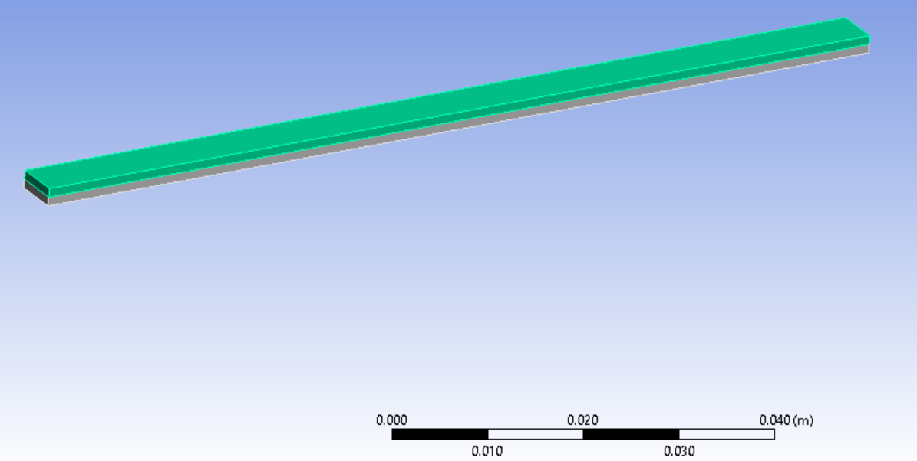
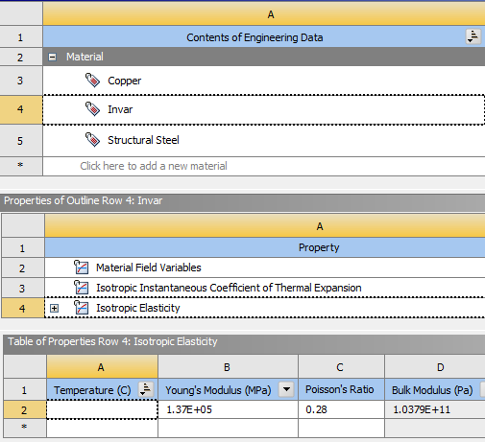
The initial setup for the Bi-metallic Strip case can be completed in Ansys Workbench 2021 using the Static Structural component system from the list provided, Ansys (2021). The two metals present in the strip are Copper, and Invar which is an alloy of iron and nickel known for its invariability in dimensions under heating, Britannica (2016). The relevant material property information is included with the engineering data (figure 1), this step is crucial for obtaining accurate results as without the correct property data the results will never be valid. In Solidworks the strip assembly is created with the dimensions specified, and when loaded in Static Structural solver the materials are assigned with Invar layered below the copper, and one end of the strip fixed with a Fixed Support (figure 2). The simulation is run with a small mesh size of 0.25mm per element and heated for an increase of 100ºC.
Figure 1
Bi-Metallic Strip | Table #1
mesh size (mm) | 0.25
thermal condition (°C) | 100
Length (mm) | 100
Width(mm) | 5
Thickness (mm) | 1

Figure 2

    - Canti-Lever Uniform Load

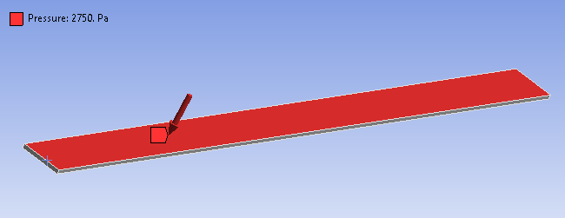
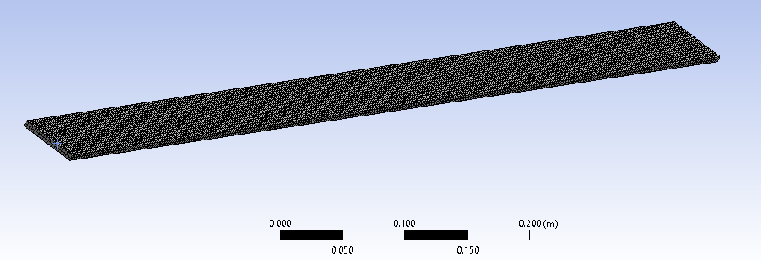
The Canti-Lever simulation is run with a pressure applied instead of a temperature increase, using Elastic-Plastic as the beams material. This material has a high Modulus of Elasticity and Shear Modulus, which means it is highly resistant to permanent deformation, Instron (2020). With one end assigned with a Fixed Support a uniform load in the form of 2750 Pascals (figure 4) of pressure is directed down on the topside of the beam. An Initial mesh size of 2.5mm (figure 3) is used to capture the deformation profile. The dimensions can be seen in Table 2 below.
Figure 3
Figure 4
Canti-lever with Uniform Load | Table #2
mesh size(mm) | 2.5
pressure (Pa) | 2750
Length (mm) | 1000
Width (mm) | 50
Thickness (mm) | 5

  - Fully Linked System
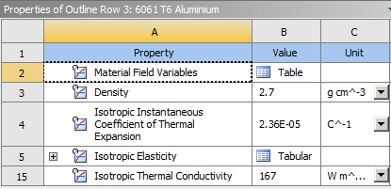
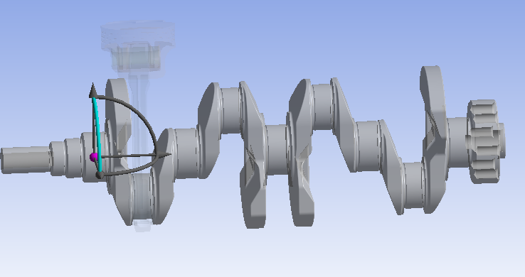
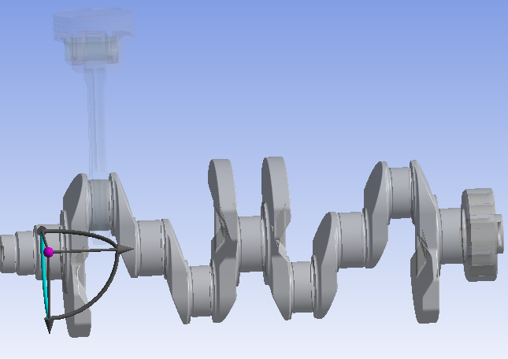
In the Fully Linked System of crankshaft, con-rod, Gudgeon pin and piston there are two different metals assigned to the geometry (figure 5). Structural steel is assigned to all but the piston, which is given 6061 T6 Aluminium. The material assignment for all the parts other than the piston is not important since the parts are all rigid bodies and will not be tested to produce results. This alloy of aluminium is used in the production of pistons for its high strength attributes, aalco (2018). For the system to function as a working crankshaft would, Revolute joints are added between the necessary components and a general joint is included between Ground-Piston so that the piston is free in Z axis and moves vertically up and down with the rotation of the crankshaft (figures 6&7).
Figure 5
Figure 6
Fully Linked System - Piston It. 0 | Table #3
mesh size(mm) | 4
underside mesh size (mm) | 2
topside mesh size (mm) | 2
RPM | 4000
With this, the rigid dynamics section is complete, and the Static structural component can be modified. Supressing all other bodies, we focus on the piston giving it an overall mesh plus face sizing meshes for topside and bottom side of the piston (Table 3). The Piston is defined as a flexible body instead of rigid so that we see some deformation. In this section we also bring in the Motion loads from the rigid dynamic’s component.
Figure 7

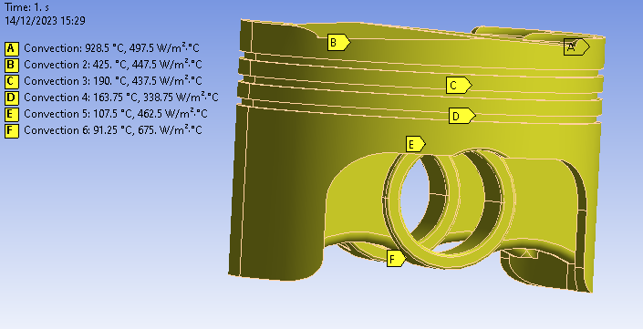
To achieve an accurate temperature profile on the piston we must include Film Coefficient and Ambient Temperature data to the different sections of the piston (figure 8). Ansys (2020) state that the Film Coefficient can be thought of the amount of ‘heat flux’ needed to cause one unit difference in temperature between the bulk and surface temperature. With the Steady-state thermal component complete we are almost ready to solve, the final step before solving the simulation is to turn ON weak springs to add constraint to the geometry so that it is supported.
Figure 8

- Results Evaluation
  - Validation test results
    - Bi-Metallic Strip

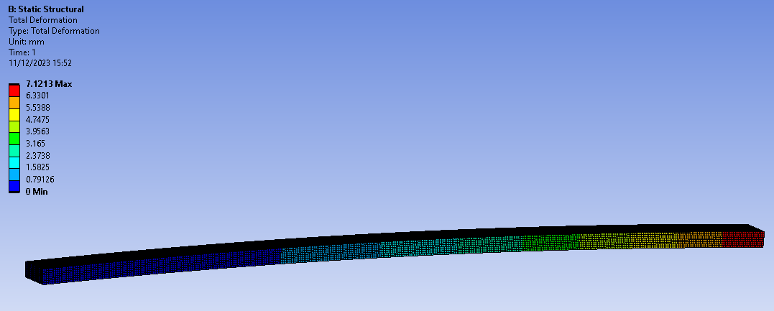
When a heat increase of 100ºC is applied to the Bi-metallic strip of the dimensions specified, the deformation profile on the unfixed end is as shown below, with a max deformation of about 7.12 depending on mesh size (figure 9). This model had a mesh element size of 0.25mm. The analytical method below validates the results with an almost 99% accuracy, the deviation could be due to the engineering data entered for materials. A study of tip deflection on a copper-steel bi-metallic strip by Khan, Muhammad Talha (2021), found a 2mm difference in deflection between the formulation (figure 10) and simulation methods, a 1.59% error. After completing a mesh independence study on the Bi-metallic strip with a mesh element size from 0.1mm to 3mm (Table #4), the smallest mesh size as expected produced the highest % accuracy at 98.9986 %. This is a smaller error than what was found in the tip deflection study, with both studies completed on ANSYS. These factors all contribute to validating the simulation.
Figure 9
Figure 10
Bi-Metallic Strip (Table #4)
Mesh size (mm) | Max Deformation | % accuracy to analytics
0.1 | 7.1203 | 98.9986
0.25 | 7.1213 | 98.9847
0.5 | 7.123 | 98.9611
1 | 7.1233 | 98.9569
2 | 7.1224 | 98.9694
3 | 7.1213 | 98.9847

    - Canti-lever Uniform Load

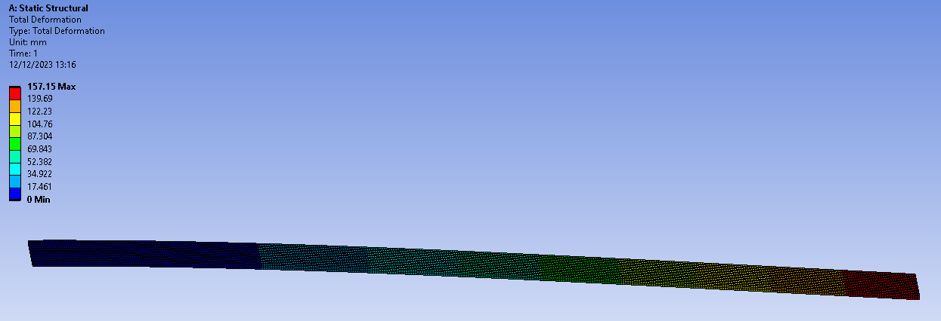
The Canti-lever, made from an Elastic-Plastic when loaded uniformly with 2750 Pa (figure 13) and fixed at one end, shows considerable deformation under the load. Using a mesh element size of 2.5mm the simulation predicted 157.15mm max deformation (figure 11), which has a 99.995% accuracy to the analytical method shown below (figure 12). A study on Stress and Deflection of a Canitlever Beam by M. Qais Malikzada (2018) using ANSYS predicted the deflection of the beam to be of 98.766% accuracy to the analytical solution. This combined with our own more accurate simulation results validates the software ability to predict deformation.

Figure 11

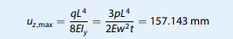

Figure 12

Figure 13

  - Fully Linked System
    - Piston Iteration - original

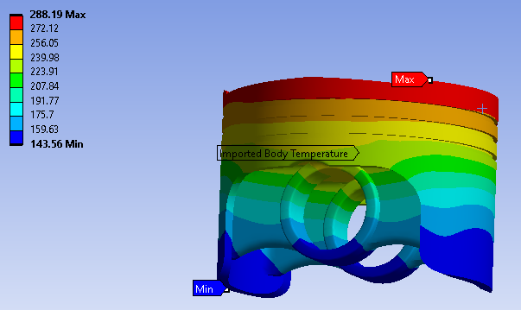
When completing an analysis of the forces and resultant deformation/stress on a piston in a fully linked crankshaft driven system, the results gathered vary with piston model iterations, bar the temperature profile which is similar across the iterations as the Film Coefficient and ambient temperature data input is the same, with only minor model changes.
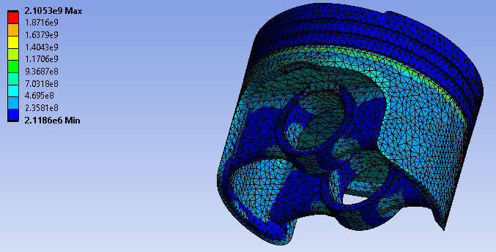
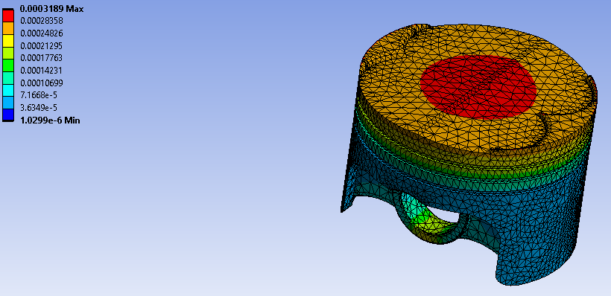
The max deformation seen across the piston geometry is located top and centre, with a size of 3.189e-1 mm. Some deformation can also be seen on the underside at the Gudgeon pin joint but not to an excessive extent. In a paper on the design and analysis of pistons, M.Viswanath (2021), the max deformation recorded in the simulation of the piston (Copper Alloy) was 3.687e-1 mm. From this we can be reasonably sure of the validity of the simulation, and it is likely that 6062 T6 Aluminium has similar properties to the Copper alloy used in the study referenced.
Figure 15
Figure 14
The Stress (von mises) distribution displayed (figure 16) illustrates the location of maximum compressive force, seen just above where the Gudgeon pin/Con-rod applies force up into the piston.
Figure 16

    - Piston Iteration - 1
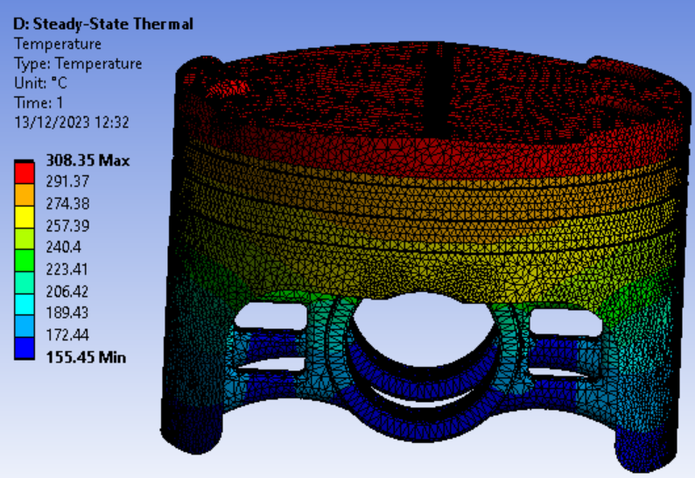
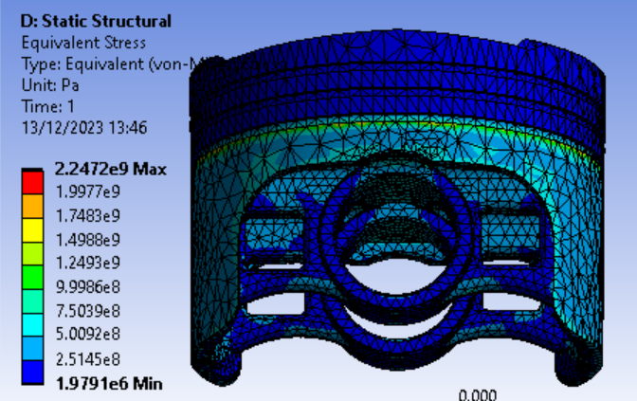
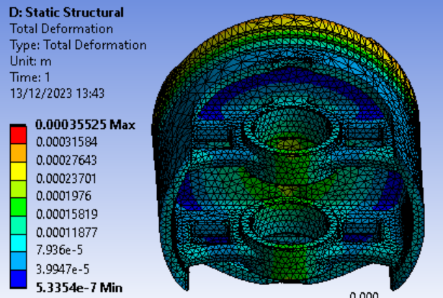
The first piston model iteration has been altered to reduce the piston mass by making cut outs from some of the underside wall material. This has had a significant effect on some of the data gathered from the simulation. The maximum calculated temperature (figure 17) of Piston Iteration 1 was 308.25ºC, which is an increase of 20ºC from the original piston.
Figure 19
Figure 18
Figure 17

The maximum calculated deformation for this piston iteration is higher than that of the original, however more importantly there is only very minor deformation around the areas with material removed (figure 18), therefore this modification is a possible improvement in overall weight and inertia reduction.

When analysing the equivalent stress of the piston (figure 19) in comparison to the original piston stress profile it is hard to see any change, which is not a bad thing to know that there is not an increase.

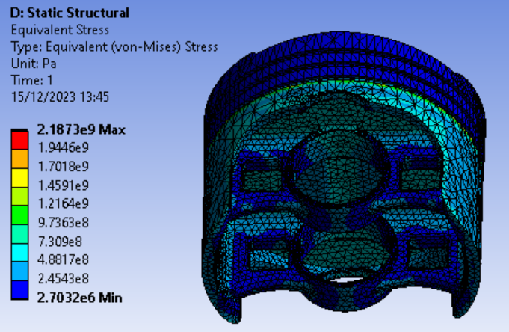
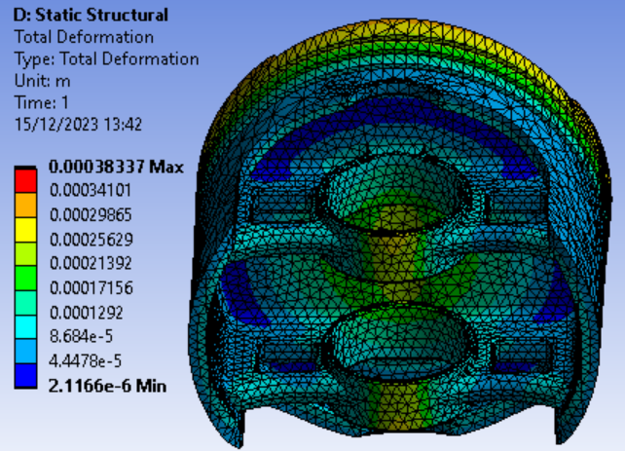
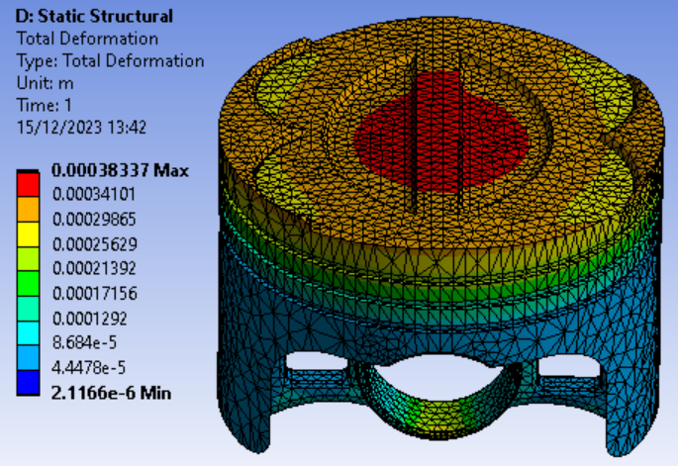
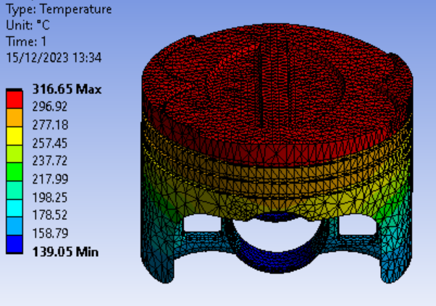
    - Piston Iteration – 2
Figure 23
Figure 22
Figure 21
Figure 20

The second piston iteration involved two changes made to the model geometry, a 1.5mm cut into the top surface of the piston and a radial wall thickness reduction around where the Gudgeon pin fits. When analysing the temperature of the piston there are a few noticeable differences from the previous iterations (figure 20). The maximum temperature had another increase of 8ºC this time, while the minimum temperature decreased. This decrease tells us this iteration has greater heat dissipation capabilities.
Analysing the changes in deformation on the top of the piston we see a reduction in deformation on the outer edges of the circular face (figure 21). Since the maximum value has also increased since the previous iteration, this indicates that the deformation is now more centrally concentrated, which could increase the pistons lifetime as deformation is more detrimental on the outer edges. On the underside of the piston however, where the radial wall thickness has been reduced the deformation has increased significantly (figure 22). Since this is a point of large force input and rapid direction change, we may want to revert this modification to ensure a long-life piston.
The stress profile appears mostly the same without much change other than a slight decrease in maximum recorded stress in comparison to the previous iteration.

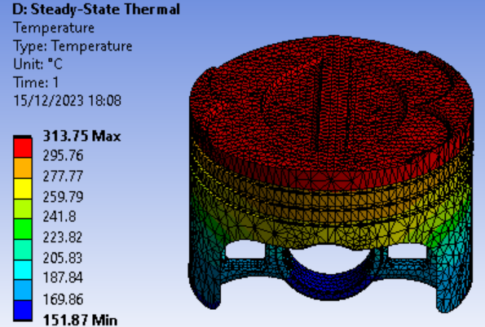

    - Piston Iteration – 3 (final)
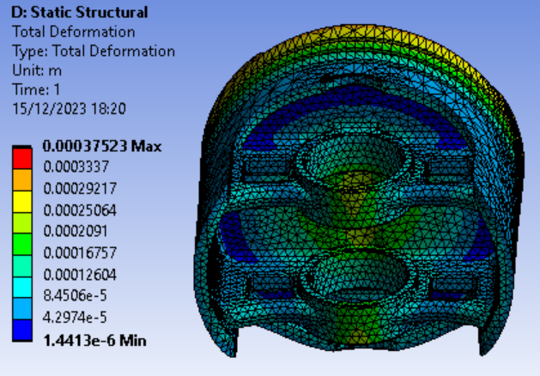
Figure 24
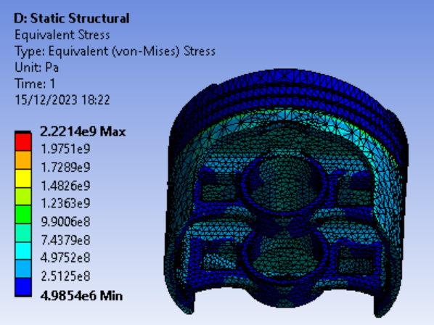
The final iteration of the piston geometry run in Ansys is identical to the 2nd except the radial wall thickness of the Gudgeon pin hole has been reverted to its original size, so that the pistons lifetime is not durastically reduced. The maximum temperature has dropped a few degrees due to increase in mass, while the minimum has increased (figure 24). This indicates a reduction in heat dissipation rate. In a study on Thermal load characteristics by CM Peng (2018) it was recorded that the skirt temperature remains mostly the same throughout a crank rotation (about 400 K). It should be noted that across all iterations that were tested we did not see temperatures too dissimilar to this.
Figure 27
Figure 26
Reverting the Gudgeon pin hole radius has lowered the minimum deformation while maintaining the centrally focused deformation on the top surface (figure 25).
The stress profile remains mostly unchanged from previous iterations.

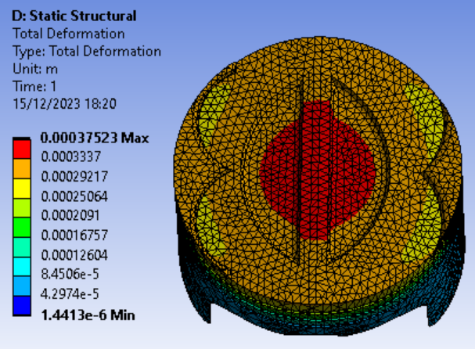
Figure 25

- Conclusion

To conclude this report, using the simulations run along with the analytical validation and online sources we can confidently assume validity of the CAE software and its use in a professional environment. With the piston iterative design aspect, using the results from Ansys we now have a better understanding of the possible improvements available and the effects they will have on the lifecycle of a piston. To get an even better understanding, the process could be expanded by varying the forces involved and rotational speeds.

References:

- Ansys Workbench overview, Ansys (2021) https://www.ansys.com/en-gb/products/ansys-workbench Accessed on: 13/12/2023
- Britannica, The Editors of Encyclopaedia. "Invar". Encyclopedia Britannica, 17 Jun. 2016, https://www.britannica.com/technology/Invar. Accessed 13 December 2023.
- Modulus of Elasticity, INSTRON (2020) https://www.instron.com/en/resources/glossary/modulus-of-elasticity Accessed on: 14/12/2023
- Aluminium Alloy 6061 – T6 Extrusions, aalco (2018) file:///C:/Users/2003607/Downloads/Aalco-Metals-Ltd_Aluminium-Alloy-6061-T6-Extrusions_145.pdf Accessed on: 14/12/2023
- Film Coefficient, Ansys (2020) https://courses.ansys.com/wp-content/uploads/2020/08/Lesson-2-Film-Coefficient-tp.pdf Accessed on: 14/12/2023
- Khan, Muhammad Talha & Afzal, Dr & Javaid, Farah & Tayyaba, Engr. Dr. Shahzadi & Ashrf, Muhammad & Hossain, M. Khalid. (2021). Study of Tip Deflection on a Copper-Steel bimetallic Strip by Fuzzy Logic and ANSYS Static Structural. Proceedings of International Exchange and Innovation Conference on Engineering & Sciences (IEICES). 7. 10.5109/4738596. Accessed on: 16/12/2023
- Stress and Deflection Analysis of Cantilever Beam under Different Load Configuration and Its Validation Using ANSYS, M. Qais Malikzada (2018) file:///C:/Users/User/Downloads/Stress_and_Deflection_Analysis_of_Cantil.pdf Accessed on: 16/12/2023
- Design and Analysis of Piston on Different Materials using CAE Tools (page 6), M.Viswanath (2021) https://www.ijert.org/research/design-and-analysis-of-piston-on-different-materials-using-cae-tools-IJERTCONV9IS10010.pdf Accessed on: 16/12/2023
- Research On Thermal Load Characteristics Of Piston Based On Fluid-Structure Coupled Heat Transfer, CM Peng (2018) https://iopscience.iop.org/article/10.1088/1757-899X/423/1/012138/pdf Accessed on: 17/12/2023

