BMSW4004
Mariana Codreanu
2118364
Lecturer: Julius Azasoo
Problem solving and decision making
report
Contents
Abstract 2
Introduction 2
1. The nature and impact of NHS- staff shortage on employees and their organisations. 3
2. Analysis of the macro-environmental factors contributing to the NHS – staff shortage. 4
3. Identify potential root causes of the problem 6
4. Identify and evaluate the alternative solutions to staff shortages. 9
5. Implement and monitor the solutions. 10
Conclusion and Recommendations 10
References 12

Abstract

NHS is facing the one of the biggest issues nowadays, staff shortage. In this report will be presented how the problem-solving technical skills are helping in identifying the causes and find the alternative solutions to solve the matter of situation. A serious shortage of skilled specialist, and experienced staff could easily become a catastrophe. Because of the low resources NHS is dealing, less skilled staff is hired temporary to cover their needs, but this solution carries a potential risk to patients and again will cause other significant problems they will have to deal with. To identify and analyse the macroeconomically factors that influence on staff shortage in NHS, it will be used the PESTLE analysis tool. By using the Fishbone diagram, it is easy to reach the root cause of the problem. Grid Analysis is a useful technique to use for making decisions. Was chosen this method because is the most effective one when there are a lot of alternative solutions and many factors to take in consideration. In conclusion will be analyzed the possible solutions and recommendations.

Introduction

The human beings are facing every day with situations which are contradictory, having obstructions that are hard to overcome, or they are experiencing difficulties. To cope with these situations, it is necessary to apply some processes to achieve knowledges to successfully solving the situation or to remove the obstructions.
The definition of the term problem is presented differently, J. Linhart (1976) defines the term problem as an interactive relation between a subject and its surroundings, which incorporate the inner conflict that is solved by the subject by searching of transitions from initial condition to the final condition.
According to R. E. Mayer (1990) problem solving is defined as a summary of the cognitive processes focused on the change of the given state to the final state where the solution procedure is not obvious. It can also be identified as a process to solve a gap between a present situation and a desired goal, where the goal was blocked by known and unknown obstacles. Decision making is the process of selecting one or multiple possible solutions with the scope to achieve the goal.
Problem definition, problem solving, and decision making are inseparable concepts.
Nowadays, NHS staff shortage is one of the biggest issue in England. Workforce shortages are giving significant impact on patients care and staff experience. In the face of pressure to work with this lack of staff and to provide the proper care, it is important to understand the cause of the problem, the factors that are influencing its development, use the date from observational study, to find appropriate possible solutions and ways of implementing them.

The nature and impact of NHS- staff shortage on employees and their organisations.
In the past few years, NHS is facing the most challenging period of staff crisis. To an effective and sustainable delivery of high-quality care, it is essential to develop skilled and supported workforce. As noted in the Health Foundation’s 2016 report on workforce, staffing matters; funding counts, “the current ability of the NHS to deliver its services is being compromised by staff shortages, planning inadequacies and an inability to make best use of skills of available staff”. Unfilled vacancies increase the pressure on the existing staff and, leading to high stress level and absenteeism, that also leads to poor quality services. Overloaded and insufficient staff can also increase the treatment waiting time as shown in (Figure 1.), which is a very alarming factor, untreated patients can lead to mortality increasement.
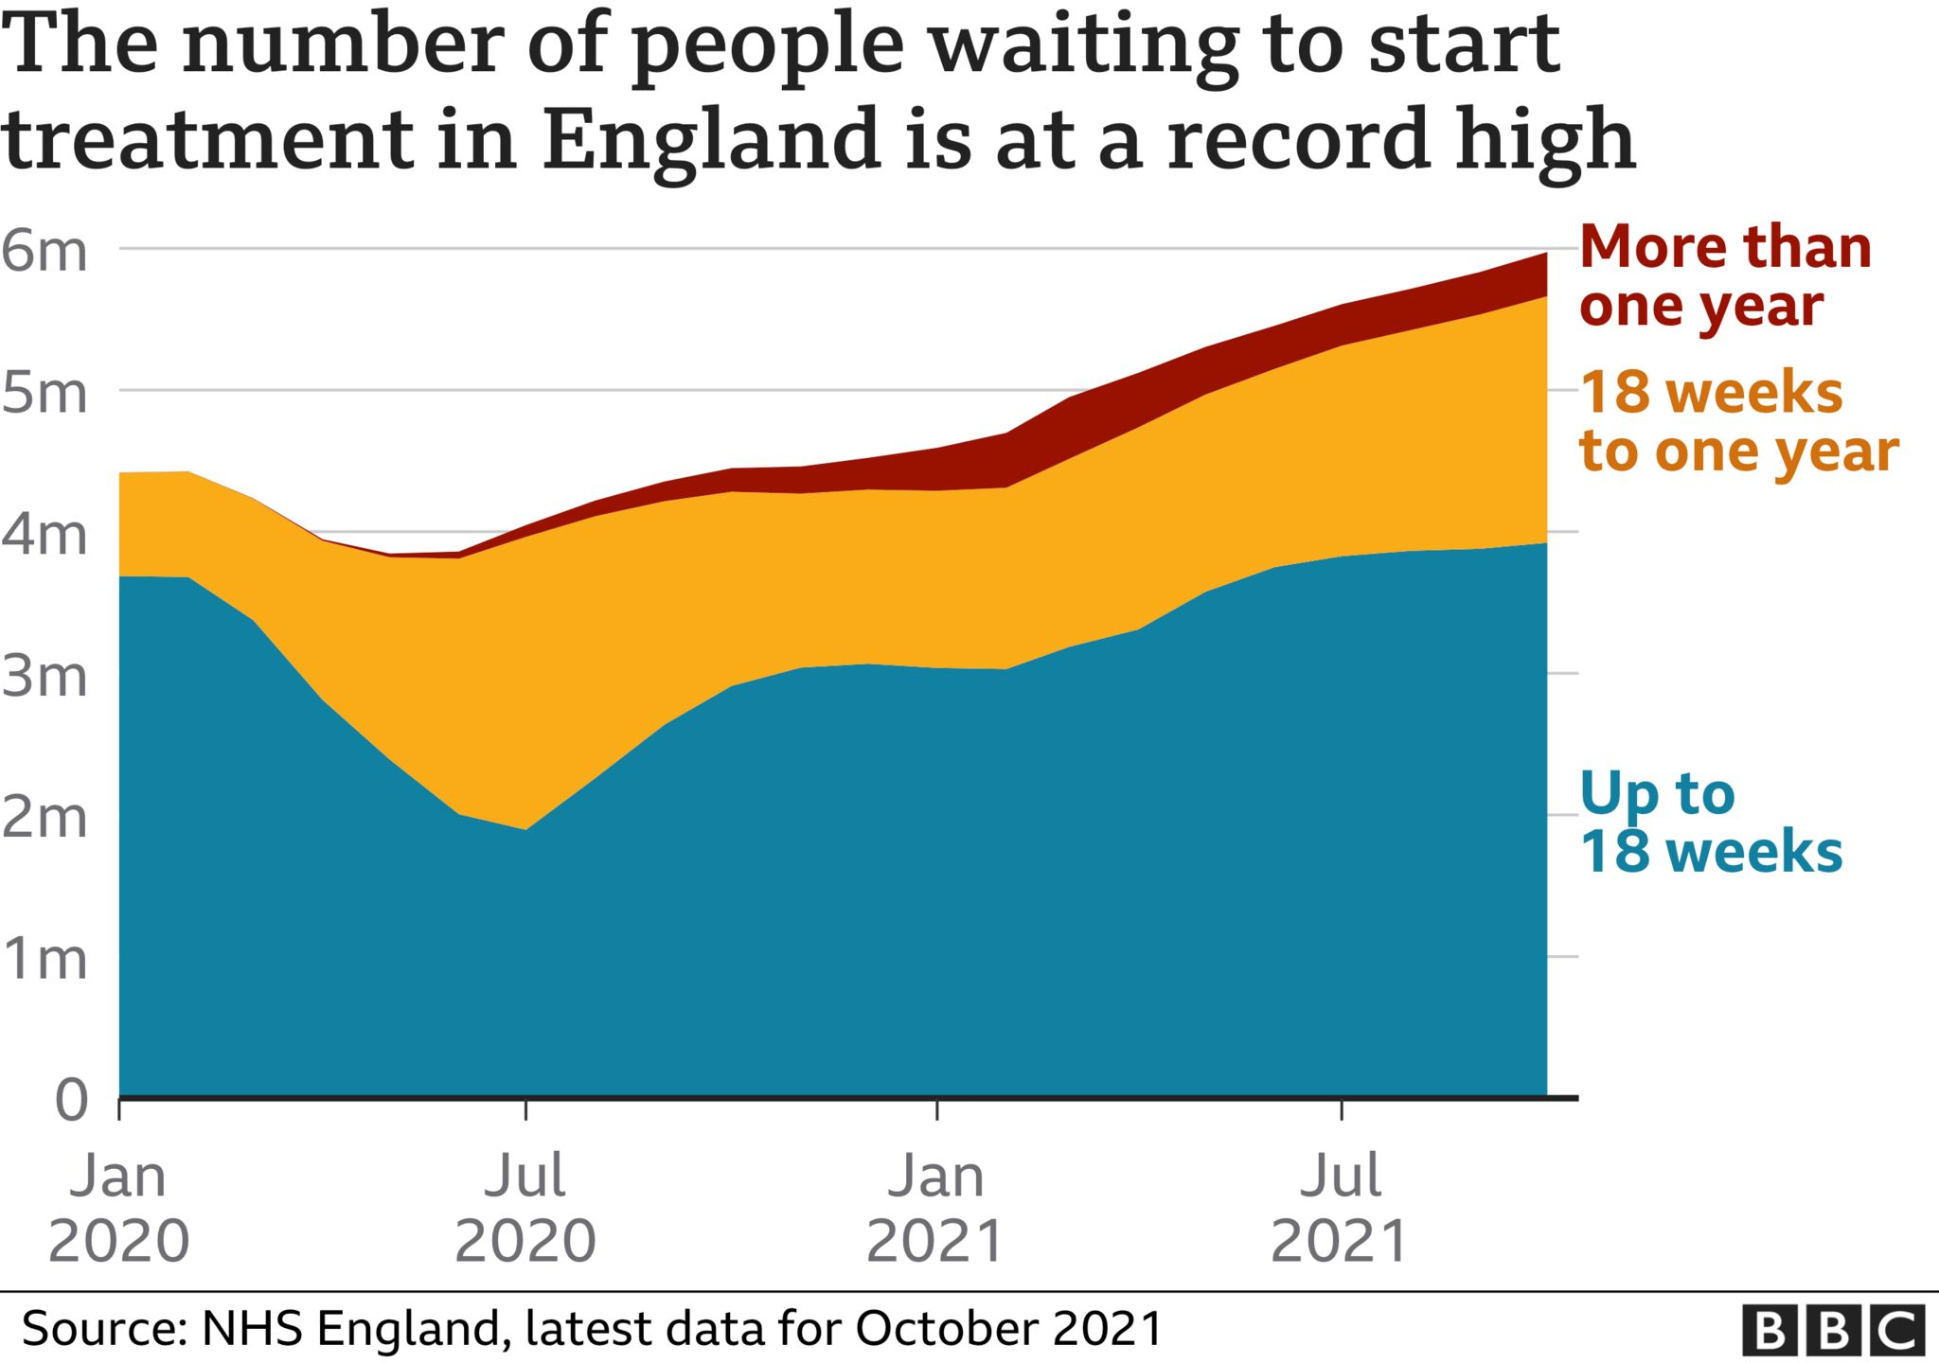
Figure 1. The number of people waiting to start treatment in England from 2020 to 2021.
A serious shortage of skilled specialist, and experienced staff could easily become a catastrophe. Because of the low resources NHS is dealing, less skilled staff is hired temporary to cover their needs, but this solution carries a potential risk to patients and again will cause other significant problems they will have to deal with.
A new report published recently by Health Foundation’s Real Centre, shows significant falls in the NHS nursing force over the last 10 years (Figure 2), and it will continue so, if necessary, measurements won’t be taken. A shortage of nurses may also significantly affect the quality of patient care, with increased waiting time, potential risks to patients’ safety and patient experience.
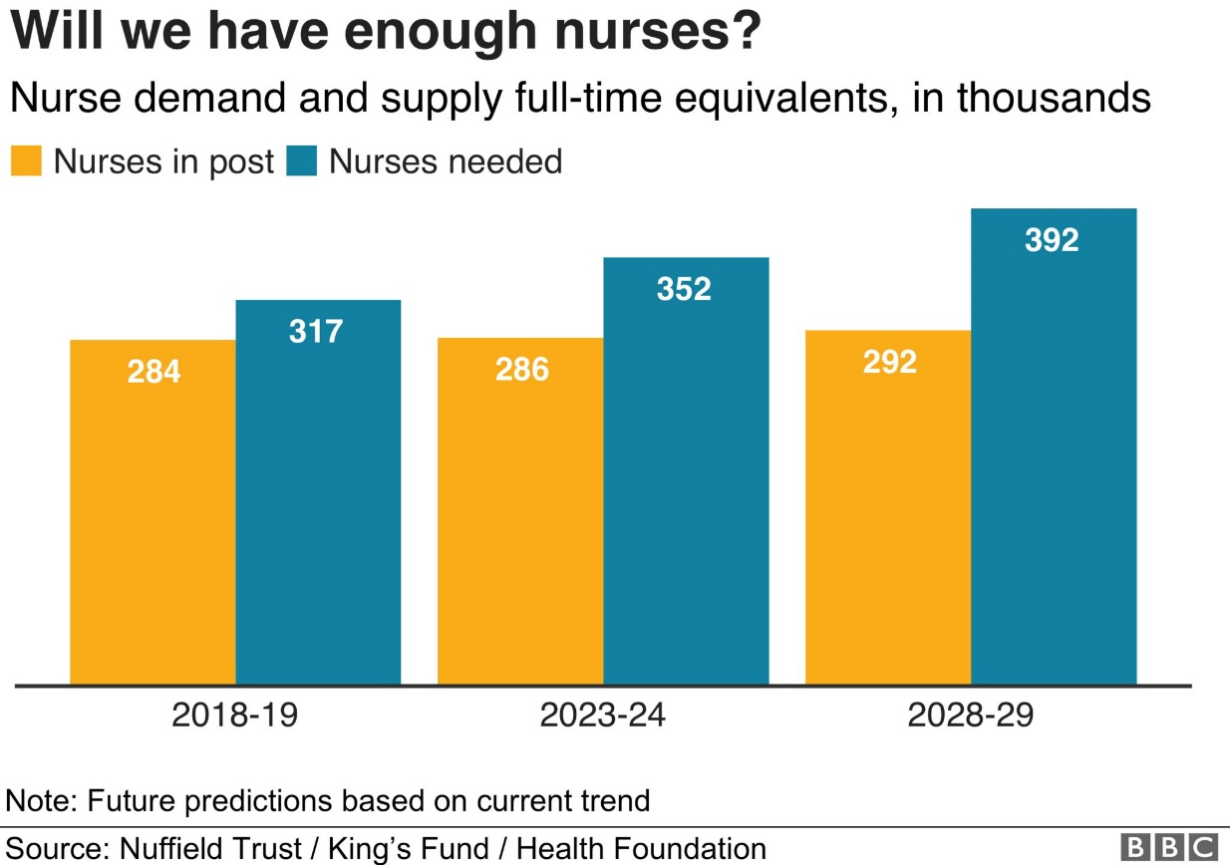
Figure.2. Number of nurses needed and nurses in post

Analysis of the macro-environmental factors contributing to the NHS – staff shortage.

The National Health Services recent years have shown numerous struggles with lack of qualified staff and tough financial standings. To identify and analyse the macroeconomically factors that influence on staff shortage in NHS, it will be used the PESTLE analysis tool. The environment was proved that can be source of threats and opportunities at the same time. The analysis is named PESTLE in reference to the acronym formed by the initials of the macroeconomic variable included in the model (Political, Economic, Social-Cultural, Technological, Legal and Environmental). The model helps in the evaluation process of the dynamic and competitive business envenoming the model appraises each of the key factors, which are directly and indirectly affecting the business performance so that strategies could be developed to overcome the issues for a better market position (Johnson, et 2013).
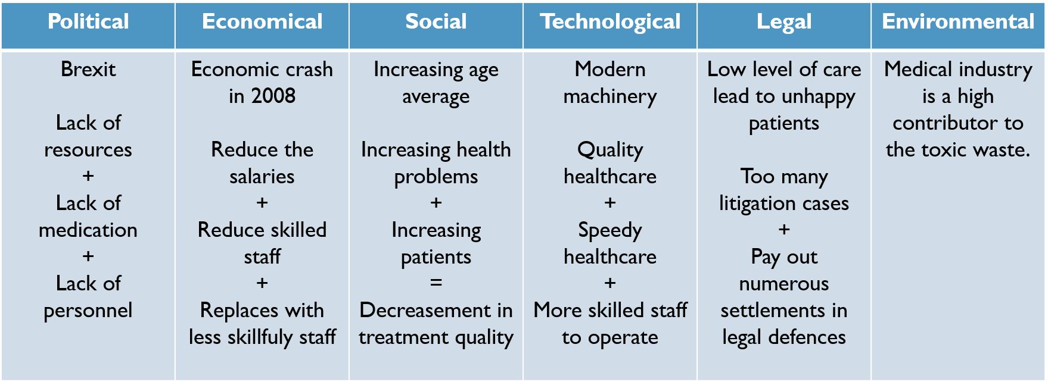

Figure 3. PESTLE analysis of NHS
The healthcare industry is affected directly by pollical factors, within healthcare reforms and insurance coverage. A political major cause was the removal of bursary reform from 1st of August 2017, that make the financial burden more apparent, causing serious financial struggles for staff and students paying for accommodation, travel, or essentials. Another bigger question mark in current UK politics is Brexit. Post Brexit it considers changes in healthcare across multiple areas like medicines and devices, international trade agreements, devolution, procurement, and workforce.
Since the recession of 2008, the economic picture become more changeling. With a low pay the staff cannot provide efficient and quality care for all patients, in the same regard, skilled staff are quitting providing a lack of personnel or a replacement with less skilled staff.
The UK’s aging population is placing an additional stain on NHS. This is one of the social factors that affects the healthcare system. An older population tends to have more health problems that requires more attention and care, that can also be extremely costly to treat and to manage.
With the new technologies, healthcare is being improved. A lot of modern tools are helping to speed the treatments, make them more precisely, and easily managing the patients’ health conditions. These technological improvements are positive for both sides, patients, and organisation, at the same time playing and important role in education, qualifying clinical professionals, that will provide a high level of care.
Medical industry is a high contributor to the toxic waste. This matter brought the attention of the “green” organisations which call upon NHS to develop new programs and to design a healthy built environment.
Covid-19 has forced the world to adapt to new rules and legislations. The healthcare system was one of the most affected by Covid-19. Despite the new legislation in the pandemic that supposed to support the staff as much as possible, it overwhelmed the staff, because of the colossal number of patients they had to take care. Also, because of the risks and the compulsory immunization, most of the staff chose to quite the organisation. In the past years the pandemic caused a massive staff shortage within NHS, this reduced the patients care level, that raised many litigation cases.

Identify potential root causes of the problem

Root cause analysis is a structured process that helps identifying underlying factors or causes of an advert event. A cause-and-effect diagram can also help brainstorming to identify possible causes of a problem. In the following diagram was shown the root cause analysis of staff shortage. The main influencing factors are environment, system, equipment, and people.
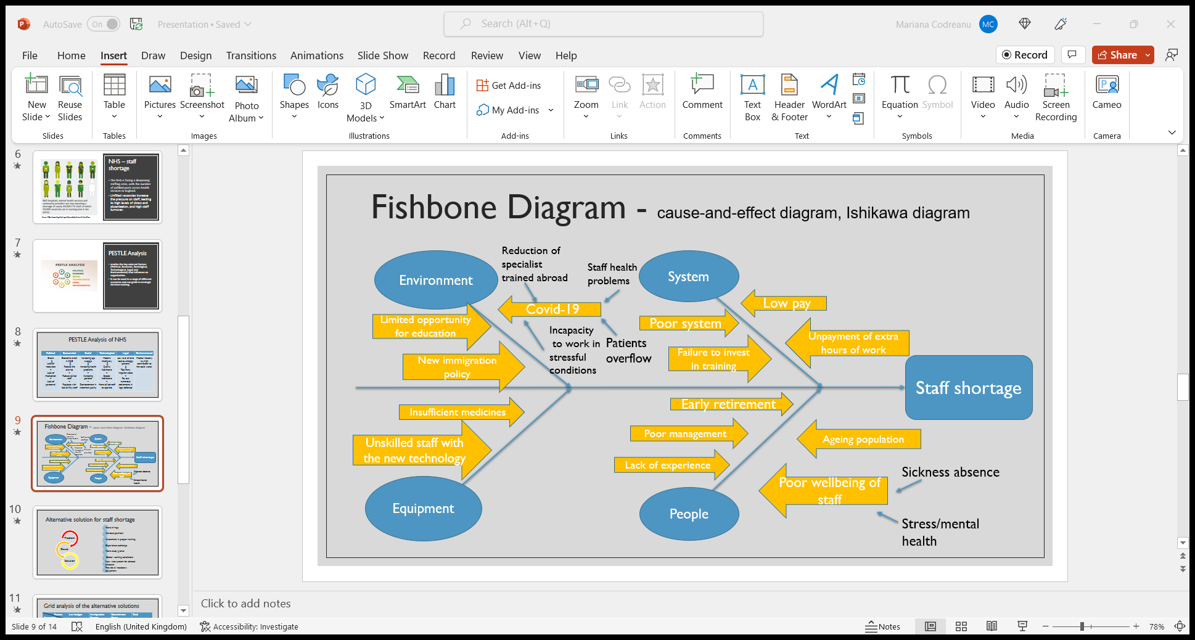
Figure 4. Fishbone diagram of staff shortage.

According to diagram the system is playing a major role on influencing staff shortage. Poor management system can create difficulties for staff to operate properly. Low pay and failure to invest in ongoing training and development are other possible causes of the problem, because of the financial struggle the system is facing. A recent report sustain that healthcare workers get unpaid extra hours; this can be considered an alarming matter of situation.
Considering the possible causes of environmental factor, can underline options like limited opportunities for education, for example the bursaries cut. New immigration policy - post Brexit consequences are quite visible according with the lack of personnel NHS is facing, considering an ample part of joiners to nursing and midwifery are coming from abroad (Figure 5).
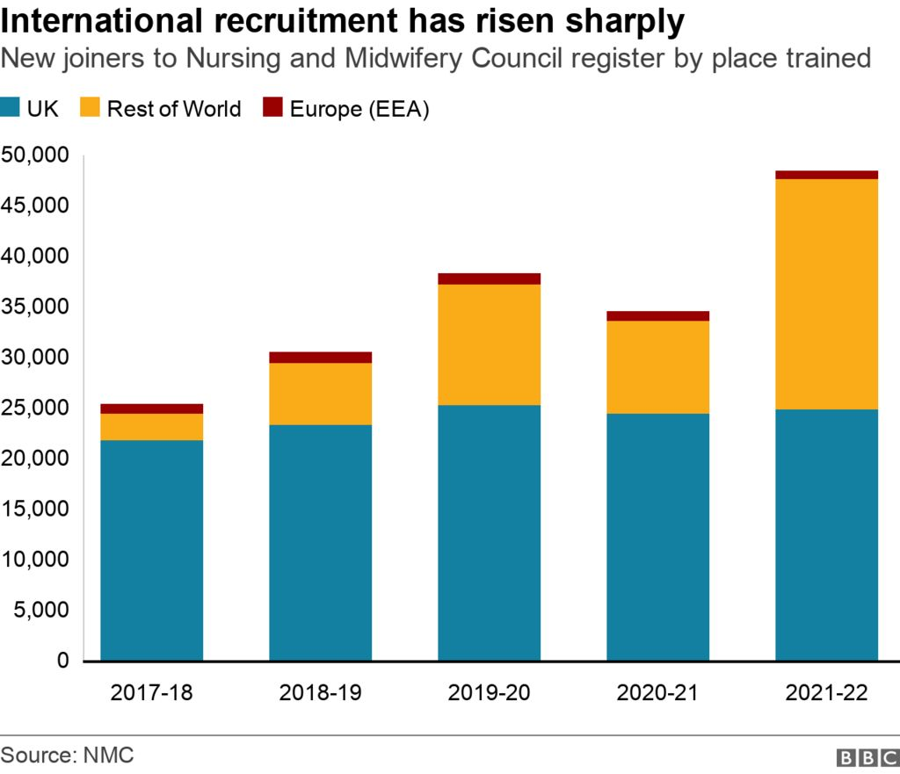
Figure 5. Staff joined to Nursing and Midwifery Council register by place trained.
The Covid-19 factor brought multiple root causes of the main problem. First, this can create patients number overflow, incapacity of staff to work in stressful conditions, high risks, sick leaves, and health problems. The pandemic constituted new travel legislations that influenced the recruitment reduction of specialists trained abroad, including medications and equipment import.
Identifying possible causes of People factor, can list ageing population, which increase the number of people with health problems, poor management, lack of experience of the staff and their poor wellbeing that also could cause stress or mental disorders and calling out for sickness absence. All these causes can contribute to a poor work environment and people are determined to avoid it and will result the lack of personnel.
The financial situation the system is facing is causing multiple problems, from which can be counted an insufficient training for the staff to operate and menage with the new technologies, or insufficient machineries, tools, and medicines necessary for an increased number of patients.
By using the Fishbone diagram, it is easy to reach the root cause of the problem.

Identify and evaluate the alternative solutions to staff shortages.

Considering the problems, the staff faced, can be deducted the following suggestions of alternative solutions:
- More hirings
- Payment increase
- Investment in proper training
- Experience exchange
- More study grants
- Better working conditions
- New visas system for immigration students
- Providing the necessary equipment
An analysis of alternatives is an analytical comparison of the operational effectiveness, costs, and risks of proposed material solutions to gaps and shortfalls in operational capability.
Next step is analysing the possible solutions and subtraction of the most reasonable ones. For this was used a Grid Analytic table, a framework for evaluating ideas and making decision using a set of weighted criteria to rank the ideas (Figure 6).
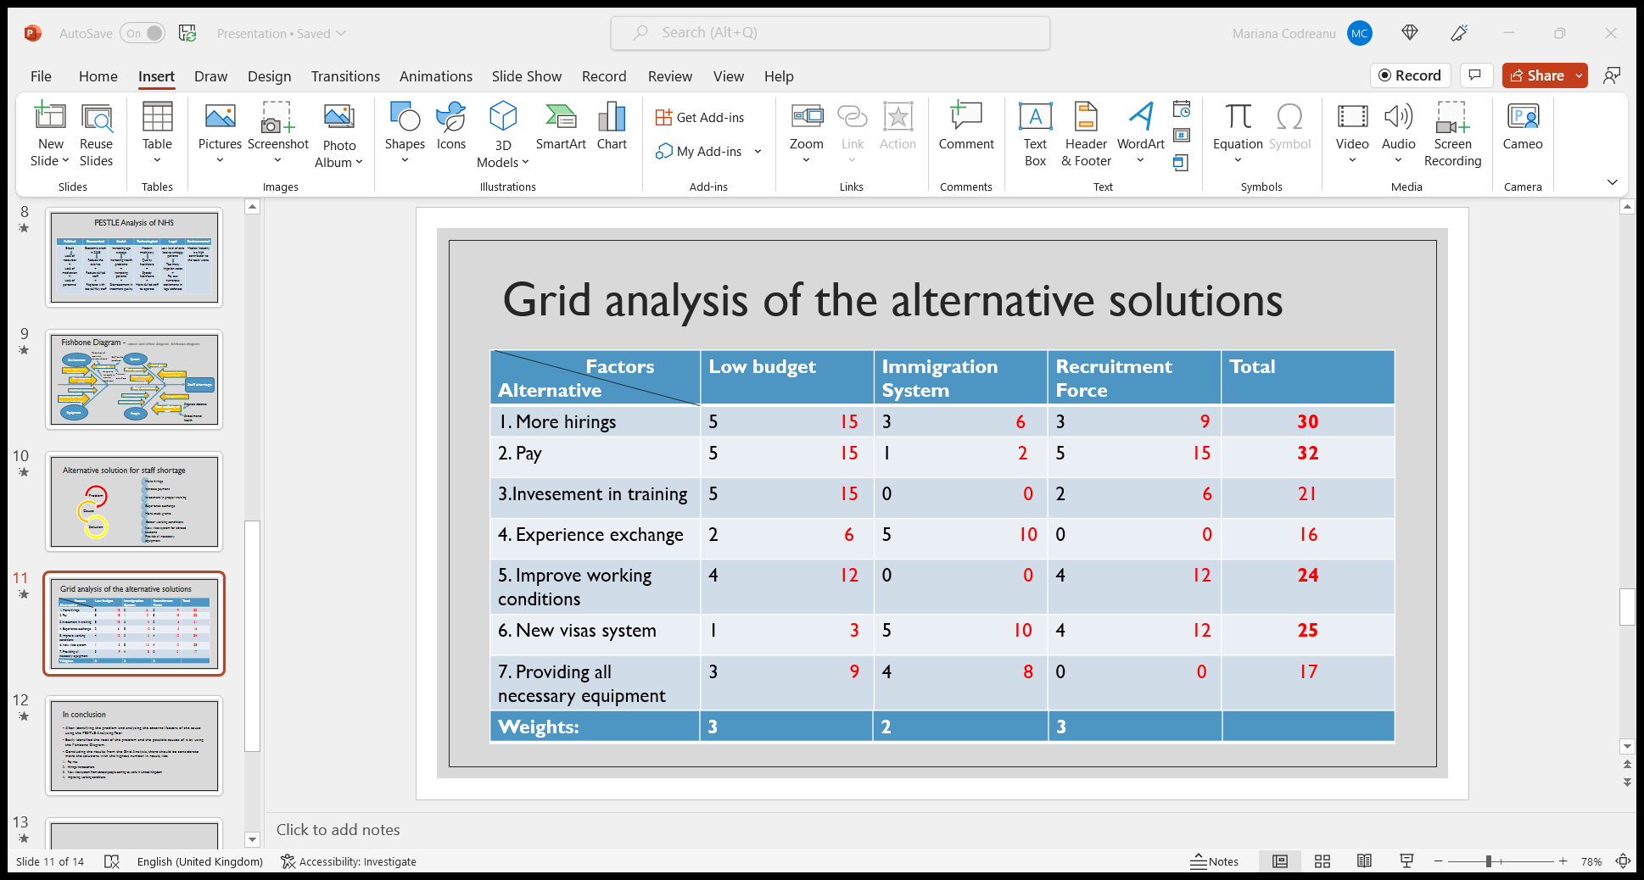
Figure 6. Grid analysis of the alternative solution
The first step was listed the alternative options and then the factors (criteria) that influenced in making decisions. Was created a table, with options as the row labels, and factors as the column headings. A rate on a scale of 0-3 was used, where 3 is the most influenced by the factor. After each solution was rated on a scale of 0 to 5, depending on the influence by the factor from the above. Were selected 7 possible solutions of the problem, in result the higher score reached: payment increase with a 32 score, hiring increase with a 30 score, new visa system for immigrants’ students with a 25 score and better working conditions for employees scored with 24 points.
Grid Analysis is a useful technique to use for making decisions. Was chosen this method because is the most effective one when there are a lot of alternative solutions and many factors to take in consideration.

Implement and monitor the solutions.

The last step in the problem-solving process is to execute or implement the solutions. An essential part of the execution is to convince the others that the conclusions are valid, which requires an effective communication and good management skills. An important role of anchor institutions is to invest in skills and training for local communities, which also benefits organisations themselves through a better skilled and more effective workforce, but NHS providers are being left without the funding needed to provide this.
Firstly, to implement the premiere solution, pay increasement, need to focus on the financial side of NHS. Was talked a lot about the crisis affected the organisation and about how difficult is to confront with expenses, but on another look need an attention on how to influence the earning of NHS. To influence the income of the organisation, need to offer high quality services and care, to attract the stakeholders. Another thing to do is to invest in local communities, that will help to develop local skill-base and affects the root causes of ill health and health inequality. Once the financial position will be improved, easily will be implemented all the alternative solutions noted above.

Conclusion and Recommendations

To effectively run and manage a successful organisation it is very important to develop the problem-solving techniques. Finding a suitable solution for issues can be accomplished by following the basis four steps of the problem-solving process, and these are defining the problem, staff shortage in NHS, analysis of macro-environmental factors that influence the problem, by using PESTLE analysis tool, identify the potential root causes of the problem, using the Fishbone Analysis easily reached on multiple root causes of staff shortage, and the last step was to analyse, identify and implement the higher scored solutions.
As recommendations could identify the following:
- Review relative pay and working conditions for employees
- Supporting flexing routes of work
- Develop detailed regional plans based on demographics and capacity of patients.
- Provide access to work experience to improve work skills.
- Accessibility to study bursaries.

References
- Blech, C. & J. Funke (2010). You cannot have your cake and eat it, too: How induced goal conflicts affect complex problem solving, Open Psychology Journal 3
- British Medical Association (2007) A rational way forward for the NHS in England: a discussion paper outlining an alternative approach to health reform. London: British Medical Association.
- Buchan J, Charlesworth A, Gershlick B, Seccombe I. (2017) Rising Pressure: The NHS Workforce Challenge. Health Foundation.
- Cowper, A. (1AD) ‘The NHS workforce plan is an off-the-scale fantasy’, BMJ. England: BMJ Publishing Group LTD.
- Dayan M, McCarey M, Hervey T, Fahy N, Greer S, Jarman H, Stewart E and Bristow D (2021) Going it alone: health and Brexit in the UK. Research report, Nuffield Trust
- Dayan M, Palmer W. (2018). What’s Really Going on with Nursing Outside Hospital? Nuffield Trust.
- Duncker, K. (1945). On problem solving. Psychological Monographs
- Funke, J. & P. A. Frensch (2007). Complex problem solving: The European perspective – 10 years after, in D. H. Jonassen (ed.), Solve Complex Scientific Problems, Lawrence Erlbaum, New York
- HANNEY, N. and KARAGIC, H., (2019) Responding to the NHS and social care workforce crisis: The enhancement of opportunities through collaborative partnerships. Higher Education, Skills, and Work - Based Learning, 9(2).
- Health Foundation (2018). The Health Care Workforce in England: Make or Break? Health Foundation.
- LIMB, M., (2015). Shortages of skilled NHS staff could “easily become a catastrophe,” Smith Institute says. BMJ: British Medical Journal (Online).
- Linhart, J. (1976). Činnost a poznávání. Academia. Praha.
Macmillan, New York,
- Mayer, R. E. & M. C. Wittrock (1996). Problem Solving Transfer, in R. Calfee, R. Berliner (eds.), Handbook of Educational Psychology,
- Mayer, R. E. (1990). Problem solving, in W. M. Eysenck (ed.), The Blackwell Dictionary of Cognitive Psychology, Basil Blackwell, Oxford,
- Open Democracy, (2016) NHS staff shortage "shock".
- Palmer W, Hutchings R and Leone C (2020) Laying foundations: Attitudes and access to mental health nurse education. Report, Nuffield Trust.
- IACOBUCCI, G., (2019). Ongoing GP shortage puts NHS long term plan at risk, warn experts. BMJ: British Medical Journal (Online).
- Department of Health, (2016). Managing the supply of NHS clinical staff in England, London, National Audit Office,
- Wadsworth, J., Dhingra, S., Ottaviano, G., & Van Reenen, J., (2016). ‘Brexit and the impact of immigration on the UK’, CEP Brexit Analysis n° 5, London, London School of Economics.

