
Level 6

MODULE CODE: BMSS6003

WORD COUNT: 7500 Words
MODULE TUTOR: Alison Connaughton
PROGRAMME: BSc Sport and Exercise Therapy
MODULE: Research Project for Sport and Exercise Therapists
MODULE TITLE: Experimental Dissertation
HAND IN DATE: 04/04/25

Jordan Discombe – 2214228

Word Count – 7902/7500

The Relationship Between Muscle Oxygenation Thresholds and Endurance Performance: A Near-Infrared Spectroscopy Based Analysis

Abstract

Background: Muscle oxygenation thresholds have emerged as potential indicators of endurance performance, yet their relationship with traditional endurance assessments remains unclear. Near-infrared spectroscopy provides a non-invasive method to measure muscle oxygenation dynamics, which could enhance training and performance evaluation.
Objective: This study investigates the correlation between speed at muscle oxygenation thresholds BP1, BP2, and Peak SmO₂ desaturation and endurance performance, as measured by the Cooper Test.
Methods: Thirteen recreationally active individuals completed an incremental treadmill test with NIRS monitoring and a 12-minute maximal running test. Pearson correlation and regression analyses examined the relationships between average speed at BP1, BP2, Peak SmO₂ desaturation thresholds, and average running speed during the CT.
Results: Strong significant positive correlations were found between muscle oxygenation thresholds and average running speed (BP1: r = 0.872, p < 0.001; BP2: r = 0.865, p < 0.001; Peak SmO₂ Desaturation: r = 0.901, p < 0.001). Regression analysis confirmed that CT speed significantly predicts BP1 (R² = 0.760, p < 0.001), BP2 (R² = 0.748, p < 0.001), and Peak SmO₂ (R² = 0.812, p < 0.001) speeds, with Peak SmO₂ desaturation showing the strongest association. However, muscle oxygenation thresholds alone were not fully predictive of endurance performance, suggesting additional physiological and biomechanical factors contribute to individual variability.
Conclusion: Muscle oxygenation thresholds strongly correlate with endurance performance and serve as valuable physiological markers. However, they should be used alongside traditional endurance assessments rather than as standalone predictors. The findings highlight the potential of NIRS-based monitoring for guiding training interventions. Future research should expand sample sizes, conduct longitudinal studies, and compare SmO₂ thresholds with conventional endurance markers to further establish their practical application.
Keywords: Muscle Oxygenation; Near-Infrared Spectroscopy; Endurance Performance; BP1; BP2; Peak SmO₂ Desaturation; Cooper Test; Aerobic Capacity; Physiological Assessment.

Declaration

Undergraduate Dissertation Certificate



Name of the Programme of Study: BSc Sport and Exercise Therapy

Name of Student (Capital Letters): Jordan Discombe

DECLARATION

I certify that the whole of this work is the result of my individual effort, and that all sources have been acknowledged.

Signed ............................................................... (Student)

Date ......10/03/2025......................................

DECLARATION

I am satisfied that this work is the result of the student’s effort.

Signed .............................................................. (Lecturer)

Date ..............................................................

Acknowledgments

I acknowledge the use of Primo Research Assistant Beta (https://librarysearch.uwtsd.ac.uk/discovery/researchAssistant?) on multiple occasions to support me on my research using the prompt(s):
1. Can you provide me with references on…….?.

I acknowledge the use of Microsoft Word Editor (https://www.microsoft.com/en-gb/microsoft-365/word) on multiple occasions to check for the following:
1. Spelling, Grammar, Conciseness and Similarity errors.

I confirm that I have not presented any AI generated text as my own work. I confirm I
have copies of my drafts, notes, and other resources I used before, and after the use of
AI tools which I may be asked to provide in evidence.

I would also like to sincerely thank Geraint Forster for his guidance and support throughout my dissertation. His valuable insights and encouragement have been greatly appreciated.

Table Of Contents
Title……………………....……………………………………………………………………II
Abstract………………………………………………………………………………………III
Declaration………………………………………………………….………………………..IV
Acknowledgments…………………………………………………………………………….V
1.0 Introduction………………………………………………………………………………..1
2.0 Literature Review………………………………………………………………………….5
2.1 Field Based Test (Coopers Test)………………………………………………………6
2.2 Muscle Oxygen Testing……………………………………………………………….7
2.3 Comparing Muscle Oxygen Testing with Traditional Methods………………………9
3.0 Methodology……………………………………………………………………………..12
3.1 Study Design…………………………………………………………………………12
3.2 Pilot Study……………………………………………………………………………12
3.3 Participants…………………………………………………………………………...12
3.4 Ramp test Protocol………………………………………………………………...…14
3.5 Coopers test Protocol………………………………………………………………...14
3.6 Equipment……………………………………………………………………………15
3.7 Data Collection Procedures………………………………………………………….15
3.8 Data Analysis………………………………………………………………………...15
3.9 Ethical Considerations……………………………………………………………….16
3.10 Rationale for Methodological Choices……………………………………………..16
3.11 Limitations………………………………………………………………………….17
4.0 Results…………………………………………………………………………………....18
4.1 Muscle Oxygenation Data…………………………………………………………….18
4.2 Coopers test Performance……………………………………………………………..19
4.3 Borg Scale Ratings and RPE Exertion Trends………….…………………………….20
4.4 Correlation and Regression Analysis………………………………………………....21
4.5 Summary of Key Findings…………………………………………………………....22
5.0 Discussion………………………………………………………………………………..24
5.1 Summary of Key Findings…………………………………………………………....24
5.2 Physiological Meaning of Results………………………………………………….…24
5.3 Comparison with Previous Studies…….………………………………………….......25

5.4 Influence of External Factors……………………………………………………….....26

5.5 Application for Coaches and Athletes…………………………………………………26

5.6 Benefits of Muscle Oxygenation Testing………………………………………….…..27

5.7 Limitations………………………………………………………………………….....27

5.8 Future Research Directions…………………………………………………………....28

6.0 Conclusion………………………………………………………………………………..30

7.0 References……………………………………………………………………………..…32

8.0 Appendices……………………………………………………………………………….38

1.0 ⎪ Introduction

Endurance performance assessment represents a foundational element within sports science, offering critical insights into an athlete's aerobic capacity and overall physiological fitness. Accurate evaluation of endurance performance is indispensable for optimising training regimens, monitoring athletic progress and predicting competitive outcomes. The ability to assess endurance accurately enables coaches, sports scientists, and athletes to make data-driven decisions, enhancing performance while minimising the risk of overtraining and injury (Weakley et al., 2024).
Several methodologies have been established to evaluate endurance performance, each characterised by distinct advantages and limitations depending on their application context. Commonly utilised methods include the Cooper Test (CT), Cardiopulmonary Exercise Testing (CPET), and lactate threshold testing. The CT is a practical, field-based assessment in which athletes endeavour to cover the maximum possible distance within 12 minutes (Agrawal and Gunjal, 2023). Furthermore, the distance achieved during the CT correlates strongly with maximal oxygen uptake (VO2 max), a pivotal indicator of aerobic fitness. CPET, considered the gold standard, offers comprehensive data on oxygen consumption, carbon dioxide production, and ventilatory thresholds, thus providing detailed insights into an individual's cardiovascular, respiratory and metabolic responses to exercise (Kabbadj et al., 2024). Lactate threshold testing involves the measurement of blood lactate concentrations during incremental exercise, identifying the intensity at which lactate begins to accumulate rapidly which is a critical marker of the shift from predominantly aerobic to anaerobic metabolism (Kominami and Akino, 2023).
The importance of these assessments extends beyond competitive athletics, influencing training practices in recreational sports, rehabilitation programs, and even military and occupational fitness evaluations. Accurate endurance testing informs personalised training plans, guides intensity prescriptions, and helps detect early signs of overtraining or underperformance. Additionally, it supports longitudinal tracking of fitness development, allowing athletes and coaches to adjust strategies proactively (Talsnes et al., 2024).
Despite their widespread application, traditional endurance performance assessment methods exhibit several inherent limitations. CPET, while offering robust and comprehensive physiological data, is both financially demanding and logistically complex. It requires specialised equipment and technical expertise, thereby restricting its accessibility primarily to clinical settings and elite sports environments (Mazaheri et al., 2021). Similarly, lactate threshold testing, although effective in identifying metabolic thresholds, is invasive due to the necessity for frequent blood sampling and can be time-consuming, factors that may limit its routine implementation within regular training environments (Stessens et al., 2024).
Field tests, such as the Cooper Test, present more accessible and cost-effective alternatives; however, they are susceptible to external influences, including environmental conditions, an athlete's motivational state, and pacing strategies. These extrinsic factors can introduce considerable variability, thereby diminishing the reliability and reproducibility of field-based assessments for precise physiological monitoring (Bok and Foster, 2021). The inherent trade-offs between accuracy, practicality, and non-invasiveness in these methods underscore the need for innovative approaches that can bridge these gaps effectively.
Furthermore, traditional methods often fail to capture real-time physiological adaptations during exercise, limiting the granularity of data available for performance analysis. Kim et al (2024) argue that this gap highlights the need for advanced assessment tools that can provide continuous, dynamic insights into an athlete's physiological state without the constraints of laboratory settings or invasive procedures.
Muscle oxygen testing, facilitated by near-infrared spectroscopy (NIRS), has emerged as a promising advancement in the realm of sports science. According to Perrey, Quaresima, and Ferrari (2024), this technology enables real-time, non-invasive assessment of muscle oxygenation dynamics during exercise, providing a nuanced understanding of an athlete's physiological responses. NIRS operates by measuring the absorption characteristics of oxygenated and deoxygenated haemoglobin within muscle tissue, thereby allowing for continuous monitoring of muscle oxygen saturation (SmO₂) during dynamic activities.
Feldman et al (2022) describe key variables derived from muscle oxygen testing, including the speed achieved at the first breakpoint (BP1), the second breakpoint (BP2), and peak SmO₂ desaturation. They explain that BP1 typically corresponds to the aerobic threshold, representing the exercise intensity at which the body begins to rely more extensively on oxygen-dependent metabolic pathways. Additionally, BP2 is indicative of the anaerobic threshold, beyond which there is a marked increase in lactate accumulation, signifying a shift towards anaerobic energy production. Whereas peak SmO₂ desaturation denotes the lowest oxygen saturation level achieved during exercise before exhaustion, serving as an additional metric for evaluating muscle oxygen utilisation and oxidative capacity.
Perrey, Quaresima and Ferrari (2024) highlight the advantages of muscle oxygen testing which are multifaceted. They state that the method is inherently non-invasive, requiring minimal preparatory procedures, and offers real-time physiological data acquisition. This immediacy of feedback is particularly advantageous in both training and testing contexts, facilitating timely adjustments to exercise protocols. Moreover, the portability and user-friendliness of NIRS devices render them suitable for diverse environments, including laboratory settings, athletic training facilities and outdoor field conditions. Consequently, muscle oxygen testing holds significant potential for broad application across various sports and athletic disciplines.

Despite these advantages, NIRS has inherent limitations. Perrey, Quaresima and Ferrari (2024) notes that it measures oxygen saturation at a shallow depth of approximately 2cm, limiting insights into deeper muscle layers. Additionally, as NIRS typically records from a single site, it assumes that the entire muscle group responds similarly, which may not always be the case. These factors should be considered when interpreting results from muscle oxygen testing. Additionally, muscle oxygen testing provides granular data on muscle-specific oxygen dynamics, enabling more precise assessments of localised muscular endurance and recovery patterns. Stöggl and Dennis-Peter Born (2021) argue that this feature is particularly valuable for sports requiring asymmetrical or unilateral exertion, such as cycling, rowing, and certain track and field events. By identifying discrepancies in muscle oxygenation between limbs or muscle groups, coaches can tailor training interventions to address specific weaknesses and optimise performance outcomes.

The primary aim of this study is to evaluate the efficacy of muscle oxygen testing as a viable alternative to traditional field-based tests for assessing endurance performance. Specifically, the research seeks to elucidate the relationship between the speeds at which muscle oxygenation thresholds including BP1, BP2, and peak SmO₂ desaturation were achieved and average speed obtained from the CT.

Research Question: "Can muscle oxygen testing serve as an alternative to field-based tests in assessing endurance performance?"

Hypothesis: It is hypothesised that significant correlations exist between BP1, BP2, and peak SmO₂ desaturation speeds, as identified through muscle oxygen testing, and average speed derived from the CT.

Null Hypothesis:
H0−1: There is no significant relationship between BP1, BP2, and peak SmO₂ desaturation speeds and average speed derived from the CT.

By investigating these relationships, the study aspires to contribute to the evolution of endurance performance assessment methodologies. The findings may offer valuable insights into the potential of muscle oxygen testing to enhance the accuracy, accessibility, and non-invasiveness of endurance evaluations, thereby informing the development of more refined training interventions and athlete monitoring strategies.
Ultimately, this research aims to bridge the gap between laboratory-based precision and field-based practicality, providing athletes and coaches with robust, real-time data to optimise performance strategies. The integration of muscle oxygen testing into regular training and assessment routines could revolutionise endurance sports by offering a comprehensive, adaptable, and scientifically grounded approach to performance evaluation.

2.0 ⎪ Literature Review
Endurance performance is fundamentally influenced by the interplay of various physiological parameters, among which VO₂ max and LT are considered pivotal. VO₂ max, defined as the maximum rate at which an individual can consume oxygen during intense exercise, has long been regarded as a key indicator of aerobic capacity and endurance potential (Agrawal and Gunjal, 2023). It reflects the integrated efficiency of the respiratory, cardiovascular, and muscular systems in transporting and utilising oxygen. Despite its widespread use, VO₂ max has notable limitations when considered as a sole predictor of endurance performance. Research suggests that athletes with similar VO₂ max values can exhibit markedly different endurance capacities, highlighting the influence of other factors such as metabolic thresholds, exercise economy, and psychological resilience (Meyler, Bottoms and Muniz-Pumares, 2021).
Further limitations of VO₂ max stem from its inability to capture real-time performance variability under different environmental conditions or psychological states. It also does not provide insights into the dynamic shifts in metabolic pathways during prolonged exercise. Additionally, VO₂ max tests are typically conducted under controlled laboratory settings, which may not accurately reflect the physiological demands experienced in real-world competitive environments (Martin-Rincon and Calbet, 2020). Therefore, while VO₂ max remains a critical measure, it should be interpreted alongside other physiological markers to obtain a comprehensive understanding of endurance performance (Hov et al., 2023).
LT, specifically delineated as LT1 and LT2, represents critical points during incremental exercise where lactate begins to accumulate in the bloodstream. LT1 corresponds to the initial rise in blood lactate above resting levels, indicating the onset of blood lactate accumulation, while LT2 denotes a more pronounced increase, often associated with the anaerobic threshold (Wackerhage et al., 2022). Understanding these thresholds is valuable to coaches, as they help delineate the moderate, heavy and sever exercise domains. This information is crucial for optimising training interventions, as training within each domain elicits different physiological adaptions. Training within the moderate domain promotes aerobic efficiency and recovery, the heavy domain improves anaerobic capacity and high-intensity performance (Watanabe et al., 2024). However, each domain has associated trade-offs, as excessive training in severe domain can increase fatigue and injury risk, while training exclusively in the moderate domain may limit high-intensity performance improvements.

Testing methods for LT typically involve blood sampling during graded exercise protocols, which, although effective, present practical limitations due to their invasive nature, requirement for specialised equipment and data interpretation (Mentzoni et al., 2024). Moreover, the interpretation of lactate threshold data can be influenced by factors such as nutrition, hydration status, and recent training load, which may affect lactate production and clearance rates. Additionally, the invasive aspect of blood sampling can cause discomfort, potentially influencing the athlete's performance during testing sessions (Lewis et al., 2024). Despite these challenges, LT remains a valuable tool for tailoring training programs, as it helps identify the exercise intensities that optimise endurance adaptations while minimising the risk of overtraining (Casado et al., 2023; Rago, Krustrup and Mohr, 2022).

2.1 ⎪ Field-Based Tests (Cooper Test)
The CT, introduced by Dr. Kenneth H. Cooper in 1968, has become a cornerstone in field-based endurance performance assessment. This test requires individuals to cover as much distance as possible within a 12-minute timeframe, with the distance achieved serving as an indirect estimate of VO₂ max (Agrawal and Gunjal, 2023). Furthermore, its simplicity, minimal equipment requirements, and suitability for large groups have contributed to its widespread adoption in both athletic and military settings.
One of the primary advantages of the CT is its practicality. Unlike laboratory-based assessments, the CT can be administered in various environments with minimal logistical constraints, making it an attractive option for coaches and sports practitioners. Its cost-effectiveness and ease of implementation allow for frequent testing, facilitating longitudinal monitoring of an athlete’s aerobic capacity over time (Cole et al., 2024).
Additionally, the CT promotes self-regulated pacing strategies, providing insights into an athlete's ability to manage effort across the duration of the test (Ranieri et al., 2024). This aspect is particularly relevant for endurance sports where pacing plays a critical role in performance. The CT also encourages competitive environments, which can enhance motivation and effort levels, leading to more accurate reflections of an athlete’s true capacity (Ranieri et al., 2024).
However, the CT is not without limitations. A systematic review by Benhammou et al (2024) states performance outcomes can be significantly influenced by external factors such as weather conditions, terrain, and the athlete’s motivational state. Moreover, pacing strategies also play a critical role; individuals with poor pacing skills may underperform relative to their true physiological potential. Additionally, while the CT provides a useful estimation of aerobic capacity, it lacks the specificity to offer detailed insights into the underlying physiological mechanisms contributing to endurance performance.
Further critiques of the CT highlight issues related to inter-individual variability. Differences in running economy, psychological preparedness, and even minor injuries can disproportionately affect test results. Moreover, the linear relationship between distance covered and VO₂ max estimation may oversimplify complex physiological responses, potentially leading to inaccurate assessments in certain populations. The absence of real-time physiological data during the CT also limits its diagnostic capabilities, reducing its effectiveness in identifying specific training needs or physiological imbalances (Shushan et al., 2022).
Despite its limitations, the CT remains one of the most researched and widely used field tests for aerobic fitness. Studies validate its efficacy across diverse populations, including elite athletes, military personnel, and general fitness enthusiasts (Martínez-Lemos et al., 2024). Its reliance on self-paced endurance aligns well with physiological variables measured through NIRS, allowing for meaningful correlations between field performance and muscle oxygen dynamics (Arnet et al., 2025).
2.2 ⎪ Muscle Oxygen Testing
Perrey, Quaresima, and Ferrari (2024) highlight that muscle oxygenation has emerged as a key indicator of athletic performance, reflecting the ability of muscles to utilise oxygen during exercise. NIRS has gained popularity as a non-invasive method for measuring muscle oxygenation in real time, offering insights into physiological responses. The technology functions by emitting near-infrared light into muscle tissue, where absorption and scattering determine the relative concentrations of oxygenated and deoxygenated haemoglobin, enabling assessment of local muscle oxygenation and metabolic function.
One of the primary physiological mechanisms underlying changes in muscle oxygenation is the arterio-venous oxygen difference (a-vO₂ diff), which represents the difference in oxygen content between arterial and venous blood (Gibala and Little, 2020). Additionally, as exercise intensity increases, oxygen extraction by working muscles rises, leading to a greater a-vO₂ difference and a corresponding decline in muscle oxygenation. In the transition from moderate to heavy exercise domains, muscle oxygenation declines due to a combination of increased mitochondrial oxygen consumption and a shift towards a greater reliance on anaerobic energy production (Watanabe et al., 2024). This is marked by BP1, often associated with the aerobic threshold, where oxygen availability begins to lag behind demand, requiring an upregulation of oxidative metabolism (Baumbach et al., 2020).
As exercise progresses into the severe domain, oxygen supply becomes further limited relative to demand, and BP2 occurs, corresponding to the anaerobic threshold (Akbaş, 2024) This phase is characterised by a sharp rise in lactate accumulation, reduced mitochondrial efficiency, and increased reliance on glycolytic energy pathways. The significant drop in muscle oxygenation reflects the exhaustion of local oxygen reserves, the redistribution of blood flow, and an escalating a-vO₂ difference, all of which contribute to the decline in SmO₂ levels (Chalitsios, Nikodelis and Mougios, 2024). Unlike VO₂ max testing, where an incline in oxygen uptake is observed, NIRS-based muscle oxygen testing focuses on the expected drop in SmO₂ as intensity increases, as represented in figure 1 (Yogev et al., 2023). This reverse-response pattern provides valuable insights into an athlete’s metabolic efficiency and fatigue resistance. 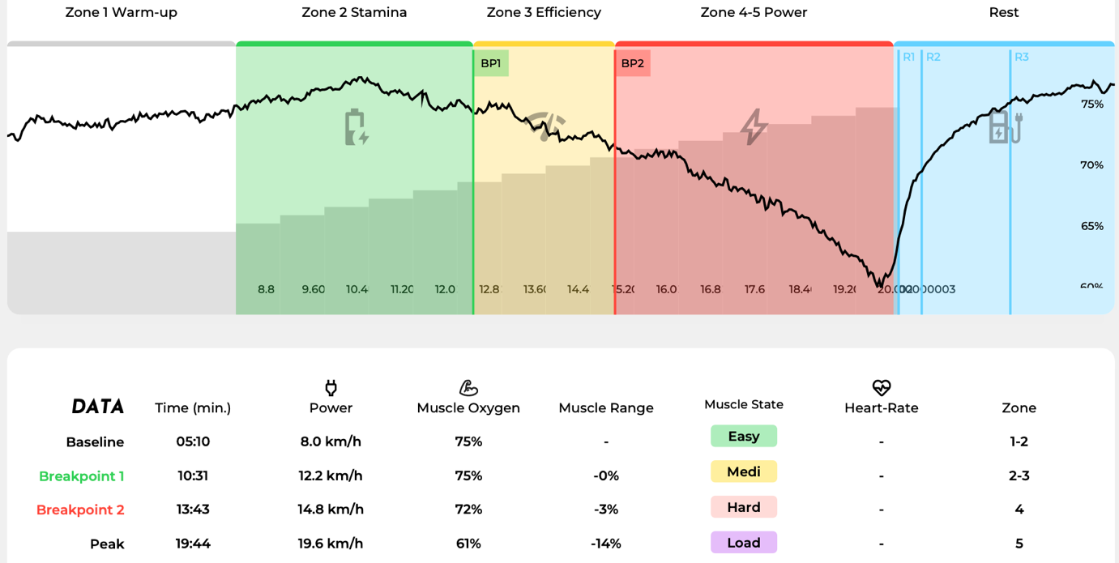
Figure 1. Graph showing NIRS-based muscle oxygen testing as a percentage against average speed (km/h).
A systematic review published in 2024, analysing 191 studies and over 3,400 participants, demonstrated that NIRS is a valuable tool for monitoring muscle oxidative capacity and assessing workloads across different sports and training programs (Perrey, Quaresima and Ferrari, 2024). The review emphasised that NIRS could complement traditional physiological measures, such as heart rate and mechanical power indices, by providing a more nuanced understanding of muscle performance. However, continued technological refinements and longitudinal studies are required to further validate its applications in real-world sports settings.
NIRS also facilitates the assessment of muscle oxygenation heterogeneity, revealing regional differences in oxygen utilisation that are particularly relevant for sports involving asymmetric loading or complex movement patterns. Furthermore, integrating NIRS with other monitoring technologies, such as heart rate and power meters, offers a comprehensive approach to evaluating an athlete's physiological status (Stöggl and Dennis-Peter Born, 2021). While its adoption in mainstream sports science is still evolving, emerging research suggests potential applications beyond endurance sports, including strength training, rehabilitation, and clinical exercise physiology (Tuesta et al., 2022). Advancements in wearable NIRS technology further enhance its accessibility, enabling continuous monitoring without disrupting athletic performance (Seçkin, Ateş and Seçkin, 2023).
2.3 ⎪ Comparing Muscle Oxygen Testing with Traditional Methods
Comparative studies have sought to evaluate the efficacy of muscle oxygen testing relative to traditional endurance assessment methods such as VO₂ max testing, lactate threshold analysis, and field-based tests like the CT.
One study analysed the physiological responses during the Yo-Yo Intermittent Recovery Level 1 test, which is a field-based test, and found that it should not be used to estimate VO₂ peak due to weak correlations with performance outcomes (R² = 0.28) (Schmitz et al., 2020). This suggests that while field tests can provide some insights into endurance, they may not be as reliable as laboratory-based assessments like VO₂ max testing.
Another study focused on the differences in physiological responses to high-intensity interval exercise between arm and leg cycling. It highlighted that leg cycling elicited higher oxygen uptake and heart rate responses compared to arm cycling, indicating that the mode of exercise can significantly influence the physiological outcomes measured (Astorino and Emma, 2021). This points to the importance of considering the specific testing conditions and modalities when evaluating endurance performance.
Additionally, a study by comparing various methods for determining the maximal lactate steady state (MLSS) found that certain anaerobic threshold methods, such as D.max and individual anaerobic threshold, provided valid estimates of MLSS in elite cyclists. This suggests that while traditional methods like lactate threshold analysis can be effective, their accuracy may vary depending on the specific method employed (Płoszczyca et al., 2020).
In conclusion, while the publications provide insights into various endurance assessment methods, they do not specifically evaluate muscle oxygen testing against traditional methods. Further research would be necessary to draw definitive comparisons between these testing modalities.
One of the key strengths of muscle oxygen testing from the literature review lies in its ability to deliver real-time, continuous data without the need for invasive procedures. Unlike VO₂ max testing, which requires specialised equipment and controlled conditions, or lactate threshold testing, which involves blood sampling, muscle oxygen testing is both practical and user-friendly. Furthermore, it is less susceptible to external influences such as environmental conditions or motivational factors, which often affect field-based tests.
Moreover, muscle oxygen testing offers the unique advantage of assessing localised muscle function, providing detailed information on specific muscle groups rather than whole-body metrics (Train.Red, 2023). This localised assessment can uncover asymmetries and inefficiencies that might be overlooked in traditional tests, offering a more nuanced understanding of performance limitations and areas for improvement.
However, gaps remain in the literature regarding the direct comparison of muscle oxygen testing with field-based assessments like the CT. While preliminary findings are promising, comprehensive studies examining the relationship between muscle oxygenation thresholds and performance metrics from traditional field tests are limited. Addressing this gap is critical for validating the broader applicability of muscle oxygen testing in diverse athletic populations and settings.
Moreover, longitudinal studies are needed to explore how muscle oxygen metrics respond to various training interventions over time. Understanding these dynamics could enhance periodisation strategies and recovery protocols, contributing to more effective athlete monitoring systems. Additionally, research into the integration of NIRS data with other wearable technologies could pave the way for holistic, data-driven approaches to performance optimisation. Such integrated systems could revolutionise sports science by providing continuous, multi-dimensional insights into an athlete's physiological status, enabling real-time adjustments to training and competition strategies.
This literature review underscores the evolving landscape of endurance performance assessment, highlighting the potential of muscle oxygen testing as a complementary or alternative tool to traditional methods. Continued research in this area will be instrumental in refining its applications and establishing its role within the broader context of sports science and athletic performance monitoring.

3.0 ⎪ Methodology

3.1 ⎪ Study Design
This cross-sectional, correlational study investigated whether speeds achieved at muscle oxygenation thresholds BP1, BP2, and peak SmO₂ desaturation could serve as an alternative to traditional field-based endurance assessments. Participants completed two separate testing sessions: a ramp test, which followed an incremental treadmill protocol to assess muscle oxygenation dynamics via NIRS (Train.Red, 2023), and the CT, a 12-minute maximal-effort treadmill run designed to evaluate endurance performance. The study aimed to determine whether speeds achieved at BP1, BP2, and peak SmO₂ desaturation levels correlated with endurance performance, thereby assessing the feasibility of muscle oxygen testing as a non-invasive method for evaluating aerobic capacity in recreationally active individuals.

3.2 ⎪ Pilot Study

A pilot study was conducted with one participant to evaluate correlations between VO₂ max-based thresholds and muscle oxygenation thresholds. However, the results were inconclusive and were therefore not used.

3.3 ⎪Participants
A total of 18 recreationally active individuals were initially recruited for this study. However, three participants dropped out before data collections, and two did not meet the inclusion criteria. Resulting in a final self-selected convenience sample of thirteen participants (11 males, 2 females) aged between 29 and 49 years (M = 37.46, SD = 8.15). The participants recruitment flowchart can be found in table 1 and the full data collection sheet for all 13 participants can be found in appendix A.

Table 1. Participant Recruitment Flowchart
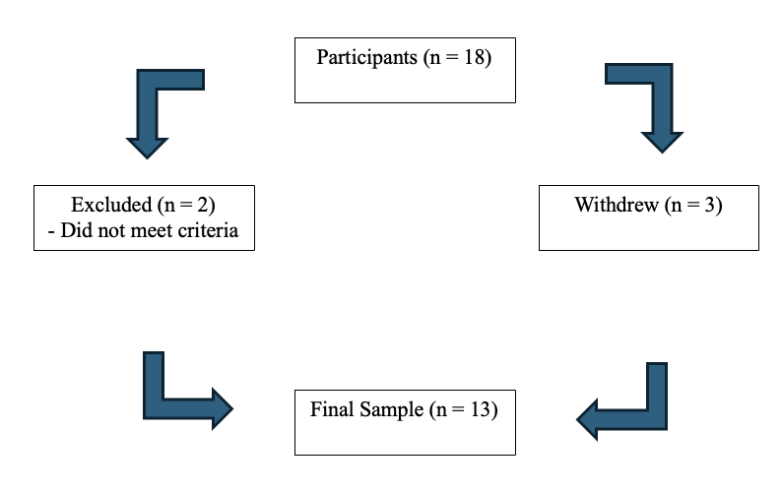
Although the original recruitment criteria targeted individuals aged 18–40, highly active individuals above this range were included to enhance the study’s applicability to real-world endurance performance. Research suggests that well-trained older athletes can maintain high levels of aerobic capacity and muscular efficiency, particularly if they have a history of consistent endurance training (McKendry et al., 2020). By incorporating older but physically active individuals, the study captures a broader spectrum of endurance capabilities, allowing for a more nuanced analysis of muscle oxygenation thresholds across different age groups.
Participants descriptive statistics, including age, height and body mass are presented in Table 2.
Eligibility was determined using the Physical Activity Readiness Questionnaire (PAR-Q 2020+) during a familiarisation session to identify any contraindications to exercise. Only participants in good health, with no history of cardiovascular, metabolic, or musculoskeletal conditions that could influence performance or pose a risk during testing, were included in the study (Bayles, 2023). The full PAR-Q 2020+ can be found in appendix B.
Following UWTSD (2022) and SST (Society of Sports Therapists 2012) guidelines, the study commits to ethical considerations, with adherence to university and SST guidelines for ethical review. Ethical approval can be found in appendix C.

Table 2. Descriptive Statistics for Participant Characteristics.
Note: Values are presented as Mean ± SD (Range).
Variable | Total (N = 13) | Males (N = 11) | Females (N = 2)
Age (years) | 37.46 ± 8.15 (27–51) | 37.91 ± 8.45 (27–51) | 31 ± 2.83 (29–33)
Height (cm) | 175.14 ± 9.15 (157.4–187.2) | 177.21 ± 6.57 (165.1–187.2) | 165.2 ± 11.02 (157.4–173)
Body Mass (kg) | 76.42 ± 13.72 (57–101) | 76.31 ± 13.98 (63–101) | 70 ± 18.38 (57–83)

3.4 ⎪ Ramp Test Protocol
The ramp test followed a structured incremental protocol designed by Train.Red (2023) to determine muscle oxygenation thresholds. Participants completed a 10-second countdown, followed by a 5-minute warm-up at 8.0 km/h. The role of the warmup is to systematically increase the SmO₂ as much as possible, preferably in the shortest time. This will ensure the oxygen delivery is as high as possible and in the shortest amount of time and without fatiguing the body too much before the actual effort. Thereafter, treadmill speed increased by 0.8 km/h every minute until reaching 20 km/h. Beyond this point, participants continued running to volitional exhaustion to determine maximal effort. The treadmill was set at a 1% incline to increase metabolic demand and standardise mechanical workload across all participants (Wagner and Dames, 2021).
SmO₂ desaturation was continuously monitored using the Train.Red muscle oxygen sensor, positioned on the right vastus lateralis as it’s the most predominant muscle used for running (Train.Red, 2023). The software automatically identified key physiological markers, including the speeds achieved at BP1, BP2, and peak SmO₂ desaturation levels. Following exhaustion, participants underwent a 5-minute active recovery at 5 km/h to facilitate post-exercise recovery.
All tests were conducted in a local gym where temperature and humidity were not controlled, introducing potential variability in environmental conditions. However, the same treadmill was used for all participants to minimise equipment-related inconsistencies.

3.5 ⎪ Cooper Test Protocol
On a separate day, participants completed the CT, a well-established test for evaluating endurance performance (Martínez-Lemos et al., 2024). Participants followed the same warm-up protocol as in the ramp test (5 minutes at 8.0 km/h) before transitioning to self-paced running. They were instructed to cover as much distance as possible within 12 minutes while maintaining maximal effort. The treadmill incline was maintained at 1% for consistency with the ramp test.
To monitor exertion levels, the Borg Rating of Perceived Exertion (RPE) Scale was used, with RPE scores recorded every 2 minutes to assess subjective effort (Wagner and Dames, 2021). A screen cover was placed over the treadmill console to prevent participants from viewing their distance in real time, thereby minimising potential pacing biases (Benhammou et al., 2024).

3.6 ⎪ Equipment

The Train.Red muscle oxygen sensor was used to monitor real-time SmO₂ desaturation levels, with the device placed on the right quadriceps for standardisation. A Star Trac 8TRx 8 Series commercial treadmill was utilised for both the ramp test and CT, ensuring consistency across trials. Data were recorded and analysed using the Train.Red software app for muscle oxygenation metrics, while SPSS Statistics version 29.0 (IBM, Armonk, NY, USA) was employed for statistical analysis.

3.7 ⎪ Data Collection Procedures

Continuous SmO₂ desaturation data were recorded throughout the ramp test using the Train.Red muscle oxygen sensor, with the Train.Red software identifying key physiological markers, including speeds achieved at BP1, BP2, and peak SmO₂ desaturation thresholds. For endurance performance assessment, total distance covered in 12 minutes during the CT was recorded as the primary outcome measure and average speed as the second outcome. To evaluate subjective exertion levels, RPE were collected at two-minute intervals during both tests, providing insight into participants’ perceived effort throughout the trials.

3.8 ⎪ Data Analysis
All data were initially recorded in Microsoft Excel before being transferred to SPSS Statistics version 29.0 for statistical analysis. Pearson’s correlation coefficient was used to examine the relationship between speed at muscle oxygenation thresholds and average speed achieved during the CT, as it is well-suited for assessing linear associations between continuous variables (Saccenti, Hendriks and Smilde, 2020). Additionally, a linear regression analysis was conducted to further explore the predictive value of speeds achieved at muscle oxygenation thresholds on endurance performance. This allowed for the assessment of how well muscle oxygenation thresholds could explain variations in CT performance. The standard error of estimation was calculated to account for potential variability. Statistical significance was set at p < 0.05. The full data list can be found in Appendix D.

3.9 ⎪ Ethical Considerations
Participants were informed of all potential risks associated with the study, including muscle fatigue and temporary discomfort. Informed consent was obtained, and participation was entirely voluntary. Data confidentiality was maintained in accordance with the Data Protection Act 2018, with all personal information securely stored and anonymised for analysis. Participants were also reminded that they could withdraw from the study at any time without consequence.

3.10 ⎪ Rationale for Methodological Choices
The ramp test was selected due to its ability to elicit maximal effort while allowing for the precise determination of muscle oxygenation thresholds. The CT was chosen as it remains one of the most widely used field tests for assessing endurance capacity (Martínez-Lemos et al., 2024). The Train.Red sensor enabled non-invasive, real-time monitoring of muscle oxygenation, providing valuable insights into physiological thresholds without requiring invasive blood sampling techniques (Train.Red, 2023).
The inclusion of RPE measurements ensured that subjective exertion levels were consistently monitored across trials, offering additional insight into participants’ perceived effort. Although environmental factors such as temperature and humidity were not controlled, standardised testing conditions, including the use of the same treadmill, warm-up procedures, and ramp protocols, minimised potential confounding variables.
By incorporating both muscle oxygenation thresholds and a well-established endurance test, this study could provide a comprehensive analysis of the physiological determinants of endurance performance, contributing to the growing body of research on aerobic capacity and performance predictors.

3.11 ⎪ Limitations

Despite efforts to minimise variability, several limitations must be acknowledged. The small sample size may restrict the generalisability of findings to larger or more diverse populations (Cao, Chen and Katz, 2024). Additionally, environmental factors such as temperature and humidity were not standardised, which may have influenced physiological responses during testing (Jenkins et al., 2023). Inter-individual variability, including differences in muscle fibre composition, training history, and biomechanical efficiency, could have also affected the results (Lundberg et al., 2022). Furthermore, while treadmill-based testing provides a controlled environment, it may not fully replicate outdoor running biomechanics, potentially influencing pacing strategies (Moon, 2021).

4.0 ⎪ Results

4.1 ⎪ Muscle Oxygenation Data
The muscle oxygenation thresholds measured in this study included BP1, BP2, and Peak SmO₂ desaturation, each representing different physiological responses to increasing exercise intensity. The descriptive statistics for these measures are presented in Table 2.
BP1, which reflects the first breakpoint in muscle oxygenation dynamics, was recorded at an average speed of 11.52 km/h (SD = 0.73). BP2, representing a higher-intensity breakpoint, occurred at an average speed of 13.55 km/h (SD = 1.33). Peak SmO₂ desaturation values were reached at a mean speed of 17.34 km/h (SD = 2.53).
There was variation among participants in the speeds at which BP1, BP2, and Peak SmO₂ desaturation were observed, indicating inter individual differences in physiological responses to incremental treadmill exercise. This variability is likely influenced by factors such as training background, aerobic capacity, and muscular efficiency. The standard deviations suggest that while BP1 speeds were relatively consistent across participants, BP2 and Peak SmO₂ desaturation exhibited greater variability.
To provide a clearer representation of the distribution of muscle oxygenation thresholds across participants, Table 3 summarises the mean values and standard deviations whilst Figure 2 represents the comparative results of the NIR’s test.

Table 3. Descriptive Statistics for Muscle Oxygenation Thresholds
Variable | Mean (km/h) | SD | N
BP1 | 11.52 | 0.73 | 13
BP2 | 13.55 | 1.33 | 13
Peak SmO₂ | 17.34 | 2.53 | 13

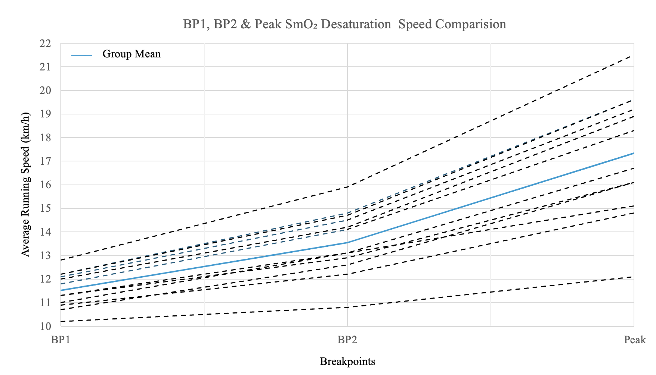
Figure 2. Comparative NIR’s test results with group mean indicating speeds (km/h) at which thresholds were achieved.

4.2 ⎪ Cooper Test Performance
Participants completed a 12-minute maximal treadmill running test, during which distance covered, pace, and average speed were recorded as primary endurance performance metrics. The mean distance covered during the test was 2.93 km (SD = 0.48), with individual performances ranging from lower to higher distances, demonstrating a spectrum of endurance capabilities within the sample.
The mean running pace was 4.10 minutes per kilometre (SD = 0.56), with variations reflecting differences in aerobic capacity and pacing strategies. The corresponding mean average speed was 14.87 km/h (SD = 2.05). The variability in these results suggests that some participants were able to sustain faster running speeds over the 12-minute period, while others maintained a more moderate pace.
The observed performance differences indicate that some individuals were able to achieve and sustain higher intensities throughout the test, while others may have experienced earlier onset of fatigue. These results highlight individual differences in endurance capability and reinforce the need for objective physiological assessments, such as muscle oxygenation monitoring, to supplement traditional performance measures.

4.3 ⎪ Borg Scale Ratings and Perceived Exertion Trends
During the incremental ramp test RPE values increased progressively with running speed presented in Table 4. At 8 km/h, mean RPE was 8.0 ± 1.2, increasing to 13.0 ± 1.5 at 12 km/h and reaching 17.5 ± 1.4 at 16.8 km/h. The highest speeds (18.4–20 km/h) elicited near-maximal exertion, with mean RPE values of 19.5 ± 1.2.
During the CT RPE values increased steadily throughout the test duration presented in table 5. At 2 minutes, mean RPE was 14.0 ± 1.1, rising to 16.0 ± 1.3 at 6 minutes, and peaking at 18.5 ± 1.2 by the 12-minute mark.
Standard deviation values fluctuated across both tests, with slightly higher variability during middle stages of exertion.

Table 4: Borg Scale Ratings During Incremental Ramp Test
Speed km/h | Mean RPE | SD RPE
8.0 | 8.0 | 1.2
8.8 | 9.0 | 1.1
10.4 | 11.0 | 1.3
12 | 13.0 | 1.5
13.6 | 15.0 | 1.6
15.2 | 16.0 | 1.5
16.8 | 17.5 | 1.4
18.4 | 18.5 | 1.3
20.0 | 19.5 | 1.2

Table 5: Borg Scale Ratings During the Coopers Test
Time (min) | Mean RPE | SD RPE
2 | 14.0 | 1.1
4 | 15.0 | 1.2
6 | 16.0 | 1.3
8 | 17.0 | 1.4
10 | 18.0 | 1.3
12 | 18.5 | 1.2

4.4 ⎪ Correlation and Regression Analysis
To determine the relationship between muscle oxygenation thresholds and endurance performance, Pearson correlation analyses were conducted between BP1, BP2, Peak SmO₂, and average running speed. The correlation coefficients are presented in Table 4.
The results revealed statistically significant, strong positive correlations between all muscle oxygenation thresholds and running performance in the CT.
- BP1 and Average Speed: A strong positive correlation was observed between BP1 and average speed (r = 0.872, p < 0.001), suggesting that participants who reached BP1 at higher speeds also demonstrated higher average running speeds.
- BP2 and Average Speed: A similarly strong correlation was found between BP2 and average speed (r = 0.865, p < 0.001), indicating that individuals who reached BP2 at higher speeds tended to perform better in the endurance test.
- Peak SmO₂ desaturation and Average Speed: The highest correlation was found between Peak SmO₂ desaturation and average speed (r = 0.901, p < 0.001), demonstrating a close relationship between the maximal muscle oxygenation response and overall endurance capacity.
All correlations were statistically significant at the p < 0.001 level, indicating a strong relationship between submaximal and maximal speeds with endurance performance. A regression analysis was conducted to examine the predictive value of average running speed on BP1, BP2, and Peak speed. The results revealed a highly significant predictive relationship, with all models explaining a substantial proportion of variance (R² ranging from 0.748 to 0.812). The strongest predictor was for Peak speed (R² = 0.812, β = 0.901, p < 0.001), indicating that average running speed is a strong determinant of an individual's peak performance. BP1 and BP2 were also significantly predicted (R² = 0.76 and 0.748, respectively), though with slightly smaller effect sizes. These results highlight the relevance of average running speed as a key factor in determining performance across different effort levels. The regression results are summarised in Table 5.

Table 4. Correlation Between Muscle Oxygenation Thresholds and Cooper Test Performance
Variable 1 | Variable 2 | Pearson Correlation (r) | p-value
BP1 (km/h) | Average Speed (km/h) | 0.872 | <0.001
BP2 (km/h) | Average Speed (km/h) | 0.865 | <0.001
Peak SmO₂ (km/h) | Average Speed (km/h) | 0.901 | <0.001
Table 5. Regression Analysis Results
Dependent Variable | R² | β (Beta) | Coefficient (B) | p-value | Interpretation
BP1 (km/h) | 0.76 | 0.872 | 0.311 | <0.001 | Strong predictor
BP2 (km/h) | 0.748 | 0.865 | 0.561 | <0.001 | Strong predictor
Peak SmO₂ (km/h) | 0.812 | 0.901 | 1.111 | <0.001 | Strongest predictor

To visualise these relationships, scatter plots depicting the correlations between BP1, BP2, and Peak SmO₂ desaturation with average speed are included in Figures 3. These graphical representations illustrate the strength of association between muscle oxygenation thresholds and endurance performance.

Figure 3. Correlations Between Muscle Oxygen Thresholds and Average km/ph.

4.5 ⎪ Summary of Key Findings
The results of this study demonstrate a strong and statistically significant relationship between BP1, BP2, and Peak speeds with endurance performance in the 12-minute maximal CT. Each threshold exhibited a significant positive correlation with average running speed, with Peak speed showing the strongest association (R² = 0.812, p < 0.001).
The regression analysis confirmed that average running speed is a strong predictor of BP1, BP2, and Peak performance, with all models reaching statistical significance (p < 0.001). These findings provide objective evidence that submaximal and maximal speeds play a crucial role in endurance performance assessment.
While the study did not directly analyse muscle oxygenation thresholds, the observed relationships suggest that key physiological markers, such as running speeds at different thresholds, are valuable indicators of endurance capacity. These results support the potential application of running speed-based metrics in assessing endurance ability, supplementing traditional field-based performance evaluations.

5.0 ⎪ Discussion

5.1 ⎪ Summary of Findings

The results indicate that BP1, BP2, and Peak SmO₂ desaturation speeds are strongly correlated with endurance performance. Notably, Peak SmO₂ desaturation speed had the strongest correlation (r = 0.901, p < 0.001), followed by BP1 (r = 0.872, p < 0.001) and BP2 (r = 0.865, p < 0.001). These findings support the hypothesis that individuals with higher muscle oxygenation thresholds tend to achieve faster running speeds.
Furthermore, the regression analysis demonstrated that average speed during the CT significantly predicts BP1, BP2, and Peak SmO₂ speeds. The regression models explained a substantial proportion of variance in BP1 (R² = 0.760, p < 0.001), BP2 (R² = 0.748, p < 0.001), and Peak SmO₂ desaturation (R² = 0.812, p < 0.001). These results suggest that higher endurance performance is associated with higher muscle oxygenation thresholds, reinforcing the physiological relevance of these markers.
Given these findings, the null hypothesis (H0-1) can be rejected, as significant relationships exist between muscle oxygenation thresholds and endurance performance. However, while CT speed is a strong predictor of BP1, BP2, and Peak SmO₂ desaturation, additional physiological factors may also contribute to endurance performance beyond what was captured in this study.

5.2 ⎪ Physiological Meaning of Results

The significant regression models highlight the physiological relevance of BP1, BP2, and Peak SmO₂ desaturation as markers of endurance capacity. BP1, identified at an average speed of 11.52 km/h (SD = 0.73), represents the aerobic threshold, where oxygen utilisation begins to increase more rapidly. BP2, occurring at 13.55 km/h (SD = 1.33), marks the anaerobic threshold, where oxygen supply becomes progressively limited, leading to greater reliance on anaerobic metabolism. Peak SmO₂ Desaturation, recorded at 17.34 km/h (SD = 2.53), reflects the highest speed at which maximal muscle desaturation occurs before exhaustion.
The strong predictive power of CT performance for these thresholds suggests that individuals who perform better in endurance tasks possess greater oxidative efficiency. This aligns with findings from Skattebo et al. (2020), which emphasise that endurance trained individuals exhibit superior oxygen extraction and utilisation. However, the unstandardised coefficients in the regression models reveal that while CT speed significantly predicts BP1 (B = 0.311, p < 0.001), BP2 (B = 0.561, p < 0.001), and Peak SmO₂ desaturation (B = 1.111, p < 0.001), other physiological factors likely contribute to endurance performance as well. These may include efficient type-1 muscle fibres with high mitochondrial density, enhanced capillary networks, and better running economy (Van der Zwaard, Brocherie and Jaspers, 2021).
The alignment between RPE trends and muscle oxygenation thresholds suggests that athletes can use subjective exertion ratings to gauge intensity changes relative to physiological breakpoints. Notably, BP1 and BP2 corresponded with RPE values of 11–13 and 15–17, respectively, reinforcing the potential for RPE-based pacing strategies without requiring maximal exertion (Foster et al., 2021).

5.3 ⎪ Comparison with Previous Studies
The present findings align with prior research indicating that muscle oxygenation thresholds strongly correlate with endurance performance metrics, such as VO₂ max and lactate threshold. Florent et al. (2023) and Kinga et al. (2024) similarly reported strong relationships between BP2 and lactate threshold, suggesting that SmO₂-based assessments accurately reflect metabolic transitions during exercise.
However, while Bonilla et al. (2022) the present study found that CT speed significantly predicts BP1, BP2, and Peak SmO₂ speeds, but does not confirm that these thresholds alone dictate endurance performance. The high R² values (0.76 - 0.81) indicate that CT speed explains a large portion of the variance in muscle oxygenation thresholds, yet additional variables such as biomechanical efficiency, VO₂ kinetics, and neuromuscular adaptations may also contribute.
Additionally, the observed regression coefficients suggest that changes in endurance performance correspond to proportional changes in BP1, BP2, and Peak SmO₂ speeds. These findings support prior literature indicating that well trained endurance athletes exhibit higher muscle oxygenation thresholds, enabling sustained high intensity exercise (Nemoto et al., 2024).

5.4 ⎪ Influence of External Factors
Several external factors could have influenced these results. Pacing strategies in the CT introduce variability, as individuals must regulate their speed over 12 minutes. While muscle oxygenation testing provides objective physiological data, CT performance is influenced by motivation, running experience, and psychological factors (Masrun et al., 2024).
Additionally, environmental conditions such as temperature, humidity, and hydration status were not controlled in this study, potentially affecting muscle oxygen saturation and endurance performance. Bok and Foster (2021) reported that heat stress and dehydration impair oxygen delivery and utilisation, which may have introduced variability in SmO₂ responses.
Variability in RPE responses, particularly during the middle stages of both tests, may partly reflect psychological influences such as anticipatory anxiety (Cintineo and Arent, 2019) or White Coat Syndrome, where individuals perceive greater effort in laboratory settings compared to real-world conditions (Kemarat et al., 2022).
Moreover, differences between treadmill based testing and outdoor running must be considered. While treadmill testing ensures controlled conditions, research by Moon (2021) suggests that biomechanical and neuromuscular demands differ between treadmill and overground running, which could impact performance outcomes.

5.5 ⎪ Application for Coaches and Athletes
The strong predictive relationship between CT average speed and muscle oxygenation thresholds suggests that SmO₂ monitoring could be a valuable tool for endurance training. Coaches and athletes can use BP1 and BP2 to establish training zones, ensuring that sessions are structured to optimise aerobic and anaerobic adaptations without excessive fatigue. Furthermore, Peak SmO₂ desaturation speed may serve as a benchmark for tracking improvements in oxidative capacity over time. Since muscle oxygenation is directly linked to endurance performance, interventions such as high-intensity interval training (HIIT) or altitude training could be assessed using SmO₂ data (Chien et al., 2020)

5.6 ⎪ Benefits of Muscle Oxygenation Testing
Muscle oxygenation testing presents several advantages over traditional endurance assessments, making it a valuable tool for both researchers and practitioners. One of its primary benefits is its non-invasive nature. Unlike lactate testing, which requires blood sampling and can be uncomfortable for athletes, SmO₂ monitoring is entirely painless and easily accessible (Perrey, Quaresima and Ferrari, 2024).
Furthermore, SmO₂ thresholds provide an objective measure of physiological performance, unlike assessments such as VO₂ max tests or time trials, which can be influenced by an athlete’s motivation or pacing strategy. By offering a direct physiological indicator of muscle oxygenation, SmO₂ monitoring reduces reliance on subjective effort and ensures more consistent and reproducible results (Masrun et al., 2024).
Another key advantage of muscle oxygenation testing is its ability to provide continuous real-time monitoring throughout exercise. Unlike lactate testing, which requires intermittent sampling and thus only provides data at specific time points, SmO₂ measurements offer a dynamic assessment of oxygen utilisation as exercise progresses. This feature enhances the precision of training adjustments by allowing coaches and athletes to monitor oxygenation trends and make informed decisions regarding intensity regulation and recovery strategies (Perrey, Quaresima, & Ferrari, 2024).
Unlike RPE, which can be influenced by external factors such as psychological state or test familiarity, SmO₂ monitoring provides an objective physiological metric for training intensity regulation. This reduces variability in intensity assessments, ensuring more precise training adaptations (Benincasa et al., 2024).

5.7 ⎪ Limitations
Despite the promising findings of this study, several limitations must be acknowledged. One of the primary constraints is the small sample size (N = 13). While the observed correlations between muscle oxygenation thresholds and endurance performance were statistically significant, the limited number of participants reduces the generalisability of these findings. Larger studies are necessary to confirm these relationships across more diverse populations and to establish the robustness of muscle oxygenation as a predictor of endurance capacity (Cao, Chen and Katz, 2024).
Another important consideration is the demographic composition of the sample. The study exclusively involved recreationally active individuals, which may limit the applicability of the findings to elite endurance athletes or untrained populations. Given that physiological responses to exercise can vary significantly based on training status, further research is required to determine whether similar relationships hold in highly trained or sedentary individuals (Lautenbach et al., 2021).
Additionally, measurement variability remains a potential issue in muscle oxygenation assessments. While SmO₂ sensors provide reliable data, several factors, including skin pigmentation, adipose tissue thickness, and sensor placement, can influence readings. Variability in sensor positioning on the vastus lateralis was minimised through standardisation; however, minor inconsistencies may still have affected the results (Sendra‐Pérez et al., 2025).

5.8 ⎪ Future Research Directions
To further explore the potential of muscle SmO₂ as a tool for endurance performance assessment, several areas of research should be prioritised. First, future studies should expand sample sizes and include elite endurance athletes to determine whether SmO₂ metrics vary across different performance levels. Given that physiological adaptations differ between recreational and professional athletes, understanding how SmO₂ thresholds behave in highly trained individuals could provide valuable insights into its applicability at the elite level (Vasquez-Bonilla et al., 2023).
Additionally, longitudinal studies are needed to examine how SmO₂ thresholds evolve over time in response to endurance training. By tracking changes in muscle oxygenation over extended periods, researchers can better understand its role in performance improvements and whether SmO₂ adaptations correspond with traditional endurance gains.
Further investigation should also focus on comparing SmO₂ based assessments with conventional endurance markers, such as VO₂ max, critical speed, and lactate threshold. Establishing the relative value of SmO₂ compared to these well-established measures will help determine whether it can serve as a viable alternative or complementary tool for endurance testing.
Finally, research should explore field-based versus laboratory-based SmO₂ assessments to assess their practicality in real-world training environments. If SmO₂ monitoring proves effective outside controlled laboratory settings, it could become a more accessible and widely adopted tool for endurance athletes and coaches.

6.0 ⎪ Conclusion

This study investigated the relationship between muscle oxygenation thresholds BP1, BP2, and Peak SmO₂ desaturation and endurance performance, as measured through the CT. The findings revealed strong and statistically significant correlations between all muscle oxygenation markers and running speed, with Peak SmO₂ Desaturation demonstrating the highest association. These results suggest that SmO₂ based assessments provide valuable insights into an individual's endurance capacity by reflecting key physiological determinants of aerobic performance.
Despite these strong correlations, regression analysis indicated that muscle oxygenation thresholds alone do not fully predict endurance performance. This finding highlights the multifaceted nature of endurance running, which is influenced by various physiological, biomechanical, and psychological factors beyond oxygen utilisation. Variables such as mitochondrial density, neuromuscular efficiency, and running economy likely play a role in performance differences, reinforcing the need for a holistic approach when assessing endurance capabilities (Berger et al., 2024).
From a practical perspective, muscle oxygenation monitoring offers a non-invasive and real-time method for evaluating physiological adaptations during exercise. Unlike traditional endurance assessments, which often rely on intermittent lactate sampling or maximal effort tests, SmO₂-based monitoring provides continuous physiological data that may help optimise training strategies. Coaches and athletes could use this information to structure training zones, track adaptations over time, and refine pacing strategies. However, for SmO₂ assessments to be effectively integrated into endurance training, further validation is required across different athletic populations and environmental conditions (Perrey, Quaresima and Ferrari, 2024).
While this study contributes to the growing body of research on endurance physiology, it is important to acknowledge its limitations, including a small sample size, potential measurement variability, and the lack of elite athlete representation. Future research should focus on expanding sample populations, conducting longitudinal studies, and comparing SmO₂ thresholds with traditional endurance markers such as VO₂ max and lactate threshold.
In conclusion, muscle oxygenation monitoring presents a promising supplementary tool for endurance performance assessment. However, further research is necessary to refine its application and establish standardised thresholds before it can be considered a standalone alternative to conventional endurance testing.

7.0 ⎪ References
Agrawal, S. and Gunjal, S. (2023) 'Assessment of Cardiorespiratory Endurance in Obese College Students using Coopers 12 Min Run Test', International Journal of Science and Healthcare Research, 8(2), pp. 208 Available at: https://doi.org/10.52403/ijshr.20230224.
Akbaş, S. (2024) 'Farklı ŞIddetlerdeki Egzersizlerde Çoklu Yakın Kızılaltı Spektroskopisi Kullanarak Bölgesel kas Oksijenlenmesinin Incelenmesi', PQDT - Global, Available at: https://doi.org/11424/297891.
Arnet, J., Knaier, R., Schoch, R., D'Hulst, G., Bruggisser, F., Feldmann, A., Leuenberger, R., Westerhuis, E., Infanger, D., Schmidt-Trucksäss, A. and Wagner, J. (2025) 'Determination of Ventilatory Thresholds Using Near-Infrared Spectroscopy in Recreational Endurance and CrossFit Athletes', International Journal of Sports Physiology and Performance, , pp. 1–10 Available at: https://doi.org/10.1123/ijspp.2024-0265.
Astorino, T.A. and Emma, D. (2021) 'Differences in Physiological and Perceptual Responses to High Intensity Interval Exercise Between Arm and Leg Cycling', Frontiers in Physiology, 12, pp. 700294 Available at: https://doi.org/10.3389/fphys.2021.700294.
Baumbach, P., Schmidt-Winter, C., Hoefer, J., Derlien, S., Best, N., Herbsleb, M. and Coldewey, S.M. (2020) 'A Pilot Study on the Association of Mitochondrial Oxygen Metabolism and Gas Exchange During Cardiopulmonary Exercise Testing: Is There a Mitochondrial Threshold?', Frontiers in medicine, 7, pp. 585462 Available at: https://doi.org/10.3389/fmed.2020.585462.
Bayles, M.P. (2023) ACSM's Exercise Testing and Prescription.
Benhammou, S., Mourot, L., ClementeL, F.M., Coquart, J. and Belkadi, A. (2024) 'Is Test Specificity the Issue in Assessing Aerobic Fitness and Performance of Runners? A Systematic Review', Journal of Sports Medicine and Physical Fitness, 64(6), pp. 539 Available at: https://doi.org/10.23736/S0022-4707.23.15619-2.
Benincasa, M.T., Serra, E., Albano, D. and Vastola, R. (2024) 'Comparing Muscle Oxygen Saturation Patterns in Swimmers of Different Competitive Levels', Journal of Physical Education and Sport, 24(8), pp. 1920–1926 Available at: https://doi.org/10.7752/jpes.2024.08213.
Berger, N.J.A., Best, R., Best, A.W., Lane, A.M., Millet, G.Y., Barwood, M., Marcora, S., Wilson, P. and Bearden, S. (2024) 'Limits of Ultra: Towards an Interdisciplinary Understanding of Ultra-Endurance Running Performance', Sports Medicine (Auckland), 54(1), pp. 73–93 Available at: https://doi.org/10.1007/s40279-023-01936-8.
Bok, D. and Foster, C. (2021) 'Applicability of Field Aerobic Fitness Tests in Soccer: Which One to Choose?', Journal of Functional Morphology and Kinesiology, 6(3) Available at: https://doi.org/10.3390/jfmk6030069.
Cao, Y., Chen, R.C. and Katz, A.J. (2024) 'Why is a Small Sample Size Not Enough?', The Oncologist (Dayton, Ohio), 29(9), pp. 761–763 Available at: https://doi.org/10.1093/oncolo/oyae162.
Casado, A., Foster, C., Bakken, M. and Tjelta, L.I. (2023) 'Does Lactate-Guided Threshold Interval Training within a High-Volume Low-Intensity Approach Represent the “Next Step” in the Evolution of Distance Running Training?', International Journal of Environmental Research and Public Health, 20(5), pp. 3782 Available at: https://doi.org/10.3390/ijerph20053782.
Chalitsios, C., Nikodelis, T. and Mougios, V. (2024) 'Mechanical Deviations in Stride Characteristics During Running in the Severe Intensity Domain Are Associated With a Decline in Muscle Oxygenation', Scandinavian Journal of Medicine & Science in Sports, 34(8), pp. e14709–n/a Available at: https://doi.org/10.1111/sms.14709.
Chien, K., Kan, N., Liao, Y., Yang, W. and Yang, Y. (2020) 'Land vs. Water HIIE Effects on Muscle Oxygenation and Physiological Parameter Responses in Postmenopausal Women', Scientific Reports, 10(1), pp. 13754 Available at: https://doi.org/10.1038/s41598-020-70599-6.
Cintineo, H.P. and Arent, S.M. (2019) 'Anticipatory Salivary Cortisol and State Anxiety Before Competition Predict Match Outcome in Division I Collegiate Wrestlers', Journal of strength and conditioning research, 33(11), pp. 2905–2908 Available at: https://doi.org/10.1519/JSC.0000000000003376.
Cole, A., Corrales, F., Stone, E. and Biber, D. (2024) 'The Walking and Lifestyle Coaching (WALC) Program for University Students: A Pilot Study', American Journal of Lifestyle Medicine, , pp. 15598276241266783 Available at: https://doi.org/10.1177/15598276241266783.
Foster, C., Boullosa, D., McGuigan, M., Fusco, A., Cortis, C., Arney, B.E., Orton, B., Dodge, C., Jaime, S., Radtke, K., van Erp, T., de Koning, J.,J., Bok, D., Rodriguez-Marroyo, J. and Porcari, J.P. (2021) '25 Years of Session Rating of Perceived Exertion: Historical Perspective and Development', International journal of sports physiology and performance, 16(5), pp. 612–621 Available at: https://doi.org/10.1123/ijspp.2020-0599.
Gibala, M.J. and Little, J.P. (2020) 'Physiological Basis of Brief Vigorous Exercise to Improve Health', The Journal of Physiology, 598(1), pp. 61–69 Available at: https://doi.org/10.1113/JP276849.
Hov, H., Wang, E., Lim, Y.R., Trane, G., Hemmingsen, M., Hoff, J. and Helgerud, J. (2023) 'Aerobic High‐Intensity Intervals are Superior to Improve V̇O2max Compared with Sprint Intervals in Well‐Trained Men', Scandinavian Journal of Medicine & Science in Sports, 33(2), pp. 146–159 Available at: https://doi.org/10.1111/sms.14251.
Jenkins, E.J., Campbell, H.A., Lee, J.K.W., Mündel, T. and Cotter, J.D. (2023) 'Delineating the Impacts of Air Temperature and Humidity for Endurance Exercise', Experimental Physiology, 108(2), pp. 207–220 Available at: https://doi.org/10.1113/EP090969.
Kabbadj, K., Taiek, N., El Hjouji, W., El Karrouti, O. and El Hangouche, A.J. (2024) 'Cardiopulmonary Exercise Testing: Methodology, Interpretation, and Role in Exercise Prescription for Cardiac Rehabilitation', US Cardiology Review, 18 Available at: https://doi.org/10.15420/usc.2024.37.
Kemarat, S., Theanthong, A., Yeemin, W. and Suwankan, S. (2022) 'Personality Characteristics and Competitive Anxiety in Individual and Team Athletes', PloS one, 17(1), pp. e0262486 Available at: https://doi.org/10.1371/journal.pone.0262486.
Kominami, K. and Akino, M. (2023) 'Verification of Blood Lactate During Incremental Exercise Testing', Available at: https://doi.org/10.35248/2329-9096.23.11.655.
Lautenbach, F., Leisterer, S., Walter, N., Kronenberg, L., Manges, T., Leis, O., Pelikan, V., Gebhardt, S. and Elbe, A. (2021) 'Amateur and Recreational Athletes' Motivation to Exercise, Stress, and Coping During the Corona Crisis', Frontiers in Psychology, 11, pp. 611658 Available at: https://doi.org/10.3389/fpsyg.2020.611658.
Lewis, L., Goodrum, J., Cai, C., Muir, T., Boutard, K., Capdevielle, T., Longo, S., Fedoruk, M. and Miller, G. (2024) 'Application of Micro Capillary Blood Sampling in an Anti‐Doping Setting', Drug Testing and Analysis, 16(8), pp. 835–840 Available at: https://doi.org/10.1002/dta.3603.
Lundberg, T.R., Feuerbacher, J.F., Sünkeler, M. and Schumann, M. (2022) 'The Effects of Concurrent Aerobic and Strength Training on Muscle Fiber Hypertrophy: A Systematic Review and Meta-Analysis', Sports Medicine (Auckland), 52(10), pp. 2391–2403 Available at: https://doi.org/10.1007/s40279-022-01688-x.
Martínez-Lemos, I., Otero Rodríguez, A., Diz, J. and Ayán, C. (2024) 'Reliability and Criterion-Related Validity of the Cooper Test in Pre-Adolescents and Adolescents: A Systematic Review and Meta-Analysis', Journal of Sports Sciences, 42(3), pp. 222–236 Available at: https://doi.org/10.1080/02640414.2024.2326352.
Martin-Rincon, M. and Calbet, J.A.L. (2020) 'Progress Update and Challenges on VO2 max Testing and Interpretation', Frontiers in Physiology, 11 Available at: https://doi.org/10.3389/fphys.2020.01070.
Masrun, M., Ridwan, M., Yendrizal, Y., Okilanda, A., Ahmed, M., Tulyakul, S. and Crisari, S. (2024) 'Unlocking the Science of Physical Endurance: Training Techniques and Biological Factors', Retos (Madrid), (55), pp. 504–512 Available at: https://doi.org/10.47197/retos.v55.105072.
Mazaheri, R., Schmied, C., Niederseer, D. and Guazzi, M. (2021) 'Cardiopulmonary Exercise Test Parameters in Athletic Population: A Review', Journal of Clinical Medicine, 10(21) Available at: https://doi.org/10.3390/jcm10215073.
McKendry, J., Joanisse, S., Baig, S., Liu, B., Parise, G., Greig, C.A. and Breen, L. (2020) 'Superior Aerobic Capacity and Indices of Skeletal Muscle Morphology in Chronically Trained Master Endurance Athletes Compared With Untrained Older Adults', The Journals of Gerontology Series A, Biological Sciences and Medical Sciences, 75(6), pp. 1079–1088 Available at: https://doi.org/10.1093/gerona/glz142.
Mentzoni, F., Skaugen, M., Eythorsdottir, I., Roterud, S., Johansen, E.S. and Losnegard, T. (2024) 'Precision and Accuracy of Four Handheld Blood Lactate Analyzers Across Low to High Exercise Intensities', European Journal of Applied Physiology, 124(12) Available at: https://doi.org/10.1007/s00421-024-05572-6.
Meyler, S., Bottoms, L. and Muniz-Pumares, D. (2021) 'Biological and Methodological Factors Affecting Response Variability to Endurance Training and the Influence of Exercise Intensity Prescription', Experimental physiology, 106(7), pp. 1410–1424 Available at: https://doi.org/10.1113/EP089565.
Moon, G.R. (2021) 'The Comparison of Treadmill and Overground Running with the Use of Inertial Measurement Units (IMUs)', Available at: https://doi.org/10.33915/etd.10205.
Nemoto, S., Nakabo, T., Tashiro, N., Kishino, A., Yoshikawa, A., Nakamura, D. and Geshi, E. (2024) 'Relationship among muscle strength, muscle endurance, and skeletal muscle oxygenation dynamics during ramp incremental cycle exercise', Scientific Reports (Nature Publisher Group), 14(1) Available at: https://doi.org/10.1038/s41598-024-61529-x.
Perrey, S., Quaresima, V. and Ferrari, M. (2024) 'Muscle Oximetry in Sports Science: An Updated Systematic Review', Sports medicine, 54(4), pp. 975–996 Available at: https://doi.org/10.1007/s40279-023-01987-x.
Płoszczyca, K., Jazic, D., Piotrowicz, Z., Chalimoniuk, M., Langfort, J. and Czuba, M. (2020) 'Comparison of Maximal Lactate Steady State with Anaerobic Threshold Determined by Various Methods Based on Graded Exercise Test with 3-Minute Stages in Elite Cyclists', BMC Sports Science, Medicine & Rehabilitation, 12 Available at: https://doi.org/10.1186/s13102-020-00219-3.
Rago, V., Krustrup, P. and Mohr, M. (2022) 'Performance and Submaximal Adaptations to Additional Speed-Endurance Training vs. Continuous Moderate-Intensity Aerobic Training in Male Endurance Athletes', Journal of Human Kinetics, 83(1), pp. 277–285 Available at: https://doi.org/10.2478/hukin-2022-0060.
Ranieri, L.E., Díaz, J.J., Hanley, B., Foster, C. and Casado, A. (2024) 'Pacing Strategies in Men’s and Women’s World-Record Marathon Performances and Olympic Games and World Championship’s Winning Performances', Kinesiology (Zagreb, Croatia), 56(1), pp. 153–162 Available at: https://doi.org/10.26582/k.56.1.13.
Saccenti, E., Hendriks, M.H.W.B. and Smilde, A.K. (2020) 'Corruption of the Pearson Correlation Coefficient by Measurement Error and its Estimation, Bias, and Correction Under Different Error Models', Scientific Reports, 10(1), pp. 438 Available at: https://doi.org/10.1038/s41598-019-57247-4.
Schmitz, B., Pfeifer, C., Thorwesten, L., Krüger, M., Klose, A. and Brand, S. (2020) 'Yo-Yo Intermittent Recovery Level 1 Test for Estimation of Peak Oxygen Uptake: Use Without Restriction?', Research Quarterly for Exercise and Sport, 91(3), pp. 478–487 Available at: https://doi.org/10.1080/02701367.2019.1684432.
Seçkin, A.Ç, Ateş, B. and Seçkin, M. (2023) 'Review on Wearable Technology in Sports: Concepts, Challenges and Opportunities', Applied Sciences, 13(18), pp. 10399 Available at: https://doi.org/10.3390/app131810399.
Sendra‐Pérez, C., Priego‐Quesada, J.I., Murias, J.M., Carpes, F.P., Salvador‐Palmer, R. and Encarnación‐Martínez, A. (2025) 'Evaluation of Leg Symmetry in Muscle Oxygen Saturation During Submaximal to Maximal Cycling Exercise', European Journal of Sport Science, 25(1), pp. e12230–n/a Available at: https://doi.org/10.1002/ejsc.12230.
Shushan, T., McLaren, S.J., Buchheit, M., Scott, T.J., Barrett, S. and Lovell, R. (2022) 'Submaximal Fitness Tests in Team Sports: A Theoretical Framework for Evaluating Physiological State', Sports Medicine, 52(11), pp. 2605–2626 Available at: https://doi.org/10.1007/s40279-022-01712-0.
Stessens, L., Gielen, J., Meeusen, R. and Aerts, J. (2024) 'Physical Performance Estimation in Practice: A Systematic Review of Advancements in Performance Prediction and Modeling in Cycling', International Journal of Sports Science &amp; Coaching, 19(5) Available at: https://doi.org/10.1177/17479541241262385.
Stöggl, T. and Dennis-Peter Born (2021) 'Near Infrared Spectroscopy for Muscle Specific Analysis of Intensity and Fatigue during Cross-Country Skiing Competition—A Case Report', Sensors, 21(7) Available at: https://doi.org/10.3390/s21072535.
Talsnes, R.K., Tønnessen, E., Bucher Sandbakk, S., Haugen, T. and Sandbakk, Ø (2024) 'Warning Signs, Monitoring Tools, and Actions Taken by World-Class Endurance Coaches in Cases of Underperformance', International Journal of Sports Physiology and Performance, 20(2), pp. 238–8 Available at: https://doi.org/10.1123/ijspp.2024-0161.
Tuesta, M., Yáñez-Sepúlveda, R., Verdugo-Marchese, H., Mateluna, C. and Alvear-Ordenes, I. (2022) 'Near-Infrared Spectroscopy Used to Assess Physiological Muscle Adaptations in Exercise Clinical Trials: A Systematic Review', Biology, 11(7), pp. 1073 Available at: https://doi.org/10.3390/biology11071073.
Van der Zwaard, S., Brocherie, F. and Jaspers, R.T. (2021) 'Under the Hood: Skeletal Muscle Determinants of Endurance Performance', Frontiers in Sports and Active Living, 3, pp. 719434 Available at: https://doi.org/10.3389/fspor.2021.719434.
Vasquez-Bonilla, A.A., González-Custodio, A., Timón, R. and Olcina, G. (2023) 'A proposal to identify the maximal metabolic steady state by muscle oxygenation and VO2max levels in trained cyclists', Sport Sciences for Health, 19(3), pp. 919–927 Available at: https://doi.org/10.1007/s11332-022-00985-2.
Wackerhage, H., Gehlert, S., Schulz, H., Weber, S., Ring-Dimitriou, S. and Heine, O. (2022) 'Lactate Thresholds and the Simulation of Human Energy Metabolism: Contributions by the Cologne Sports Medicine Group in the 1970s and 1980s', Frontiers in Physiology, 13, pp. 899670 Available at: https://doi.org/10.3389/fphys.2022.899670.
Wagner, M. and Dames, K.D. (2021) 'Making the Grade: An Exploration of Incline Running on a Bodyweight-Supportive Treadmill', Journal of Sport Rehabilitation, 30(6), pp. 1–898 Available at: https://doi.org/10.1123/jsr.2020-0343.
Watanabe, T., Inaba, T., van Rassel, C.R., MacInnis, M.J., Kakinoki, K. and Hatta, H. (2024) 'Identifying Physiological Determinants of 800m Running Performance Using Post-Exercise Blood Lactate Kinetics', European Journal of Applied Physiology, 124(10), pp. 2951–2964 Available at: https://doi.org/10.1007/s00421-024-05504-4.
Weakley, J., Black, G., McLaren, S., Scantlebury, S., Suchomel, T.J., McMahon, E., Watts, D. and Read, D.B. (2024) 'Testing and Profiling Athletes: Recommendations for Test Selection, Implementation, and Maximizing Information', Strength and Conditioning Journal, 46(2), pp. 159–179 Available at: https://doi.org/10.1519/SSC.0000000000000784.
Yogev, A., Arnold, J., Nelson, H., Clarke, D.C., Guenette, J.A., Sporer, B.C. and Koehle, M.S. (2023) 'Comparing the Reliability of Muscle Oxygen Saturation with Common Performance and Physiological Markers Across Cycling Exercise Intensity', Frontiers in Sports and Active Living, 5, pp. 1143393 Available at: https://doi.org/10.3389/fspor.2023.1143393.

8.0 ⎪ Appendices
Appendix A: Participant Information Sheet.
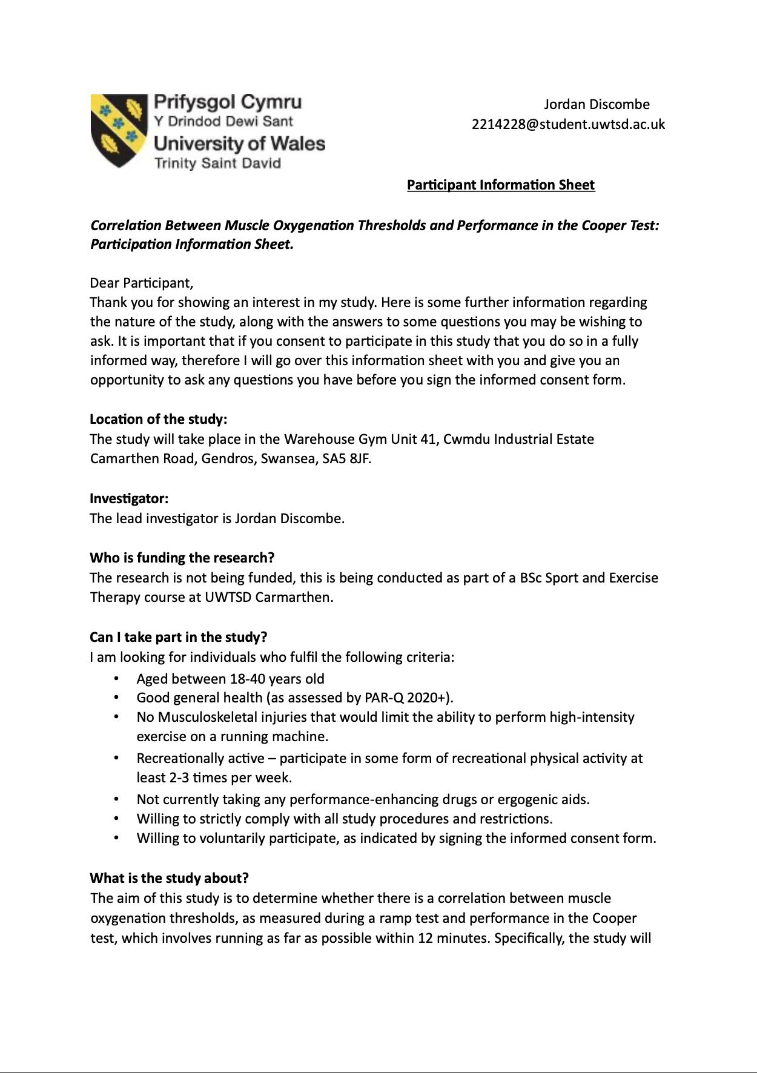

Appendix B: PAR-Q (Physical Activity Readiness Questionnaire)
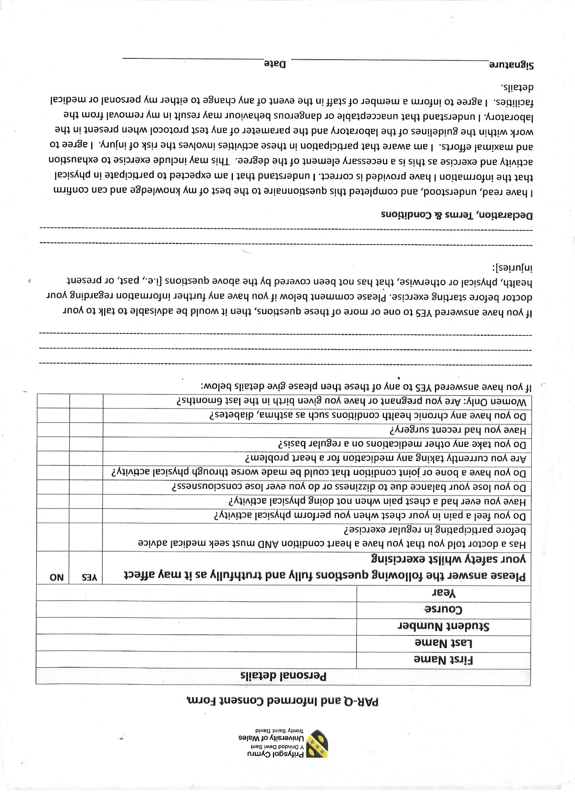

Appendix C: Ethical Approval
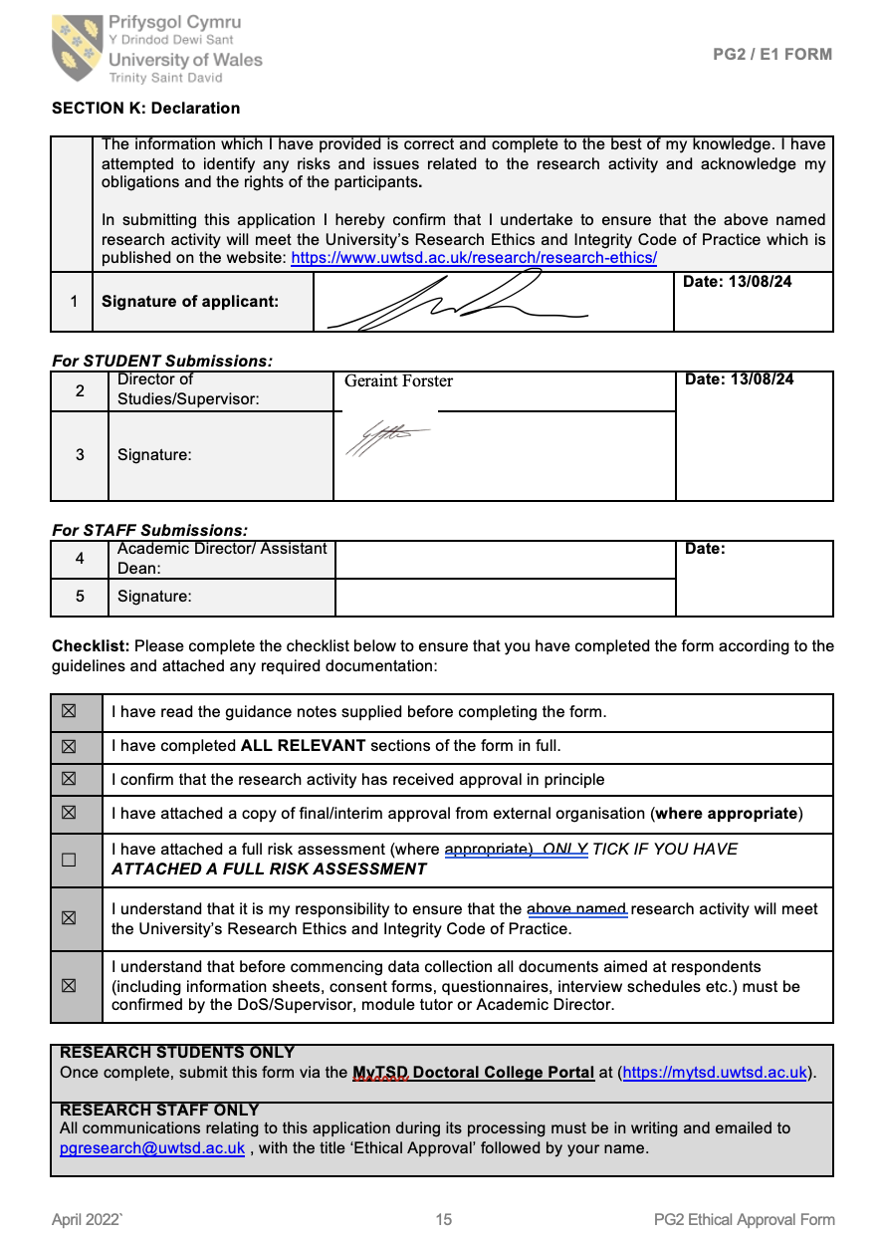

Appendix D: Additional Supporting Data
Excel Data used for SPSS Interpretation
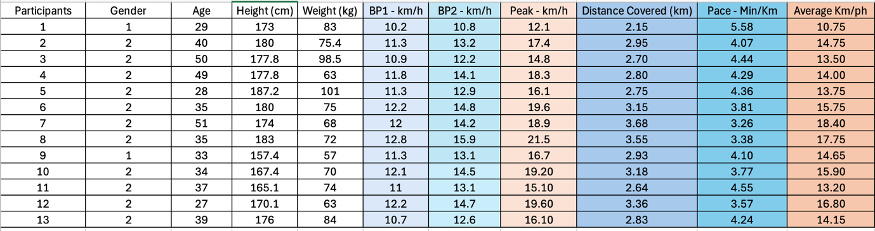
Borg Data Ramp Test
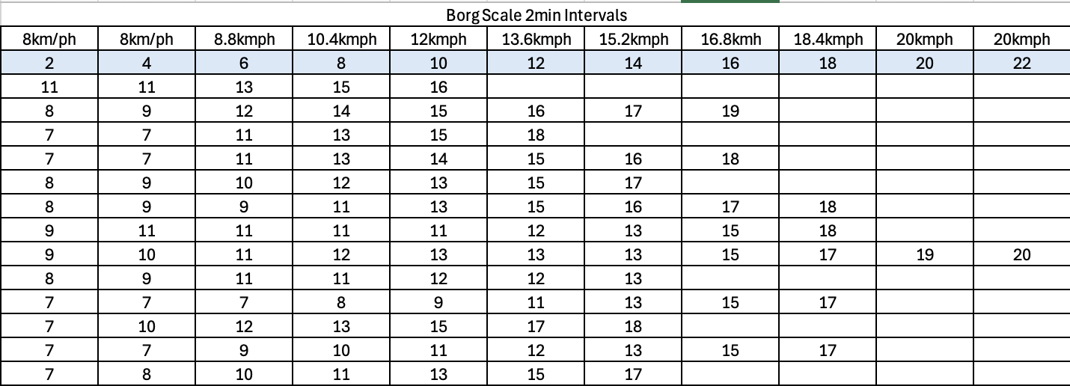
Borg Data Coopers Test
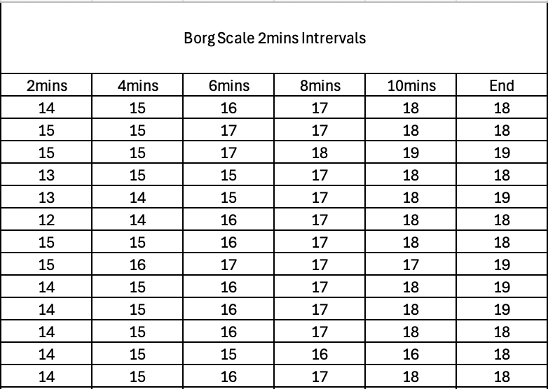

SPSS Correlation Analysis
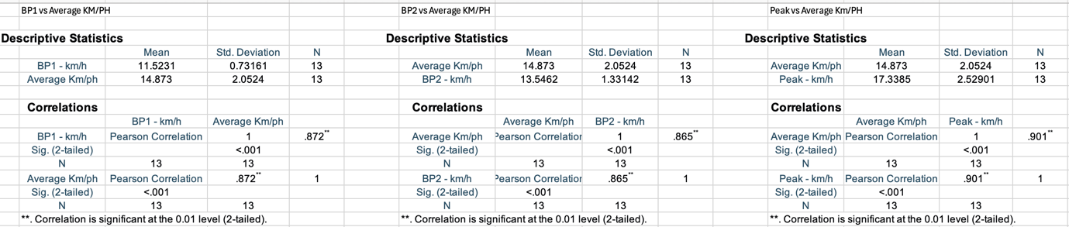

SPSS Regression Analysis



