Liam Joseph Berner
1706870
HND Construction Management
Learning Contract Submission 3
Work Based Project
Ceredigion Sustainable Development
Peter Egan, 07720155434
ACBA5009

The standards required by Sustainable Drainage Systems (SuDS) (Welsh Gov SuDS 2010) were detailed as part of the adopted road and drainage scheme carried out by my placement company. The drainage had progressed to the setting out of a C1 type manhole (Sewers for Adoption 2018). Appendix 1 details a brick built C1 type manhole 161 it can be seen with the brickwork at road formation level allowing for a double lid entry system to meet the requirements of undertaker’s rights (Department for Transport 2017). Appendix 2 shows how an operative in the future would be able to stand and work in the C1 type manhole as required under Health and Safety regulations (Working in Enclosed Spaces 2001). The invert and outflow level of the pipe work can be seen at approximately 1000mm from the top of pipes to the manhole cover finished underside level, a confined space.
Appendix 3 shows the concrete cover for a standard road manhole cover, while appendix 4 shows the size of the aperture to access the manhole prior to the fitting of a standard road manhole cover. The difference between the size of the apertures to access the manholes can be seen in appendices 1 and 4. Appendix 5 is are a view of manhole 162 from concrete lid to the invert level.
The new SuDS regulations for the control and disposal of surface water are, a requirement of the specimen section 38 agreement in appendix 6. The section 38 agreement in appendix 6 requires a bond with performance security. The bond with performance security is to ensure that the company or others instructed can complete the obligations of the section 38 agreement. appendix 7 details the conditions of a quotation received for a bond fee with a collateral deposit required and conditions requesting further information. The quotation applies to the actual road and drainage scheme that is part of my placement.
The conditional information required in the quotation requests the latest management accounts of two interlinked companies. I had previously been aware of the requirement of a surety bond for the section 38 agreement during conversations with the construction manager. But until reading the quotation I would never have considered the need for the financial history of the companies involved in the development project to be relevant. Further the quotation is conditional on a cash collateral deposit of £134,000 which is to be paid into a bank account totally controlled by the insurance company. The terms of the cash collateral deposit deed can be seen in appendix 8.
The situation regarding the cash collateral deposit will affect the cashflow within the development companies’ finances, capital lock-up will have a negative effect on a companies’ cash reserves whether borrowed or reserves (Harris. F, McCaffer. R, Edum-Fotwe. F, p.284 2013). This capital lock-up adversely affects cashflow in a project especially in the case of new housing development where cash is either reserves or borrowed. Unlike contracting where interim valuations of a contract control a contractors cashflow (Harris. F, McCaffer. R, Edum-Fotwe. F, p.289 2013)
On reflection my personal Workplace Learning (WPL) is enhanced by dialog and collaboration with colleagues (Sutherland, D. Tikkanen, O. Tikkanen, T. (2018). With individual participation while learning through work considered person dependent. (Malloch, M. Cairns, L. Evans, K. O’Connor, B. p.64 2011)

Word Count 552

References
Welsh Government (2010) Sustainable Drainage (SuDS) Statutory Guidance, Merthyr Tydfil, Welsh Government
Water UK (2018) Sewers for Adoption, A Design Guide for Developers, Eighth edition Milton Keynes, Water UK
Health and Safety Authority (2001) Code of Practice for Working in Confined Spaces, London HSE Books
Department for Transport (2017) Highways Adoption, The adoption of roads into the public highway (1980 Highways Act) London Department for Transport
Kent Council (2010) Make it Happen, Model agreement housing with bond, Ashford, Kent Council
Harris, F. McCaffer, R and Edum-Fotwe, F. (2013) Modern Construction Management seventh edition, Oxford, Wiley-Blackwell
Sutherland, D. Tikkanen, O. Tikkanen, T. (2018) The developing field of workplace and the contribution pf PIAAC, International Journal of Lifelong Education
Malloch, M. Cairns, L. Evans. O’Connor, B. N. (2011) The Sage Handbook of Workplace Learning, London, Sage
Appendices
Appendix 1 Page 3
Appendix 2 Page 4
Appendix 3 Page 5
Appendix 4 Page 6
Appendix 5 Page 7
Appendix 6 Pages 8 – 13
Appendix 7 Pages 14 - 15
Appendix 8 Pages 16 - 21

Appendix 1 Shows a C1 type manhole built to allow access to considered, a safe working environment in the future as current regulations for undertaker’s rights require.
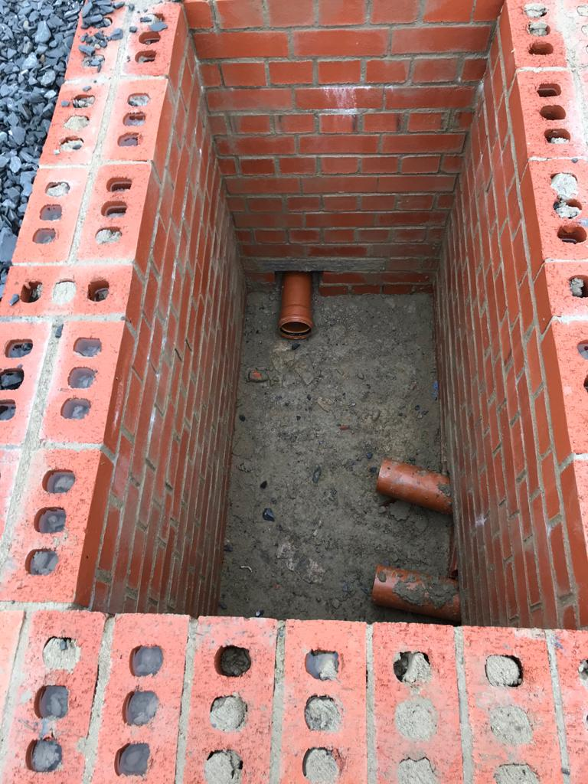

Appendix 2 Shows a C1 type manhole with an operative standing inside the chamber standing prior to the fitting of a double access manhole cover.
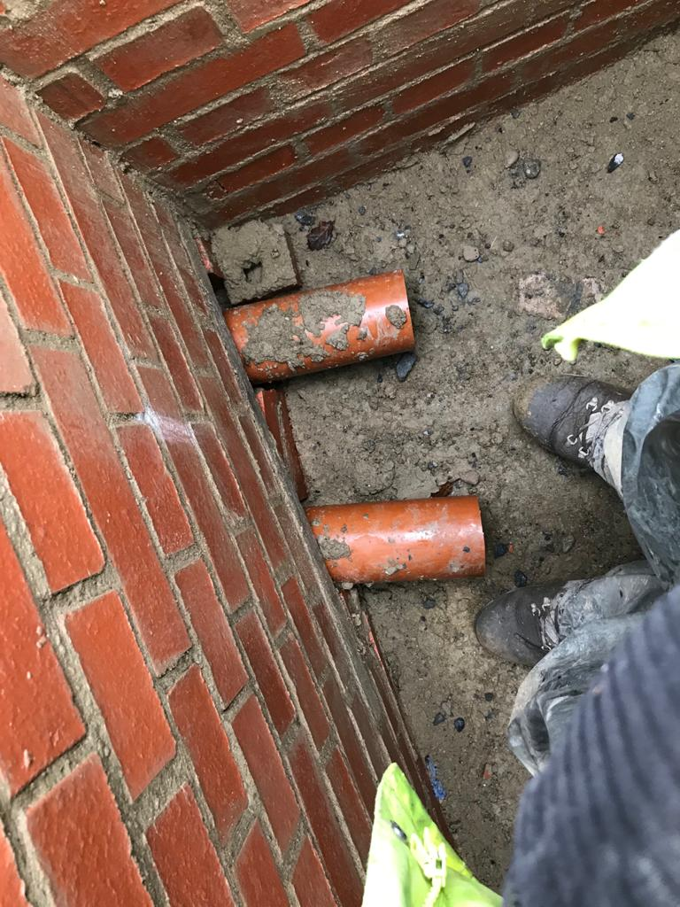

Appendix 3 Is an example of a standard concrete biscuit lid prior to the fitting of a standard manhole cover.

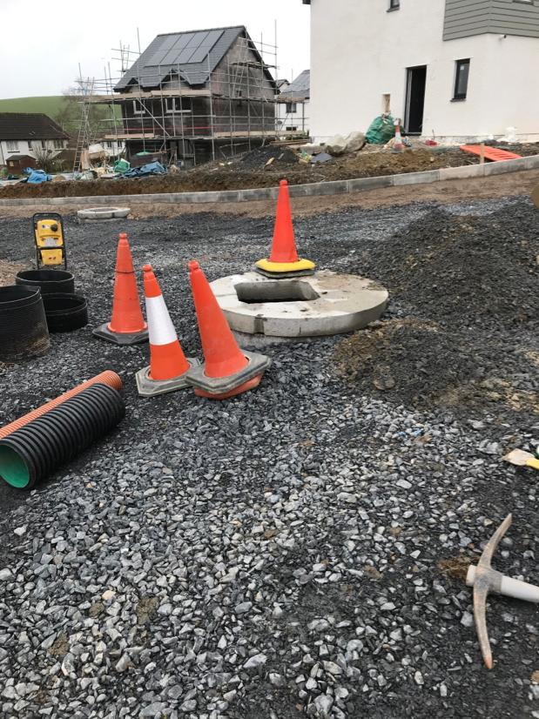

Appendix 4 Is a standard manhole aperture prior to the manhole cover fitting.
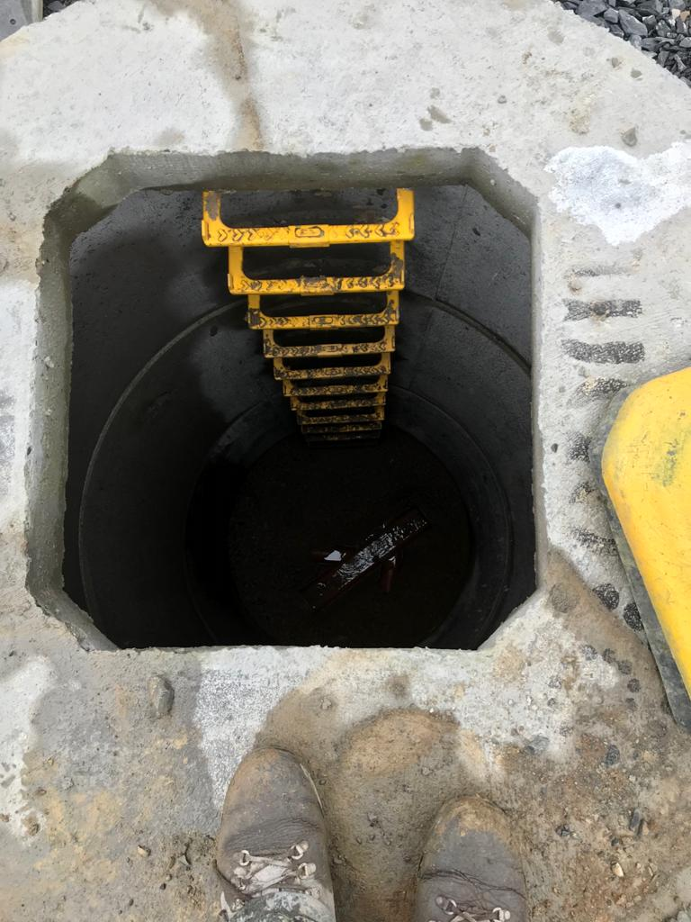

Appendix 5 Is shown to highlight the access arrangement for an operative the manhole shown is over three metres deep and allows for safe access.

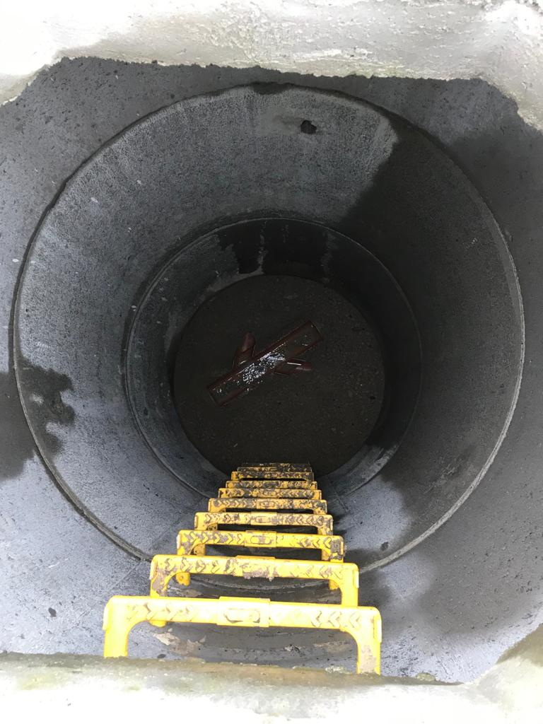

Appendix 6 Is an example of a pages from a standard section 38 agreement.

Appendix 7 Is an example of a Road and Drainage section 38 Bond quotation with Conditions.

Appendix 8 Details the format and conditions of the Cash Collateral Deposit Deed required as part of the bond quotation.

