
An Investigation of Individual Auditor’s Perceptions of Audit Quality Influences

30 November 2020
Module Name:
Name:
Student Number:

Independent Project (BMBM6020)
Peter Basford
1707183

Table of Contents
Table of Contents 1
Research Question 2
Background 2
Initial Literature Review 3
Objectives 6
Research Techniques 6
Research Rationale 8
Bibliography and References 9
Appendices 11

Research Question
This dissertation will aim to examine the factors that are perceived to impact audit quality at the individual level, as opposed to the top-down corporate level. There has been much discussion in the last few years of reforms within the audit industry, however, little has been done to examine the attitudes of the auditors themselves.

Background
“The Auditors fluttered anxiously. And, as always happens in their species when something goes radically wrong and needs fixing instantly, they settled down to try to work out who was to blame. […] The Auditors lived by consensus, which made picking scapegoats a little problematical. It brightened up. After all, if everyone was to blame, then it was no one's actual fault. That's what collective responsibility meant, after all. It was more like bad luck, or something” (Pratchett, 1996, p. 172)
The international audit community has seen a string of high profile and public collapses of businesses that had been, up to that point, given a clean bill of health by their independent auditors. In the UK alone we have seen the failures at Patisserie Valerie, Carillion, BHS and Thomas cook, to name a few. Abroad we have seen similar situations, such as EY’s failure to identify that German financial technology and risk management (somewhat ironic) company Wirecard recorded €1.9bn that did not exist (BBC News, 2019; Jones, 2020; Shoaib, 2018; Jewers, 2019; Kinder, 2020).
The UK government has produced a series of reports in the last couple of years. Sir John Kingman (2018) carried out the initial review of the Financial Reporting Council, the regulatory body responsible for the UK audit industry in late 2018, this was followed by the Business, Energy and Industrial Strategy select committee carrying out a review of the audit process between January and April 2019 (BEISC, 2019). Concurrent to the select committee conducting their investigation the Competition and Markets Authority were producing their report “Statutory audit services market study” (C&MA, 2019) and finally, Sir Donald Brydon released his report on the quality and effectiveness of audits in December 2019. All this goes to show that the issue is a very real and current one; unfortunately, the government has had the slight distraction of the whole global Covid-19 situation which rather rapidly drew the attention of all departments of the government from near the beginning of 2020.

Initial Literature Review
While there have been some examinations of the impact and attitudes of individuals on audit quality there are limitations on the usefulness of this work to the current question.
Bell, et al. (2015) looked at how the length of audit firm tenure affected the quality of each year’s audit. Not only is the research fairly recent but it examines so-called “Big 4” accounting firms both elements that increase it’s relevance to the current UK market. Though the research is based on their services to US businesses, three of the four of these firms originate from and are headquartered in the UK meaning that it can be assumed that the organisational culture is British influenced. The article does not, however specifically examine individual attitudes, rather it makes fairly safe assumptions as to the causes of their findings. For example, they find that the first year produces significantly lower work than the following year before seeing a decline to first-year quality by the 13th year. This, they assume, is due to the need for first-year auditors to gain familiarity and then once it has become a long-running engagement the auditors begin to become complacent and familiarity with the auditee’s staff becomes more of a threat to their standards.
Three studies carried out in China have examined issues of individual auditors. This is only possible due to the identities of all auditors being public knowledge as part of their reports in China, allowing them to easily carry out large scale analysis; this data is not fully available for western markets meaning that these studies cannot be replicated there. As such, we cannot be entirely sure how the more collectivist Chinese culture will have impacted their conclusions compared to the more individualistic western cultures. One paper examines the individual traits that may influence their degree of caution in issuing their audit reports (Gul, et al., 2013). They discover that those with experience working with one of the Big 4 tended towards caution while those with stronger political opinions tended toward incaution. The other two Chinese articles both examine the possibility of contagion of bad audit quality, that is, if the idiom “one rotten apple spoils the barrel” applies to audit teams (Su & Wu, 2016; Li, et al., 2017). These works establish that it does hold true to a certain extent, that one poor worker can discourage their co-workers from their normal quality of work. While not directly applicable to western markets, it does provide intriguing potential future lines of questioning.
Perhaps most relevant to the subject of this proposal are two papers form the US and France. Brown, et al. (2016) surveyed specifically junior level US auditors regarding their mood at work, their confidence, the activities they and their teams undertook as part of an audit and their working environment. They discovered that while auditors held a generally positive opinion of their work they widely expressed concern regarding the time pressure they were under and the multitasking and interruptions to their work they experienced. Herrbach (2001) used a similar approach to this in the french audit industry, anonymously surveying auditors as to the behaviours they had that may contribute to reducing the quality of audits. He found that as pay increased so too did audit quality. He hypothesised that this was either that those with high pay were identified as skilled workers or those receiving lower pay experienced reduced motivation due to said pay. Brown (2016) is the most relevant research found to this research proposal due to its recent nature, similarity in approach and similar working culture. Herrbach (2001) would be similarly relevant if not for the age of the research. Never-the-less a further examination of their methodology may prove useful.

Objectives
This research proposes to examine the opinions and beliefs of auditors regarding audit quality and possible influences to said quality. The objectives of this dissertation will be:
- To critically review further existing literature of the topic of audit quality and individual influences upon it.
- To conduct primary research on perceptions of working auditors and analyse the results.
- To draw conclusions as to the current state of workers within the industry, examine limitations of this work and identify future lines of investigation.

Research Techniques
To fully appreciate what has been analysed before a further literature review will be required. Taking inspiration from the previously mentioned studies by Herrbach (2001) and Brown, et al. (2016) the logical approach to gathering data on these topics would be to conduct questionnaires submitted to auditors. The obvious means of distributing said questionnaires is to have them hosted online for ease of access. As an obvious time-saving and convenience measure, these will need to be self-completed questionnaires (Saunders, et al., 2019). As they say, quantity has a quality all of its own, in this case establishing trends in the feelings and perceptions of auditors will be improved by a larger sample size to help counteract the influence of any potential outliers (Dillman, et al., 2014). Care will have to be taken in writing the questionnaires, to ensure the neutrality of questions. Proof-reading will assist with this to prevent any author bias creeping in. Another benefit of using self-completed questionnaires will be that it helps to minimise the inclination for respondents to merely reply with what they think is the socially acceptable answer to each question (Ibid.).
Interviews may well also contribute to the fact-finding process. A review of existing methodology literature will be needed, to determine the most appropriate ways to go about things. A limited number of exploratory unstructured interviews could be used to inform the questionnaire and focus on particularly relevant questions. Similarly useful may be use the questionnaires to establish broad areas of concern within the industry and then use semi-structured interviews to probe more deeply into the reasoning behind people’s opinions (Saunders, et al., 2019). Potential drawbacks to using interviews are the complexities of scheduling them, though this may be made easier thanks to Covid-19 and the resultant proliferation of voice over IP and videotelephony software alongside the greater number of people working from home. Interviews are not without their own problems surrounding reliability. Like questionnaires, there exists the possibility for interviewer bias to creep in, however, this is more difficult to spot during an interview if it is a more subtle matter than mere phrasing such as body language or tone of voice.

Research Rationale
Considering the somewhat limited scope of existing research in this area and current nature of the problems in the audit industry it holds up well as an area for further investigation. Of the recent government inquiries and reports it is notable that while evidence was sought from some accountants, these were always people at the pinnacle of their careers, CEOs, official statements from industry bodies and other such notables. This leaves out the opinions and views of everyone else working in the field and may add bias to the evidence they will have received. This cross-sectional study will also be a valuable record of the attitudes and perceptions of auditors during these turbulent times, both for the industry and the world as a whole.

Bibliography and References
BBC News, 2019. Patisserie Valerie scandal: Five people arrested. [Online]
Available at: https://www.bbc.co.uk/news/business-48736447
[Accessed 25 11 2020].
BEISC, 2019. Future of audit inquiry. [Online]
Available at: https://old.parliament.uk/business/committees/committees-a-z/commons-select/business-energy-industrial-strategy/inquiries/parliament-2017/future-of-audit-17-19/
[Accessed 25 11 2020].
Bell, T. B., Causholli, M. & Knechel, W. R., 2015. Audit Firm Tenure, Non‐Audit Services, and Internal Assessments of Audit Quality. Journal of Accounting Research, 53(3), pp. 461-509.
Brown, V. L., Gissel, J. L. & Gordon Neely, D., 2016. Audit quality indicators: perceptions of junior-level auditors. Managerial Auditing Journal, 31(8/9), pp. 949-980.
Brydon, D., 2019. Assess, Assure and Inform, Improving Audit Quality and Effectiveness, London: Her Majesty’s Stationery Office.
C&MA, 2019. Statutory Audit Services Market Study, London: C&MA.
Dillman, D. A., Smyth, J. D. & Christian, L. M., 2014. Internet, Phone, Mail, and Mixed-Mode Surveys: The Tailored Design Method. 4th ed. Hoboken: Wiley.
Gul, F. A., Wu, D. & Yang, Z., 2013. Do Individual Auditors Affect Audit Quality? Evidence from Archival Data. The Accounting Review, 88(6), pp. 1993-2023.
Herrbach, O., 2001. Audit quality, auditor behaviour and the psychological contract. The European Accounting Review, 10(4), pp. 787-802.
Jewers, C., 2019. FRC extends Thomas Cook investigation to more statements audited by EY. [Online]
Available at: https://www.accountancyage.com/2019/12/19/frc-extends-thomas-cook-investigation-to-more-statements-audited-by-ey/
[Accessed 25 11 2020].
Jones, H., 2020. UK watchdog finds apparent breaches by KPMG's Carillion audit. [Online]
Available at: https://uk.reuters.com/article/uk-britain-accounts-carillion/uk-watchdog-finds-apparent-breaches-by-kpmgs-carillion-audit-idUKKCN26C0UQ
[Accessed 25 11 2020].
Kinder, T., 2020. EY chairman admits ‘regret’ over Wirecard failures in letter to clients. [Online]
Available at: https://www.ft.com/content/5d4dd451-e1b3-46de-b37e-c50b7b15ed6a
[Accessed 11 11 2020].
Kingman, J., 2018. Independent Review of the Financial Reporting Council, London: Her Majesty’s Stationery Office.
Li, L., Qi, B., Tian, G. & Zhang, G., 2017. The Contagion Effect of Low-Quality Audits at the Level of Individual Auditors. The Accounting Review, 92(1), pp. 137-163.
Pratchett, T., 1996. Hogfather. 1st ed. London: Victor Gollancz Ltd.
Saunders, M. N. K., Lewis, P. & Thornhill, A., 2019. Research methods for business students. 8th ed. Harlow: Pearson Education Ltd.
Shoaib, A., 2018. PwC auditor spent just two hours on BHS audit, says chairman. [Online]
Available at: https://www.accountancyage.com/2018/06/22/pwc-auditor-spent-just-two-hours-on-bhs-audit-says-chairman/
[Accessed 25 11 2020].
Su, L. & Wu, D., 2016. Is Audit Behavior Contagious? Teamwork Experience and Audit Quality by Individual Auditors. SSRN Electronic Journal, Issue July.
Wood, Z., 2019. Patisserie Valerie accounts black hole now £94m, says KPMG. [Online]
Available at: https://www.theguardian.com/business/2019/mar/15/patisserie-valerie-accounts-black-hole-94m-say-kpmg
[Accessed 25 11 2020].

Appendices
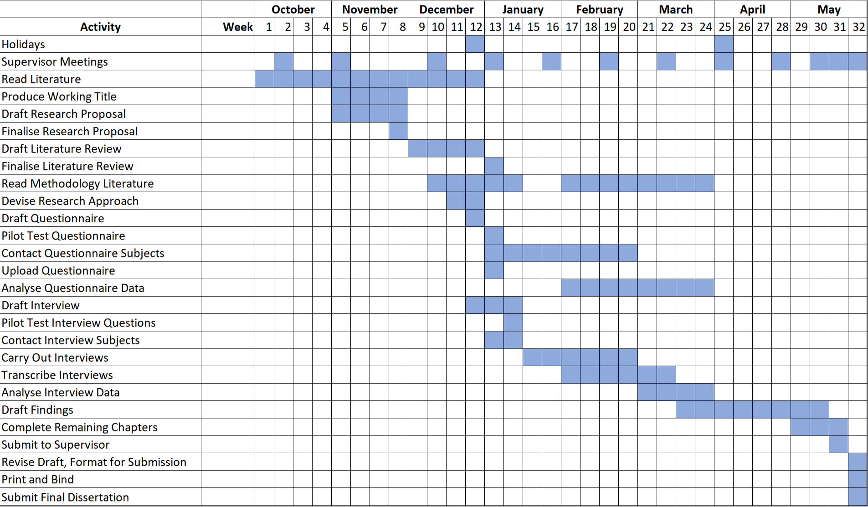
Appendix 1: Gantt Chart

