Graduate Diploma in Professional Learning- SLD/PMLD

Module Title: Teaching, the Curriculum and Assessment

Module no: M6X02186

Title: Can Attention Autism impact the joint attention skills for children on the autism spectrum in a special educational needs (SEN) setting?

1811104

Eirian Griffiths

Contents
Introduction…………………………………………………………………………………...Page 3
Literature Review……………………………………………………………………………...Page 4
Methodology……………………………………………………………………………………Page 7
Findings……………………………………………………………………………………….Page 9
Analysis………………………………………………………………………………………..Page 14
Conclusions and Recommendations……………………………………………………….Page 16
Appendices …………………………………………………………………………………..Page 18
References …………………………………………………………………………………Page 24

Introduction
It was imperative to choose a research project that would have a meaningful impact on children’s learning within a specialist classroom for children with autism. After seeking advice from the Assistant Head in charge of the Caerphilly Autistic Spectrum Service (CASS 2019) an Attention Autism training course was attended (Gina Davies 2013).

The impact of Attention Autism (AA) on joint attention (JA) skills for children with autism will be investigated through the following study. The participants will take part in the four prescribed stages, each progressively more difficult than the last. The main aim is to increase children’s JA levels and early communication skills through providing different stimulating activities. AA sessions begin with the lead adult drawing out and labelling the steps that will follow. Stage one - The bucket – Focus, consists of an adult pulling exciting eye catching items out of a bucket, which is structured with a song. In stage two - The attention builder –Sustain, the lead adult actively takes part in a multi-sensory practical activity. Stage three- The interactive game – Shift, is the turn-taking stage, where the children are invited to participate. The use of a song offers a repetitive element and indicates the start and finish of each person’s turn. Staff have a key role as they are chosen to have a turn, thus modelling expectations of participation. Stage four – The table activities- transition, builds on the participation skills encouraged in stage three; a self-contained task is modelled and the children are given materials to complete the same task independently.

This project explores the impact of AA on JA skills for children with autism in a SEN setting because although it has been found that children with autism have difficulty with joint engagement, symbolic play and JA, all of which affect learning and development (Kasari et al., 2008), there is little evidence based on the impact of AA on JA skills for children with autism. This research establishes the importance of AA in order to place greater emphasis on including it within planning and incorporate it further into teaching if deemed to have a significant positive impact on learning.

The prediction is that AA will have an influential impact on JA skills for children with autism in a SEN setting and the hypothesis is that the participants will show increased levels of JA skills.

Literature Review

Joint Attention
JA in typically developing children begins at an early age and is a pivotal skill in development (Meindl and Cannella 2011). JA emerges around nine months and is established by eighteen months (Joint Attention and Social Referencing, 2007). Vivanti et al. state that JA is:
“sharing the focus of attention with other people to a common point of reference, by either directing (initiation of joint attention) or following (response of joint attention) another person’s focus of attention towards a target” (Vivanti et al., 2017, p.1867).
The important point is that JA cannot be achieved individually and a person’s ability to interact with others affects this skill.

JA plays a vital role in improving language and is a building block for social skills and communication (Baron-Cohen 2008). Eilan (2005) stresses the importance of JA for early verbal communication development is hard to overestimate. Jones, Carr and Feeley (2006) add that JA skills develop early and play a fundamental role for social and language development. Yet, as Gupta (2004) points out the most distinguishing early characteristic of children with autism is a deficit in JA. Within Wing’s Triad of Impairments, impaired and deviant language and communication are included within the diagnostic criteria for autism (Jordan and Powell 1995). Loveland and Landry (1986) also found a JA and language deficit in children with autism.

Atypical attention in autism
The development of attention is atypical in children with autism (Patten and Watson 2011). The key factors that reoccur when looking at JA are communication and social interaction. Seemann suggests that “what is usually called joint attention is more appropriately thought of as entailing the capacity for a joint engagement with others” (Seemann, 2012, p. 7). Therefore, children with autism also face difficulties in relation to the function of JA as they lack interest in social interaction (Jones, Carr and Feely 2006). Jordan and Powell (1995) agree that for children with autism the focus of attention is idiosyncratic and not necessarily responsive to social direction. Lawson supports this as someone with autism, as she writes “we seem to find dividing our attention very difficult, unless it is clearly connected to our own interests” (Lawson, 2011, p.42).

Interventions
There is evidence that suggests JA is a fundamental early-developing social-communicative skill (Tomasello 1995 and Redcay and Saxe 2013); a critical part of JA being engaging with another person in order to share an object or event that is interesting. Mundy and Sigman support this by saying that “processes involved in joint attention contribute to social interactions, social learning and social cognition” (Mundy and Sigman, 2006, p.293). Yet, it has been determined that JA skills are low or even absent in children with autism, which has been linked to poorer language outcomes (Charman et al., 1997 and Mundy, Sigman and Kasari, 1990). Therefore, not only is it important to develop this skill for children with autism but also in order to do so, intervention strategies need to be implemented early on (Jones and Carr 2004).

Mundy, Sigman and Kasari (1990) carried out a study to examine the degree to which individual differences in gestural JA skills predicted language development among children with autism. The results indicated that even when controlling language level, mental age, or IQ, children with autism displayed deficits in these skills. Swettenham et al. (1998) observed spontaneous shifts of attention in typically developing children, developmentally delayed children and children with autism. The children with autism showed fewer shifts of attention between an object and a person and between person and person. The children with autism spent less time looking at people and spent more time looking at objects, which suggests that children with autism attend to objects, rather than people, more than typically developing children. As Bruner points out JA “depends not only on a shared or joint focus, but on shared context and shared presumptions” (Bruner, 2014, p.6). Vismara and Lyons (2007) found that children with autism are capable of generating JA behaviours but do not have the social motivation to share interests with others. Mundy (2016) agrees that in the study of JA is important to consider the role of motivation. This highlights that in order for children with autism to develop JA skills, the need of motivation is required. Jones, Carr and Feeley (2006) also suggest that as typically developing children engage with familiar people in JA with preferred and interesting objects, then using this same method would further support developing JA skills in children with autism.

Practical intervention strategies that specifically address that JA represents a key feature of autism lag behind the development of theory (Jones and Carr 2004). There is evidence collected to confirm that JA is difficult for children with autism, though there is little empirical research on interventions and strategies that address attention (Patten and Watson 2011). From evidence that is available, it suggests that children with autism benefit from intervention directed at improving attention (Patten and Watson 2011).
Mason adds “there is growing evidence to support that joint attention can indeed be taught for those who do not naturally acquire it” (Mason, 2009, p.137). Leekam writes of the possibility that “children with autism find different routes to language and this in turn assists the development of joint attention” (Leekam, 2005, p.223). Although there are few interventions for JA, Kasari et al. (2012), Jones and Feely (2009), Kaale, Smith, and Sponheim (2011), and Wong (2013) have all shown a positive increase in JA.

Attention Autism
There are few published studies that investigate the impact of AA on JA skills for children with autism. Morgan (2011) researched preschool readiness in children before and after using AA. Overall, it was found that the preschoolers benefitted from AA and gained measured improvement in their attention levels. Though, this study used a sample of only three children so the skills cannot be generalised. Buckingham (2012) analysed the impact of AA on JA skills for children with autism in key stage one. The results showed the children developed JA skills at different rates. McKeown (2015) also evaluated the effect of AA on secondary aged students’ social skills and concerning behaviours. The findings showed there was a positive impact on social skills and concerning behaviours reduced. Though, the sample size was small so the outcomes cannot be considered reliable.

Methodology
This study will be will be carried out using action research. Action research enables anyone to investigate and evaluate their work (McNiff 2017). Kurt Lewin is often referred to as the originator of action research (Adelman 2006). Action research is applied research undertaken by a practitioner who has identified a need for a change, or to improve practice. Improvement and involvement are central to action research (Robson 2002). Kemmis and Wilkinson (1998) view the process of action research as a spiral, or cyclical, process. Action research is flexible in design; an assumption is built and as the research proceeds the researcher will go back to revisit, critically analyse and revise the aims, assumptions, beliefs and practices (Thomas 2009).

Participants
The participants for this project were four children with autism within the school curriculum age phase in a SEN setting. Participants included a female from year nine, a male from year six and two males from year five. The mean age was 10.75 years old (approximately ten years and nine months old) and the actual range of ages was nine years and six months – thirteen years and eight months.
All participants have a statement of SEN and a diagnosis of autism. Appendix 1 shows a table of the raw P-level scores of participants in Attention when assessed using PIVATS (Lancashire County Council, 2019) prior to the beginning of the research project. The mean P-level score in Attention was sixteen.

Materials
Before this investigation took place, an ethics form was submitted and approval from the University was required (BERA 2018). The key elements of the ethics form were discussed in an intersessional task (Appendix 2).
Taking the Research Ethics & Integrity Code of Practice (University of Wales Trinity Saint David, 2017-2020) into consideration, written consent was obtained by gaining parental permission due to the children’s low level of cognition (Appendix 3). The parents were given information regarding the AA sessions, alongside information about the procedures and methodology. Each parent received feedback about the AA sessions via the home-school communication books. Parents were informed about their right to refuse or withdraw their child from the research project. Parents were also invited to receive an overview of the outcome of the research and to view their child’s results once all the data had been collected and analysed.

Procedure
Before carrying out the action research, a two day AA course was attended and what was learnt in the training was fed back to all staff. Following on from the training, AA sessions were introduced on a daily basis. The approach was implemented over a six week period. The physical setting in which tasks were completed remained the same for all participants in each session.
The children were baselined the first time the intervention took place. A total of six observations using two different assessment sheets (Appendix 4 and 5) were carried out. During the six observations, the children were filmed in order for the researcher to complete the assessment sheets accurately. Following the school’s General Data Protection Regulation (GDPR) guidelines (GDPR 2016) the videos were deleted once the assessments were complete.

Findings
The data collected is quantitated data; using a standardised observation sheet for AA with criteria devised by Gina Davies, the founder of the AA approach (Appendix 4).
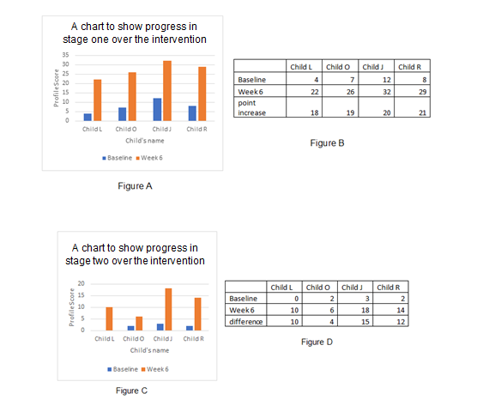
Figure A and B shows the progress made in stage one over the six-week intervention. The children made a similar increase in point scores; the lowest being an increase in eighteen points and the highest being an increase in twenty-one points. All children made progress with increased attention skills.
A chart to show progress in stage one over the intervention

Figure C and D shows the progress made in stage two over the three sessions it was assessed. Most of the children made a similar increase in point scores, with the exception of Child O. All children made progress with increased attention skills. In stage two, Child J made the most progress overall. There is a difference of eleven points between the least and the most progress made.

The results of each child’s scores were also examined in order to establish what progress was made.
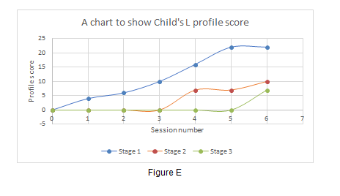

Figure E shows Child L started with a base line score of four in stage one and the points increased to twenty-two, showing an improvement of eighteen points over the six sessions. Child L had an increase in points before steadying off in the last two assessed sessions. Child L’s points increased from seven to ten for stage two, showing an increase of 43% over three sessions; the scores increased between the fifth and sixth week. In stage three, a baseline score of seven was assessed.
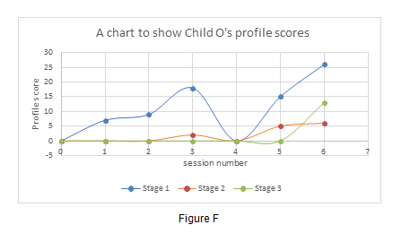

Figure F shows Child O started with a base line score of seven in stage one and the points increased to twenty-six, showing an improvement of nineteen points over the six sessions. There was a high increase of eleven points in Child O’s scores between session five and six. Child O’s points increased from two to six for stage two, showing an increase of four. Child O scores increased by 20% from session five to six. In stage three, a baseline score of thirteen was assessed.

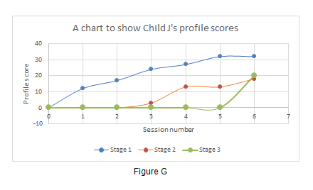
Figure G shows Child J started with a base line score of twelve in stage one and the points increased to thirty-two, showing an improvement of twenty points over the six sessions. Child J’s points increased from three to eighteen for stage two, showing an increase of fifteen. The scores increased by 39% from session five to six. In stage three, a baseline score of twenty was assessed.
Figure G
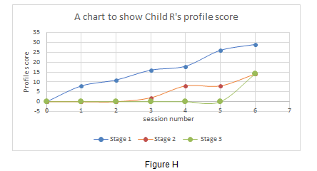

Figure H shows Child R started with a base line score of eight in stage one and the points increased to twenty-nine, showing an improvement of twenty-one points over the six sessions. Child R made steady progress from session one to six; there is a point increase of three and above between each of the sessions. Child R’s points increased from two to fourteen for stage two, showing an increase of twelve. Child R’s scores increased by 75% from session five to six. In stage three, a baseline score of fourteen was assessed.
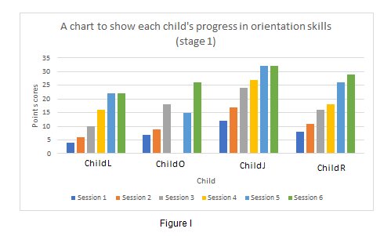

Figure I shows each child’s progression in orientation skills (stage one) over the six sessions. All children made progress during the orientation stage of the intervention. Most children made steady progress, with the exception of Child O.
Figure I
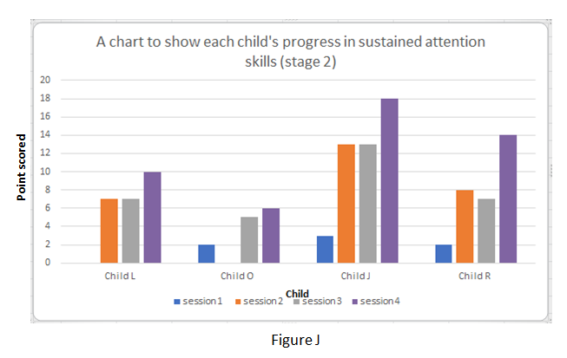

Figure J shows each child’s progression in sustained attention (stage two) over the four sessions. Child L and J remained at the same point level for sessions three and four. Child J made the most progress overall between session one and six.
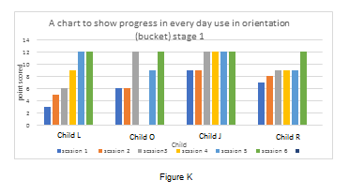
In order to ensure the data collected was triangulated, assessment sheets measuring transferrable everyday use of AA skills were also used (Appendix 5). Figure K shows each child’s progression in everyday use of skills in orientation (bucket) stage one. All children reached a point score of twelve by session six. Child L and J remained at the same score for session five and six. Child J made the quickest progress in session one. Child J had the smallest point increase though this was due to the child picking up the strategies in everyday use the quickest. Child L made the most progress overall.
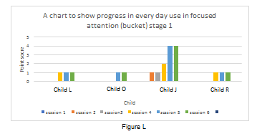
Figure L shows each child’s progression in everyday use of skills in focused attention (bucket) stage one. All children stayed at the same point score for session five and six. Most children reach a score of one for everyday use of focused attention skills, with the exception of Child J, whose points increased to three.
Child J
Child O
Child L
Figure L

Analysis
It is important to note that as the AA approach is child led, the class only completed three out of the four stages over the six-week period that the sessions were observed. In keeping with following the AA intervention strategy guidelines, stage two was not started until stage one’s skills were imbedded and the same with stage three. Stage two was started during week three and a baseline for stage three was obtained in week six.

Overall the results show that, for most children, the use of the AA approach increased their JA skills. However, this was not true for all the children. Child O’s scores were sporadic and dropped in session four as the child was absent all week due to illness. From the results, it is clear that Child O’s scores were impacted by being absent as the scores in stage one in session five are lower than in session three. It took the week of session five for Child O to get back into routine. Before being absent Child O was making excellent progress in stage one as the scores increased by nine points between sessions two and three. If assessed for longer, Child O would continue to make progress; this is evident from the fact that there was a high increase of eleven points between stages five and six.

Child J had the highest baseline scores for stage one, two and three out of all the children. One of the reasons for this could be that the children showed ability for their skills to be increased with the right intervention and for this particular child, AA was just that. Child J was noticeable more interested in the AA sessions from the start, from the way Child J would repeat the word ‘bucket’ and join in with the song, to the fact that when sessions took place, Child J physically leaned towards the activity and would sit on the edge of their seat in anticipation. Child J made the most verbal responses in relation to the sessions, modelling language the leader used and making the same sounds to show engagement in activity, for example, when the crocodile snapped the leaders’ fingers and shouted ‘ow!’ Child J repeated this and laughed. The results show that in stage one, Child J increased their attention point score gradually over the six sessions by three points or more each week. The biggest increase being by seven points between sessions two and three. Child J reached the maximum number of points in stage one by session five. By the end of stage two, Child J achieved eighteen points out of a possible twenty-four points. It is important to note that stage two was assessed for four weeks, rather than six as stage one is required to be achieved first. If the intervention was to continue for longer from the existing results it is evident that the scores would continue to rise.

Child L’s results were positive as in stage one the point score increased gradually from two to four to six points between each session. However, the scores rose more steadily in stage one than stage two. It can be hypothesised that that if given more time, Child L would show the same progress in stage two as stage one; the stages get progressively more difficult, so Child L may have just needed more time to show improvement.

Child R’s points decreased by one in stage two between sessions two and three. This was due to Child R needing to be prompted back onto task when being assessed on focused and sustained attention for a range of attention building activities that are based on exploratory and sensory experiences. Child R was distracted by something during to the session and whilst every attempt was made to keep other variables the same in a busy classroom achieving this is problematic.

On refection, the AA approach increased the JA skills for children with autism in a SEN setting. The fact that in AA the environment is required to be clear of distraction worked at an advantage as this meant the children could focus on what was required. In addition, giving the children time to react meant they were more responsive because they were given time to process. The way in which the AA sessions were set up fitted well into an already well established class routine that uses the TEACCH approach (National Autistic Society 2017). Bucket photographic symbols were made so children could place the symbol from their schedule onto the corresponding baseboard. Also, the structure of the approach is predictable so the children knew what was expected.

Conclusion & Recommendations
The results of this study support the hypothesis that AA has a positive impact on JA skills for children with autism in a SEN setting. On average, the participant scores increased from the initial baseline assessments carried out at the start of the six week period.

This study supports the conclusions of Buckingham (2012) whose findings of AA showed the children developed JA skills at different rates. It is interesting that Buckingham (2012) results in a key stage one class were similar to the results for this project carried out with an older age group. Morgan (2011) found that children who initially had lower scores in join attention showed a greater improvement overall but this was not true of the findings for this project. The child who had the highest baseline score also had the highest score overall. Also, the children made similar point increases regardless of whether their baseline was low or not. In addition, Wong (2013) found implementing an intervention significantly improved JA skills of young children with autism and this study reflects the same findings with older pupils. This study is further evidence of using interventions to increase JA skills for children with autism.

Mckeown (2015) found that by implementing the AA intervention, concerning behaviours decreased. Although this was not focused upon for this project, a member of the Senior Leadership Team observing an AA session noted that one pupil who can exhibit challenging behaviour was significantly calmer within the session. The impact of AA on behaviours is something that could be examined as a possible extension to this research project. Mckeown (2015) also found gains in social skills as measured on the Social Skills Improvement System (SSIS). Though social skills were not measured against the same criteria, the assessment data gathered showed a positive impact on reactive responses. The results for this project highlight the transferrable everyday use of AA skills, such as in stage one orientation (bucket) progress is measured throughout the six sessions.

Independent variables were kept as constant as possible throughout this project, such as the setting, structure, assessment criteria and time of day. Wilding writes that “learning is most effective when the brain is in acquisition mode, generally between 10:00 am to 2:00 p.m.” (Wilding, 2018, p.1). In line with Pope’s (2016) research that students learn more in the morning than later in the school day, the sessions for this research were completed between eleven and twelve. It would be interesting to consider time of day preferences for learners as it would be influential to observe whether the assessment results would be affected. If the sessions were measured at different times, it could be determined when individual learners attend the best and advantage of the best times could be utilised.
There are factors worth considering that may have affected the results. One pupil’s results in in particular were affected because they were absent for a week. The National Autistic Society guidelines stress that before a child with autism “can access learning, work may need to be done on their emotional well-being, reducing stress and increasing self-confidence” (National Autistic Society, 2019, p.1). It took the pupil a week after being ill to get back into routine and be in a place where they were ready to learn.

Another factor that could come into question is that the pupils assessed were aged nine to thirteen; as Jones and Carr (2004) stress that intervention strategies need to be implemented early on. However, existing studies such as Buckingham (2012) and Morgan (2011) already focus on interventions introduced earlier on and even though McKeown (2015) focused on secondary aged pupils there is no existing research on the effects of interventions on pupils in-between these ages. This research project ensured a focus on an age of pupils who have not previously been assessed. It would help if this study was replicated by someone else because it would confirm the reliability of evidence collected.

On reflection, though the findings were positive, a number of improvements could have been made to this project. For example, stage one progress is measured in more detail than stages two and three due to it being the first stage. If the study was assessed over a longer period of time, then stages two and three would also be assessed in more detail. The action research could have been validated further by carrying out the assessment for a longer period of time. As AA is child led, only a baseline for stage three was assessed and sufficient evidence for progress in this stage was not collected. If the research project was extended, the progression over stage three and the baseline and progression for stage four could have been measured. The research tasks and assessments could also be repeated at a later date to confirm the reliability of the results.

In conclusion, the results of this study are positive and this project will influence what takes place in class for children with autism in a SEN setting. The importance of implementing the AA approach on JA skills has been established. The next step is to place more of a focus on transferring the skills learnt in AA sessions to other class activities. An influential factor is that this research project encourages critical and reflective practice, as even when the investigation is finished and the findings have been considered the job is not complete because practice will continue to be reviewed, evaluated and improved (Bell 2010).

Appendices

Appendix 1
A table of the raw P-level scores in Attention.
Children: | Raw P-level score for Attention:
Child L | PSD6a  P6a 10
Child O | PSD8d  P8d  17
Child J | PSD9d  1Cd  22
Child R | PSD7a  P7a  15

Appendix 2
We discussed the key elements of the Ethics form in an intersessional task on the 13/2/19. The points that were considered are as follows:
- Readings: BERA guidelines – Guidance on research with children/ Research Integrity and Ethics - code of practice
- Outline the purpose, aims and objectives of the research activity- Include key research questions. Show how existing research has informed proposed activity
- Explain what the research activity will add/ how it addresses area of importance
- Provide a summary of the methods that may be used
- Make it clear what specific techniques may be used
- Identify locations of where research activity will take place
- Expected number of participants. How will you identify participants?
- Identify risks to participants/investigator/ University
- Ethics form acts as a risk assessment for research - Identify Risks to you – university is liable - Consider feedback, consent and confidentiality
- List measures put in place to limit any adverse effects or outcomes of research activity
- Research books available- tell you how to research
- Acknowledge ethical pitfalls of methods of approach
- (Example: could upset parent- what preventative measures can be put in place?/Upset Participant- parental response)
- Head teacher hold researcher responsible for putting in intervention
- Write how you deal with what you do with the materials/information after
- Consider data protection storage – encrypted pen drive (password)
- Consider how long keep videos recorded- write when they will be destroyed
- Primary data- information you are collecting- explain how you will look after it
- Do not put schools name down- anonymise everything
- Write context of where research is taking place
- Reference BERA- explain the reason you are doing this project for
- EWC- code of conduct/Professional standards
- Ensure explain purpose of research activity – benefits of teaching and pupils. Be clear what you are looking at/what you expect to see
- What are you going to do? How? Including observation? Participant or non-participant observer?
- Baseline test
- Pre and post questionnaire
- Narrow and focused

Appendix 3
Dear Parents,
As part of my Graduate Diploma in Special Educational Needs, I am doing a piece of action research. My action research is going to be on Attention Autism. Attention Autism is an approach used to build attention and foster early communication skills in children and young people with autism and associated communication difficulties. The programme was devised and developed by Gina Davies, a speech and language therapist who leads the ‘Gina Davies Autism Centre’ which is a nationally recognised provider of advice and training.

The aim of the research will be to develop natural and spontaneous communication through the use of visually based and highly motivating activities. The sessions will include presenting visually stimulating items in order to capture and sustain the children’s attention. Each session will be progressively longer and will follow the prescribed stages of the Attention Autism programme. The main aim will be to increase the child’s Joint Attention levels on providing different stimulating activities.

The children will be observed during the Attention Autism sessions and then given a baseline score. The children will then be scored periodically throughout a six-week block. You will be given feedback on how your child is doing via the home/ school diary, as normal. In addition, I will show you your child’s data, if you wish.

Please complete the form below to say if you are happy for your child’s data to be included in my action research project. Your child’s data will be made anonymous and your child will never be identified. You have the right to withdraw your child’s data from my project at any time either in person or via your child’s home/school book.
This consent is for the use of your child’s data; the Attention Autism sessions will be run as part of your child’s curriculum.

This is an exciting project which we believe will increase the children’s Joint Attention skills and communication skills.

If you would like any more information before giving your consent or not, please don’t hesitate to contact me.
Yours sincerely,
Eirian Griffiths
Class Teacher.

I am / am not happy for my child’s data to be used in action research carried out by Eirian Griffiths.
Please tick the following boxes as appropriate:

- I understand that I can withdraw my child’s data at any time.
- I understand that Attention Autism sessions will take place as part of my child’s normal school day.
- I understand that my child’s data will be anonymous and he/she will never be identified.

Signed: ………………………………………………… Date: …………………………

Parent/Carer of: ………………………………………………

Appendix 4
Standardised observation sheet - criteria devised by Gina Davies, founder of the Attention Autism approach.

Coding: 0 - not present, 1 - emerging, 2 -developing, 3 - frequent, 4 - fluent
Stage one

Orientation (bucket) | Session 1 | Session 2 | Session 3 | Session 4 | Session 5 | Session 6
Alerts to object by body stilling.
Reactive response, e.g. searching, eye-gaze, locating, reaching.
Focused attention (bucket)
Able to focus attention for a series of 3 objects (e.g. bucket activity) that lasts 2 minutes in total.
Able to focus attention for a series of objects (e.g. bucket activity) that lasts 5 minutes in total.
Able to focus attention for a series of objects (e.g. bucket activity) that lasts 10 minutes in total.
Able to focus attention for a wide range of objects (e.g. minimum 15 different objects).
Sustain attention  (1 activity that takes longer, i.e. the attention activity) | Session 1 | Session 2 | Session 3 | Session 4 | Session 5 | Session  6
Able to focus and sustain attention to one activity that lasts for 2 minutes.
Able to focus and sustain attention to one activity that lasts for 5 minutes.
Able to focus and sustain attention to one activity that lasts for 10 minutes.
Able to focus and sustain attention for a range of attention building activities that are based on exploratory and sensory experiences e.g. coloured water pouring.
Able to focus and sustain attention for a range of attention building activities that are less obviously motivating, such as sorting unifix cubes.
Stage Two

Stage Three

Stage Four

Shift attention from group, through a transition, to an individualised task, and transition back to group | Session 1 | Session 2 | Session 3 | Session 4 | Session 5 | Session 6
Able to focus attention and sustain it for a demonstration, remember the information during a transition, and reproduce it in an independent activity.
Able to focus attention and sustain it for a demonstration, remember the information during a transition, reproduce it in an independent activity, and return to the group.
Able to focus attention and sustain it for a demonstration, remember the information during a transition, reproduce it for a shared activity with an adult partner, and return to the group.
Able to focus attention and sustain it for a demonstration, remember the information during a transition, reproduce it for a shared activity with a peer, and return to the group.
Shift attention to own participation  (interactive game) | Session 1 | Session 2 | Session 3 | Session 4 | Session 5 | Session 6
Able to wait briefly to go first on adult invitation, whilst sustaining attention for the activity overall.
Able to watch 2 peers taking their turns, whilst sustaining attention for the activity overall.
Able to watch their peer group taking their turns for the duration of the activity.
Able to wait until third or later for a turn, whilst sustaining attention for the activity overall.
Able to wait for random turns, whilst sustaining attention for the activity overall.
Able to tolerate not having a turn.
Able to take their turn independently following the adult invitation.
Able to return to seat independently after their turn and refocus their attention on the group.

Appendix 5
Assessment sheets measuring transferrable everyday use of Attention Autism skills:
Stage One | Session 1 | Session 2 | Session 3 | Session 4 | Session 5 | Session 6
Orientation (bucket)
Everyday Use: Alerts to dominant stimulus presented by an adult.
Focused attention (bucket)
Everyday use: Focuses attention on objects presented by an adult, e.g. a whisk used in cookery, or a paintbrush in art.
Stage Two
Sustain attention (1 activity that takes longer, i.e. the attention activity)
Everyday use: Able to sustain attention in structured activities led by an adult.
Stage Three
Shift attention to own participation (interactive game)
Everyday use: Able to tolerate turn-taking in structured group activities.
Stage Four
Shift attention from group, through a transition, to an individualised task, and transition back to group
Everyday use: Able to use demonstration and imitation as learning strategies.

Coding: 0 - not present, 1 - emerging, 2 -developing, 3 - frequent, 4 - fluent

References

Adelman, C. (2006) Kurt Lewin and the Origins of Action Research, Educational Action Research, 1:1, 7-24, DOI: 10.1080/0965079930010102.

Baron-Cohen, S. (2008) Autism and Asperger Syndrome. Oxford: Oxford University Press.

Bell, J. (2010) Doing Your Research Project: A guide for first-time researchers in education, health and social science. (5th ed.) Maidenhead: Open University Press.

BERA (2018) Ethical guidelines for educational research. (4th ed.) [Online] Available at: https://www.bera.ac.uk/wp-content/uploads/2018/06/BERA-Ethical-Guidelines-for-Educational-Research_4thEdn_2018.pdf (Accessed: 16th June 2019).

Bruner, J. (2014) ‘From Joint Attention to the meeting of minds: An introduction’, in Moore, C., and Dunham, P. (ed.) Joint Attention Its Origins and Role in Development. New York and London: Psychology Press.

Buckingham, K. (2012) The impact of the Attention Autism approach on joint attention skills in a Key Stage One class in a special school. [Online] Available at: http://www.southamptoninclusion.net/wp-content/uploads/2016/02/Research-Kate-Buckingham.pdf (Accessed: 5th May 2019).

CASS (2019) Caerphilly Autistic Spectrum service. [Online] Available at: http://www.trinityfieldsschoolandresourcecentre.co.uk/resourcecentre/cassteam/default.htm (Accessed: 5th May 2019).

Charman, T., Swettenham, J., Baron-Cohen, S., Cox, A., Baird, G. and Drew, A.
(1997) ‘Infants with autism: An investigation of empathy, pretend play, Joint Attention,
and imitation’, Developmental Psychology, 33 (5), pp. 781–789.

Eilan, E. (2005) ‘Joint Attention, Communication, and Mind’, in Eilan, E., Hoerl, C., McCormack, T., Roessler, J. (ed.) Joint Attention: Communication and Other Minds: Issues in Philosophy and Psychology. Oxford: Oxford University Press.

GDPR (2016) General Data Protection Regulation (GDPR). [Online] Available at: http://www.trinityfieldsschoolandresourcecentre.co.uk/policies/default.htm (Accessed: 5th May 2019).

Gina Davies (2013) Practical Help with Autism. [Online] Available at: http://ginadavies.co.uk/ (Accessed: 5th May 2019).

Gupta, V.B. (ed.) (2004) Autistic Spectrum Disorders in Children. Taylor & Francis e-library. [Online] Available at: https://books.google.co.uk/books?id=tOZqDydjMMIC&printsec=frontcover&source=gbs_ge_summary_r&cad=0#v=onepage&q&f=false (Accessed: 27th April 2019).

Joint Attention and Social Referencing (2007). [Online] Available at: http://www.infantva.org/documents/CoPA-Nov-JointAttentionSocialRefer.pdf (Accessed: 26th April 2019).

Jones, E. A. and Carr, E. G. (2004) ‘Joint Attention in Children with Autism: Theory and Intervention’, Focus on Autism and other developmental disabilities, 19(1), pp. 13-26.

Jones, E. A., Carr, E. G. and Feeley, K.M. (2006) ‘Multiple effects of Joint Attention intervention for children with autism’, Behavior Modification, 30 (6), pp. 782–834.

Jones, E. and Feely, K.M (2009) Parent Implemented Joint Attention Intervention for Preschoolers with Autism. [Online] Available at: https://free.openeclass.org/modules/document/file.php/SOC176/joint%20attention.pdf (Accessed: 27th April 2019).

Jordan, R. and Powell, S. (1995) Understanding and Teaching Children with Autism. Chichester: John Wiley and Sons.

Kaale, A., Smith, L. and Sponheim, E. (2011) ‘A randomized controlled trial of preschool-based Joint Attention intervention for children with autism’, Journal of Child Psychology & Psychiatry. 53(1), pp. 97-105.

Kasari, C., Gulsrud, A., Freeman, S., Paparella, T., and Hellemann, G. (2012) ‘Longitudinal follow-up of children with autism receiving targeted interventions on Joint Attention and play’, Journal of the American Academy of Child and Adolescent Psychiatry, 51(5), pp.487-95.

Kasari, C., Paparella, T., Freeman, S., and Laudan B, J. (2008) ‘Language outcome in autism: randomized comparison of Joint Attention and play interventions’, Journal of consulting and clinical psychology, 76(1), pp.125-37.

Kemmis, S. and Wilkinson, M. (1998) ‘Participatory action research and the study of practise’, in Atwech, B., Kemmis, S. and Weeks, P. (ed.) Action Research in Practice: Partnership for Social Justice in Education. London and New York: Routledge.

Lancashire County Council (2019) PIVATS Milestones and the Pre-Key Stage Standards. [Online] Available at: http://www3.lancashire.gov.uk/corporate/web/?PIVATS/14585 (Accessed: 16th June 2019).

Lawson, L. (2011) The Passionate Mind How People with Autism Learn. London and Philadelphia: Jessica Kingsley Publishers.

Leekam, S. (2005) ‘Why do children with Autism have a Joint Attention impairment?’, in Eilan, E., Hoerl, C., McCormack, T., Roessler, J. (ed.) Joint Attention: Communication and Other Minds: Issues in Philosophy and Psychology. Oxford: Oxford University Press.

Loveland, K. A. and Landry S.H. (1986) ‘Joint Attention and language in autism and development language delay’, Journal of autism and developmental disorders, 16(3), pp. 335-49.

Mckeown, L. (2015) ‘An evaluation of the Attention Autism programme for secondary aged children with autism in a mainstream setting’, Good Autism Practice (GAP), 16(1), pp. 12-17(6).

McNiff, J. (2017) Action Research All You Need to Know. London: SAGE Publications Ltd.

Meindl, J. N. and Cannella – Malone, H. I. (2011) ‘Initiating and responding to Joint Attention bids in children with autism: A review of the literature’, Research in
Developmental Disabilities, 32 (5), pp. 1441 – 1454.

Morgan, H. (2011) Evaluation of Attention Hillingdon: a social communication intervention for preschoolers with autism spectrum disorder. Institute of Education, University of London.

Mundy, P. (2016) Autism and Joint Attention: Development, Neuroscience, and Clinical Fundamentals. New York: The Guilford Press.

Mundy, P., Sigman, M. and Kasari, C. (1990) ‘A longitudinal study of Joint Attention and language development in autistic children’, Journal of Autism and Developmental Disorders, 20(1), pp. 115–128.

Mundy, P. and Sigman, M. (2006) ‘Joint Attention, social competence, and developmental psychopathology’, in Cicchetti, D. and Cohen, D.J. (ed.) Developmental Psychopathology, Volume 1: Theory and Method. 2nd Ed. New Jersey: John Wiley and sons, Inc.

National Autistic Society (2017) TEACCH. [Online] Available at: https://www.autism.org.uk/about/strategies/teacch.aspx (Accessed: 18th June 2019).

National Autistic Society (2019) School absence and refusal strategies. [Online] Available at: https://www.autism.org.uk/about/in-education/exclusion/school-refusal-strategies.aspx (Accessed: 18th June 2019).

Patten, E. and Watson, L. (2011) ‘Interventions Targeting Attention in Young Children with Autism’, American Journal of Speech - Language Pathology, 20(1), pp. 60-69.

Pope, Nolan G. (2016) How The Time Of Day Affects Productively: Evidence From School Schedules. [Online] Available at: https://www.autism.org.uk/about/strategies/teacch.aspx (Accessed: 18th June 2019).

Redcay, E. and Saxe, R. (2013) ‘Do you see what I see? The neutral bases of Joint Attention’, in Janet Metcalfe, J. and Terrace, H.S. (ed.) Agency and Joint Attention. USA: Oxford University Press.

Robson, C. (2002) Real World Research. 2nd Ed. UK: Blackwell Publishing.

Seemann, A. (ed.) (2012) Joint Attention: New Developments in Psychology, Philosophy of Mind, and Social Neuroscience. London: The MIT press.

Swettenham, J., Baron-Cohen, S., Charman, T., Cox, A., Baird, G., Drew, A., Rees, L. and Wheelwright, S (1998) ‘The frequency and distribution of spontaneous attention shifts between social and nonsocial stimuli in autistic, typically developing, and nonautistic developmentally delayed infants’, Journal of Child Psychology and Psychiatry, and allied disciplines, 39(5), pp.747-53.

Thomas, G. (2009) How to do your Research Project. London: SAGE Publications Inc.

Tomasello, M. (1995) ‘Joint Attention as social cognition’, in Moore, C., Dunham, P.J (ed.) Joint Attention Its Origins and Role in Development. New York and London: Psychology Press.

University of Wales Trinity Saint David - Prifysgol Cymru Y Drindod Dewi Sant (2017-2020) Research Ethics & Integrity Code of Practice. [Online] Available at: https://www.uwtsd.ac.uk/media/uwtsd-website/content-assets/documents/research/research-ethics-integrity-code-practice.pdf (Accessed: 16th June 2019).

Vismara, L. and Lyons, G. (2007) ‘Using Perseverative Interests to Elicit Joint
Attention Behaviors in Young Children with Autism: Theoretical and Clinical
Implications for Understanding Motivation’, Journal of Positive Behavior Interventions, 9(4), pp. 214–228.

Vivanti, G., Fanning, P., Hocking, D., Sievers, S. and Dissanayake, C. (2017) ‘Social Attention, Joint Attention and Sustained Attention in Autism Spectrum Disorder and Williams Syndrome: Convergences and Divergences’, Journal of autism and developmental disorders, 47(6), pp. 1866–1877.

Wilding, M. (2018) What’s The Best Time of Day to Learn and Create? [Online] Available at: https://medium.com/the-mission/whats-the-best-time-of-day-to-learn-and-create-b3ee577fb2df (Accessed: 16th June 2019).

Wong, C.S. (2013) A play and Joint Attention intervention for teachers of young children with autism: A randomized controlled pilot study. [Online] Available at: https://journals-sagepub-com.ezproxy.uwtsd.ac.uk/doi/pdf/10.1177/1362361312474723 (Accessed: 16th June 2019).

