Planning and Delivering an International Meeting/Event
Module Title: International Meetings Management BMIH6007



Student Name: Ella Daniela Mirea
Student Number: 2246573
Lecturer: Kathryn Flynn (Module Lead) & Kat Roberts

I hereby confirm I did not use AI for my assessment

An Immersive MICE Event for International Students in Wales

CROESO CONNECT - THE INTERACTIVE WELCOME BADGE

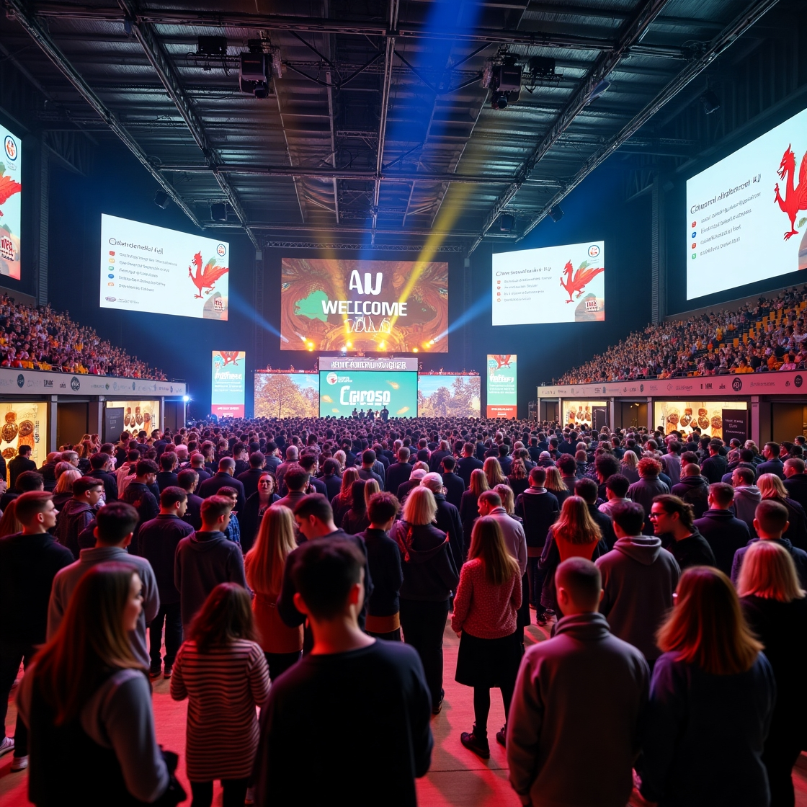

Table of contents

1. Introduction 4
2. Event Cycle 4
2.1. Application in Croeso Event 5
3. Event Concept 5
4. Aims and Objectives 7
4.1. Overarching Aim 7
4.2. SMART Objectives 7
5. Event Management 8
5.1. Planning Activities 8
5.2. Operational Activities 8
5.3. Marketing Activities 9
5.4. Skills Required 9
6. Event Budget 10
6.1. Costs and predicted revenues 10
6.2. Funding Plan/Income 10
7. Industry Trends, Issues, and Impacts 11
7.1. Emerging Industry Trends 11
7.2. Key Issues and Challenges 12
7.3. Impacts on the Education and Tourism Sectors 12
8. Situational and Cultural Considerations 13
Situational (SWOT ANALYSIS) 13
Cultural consideration 14
9. Conclusion 15

Introduction
Croeso Connect is a carefully designed, MICE event happening from 1-3 June 2025 at Swansea Arena. Created for international students new to Welsh universities including Cardiff, Swansea, Bangor and Aberystwyth, it acts as an exciting introduction to local culture and the start of their student and social lives here. This year’s event follows the theme of Visit Wales 2025, Croeso and blends culture with advanced technology through a digital cultural introduction for travelers. Upon arrival, students use their RFID badges to enter and then follow a mobile app through several interactive stations, allowing for instant involvement, unique material and interesting challenges based on their location. They demonstrate how Visit Wales ensures inclusiveness, highlights local areas and puts visitors at the heart of everything. The event easily uses the four aspects of the Experience Economy from Vitasovic (2024) stated that helping people enjoy their experience and feel connected in the new setting through education, escapism, entertainment, and aesthetics. Unlike conventional orientation techniques, Croeso Connect actively introduces international students to Wales, helps them join the local community, learn the culture and feel accepted right away.
This report outlines the strategy and process used to plan and deliver the immersive MICE event Croeso Connect which followed Visit Wales’ “Year of Croeso” in 2025. It explains the event process, purpose, goals, organisation, funding, current industry developments and cultural elements using helpful theories and real examples, to ensure the event runs well.

Event Cycle
The Event Cycle, as defined by Bowdin et al. (2023), comprises five key stages: research, design, planning, implementation, and evaluation. This structured and cyclical model ensures that event management is thorough, adaptable, and continuously improving.

Application in Croeso Event
RESEARCH | Event management gathered information by consulting Welsh universities, Visit Wales and reports on what international students expect. The conference focused on encouraging cultural integration, social participation and student connection due to these findings.
DESIGN | Design complete theoretical frameworks, as Radder and Han (2015) did in fact for the Experience Economy and the Technology Acceptance Model, as explained by Ibrahim et al. (2017). They wanted to achieve an environment where visitors enjoyed old traditions along with new technological tools.
PLANNING | All planning activities were conducted between January and May 2025. Key actions were getting the Swansea Arena, making the RFID-enabled app for the conference, handling the logistics and marketing the conference to international students.
IMPLEMENTATION | Orients, Culture and Identity are scheduled topics for the event’s implementation between 1 and 3 June 2025. The use of marked areas and RFID badges will show visitors the way and gaming through the app will enhance how much they interact during the event.
EVALUATION | The evaluation will take place in July 2025 by studying app analytics, getting feedback and speaking with stakeholders to find out what needs improvement.

Table 1: Event cycle of Croeso Event

Event Concept
Croeso Connect brings together people attending physically and those connecting online, all to help international students access the Welsh culture. With RFID badges and a unique mobile application, attendees can be tracked, attended sessions can be recorded and interaction is instantly encouraged and rewarded. Because Croeso Connect uses practical activities and digital reflection, the Experiential Learning Theory developed by Passarelli and Kolb (2023) is a helpful model. By getting involved, students can learn about the culture and keep the information they receive.
The space for the event has been divided into various cultural zones, where people can experience Welsh language, music, crafts, food and stories. Every section of the center shows a piece of Welsh history, arranged to create a strong feeling of place and belonging. Students can use the app for gamified assignments to learn about different cultures get live updates and track their performance on a leaderboard. With reference to Pine and Gilmore’s four types of experiences education, escapism, aesthetics and entertainment the event treats visitors to a rich and memorable introduction to Welsh life (Amoah & Marriott, 2021). Students enjoy small lessons in language, witness performances, see heritage displays and try out local dishes, making everything more interesting and helpful. Croeso Connect creates a sense of belonging, supports cultures and turns orientation into a fun cultural event. It means more than a friendly welcome it is also a way for international students to quickly feel involved in Welsh and student life

Day | Theme | Activities
Day 1 | Orientation & Digital Onboarding | - Welcome Ceremony by University Leaders  - RFID Badge Distribution & App Walkthrough  - Keynote Speech by Welsh Cultural Ambassador  - Icebreaker Cultural Games  - Traditional Music Evening (Live Folk Music)
Day 2 | Culture & Community | - Welsh Language Mini-Lessons  - Heritage Booths (Antiques, Storytelling, Handicrafts)  - Scavenger Hunt Using the App  - Welsh Food Court (Lamb cawl, Bara brith, Welsh cakes)  - Cultural Showcase Performances
Day 3 | Identity & Interaction | - Keynotes: Global Student Belonging  - Mobile Challenge Finale with Leaderboards  - Award Ceremony (Top Cultural Explorers)  - Alumni Panel: 'Belonging in Wales'  - Farewell Dinner with Certificates of Participation

Table 2: Day-wise Itinerary

Aims and Objectives

Overarching Aim
The primary aim of Croeso Connect is to create a culturally immersive and digitally integrated onboarding experience that enhances the sense of belonging, orientation, and engagement among newly arrived international students studying in Wales. By combining real-world cultural interaction with innovative digital tools, the event seeks to introduce students to the essence of Welsh identity while fostering community connections and long-term attachment to their host country.

SMART Objectives
Croeso Connect is built on clearly defined SMART (Specific, Measurable, Achievable, Relevant, Time-bound) objectives to ensure successful delivery and evaluation (Glushchenko, 2023).
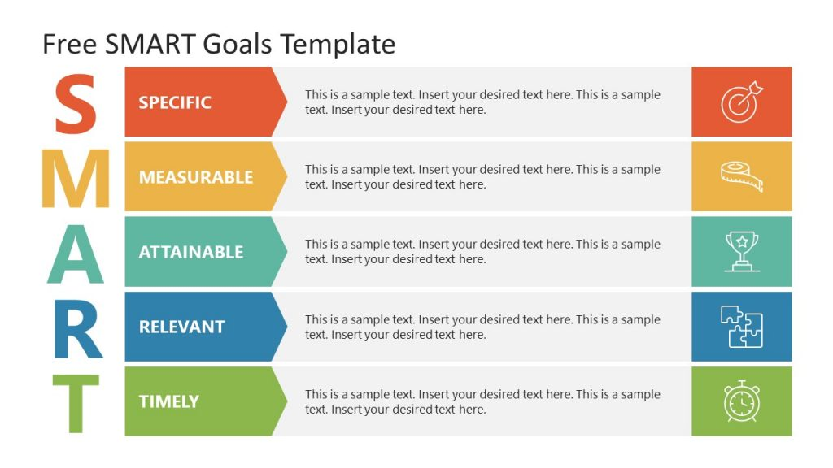
- Collect and analyze feedback from 75% of attendees within two weeks post-event.
- Complete evaluation and model development for future events within one month of the festival.
- Engagement tracked through RFID-enabled check-ins, completed challenges, and app interactions.
- Inclusion of at least 10 identifiable cultural themes such as language, music, and cuisine.

Figure 1: SMART analysis of Croeso event
- Objectives support enhanced cultural understanding and social cohesion.
- Goals align with efforts to boost student retention and cultural integration within universities.
- Ensure all digital tools, including RFID badges and apps, are user-tested for accessibility.
- Offer pre-event tech training to accommodate all student skill levels.
- To achieve an 85% app engagement rate from all registered participants by the end of the three-day event.
- To introduce 10 core elements of Welsh culture via physical activities and app-based interactions.

Event Management
Effective event management for Croeso Connect involves the strategic coordination of planning, operational, and marketing activities, supported by a range of specialized skills. The goal is to deliver a seamless and engaging onboarding experience that meets both cultural and technological objectives.

Planning Activities
Planning began months in advance and was grounded in collaboration with key stakeholders, including Welsh universities (Cardiff, Swansea, Bangor, Aberystwyth) and Visit Wales. These initial stakeholder meetings were essential to align objectives, establish responsibilities, and develop a shared vision for the event.
Central to digitizing the event were providing welcome badges with RFID technology and creating a mobile app, the main focus of the event’s logistics. For these technologies, companies needed to start sourcing vendors early, test devices and do customization. In addition, training and recruiting student volunteers helped guarantee that the event had people ready to support international students well. This model matches the stakeholder theory which values involving everyone affected by a decision to reach common goals (Mahajan et al., 2023).

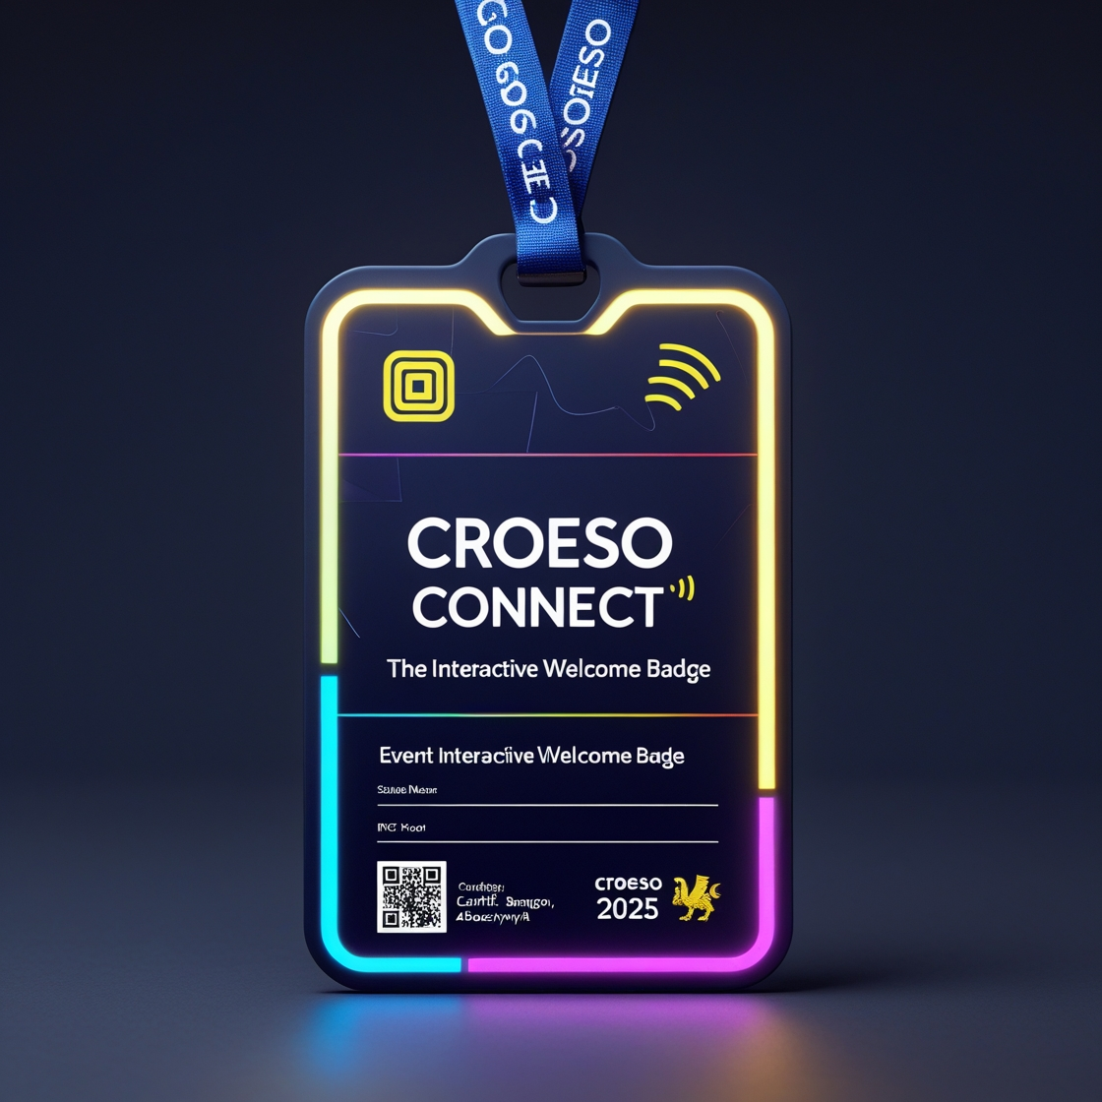
Operational Activities
Running the event mainly took place at the Swansea Arena, thanks to its size and capable equipment. Event spaces were arranged into the Welcome Hall, Food Court and Cultural Market, so that each area was tailored for various cultural and interactive activities. Audiovisual materials and RFID scanners gave management instant data for analysis and promoted involvement from participants with special activities on their phones. Signage made it easy for people to navigate; additional arrangements helped the disabled and following safety measures kept all attendees healthy.
Figure 2: RFID Cards for students

Marketing Activities
Marketing focused on reaching international students ahead of their arrival in Wales. Pre-arrival digital welcome kits were distributed through university channels, containing event schedules, app instructions, and cultural briefs (Schneidmiller, 2016). To build pre-event excitement and increase attendance, social media platforms such as Instagram, Facebook, YouTube and TikTok were used to share teaser content and student testimonials (Oywaya, 2023). Strategic partnerships with embassies and student unions also played a vital role in enhancing reach and legitimacy, especially among diverse national cohorts (Heitor, 2015).
Hashtags used for marketing campaign are #CroesoConnect #WelcomeToWales #StudyInWales #GlobalStudentsWales #ExploreWithCroeso2025 #RFIDExperience.


Figure 3: Social media platforms used for marketing

Skills Required
To ensure successful delivery, several key skills were essential:
- Event Logistics Management: Coordinating timelines, vendor contracts, and setup.
- Cultural Facilitation and Inclusivity Training: Ensuring content is respectful, engaging, and accessible.
- RFID and App Technology Management: Overseeing technical integrations and troubleshooting.
- Volunteer Coordination: Recruiting, training, and managing student support staff.

Event Budget

Costs and predicted revenues
Item | Cost (£)
RFID Badges (500) | £8,000
App Dev & Hosting | £6,000
Marketing | £3,500
Booths, Signage, QR Equipment | £2,500
Staffing & Honorariums | £5,500
Food, Merch, Beverages | £4,000
Transport & Insurance | £3,000
Contingency (10%) | £2,500
Total | £35,000

Table 3: Costs and predicted revenues

Funding Plan/Income
Funding Source / Income | Projected Amount (£)
Visit Wales Student Experience Grant | 18,000
University Contributions (4 partners) | 8,000
Business & Venue Sponsorships (extended) | 8,000 ↑
Premium Badge Upgrades (£6 x 750 opt-ins est.) | 4,500 ↑
Cultural Booth Vendor Fees (£250 x 6 stalls) | 1,500
Merchandise Sales (souvenirs, extras) | 2,000
🔹 Total Projected Income | £42,000

Table 4: Funding Plan/Income

Industry Trends, Issues, and Impacts
The both the design and execution of Croeso Connect are highly reliant on present trends in the MICE sector, mainly regarding education, use of technology and cultural connections. Understanding what is happening now, expecting future problems and understanding the wider effects are vital for the event to be a success and support Wales.

Emerging Industry Trends
- Gamification in Events
Gamification has become a dominant trend in engaging younger, digitally fluent audiences, particularly Generation Z. As noted by Loijas (2024), interactive experiences such as mobile-based challenges, leaderboards, and point-earning tasks significantly boost engagement and retention. At Croeso Connect, gamification is embedded through RFID-enabled badges and a custom-built app that tracks participation in real-time and rewards users for engaging with cultural zones and workshops.
- Digital Hospitality
The adoption of digital technologies in hospitality and event management continues to rise. According to Balatska et al. (2022), features like contactless check-ins, mobile navigation, and real-time feedback mechanisms now form the backbone of modern event experiences. Croeso Connect integrates these technologies seamlessly, using RFID for personalized interaction and an intuitive app to guide students throughout the venue. This also reflects Wales’ innovative spirit in merging tradition with technology.
- Cultural Intelligence and Inclusivity
Post-pandemic educational environments have placed renewed emphasis on inclusivity, mental well-being, and cultural respect. Thomas et al. (2017) emphasize the value of culturally intelligent programming that acknowledges diverse student backgrounds while fostering a sense of shared identity. Croeso Connect aligns with this trend by blending Welsh culture with international perspectives, creating a welcoming environment that supports cross-cultural dialogue.

Key Issues and Challenges
Despite the advantages, integrating advanced technology and cultural elements poses notable challenges:
- Technological Dependence
Reliance on digital tools increases the risk of technical malfunctions, such as RFID scanner errors, app crashes, or connectivity issues (Naciri et al., 2023). These could disrupt the user experience and compromise real-time engagement. Contingency plans, such as manual backups and IT support teams, are essential.
- Diversity Management
Managing a culturally diverse audience requires careful planning (Byrnes, 2022). While the event promotes Welsh culture, organizers must avoid alienating students by ensuring representation and sensitivity to global cultural norms. Activities need to be inclusive and multilingual where possible, balancing celebration of local traditions with global respect.
- Digital Fatigue
The overuse of screens and mobile apps can lead to digital fatigue, especially among students who are already immersed in virtual learning environments (Maxmudovna, 2024). To combat this, Croeso Connect alternates between tech-based and tactile experiences e.g., heritage booths, live performances, and food sampling ensuring balance and engagement without overwhelming attendees.

Impacts on the Education and Tourism Sectors
Croeso Connect holds considerable potential to positively impact both the education and tourism sectors in Wales:
- Global Reputation and Brand Image
By showcasing a tech-savvy, student-friendly environment, Wales positions itself as a forward-thinking education hub. The event elevates its international standing and highlights the country’s ability to host culturally rich, digitally enhanced experiences.
- Enhanced Student-University Relationships
By engaging students early with meaningful, personalized experiences, universities can strengthen emotional bonds and increase student retention. This aligns with broader institutional goals of student satisfaction, well-being, and community building (Thomas, 2012).
- Synergistic Support for Tourism
Croeso Connect promotes Welsh heritage, cuisine, and landmarks in a way that encourages further exploration. Students act as informal ambassadors, often inviting family and friends to visit, indirectly supporting local tourism.

Situational and Cultural Considerations

Situational (SWOT ANALYSIS)
The SWOT analysis helps identify the internal strengths and weaknesses, along with external opportunities and threats that may impact the success of event. It provides a clear overview to support strategic planning and informed decision-making (Sammut-Bonnici & Galea, 2015; van de Vijver, 2019).

S  Strength | W  Weakness | O  Opportunities | T  Threats
- Unique integration of RFID technology and cultural onboarding creates an innovative welcome experience.  - Backed by strong institutional support from universities and stakeholders.  - Aligns with Wales’ national tourism agenda, enhancing strategic relevance.  - Offers a tech-enhanced, memorable orientation for international students. | - High initial cost for technological infrastructure (e.g., RFID and app development).  - Limited scalability to smaller campuses with fewer resources.  - Requires extensive stakeholder coordination, increasing logistical complexity.  - Potential over-reliance on technology may pose challenges for smooth execution. | - Growing influx of international students boosts demand for onboarding initiatives.  - Potential to expand the model across other universities in the UK.  - Ability to collect long-term data on student engagement and event impact.  - Can support branding Wales as a student-friendly and inclusive destination. | - Competing welcome events at other UK institutions may reduce attendance.  - Tech resistance from non-tech-savvy students could hinder participation.  - Heavy dependence on app functionality may affect user experience if issues arise.  - Risk of technical malfunctions disrupting real-time event activities and engagement.

Table 5: SWOT Analysis of event

Croeso Connect is highlighted by the SWOT analysis as having strengths in using RFID, cultural onboarding and the support of key institutions working toward the targets set by Welsh tourism. Even so, obstacles that include spending a lot to get started, working with complicated details and facing limits on expansion for smaller campuses could make it hard to implement. Growing numbers of international students, possible expansions to other UK universities and collecting valuable data are opportunities for the future. Issues such as rival events, some users not liking new technology and technical failures that could disrupt the app’s usability can all influence what participants think of the event.

Cultural consideration
The inclusive digital experience of Croeso Connect mirrors considerations for cultural onboarding by tapping themes of national identity. RFID and interactive technologies are used to support multicultural engagement which assists new students from various ethnicities to feel welcomed and integrated when arriving at a new university or college.
The event therefore makes provisionality a prerequisite of its accessibility and grants cultural storytelling a personalised perspective to foster the performance of belonging. It must also be seen that different people have different attitudes towards technology, different communication preferences and they come from different cultural norms. In planning, promotion and execution of onboarding approach, ensuring intercultural awareness and support plays a great role in fostering both inclusivity and cultural resonance which in turn make the onboarding process more meaningful and widely accepted (Frisch, 2023).

Conclusion
Croeso Connect is more than a cultural orientation, it is the transformational way of onboarding the students through gamification engagement using RFID technology to make it all possible and to help students really connect with Wales. Designed strategically and operationally feasible, it seeks cultural resonance as well as technological novelty by aligning itself with the national theme of the Visit Wales ‘Year of Croeso’. This event will incorporate key academic theories from the Experience Economy along with the Technology Acceptance Model, industry trends and strategic event planning principles in order for Wales to become a benchmark for international student engagement. Identified as scalable, with a positive expected surplus, along with strong institutional collaboration. Croeso Connect will have the potential to become an annual flagship initiative which changes based on Wales' education and tourism aspirations.

References

Amoah, F., & Marriott, A. (2021). Dimensions of online shopping experience and satisfaction: An application of Pine and Gilmore's 4Es. African Journal of Business and Economic Research, 16(2), 117.
Balatska, N., Radkevych, L., Robul, Y., Vdovichena, O., & Strenkovska, A. (2022). Digital technologies and digital marketing: New opportunities for tourism and hospitality business. Financial & Credit Activity: Problems of Theory & Practice, 6(47).
Bowdin, G. A., Allen, J., Harris, R., Jago, L., O'toole, W., & McDonnell, I. (2023). Events management. Routledge.
Byrnes, W. J. (2022). Management and the Arts. Routledge.
Frisch, L. K. (2023). Cultural diversity: the road to a sustainable organizational culture: an analysis of the luxembourgish organizations' concepts from the onboarding process onwards.
Glushchenko, V. V. (2023). Ergodesign and “specific”," measurable"," achievable"," relevant", and" time-bound"(SMART) technologies as tools for the formation of innovative leadership programs. ASEAN Journal of Economic and Economic Education, 2(1), 23-34.
Heitor, M. (2015). How university global partnerships may facilitate a new era of international affairs and foster political and economic relations. Technological forecasting and social change, 95, 276-293.
Ibrahim, R., Leng, N., Yusoff, R., Samy, G., Masrom, S., & Rizman, Z. (2017). E-learning acceptance based on technology acceptance model (TAM). Journal of Fundamental and Applied Sciences, 9(4S), 871-889.
Loijas, J. (2024). HOW GAMIFICATION SHAPES LEARNING AND INTERACTION IN VIRTUAL EDUCATIONAL EVENTS.
Mahajan, R., Lim, W. M., Sareen, M., Kumar, S., & Panwar, R. (2023). Stakeholder theory. Journal of Business Research, 166, 114104.
Maxmudovna, K. M. (2024). CHALLENGES AND SOLUTIONS IN THE DIGITAL AGE OF MOBILE EDUCATION. Строительство и образование(Спецвыпуск 1), 107-110.
Naciri, L., Gallab, M., Soulhi, A., Merzouk, S., & Di Nardo, M. (2023). Digital technologies’ risks and opportunities: Case study of an RFID system. Applied System Innovation, 6(3), 54.
Oywaya, C. N. (2023). The influence of social media marketing on the performance of online based small and medium enterprise in Nairobi County, Kenya University of Nairobi].
Passarelli, A. M., & Kolb, D. A. (2023). Using experiential learning theory to promote student learning and development in programs of education abroad. In Student learning abroad (pp. 137-161). Routledge.
Radder, L., & Han, X. (2015). An examination of the museum experience based on Pine and Gilmore's experience economy realms. Journal of Applied Business Research, 31(2), 455.
Sammut-Bonnici, T., & Galea, D. (2015). SWOT analysis. Wiley Encyclopedia of management, 12(1).
Schneidmiller, H. (2016). International Student Orientation: The Needs And Challenges Students Face Upon Arrival.
Thomas, B., Thomas, S., & Powell, L. (2017). THE DEVELOPMENT OF KEY CHARACTERISTICS OF WELSH ISLAND CULTURAL IDENTITY AND SUSTAINABLE TOURISM IN WALES. Scientific Culture, 3(1).
Thomas, L. (2012). Building student engagement and belonging in Higher Education at a time of change. Paul Hamlyn Foundation, 100(1-99), 1-102.
van de Vijver, F. J. (2019). Culture and psychology: A SWOT analysis of cross-cultural psychology. In Progress in Psychological Science Around the World. Volume 2: Social and Applied Issues (pp. 279-298). Routledge.
Vitasovic, A. (2024). EXPERIENCES AS A PART OF EXPERIENCE ECONOMY. Economic and Social Development: Book of Proceedings, 453-465.

