Fahad khan BMPH 5005 Suzanne Sutton 1907308

Introduction to research
Mental Health

Abstract
What is mental health and how does this affect people? For time in memorial, people have suffered from this however only now has this come to light. What causes people to suffer from this. In this literature review we shall explore what affects in people this has. Coping mechanisms and the willingness to acknowledge this as a condition rather than a hindrance will be observed and discussed as well as recommendations and how information is gathered. From this a discussion can, be formulated and exploration into the workings of the mind can begin.
Introduction
Mental health is a condition almost all of us suffer from at some point in our lives and it affects almost all of us, whether that be a though in the moment or a prolonged struggle. It is widely realised and accepted these day however this has not always been the case. In this literature review we will look at mental health a little deeper and dive into how it affects us and in the ways it affects us. We will discover treatment and medication that can be used and the road to recover effectively. We will discuss and dive into ethical considerations as well as obstacles such as inequalities and racial divides and discuss the topic of influenced whether that be drugs or by another’s control. Mental health has not really been recognised over the year and there is more help available currently to seek help and get more support from professionals such as doctors or seeking help from councillors. Which we will discuss about what treatment we can get such as things like medication and therapy session to help manage one’s mental health and even going to rehabilitation or making changes to your lifestyle to improve a person’s mental health and wellbeing which I believe will help significantly.
Background
Mental health issues are common today and more se accepted as an illness rather than a taboo. Encouragement today to be open and expressive of mental health issues is healthy and can be progressive to recovery. Mental health topic has been chosen because of personal experience within the family if mental health struggles. Mental health from my experience includes the influences of others, manipulation, torment, control and coercive behaviours of others towards others. In addition to this, also the interest of finding other ways to help that may not have been thought about, suggestions and improvements based on experience personally and viewing others around.
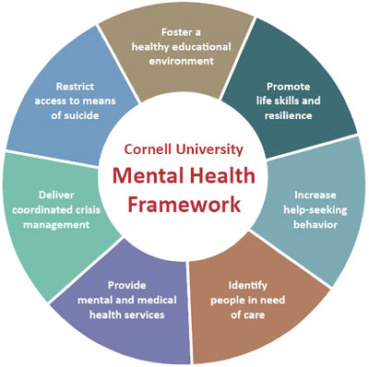
(kelley.S, 2011)
By past experiences, an interest in mental health and how the minds of other work have become an interesting topic to discuss. Influences on others such as covid and financial stability. Has been underfunded and pushed under the rug so to speak for years. Only now has mental health in recent year been accepted and acknowledged as a condition as opposed to a taboo. Depression for example is a big factor in mental health initially but can come with other factors such as the following:
- Alcoholism- The influence of ones judgement made by a disturbed and unsought consciousness. Alcohol depicts this and therefore can impair the judgment of ones self. Excessive consumption not only disturbs the mind but also the heath, weather that be mental or physical.
- Financial stability- The stress of this is an everyday occurrence is many people especially in this current financial global crisis. The stress invoked on someone can leave them feeling depressed, anxious, under valued and ashamed. All these combines especially, can make ones self feel worthless thus creating a downward spiral. This effectively affects the mental stability of the person thus mental health issues begin to arise from this situation.
- Coercive control- This most recently has been understood as a form of abuse and a serious one at that. The ability of someone else to control someone subtly or even in a damaging openly manner. This is the manipulation of someone caused by another maliciously for their own gain or satisfaction. This can effectively change how a person views themselves on the appreciation of others. Damage usually is long lasting and very difficult to undo.
- Drug abuse- Under the influence of substances drastically changes people’s judgement and thought process. The addiction of substances damages the cells in the brain thus changing the mental ability and capacity of the person. The need for the substance often changes the perception the abuser has and thus the thought process of every day tasks is changes and sometimes eliminated thus creating mental health issues to arise as the thought process to which comes to us as normal is then changes and even lost.
The above has the ability to completely change a stable person’s life around almost in an instance. Some are quicker than others to do this, however a combination of all is a damaging cocktail to anyone. Prevention can only be progressive and also cannot always be prevented as mental health is a complex topic affecting a range of spectrums. A disability can also change a person’s perception whether that be a physical or hidden disability. Additionally, suicide and abuse of the above frequently come into play when mental health is apparent.

Methodology
It Is believed according to Choudhury; AI is to make a huge difference when it comes to mental health and the neurological aspects of this. The belief however is based of neuropsychology views and psychiatric reports of this treatment. AI here it is believed that this can redefine mental health issues on a more objective scale. This can identify them on various levels it is believed such as personalising treatment individual, empowerment, yet issues such as bias, privacy and ethical concerns are to be thought of. (Choudhury, 2021)
In Adkins study, the use of online tools to capture barriers that comes with mental health struggles such as depression and anxiety in students. This study shows the use of apps and web to interact and gather information about the struggle of student life. The study was intended to reach out to students in a way they can relate to and the use of technology is creative however there are risks attached to this method. (Adkins, 2019)
In Arundells study relays the acknowledgement of inequalities and barriers associated with mental health. The study found that race and age discrimination plays a huge role in mental health impacts. The study found that psychological treatment and help was the best way for treatment. The study invoked the notion that barriers include access to care, financial situations and communications between themselves and others. It is acknowledged that the data is useful for treatment by clinicians, commissioners and service providers for recovery and treatment. (Arundell, 2020)
In Betts findings, it is discovered that mental health barriers again are influenced by such things as self-efficacy, knowledge and support as well as other influenced. The study relates to e-health which again suggests the use of technology to aid treatment and potential recovery. The ethical and bias around technology must be taken with precaution. This study also includes adults up to the age of 60 for a larger spectrum. (Betts, 2021)
In Gerlach study this was aimed at adults between 50-80 years old. In this study it was determined that most people were comfortable discussing their mental health issues and barriers. This goes to show the treatment from 20 years ago has come a long way suggesting that things have improved over a 20 year span. It is shown in the study that primary care has had a huge impact and impression on the treatment of mental health. (Gerlach, 2022)

There are a range of methods relating to mental health, however some are more effective than others. As mental health is a delicate topic, the process of diagnosis and testing must be taken with precaution as the delicacy of someone’s mental state can determine the recovery. Should this be compromised the person rather than recovering, may spiral into a desperate state of despair resulting in a malfunction in the recovery process.
Discussion is the best approach to this. Other means of methodisation to gather information are not widely used due to the sensitive nature of the topic. For example, a questionnaire would now be appropriate as each person is different for a start. The use of a questionnaire would never work as asking someone to write down on paper information, you cannot gather emotions and feelings through a questionnaire, and also in addition can be quite damaging to a person to write and relive information in order to progress. Medical diagnosis and management is the best approach here, to which Some methods we can discuss about can be found below.
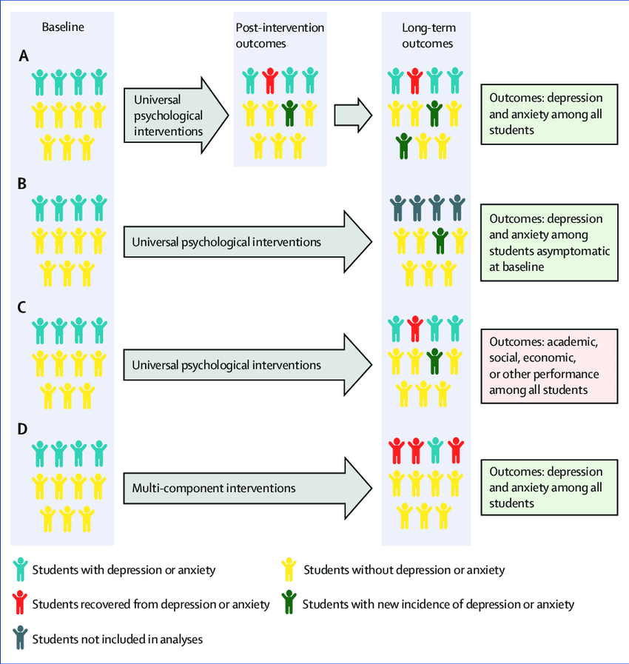
(ResearchGate, 2023)
Psychotherapy- normally undertaken by a trained professional to which behaviours and thought processes are discussed by both the patient and the medically trained personnel. Thoughts and feeling are explored during the treatment and dive deep into the persons functioning mind. This can improve a person considerable but not always fully recover them I the process. This treatment usually can be combined with other methods to achieve the desired goal. The end goal can be reached with a combination of successive discussions and exploration including Cognitive Behavioural Therapy, Exposure Therapy, Dialectical Behaviour Therapy
Factors that can affect the effectiveness of this treatment often includes financial stabilities of both the person and the organization. If funding is not there then the service cannot exist in an effective state.
Medication- this option does not cure mental health issues and is generally used to relive and assist recovery. Mental health cannot be recovered by a magic tablet. Mental health must be managed by changing the persons perspective and thought process. Medication can often be used to calm the affected person don, for example, if the suffering person were to feel anxious or a panic attack coming on. The use of tablets can relieve these symptoms and can change a person’s behaviour in such a way, as an example, from being very drawn out or subdued to a happier state of mood. Placebos and other medically tested and approved medication will ensure this is apparent.
Support group- To be able to discuss with others their current state and experiences. By doing this others can support each other and also discuss and share personal suggestion on how best to manage a situation thus giving others a better idea of how to manage a similar issue they may be going through. Often support groups do not need heavy financial funding and therefore can be easier to set up, however moderation would need to be present as well as a qualified trained professional to guide the group. The monitorisation if what is spoken between must be in place in order to safeguard and protect vulnerabilities within the group and the wider support committee.
Self-help plan- The plan would be a part of the recovery process in combination with the above mentioned. This is crucial to recovery as each plan would be tailored to the individual and therefore is no set plan to follow. There are no prejudices when it comes to recovery however barriers must be taken in to account that an occur, such as financial and even willingness to partake in recovery. Other barriers such as addiction and substance abuse can be factored in. Other forms of abuse must be observes should the patient be in danger to others and themselves.
Quantitive data can be gathered as a blanked approach if you like as interviews in the form of help and recovery can help gather information on how mental health affects people for example, but it is recommended to do this with health providers as opposed to patients themselves.
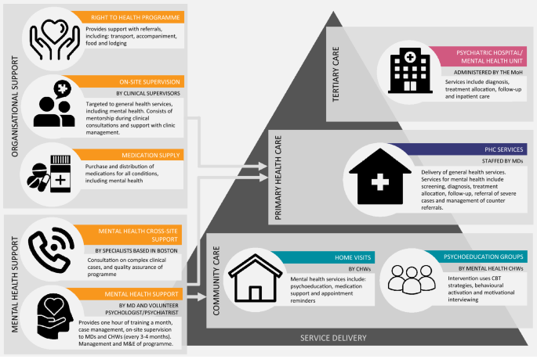
(levine.N, 2020)
By doing this implementation data is gathered from this is a constant progression to the aid, help and recovery can be used to train personnel better for the future. This can give the corrective outcomes required such as gaining implementation outcome data such as fidelity, acceptability, appropriateness and feasibility of the data and usage gained from this.
Results
There are no direct results we can ascertain from mental health other than the hope and belief in recovery. Mental health cannot be defined by statistical results. We could argue here that every single person in existence suffer from mental health issues at some point during our existence. How could we possibly be able to statistically gather information here. Generically this could be done but as a case to determine how many people are affected by their mental health, for example. The current climate with the cost of living crisis would depict a sharp rise in this however if it were that there was no living crisis then the results would be very different, based on this the information gathered would be erratic in a sense due to change in environment, circumstances. However, this is generally how mental health issues are brought upon so we could also argue back to the statement above that everyone suffers a come point.

Discussion
We can surmise from the image above about students suffering from mental health, that a great proportion suffer however the cause varies differently. This is true for mental health issues as a whole because different factors negatively affected people differently as we are all uniquely different. The flow diagram shows us the impact on each category.
We can surmise generally speaking that mental health affects peoples live down to the core aspects of life, from finances to addiction to mental anguish along with the rest. That comes with mental health. To gather results in such a case would be crass however as stated we can see that mental health affects people in a variety of ways.
From the literature studies above, we can surmise that people hare more readily available to discuss their mental health struggles. We see that younger persons are more prone to struggle mentally than those of the older generation. There are a number of methods used here in the literature review includes the wide use of technological advanced of today. A lot of the studies were conducted online or using apps and data capture from these methods, but people as stated are more readily to talk. The suggestion that treatment has improved within 2 decades is encouraging. The treatment available is more widely accepted than that 20 years ago.
To gather this information the studies use a variety of methods to get the best methods of data capture based on the age category. This can include the use of Boolean method, cone method. For Boolean this is classed as an explorative tool which is intended to show relations between each data set gathered. This is a comparative tool between the sets of data to gain an overall review.
The cone technique is used to gather mass information and Siv the sources down from generic for example down to specific and relevant information. To get the best results the spiral technique is the best option as more specific information can be gathered for a specific topic such as mental health, however it can be very broad topic at the same time.

Conclusion and recommendations
From this literature review we can see how progress in relation to mental health treatment, acceptance and willingness to talk about issues people may have are now no longer a taboo. In this we have seen how progression has been made however there is still a long way to go to eliminate certain mental health issues. Influences such as coercive control, financial dependencies or lack thereof, drugs and ethical and racial discrimination come in to play and can be a form of forced mental health issues is you will. Other influences also come into play but treatment can aid with this.
Personal instances in peoples lives including my own give fascination into this topic, however for everyone there is a common denominator which relates to the same issue we all have in common which is mental health.
Treatment has been vastly improved over recent decades, more funding and acceptance in society and in recent years mental health has now become recognised and encouraged to be discussed and seen as healthy to talk. Medication along with primary care such as discussion and counselling have become a lifeline to those suffering on a daily basis. Self-confidence and awareness is important as stated although racial and financial situations do affect this greatly. Inequalities still exist and will for many years to come, but everyone is entitled to help that is out there.
Treatment must be ethically thought about and carefully managed. Online treatment for example can be great yet there are many influences online and peoples minds will tend to wander and there is the risk that they may stray and begin viewing other more damaging content hence making their mental health worse. Combine this with personal influences such a coercive control and mental manipulation but others can exacerbate the situation therefore moderation and care needs to be considered.

References

References
Adkins, E. e. a. G. A., 2019. Digital Mental Health Interventions for Depression, Anxiety, and Enhancement of Psychological Well-Being Among College Students: Systematic Review, s.l.: Pubmeds.
Arundell, L. e. a. B. H., 2020. Advancing mental health equality: a mapping review of interventions, economic evaluations and barriers and facilitators, s.l.: Pubmeds.
Betts, D. e. a. B. D., 2021. Barriers and facilitators to the use of e-health by older adults: a scoping review, s.l.: Pubmeds.
Choudhury, M. e. a. D. C., 2021. Artificial Intelligence for Mental Health Care: Clinical Applications, Barriers, Facilitators, and Artificial Wisdom, s.l.: Pubmed.
Gerlach, L. E. a. M. D., 2022. erceptions of Overall Mental Health and Barriers to Mental Health Treatment Among US Older Adults, s.l.: Pubmeds.
kelley.S, 2011. Mental health framework takes a comprehensive approach. [Online]
Available at: https://news.cornell.edu/stories/2011/02/mental-health-approach-supports-whole-person
[Accessed 22 03 2023].
levine.N, E. e. a., 2020. biomedcentral. [Online]
Available at: https://ijmhs.biomedcentral.com/articles/10.1186/s13033-020-00346-x
[Accessed 22 03 2023].
ResearchGate, 2023. [Online]
Available at: https://www.researchgate.net/figure/Figure-Methods-of-analysing-mental-health-interventions-A-Mixed_fig1_337255490
[Accessed 22 03 2023].

