

University of Wales
Trinity Saint David

Program: BSc Cloud Computing Name: Ivo Ivanov
Modul: Software Development (Python) Student number: 2111853
Lecture: Suneth Fernando 27/04/2022
Assignment Title: Assessment 1

Table of contents

What is a variable and why are they important in writing programs?.....................................................2
Explain what an if/else statement is, how and why they are used……………………………………...2
Explain why loops are needed in a program and when you might use a for loop…………...…………5
Explain why loops are needed in a program and when you might use a while loop…………………...7
Exercise 1……………………………………………………………………………………………….9
Exercise 2 ……………………………………………………………………………………………..10
Exercise 3……………………………………………………………………………………………...11
Exercise 4…………………………………………………………………………………………………………………………………………13

- What is a variable and why are they important in writing programs?
Variables and data types in Python, as the name suggests, are values that vary. In a programming language, a variable is a place in memory where we store a value. The value we saved may change in the future according to specifications. Python has no additional commands for declaring a variable. As soon as the value is assigned to it, the variable is declared.
Variable can accept value as a string, integer or float:
x = 10 # variable (x) is declared when we give it value integer (10).
x = 10.00 # variable (x) is declared when we give it value float (10.00)
x = y # variable (x) is declared when we give it value string (y)
There are certain rules to keep in mind when declaring a variable:
- The variable name cannot start with a number. It can only start with a symbol or an underscore.
- Variables in Python are case sensitive.
- They can only contain alphanumeric characters and underscores.
- No special characters are allowed.

- Explain what an if/else statement is, how and why they are used.
In Python, we can make decisions using the following statements:
If statements
If otherwise statements
Statements by Elif
Nested operators if and if-else, and Elif

1. If statements
If the expression is one of the most commonly used conditional expressions in most programming languages. It decides whether some statements need to be implemented or not. If the operator checks for a condition, if the condition is true, then the set of code present in the if block will be executed and if the condition is false, then the set of code present in the if block will not be met.

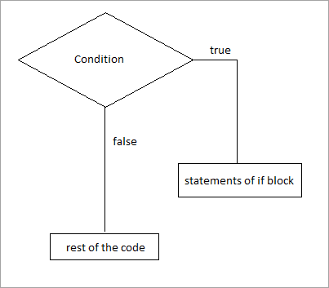
Exam 1:
if Num < 10: #if statement compare is variable Num is smaller than 10
print("Num is smaller than 10")

The output is:
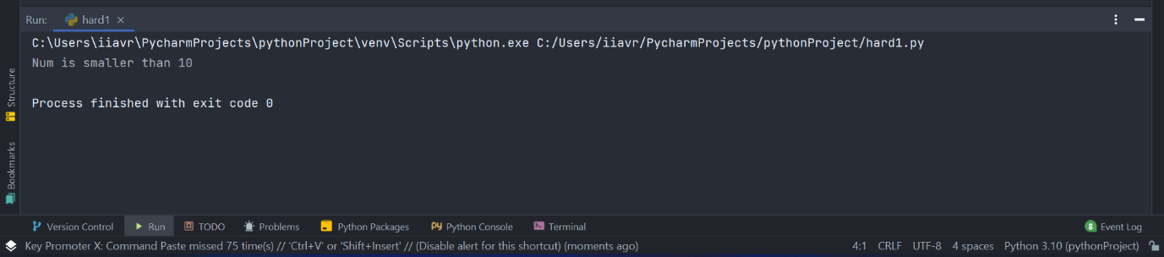

Exam 2:
a = 8
b = 0
if a > b: #if statement compare is variable “a” is a greater than “b”
print("a is greater that b") # “a” is greater than “b” and follow
#print statement to be executed

The output is: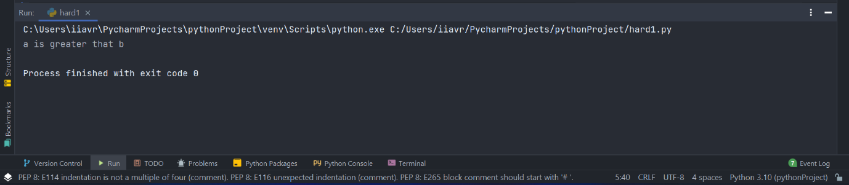

2. If-else statements
The operator himself says that if a condition is true, execute the expressions present inside the if block, and if the condition is false, execute the else block.
The else block will only be executed when the condition becomes false, this is the block in which you will perform some actions when the condition is not true.
The if-else operator evaluates the Boolean expression and executes the code block present in the if block if the condition becomes TRUE and executes the code block present in the else block if the condition becomes FALSE.

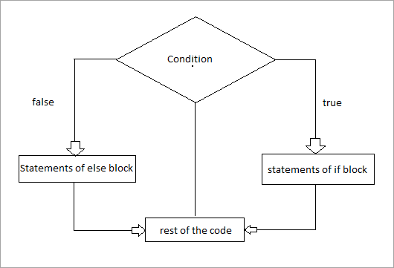

a = 5
if a > 10: #if “a” is greater than 10 the stateman will be True
print("number is greater than 10")
else: ##if “a” is greater than 10 the stateman will be False
print("number is less than 10")

The output is:
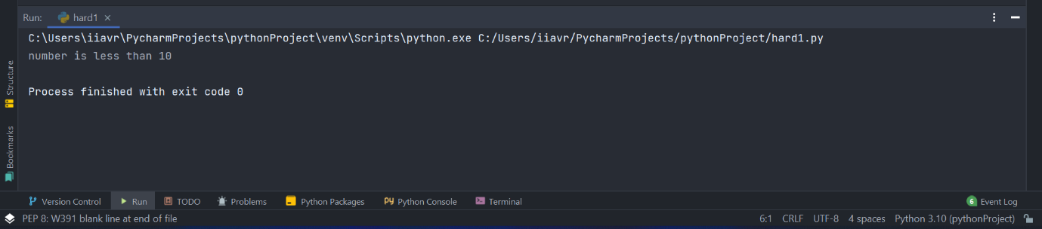

3. elif statements:
In python we have another conditional expression called elif operators. The elif operator is used to check multiple conditions only if the given condition is incorrect. It is similar to the if-else statement and the only difference is that in else we will not check the status, but in elif we will check the status.
elif operators are similar to if-else statements, but elif statements evaluate many conditions.
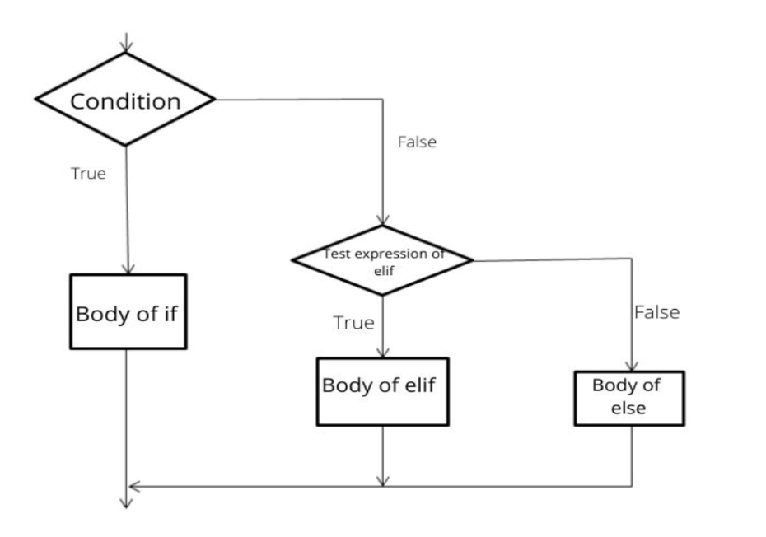

a = 10
if a == 0:
print("Number is Zero") #if statement is False then follow no execution
elif a > 5: # elif statement is True then follow print execution
print("Number is greater than 5")
else:
print("Number is smaller than 5")

The output is:

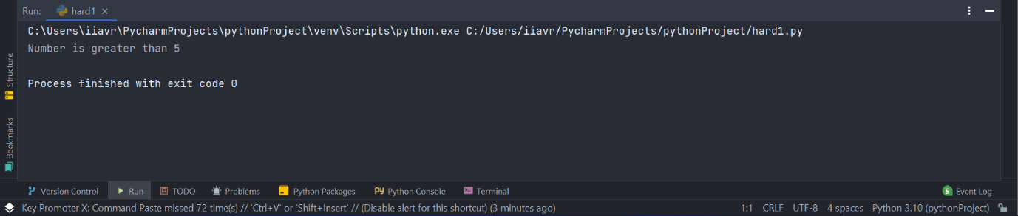

In the example above, we declared a variable called ‘num’ with a value of 10, and in the if statement we check the condition if the condition becomes true. The code block present inside the if condition will then be executed.
If the condition becomes false, then it will check the elif condition, if the condition becomes true, then a block of code present in the elif instruction will be executed.
If incorrect, a block of code present in the else statement will be executed.

- Explain why loops are needed in a program and when you might use a for and a while loop.
- for loop is used when we want to execute an N code a number of times (unlike the while loop, it is used when we want our code to execute while a condition is true).

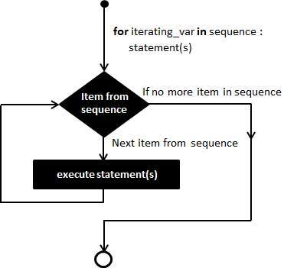

There is example for FOR cycle with five loops.

for i in range(0, 5): #we use for loop when we want to execute code 0 to 4
print(i)

Output:
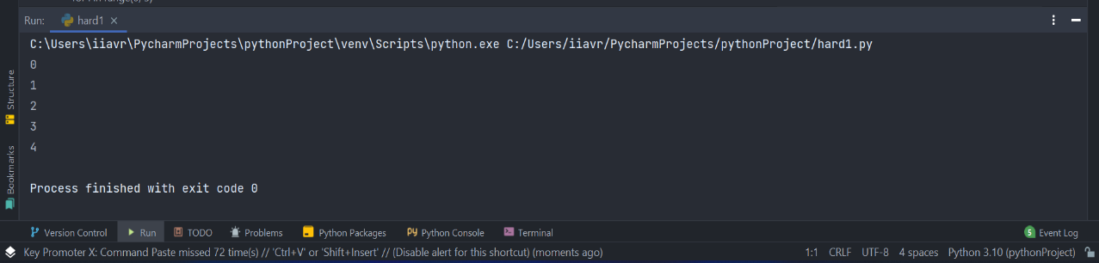

We can exit the loop at any time using the break keyword.

for x in range(10):
print(x)
if x == 3:
break #we can exit the loop at any time using break keyword

The output is:
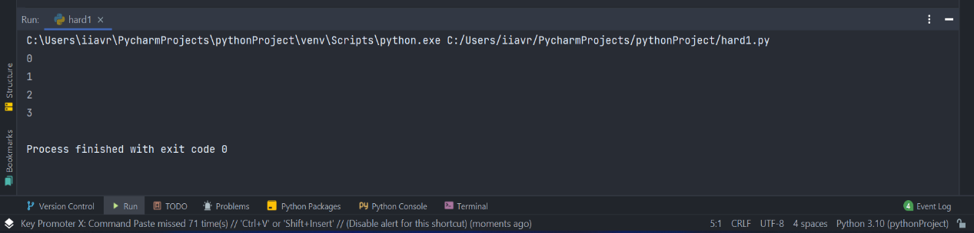

for cycles have another major application. We can request execution of string, integer and float.

collection = [7.0, "hello", 3] #we have list with string, integer and float
for i in collection: # we are executing the list
print(i)

The output is:

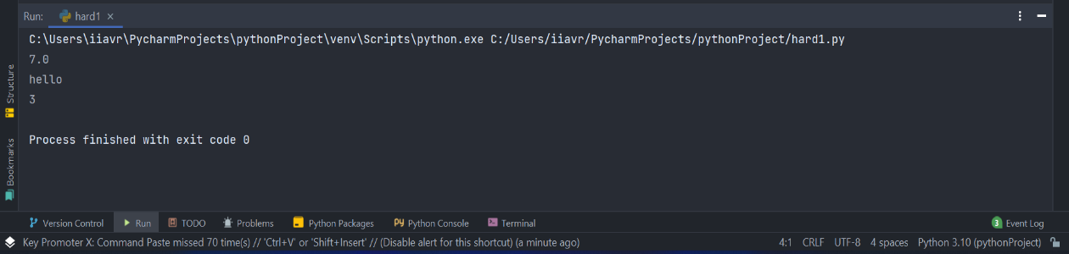

- While loop
As already mentioned, the WHILE loop is not used for a certain number of iterations, but for iterations until a condition is met.

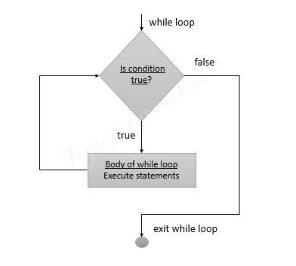

i = 0
while i < 5: #while i is less than 5, do next
i += 1 #of each iteration increase value of i by 1
print(i)

The output is:

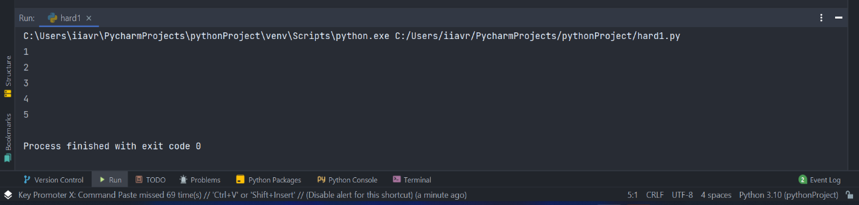

With the help of the WHILE loop we can create endless loops. For example, if we want the user to enter text while entering a specific word, the cycle would do a great job, because we do not know in advance how much experience the user will take to enter the word. The idea is to create an infinite loop (we use TRUE for the condition, that it is always true) and to exit the loop using break when the user enters the desired word:

while True:
n = int(input("Write number smaller than 10: "))
if n < 10:
break

The output is:

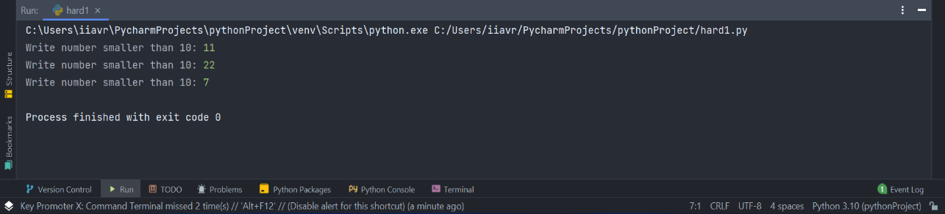

Exercise 1: Show how variables can contain different types of values by declaring three variables that will contain a name, a measure of height (e.g. 1.84m) and a person's age (e.g. 26). Prompt the user to input these values and display them on the screen. The variables should be appropriately typed for the data required.

Solution 1:
name = str(input("please enter your name: "))
age = int(input("Please enter your age: "))
height_in_metres = float(input("please enter height in metres: "))
max_height = 3.0
if height_in_metres >= 3.0:
print("The set height is too high. Please enter a new value: ")
height_in_metres = float(input("Please enter your height in metres: "))
print("Thanks, you entered", "Your name is: ", name, "\nYour age is: ", age, "\nYour height is: ",
height_in_metres, str("cm. tall"))

The output 1 is:
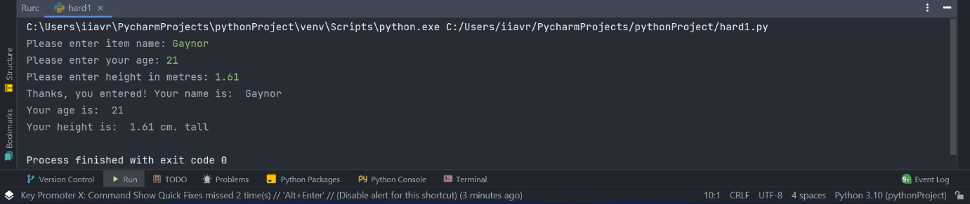

The output 2 is:
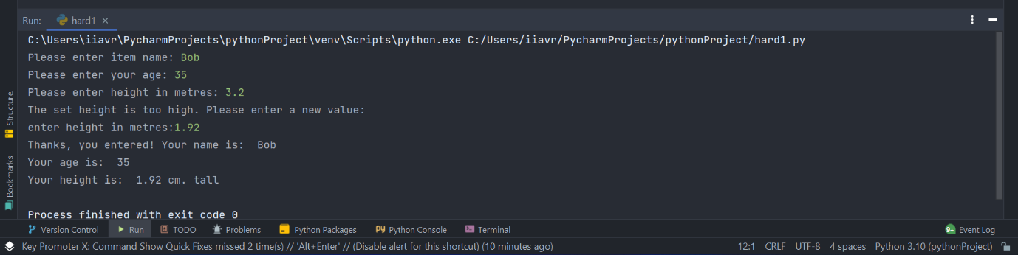

Exercise 2: Allow the user to enter the dimensions of shapes shown below (in cm), then calculate the area of the blue shaded part. Note: The square and rectangular areas are empty.

Solution 1:
from math import pi
r = float(input("Input the radius of the circle: "))
b = float(input("Please enter side of square: "))
c = float(input("Please enter width of rectangle: "))
d = float(input("Please enter length of rectangle: "))
radius = pi * r * r
square = b * b
rectangle = c * d
c = rectangle * radius
shaded_area = radius - (square + rectangle)
while True:
print(float(input("Please enter width of rectangle: ")))
print("The shaded area is: ", round(shaded_area, 1), str("cm."))
if c > r:
break

The output is:
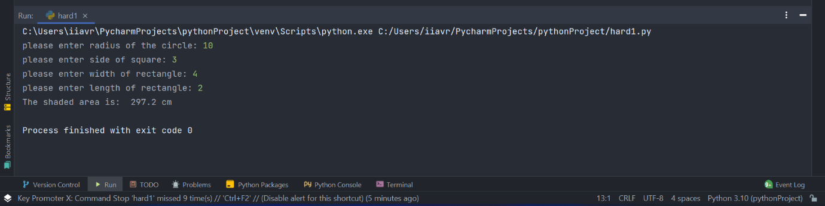

Solution 2:
from math import pi
r = float(input("Input the radius of the circle: "))
b = float(input("Please enter side of square: "))
c = float(input("Please enter width of rectangle: "))
d = float(input("Please enter length of rectangle: "))
radius = pi * r * r
square = b * b
rectangle = c * d
c = rectangle * radius
shaded_area = radius - (square + rectangle)
while True:
print(float(input("Please enter width of rectangle: ")))
print("The shaded area is: ", round(shaded_area + 10, 1), str("cm."))
if c > r:
break

The output is:
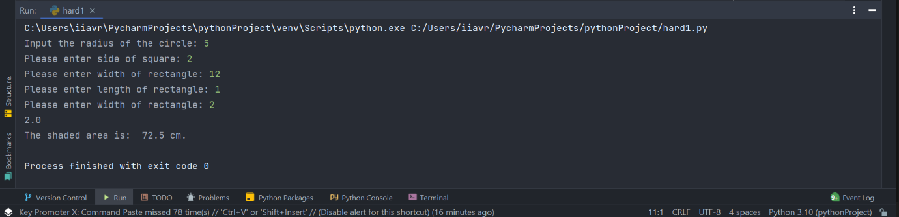

Exercise 3: Write a program that allows the user to car mileage (per day) for a week. When the mileage has been entered, calculate the total mileage. Finally, calculate the total cost of petrol for the week, at the rate of £1.35/later and 11.2 miles to the liter. Use a list/array and loop(s) where appropriate.

Solution 1:
def is_digit(string): # function to check if str is float or number
if string.isdigit():
return True
else:
try:
float(string)
return True
except ValueError:
return False
def insert_miles(): # Function to read miles from the keyboard
miles = input() # We read the number on the keyboard
if is_digit(miles): # Let's check if it's a number
miles = float(miles) # We transform the string into int
else: # If there is no number:
print("Please try again") # I was displaying the message
miles = insert_miles() # We're reading another number on the keyboard
if miles < 0: # Check if the number is not negative
print("Please try again...") # I'm posting the message
miles = insert_miles() # We're reading the number again
return miles
if "_main_" == "_main_":
rate = 1.35 # We declare the values needed to calculate consumption £/litre
miles_per_litre = 11.2 # We declare the values needed to calculate consumption miles/litre
week_days = ["Monday", "Tuesday", "Wednesday", "Thursday",
"Friday", "Saturday", "Sunday"] # we declare the days of the week
total_mileage = 0 # declare our count
for day in week_days: # we go through the massif with the days of the week
print("Enter miles for {0}".format(day)) # I was displaying the message
total_mileage += insert_miles() # We collect what we went for today
rez = (total_mileage / miles_per_litre) * rate # We calculate the total expenses
print("The total mileage was: {0}".format(round(total_mileage, 1))) # I was displaying the message
print("Cost of petrol: {0}".format(round(rez, 2))) # I was displaying the message

Output: 1

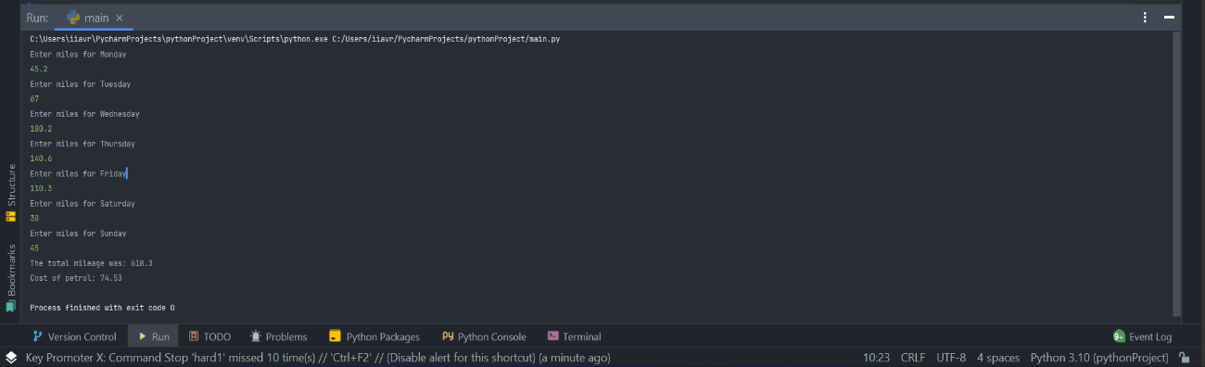

Output 2:



