HNC Manufacturing Systems Engineering Operations

2019 – 2020 Quality & Business Improvements

Assignment TWO

Quality Tools and Root Cause Analysis

Sliding Jaw

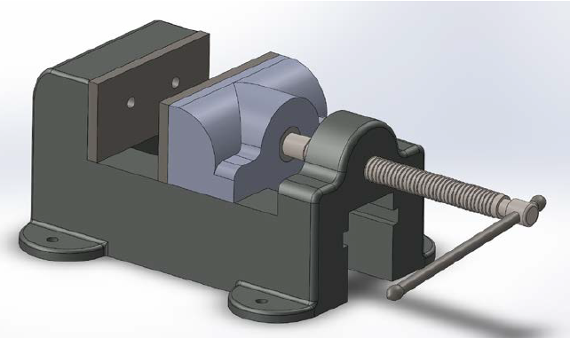

Stuart Jones

1909136

CONTENTS

Assignment requirements 3

Problem Statement 4

Data Summary 5

Data Analysis 6

Root Cause Analysis 9

Action Plan 13

ASSIGNMENT TASK DESCRIPTION

You have been brought into a manufacturing company as a consultant Process Improvement Engineer to develop a data-informed, improvement plan for an existing manufacturing process. The component being manufactured is the “sliding jaw” from a machine vice assembly.

The “sliding jaw” is initially produced using a sand-casting process (Operation 1) and then the faces which mate with other components in the vice assembly are machined using a vertical machining centre. Two separate foundry workers (A&B), work independently of each other at the foundry to produce the castings. Two separate machinists (C&D) work independently of each other at the machine-shop to finish the component.

Using the defect data provided along with appropriate quality tools to analyse the problem and to determine a prioritised corrective action plan to improve the process and reduce the risk of continued defects.

Clearly state any assumptions which you have made in your introduction.

A suggested structure for your report is as follows:

• Problem identification/problem statement
• Data summary (the data itself has been collected and is presented in table 1)
• Data analysis
• Root Cause Analysis
• Action Plan

LEARNING OUTCOME

Apply a range of tools and techniques that can be used to investigate problems, assess risk, and analyse areas for improvement.

PROBLEM STATEMENT

A local manufacturing company is experiencing some issues with its process of casting and machining a unique product, which is an integral component of a larger assembly. The component being manufactured is sliding jaw which fits neatly into a machine vice assembly.

The manufacturer has noticed that the defect rates throughout their process is significant; they are losing money and wish to improve the process to reduce defects, which in turn will increase outputs thus improving the company profits.

They are aware of defect parts being produced at both their main process points; Sand Casting and Machine Milling/Drilling. We can assume that the manufacturing company produces approximately 3,000 units a week, and with a defect fallout of approximately 300 a week, the company is operating at a 10% defect rate, so there is room for improvement.

They have collated data but are not sure how to analyse it, how to review it, and how to develop an improvement plan which will reduce the defects accordingly.

They have employed my services, an independent Process Improvement Engineer, to review their process, analyse the data, and submit an improvement plan for the existing process. Using a range of quality improvement tools and techniques, I will develop a plan to improve their process based on the data collected from the process.

DATA SUMMARY

First, all possible defect types were identified:

- Surface Finish
- Defective Finishing
- Blow Hole
- Improper Shape
- Others

Second, a spread sheet was developed in order to collate the information. There are 2 main manufacturing points, Sand Casting and Machining, which run down the left. Across the top are the days of the week, each split into two; am and pm.

The data collection process was explained to the 4 operators, to record every defective part made, using the code at the base of the sheet to keep it clean and standardised.

Table below is actual data recorded from 1 weeks production:

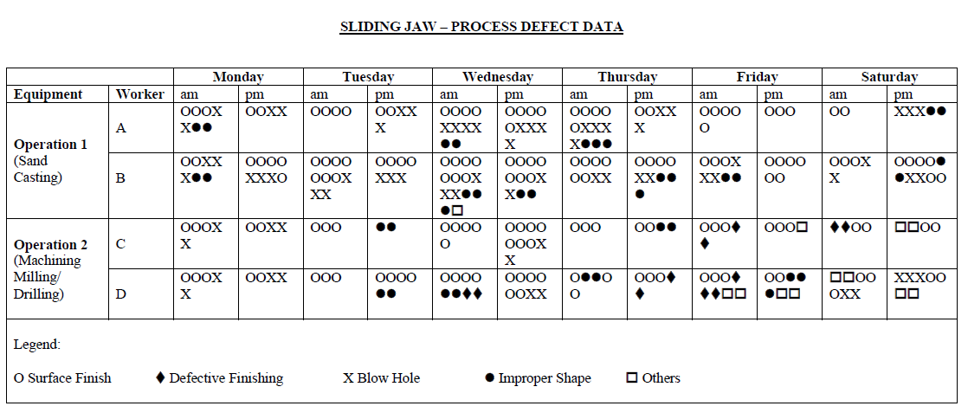

There is a lot of information in this table that needs to be broken down in order to analyse it. There are several tools we can use to do this, which leads us into the Data Analysis section.

DATA ANALYSIS

First, an analysis was done on the defects to determine the biggest problem, and sort the remaining problems in descending order. We need to prioritise our efforts on the largest problem, so I entered the data into an Excel spreadsheet and created a Pareto Graph to highlight the issues, largest to smallest.

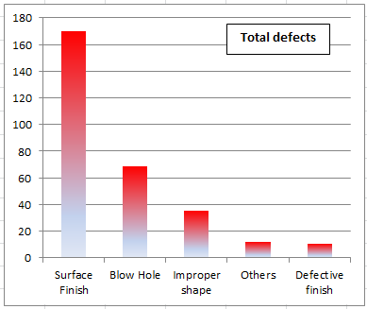

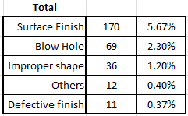

The data is telling us that the Surface Finish is the biggest problem, a total of 170 defects in a week. If we assume the company produced 3,000 units, then the Surface Finish is 5.67% of the total units per week.

Before we consider looking at the other defects, resolving the Surface Finish issue could be a big win, it is where the company will see the greatest impact.

Process Analysis

So where in the process are we suffering the Surface Defect failures? At the foundry or Machine shop? Graph below is a breakdown of where the failures are happening in the process.

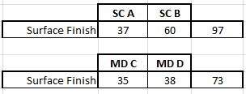

We have a total of 97 defects at the Foundry Sand Casting stage, and 73 at the Machining/Drilling stage. I have also broken this down into operators too, so we can establish if there is a pattern.

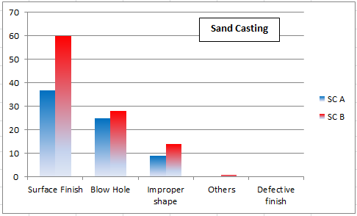
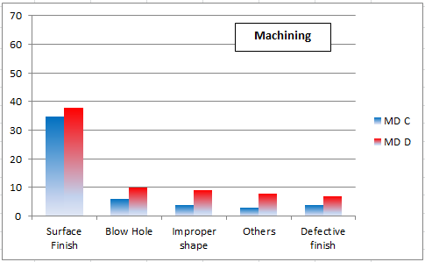

The Surface finish defects are occurring more at the foundry than at Machining, and this could also be having an impact on machining too. The machining process is to skim the face, and to drill the hole. Generally talking, these 2 processes would not cause significant surface finish defects, when compared to a sand casting process.

It can be assumed that when machining material off the face to within the tolerances allowed, it may not be removing enough material for a satisfactory finish. The cast process could be leaving a porous finish where the contours are deeper than the machining tolerance, thus leaving a poor surface finish after machining.

Operator Analysis

As well as making improvements to the process, we can also make improvements to the operators skills. The data shows us that one of the foundry operators is producing more defects than their colleague:

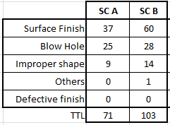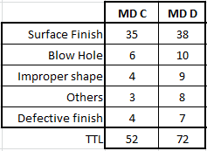

Foundry operator A produces a total of 71 defects in a week, foundry operator B produces 103 defects in a week; that is 32 defective parts more than foundry operator A.

Machining operator A produces a total of 52 defects in a week, foundry operator B produces 72 defects in a week; that is 20 defective parts more than machining operator A.

Why are the operators producing different amounts of defects?

Are they using the same type of equipment? Have they both received the same standard of training? Does one have more experience than the other? Do they both understand the impact defects have on the business?

There are opportunities here to reduce defects and increase outputs, by focusing our efforts on the issues causing operator B to produce more defective parts than operator A.

ROOT CAUSE ANALYSIS

Why are we seeing problems with the surface finish?

Again back to the data, I extracted the surface finish data from the spreadsheet, we can see that the surface finish issue is at its greatest on the Wednesday, i.e. mid-week.

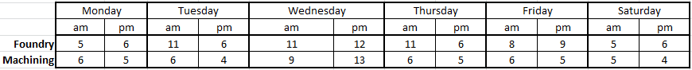

If we follow the lines on the graph, they both begin to increase Wednesday AM, and hits a peak Wednesday PM. It would appear there is a change in the process on Thursday AM because there is a significant drop in defects after that.

It can be assumed that the foundry operators were responding to the large amount of defects and changed the sand cast for a new one Wednesday PM, which would have reduced the defects from Thursday onwards.
We also notice that volume of defects in both foundry and machining are relevant to each other, suggesting a single issue is causing both processes to cause defects.

So we have identified that the sand cast is changed when the operators notice a significant increase in defects. However, it would be sensible to replace the sand cast earlier, perhaps Tuesday PM to avoid the mid-week spike in defects.

To support this theory, we can use the 5-Why tool to establish what is the root cause here.

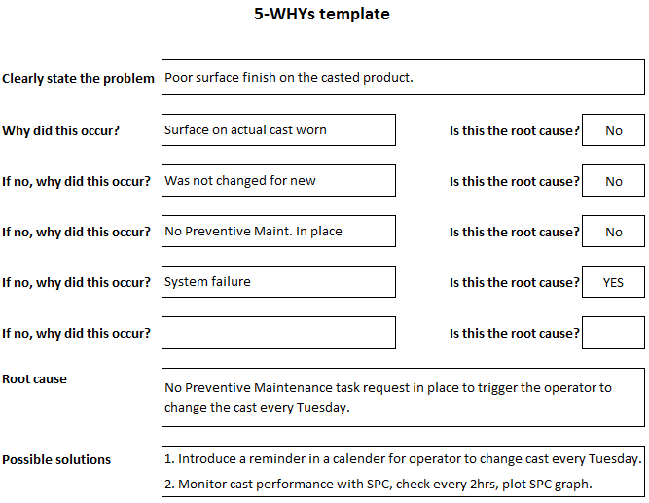

At the moment, the sand cast is changed when the operators notice a large amount of defects (don’t change it until its broken!!). However the 5-WHY tool is suggesting we implement a structured change of the sand cast, based on the factual evidence collated.

If we change the sand cast on the Tuesday, irrespective of defect amounts, we will almost certainly avoid a spike in defects the following day (or days).

With regards to the operators, we have established that there is a trend between the 2 in each area, one is performing better than the other. We must be careful not to make this a blame exercise, but instead to promote standardised working, to identify best working practice and encourage everyone to adapt that practice. To work to the company standards and expectations, which will lead to an efficient and competitive company.

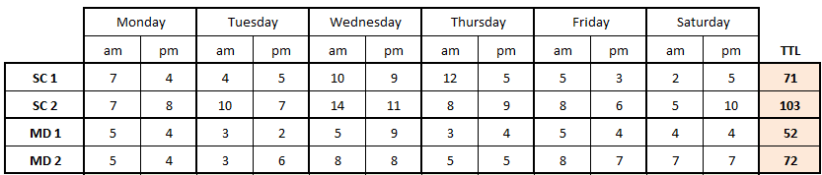

Here we see the 2 sand casting operators have a different performance, resulting in a difference of 32 defects between them. We need to ask why, and how. Using the Isikawa diagram we can review all the potential issues that are impacting on the performance of the second operator.

Isikawa Diagram

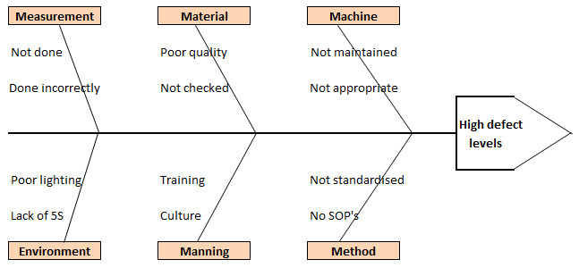

Using this diagram, we can discuss in a group what issues are causing the greatest problems, and establish what issues to prioritise, based on impact and easiness to correct.

As the main defect is surface finish, I would start with the ‘Machine – not maintained’ issue, introducing a structured preventive maintenance programme which involves inspection and replacement of part the cast unit before failure.

‘Manning’ would be a good second choice, considering we have inconsistencies between the operators’ performance and defect levels. I would start with Training, check that the operators are trained correctly, and that they are using their training appropriately.

‘Method’ would be a close third to focus on. Are there Standard Operating Procedures in place? Instructions for the operators to follow, no guess work, no cutting corners, etc.

Standardising all working methods so that the best practice is followed. To start with, we can observe and document how the better operator works, and train the other operator to perform his tasks in the same manner. This should have an impact on the defect levels.

ACTION PLAN

Through data collection and analysis, we are able to align our focus and efforts on the issues that are causing the biggest problems. So my recommendations to the manufacturing company would be these initiatives:

Preventive Maintenance of the Sand Cast Unit.
We have identified that the surface finish defects peak significantly mid-week, so it would be wise to change the sand cast unit on Tuesday evening, 24hrs earlier than they did change it. The Foundry Operators lose production time they change it on the Wednesday anyway, so change it one day earlier to prevent the spike in surface finish defects.

Second suggestion is to introduce an inspection system, visually check the Sand Cast Unit for defects, age, signs of deterioration, etc. This is a simple, cheap and effective system to prevent further defects.

Operator Training.
The data clearly shows there are inconsistencies between the production operators, one is registering more defects than the other. Investigate this issue, is it the operator, the machine, the process, the method, etc.
It’s important to remember this is not a blame exercise, but in order to fix something, we need to understand what it is that needs fixing. And once the problem has been identified, train the operators to follow the best working practice. Encourage them to share knowledge, one operator may not have the experience to prevent defects before they happen.

Communicate Results
Continue recording the defects every week, trend them whilst the company goes through this period of improving the process to reduce defects. As the defect rate falls, simplify the data collated into easy to read graphs and share it with the operators.
This information must be shared so everyone knows that the improvements being made around them, and with them, is having a positive impact on the defect levels. It builds trust and also motivates people.

If we hadn’t collated the data, reviewed it, and formed suggestions based solely on the structured analysis, then we would be taking ‘pot-shots’ at whatever problem arose. Doing it this way gives us the confidence that we are focusing our resources on the big problems, and that the desired results will be achieved.

--- end ---

