Wednesday, November 19, 2025

Lecturer’s Name - Ivan Rodriguez Hernandez
Module Name - Stakeholder Engagement
Student Name - Ovidiu Florin Socel
Student Number - 2310644
Module code - LCBB4013

Newent Community Park and Green Corridor.
Stakeholder Management Plan.
Portfolio.
Contents
Introduction. 2
1. Project Overview and Relevance. 2
2. Key Stakeholders and Expected Benefits. 4
Stakeholder Engagement Strategies. 4
1. Overview. 4
2. Stakeholder Identification and Analysis. 5
3. Stakeholder Mapping. 5
4. Stakeholder Engagement Strategy. 6
4.1 Alignment with National Standards for Community Engagement (Scottish Government, 2016). 6
5. Communication and Consultation Plan 7
6. Ethical and Diversity, Equity and Inclusion DEI Considerations in Consultation. 7
7. Theoretical Underpinning and Reflection Link. 8
Ethical Considerations in Stakeholder Consultation, Participation and Feedback. 8
1. Introduction. 8
2. Consultation Methods. 9
3. Ethical Considerations in Consultation and Data Collection. 9
3.1 Informed Consent and Transparency. 9
3.2 Confidentiality and Data Protection. 10
3.3 Managing Bias and Ensuring Objectivity. 10
3.4 Avoiding Consultation Fatigue. 10
4. Diversity, Equity, and Inclusion (DEI) Principles. 10
4.1 Inclusive Access and Representation. 10
4.2 Equitable Participation. 10
5. Feedback Collection and Review Process. 11
6. Ethical Reflection. 11
Conclusion and Reflection. 11
1. Conclusion. 11
2. Reflection on the Importance of Stakeholder Engagement. 12
3. Final Reflection. 12
References. 13

Newent Community Park and Green Corridor.

Introduction.
- Project Overview and Relevance.
The proposed Newent Community Park and Green Corridor is a sustainable green infrastructure initiative situated within the south-east Newent mixed-use development area in the Forest of Dean District Council’s (FoDDC) Local Plan 2021–2041 (Policy LP.74). The development project contains 600 residential units together with employment areas and community facilities which include a new school and GP surgery (FoDDC, 2024). The Community Park will establish a versatile green space that supports population growth by fostering better health outcomes, environmental sustainability, and community unity.
Public green spaces serve as essential elements for community health and ecological sustainability, and urban liveability. The surrounding areas of Newent and expanding towns serve as defensive barriers against climate change while creating peaceful spaces for social interaction and leisure activities. Furthermore, the project supports the UK Government’s 25-Year Environment Plan (DEFRA, 2018) and aligns with the United Nations Sustainable Development Goals (particularly SDG 11: Sustainable Cities and Communities).
The Junior Stakeholder Manager position in my consultancy team requires me to identify and manage diverse stakeholder interests through active communication, ethical consultation, and transparent decision-making. Stakeholder engagement is an essential element of infrastructure and community development projects because it establishes trust relationships and minimises resistance, resulting in superior long-term project outcomes (Bourne, 2016).

Figure 1: Masterplan-style illustration showing the proposed park layout within the wider development context (Source: Edit by Socel, 2025).

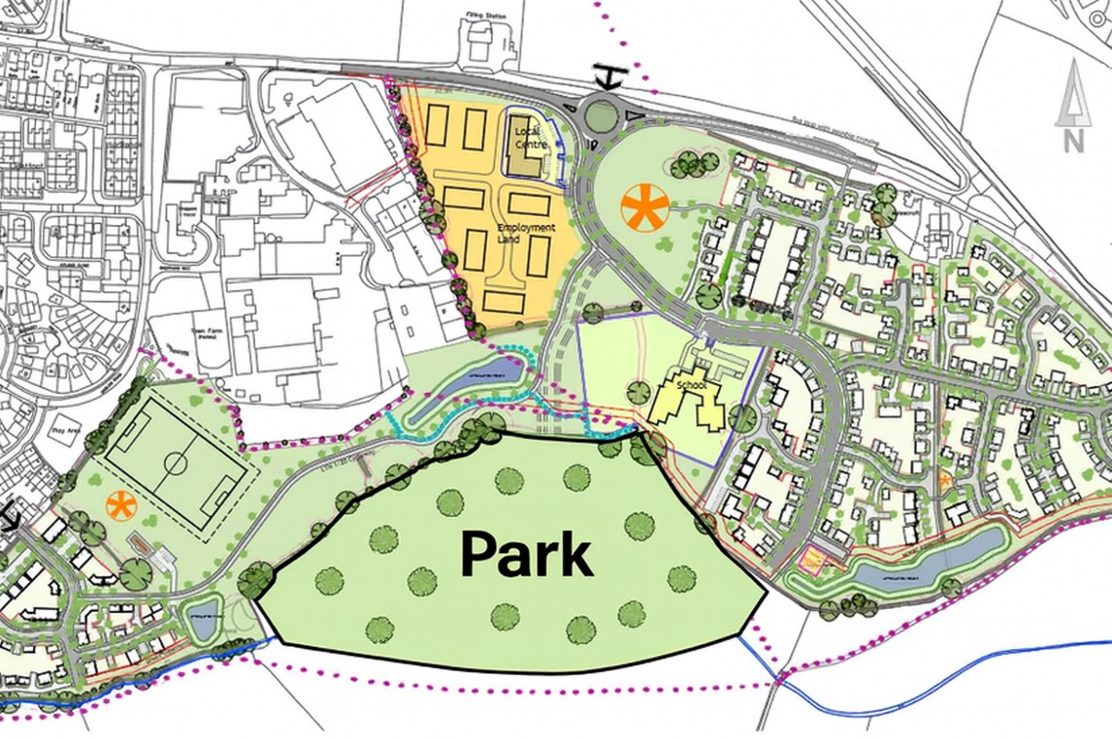
Park Measurements and Facility Suitability
Feature | Details | Values
Estimated Park Length | West to East | 480–520 m
Estimated Park Depth | North to South | 95–130 m
Total Park Area | Based on the footprint | 4.2–5.0 ha (42,000–50,000 m²)
Terrain & Layout | Riverside green corridor | Footpaths, trees, watercourse bends, recreation lawn
Children's Play Area | Minimum requirement 400–800 m² | Supported
Community Garden | Minimum requirement 250–750 m² | Supported
Dog Exercise Run | Minimum requirement 1,000–2,000 m² | Supported
Fitness Trail | Length 300–600 m | Supported
Picnic Lawn | Minimum requirement 2,000 m² | Supported
Wildlife Habitat | 1–2 hectares | Supported
Path Width | Shared walking/cycling path | 2.5–3 m
Corridor Width | Average Park width | 100–120 m

- Key Stakeholders and Expected Benefits.
At least six key stakeholders have been identified for the project:
Table 1: Stakeholders’ Interests and Benefits.
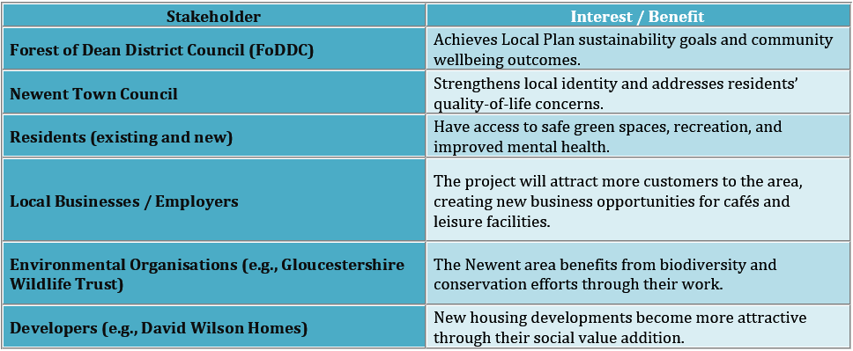

Stakeholder Engagement Strategies.

Overview.
Stakeholder engagement stands as the key factor for achieving success in community-based infrastructure projects, which need to handle environmental and social changes. For the Newent Community Park and Green Corridor Project, engagement will ensure that the diverse interests of residents, developers, local authorities, and environmental groups are effectively balanced. In line with the Scottish Government’s National Standards for Community Engagement (2016), the engagement process will prioritise inclusion, transparency, mutual learning, and measurable impact. The standards establish a functional system which helps organisations plan stakeholder engagement and execute it while assessing its results to develop decisions through collaborative effort instead of top-down implementation (Scottish Government, 2016).
The engagement strategy follows Freeman’s (1984) Stakeholder Theory, which states that organisations need to handle all groups who influence or experience impact from their projects to achieve success. Infrastructure development projects experience delays and damage to organisational reputation because stakeholders receive inadequate management, and community needs remain unmet (Yang et al., 2011). Organisations that achieve successful engagement will build a stronger social license to operate, leading to improved sustainability outcomes for their projects.

Stakeholder Identification and Analysis.
Stakeholder identification framework and the AA1000 Stakeholder Engagement Standard (AccountAbility, 2015), the main stakeholders in this project include:
- Forest of Dean District Council (FoDDC)
- Newent Town Council
- Residents (existing and new)
- Developers (e.g., David Wilson Homes, Platform Housing Group)
- Local businesses and employers
- Environmental organisations (e.g., Gloucestershire Wildlife Trust)
- Educational and health providers (e.g., proposed school, GP surgery)
The project stakeholders maintain different levels of control and interest, and the ability to shape project results.
Table 2: Power Influence Matrix.
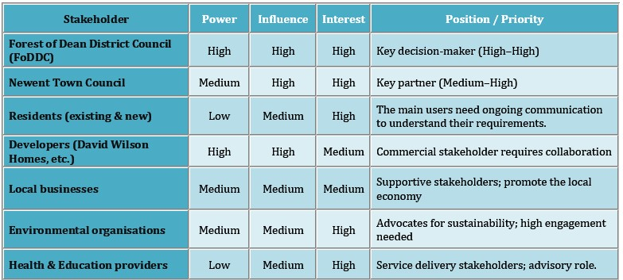
The table helps decision-makers set priorities, recommending that stakeholders receive more intensive engagement based on their power levels and interest points.

Stakeholder Mapping.
A Power-Interest Grid adapted from Mendelow (1991). enables stakeholders to be visualised in their positions.

Table 3: Stakeholders Engagement Strategies.
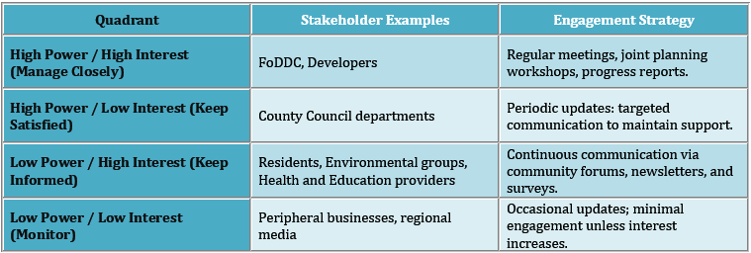

Stakeholder Engagement Strategy.

4.1 Alignment with National Standards for Community Engagement (Scottish Government, 2016).
Each stage of engagement will follow the seven national standards:
- Standard - Application in the Newent Park Project.
- Inclusion - All demographic groups, including age, gender, disability and ethnicity, must be represented. Accessible meeting venues and digital consultation tools will reduce barriers to participation.
- Support - The program should offer participants detailed project information and guidance which explains complex technical aspects. Partner with community organisations to facilitate participation.
- Planning - Co-design engagement activities with Newent Town Council and FoDDC. Share timelines publicly to manage expectations.
- Working Together - Establish a Stakeholder Working Group (SWG) to co-create design options and monitor progress.
- Methods - The research will use surveys as quantitative data collection methods alongside focus groups and workshops for qualitative data collection to capture diverse participant perspectives.
- Communication - The council needs to maintain resident information through scheduled newsletters, local media and its official website.
- Impact - The project design and implementation received direction from community input, which needs to be documented and reported.
The method follows Arnstein’s (1969) Ladder of Citizen Participation, starting with consultation before moving to collaborative participation, which strengthens both project trustworthiness and legitimacy.

- Communication and Consultation Plan.
A structured Communication and Consultation Plan enables activities to be meaningful and accessible to all participants while showing proper responses.
Table 4: Communication Plan.
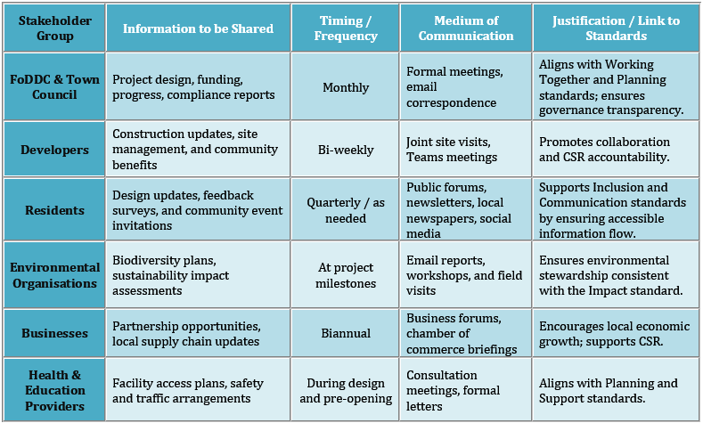

Ethical and Diversity, Equity and Inclusion DEI Considerations in Consultation.
The ethical consultation process protects all participants through its commitment to equal treatment and respectful behaviour, and complete confidentiality. The National Standards’ Inclusion and Support principles direct this process to create equal participation opportunities for all students, regardless of their socio-economic background or ability level. Key ethical considerations include:
Research needs participants to understand the process of their feedback data after they submit it.
Data Protection - All responses will comply with the General Data Protection Regulation GDPR.
Bias Reduction - The process of facilitation becomes more unbiased through the implementation of diverse teams and systems that enable participants to give feedback anonymously (Bryson et al., 2013).
DEI Commitment - The initiative will actively find underrepresented groups, including young families, elderly residents and ethnic minorities, to hear their voices properly.
The practice of ethical engagement creates trust with local communities while supporting Corporate Social Responsibility (CSR) goals by demonstrating organisational accountability and stakeholder value (Carroll, 1999).

Theoretical Underpinning and Reflection Link.
The theoretical framework supports this engagement strategy through:
- Freeman’s (1984) Stakeholder Theory recognises stakeholder interdependence.
- The National Standards for Community Engagement (2016) offer organisations step-by-step guidance to create inclusive practices through ethical communication methods.
- The Junior Stakeholder Manager can develop personal learning through active engagement and reflective practice according to Kolb’s (1984) Reflective Cycle.
The consultant develops vital competencies for sustainable community development through this project by acquiring stakeholder mapping and conflict resolution, and ethical leadership skills (Rowe and Frewer, 2005).

Ethical Considerations in Stakeholder Consultation, Participation and Feedback.

Introduction.
The core of stakeholder consultation and decision-making requires ethical engagement throughout its entire process. The Newent Community Park and Green Corridor Project must follow ethical principles to enable fair participation by all stakeholders. The process follows the Scottish Government’s National Standards for Community Engagement (2016), which establish four essential principles for community engagement, including inclusion and support, communication and impact. The quality of life of people depends on community projects, so ethical consultation builds trust, makes projects more legitimate, and protects participant rights (Bryson et al., 2013).
The following section explains the project's consultation strategy, ethical data collection procedures, methods for participant involvement, DEI principles, and stakeholder feedback review system.

Consultation Methods.
The Newent Community Park consultation will use both qualitative and quantitative engagement methods to achieve representative results and deliver detailed information. Rowe and Frewer (2005) state that stakeholders need to participate through deliberative and consultative methods to achieve a complete understanding of their perspectives.
The proposed methods include:
- Community Workshops and Design Charrettes - The Newent Community Centre hosts quarterly meetings which bring together residents and business leaders, and environmental groups to develop design ideas and review proposed layouts.
- Surveys and Feedback Forms - The FoDDC website offers digital versions of the document by making public facilities available in physical form for those who cannot attend meetings.
- Focus Groups - The research studied three distinct population groups, which included young families, elderly residents and people with disabilities, to ensure all accessibility problems received adequate evaluation.
- Stakeholder Advisory Boards - The FoDDC representatives will join Town Council members and developers, and community representatives to create a multi-sectoral panel which will track consultation progress and maintain ethical standards.

Ethical Considerations in Consultation and Data Collection.
Stakeholder engagement requires ethical practice that goes beyond rule compliance, ensuring stakeholders receive complete respect, fair treatment and absolute integrity throughout all decision-making processes (Bourne, 2016). The consultation activities will follow multiple essential ethical principles.

3.1 Informed Consent and Transparency.
The research team will give all participants a full explanation of the study objectives and complete details about data protection protocols and their right to leave the study. By following UK GDPR guidelines, the research team will get written or digital consent from participants before starting the study. Transparency ensures that stakeholders understand how their feedback influences project outcomes (UNECE, 2015).

3.2 Confidentiality and Data Protection.
Participant information will be anonymised during data analysis to protect individual identities. The encrypted system at FoDDC will protect all data through secure storage while authorised staff members maintain exclusive access to the information. These procedures align with the (UK Government, 2018) and uphold the Support and Communication standards of the National Framework.

3.3 Managing Bias and Ensuring Objectivity.
The interpretation process for data collection creates opportunities for bias to enter at all stages of collection. Questions in surveys and workshops will be neutrally phrased to avoid leading responses (Bryson et al., 2013). Independent observers must attend consultation events to monitor the process while maintaining both fairness and transparency.

3.4 Avoiding Consultation Fatigue.
The practice of over-consultation leads to decreased participant involvement and produces lower-quality research data. The organisation will schedule engagement activities with caution to avoid conflicts with other local consultation events by including FoDDC housing plans.

Diversity, Equity, and Inclusion (DEI) Principles.
The Newent community needs DEI principles to create an environment where every member from all backgrounds and with different abilities and social statuses can actively participate. The National Standards for Community Engagement (2016) define Inclusion and Support as essential elements which enable fair participation according to their framework.

4.1 Inclusive Access and Representation.
The consultation sites will provide wheelchair accessibility and be situated in areas with easy access to public transportation. The event will offer vital accommodations through interpreter services and digital tools, which include screen readers and large-text versions. The content of engagement materials will use simple English with translations for major community languages when needed.

4.2 Equitable Participation.
The program will actively find underserved communities which consist of low-income families and elderly residents. The program will reach its target audience through strategic alliances with local educational institutions and healthcare facilities, and community-based organisations. Equity requires more than open invitations because it needs to eliminate every obstacle which blocks complete participation (Agyeman, 2013).

Feedback Collection and Review Process.
The project team will collect stakeholder feedback through existing procedures, which will be merged with project planning activities for analysis and combination. The process will be iterative, and feedback will not only be gathered but also actively acted upon.
- Data Collation - The Stakeholder Manager will maintain a primary database system that processes all consultation responses collected from surveys, workshop materials and email interactions.
- Thematic Analysis - The research team will apply qualitative data coding techniques to discover essential themes, which include environmental issues and accessibility requirements, and recreational activities.
- Feedback Reports - The FoDDC website, together with community newsletters, will distribute summary reports after each consultation phase.
- Response Integration - The Stakeholder Advisory Board will assess approved proposals to develop design changes, including cycle lanes and accessible playground equipment.
- Feedback Loop - Participants will receive information on how their feedback influenced project decisions, which will establish trust through loop closure.
The feedback model operates through cycles because it implements the Plan–Do–Check–Act (PDCA) continuous improvement method from Deming (1986) and the Impact principle of the National Standards, which enables measurement of significant engagement results.

Ethical Reflection.
The Junior Stakeholder Manager position transforms into an ethical facilitation role applying ethical principles and DEI standards through reflective practice. The Reflective Cycle from Kolb (1984) enables students to learn through experience during each stage of planning, consultation, and feedback, enhancing their ability to understand others and communicate effectively, and analyse information. The Newent Community Park project will achieve sustainability and maintain its legitimacy through ethical community engagement, which builds strong relationships with residents.

Conclusion and Reflection.

Conclusion.
The Newent Community Park and Green Corridor Project offers a timely and feasible response to the challenges posed by rapid housing development and infrastructure pressure in the town. The plan supports the Forest of Dean District Council Local Plan 2021–2041 (FoDDC, 2024), which focuses on sustainable development, community health and environmental protection.
The evidence in this portfolio demonstrates that successful project delivery depends on proper stakeholder engagement strategies. Freeman established Stakeholder Theory in 1984, which defines organisational success through stakeholder requirements identification and management. The case involves multiple groups with common interests in health, sustainability, quality of life, including residents, FoDDC, Newent Town Council, developers and environmental organisations. The power–interest matrix from Mendelow (1991) and structured communication planning enable organisations to create specific engagement approaches that fulfil stakeholder requirements.

Reflection on the Importance of Stakeholder Engagement.
The portfolio development process helped me recognise how stakeholders affect both project outcomes and long-term organisational success. The project demonstrates that stakeholder engagement is not simply a procedural step but the foundation of legitimacy, trust, and long-term impact (Bourne, 2016).
Communication skills are a core component which supports my entire educational experience. Berlo’s (1960) and Schramm’s (1954) models illustrate how messages can break down due to barriers like cultural differences or emotional responses. The research results showed that stakeholder engagement needs feedback systems, basic communication tools and complete response attention from stakeholders. The park system maintains communication through both top-down and participatory and responsive methods.

Final Reflection.
The portfolio, along with my personal assessment, demonstrates that successful stakeholder engagement is the critical element for reaching sustainable project results. The Newent Community Park project needs stakeholder engagement to fulfil actual community requirements while minimising opposition and creating enduring bonds between local people and council officials, developers, and environmental groups.
Based on the frameworks applied and the lessons learned, it’s concluded that the Newent Community Park and Green Corridor Project can be done successfully. The project will reach its short-term goals through stakeholder involvement, which will create lasting community identity and strength through ethical practices and open communication.

References.
AccountAbility (2015) AA1000 Stakeholder Engagement Standard (AA1000SES) 2015. London: AccountAbility. accountability.org+1
Agyeman, J. (2013) Introducing Just Sustainabilities: Policy, Planning, and Practice. London: Zed Books. Bloomsbury+1
Arnstein, S.R. (1969) ‘A ladder of citizen participation’, Journal of the American Institute of Planners, 35(4), pp. 216–224. Taylor & Francis Online+1
Berlo, D.K. (1960) The Process of Communication: An Introduction to Theory and Practice. New York: Holt, Rinehart and Winston. SCIRP
Bourne, L. (2016) Stakeholder Relationship Management: A Maturity Model for Organisational Implementation. 2nd edn. Abingdon: Routledge. Browns Books+1
Bryson, J.M., Quick, K.S., Slotterback, C.S. and Crosby, B.C. (2013) ‘Designing public participation processes’, Public Administration Review, 73(1), pp. 23–34. experts.umn.edu+1
Carroll, A.B. (1999) ‘Corporate social responsibility: Evolution of a definitional construct’, Business & Society, 38(3), pp. 268–295. SAGE Journals+1
Department for Environment, Food and Rural Affairs (DEFRA) (2018) A Green Future: Our 25 Year Plan to Improve the Environment. London: HM Government. GOV.UK+2FAOLEX Database+2
Deming, W.E. (1986) Out of the Crisis. Cambridge, MA: MIT Press. MIT Press+1
Forest of Dean District Council (2024) Forest of Dean District Local Plan 2021–2041: Draft Policy LP.74 South East Newent. [online] Coleford: Forest of Dean District Council. Available at: Forest of Dean District Council Local Plan pages (Accessed: 27 October 2025). fdean.gov.uk+1
Freeman, R.E. (1984) Strategic Management: A Stakeholder Approach. Boston, MA: Pitman. ira.lib.polyu.edu.hk
Kabisch, N., Qureshi, S. and Haase, D. (2015) ‘Human–environment interactions in urban green spaces — A systematic review of contemporary issues and prospects for future research’, Environmental Impact Assessment Review, 50, pp. 25–34. Academia+1
Kolb, D.A. (1984) Experiential Learning: Experience as the Source of Learning and Development. Englewood Cliffs, NJ: Prentice-Hall. SCIRP+1
Mendelow, A.L. (1991) ‘Environmental scanning: The impact of the stakeholder concept’, in Proceedings of the Second International Conference on Information Systems. Cambridge, MA: Association for Information Systems, pp. 407–418. Scribd+1
Reed, M.S., Graves, A., Dandy, N., Posthumus, H., Hubacek, K., Morris, J., Prell, C., Quinn, C.H. and Stringer, L.C. (2009) ‘Who’s in and why? A typology of stakeholder analysis methods for natural resource management’, Journal of Environmental Management, 90(5), pp. 1933–1949. ResearchGate+1
Rowe, G. and Frewer, L.J. (2005) ‘A typology of public engagement mechanisms’, Science, Technology & Human Values, 30(2), pp. 251–290. Simply Psychology+1
Schramm, W. (1954) ‘How communication works’, in Schramm, W. (ed.) The Process and Effects of Mass Communication. Urbana, IL: University of Illinois Press, pp. 3–26. History of Social Work+1
Scottish Community Development Centre (SCDC) (2016) National Standards for Community Engagement. Edinburgh: Scottish Government & Scottish Community Development Centre. Scottish Government+3whatworksscotland.ac.uk+3wisepower-project.eu+3
UK Government (2018) Data Protection Act 2018 (c.12). London: The Stationery Office. Legislation.gov.uk+1
United Nations Economic Commission for Europe (UNECE) (2015) Guidelines on Access to Information, Public Participation and Access to Justice in Environmental Matters. Geneva: UNECE. unece.org+1
Yang, J., Shen, G.Q., Ho, M., Drew, D.S. and Xue, X. (2011) ‘Stakeholder management in construction: An empirical study to address research gaps in previous studies’, International Journal of Project Management, 29(7), pp. 900–910. ScienceDirect+1

