The importance of reflective practice as a professional practitioner
What is reflection and reflective practice?
Reflection and reflective practice are key values of professionals and play a key role in early years practitioners (Brock, 2015). As Schon (1983) highlights that a professional practitioner will need to allow themselves to experience a surprised situation in which they are uncertain on. Schön (1983) suggests that as a professional practitioner you will need to be able to reflect on the situation that has happened and find a new understanding and change the situation. Reflective practice is about how you work as an individual and as a team, this will help to improve your practice and help to improve the outcomes you provide for the children and families in your care (Lyndon and Trodd, 2016). There are two types of reflective practice according to Schön (1976) Reflection in action and reflection on action, reflection in action refers to reflecting when doing something for example thinking on your feet and acting straight away. Whereas reflection on action is reflecting after you have done something and thinking what you could have done differently in the situation (Brock, 2015).
How can reflective practice support you developing as a professional.
As an early year’s professional practitioner, reflecting and reflective practice is a vital part of the job. This helps practitioners to develop their understanding of their own practice and to enable them to develop the necessary skills to achieve their best development and learning outcomes for them and the children (birth to five matters, no date). According to Brock (2015) practitioners who apply reflective practice in their setting will be more aware and in control of situations around them. Reflection must be used daily to better practitioners practice and teaching skills (Brock, 2015). Reflective practice is required to be meaningful, for a professional practitioner it would have to be based around working with young children within the early years (Brock, 2015). Paige-Smith and Croft (2011) believe that early year’s practitioners may even change their practice by focusing more on the children’s perspectives and how different children learn about the world around them, by doing this practitioners can then focus on the children’s interests and plan different activities which can help and support the children’s individual needs (Paige-Smith and Croft, 2011). Johns and Burnie (2014) identifies that practitioners who carry out reflection will pay more attention to their own self within practice. Practitioners should be more mindful of their thinking and their reaction to certain situations. Furthermore, Johns and Burnie (2014) highlight that reflection becomes a more natural quality within a practitioner’s everyday practice and therefore be more valuable to offering their best intention to the child’s development.

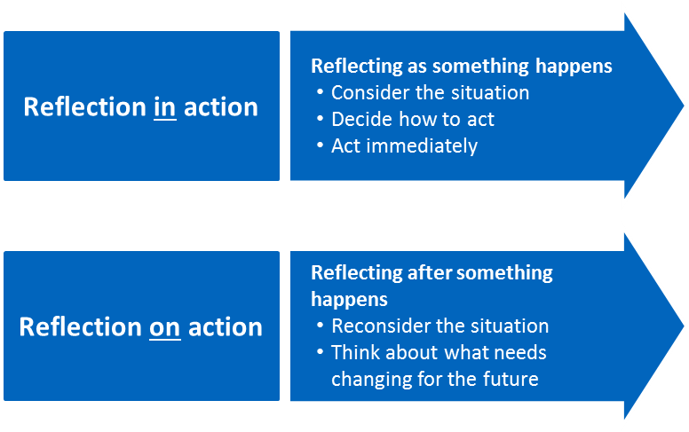

(Cambridge Assessment,2023)

How reflective practice can improve quality in the early years setting.
Tarrant (2017) believes that professional practitioners in the early years should use reflection not only by themselves but also as a team or with other work colleagues within the setting. This will then further develop practitioners support for one and other and help to create a professional and safe works environment for the best results of using reflective practice. Furthermore Tarrant (2017) highlights the importance of being able to communicate and carry out good reflective practice with other practitioners within your setting to develop trust. When working in early years settings it is possible that another practitioner will also observe a situation that is ongoing with a child for them to both be able to reflect on the information they have found together. Paige-Smith and Craft (2011) indicate that developing effective relationships with both children and families is a key skill for professional practitioners. Moreover Paige-Smith and Craft (2011) also recommend being able to communicate effectively to families about their child’s development or change in behaviours is a vital part of your job role. By creating a positive relationship with children’s family’s parents and carers could contribute and help reflect on situations at home and the information given may be helpful to help create a plan that will best support the individual child’s development (Paige-smith and Craft, 2011). Similarly, Hallet (2013) agrees that by practitioners reflecting with parents of children and other work colleagues, this will help to possibly solve any problems or find simple solutions that everyone can follow and give feedback to improve on the child’s development.

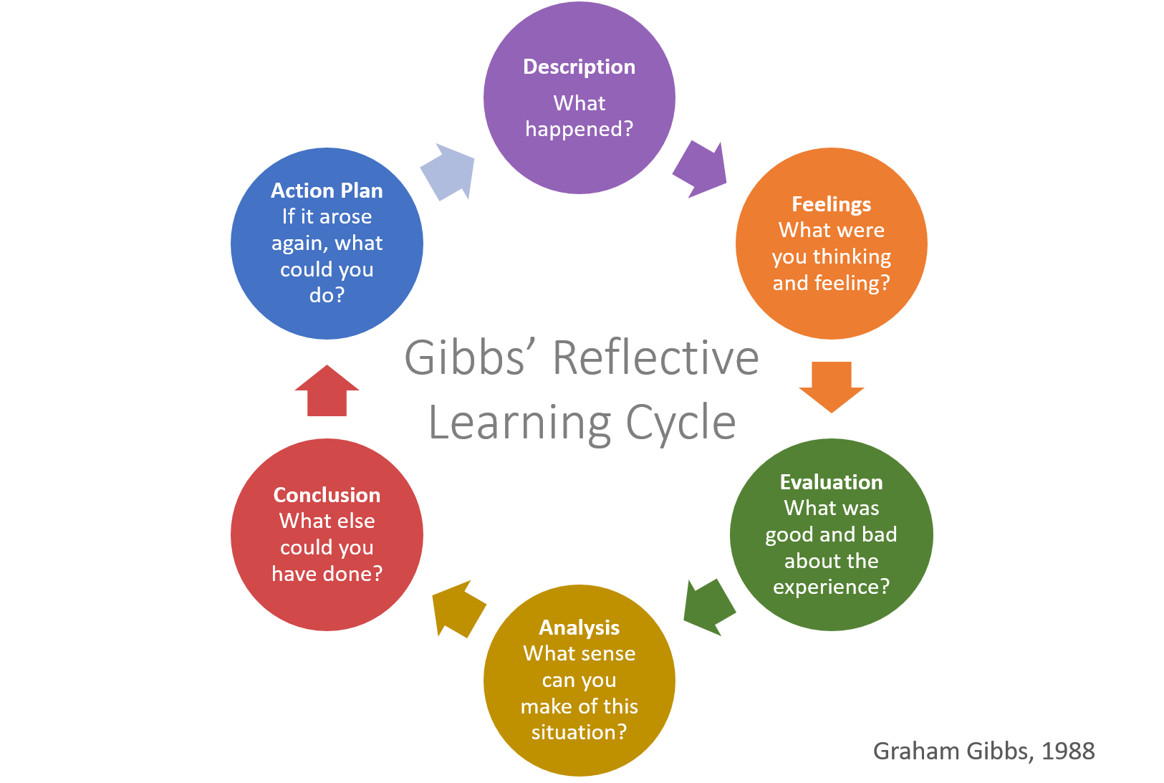
Models and theories of reflection
According to Brock (2015) when it comes to models of reflection there are many different ones that can support you in your reflective practice. Although the models are different, they can support you in the same ways as they all have similar stages some more than others (Brock, 2015). University of Cumbria (2020) highlight that Gibbs’ (1988) reflective cycle is the most used in early years settings as the cycle has more in-depth stages. Gibbs' (1988) Reflective Cycle was established by Graham Gibbs in 1988 to give organisation through learning from different experiences. This cycle offers a structure for examining experiences, and given its recurring nature offers itself mainly to repetitive experiences, this then allows practitioners to move on and learn and plan from things that either went well or didn’t go too well. It covers 6 stages including the description on what happened how the people involved were feeling at the time, it then gives an evaluation and analysis and to finish off it suggests a conclusion and action plan to use in the future. One of the crucial points about Gibbs cycle is the fact that he took into consideration the importance of people’s feelings in the reflection (university of Cumbria, 2020). By reflecting on these stages in depth as a professional practitioner you would then be able to critically assess what exactly was being reflected on in order to then learn and make an effective plan from the outcomes.
(university of Edinburgh, 2023).

(Gibbs reflective cycle, 1988)
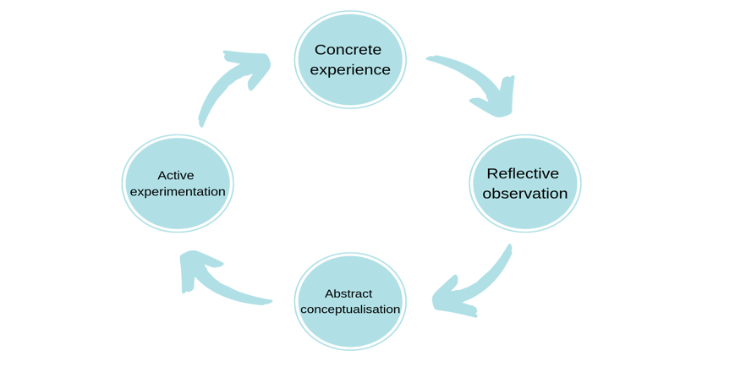
Another reflective model practitioners can use is Kolb’s Experiential cycle. Kolb’s (1984) cycle is a smaller reflective cycle made up of four stages, these are concrete experience, reflective observation, abstract conceptualise and active experimentation. University of Cambridge (no date) highlight how Kolb’s model argues that you should always start with an experience whether this is a recurrence of something that may have happened before or whether it is something new to us. The next stage involves practitioners to reflect on the situation by taking notes about anything that is unusual or practitioners have not seen before, after that practitioners will then develop new ideas as a result from what information they have found. The final stage is then used for practitioners to apply their new ideas into the different situations. By practitioners following the stages it then demonstrates that practitioners have learnt from their experiences and reflections (university of Cambridge, no date).

(Kolb’s experiential learning cycle, 1984)
According to University of Cambridge, (2023) there are both pros and cons when it comes to using these reflective models, some of these include offering practitioners who may be new to using reflective practice a format to follow, as these models have a starting point on where you can develop what has happened in the situation by following the stages one step at a time. Although these models of reflection can be very useful to practitioners there are also some cons to using them as The University of Cambridge, (2023) implies that all stages must be followed in a certain way, whereas in everyday practice you might not always start at the beginning and models may not be applied in every situation a practitioner may come across, as reflective practice is a continuous process and practitioners may wish to continue from where they previously carried out an observation (university of Cambridge, 2023)

Finally, to conclude it is highly recommended by following one of the above methods practitioners would be able to start using reflection in practice. Reflection is a key skill for all practitioners who work within the childcare settings. Practitioners who use reflection in their setting will ensure that all children will receive the upmost care and learning provided to them. Practitioners can also use reflection in the setting to see how different children are developing and if they need any more support in certain areas of their developmental needs. Reflection is also of a way of identifying children’s likes and dislikes in order to aid future planning where the individual child’s interests will be taken into consideration.

