Academic and Employability skills
Task 1 – Evaluation of blended learning and classroom learning on student attainment
BMSW4001
Khizar Fareed
2028871

Contents
Introduction
What is blended learning
Pros and Cons of blended learning at university
What is traditional learning
Pros and Cons of Traditional learning in Higher Education
Recommendations and conclusion
References

Introduction
Since the emergence of the internet and the World Wide Web becoming widely available, ‘blended learning’ appears to have become popular. However, with changes and accessibility in the wide range of technology over the last two decades, implications have evolved and converged. Blended learning has been defined as a combination of face-to-face and technology-mediated educational styles and practices since 2006. This report aims to explore blended learning and traditional learning methods and their pros and cons in higher education and whether blended learning is a more suitable option for students within higher education.

What is blended learning?
Friesen (2012) describes blended learning as a combination of particular pedagogies and technologies. Graham's definition of Blended Learning as learning methods that integrate face-to-face education with computer-facilitated training (Graham, 2006, p.41) is one of the most often used. Marcy Driscoll (2002) presents a definition in much more detail, which is outlined below;
- To attain an educational goal by combining or mixing forms of Web-based technologies (e.g., live virtual classroom, self-paced teaching, collaborative learning, streaming video, audio, and text).
- To use a combination of pedagogical techniques to get the best learning outcome possible, whether or not instructional technology is used.
- To mix face-to-face instructor-led training with any type of instructional technology (e.g., videotape, CD-ROM, Web-based training, film).
How blended learning works is that it is a method of learning that blends face-to-face and online activities in a smooth and complementary manner. In the flipped classroom, for example, online activity is presented in the form of reading materials and other artefacts before a face-to-face lesson, that could be uploaded on a closed network for the organisation such as Moodle, or even sending out an email with the necessary links to students before attending class physically.

What are the pros and cons of blended learning within university?
According to Driscoll (2002), blended learning can mean different things to different people. This term is forever evolving, along with new technology being incorporated and new methods of teaching styles developing and forming.
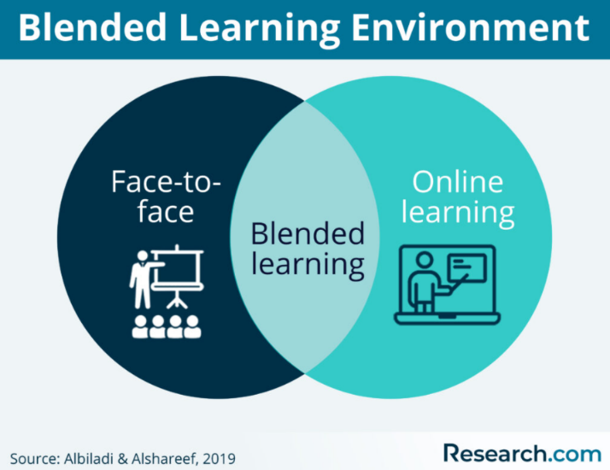

There are many benefits that blended learning brings to students within higher education settings. Blended learning is all about striking the balance between online access to knowledge and face-to-face human connection, according to Osguthorpe and Graham (2003, p.228). The goal of implementing this type of learning into a pedagogical approach is not to replace conventional teaching techniques, but to give teachers and students with the inherent benefits of face-to-face interaction and online teaching methods.
Some of the benefits listed below of blended learning are;
- Language skills – can aid in developing language skills for ESL students with the use of mixed resources and teaching methods to help aid the many different ways students learn
- Increase student engagement – students are more motivated when presented with different methods of learning and able to access learning opportunities that would not be typically available to them from traditional class room learning methods such as using internet to access presentations and online recorded seminars/TED talks.
- Improve learning environment/flexibility – allowing students to learn at their own pace. Blended learning, according to Senffner and Kepler (2015), is a flexible, scalable, and meaningful method of teaching and learning. The flexibility allows students to access content from anywhere and any device connected to the interne
- Assist those with learning disabilities – use of technologies and software’s that would not normally be implemented during traditional learning methods such as aids for those with dyslexia or visual impairments.
- Cost effective – reduced costs for institutions
There are also many setbacks to blended learning within higher education facilities. Some of these disadvantages include;
- Technology drawbacks – technology can fail at any time, system overloads and IT errors can throw a ‘curve ball’ and halt any e-learning that is due to take place so it is important that the IT infrastructure can support these learning methods.
- Cognitive overload – students learn at varying paces; however, it is important to recognize that over delivering and providing too much information can lead to students becoming overwhelmed with their studies.
Overall, for students within higher education institutions, the pros of blended learning far outweigh the disadvantages. As with the recent Covid-19 pandemic, blended-learning proved to be highly important in providing ongoing education for students.

What is traditional learning?
Traditional learning usually takes place within a face-to-face environment. Traditional classrooms are known for their high level of interaction. The instructor passes on his or her expertise and information to the pupils, while the students pass on any questions or difficulties to the teacher. For these typical classes, a pre-planned curriculum is implemented, and the instructor follows it. Students are tested on their grasp of the material on a regular basis (Taneja, 2020). Debates, group projects, and group discussions are only some of the classroom activities are held in conventional classrooms. The teacher can give each student particular attention and comprehend their issues. In distant or virtual learning, this is frequently not the case.
Pros and cons of traditional learning within Higher Education
Traditional learning methods have many advantages to offer students within higher education. it is highly beneficial for students who have shorter attention spans and also can keep many students on the ‘right track’ with their education, with little room to procrastinate or fall behind. Some of the advantages of traditional learning are below;
- In-person or one-on-one leads to higher level of student engagement with tutors.
- The traditional classroom teaching setting encourages student engagement and creates a suitable learning environment for other students.
- In a typical learning environment, tutors play a critical role in imparting discipline and providing a sense of direction to pupils.
- Accessibility – students can approach the tutor and ask for further clarification in person there and then, rather than at a later time, also students who don’t have access to internet or IT equipment don’t have to worry about this when in a face-to-face environment.
- Discipline – students are able to engage directly with their peers and teacher and remain on course for their studies
- Maintaining interpersonal relationships – being able to interact and socialize with peers in person rather than online.
It’s also imperative to note that there are many disadvantages of traditional learning within higher education for students. Some of these disadvantages I have listed below include;
- Focus and motivation – sometimes students can become disengaged with their studies because of a lack of inspiration and innovative methods of teaching being used
- One size fit’s all – accessibility may not take into consideration different students learn differently, including ESL and SEN students who may require more time, or different approaches to learning and require a degree of flexibility with their learning such as accessing resources in their own time before/after class.
- Increased costs on institutions delivering education by use of booking class rooms/spaces for students and also the increase cost for students having to commute to classrooms
It is important to note that with traditional learning, not all classes can be taught via online and they require this method of teaching. Without a regular in person face-to-face class, labs, clinical practice, or assessments are impossible to complete. Having a conventional campus learning environment will provide students with the access to technology and materials that they would not have access to in an online class, as according to an article published by The University of POTOMAC (2020).

Conclusion and Recommendations

No matter how far technology has progressed, many would argue that there is no substitute for face-to-face contact. Face-to-face interaction, for example, enhances the transfer of tacit information, or knowledge learned by experience. Many people learn more about one other's backgrounds, talents, experiences, and areas of expertise with the use of visual clues and social presence in face-to-face interaction. These indicators help people in face-to-face groups create trust. According to Heller (2010), arranging and scheduling face-to-face interaction can be difficult and expensive, but it can deliver a valuable message to the receivers, in this case students.
Blended learning is a combination of both online/e-learning and traditional face to face learning methods. The online environment has placed a strong emphasis on digital content, but it has neglected to emphasise the value of learning, whereas the conventional environment has placed a strong emphasis on content and imparting knowledge in real time. For most students, online learning is tedious since they delay owing to a lack of self-discipline, and professors have the issue of engaging pupils.
Overall, as compared to traditional learning methods, blended learning promotes accessibility and inclusiveness. This can potentially increase the number of students who can attend and finish their education. However, in order to reap these benefits, higher education institutions must endeavour to ensure that they are equipped to properly use digital technology in order to provide educational continuity in a variety of situations.
Many of the disadvantages listed by traditional learning methods, can be addressed by using blended learning methods. The lack of interactivity, accessibility, and motivation can be addressed by e-learning methods available via blended learning programmes.
There are different models of blended learning that can be implemented in higher education for students. Some of these models detailed by Staker and Horn (2012) in their report, Innosite Institute break down the possible combinations of blended learning.
Models of blended learning that can be recommended for students in higher education include the following;
- The rotation model – students are usually in class in face-to-face and given opportunities to go online and complete an activity
- The enriched-virtual model – one or more face-to-face sessions with online learning and virtual meetings combined with accessing content before physical classes taking place.
Ideally for students in higher education the ‘enriched virtual model’ would be the best fit and of greatest relevance. With this type of model, blended learning can be enriched with a variety of e-learning applications, helping to bridge any gaps with traditional learning methods. This can include using Microsoft Teams for virtual classrooms, using Moodle to upload content and interactive activities and also providing modules in their full context for those who would like to access course content faster. It is important to work with students who may need the flexibility of accessing their education whenever and wherever possible and with blended learning, this can all be mad possible. It’s important to acknowledge that traditional learning was originally implemented to prepare the children as the future workforce. With technological advancements and automated industries, how education is delivered, needs to be adapted to meet the requirements of the 21st century

References
- Albiladi, W. and Alshareef, K., 2019. Blended Learning in English Teaching and Learning: A Review of the Current Literature. Journal of Language Teaching and Research, [online] 10(2), p.232. Available at: <https://www.semanticscholar.org/paper/Blended-Learning-in-English-Teaching-and-Learning%3A-Albiladi-Alshareef/91e65fccb74eff2bdd1f863ecdb7a22ebc7a8796> [Accessed 2 December 2021].
- Driscoll, M., 2002. Blended learning: let’s get beyond the hype. E-learning, 1(4), pp.1–4.
- Friesen, N., 2012. Report: Defining Blended Learning. [online] Normfriesen.info. Available at: <https://www.normfriesen.info/papers/Defining_Blended_Learning_NF.pdf> [Accessed 31 November 2021].
- Heller, R., 2010. A Cost‐Benefit Analysis of Face‐To‐Face and Virtual Communication: Overcoming the Challenges. [online] Available at: <http://www.ilr.cornell.edu/cahrs/research/whitepapers/upload/Spring10Mtng_CostBenefitVirtual Comm.pdf> [Accessed 8 December 2021].
- Graham, C., 2012. The Handbook of Blended Learning. Hoboken: Wiley, pp.3-21.
- Osguthorpe, R. and Graham, C., 2003. Quarterly Review of Distance Education. Blended Learning Environments: Definitions and Directions., 4(3).
- Senffner, D. and Kepler, L., 2016. Blended learning that works. ATD Press.
- Stalker, H., & Horn, M. B., 2012. Classifying K–12 blended learning. Mountain View, CA: Innosite Institute, Inc. http://www.innosightinstitute.org/innosight/wp‐ content/uploads/2012/05/Classifying‐K‐12‐blended‐learning2.pdf
- Taneja, V., 2020. Traditional Classroom - Meaning and definition - Teachmint. [online] Teachmint. Available at: <https://www.teachmint.com/glossary/t/traditional-classroom/> [Accessed 6 December 2021].
- University of the Potomac. 2020. Top 6 Advantages of Traditional Education | University of the Potomac. [online] Available at: <https://potomac.edu/top-advantages-of-traditional-education/> [Accessed 5 December 2021].

