Assignment feedback

Student Name: Kenny Owen
Student University Email: 1300552@student.uwtsd.ac.uk
Module code: HPAR6005  Module title: Interrogating the Data | Student ID number:  1300552 |  | Educational support needs:  Dyslexic
Assignment title: What was the cause of increased coastal erosion affecting Dunwich, East Anglia and its surrounding environs?
Assignment due date: 12th November 2018
Assignment Number: 1
(i.e. 1,2,3)
Marker’s signature: |  | Date:
Provisional.
NB. All marks are provisional until confirmed by the final examination board.

Acknowledgments

Ros Coard – Lecturer
Lesley Stevens – Academic support
Martin Bates – Lecturer and loan of relevant books
Meteorological Office – Advice on where to locate relevant literature in the public domain

Contents

1.0 Summary
2.0 Location Map
3.0 Key Words
4.0 Aims
5.0 Objectives
6.0 Introduction
7.0 Methodology
7.1 Sea Level Rise (fall) and Storminess
8.0 Results
8.1 First Century AD – 800AD
8.2 Eleventh Century
8.3 Thirteenth Century
8.4 Fourteenth Century
8.5 Fifteenth Century
8.6 Sixteenth Century
8.7 Seventeenth Century
8.9 Nineteenth Century
8.10 Twentieth Century
8.11 Twenty-first Century
8.12 Graphic Interpretation of the Results
9.0 Discussion
10.0 Conclusion
11.0 References
12.0 Appendix

1.0 Summary
This report studies the erosion effect, of the North Sea on the coastline of East Anglia and a specific geographic low lying town, Dunwich, through two thousand years, using two data sets, sea level rise (SLR) and storminess. As the sea transgresses inland, Dunwich reduces in size and importance, but what is the cause of the sea transgressing inland? The aim of this report to investigate what is the cause. This report also examines whether this is the result of climatic change by natural progression, or, simply, by anthropogenic dynamics.

A comparison of the dichotomy of the two data sets is investigated and discussed. The data compiled for this report will be extracted from historical maps, using a known cartographic discipline; geographical mapping documentation, using both historic and contemporary literature; results, displayed with the use of graphics comparing and contrasting the various evidence; and finally, concluding with the success of this study, however, with an air of caution for the future. This document is designed so it can be easily read by academics and any ordinary citizen who has an interest in this topic.

2.0 Location and Geographical Maps
Grid Reference: TM 4790 7050 - Degrees 52.27731°N, 1.62937°E

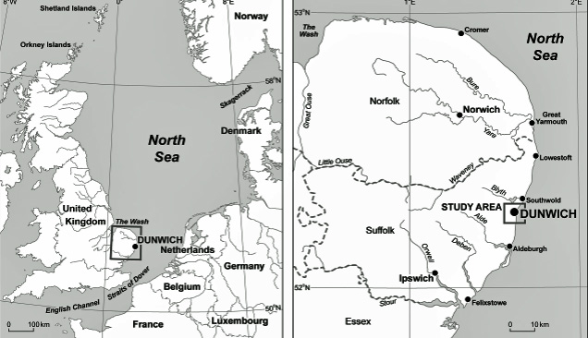
Fig. 1: Location map of Dunwich, East Anglia and its environs (Sear, et al 2013).

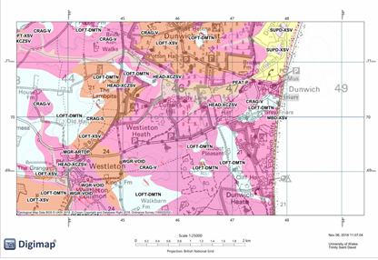
Fig. 2: Location & Geology of the region. Digimap, 2018.
SUPD-SXV: Sand and gravel –Uncertain age and origin
CRAG –V: Gravel
PEAT-P: Peat
LOFT-DMTN: Lowestoft formation - Diamicton
LOFT-XSV: Lowestoft formation – sand and gravel
MBD-XSV: Marine beach deposits – sand and gravel
HEAD-XCZSV: Head – Clay, Silt, sand and gravel
MRG-ARTDP: Artificial deposit
WRG-VOID: Worked ground

3.0 Key Words
- Dunwich
- Climate Change
- Sea Level Rise (SLR)
- Methane
- Erosion
- Demographic Impact

4.0 Aims
- To investigate the effect of coastal erosion over 2000 years along the East Anglian coastline using Dunwich as a case study.
- To identify the extent of the erosion on the East Anglian coastline and Dunwich.

5.0 Objectives
- To identify a specific area along the East Anglian coast to demonstrate the effects of coastal erosion.
- To explore the main causes of coastal erosion

6.0 Introduction
This report spans a chronology of two thousand years, from the end of the Roman period, through to contemporary times, with a view to the future, in the conclusion, looking at the effect of erosion from global warming on the British coastal region at along the East Anglian Coast with a specific view of the degradation of Dunwich, famous as a harbour for Henry VIII’s fleet. The data sets used in this report are:

- Sea level rise (SLR)
- Storminess (Sea Surge)

The report applies climatic and sea level information supplied by the Meteorological Office and other departments, listed throughout this report, in relation to the subject location. Dunwich is representative of massive coastal transgression with data taken from maps, (where maps are unavailable, documentation is studied), to view the coastal structural changes at the loci, over time, for example, coastal cliff collapse (Mortimore and Duperret 2004). The East Anglian example shows how the effect of sea level rise, and, storminess dynamics, affected these loci, its coastal environs, and, what erosion effect(s) can be expected in the future. Dunwich, was once a thriving, important city, a brief ethnological view is taken, looking at the causes of displacement, other than climate change, through economic factors, and disease.

7.0 Methodology
The first data set, sea level rise, as Gillman (2009) explains, is linked to the anthropogenic effect; that is, human intervention in the climate. As human activity has generated pollution dynamics from the biosphere (where all inhabitant components live on the Earth’s surface), this has caused an effect in the atmosphere (a gaseous component above the biosphere) which then resulted in the heating of the hydrosphere (the oceans), causing expansion, the consequence being eustatic adjustment. With biosolid pollution in the atmosphere, namely carbon dioxide (CO₂) and methane (CH₄), the greenhouse gasses, the planet is heating up and causing the ice sheets to melt. Therefore, there is more liquid water in the oceans and, with these two dynamics at work, the sea levels are rising around the globe. As Brown and Leonard (2004) inform us, ‘Global warming results when gases in the atmosphere are able to retain heat that is radiated from the surface of the earth as infrared light. The light is absorbed as energy and gradually released.’ Methane is the greater threat since, its absorption rate is twenty three times greater that CO₂. Carbon and Methane are released differently into the atmosphere. The carbon cycle can be divided in to two categories:

- CO₂ is released naturally by inhabitants through aerobic respiration after eating carbon rich foods. This is absorbed by plants through photosynthesis.
- Industry releases CO₂ into the atmosphere by burning fossil fuels and nuclear testing.

The natural fixed level of CO₂ in the atmosphere and biosphere is absorbed by plants during the process of photosynthesis. Since the 1950s, the balance has changed with a greater release of CO₂ into the atmosphere and through deforestation, photosynthesis absorption has reduced significantly. Warrick and Oerlemans (1990) found little evidence that SLR had a substantial effect during the twentieth century. Nicholls and Cazenave (2010), however, state that the Intergovernmental Panel on Climate Change (IPCC) predicts that SLR will rise by sixty centimetres by 2100, however, due to rapid ice sheet melt this figure is more likely to rise to one metre, affecting coastal communities world-wide at an elevation below ten metres. SLR was stable up until the late nineteenth century, as the Meteorological Office (2017) historic/projection tide gauge measurements show (Fig.3), however up to 1950 a rate 1.7mm a year has resulted in a 1.7metre rise. Further recent measurements show an increase to 3.3mm per-annum. See Fig.4, for observed and predicted SLR measurements.

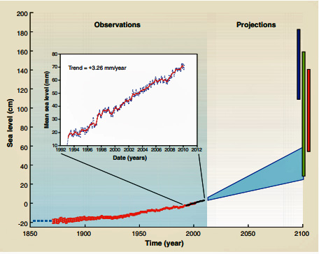
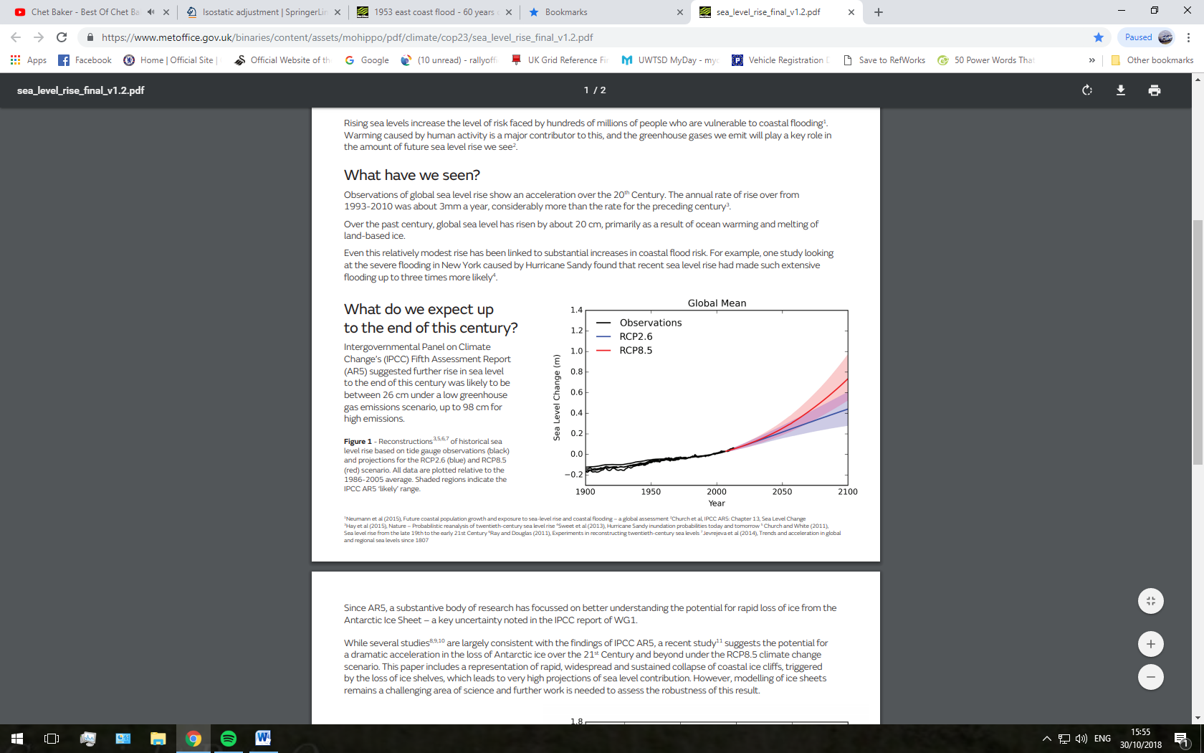
Fig. 4: Nicholls and Cazenave 2010
Fig.3: Met Office historic/projection of SLR (2017)
Methane emissions are caused through:

- The primary natural source of methane release from wetlands.
- Anthropogenic discharge originates mainly from gas drilling, rice paddy fields, enteric emissions, mining fossil fuels and disposal of solid wastes.

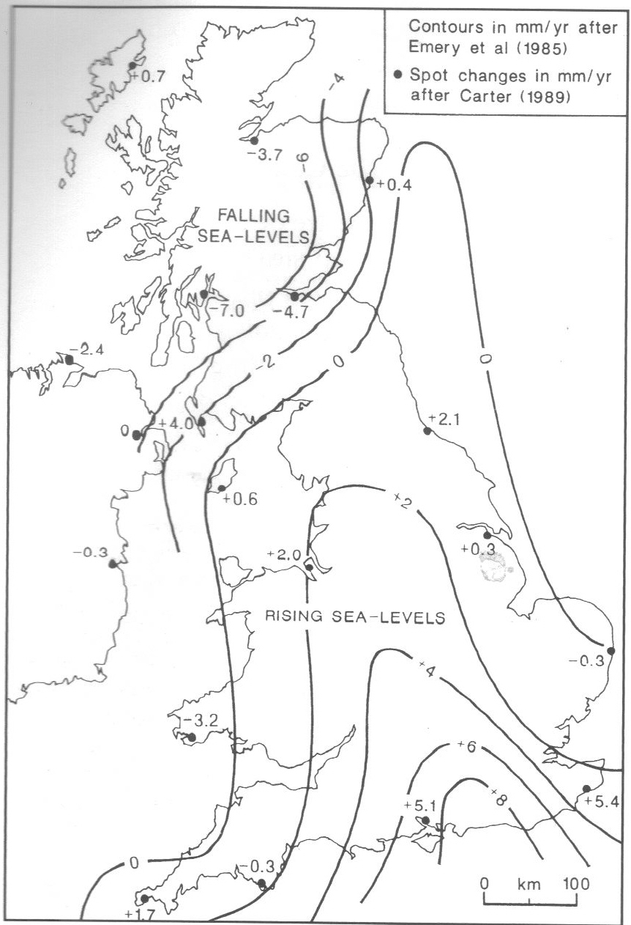
Sea level rise, and fall, can be caused by the isostatic effect when ice caps melt, the land below rises which has the result of lowering sea levels around the coast. The opposite effect happens when the weight on one edge of a tectonic plate reduces the other edge sinks which results in the lowering of the coast and therefore sea level rise occurs. Cracknell (2005, p.4) gives an account of this isostatic effect, and displays a map showing the effect on SLR around the United Kingdom (Fig.5). It is important to note that, Sea Level is accounted for in two ways: a) relative to the coast line being studied; b) absolute sea level distance is taken from the centre of the Earth. NOAA, (2018) explains, that the surface of the Earth’s oceans, are not flat and sea levels change with variability. Daily short term variations in sea level include tides, waves, specific flooding events such as ice melt and storms. Longer variations can be attributed to long term SLR, repeatable cycles, gradual trends or intermittent anomalies. While, anthropogenic dynamics influence sea levels through dredging, along with seasonal weather patterns, differences in the Earth’s declination, vertical land movement, coastal and ocean circulations and the El Niño effect. These are just a few of the influences that effect sea level over time.
Fig. 5: Cracknell, 2005.

The second data set, storminess, deals with ‘storm surges’ which occur when violent weather causes an increase in sea levels. The rotation of the Earth combined with low atmospheric pressure and gale force winds create conditions where the SLR can reach heights of three metres around the British coastline, resulting in breaching sea defences causing severe flooding. These storm surges can last for a few hours or even days spanning large areas for hundreds of kilometres. The ‘National Tidal and Sea Level Facility’ (NTSLF) (National Oceanography Centre, 2018) was established in 1953 after violent storms in the North Sea resulted in catastrophic flooding along the British east coast, especially East Anglia and the Thames Valley (Met Office, 2016). This department is based at the National Oceanography Centre (NOC) in Liverpool and monitors contemporary sea levels and future storm surges; they also keep archival documentation of such events although this data only goes back to 2004. These storm surges can be hard to predict, even hours, before they make landfall. The NOC has developed software that can model and predict the occurrence of the next storm surge using super computers (See Fig. 6) at the Met Office, for the Environment Agency, an early warning system for low-lying coastal regions of the United Kingdom.
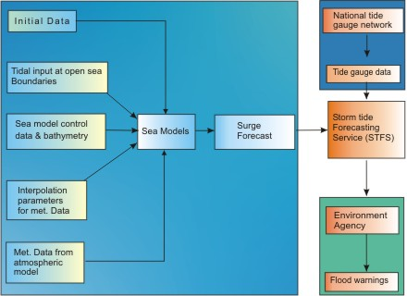
Fig. 6: National Oceanography Centre – National Tidal and Sea Level Facility (2018)
The information gathered to create the above computer generated model comes from The UK National Tide Gauge Network with stations all around the United Kingdom. The data gathered relates to SLR and Storm Surge and is measured from by using the Ordnance Datum reading at Newlyn Tidal Observatory. The data gathered for this benchmark height was obtained by using a ‘water level staff’ with observations taken every fifteen minutes, twenty four hours a day, for six years, from 1915 to 1921. For the history of Newlyn Tidal Observatory, see Bradshaw et al (2016).

A conclusion will be reached through an investigation on how sea level rise and storminess effect, through change, the coastline around East Anglia and specifically the historic coastal town of Dunwich and its ethnology. In order to achieve this, reference to documentation over the past two thousand years, including historic maps (where standard cartographic procedures were followed (Longley, et al 2001)), and bathymetry readings, since 1870, will be used to follow a pattern of sea level rise. Likewise, storminess records having been passed down through history, from Roman times, and, over the past few centuries, a greater accuracy of recording has been logged by the Metrological Office. This evidence, however, circumstantial in many early cases, has been used to calculate the results. An understanding of how gradual sea level rise has inundated the land over time, alluvial sediments deposited and degraded from tide and storm, and the effect of climate change will be investigated.

The coastal town of Dunwich (Dunwich, 2018), Suffolk lies along the east coast of England centrally between the towns of Southwold to the north and Aldeburgh to the south. Much of the old town has been obliterated since the thirteenth century, from sea level rise and storm surges blown in from the North Sea. The submerged ruins, known as Britain’s Atlantis (BBC, 2013), which lie some ten metres (32 feet) below the surface, have recently been researched by the University of Southampton (Sears, et al, 2011) by using acoustic imaging systems to see through the turbid water. In order to understand, retrospectively, the effect the North Sea had on the town, and the surrounding region, it is necessary to investigate Sea Level Rise and Storm Surges since the first century AD followed by results of the impact on the coastline, according to Cracknell (2005). The record will attempt to prove whether sea level rise has been of steady growth, or, of a rapid progression, and, storminess, whether it degraded large areas of land through flooding and devastation, or created sand and gravel banks which protected the coastline. In order to understand the methodology of how SLR and Storminess affect the region, knowledge of the geology (Fig.2 and 7) of the region is required. Dunwich stands on Pilo-Pliestocene sands and gravels of the Norwich Crag and Westleton beds which contain clasts of gritstone and granite. Transgression by marine fluvial dynamics have formed a hollowed valley and an earlier estuary north of Dunwich, now full of sediment, closed off a spit and a barrier beach south of Walberswick, Flowing north to the Walberswich marshes, the River Dunwich converges with the River Blythe at Walberswick harbour and flows into the North Sea.
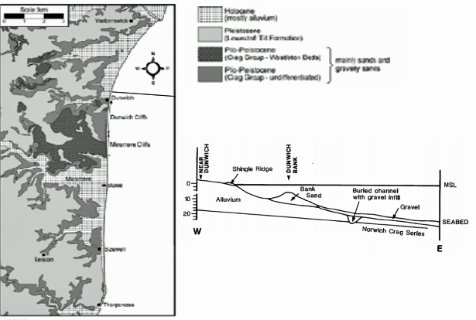
Fig.7. Sear (2009)
7.1 Sea Level Rise (fall) and Storminess
Figure 10 (Sear, 2011) shows the extent of gradual coastline recession since the eleventh century and this information is used to assist with the calculation of sea level rise. Recorded below are the notable chronologies of such regressions (or build-up of alluvial deposits), and, the effect on Dunwich and its environs. The results data below is taken largely from Sear, (2011) and the Dunwich website (2018); where information is taken from other sources, a reference will be made in the text. The data sets investigated are listed in the table below with the various comparisons, many of which are subtle yet, with differing effects.
Data Sets showing the dichotomy between Sea Level Rise and Storminess
Data Set One | DATA SETS | Data Set Two
Gradual rise of oceans due to Eustatic and Isostatic effects, expansion. Low effect from weather. | Compare & Contrast | Global warming affects climatic conditions. Low atmospheric pressure gale force winds, heavy rain and Earth’s Axis spin. Violent storms.
Coastline transgression inland – over time. |  | Coastline transgression inland –instant nuisance flooding.
Alluvial depositing or slow degradation. |  | Alluvial Depositing and violent degradation.
Consuming of landmarks and habitation long term flooding. |  | Breaching and destruction of sea defences damage to buildings and farmland.
Aquifer contamination. |  | Aquifer contamination.

The diagram below (Fig.8) reflects the dynamics of sea level rise through global warming.
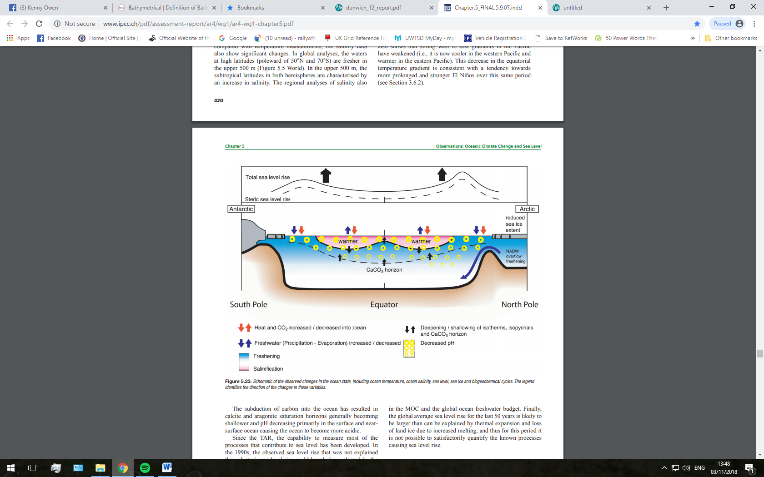
Fig. 8: A schematic drawing showing observed changes in the state of the ocean as observed by Bindoff and Willebrand (2007).

8.0 Results
By viewing the Dunwich website (Dunwich, 2018), there is a link to an Excel spreadsheet, titled, ‘Storms Dbase’ compiled by David Sear of Southampton University. This results spreadsheet covers a wide area on storm affected regions of the North Sea, including the east coast of England. It provides index values for 1) Affected Areas; 2) Damage Severity; 3) Population Affected; 4) Storm Wind Speed; 5) Storm Duration. Only the most notable chronographic information has been included below where damage to the coastline and land transgression occurred; Sears’ records have been included in the appendix due to exceeding the word count.

8.1 First Century AD to 800AD
Although no evidence has yet been found, it is believed that Dunwich was once a Roman fort, and later, a Saxon settlement (Fig.11). Cracknell (2005, p.55-59) explains how in contrast to Dunwich, the opposite of land transgression occurred, further north, the coast had silted-up during Roman times. The debouchment of the rivers Yare and Bure flowed directly in to the North Sea. Today, this is cut-off by alluvial flats. Brancaster Roman Fort was believed to have been situated on the coast; today, it is land locked (Fig.9).
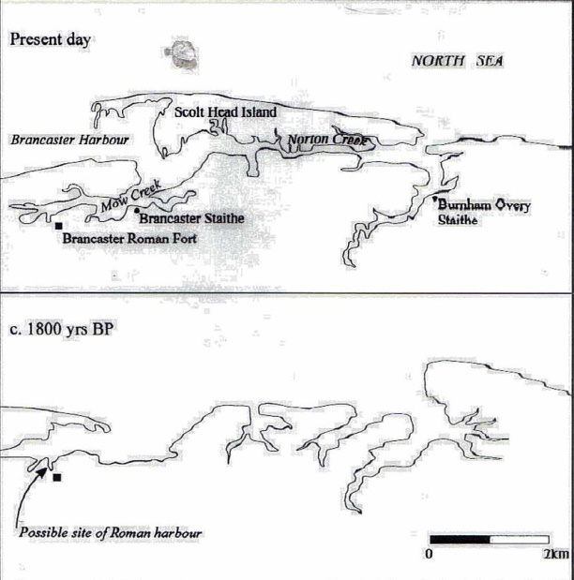
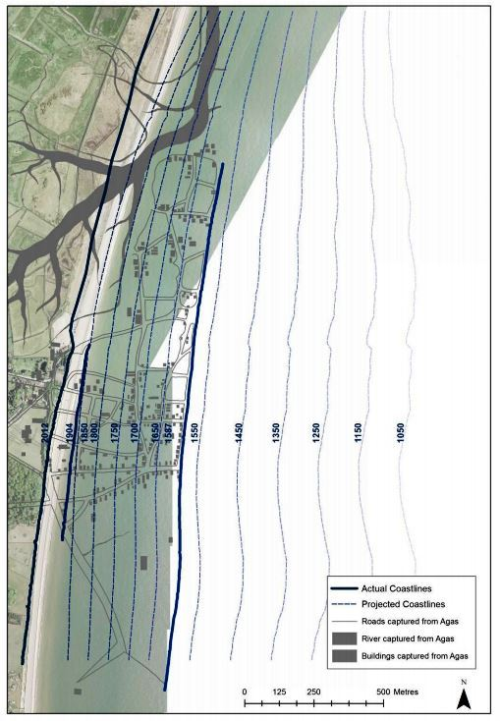
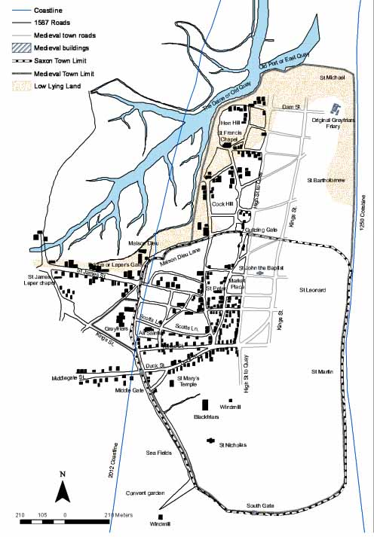
8.2 Eleventh Century
Fig.9: Brancaster Roman Fort location change (Cracknell, 2005).
Fig.10: Coastline regression since the eleventh century.
(Sear, et al, 2013)
Fig.11:
Reconstruction of Dunwich, showing Saxon settlement and sea
transgression at 1250AD.
(Sear, 2013).
According to the Doomsday book, Dunwich was the tenth largest community in Britain; its economy based largely on sea trade and fishing. Before sea erosion took hold at Dunwich, the people of the town had a larger problem, of keeping the harbour free from silting (Fig.12). Also recorded in the Doomsday book, however, was the loss of over half the taxable farmland to sea between 1066 and 1086. This suggests that alluvial silting occurred at Dunwich while its environs were affected from flooding.

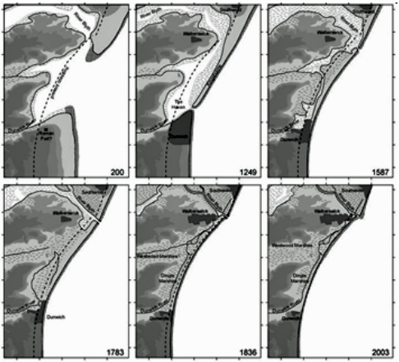
8.3 Thirteenth Century
Fig.12: Coastline evolution at Dunwich from 200AD – 2003AD (Sear, et al, 2009)
Dunwich covered an area of around eight hundred acres and contained eighteen places of worship, a mint and a Guildhall during this period. Today, only two ecclesiastical buildings remain due to sea regression (See appendix).

8.4 Fourteenth Century
Between 1328 and 1347 major storm damage occurred destroying around four hundred buildings on the low lying coastline of Dunwich. During this period the churches of St Martin (c1340) and St. Leonard (c1320) were overwhelmed by the sea and lost beneath the waves. St. Nicholas and St. Katherine’s churches were now under threat and by 1350, St. Katherine’s was lost (See appendix).

8.5 Fifteenth Century
By 1450 the sea continued its devastating regression inland and in 1420 consumed St. Nicholas church (See appendix).
8.6 Sixteenth Century
St. John’s Church was destroyed in 1540 along with the city’s Guildhall by 1587. At this point around half of the habitation had been lost to the North Sea from sea level rise and storms.

8.7 Seventeenth Century
No written information on damage.

8.8 Eighteenth Century
No written information of damage.

8.9 Nineteenth Century
No written information of damage.

8.10 Twentieth Century
The Meteorological Office (2016; Pritchard, 2013) reported, one of the worst disasters in living memory; it happened on 31st January/1st February, 1953 along the east coast of Britain (Pritchard, 2013; Met Office, 2016). Over three hundred souls lost their lives to the North Sea. It is taken for granted, in the twenty-first century, that prior warning of storms, form the Met Office, will be aired over the media well in advance of any danger; this wasn’t the case in 1953. Flood defences are now in place protecting the vulnerable regions around the British coastline protecting them from erosion. In 1953, however, this was not the case. On Saturday 31st January a low depression hanging over Iceland had moved south, showing a tight gradient pattern (Fig. 13) and moved over the west of Britain; those living in the south east had no idea an impending storm was approaching. Few houses had television and BBC radio only had irregular weather reports from only three channels. The Met Office had no formal arrangement to warn of weather surges around Britain in 1953. It was estimated that a swell in excess of ten metres, caused by the depression, brought the severe sea surge which caused the damage to the east coast with Dunwich badly affected (Fig. 14).

Pritchard (2013, p.31) reports, ‘at Dunwich (Suffolk), a 91 year-old invalid refused to be moved from a downstairs room of a school house – until the sea reached the level of her bed, at which point two Special Constables forced their way into her room through the window (having been unable to open the door because of the force of the water), and carried her to the relative safety of an upstairs room.’

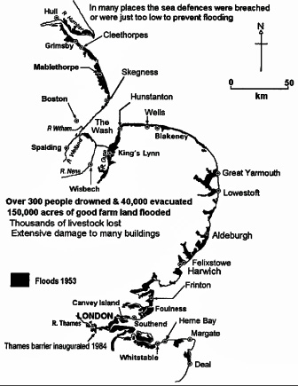
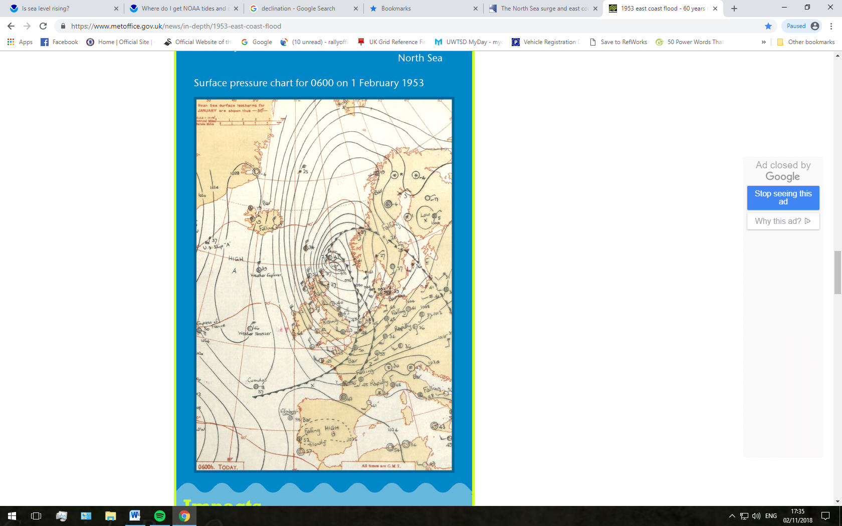
8.11 Twenty-first Century
Fig. 14: South east coast of England showing flooding from sea surge in 1953. (Prichard, 2013).
Dunwich
Fig. 13: Surface pressure chart for 1st February 1953. (Met Office, 2016).
The palimpsest (Figs.15 & 16) has been digitised, laying historical maps over a modern aerial photograph taken in 2006, which, shows the North Sea progression inland and the original location of the churches and Guildhall mentioned above. It also depicts the ancient streets where the populous lived from the fourteenth century to contemporary times and the submerged estuary of the River Dunwich which can be seen to the north.

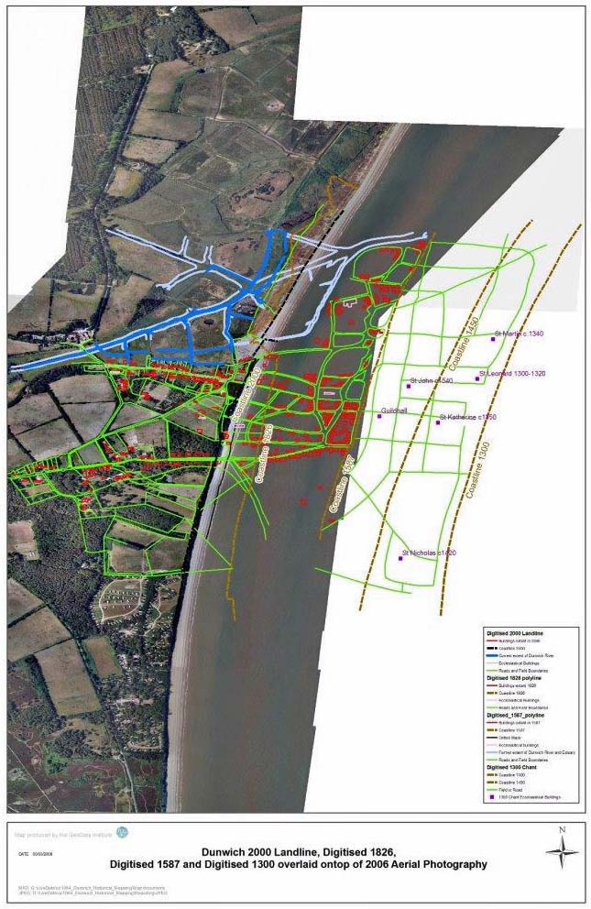
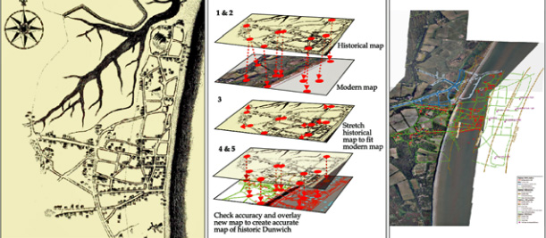
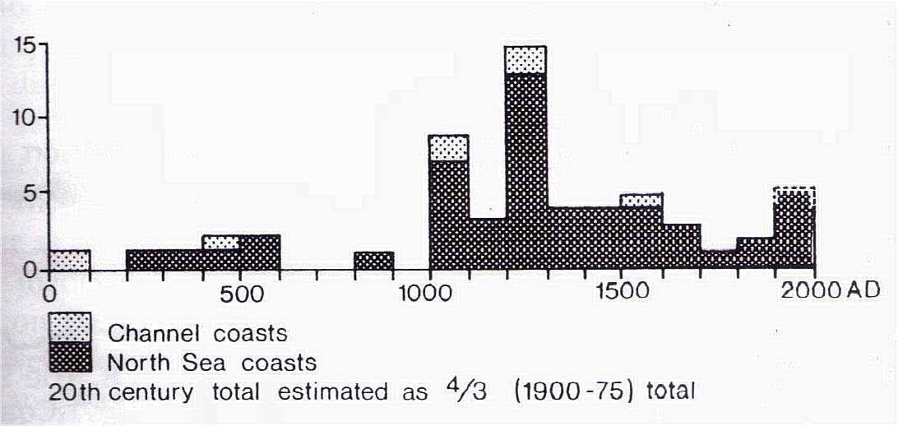
8.12 Graphic Interpretation of the Results
Fig. 15: (Dunwich, 2018).
Fig.16: Geo-rectifying historic map process. (Sear et al, 2009).
Fig.17: Cracknell, 2005.

The above graph (Fig.17) shows the effect of storminess and sea level rise over two thousand years, this study, by Professor Lamb which, is correlated with other information in Cracknell (2005).
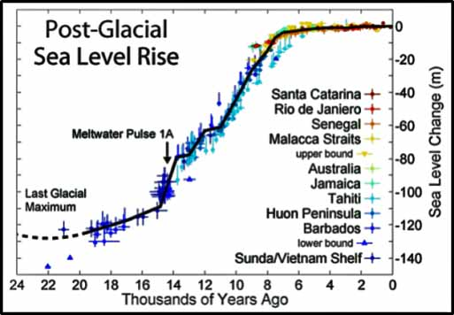
Fig.18: Wikimedia Commons, 2018
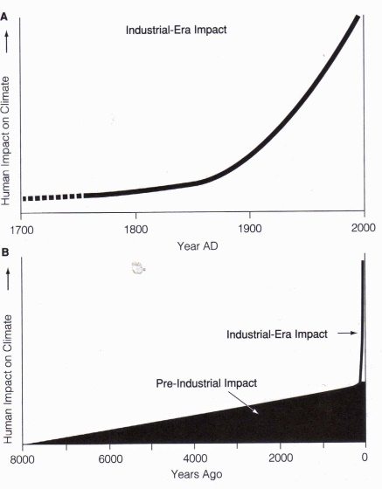
The above graph (Fig.18), depicting the southern hemisphere, shows a similar pattern to that of the northern hemisphere and, as can be seen here, rapid sea level rise is evident since the last glacial maximum, although, it is not clear where anthropogenic interference begins. Below are two graphs expanding on recent SLR events, explaining how anthropogenic dynamics have influenced climate change over time. Graph ‘A’ (Fig.19) reflects how anthropogenic dynamics have influenced climate change since the mid-seventeen hundreds. Graph ‘B’ shows a steady rise in global warming over time, and, highlighting the massive effect anthropological influence has had since the 1750s.
Fig.19: Ruddiman, 2005.
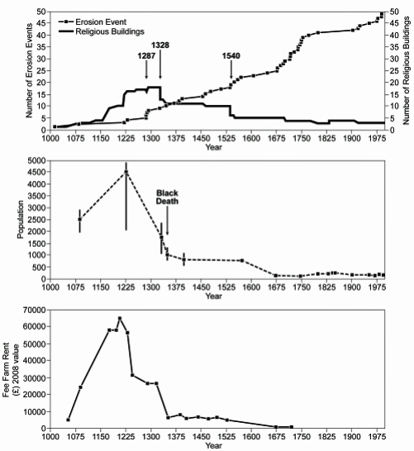
Fig.20. Sear, 2013.
A
B
C

Graph (Fig. 20), there are three indices; ‘A’: Religious buildings lost to the sea; ‘B’: An estimation of the displacement of the population of Dunwich through SLR and other factors;
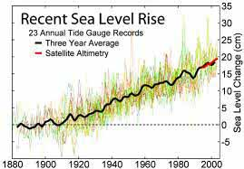
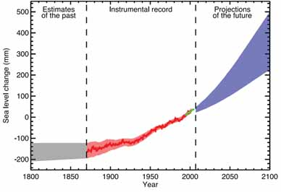
‘C’: Taxation which priced the population off the land.
Fig.21. Davies, 2013.
Fig.22. Bindoff and Willebrand, 2017.

The graph above (Fig.21) shows the increasing trend of SLR taken from bathymetry readings, however, the red band from around the 1990s shows reading conducted from satellite. Bindoff and Willebrand’s (Fig.22) data, although recorded a decade earlier and continues up to 2008, shows a similar set of results confirming SLR.

9.0 Discussion
This report set out to demonstrate the dichotomy between ‘sea level rise’ and ‘storminess’ and whether they became increasingly prevalent throughout the past two thousand years, or, was this, a more recent dynamic. Taking in to account East Anglia and specifically the historic city of Dunwich as a case study, an investigation into the reasons for sea level rise and storminess in this region was investigated. Cracknell (2005) presents a period of two thousand years of damage (Fig. 17) caused by storminess brought on by climate change. In contrast to Cracknell, Sears’ recordings above (Dunwich, 2018), show a different story, albeit showing a later chronology from the thirteenth century to more contemporary times, they show a lack of detail from 1426 to the twenty-first century stating ‘wind strength unknown’. Cracknell, however, shows that there was a heightened period of storminess from 200AD to 600AD; a period of calm from 600AD to 800AD; during the eleventh century, time of the Norman invasion, the storminess record increases significantly, especially from 1000AD to 1100AD, a less damaging period between 1100AD and 1200AD, then a large increase in storminess from1200AD to 1300AD; up until contemporary times, storminess shows a steady decline, however, increasing gradually, once again from the 1800s onwards, with an escalation during the twentieth century.

Cognitively, the information read from the graph in figure seventeen, shows a rapid rise in sea levels from the end of the last Glacial Maximum and tailing off from around eight and a half thousand years ago, at a time when the British Isles was becoming re-populated. The graph seems reasonably stable at two thousand years with a steady five metres rise in sea levels over this period. Compare this record to Ruddiman (2005, Fig. 19), and it seems he agrees with the data, showing, sea level rise since the first century AD was of steady growth, only accelerating, as Ruddiman supports in and around the Industrial Revolution in the mid-1750s, with a sharp peak from around the 1850s.

In the next graph (Fig.20) Sear (2013) alludes to three indices of reasoning behind population decline in Dunwich: A) Material loss from storminess and SLR; B) Plague; C) Land taxation. His first data documented relates to the destruction of ecclesiastical buildings transgressed by sea level rise and storminess. In graph ‘A’, there is a peak in the building of monuments from around 1150AD up to 1328AD when there were almost twenty places of worship. After 1328, a marked decline in building work can be plotted. In 1540 erosion events had taken a massive toll on religious buildings at Dunwich. By 2000, Dunwich has only three places of worship unaffected by SLR. In graph ‘B’ Sear alludes to the depopulation of Dunwich from disease and plague. Records start from around 1100AD showing a rapid rise in the population of Dunwich which stood at around 4,500, but, by 1225, there was a sharp decline, which may relate to SLR, as figs.10 and 11 depict. In 1346AD, the ‘Black Death’ took hold decimating the population of Dunwich further, and, by 1675, the demographic shows a population of under 500; this figure is close to the contemporary population. As graph ‘C’ shows, due to land loss, taxation was increased by the Crown, once again, forcing people from the land surrounding Dunwich and their economy imploded further reducing the population.

The final two graphs (Figs. 20 and 21), ‘Recent Sea Level Rise’ (Davies, 2013; Bindoff and Willebrand, 2017) shows SLR for the North Sea, recording a data set of twenty three annual tide bathymetry readings, steadily growing from around 1905, up until when, SLR remained relatively stable, to a twenty centimetre rise by 2000AD believed to be caused by anthropogenic dynamics (Ruddiman, 2005). Since 1990, recordings have been more accurately made from satellite altimetry as shown in red on the graph.

10.0 Conclusion
The above results show that climate change has seen a steady progression since the first century AD through natural processes and only escalated during the mid-1700s due to the Industrial Revolution. So, is climate change a product of anthropological dynamics or a natural progression since the last Glacial Maximum and does the above investigation show a clear dichotomy between the effects of SLR and storminess. Ruddiman (2005, p.5) confirms, that gas concentrations occurred during the centuries prior to the eighteenth century and that a subtle change is happening anyway; humans have just speeded up the process, a catalytic problem, maybe. Although this report has attempted to show decisive data, since the first century AD, concerning the effect of erosion from SLR and storminess on the East Anglia coastline, the information found from documentary evidence is patchy, if non-existent; when this data is updated, future investigation can be carried out. There is proven evidence from the data above, that climate change is affecting the coastline of East Anglia, Dunwich and its environs, and, that action to prevent climate change is necessary, if at all possible. There are two subtle dichotomies between the two data sets in that SLR is a gradual process, while storminess is a fast moving dynamic that causes change to the coastline instantly. Diagram (Fig.23) below shows the probable influx of sea water if new ways of defending the coastline are not found. Maybe the sentiment is to adapt to and not control the climate making flooding inevitable over the centuries to come.
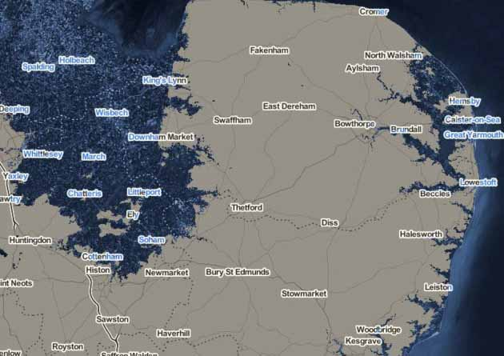
Fig.23: Semmens, 2015. Projection data of sea level rise caused by SLR and storminess.
Dunwich

11.0 References
Bindoff, N. L. and Willebrand, J., 2007. Observations: Oceanic Climate Change and Sea Level. [online] Available through: https://www.ipcc.ch/publications_and_data/ar4/wg1/en/ch5.html [Accessed: 3 November 2018] Fig.8, p.421.
Bindoff, N. L. and Willebrand, J., 2007. Observations: Oceanic Climate Change and Sea Level. [online] Available through: https://www.ipcc.ch/publications_and_data/ar4/wg1/en/ch5.html [Accessed: 3 November 2018] Fig.22, p.409.
Bradshaw, E., et al, 2016. A Century of Sea Level Measurements at Newlyn,
Southwest England. Marine Geodesy, [online] Vol.39(2) p.115-140. Available through: http://nora.nerc.ac.uk/id/eprint/512368/7/A%20Century%20of%20Sea%20Level%20Measurements%20at%20Newlyn%20Southwest%20England.pdf [Accessed: 30 October 2018].
Brown, S. and Leonard, P., 2004. Biosolids and Global Warming: Evaluating the Management Impacts. BioCycle, [online] Available at: https://www.biocycle.net/2004/08/15/biosolids-and-global-warming-evaluating-the-management-impacts/ [Accessed: 27 October 2018].
Cracknell, B. E., 2005. Outrageous Waves. Chichester: Phillimore and Company Limited.
Cracknell, B. E., 2005. Outrageous Waves. Chichester: Phillimore and Company Limited. Fig.5, p.5
Cracknell, B. E., 2005. Outrageous Waves. Chichester: Phillimore and Company Limited. Fig.17, p.11.
Cracknell, B. E., 2005. Outrageous Waves. Chichester: Phillimore and Company Limited. Fig.9, p.57.
Davies, B., 2013. Sea Level Rise Over the Next 2000 Years. [online] Available at: http://www.antarcticglaciers.org/2013/07/sea-level-rise-over-next-2000-years/ [Accessed: 4 November 2018]. Fig.21.
Ordnance Survey, 2018. University of Wales Trinity Saint David: Lampeter Campus, 1:25,000. EDINA Digimap [online] Available through: https://digimap.edina.ac.uk/roam/map/geology [Accessed: 6 November 2018]. Fig.2.
Dunwich Underwater Images Show 'Britain's Atlantis', 2018. BBC News, [online] Available at: https://www.bbc.co.uk/news/uk-england-suffolk-22482097 [Accessed: 30 October 2018].
Dunwich, 2018. Dunwich: The Search for Britain’s Atlantis, [online] Available at: http://www.dunwich.org.uk/ [Accessed: 30 October 2018].
Dunwich, 2018. Dunwich: The Search for Britain’s Atlantis, [online] Available at: http://www.dunwich.org.uk/ [Accessed: 30 October 2018] Fig.15.
Longley, P. et al, 2001. Geographic Information Systems and Science. ed2. Chichester: John Wiley and Sons Limited.
Met Office, 2016. 1953 east coast flood - 60 years on, [online] Available at: https://www.metoffice.gov.uk/news/in-depth/1953-east-coast-flood. [Accessed: 28 October 2018].
Met Office, 2016. 1953 East Coast Flood – 60 Years On. [online] Available at: https://www.metoffice.gov.uk/news/in-depth/1953-east-coast-flood [Accessed: 31 October 2018].
Met Office, 2016. 1953 East Coast Flood – 60 Years On. [online] Available at: https://www.metoffice.gov.uk/news/in-depth/1953-east-coast-flood [Accessed: 31 October 2018] Fig: 13.
Met Office, 2017. Sea Level Rise. [online] Available at: https://www.metoffice.gov.uk/binaries/content/assets/mohippo/pdf/climate/cop23/sea_level_rise_final_v1.2.pdf [Accessed: 30 October 2018] Fig.3.
Mortimore, R.N. and Duperret, A. ed., 2004. Coastal Chalk Cliff Instability. Bath: The Geological Society.
National Oceanography Centre, 2018. National Tidal and Sea Level Facility, [online] Available at: https://www.ntslf.org/ [Accessed: 28 October 2018] Fig.6.
Nicholls, R.J. and Cazenave, A., 2010. Sea-level Rise and Its Impact on Coastal Zones. Science, [online] Vol.328 p.1517-1520. Available through: http://www.webpages.uidaho.edu/envs501/downloads/Nicholls%20%26%20Cazenave%202010.pdf [Accessed: 28 October 2018], Fig.4.
NOAA, 2018. Tides and Currents. [online] Available at: https://tidesandcurrents.noaa.gov/sltrends/faq.shtml#q1 [Accessed: 2 November 2018].
Pritchard, B., 2013. The North Sea Surge and East Coast Floods of 1953. [online] Available at: https://rmets.onlinelibrary.wiley.com/doi/pdf/10.1002/wea.2044 [Accessed: 31 October 2018].
Prichard, B., 2013. The North Sea Surge and East Coast Floods of 1953. [online] Available at: https://rmets.onlinelibrary.wiley.com/doi/pdf/10.1002/wea.2044 [Accessed: 31 October 2018] Fig.14, p33.
Ruddiman, W. F., 2005. Plows, Plagues and Petroleum: How Humans Took Control of Climate. Princeton University Press: Princeton and Oxford.
Ruddiman, W. F., 2005. Plows, Plagues and Petroleum: How Humans Took Control of Climate. Princeton University Press: Princeton and Oxford. Fig.19, p.6.
Sear, D., et al, 2009. Dunwich 2008 Project Report. [online] Available at: http://www.dunwich.org.uk/resources/documents/dunwich_08_report.pdf [Accessed: 31 October 2018] Fig.7, p5.
Sear, D., et al, 2009. Dunwich 2008 Project Report. [online] Available at: http://www.dunwich.org.uk/resources/documents/dunwich_08_report.pdf [Accessed: 31 October 2018] Fig.12, p13.
Sear, D., et al, 2009. Dunwich 2008 Project Report. [online] Available at: http://www.dunwich.org.uk/resources/documents/dunwich_08_report.pdf [Accessed: 31 October 2018] Fig.16, p24.
Sear, D., et al, 2013. 5883 Dunwich, Suffolk:Mapping and Assessing the Inundated
Medieval Town. [online] Revised 2013, Version 1.3. Available at: http://www.dunwich.org.uk/resources/documents/dunwich_12_report.pdf [Accessed: 31 October 2018].
Sear, D., et al, 2013. 5883 Dunwich, Suffolk:Mapping and Assessing the Inundated
Medieval Town. [online] Revised 2013, Version 1.3. Available at: http://www.dunwich.org.uk/resources/documents/dunwich_12_report.pdf [Accessed: 31 October 2018] Fig.1, p.19.
Sear, D., et al, 2013. 5883 Dunwich, Suffolk:Mapping and assessing the inundated
medieval town. [online] Revised 2013, Version 1.3. Available at: http://www.dunwich.org.uk/resources/documents/dunwich_12_report.pdf [Accessed: 31 October 2018] Fig.10, p.97.
Sear, D., et al, 2013. 5883 Dunwich, Suffolk:Mapping and Assessing the Inundated
Medieval Town. [online] Revised 2013, Version 1.3. Available at: http://www.dunwich.org.uk/resources/documents/dunwich_12_report.pdf [Accessed: 31 October 2018] Fig.11, p118.
Sear, D., et al, 2013. 5883 Dunwich, Suffolk:Mapping and Assessing the Inundated
Medieval Town. [online] Revised 2013, Version 1.3. Available at: http://www.dunwich.org.uk/resources/documents/dunwich_12_report.pdf [Accessed: 31 October 2018] Fig.20, p17.
Semmens, A., 2015. How Rising Sea Levels Could Change the Shape of East Anglia. [online] Available at: http://www.lowestoftjournal.co.uk/news/how-rising-sea-levels-could-change-the-shape-of-east-anglia-1-4331614 [Accessed: 4 November 2018].Fig.23.
Warrick, R. and Oerlemans, J., 1990. Sea Level Rise. Climate Change - The IPCC Scientific Assessment, p.257-281 [online] Available through: https://dspace.library.uu.nl/handle/1874/22121 [Accessed: 28 October 2018].
Wikimedia Commons, 2018. Post-Glacial Sea Level. [online] Available at: https://commons.wikimedia.org/wiki/File:Post-Glacial_Sea_Level.png [Accessed: 4 November 2018] Fig.18.

12.0 Appendix

English Heritage
6th Floor
100 Wood Street
London
EC2V 7AN

Environment Agency
Freedom of Information (FOI) and Environmental Information Regulations (EIR) requests
PO Box 544
Rotherham
S60 1BY
United Kingdom

Meteorological Office
Met Office
Fitzroy Road
Exeter
Devon
EX1 3PB
United Kingdom

National Oceanography Centre
National Oceanography Centre
European Way
Southampton
SO14 3ZH
United Kingdom

National Oceanography Centre
Joseph Proudman Building
6 Brownlow Street
Liverpool
L3 5DA
United Kingdom

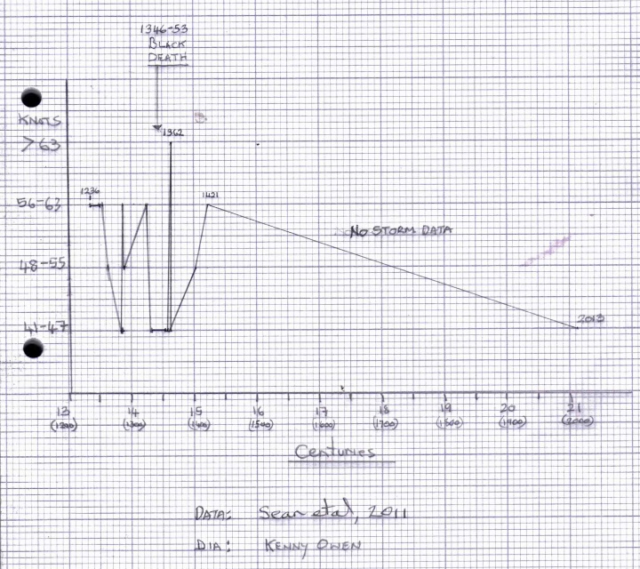
The above graph coincides with the data that Cracknell (Fig.16) shows for the ‘same period’ except verification of actual coastline damage cannot be verified here.

8.0 Information – Sears’ Results

Thirteenth Century
Sears’ recording:
c1236: Regional storm; damaged many towns; wind strength 56-63 knots.
c1250: International storm; damage to towns and coastline; wind strength 56-63 knots.
c1253: Regional storm; damage to towns and coastline; wind strength 56-63 knots.
c1262: International storm; damage to towns and coastline; wind strength 48-55 knots.
c1285: International storm; damage to towns and coastline; wind strength unknown.
c1286: Regional storm; damage to towns and coastline; wind strength 41-47 knots.
c1286: Regional storm; damage to towns and coastline; wind strength 41-47 knots.
c1287: Regional storm; damage to towns and coastline; wind strength unknown.
c1287: International storm; major loss of towns and coastline change; wind strength 56-63 knots.
c1288: International storm; major loss of towns and coastline; wind strength 48-55 knots.

Fourteenth Century
Sears’ recordings:
c1328: National storm; damage to towns and some coastline; wind strength 56-63 knots.
c1334: International storm; major loss of towns and coastline change; wind strength 41-47 knots.
c1344: National storm; damage to towns and some coastline; wind strength unknown.
c1355: Regional storm; damage to towns and some coastline; wind strength 41-47 knots.
c1357: International storm; damage to towns and some coastline; wind strength 41-47 knots.
c1362: International storm; major loss of towns and coastline change; wind strength >63 knots.
c1364: Regional storm; damage to some towns and coastline; wind strength 41-47 knots.

Fifteenth Century
Sears’ recordings:
c1404: International storm; damage to towns and some coastline; wind strength 48-55 knots.
c1421: International storm; damage to towns and some coastline; wind strength 56-63 knots.
c1426: International storm; damage to towns and some coastline; wind strength unknown.
c1455: National storm; damage to towns and some coastline; wind strength unknown.
c1464: International storm; damage to towns and some coastline; wind strength unknown.

Sixteenth Century
Sears’ recordings:
c1526: International storm; damage to towns and some coastline; wind strength unknown.
c1530: International storm; major loss of towns and coastline change; wind strength unknown.
c1552: International storm; damage to towns and some coastline; wind strength unknown.
c1560: Local storm; damage to towns and some coastline; wind strength unknown.
c1570: International storm; major loss of towns and coastline change; wind strength unknown.
c1570: International storm; damage to towns and some coastline; wind strength unknown.

Seventeenth Century
Sears’ recordings:
c1601: International storm; damage to towns and some coastline; wind strength unknown.
c1617: Local storm; damage to towns and some coastline; wind strength unknown.
c1625: International storm; damage to towns and some coastline; wind strength unknown.
c1662: International storm; damage to towns and some coastline; wind strength unknown.
c1665: International storm; damage to towns and some coastline; wind strength unknown.
c1671: International storm; damage to towns and some coastline; wind strength unknown.
c1695: International storm; damage to towns and some coastline; wind strength unknown.

Eighteenth Century
Sears’ recordings:
c1717: International storm; damage to towns and some coastline; wind strength unknown.
c1720: National storm; damage to towns and some coastline; wind strength unknown.
c1740: International storm; damage to towns and some coastline; wind strength unknown.
c1741: International storm; damage to towns and some coastline; wind strength unknown.
c1751: International storm; damage to towns and some coastline; wind strength unknown.
c1756: International storm; damage to towns and some coastline; wind strength unknown.
c1791: International storm; damage to towns and some coastline; wind strength unknown.
c1792: International storm; damage to towns and some coastline; wind strength unknown.

Nineteenth Century
Sears’ recordings:
c1825: International storm; damage to towns and some coastline; wind strength unknown.
c1855: International storm; damage to towns and some coastline; wind strength unknown.
c1862: International storm; damage to towns and some coastline; wind strength unknown.
c1897: International storm; damage to towns and some coastline; wind strength unknown.

Twentieth Century
Sears’ recordings:
c1916: International storm; damage to towns and some coastline; wind strength unknown.
c1938: International storm; damage to towns and some coastline; wind strength unknown.
c1953: International storm; major loss of towns and coastline change; wind strength unknown.
c1962: International storm; damage to towns and some coastline; wind strength unknown.
c1973: International storm; damage to towns and some coastline; wind strength unknown.
c1976: International storm; damage to towns and some coastline; wind strength unknown.
c1978: International storm; damage to towns and some coastline; wind strength unknown.
c1979: National storm; damage to towns and some coastline; wind strength unknown.
c1983: International storm; damage to towns and some coastline; wind strength unknown.
c1987: International storm; damage to towns and some coastline; wind strength unknown.

Twenty-first Century
Sears’ recordings:
c2013: International storm; damage to towns and some coastline; wind strength 41-47 knots.

SELF-REFLECTION SHEET.

PLEASE COMPLETE BEFORE SUBMISSION AND ATTACH TO YOUR WORK

Date:12th November 2018 Module: Interrogating the Data Name: Kenny Owen

Guidance: You might consider the following elements:

- Argument: does it have one/ is it backed by sufficient evidence/ how lucid is it?
- Structure: how clear is it /is my essay easy to follow/ does it help my argument?
- Analysis: is more/less analytical than narrative/ does it address the question?
- Reading: was this sufficiently broad/ have I referenced properly?
- How might I improve my performance in future?

Strengths:

Enthusiasm:

Weaknesses:

General Comments:

Please give a mark for your work:

(for eg: 1st = 70+: 2/1 = 69-60: 2/2 = 59-50: 3rd = 45-49: pass = 40-44: fail = 39- )

