When will advertising embrace diversity, gender and race equality, and start reflecting the real world? Critically discuss and respond.

Advertisements that embrace diversity can be construed as cynical, or do they imply that advertisers are striving to play a more positive role in society? It is debatable whether diversity, gender and race equality is completely encompassed by the advertising industry as in recent years, we continue to see undertones of offensive material and questionable marketing tactics. Evidentially, we as a society have become more aware of the social problems targeted towards minorities as “representation was no longer one tool among many, it was the key” (Klein, 2010, p. 108). In light of this, we could come to the concept that it may be used to the advantage of the company in an immoral manner in order to gain a competitive advantage. It is inexcusable to use racism, sexism, ableism, homophobia, or any other form of discrimination against a minority as part of a marketing approach that is intended to generate controversy and therefore attention.

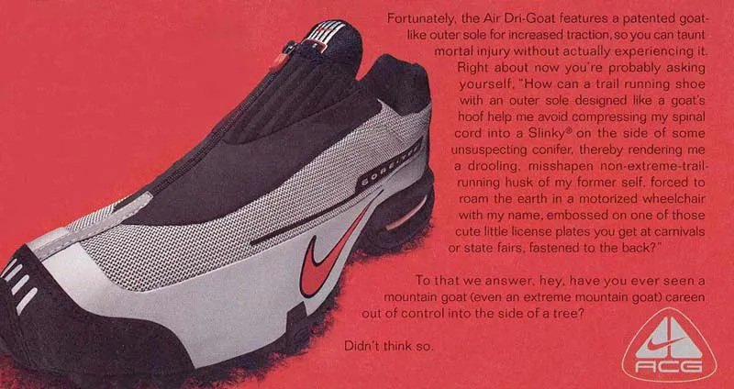
There is no argument against the fact that ableist content is wildly inappropriate in today’s age where our morals, awareness and understanding of each other has grown with society. Although, as we look at the past, advertising has not displayed the same diverse qualities, as exhibited through Nike’s 2000 withdrawn print advertisement for a new Air-Dri Goat trail running shoe, explicitly
(Nike ad, 2012)
promising that their shoes would not paralyze you. Initially, this is not a promise they can keep therefore feeding inaccurate information to the viewer, primarily, the offensive and insensitive paragraph alongside the advertised shoe stating it would prevent “a drooling, misshapen non-extreme-trail-running husk of my former self, forced to roam the earth in a motorized wheelchair with my name, embossed on one of those cute little license plates you get at carnivals or state fair, fastened to the back”. This statement is in the least patronising to those who are not able-bodied, specifically the “cute little license plates” of which is an extremely condescending manner to characterise people who suffer debilitating injuries. Considering that according to UK research, “9% of children are disabled”, “21% of working age adults are disabled” and “42% of pension age adults are disabled” (Family Resources Survey, 2022), it still leaves a higher percentage of able-bodied people in the UK, therefore the opposing argument that this advert would work is that businesses are led to where the money is and with the able-bodied being Nike’s main target audience for this product, if they advertised purely towards the disabled they would lose a large market, nevertheless there is absolutely no need to discriminate the exception of the target audience at the cost of the able-bodied to an outrageous standard through the statement.

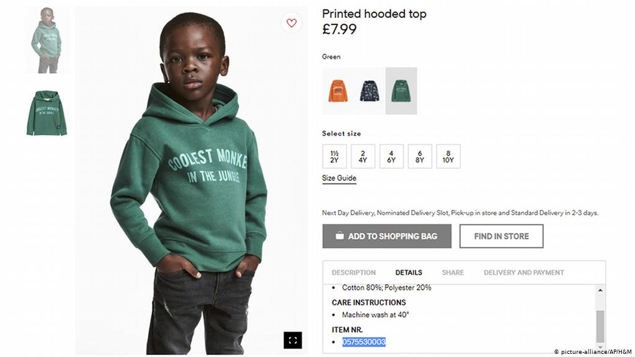
Do these companies think at all before publicising offensive material? H&M’s 2008 advert featuring a black boy wearing a hoodie written ‘Coolest Monkey in the Jungle’ would initially seem innocent enough for a young boy, although this imagery historically holds seriously racist connotations and undertones. The highly racist association of black people denigrated as simians believes to be dating back to the evolution aesthetic differences between whites and blacks from apes and the history of slavery resulting in the objectifying, “cross-cutting concept is that of dehumanization, seen as an instrument of racism that has often involved animalization” (Pisano, 2017, p. 63). The thoughtlessness and severity of the situation demonstrated here led to ambassadors cutting ties with the brand, showing the effect a mistake can have on a company in these recent years, compared to in the past. I personally side with the opinion that considering the amount of people this would have been run past, it is hard to imagine that it was purposely overlooked and may have simply been down to failure to spot the issue in advance. On the other hand, if this was the case, this could also imply that advertisers aren’t as aware of the risk of connotations as we like to think.
(H&M via AP, 2018)

Supporting the idea that the industry of advertising is yet to progress to social standards, Procter & Gamble’s Mother’s Day Campaign from 2011 portrays a friendly, sexist and strong implication that cleaning is strictly the women’s role within the household. This Mr. Clean advert consists of a mother and daughter shown cleaning a surface alongside the slogan ' This Mother’s Day, get back to the job that really matters.’ Are they implying we must teach daughters that her stereotypical role in society is the most important place a woman has? As a poor attempt of redeeming themselves after a backlash, the company air a follow up advertisement where the man is rewarded by the woman for carrying out cleaning chores, featuring the tagline ‘You gotta love a man who cleans’. This strongly implies that the minimal standard for men to be cleaning is rewarded and shocking, making them special for executing standard household chores as all residents’ responsibility. Considering the second advert was supposedly redemption, both would be considered to be following the use of stereotypes, supported by Klein’s take where “Asians and lesbians are made to feel ‘invisible’, gays were stereotyped as deviants, blacks as criminals and women as weak and inferior: a self-fulfilling prophecy responsible for almost all real-world inequalities.” (Klein, 2010, p. 108). Indicating that the woman is expected to be happy if a man lifts a finger around the house, also following the archaic roles where the man will work and provide for the family while the woman stays at home, even though this is heavily challenged in today’s society with women working full time as well as. Furthermore, this is a confusing message as if they believe themselves that the message they are conveying is true, women would be the target audience yet it declares a derogatory statement. On the other hand, as another perspective, my father questioned that they wouldn't do it if it didn't work, as women who live with men who do not contribute within the household, you could argue that they may be influenced subconsciously that the man would clean. I believe that these companies use potentially racist or sexist connotations with a purpose, it is hard to believe that they would risk the reputation of the brand and spend huge amounts of money with multiple people overseeing unknowingly producing offensive material, following the concept that any publicity is good publicity.
On a promising note for the world of advertisement and its journey of adaptation within the developing society, Procter & Gamble could take a leaf out of Coca-Cola’s book, presenting the powerful 1971 Coca-Cola ‘Hilltop’ advertisement featuring the song, ‘I’d Like to Buy the World a Coke’, uniting young people from all over the world to sing together on a hilltop in Italy. In essence, it was aimed to depict how although everyone is from different backgrounds, we all have something in common as simple as a bottle of Coke. Following onto the ‘Share a Coke’ campaign since 2013, Coca-Cola is a brand that has shown unity throughout their history of advertisement campaigns and displayed the idea of connecting people from different backgrounds and ethnicities to have something in common, hoping for world peace and harmony.
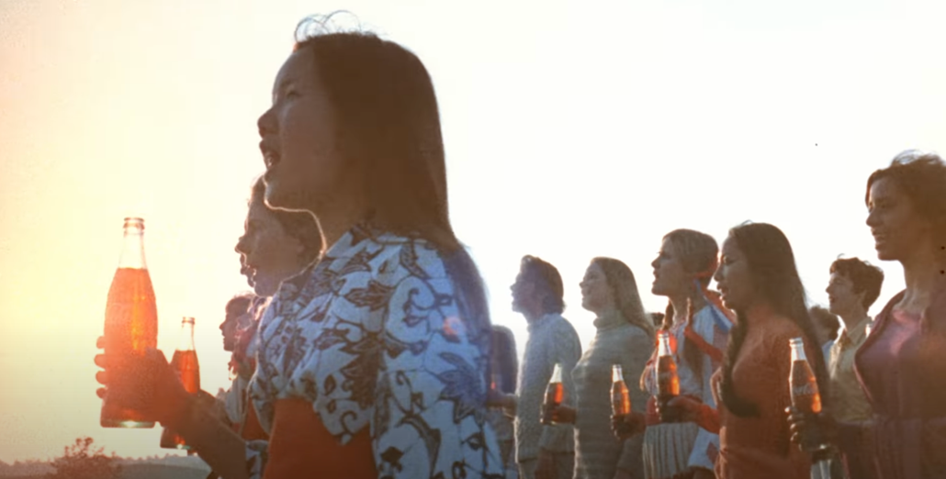
(Project ReBrief, 2012)

Daily Mail released an article on the subject with an opposing argument that “Advertisers are ‘trying too hard’ to demonstrate diversity by shoehorning in minorities” (Gordon, 2019). “Representation was no longer one tool among many, it was the key” (Klein, 2010, p. 108) and the use of diversity within advertising has become almost a requirement in order for businesses to cover all bases and avoid ‘cancel culture’, referring to the withdrawal of support through acts that are not acceptable today, something that has recently taken over to the point where everyone is stepping on eggshells to avoid offending the public, of which is inevitable as you cannot please all. Further stated by Naomi Klein, “The rush to diversity fitted in neatly with the embrace of African-American style and heroes that companies like Nike and Tommy Hilfiger had already pinpointed as a powerful marketing source.” (Klein, 2010, p. 112), taking David La Chapelle’s 1995 photograph, commissioned by Diesel as an example. Where a “photograph entitled Victory! (1945)” (Kissing sailors, 2004) displays the

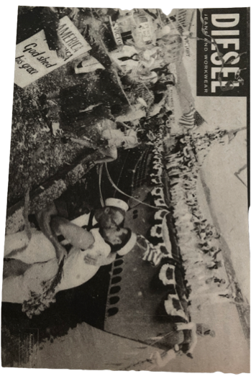
(Klein, 2010, p. 106)
celebration of an American submarine crew at the end of the Second World War, along with a superimposed image of two sailors kissing promoting their clothing, jeans and workwear to a
younger target audience by promoting representation for minorities. Although you could argue that they are using the concept of the ‘key’ to be covering all bases to their advantage as a brand who needs to make sales to succeed. In my opinion, it is never a bad thing to be seeing the representation for all minorities that has been endeavoured for so long, however I can appreciate the side of the argument where in some cases it may only be for show and not with the right intentions and motivations, only to sell their product and tick the box of the use of diversity. To question “Are they entirely cynical or do they indicate that advertisers want to evolve and play more positive social roles?” (Klein, 2010, p. 113), I believe perfectly summarises the debate at issue. Referring to the article, “a study of 1,000 adverts shown in the UK over two months found 37 per cent featured black people, though they make up about 3 per cent of the British population.” (Gordon, 2019), I find this intriguing as it begins to make you question whether companies are going near overboard to isolating and excluding white, straight couples in advertisement for example. It seems as if the brands and the media are pushing an agenda that does not reflect the real world and pushing this to be an over-representation of black people, going out of their way to avoid racism accusations. With the support of the statistic, I believe that advertising today does not represent the population demographics in the real world due to the over-representation, on the other hand I can thoroughly appreciate that if you were a black person who had only seen privileged white people depicted within the media and you can now finally relate to someone who looks like you in an advertisement you would be inspired and obligated to support. Interestingly, “The same study also found just 3 per cent of surveyed adverts feature members of the LGBT community, which makes up around 6 per cent of the UK population.” (Gordon, 2019), this comes as a surprise to me as it is widely accepted today. As a graphic designer in the real world, representation is something you would need to take into consideration whether it’s designing illustrations for a bus shelter poster or designing informative instructions for covid rules and whilst we see some representation of the LGBT community “A staggering 54% of gay and bisexual young male respondents even said they might have come out sooner if brands had shown LGBT+ people like them when they were growing up.” (Roderick, 2017) and through a contribution of the consistent lack of positive role models and representation for the community, in 1998, “28.1 percent” (Remafedi, et al., 1998, t. 1) of homosexual and bisexual males in America attempted suicide, compared to “4.2 percent” (Remafedi, et al., 1998, t. 1) of heterosexual males within the same age demographic. The concept of feeling ‘seen’ would have a huge role and contribution to this, especially considering those who live rurally where they are more likely to feel oppressed into hiding their identity and results in leading a life of self-loathing due to the rural population mainly being exposed to the acceptance for the most part on advertisements as such. Furthermore, companies seem to be virtue signalling by using the rainbow flag, of which represents the community and I feel as though when they simply change their logo to the colours of the flag for pride month, this almost turns the event to raise awareness as a trend and those who do not take part are assumed to not be supporting the occasion. By browsing through forum pages on this subject, the majority of the people are not adhered to stamping the flag on their products and logos and don’t like the idea of being pandered to. On the opposing hand, some commenters take the view that it displays capitalism in action and that where the money is determines the direction of a business. In the past, supporting LGBT people would have resulted in a loss of revenue for most companies, but today it would gained revenue for them. Ultimately, rainbow flags being displayed in shop windows, on products, and in advertisements is not a luxury that gay people have experienced in the past and as the accepting future for young gay people today, this shows the progress advertising and graphic design has made on the contrary.

The question to be answered, I believe is to be opinion-based by the minority groups and the target audience themselves as nobody else can say how one feels represented, whether it be through stereotypical connotations or just utterly discriminatory language. Furthermore, I discovered the ratio of advertisements featuring minorities to be an inaccurate representation of the population demographics, nevertheless, the media is beginning to show greater awareness towards the social and political issues through challenging and revoking sexist stereotypes as well as exposing racist and ableist content. In my opinion, the world is making a promising movement towards further understanding and awareness towards the importance of representation. As a graphic designer, upon reflecting on the effects and the consequences of neglecting a diverse reflection of the real world when designing for a client, something I’d have to always consider is the fair representation of minorities as the brand itself would most likely receive the frontal backlash.

Bibliography
Family Resources Survey: financial year 2020 to 2021 (2022) Available at: https://www.gov.uk/government/statistics/family-resources-survey-financial-year-2020-to-2021/family-resources-survey-financial-year-2020-to-2021#disability-1 (Accessed: 24 November 2022)

Gordon, A. (2019) Advertisers are ‘trying too hard’ to demonstrate diversity by shorehorning in minorities, study finds, as it reveals third of commercials now feature black people. Available at: https://www.dailymail.co.uk/news/article-7111087/Advertisers-trying-hard-demonstrate-diversity.html (Accessed: 24 November 2022)

H&M via AP. (2018) H&M apologized for running this advertisement for a hoodie. Available at: https://www.washingtonpost.com/news/business/wp/2018/01/08/hm-apologizes-for-showing-black-child-wearing-a-monkey-in-the-jungle-sweatshirt/ (Accessed: 24 November 2022)

Kissing sailors (2004) Available at: https://collections.vam.ac.uk/item/O92551/kissing-sailors-poster-la-chapelle-david/ (Accessed: 30 November 2022)

Klein, N. (2010) No logo. 10th anniversary edn. London: Fourth Estate

Nike ad (2012) Available at: http://www.seemikerun.ca/2012/05/ (Accessed: 24 November 2022)

Pisano, P. (2017) Wulf D. Hund, Charles W. Mills y Silvia Sebastiani, eds. simianization. apes, gender class, and race. Anuario colombiano de historia social y de la cultura, 44(2), p. 370.

Project ReBrief (2012) Coca-Cola, 1971 – ‘Hilltop’ | “I’d like to buy the world a Coke”. 6 March. Available at: https://www.youtube.com/watch?v=1VM2eLhvsSM (Accessed: 26 November 2022)

Remafedi, G., French, S., Story, M., Resnick, M. D. and Blum, R. (1998) The relationship between suicide risk and sexual orientation: results of a population-based study. Washington DC: American Journal of Public Health (1971), 88(1), pp. 57-60.

Roderick, L (2017) More than half of LGBT+ community feels ‘invisible’ in advertising. Available at: https://www.marketingweek.com/lgbt-community-advertising/ (Accessed: 30 November 2022)

