Roxana-Oana Imbrea

2124855

Marketing fundamentals – LCBB4004

Assessment 2

5th of September 2022

Tutor’s name: Md Sadeque Imam Shaikh

This report will evaluate, analyze, and present the impacts that Covid-19 had on Costa coffee and how the company managed to survive the pandemic, overcome the difficult situation it had to go through, and the lessons learnt and the improvement ever since Coronavirus took over the entire globe.
What is coronavirus and why did it have such a massive impact within the retail industry?
Corona virus or Covid-19 is a virus discovered in December 2019 in China, Wuhan and has spread uncontrollably across the Earth ever since it has appeared. There are many theories and rumors of how the virus appeared in the first place, including that it was contacted from animals or mistakenly spread by scientists. The virus is presented as highly contagious, easily spreadable, and considerably dangerous as severe contamination may result in death, especially in elderly.
Symptoms of the virus include severe cough, sore throat, high temperature, muscle soreness, loss of taste or smell and generally any flu like manifestations.
Ever since it appeared governments all around the globe have decided on how their countries will deal with this and a common remedy was isolation, quarantine, working from home, wearing masks, reduce social contact, close unessential businesses temporarily, limit travelling and one of the last steps was vaccination.

What is Costa Coffee and what do they do?
Costa Coffee is a coffee shop chain that was funded in England in 1971 and has gained popularity over the years though its distinctive roasted beans that add flavor to the most desired morning drink which is coffee. Costa Coffee has spread over other countries too and created more than 18.000 jobs. The company has been sold to Coca-Cola in 2019 for £5.1 billion and this ended up being an advantage for both companies.

How did Covid-19 leave its footprint on Costa Coffee in term of internal factors?
- Strengths
- Big figures in revenue and high popularity
Costa Coffee is well-known all around the globe and nit just in its mother country. The brand has over 2700 stores and franchises spread across 31 countries and has improved profits considerably over the years as shown in the below flowchart.
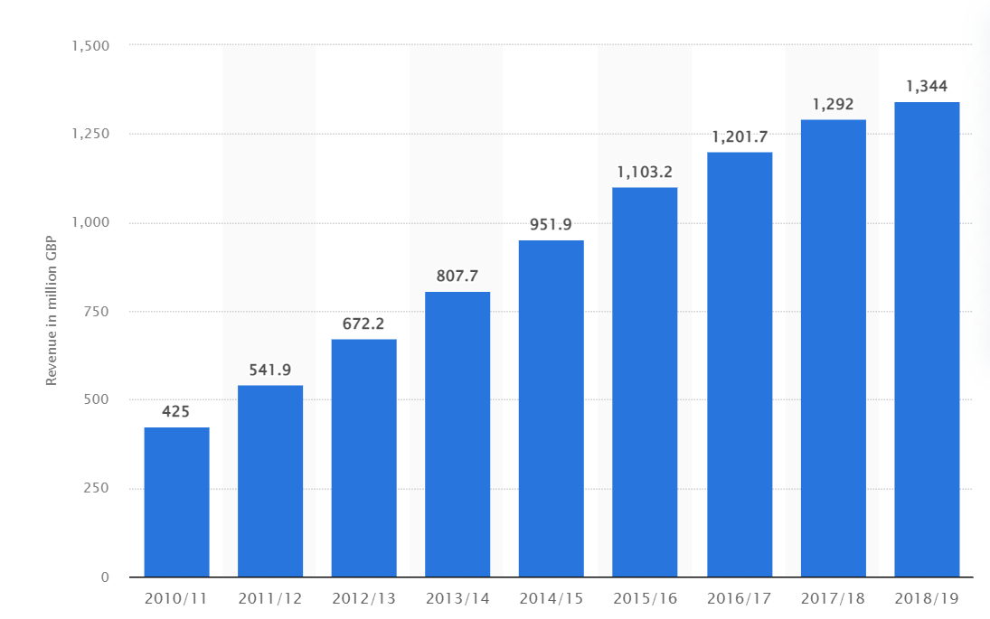

There is also a big gap between the leader in the market which is Costa coffee and the second position brand which is Starbucks; this rank is only for the UK. Costa coffee not only has stores across all around the UK and other countries but has also machines in shops for on-the-go customers, which are also helping increase popularity whilst Starbucks do not yet have this advantage of owning express vending machines.
Therefore, Costa Coffee was under a thread when the pandemic started, however given the facts mentioned above there was never a thread of liquidation, just loss of profit.

- Weaknesses
- Not globally spread
One of the weaknesses of the company is that it is not spread as much as its rival brand: Starbucks. Even though in the UK Costa is occupying the first position in terms of coffee shops, it is not globally recognized. For example, they do not have any stores open in the USA which makes Starbucks the leader in many countries.
Since Covid-19 was a big challenge, UK was Costa’s best opportunity to come back strong whilst Starbucks has had popularity across more than 70 countries.

- Opportunities
- Expansion abroad
Tied to the weakness of not having spread already significantly across the globe, one of Costa’s biggest opportunities and focus should come under the expansion abroad and becoming loved and recognized in countries that could bring a higher revenue to the company.
Even though there isa probability of another pandemic in the future, there is anow the option off drive through and having stores across many more countries does not mean more stores closed, but it would rather higher popularity and more stores to operate drive through.

- Threads
- Thread of permanent closure of some stores
The company has faced challenging times during the Coronavirus pandemic as well as other businesses in the industry due to social interaction being kept minimal and unessential business shut.
This aspect had a big consequence in terms of store closures and revenues especially because at the time it was uncertain when it will be safe to re-open the shops and which stores are worth reopening after the pandemic.

The conclusion of the internal factors is that Covid-19 had an impact on Costa coffee and its employees as the stores had to shut, however it brought opportunities such as expanding shops to Drive through shops as well as expanding in more countries in order to stand still in front of another potential global crisis.

Moving forward, this report will present the external factors and how they affected the company through Covid-19 outbreak.
- Political
- Insecurity regarding laws
Since Costa Coffee operates in more than 30 countries, they need to make sure that their company adheres to the laws and regulations of the specific location of their stores. This means that the company needs to ensure that they are up to date with any changes under political overview of the countries that they are running the business.
Covid-19 has impacted not only Costa Coffee but all businesses around the globe and depending on the location there where different laws put in place, however, most countries ended up demanding closure of non-essential businesses. For example, in the UK, Costa coffee March 2020 until July 2020, however, only drive throughs were allowed to be opened as government was still trying to keep social interaction minimal. The company fully re-opened its doors to customers towards the end of 2021 in the UK.
Although UK government allowed Costa to re-open the drive through as a compromise to benefit both parties (business and government), other countries such as France, were affected by Covid-19 more than the UK, therefore, they did not lift the restrictions for any unessential businesses.

- Economic
- Economy drop-off
Countries all around the globe faced a hard time in terms of economy during the outbreak of Coronavirus pandemic. This is due to closure of unessential business, limitation of import and export, travel restrictions, minimalization of social interactions, furlough implementations, working from home (which reduces productivity) and many other factors.
Even after Costa Coffee has reopened drive throughs, the impact of the economy drop-off was felt as people were more focused on essential spendings and saving money. Many of Costa’s customers could not afford to treat themselves due to furlough or loss of their job.
Costa Coffee had to also release some of their employees across the countries in which the company operates as a result of the pandemic. In the UK more than 1650 jobs were cut in order to reduce costs during the pandemic as all employees were left on furlough with full pay. Therefore, the company decided to cut assistance manager jobs due to the uncertainty of the outcome for the future.

- Inflation rates
Economy drop-off is directly linked to inflation rates that have gone up considerably during the outbreak of Covid-19. Because of the uncertainty and chaos that developed since Covid-19 started to spread, businesses have increased their prices to make up to the period they we’re completely shut. Costa Coffee is not an exemption to this statement.
However, a gradually increasing inflation rate would benefit Costa Coffee for a multitude of reasons such as:
- Adjustment in employees’ wages
In the UK every April there is an inflation of 2% to help the economy and businesses and even though many people believe that inflation is a bad aspect it is in fact a positive impact on businesses.
For example, a moderate inflation helped Costa to adjust employees’ wages, allowing the company to increase the pay rate of hardworking workers while the others will remain frozen. This strategy is helping Costa to save money and flourish and if the inflation would stagnate or deflation would be incorporated it could have a negative impact on the coffee brand.
- Adjustment of prices
Similar to the above point, with inflation prices can be adjusted and it helps the company make a profit on every beverage or food sold.
For example, if the inflation is Costa Coffee is buying in bulk which activates discounts for business which means that the company is feeling the inflation at a rate of 1.5% whilst their prices are upped to 2%.
On the other side if the inflation rate increases with more than 2% it can seriously harm the economy of a country, leaving its footprint on businesses like Costa Coffee.
For example, a high inflation would reduce the actual value of people savings and wages which creates problems in being able to manage finance and companies like Costa Coffee would feel the impacts on the numbers of revenue and profits.
As shown in the table below, inflation rate in the food and non-alcoholic beverages reached up to 11.08% increase.
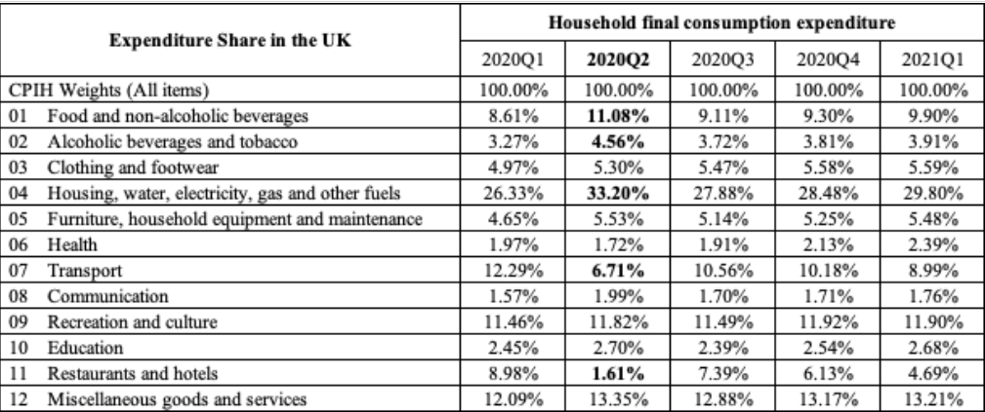

- Social
- Limited social contact during Covid-19
As the Government decided to implement lockdown during the coronavirus outbreak to monitor the social interaction amongst people, Costa Coffee had to fully shut its premises for 6 weeks before reopening the drive throughs across the UK.
Even after re-opening the company had to follow some rules in order to operate legally. These rules include wearing of masks, disinfect premises and make sure that employees wash their hands every 30 minutes as a minimum and keep a distance of 2 meters from their colleagues and customers.
- Health concerns and consciousness
As a coffee brand that operates in the food and drink industry Costa Coffee had always been aware and conscious of their customers well-being and health. The company has had rules in place regarding health and safety ever since it was funded. These rules include keeping a clean, disinfected, and tidy environment for employees and customers, wearing gloves when preparing food, regularly washing hands and ensure all products are up to date and fresh. Moreover, Costa Coffee offers information regarding nutritional values and ingredients in their food and drinks to help people with dietary restriction or just on a diet to choose accordingly.
Since Covid-19 was an eye-opening event in regards to health, many companies are now considering this when introducing new products. However, Costa Coffee has started its project back in 2015 when it was chosen to reduce the sugar in bakery products and drinks; the aim for drinks was to reach no added sugar in most of the menu.
On the other hand, even if this project was already taking place, Costa coffee decided to expand this to an entire range of products that are healthier, as a result of the pandemic.
This is a good marketing strategy as it shows the company cares about its customers and their health and are working towards making their products ‘guilt-free’ by reducing the calories, saturated fats, and sugars in their products.

- Technological
- Social media presence
Nowadays social media is one of the main and best ways to ensure marketing is in place and up to date.
For example, Costa coffee is active on a multitude of platforms such as Facebook, Instagram, TikTok and so on. This enables the company to promote itself by posting new trends and discounts, advertising their Costa Club app and also presenting the benefits of having the app. In addition, casual posts will remind customers of the drinks and food provided by the company and would psychologically trigger them to want to come into the stores. Therefore, presence on social media is vital for a businesslike Costa Coffee to maintain relationships with their customers.

- Environmental
- Recycling
After lockdown and quarantine have been installed all around the globe, people have realized the damage that humans are doing to our own environment on a daily basis because the moment all unessential interactions were banned or slowed down, the nature had a blast. Therefore, as a result people started to acknowledge the importance of minimalizing the impacts human have over the nature.
Costa Coffee is aware of the importance of recycling and has put in place a project where customers can return all takeaway cups their local Costa branch to be recycled.
This is also a good strategy for marketing as it keeps customers loyal whilst attracting new people to be interested in the company due to the interest shown towards taking care of the planet.
- Green consumption
Due to the global warming, a larger amount of people is becoming environmental concerned and aware choosing products and services that are environmental friendly, as well known as ‘green’.
Costa Coffee is not only aware of these aspects, but it is also taking its role seriously towards saving the planet. How is Costa doing so?
- Works in partnerships with organizations that are environment friendly.
One of the companies that Costa is in partnership with is Gridserve Electric Support. We have two stores near their premises to enable people to buy their favorite coffee while charging their vehicles.
Another company that Costa Coffee is involved with is Too Good To Go and our aim together is to reduce the amount of food that is going to waste by implementing a project where food that is close to their out of date deadline is significantly reduced in price so it does not end up in the bin. Costa Coffee started its partnership with this company in 2018 and apart from reducing the company carbon footprint, it has also helped people that are concerned of their finances. This has also been helpful after the Covid-19 outbreak when people where in a sensible position regarding their household finances.
In addition, any food that did not get bought would end up in local charities to avoid waste at all costs.

- Has a clear view of their plan towards achieving their goals (environment wise)
Costa Coffee has also done internal research within the organization to identify where the majority of the carbon footprint is coming from, including suppliers, in order to be able to develop a plan to minimalize the carbon emissions and to understand what are the areas in which the company has to focus on.
Therefore, Costa Coffee became one of the 20 retailers in the UK to join British Retail Consortium’s ‘Climate Roadmap’. This plan is aiming to encourage companies to commit in making changes that are leaving a positive impact on the environment, last step being to help the UK becoming Net Zero (carbon footprint reduced to 0%) before Government’s plan which is meant to be extended by 2050.
Costa is doing so by engaging with their suppliers, such as farmers, and encourage them to reduce gas emission. Another way is to work in partnership with Green Alliance to reduce the footprint while producing and distributing the coffee.
In 2017, Costa has open Costa Coffee The roastery and the company invested in modern equipment that has reduced the energy to roast a tonne of coffee by 30% compared to the previous roastery. In addition, all the energy used in the roastery is renewable energy, there are car charges in site and led lightning in order to reduce as much of energy used as possible.

- Legal
- Health and safety laws and policies
Costa Coffee is aware that health and safety is not only structured around physical wellbeing but is strongly linked to mental health and wellbeing.
During Covid-19, the company has incorporated strict rules in regards to premises’ tidiness and disinfection where employees had to wear gloves at all times as well as changing them regularly, masks where mandatory in order to exclude the risk of germ spread, washing hands had and have to be washed/disinfected every half an hour as a minimum and coffee machines, fridges, displays and floors had to be maintained.
The company has no tolerance to rude or aggressive customers and anyone posing a thread to the well-being of employees is immediately asked to leave. This is to ensure that staff is not bullied, therefore affecting their mental health.
- Human rights laws
Apart from the zero tolerance of bullying mentioned above, Costa is adhering to the national human rights laws for each location of their store and ensures that employees and customers are aware of their human rights.
For example, Costa is ensuring to pay fairly each of their employees according to hours worked, overtime and any benefits or bonuses applicable. Moreover, each employee has a contract on order to be able to work legally in the premises of the company.
Another aspect of the human rights that Costa Coffee is massively focused on is diversity an equity, ensuring that there is no racism or discrimination associated with the coffee brand.

PORTER’S FIVE FORCES analysis on Costa Coffee.
- Threat of new entrants
There are many cafes opening in the UK and other countries where costa has stores, however, they do not pose a thread to Costa as the company has built a positive image and has gained loyal customers over time.
For a new company focused on coffee, it would take many years until Costa would have to take into consideration a pose of thread from their side.
- Threat of substitutes
Costa Coffee is a large company that is popular in the countries it operates and has gained the loyalty of their customers over time. Regarding to the rivalry amongst competitors already in the industry, Costa’s concern is mostly over Starbucks and ensured to implement techniques such as sustainability and updated products and services to maintain their reputation.
Therefore, substitutes are not a big thread or concern to the company even if there are many more apart from Starbucks, they are not at the same level as Costa.

- Bargain power of suppliers
The bargain power of suppliers is high due to the number of different potential suppliers that do not massively differentiate from one another.
Therefore it makes it easy for Costa Coffee to ‘manipulate’ their suppliers towards a positive future.
For example, as mentioned above in the environmental analyses, where is stated that Costa is encouraging their suppliers to reduce carbon footprint. If there were limited suppliers in the industry a company such as Costa would not be able to actively demand or pressure suppliers as they could lose them.

- Bargain power of customers
Customers is a very important aspect of Costa, so the company ensures to keep their customers happy and returning to its premises.
The company ensures to come up with promotions, new products, sustainability, marketing strategies and community engagement (on social media for example) to make sure they understand and provide their customers their desired wants and needs.

- Rivalry of existing competitors
Costa Coffee has created a brand image over the years, and it is very popular in the countries that the company operates in.
The number one rival of Costa Coffee is Starbucks as these two are the most well-known companies in the market. The competition is tight between the coffee brands as Costa is ranked number 1 in the UK and has a lot of competitive advantage over Starbucks through:
- Costa Coffee Club
This is an app that includes features for loyal customers to collect ‘beans’ which each purchase until the beans add up to a free drink. This is a good way of saving some money for Costa regular customers.
In addition, the app is gifting customers on their birthdays with a free treat of their choice from a list provided by the company.
Another feature is click and collect or order in advance to help busy people in saving time and enjoy their favorite coffee at the same time.
- Venti Machines
Costa coffee has introduced venti machines in different stores such as Tesco, Co-op and Shell all over the UK to help their customers enjoy a Costa drink on-the-go or where there are no stores around.
This is a strategy that Starbucks has not yet implemented, therefore Costa remains first ranked in the UK.
However, even though Costa has a considerable competitive advantage over Starbucks in the UK, Starbucks is widely spread across more countries than Costa, therefore better known than Costa. Starbuck is operating in over 70 countries whilst Costa is only operating in over 30 countries, making Starbucks more popular abroad.
References

Principles of Marketing (15th edt) Author: Kotler, P., and Armstrong, G Binding, USA, 2014
Costa Coffee operator sustains €48m revenue hit due to Covid-19 – The Irish Times , August 2022
• Costa Coffee: revenue 2010-2019 | Statista , August 2022
How has inflation behaved during the pandemic? - Economics Observatory , August 2022
Climate — Sustainability | Costa Coffee, August 2022
Anti-food-waste: Costa Coffee extends Too Good To Go partnership (greenretail.world), August 2022
Sustainability (costacoffee.com), August 2022
costa-coffee-human-rights-policy.pdf, August 2022
The ultimate Marketing Plan, Dan S. Kennedy, New Delhi, 2006
Blythe, J. Essentials of Marketing. 3rd ed., Blythe, J. Essex, 2015

