Assessment 2
Organisation’s Digital Identity Management
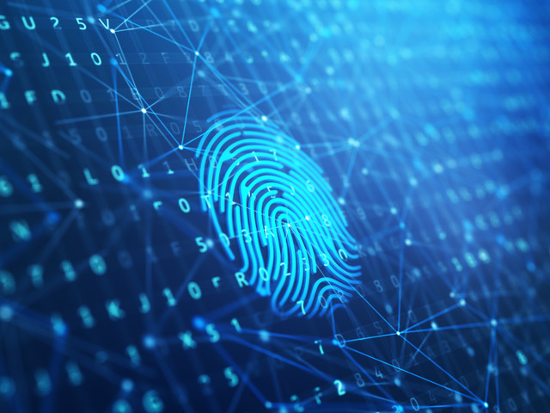

Claire Davies
1806680

Contents Page

- Executive Summary … Page 1
- Introduction … Page 2
- What is Digital Identity? … Page 3
- How is your digital identity created? … Page 3
- Why your Digital Data is used by Companies … Page 4
- Why do companies use Social Media Advertising … Page 4
- Why do companies create digital identities about their customers? …Page 5
- What are cookies and why are they used? … Page 6
- GDPR (General Data Protection Regulation) … Page 7
- Conclusion … Page 8
- References … Page 9

Executive Summary
This report is going to look at Digital Identities! What is a digital identity, how is your digital identity created, how is someone’s digital identity used, who uses your digital identity? These are many of the questions that will be answered throughout this report, many companies across the internet will use your digital identity, why and how do these companies use you online identity? Are there risks to having a digital identity, if so what are they and is there a way to minimise the risks? GDPR (General Data Protection Regulations act), how does this work to help protect your digital identity.

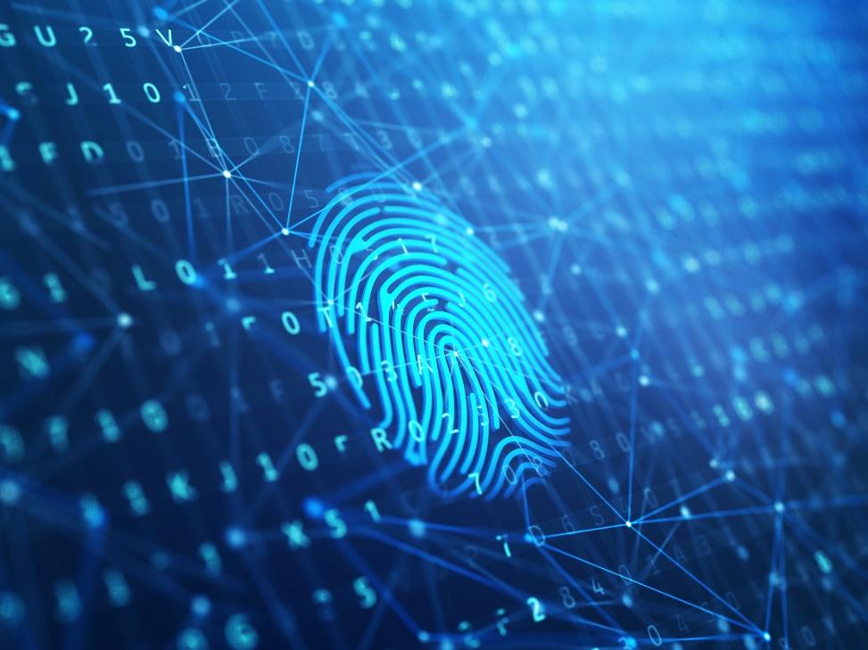

1

Introduction
We are living in a digital world these days, gone are the days where people communicate in person on a daily basis. The digital age has made it much easier to communicate with people far and wide at a click of a button. This is fantastic but could have its down-falls as every time you are inputting your personal information into a digital device that information is being stored. Everyone that uses a computer and inputs personal data about themselves are creating their very own digital identity. There are many ways in which you can create your online identity, setting up online banking, a gaming account, online shopping, social media profiles. These are just a few ways in which digital profiles are made. Different companies may require different details, so every detail you input about yourself, this is what is used to create your digital footprint/digital identity. Companies can then use all the details you have shared online to tailor their services to what best suit you and your needs. However, GDPR is there to help to protect your digital identity and all the data you provide online. As such companies are obliged to adhere to the regulations set out by GDPR, this making it safer for people to trust that their information is being used in the correct manner.

2

What is Digital Identity?
Where are living in a digital age, technology is fast becoming part of everyday life for the majority of people and businesses. Your own actions are what creates your online digital identity, every time you put any information about yourself into a digital system you are building your digital identity. There are many ways in which you do this, if you use online banking this requires you to input specific personal information about yourself, for example, your name, DOB, address, all this is then stored to create your very own personal digital identity.
How is your digital identity created?
This is through your personal digital data and your digital activity, these together is what is used to form your digital identity. Some examples are in the table below:
Personal Data | Activities
Date of Birth | Photo Uploads
Address | Social Media Activity
E Mail Address | Use of Search Engines
Bank Details | Purchase History
Medical History | Downloading Apps
Usernames and Passwords | Mobile Phone Usage

“All the information is available if you know where to look” (Prigge, 2019).
This quote to me suggests that your digital identity isn’t 100% safe no matter how safe you think it is when you are creating it. Robert Prigge talks about data breaches at the Sibos event in London 2019. He informs us of how our information can easily be bought and used for fraudulent purposes. It’s shocking to hear how easy and cheap it is for your personal data to be bought and used in this way. The most sort after data is usually you medical records, driving licence, bank details, passport, each one varies in price. So its scary to think that anyone with the right knowledge can retrieve your information and use it without your consent.

3

Why your digital data is used by companies?
This is how a company builds up a personal profile for individuals, they do this so that they can tailor products and services specifically for each and every individual that they have created a personal profile on. Certain businesses such as Ebay will use the data they have on you to tailor products that you have previously bought with similar products that may interest you. With technology advancing at such a fast rate, companies are now able to use your data to advertise product through other means such as social media advertising. So, this means that you don’t have to be online shopping for companies to be able to capture you interest in certain products or services.
Why do companies use social media advertising?
Companies use social media advertising as a way to target their audience, this is an easy way to draw people in as social media is a big part of life these days. Social media isn’t only used for personal reasons but for business to and companies advertising on various social media site can reach more and more people.
“Professional marketers specialize in devising strategies to help businesses succeed via social media marketing. They carry out different social media campaigns for business’ products or services and allow them to attract targeted customers. Marketers take advantage of popular social media sites to carry out these campaigns more effectively. Some of the common social media channels marketers work with include Facebook, Twitter, LinkedIn, Instagram, and YouTube. Apart from these, they also work with Google+ and Pinterest. Using multiple social media channels allows them to increase marketing campaigns more rapidly.” (Bidvine.com, 2020).


As you can see companies target many social media platforms, this means they have a wider audience that they can reach with their advertising. More often that not from personal experience, their advertising is usually tailored to previous product of service I have search for online and this is how they capture the interest of their targeted audience.

(Google, 2020).

4
Why do companies create digital identities about their customers?
A customer’s digital identity is a company’s way to uniquely tailor their services to each and every individual that has their own digital identity. It’s their identity that provides businesses with the information they need to be able to tailor certain products and services to people. With out this it would make it more difficult to capture their targeted audiences attention through social media advertising.
“Customer identity is the 'front door' to your digital business” (Glazier, 2018).
This is why company’s create digital identities for their customers, as the customer is what is beneficial to a company. Advertising something that appeals to an individual on a social media platform or thought their email makes it easier for the customer to just click on the link as its there, so no searching is necessary. It gives them a much more personalised shopping experience as the adverts are usually tailors to previous purchases, something that others within your age range have been interested in, these are just a couple of factors businesses use when the tailor advertisements to individuals.
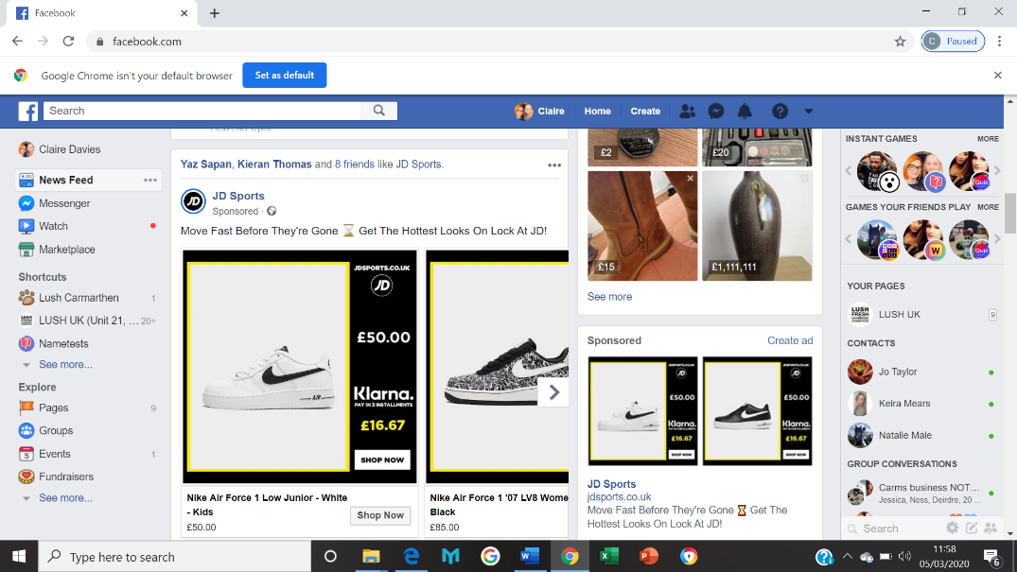
Below is a screen shot of an example of direct personal advertising on social media:

(Facebook, 2020).
This is a screen shot from my own social media page, this shows JD Sports advertising something I may be interested in. This is because recently I searched online for a pair of Nike Air Force 1’s, so now I have companies that sell this product advertising on my social media pages. It’s a very clever and smart way to capture their targeted audience attention and could also lead to a sale and so they have succeeded in what they intended. But it’s not always appreciated by the person receiving these adverts constantly.

5
What are cookies and why are they used?
Many sites on the internet will contain cookie notices, this means that you will need to accept the cookie notice before proceeding to the website. This is what it looks like:
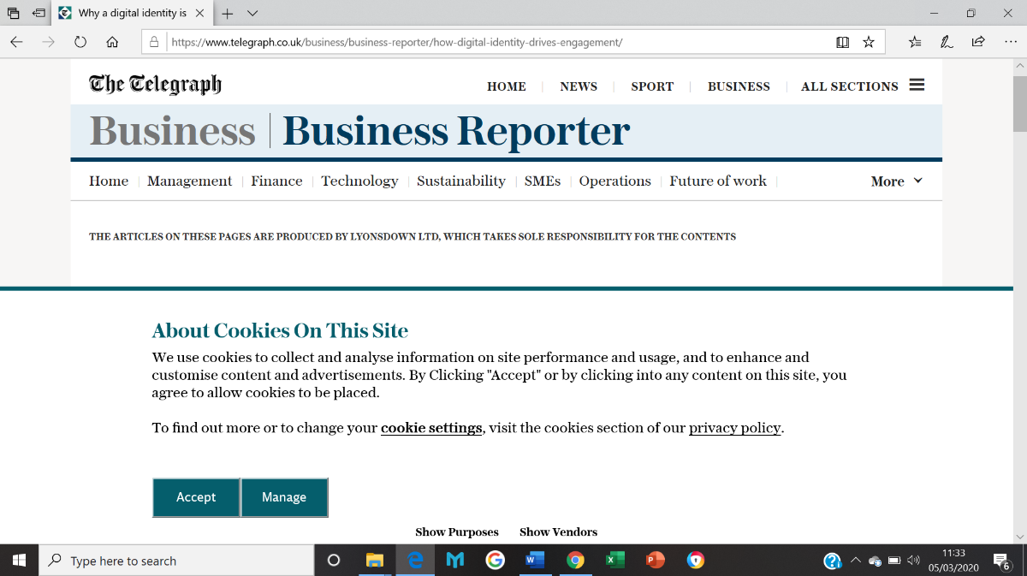

How cookies work!
“When you visit a site that uses cookies for the first time, a cookie is downloaded onto your PC. The next time you visit that site, your PC checks to see if it has a cookie that is relevant (that is, one containing the site name) and sends the information contained in that cookie back to the site.” (WebWiseTeam, 2012).
Cookies make it easier for the user when searching for something that they have previously searched for as cookies save certain information that u have already input into your computer or digital device. So they not only benefit the consumer but the customer to.
“A website might also use cookies to keep a record of your most recent visit or to record your login information. Many people find this useful so that they can store passwords on frequently used sites, or simply so they know what they have visited or downloaded in the past.” (NortonLifeLock, 2020).
Cookies are information that is gathered digitally and stored for future reference, however cookies can be cleared from any device, this is simple and easy to do.

6
GDPR (General Data Protection Regulation)
Data protection was first introduced in the 1990’s but with the increase in technology and the changes to technology the data protection was finding it hard to keep up with how quickly technology was advancing. In May 2018 the GDPR (General Data protection Regulation) was introduced in Europe. This meant that individual’s personal data/information was protected by law.
“The EU's GDPR website says the legislation is designed to "harmonise" data privacy laws across Europe as well as give greater protection and rights to individuals. Within the GDPR there are large changes for the public as well as businesses and bodies that handle personal information” (Burgess, 2019).
GDPR was introduced because we now live in a digital age, we are putting so much of our personal data into technology and that needs to be protected. Companies that require us to input data about ourselves need to follow specific guidelines when it comes to data protection.
Serious penalties are enforced when the regulations aren’t adhered to, fines have been put into place as a penalty, the fine is 4% of the annual turnover or £20 Million, whichever is of greater value to the person breaching the regulations. (Ethos, 2018).

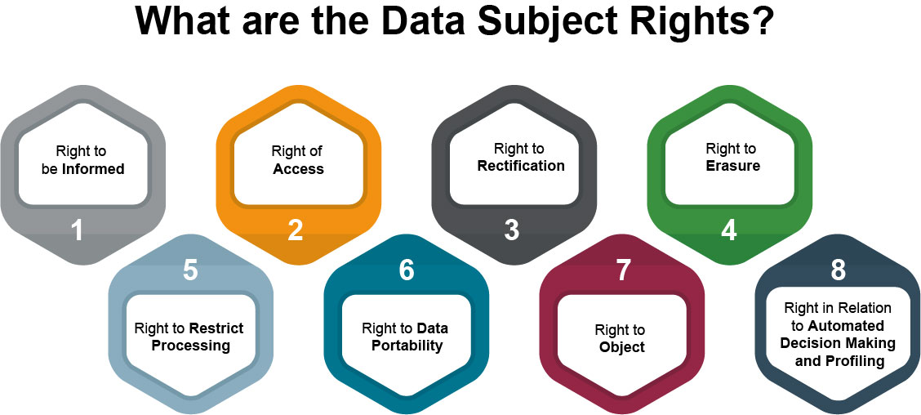

7
1. Right to be informed
This encompasses an obligation to provide ‘fair processing information’, typically through a privacy notice. It emphasizes the need for transparency over how personal data will be used.
​2. Right of Access
The right for data subjects to obtain from the data controller confirmation as to whether personal data concerning them is being processed, where and for what purpose.
3. Right to Rectification
Individuals are entitled to have personal data rectified if it is inaccurate or incomplete.
4. Right to Erasure
Also known as the “right to be forgotten,” the right to erasure entitles the data subject to:
- Have the data controller erase his/her personal data.
- Cease further dissemination of the data.
- Potentially have third parties halt processing of the data.
5. Right to Restrict Processing
Under GDPR, individuals have a right to have their personal data ‘blocked’ or suppressed under certain circumstances. When processing is restricted, data controllers are permitted to store the personal data (which differentiates this right from the right to reassure above), but not further process it.
6. Right to Data Portability
The right to data portability allows individuals to obtain and reuse their personal data they have provided to a data controller for their own purposes across different services. It allows them to move, copy or transfer personal data easily from one IT environment to another in a safe and secure way, without hindrance to usability.
7.Right to Object
Individuals have the right to object to the use of their personal data for direct marketing purposes.
8. Right in Relation to Automated Decision Marketing and Profiling
The GDPR provides safeguards for individuals against the risk that a potentially damaging decision is taken without human intervention. You should work with your legal counsel to determine whether any of your processing operations constitute profiling or, by extension, profiling involving automated decision making, and to consider whether you need to update your practices and policies to deal with the corresponding requirements of the GDPR.
(Joynt, 2017).

These are the individual’s rights with in the GDPR law.
8
Conclusion
In conclusion to this report, it seems that with us now living in a digital age, our digital identity is used far and wide across the world wide web. When we put our personal data into a website that requires certain information about a person, that is us giving our consent for that company to use the information we have provided.
Technology has advanced so much that you can store data such as usernames and passwords, DOB, addresses, phone numbers and then these can be used across several different websites. But companies that have the ability to save such information also have to adhere to the GDPR law that was brought into force in May 2018. Failing to do so has great consequences and could be very costly to anyone who doesn’t adhere to these regulations.
However, there are also risks involved when inputting your data, but with the GDPR put in place these risks are now kept to a minimum.

9

Bibliography

Bidvine.com. (2020). Retrieved from https://www.bidvine.com/social-media-marketing?utm_campaign=con-ppc-Social+Media+Marketing&utm_medium=cpc&utm_source=bing&criteria_id=133079&msclkid=c6b38db8fa8c173b7c12d3d82699e3af&utm_term=facebook%20advertising&utm_content=facebook%20advertising%20-EM
BlockBox. (2019, September 30th). Retrieved from https://www.theblockbox.io/how-blockchain-authentication-can-pave-the-way-to-self-sovereign-digital-identities/
Burgess, M. (2019, January 21st). Wired. Retrieved from Wired.co.uk: https://www.wired.co.uk/article/what-is-gdpr-uk-eu-legislation-compliance-summary-fines-2018
Ethos. (2018, May 29th). Ethos Marketing. Retrieved from https://www.ethos-marketing.com/blog/the-laymans-guide-to-gdpr/
Facebook. (2020, March). Facebook. Retrieved from https://www.facebook.com/profile.php?id=100027085266817
Glazier, I. (2018, February 23rd). Retrieved from https://www.telegraph.co.uk/business/business-reporter/how-digital-identity-drives-engagement/
Google. (2020). Retrieved from https://www.google.com/search
Joynt, N. (2017, December 13th). Retrieved from https://blogs.oracle.com/cx/understanding-the-gdpr-and-how-oracle-cx-helps-you-prepare-for-compliance
NortonLifeLock. (2020). Retrieved from https://us.norton.com/internetsecurity-privacy-what-are-cookies.html
Prigge, R. (2019). Jumino. Retrieved from https://www.jumio.com/what-is-a-digital-identity/
WebWiseTeam. (2012, October 10th). Retrieved from BBC.co.uk: http://www.bbc.co.uk/webwise/guides/about-cookies

10

