University of wales trinity saint David
Using the appropriate economic theories, discuss and evaluate the possible market structures (Perfect competition, Monopoly, Duopoly, Oligopoly) and their effect on managerial decisions.
Management Economics- LCBB5003
Lecture: Vasilios Tavlaridis
2022
Contents
Introduction 2
The market structures 2
Types of market structures 2
Perfect competition 2
Imperfect Competition 3
Pure monopoly 3
Monopolistic competition 4
Duopoly competition 5
Oligopoly competition 6
How does it affect managerial decisions and examples 7
Conclusion 8
Reference list 9

Introduction
The purpose of this essay is to explore the economic theories, discuss and evaluate the market structures. The initial part of the essay will focus on different types of market structure – the perfect competition is about blocking competitors whereas imperfect competition is less of an aggressive approach to competitors and this includes monopoly, monopolistic, duopoly, and oligopoly competition. Next, it will be explored how the above market structures influence the managerial decision, examples, and graphics will be illustrated to better explain it. The last part will focus on the advantages and disadvantages, and the conclusion.

The market structures
This means that a firm will have a profit maximized when marginal revenue is equal to marginal cost. Also, companies will attempt to maintain stability in the market, the way firms lower their price charge, can be more or the same, it will depend on competitors they have in the market; and will make them behave differently from each other. It does not matter if a company has strong rivals or not when it comes to competition, each firm will remain strong, and they will use product differentiation to gain an advantage over each other and influence them to raise the price. Also, the way both firms behave can influence their market structure and performance (Sloman, Garratt, 2018), for example, when it comes to a two-corner food shop they can charge any price they want, however they can lose or gain customers as well as increase or decrease profit.
The market plays an important role in the industry sector, with some issues needing to be addressed appropriately when it comes to any changes in market structure that happen when it comes to another substitute in the market (Cohen, 2004).

Types of market structures

Perfect competition
Many industries tend to adopt the perfect competition market structures in their organisation because perfect competition is about the free movement of firms, there is easy entry and exit which allows each firm to have the freedom to stay or leave the market at any time. Perfect competition can be designated as ‘ideal’ because of resources allocation. The aim is to produce homogeneous products, this means the products are very similar to each other and they will not have an impact on price. Also, perfect competition has some characteristics where firms cannot influence supply and demand. Perfect competition is known as ‘price taker’ prices are accepted by customers and not arguable. Additionally, there are a higher number of buyers who are well informed about market value through news and other sellers’ connection (Griffiths and Wall, 2011).
For example, the price of a famous Portuguese wine can change depending on the managerial decision making because of location or scarcity of the product however this will not influence other competitors in terms of price change.
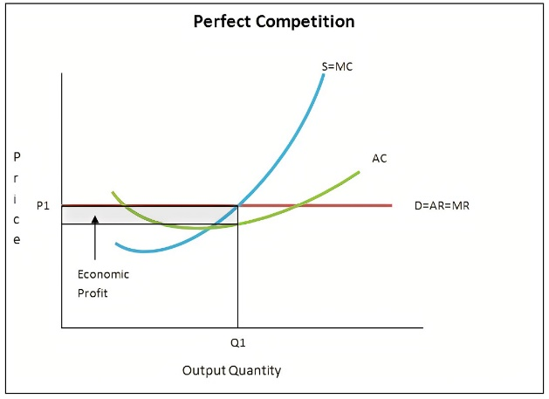
Figure 1: This graph represents the market structure of perfect competition – P1 mean price, Q1 mean quantity, the blue line represents supply equals marginal cost, the green line represents the average cost, and the red line represents demand equals average revenue equals marginal revenue (Glenn, 2012).
The table below summarises the advantages and disadvantages of perfect competition, please refer to table 1.
Advantages | Disadvantages
Resources allocation | Many firms in the market
productivity | Lack of innovative new product
Free entry and exit | Products are homogeneous
Profit and cost
Knowledge about other firms
Table 1 – This table shows the advantages and disadvantages of Perfect competition.

Imperfect Competition

Pure monopoly
It is a single firm in the market where we have just one seller, other competitors will have barriers to entry into the market. For example, the US has a small percentage of about 3 percent of their gross domestic product that is produced in a monopolistic market because of the value of their goods and services considering the dollar. Also, on monopoly, the single firm will have a higher percentage of share in the market, the way a monopoly behaves when changing price and work productivity and will give an explanation about performance how the productivity and price changes work. Also, barriers preventing entry will not make it easy for another firm to thrive in the same market. When it comes to the only firms in the market and when making decisions about production and price, monopolistic will not worry about the price, they will charge or establish the price they want and will not care about other competitors setting different prices which will influence productivity and demand. Also, monopolistic will try to maximize profit, which equals the marginal revenue and marginal cost; the cartel aims to maximize the profit for all members; establish the price avoiding a lot of production by controlling them (Marks, 2014).
The table below summarize the advantages and disadvantages of pure monopoly, please refer to table 2.
Advantages | Disadvantages
Barrier to entry | The consumer has no power to disagree on price
Profit | Prices are unfair
Benefit government | Lack of quality
Higher demand in the market | Maximize profit
Primary care (good and services)
Table 2 – This table represents the advantages and disadvantages of Pure monopoly.

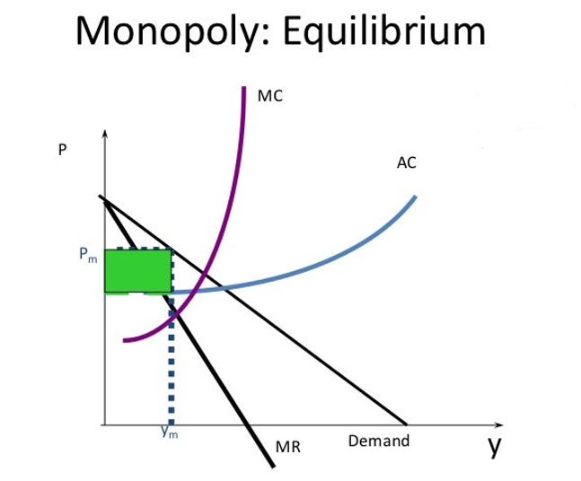
Figure 2: This graph represents the Monopoly market structure Pm mean price; Y_{m} mean demand; the dark line MR represents marginal revenue and demand; the blue line AC represents average cost and purple line MC represents marginal cost (Kumar, 2009 modified).

Monopolistic competition
This model is not perfect, represents many firms in the market with ease of entry and exit. Firms will try to persuade consumers by showing their product differentiation and charging any price they want (Keat, Young, and Erfle, 2014). The monopolistic competition aims to attract other consumers with their product by using marketing, advertisement, and trying to convince them to buy a product, and using qualities on their product differentiation such as package, design to show they are ‘better than other firms. Also, here demand will be considered elastic and there are consequences on decreasing and increasing prices (Marks, 2014).
This table displays the advantages and disadvantages of monopolistic competition. Please refer to table 3.

Advantages | Disadvantages
Product differentiation
Research help (innovative and more features) | Not improving on a product just want product differentiation
Marketing strategy(advertisement) | Advertising is expensive
Barrier to entry
Table 3 – This table shows the advantages and disadvantages of Monopolistic competition.

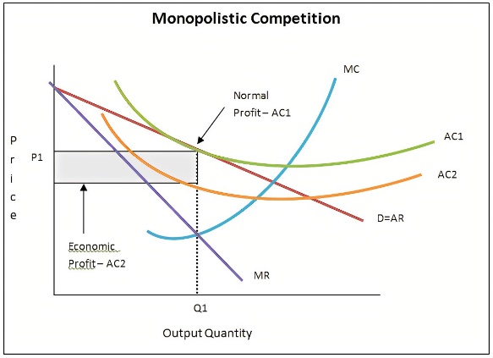
Figure 3: This graph represents market structure monopolistic competition; The purple line MR represents marginal revenue; blue line MC represents marginal cost; the red line D=AR represents demand equals average cost; orange and green line AC1 normal profit and AC2 represents average cost economic profit (Glenn, 2012).

Duopoly competition
The Duopoly competition is important in the market structure where competitors use their products to compete that can give them a greater net result. Also, they can have many results depending on how they use their approaches. When it comes to long-run outcomes, companies would use cooperative equilibrium for their benefit and profits but behaving inappropriately means being unethical with other competitors. The relative equilibrium promotes equality and has an active strategy by intervening and avoiding disagreement (Vrankić, Herceg, and Bach, 2021). There are two categories of duopolies – Cournot meaning that both firms will collaborate when producing their product to have equal further ‘equilibrium’; and the Bertrand when companies compete on price, not on the production side therefore customers will have a preference to buy an affordable product (Sloman, Garratt, 2018). A good example of the duopoly competition is Apple and Samsung they try to mimic each other which is a good strategy to achieve similar outcomes, for example increasing the number of cameras on their devices was a great approach for these firms to attract more customers.
This table displays the advantages and disadvantages of duopoly competition, please refer to table 4.
Advantages | Disadvantages
Good production | Collusion (can impact profit)
Connection and collaboration | Lack of new entrants
Price competition | Not investing in diversified (new products)
Goods are good on quality | Firms need each other
Barrier to entry | Companies may have problems charging prices
Table 4 – This table represents the advantages and disadvantages of the Duopoly Competition.

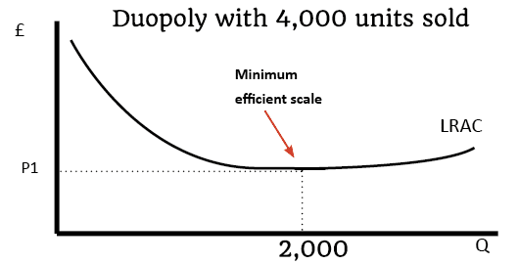
Figure 4: This graphic is considered Duopoly, where P1 is price and Q quantity (Pettinger,2012).

Oligopoly competition
The oligopoly competition is important for organisation structure, and it reflects on different areas such as energy, technology, and telecommunications. There is a purpose for oligopoly problems on the operation and economic side as well as formulation, analysis, and solution. In an oligopoly, there are not many firms just fewer large firms in the market, where firms know each other, and their reactions and actions can lead to counteractions. Also, oligopoly allows firms to use a percentage of employment input or output for both firms known as concentration ratios. Having product differentiation will help firms to advertise and promote their brand and to be in a good position against their competitors. Oligopoly can have two categories – non-collusive they will use strategies against each other where disagreement is likely to occur between them will not allow them to find a solution for their issue and collusive oligopoly firms will work as a team to find a solution for their issues as uncertainly my happen and cannot predict it (Griffiths, Wall, 2011).
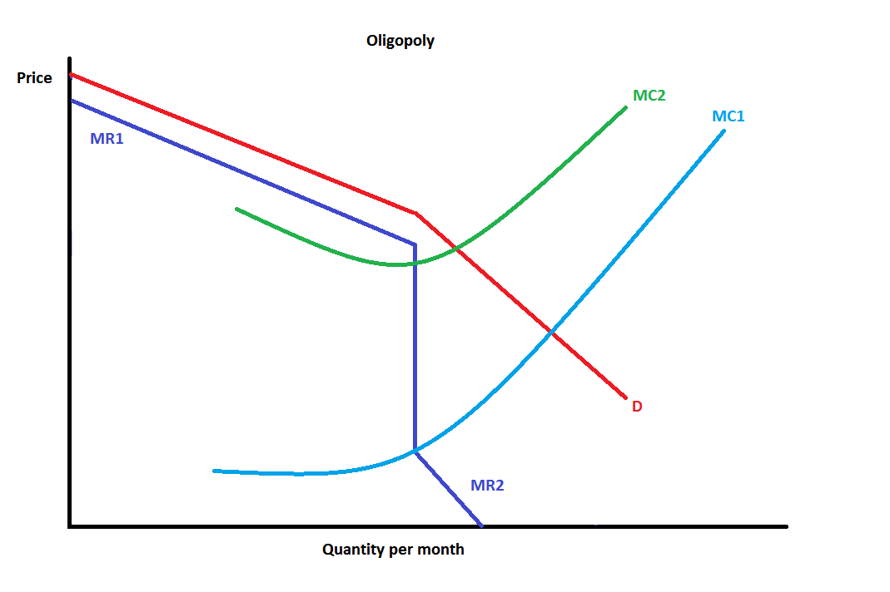
Figure 5: This graph represents market structure Oligopoly; the blue line MR1 and MR2 represent marginal revenue; the red line D represents demand; the baby blue MC1 and green MC2 represent marginal cost (microeconomics,2012).
This table displays the advantages and disadvantages of oligopoly competition, please refer to table 5.
Advantages | Disadvantages
Behavior (strategy on decision making) | Barrier to entry
Invest in the research department | Collusion (will lead to less competition)
They will provide enough information to costumers | Not behaving in a good manner can influence decision making
Innovative product | Many firm’s consumers will not have choice
Table 5 – This table shows the advantages and disadvantages of Oligopoly Competition.

How does it affect managerial decisions and examples
The ‘Game of theory’ is used by firms as strategic interaction on how both firms can influence each other by behaviours and choices they make (Sloman, Garratt, 2018). Oligopoly is considered to have few firms operating in the market which makes it difficult for managers when making the decision that can influence both companies, we can consider an example of other companies using product differentiation (Baye, Prince, 2016), for example, the pharma and automobile industry. As a business owner having a few Portuguese shops in the town as competitors and selling identical or slightly different products such as large and mini quiches they can charge a different or same price as other competitors this will give the option to decrease, increase or keep the price, manager decisions can affect other firms’ decision-making and vice versa. An example of monopolistic competition is restaurants charging a higher price for the quality of their food. Also, perfect competition is not real but abstract because of natural catastrophes in agriculture farmers may increase the product price to buyers.

Conclusion
Economists and firms use market structure to examine and evaluate competition in the market between rivals which can be affected by demand and supply, performance, and other factors on microeconomic and macroeconomic. From different firms’ competition will be higher, behave on decision making can impact both firms’ performance, consumers loyalty, profit, and productivity. A perfect competition price will be equal to marginal cost, homogeneous product, and the use of innovation on the design of product just to be slightly different from competitor. We can find monopoly competition to have a higher share in the market and the price will be charged as they want. For the monopolistic competition, there will be no demand because of other firms entering the market with new products and prices will be higher which is not efficient. On a duopoly competition, both companies compete in the market with their product in cooperative equilibrium for both firms’ benefit. The oligopoly competition has fewer large firms in the market with support or government involvement to control competition in the market.

Reference list
Baye, M, & Prince, JT 2016, Managerial Economics and Business Strategy, McGraw-Hill Higher Education, NY. Available from: ProQuest Ebook Central. [22 February 2022].
Cohen, A. (2004) ‘Market structure and market definition: the case of small market banks and thrifts’, Economics Letters, 85(1), pp. 77–83. Doi: 10.1016/j.econlet.2004.02.018.
Glenn (2012). Economic Thoughts with Glenn.
Griffiths, A. and Wall, S. (2011) Economics for business and management. Third edition. Harlow, England: Pearson Education Limited.
Honja, T. (2015). Managerial Decision Tools for the Efficiency of Perfect Competition: An Approach for Ensuring Economies of Scale in Perfectly Competitive Markets. European Journal of Business and Management, [online] 7(1). Available at: https://www.iiste.org/Journals/index.php/EJBM/article/viewFile/18880/19350 [Accessed 15 Feb. 2022].
Keat, P.G., Young, P.K.Y. and Erfle, S.E. (2014) Managerial economics: Economic tools for today’s decision-makers. Seventh edition. Harlow, England: Pearson Education Limited.
Kumar, R. (2009). Monopoly Market Structure. Available at: https://www.slideshare.net/rajesh1128/monopoly-market-structure [Accessed 24 Feb. 2022].
Marks, SG 2014, Managerial Economics, Wiley Textbooks, New York. Available from: ProQuest Ebook Central. [21 February 2022].
Microeconomics (2012). Comparing Market Structure. Available at: https://www.bing.com/images/search?view=detailV2&ccid=%2fgaS%2bTjr&id=85225EE7D9D5506A3A7AA6245EE1A9F3B89CB95D&thid=OIP._gaS-TjrHYKe0z0_frrLcgHaE7&mediaurl=https%3a%2f%2fth.bing.com%2fth%2fid%2fR.fe0692f938eb1d829ed33d3f7ebacb72%3frik%3dXbmcuPOp4V4kpg%26riu%3dhttp%253a%252f%252f3.bp.blogspot.com%252f-K76jRbq_TIE%252fT6VtRPm0BBI%252fAAAAAAAABAw%252fI9FjeBWa6bg%252fs1600%252foligopoly_graph.png%26ehk%3d0Sn15aEupzqrO%252bknZwkeUHLmHXJFMyZ3mGkGd9wiJ0E%253d%26risl%3d%26pid%3dImgRaw%26r%3d0&exph=712&expw=1069&q=types+of+market+structures+graph+oligopoly+competition&simid=608008429771767329&FORM=IRPRST&ck=29473D7E49A5C8B27102BDAFCA1F6EF3&selectedIndex=1&ajaxhist=0&ajaxserp=0 [Accessed 25 Feb. 2022].
Pettinger, T. (2020). Economics Help.
Sloman, J, & Garratt, D 2018, Essentials of Economics eBook PDF, Pearson Education, Limited, Harlow. Available from: ProQuest Ebook Central. [23 February 2022].
Vrankić, I., Herceg, T. and Pejić Bach, M. (2021). Dynamics and stability of evolutionary optimal strategies in a duopoly. Central European Journal of Operations Research, 29(3), pp.1001–1019.

