Assessment 1
Organisational Structure & Culture in airline industry



Course: BA Business Management
Module name: Introducing the Modern Workplace
Module code: LCBB4003
Lecture name: Aparna Venkatesan
Student Name: Sali Refat
Student ID: 2122704

Contents
1.0 Introduction 1
2.0 Company background 1
3.0 Organisational structure and culture of British Airways 1
3.1 Organisational structure of British Airways 2
3.1.1 Matrix Organisational Structure 2
3.2 Organizational Functions of British Airways 2
3.3 Organisational culture of British Airways 4
3.4 Relation of the Functions with Organisational Structure 5
4.0 Different factors in British Airways that influences its employees’ behaviours 5
4.1 Work culture: 6
4.2 Organisational leadership: 6
4.3 Employee job responsibilities: 6
4.4 Work-life balance: 6
4.5 Cultural background 6
5.0 Behavioural approach to management 6
5.1 Extrinsic motivation: 6
5.2 Intrinsic motivation: 7
5.1.1. Physical requirements 7
5.1.2. Safety 8
5.1.3. Love and belonging 8
5.1.4. Esteem 8
5.1.5. Self-actualization 8
6.0 Conclusion 8
References 9

1.0 Introduction
The success of an organisation is dependent on both a strong foundation and a vibrant culture working together. By concentrating on these aspects, a company may easily recruit new clients and make up lost ground in the face of increasingly intense competition. The success of an organisation, regardless of its size, is directly correlated to the structure of its internal operations. This analysis examines British Airways from the inside out, delving into the company's structure, culture, and how those elements interact to shape the airline's success. Numerous internal factors at British Airways that affect employees' behaviors are also briefly discussed.

2.0 Company background
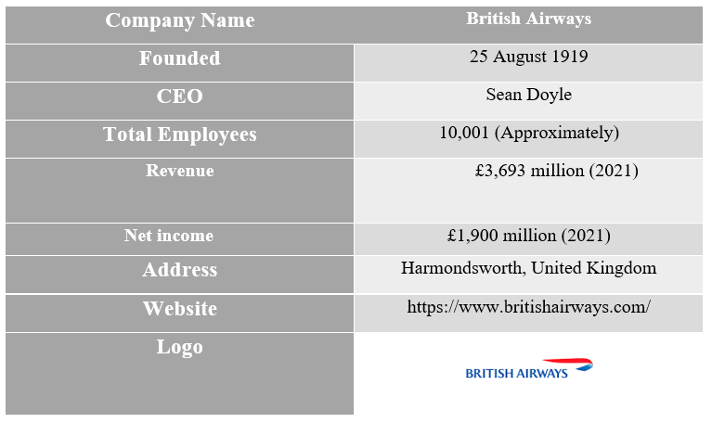
Figure: Company background of British Airways
Source: (British Airways, 2022)

3.0 Organisational structure and culture of British Airways
A company's organisational structure describes the chain of command that led to the completion of a certain operation. It describes the duties and obligations of an employee in a specific organisation (Harvey and Turnbull, 2006).

3.1 Organisational structure of British Airways
British Airways' organisational structure and culture are highly intertwined and mutually influential on the company's bottom line (Jarvis, 2014). It is crucial to have a firm grasp of organisational culture, structure, and business performance in order to comprehend the impact of culture and structure on British Airways' bottom line (Ryall and Craig 2003). British Airways uses a matrix structure, one of several possible organisational structures.

3.1.1 Matrix Organisational Structure
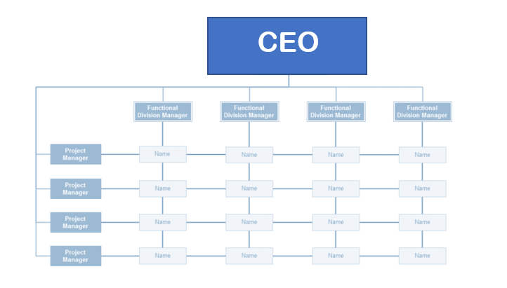
Figure: Matrix Organisational Structure
Source: British Airways (2022)
Workers in a matrix organisation report to both their superiors and each other in a grid-like structure rather than having a traditional chain of command (Mills, 2017). This means that workers may have to report to two managers, the functional manager and the product manager, depending on their specific job responsibilities (Harvey and Turnbull, 2006). This approach divides employees into teams that each report to a different manager, one of whom may be a project or product manager and another who may be functional. Workers at British Airways who operate inside a matrix structure have the chance to expand their skill sets by taking on a number of projects that demand for a variety of specialisations and approaches.

3.2 Organizational Functions of British Airways
Inside of large corporations, some of the most prevalent job roles are marketing, human resources, operations, information technology, accounting, customer service, and warehouse management (Madar, 2015). The efforts that British Airways is making to realise its strategic aims and realise its commercial aspirations have been met with support from all corners of the organisation. The following is information on the functioning of the company:
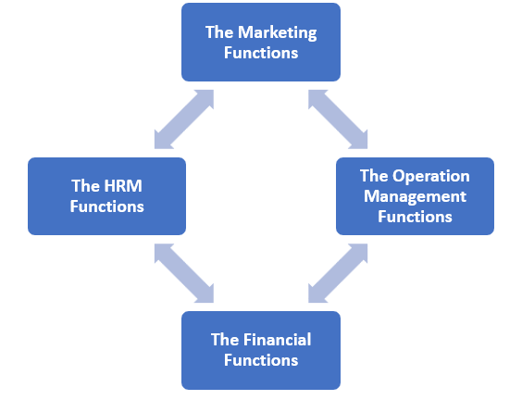
Figure: Organizational Functions of British Airways
Source: British Airways (2022)
3.2.1 The Marketing Functions
British Airways targets middle- to high-income customers, according to its market segmentation analysis (Jarvis, 2014). British Airways' marketing department advertises the company's brand, promotional events, and goods on television. British Airways' marketing approach includes customer relationship management, social media promotion, and brand community building (Harvey and Turnbull, 2006). The company also offers big discounts to Visa and Mastercard users who purchase online and on comparable services.
3.2.2 The HRM Functions
Human resource management at any company would likely utilise a comprehensive search approach to find candidates with the right expertise and skills (Mills, 2017). British Airways human resources and management division recruits, trains, motivates and manages employees.
3.2.3 The OM Functions
Operations management runs British Airways' airport operations and maintenance programmes (Madar, 2015). Airline operations management is crucial to these programmes' success in attracting new consumers. At the operational level, British Airways management organises and incorporates staff from throughout the organisation and maintains open communication and engagement.
3.2.4 The Financial Functions
The financial personnel is responsible for a variety of responsibilities, including but not limited to planning, budgeting, and the distribution of monies (Jarvis, 2014). The financial processes of British Airways guarantee that all corporate money as well as employee pay are dispersed in a manner that is both fair and responsible.

3.3 Organisational culture of British Airways
An organization's ideas, standards, and practises are mirrored in its members' opinions of themselves, the connections they have with other people, the things they do in the world, and the goals they have for the future (Harvey and Turnbull, 2006). Conventions of speech and behaviour that have been developed by a group of people over the course of some period of time form that group's culture. The cultural practises of British Airways include the company's values, traditions, and processes in addition to the company's overall operations. British Airways makes extensive use of two of Charles Handy's four kinds of culture, namely role culture and task culture (Harvey and Turnbull, 2006). In a society that is focused on accomplishing certain tasks, different people will collaborate for the express goal of getting the job done. There are many different ways in which workers might profit from being part of a task culture. For instance, since they have a larger voice in the choices that the team makes, they could be more driven to put in long hours of labour. The standard operating procedure at British Airways is to treat all employees and customers the same, regardless of their race, gender, age, religion, sexual orientation, or any other factor that could make either group feel unwelcome. This policy applies to both domestic and international travellers (Madar, 2015). Before boarding their aircraft, passengers are greeted warmly by staff members, and they are subjected to the highest possible level of a safety screening. British Airways places a high priority on the safety and well-being of its passengers. The organisational culture of British Airways places a focus on providing safe and entertaining flights as well as superior service to passengers. Because they do not want to put their customers in danger, they do a thorough inspection of the aeroplane before boarding begins (Jarvis, 2014). They invest a significant amount of money into maintaining a fleet of cutting-edge aircraft with first-rate amenities in order to satisfy the needs of their customers and provide an enjoyable trip.

3.4 Relation of the Functions with Organisational Structure
The efficiency of an organisation is the product of a number of interconnected factors. The Finance department of British Airways is in charge of all financial concerns that are linked to employees. This includes, but is not limited to, paying for employee activities, salaries, and expenses; rewarding and disciplining workers; and a variety of other responsibilities (Maertens,2018). British Airways has a system in place to ensure that all of its departments are cooperating with one another to achieve a common goal; this system maintains both the overall strategy of the corporation as well as the ties between its many divisions (Harvey and Turnbull, 2006).

4.0 Different factors in British Airways that influence its employees’ behaviours
Organizational culture has a substantial impact on the effectiveness and efficiency with which employees perform their duties (Jarvis, 2014). The many aspects of British Airways that have an effect on the behaviours of its personnel are reliant on a number of other factors. Depending on these criteria, BA exerts control over the behaviours of its employees for the purpose of advancing the firm. Some of these aspects are discussed as follows:

Figure: Factors influencing the behaviour of British Airways employees
Source: (Airways, 2017).
4.1 Work culture: The culture of the firm has a significant role in affecting the actions and behaviours of BA workers (Hopper, 2020). Two of the flexible work choices that BA offers include job sharing and working from home. BA gives remuneration that is in line with both the worth of the position and the going rate for it in the market. There are opportunities for advancement and the development of new skills, but doing so comes at a cost. When BA is effective, the company as a whole reaps the rewards.

4.2 Organisational leadership:
Effective organisational leadership at British Airways (BA) inspires and encourages individuals to attain better levels of performance, and it motivates those workers with a variety of different opportunities, including the BA Club, income protection, discounts, pension, and childcare vouchers (Soni and Soni, 2016).

4.3 Employee job responsibilities:
A large diversity of tasks and duties may lead to burnout for workers, with all the negative repercussions that entails, making employee job obligations a significant factor influencing employee behaviour at BA (Mills, 2017).

4.4 Work-life balance:
The degree to which employees of BA are able to achieve a balance between their job and personal lives has a direct and profound impact on them as individuals. If British Airways workers do not have a healthy work-life balance, it is quite probable that this will have a negative impact on their behaviour and performance on a variety of different levels.

4.5 Cultural background
Similarly, cultural background, interpersonal skills, and competencies, and other individual-specific elements all have a significant impact on employee behaviours in the workplace.

5.0 Behavioural approach to management
The behavioural management theory stunned the management world by emphasising the necessity to consider the dynamics among workers (Hopper, 2020). To attain their maximum potential and excel in their personal and professional life, everyone needs motivation. It is essential for the organisation since it motivates employees and increases production. British Airways, a global leader in the aviation industry, understands the need of building an atmosphere in which workers feel appreciated and respected in order for them to reach their maximum potential. There are two basic forms of inspiration described here:
5.1 Extrinsic motivation: This is the form of incentive that is most common in companies like BA since it has a big effect on employee behaviour and production. Exogenous effects include things like rewards, incentives, privileges, and even activities that have been planned out in advance (Biswas, 2010). Companies such as British Airways make use of it since it is the single most significant aspect in the equation when trying to spark the interest of their employees in working for the firm.
5.2 Intrinsic motivation: It is conceivable that an employee's behaviour and performance in the job might be significantly influenced by intrinsic motivational factors such as acceptance, curiosity, authority, social ties, and independence (Soni and Soni, 2016). The management of British Airways will benefit from this since it will make it easier for them to retain their top employees (Lester, 2013). In addition, British Airways employs certain ideas of motivation in order to modify the behaviour of its workers and make them more focused on achieving a shared objective. Maslow's hierarchy of needs is one such theory of motivation.
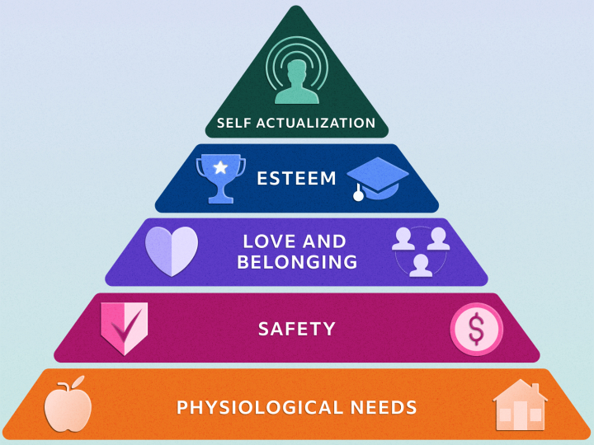
Figure: Maslow’s hierarchy of needs in British Airways
Source: (Szuster, 2008).
At each tier, employees of British Airways are provided with a unique set of benefits designed to make them happy at work.

5.1.1. Physical requirements
British Airways employees have access to the essential resources and opportunities at work, enabling them to feel that their basic needs are being met (Hopper, 2020). British Airways offers its staff clean bathrooms, planned meals and snack breaks, and a nice work environment. British Airways offers its employees with a livable salary, allowing them to afford food, housing, and utilities.

5.1.2. Safety
British Airways’ commitment to employee safety may potentially have an impact on the job satisfaction of its employees (Mills, 2017). British Airways employees have faith in the company's dedication to their safety on the job. The employees of British Airways must also feel emotionally protected and supported as part of their job security.

5.1.3. Love and belonging
British Airways employees experience a small shift in their love and belonging needs at work compared to other parts of their lives at the same level of Maslow's scale (Lester, 2013). British Airways personnel could be less committed to their jobs and less driven to achieve if they don't feel like they belong in the company.

5.1.4. Esteem
The employees of British Airways consider they are contributing to a greater purpose and being valued (Airways, 2017). It is essential for employees to feel as if they are growing, advancing, and achieving success on the work, and that others recognise this. Staff members at British Airways are more likely to achieve success if they possess self-assurance and get positive feedback.

5.1.5. Self-actualization
British Airways is committed to helping its workers reach the pinnacle of self-actualization on Maslow's hierarchy of needs (Soni and Soni, 2016). British Airways workers choose to ensure they are making a positive impact in their roles, as this drives them forward in their careers.

6.0 Conclusion
In the opinion of many, a company's bottom line may benefit from investing in its workers' happiness since doing so increases worker satisfaction, engagement, and motivation, all of which lead to greater output. And for better output, a well-established culture and the appropriate organisational structure to sustain it are essential. In order to achieve its full potential, British Airways should prioritise the aforementioned elements.

References
- British Airways (2022) About British Airways, About BA | British Airways. Available at: https://www.britishairways.com/en-us/information/about-ba (Accessed: December 19, 2022).
- Airways, B., 2017. British Airways. Where we fly.[online] Available at: https://www. britishairways. com/travel/where-we-fly/public/en_gb/map [Accessed 13 November 2017]. Search in.
- Balmer, J.M., Stuart, H. and Greyser, S.A., 2009. Aligning identity and strategy: Corporate branding at British Airways in the late 20th century. California Management Review, 51(3), pp.6-23.
- Grugulis, I. and Wilkinson, A., 2002. Managing culture at British Airways: hype, hope and reality. Long Range Planning, 35(2), pp.179-194.
- Grundy, M. and Moxon, R., 2013. The effectiveness of airline crisis management on brand protection: A case study of British Airways. Journal of Air Transport Management, 28, pp.55-61.
- O'Leary, M., 2002. The British Airways human factors reporting programme. Reliability engineering & System safety, 75(2), pp.245-255.
- Madar, A., 2015. Implementation of total quality management Case study: British Airways. Bulletin of the Transilvania University of Brasov. Series V: Economic Sciences, 8(1).
- Mills, A.J., 2017. The gendering of organizational culture: Social and organizational discourses in the making of British Airways☆. In Insights and Research on the Study of Gender and Intersectionality in International Airline Cultures. Emerald Publishing Limited.
- Harvey, G. and Turnbull, P., 2006. Employment Relations, Management Style and Flight Crew Attitudes at Low Cost Airline Subsidiaries:: The Cases of British Airways/Go and bmi/bmibaby. European Management Journal, 24(5), pp.330-337.
- Jarvis, P., 2014. British Airways: An Illustrated History. Amberley Publishing Limited.
- Szuster, D., 2008. Green Marketing-A Case Study Of British Airways. Aalborg University.
- Lester, D., 2013. Measuring Maslow's hierarchy of needs. Psychological reports, 113(1), pp.15-17.
- Soni, B. and Soni, R., 2016, July. Enhancing Maslow's hierarchy of needs for effective leadership. In Competition Forum (Vol. 14, No. 2, p. 259). American Society for Competitiveness.
- Hopper, E., 2020. Maslow’s hierarchy of needs explained. ThoughtCo, ThoughtCo, 24.

