University of Wales Trinity Saint David
Wales Institute of Science and Art


Electronic Circuits Testing and Applications

Vehicle Electronics
(ACHA4031)

Owain Holgate
2404061
26/04/2026
Contents
1 Task 3 1
1.1 Scope Time Division Calculations (6) 1
1.2 Function Generator output square wave (6) 2
1.3 Capacitor charge and discharge wave marked at correct points. (6) 3
1.4 Basic Capacitor Calculations (6) 4
1.5 Capacitor discharge table (5) 5
1.6 Plot log(V) Gradient (5) 6
1.7 Gradient Calculations and Compare(8) 7
1.7.1 Gradient Calculations 7
1.7.2 Comparison table 7
1.8 Capacitor Uses (5) 8
1.9 Inaccuracies Question (4) 9
1.10 Risk Question (10) 10
2 References 11

Task 3

Scope Time Division Calculations (6)
1 complete wave form occupied 1 full width of the screen. Therefore the scope time division calculation would be 40/10 = 4. This is because the total time of one wave form over the number of horizontal divisions.

Function Generator output square wave (6)
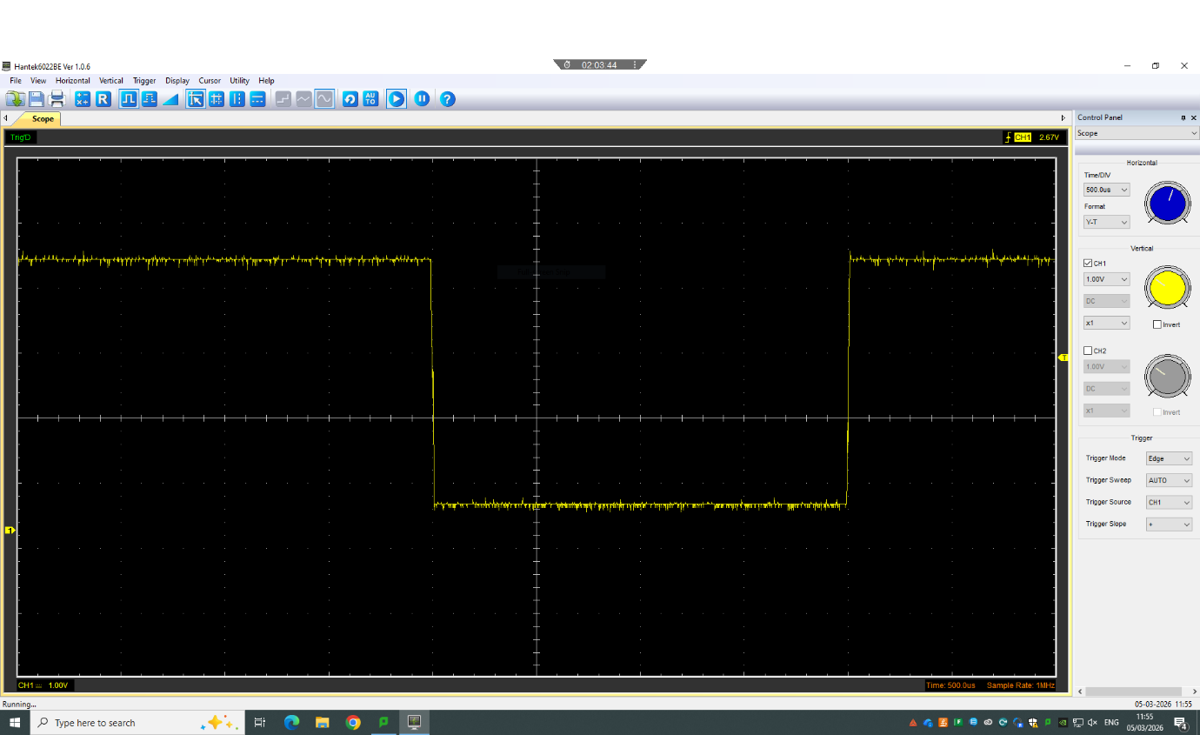
(Figure 1: Oscilloscope capture of a square wave signal)

Capacitor charge and discharge wave marked at correct points. (6)
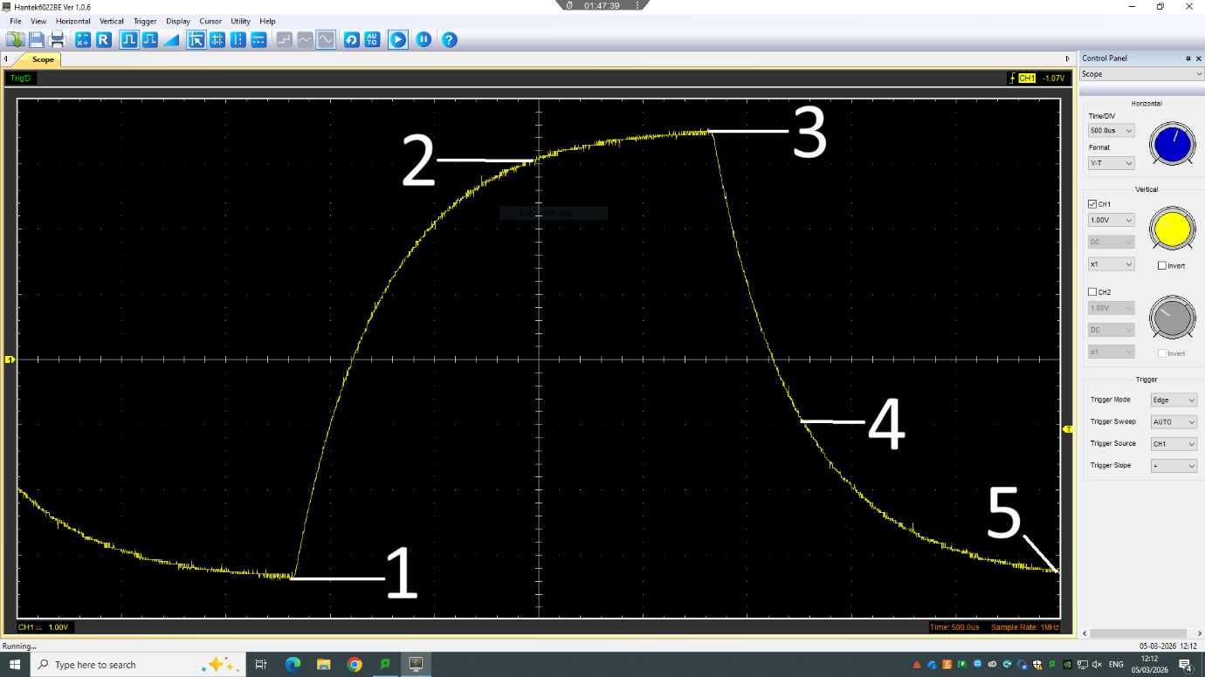
(Figure 2: Annotated oscilloscope capture of a transient waveform)

Annotation 1 shows the starting point of the charge. Annotation 2 shows the time constant point (t) which is 63% of the maximum voltage. Annotation 3 shows the Vmax where it is fully charged and the start of the discharge as the graph begins to drop straight after. Annotation 4 shows the time constant during discharge (t) which is 37% of the Vmax. Annotation 5 shows the fully discharged region where the curve levels off near zero.

Basic Capacitor Calculations (6)

In order to calculate the capacitance the required equation is Tau(t) = R*C. Once rearranged it creates the equation C = t/R. When the units are inputted this becomes (4*10^-3)/40 = (1*10-4), this means that Tau(t) is 100μF

Capacitor discharge table (5)
Time (s) | Voltage (V) | ln (V) | dy = y2 – y1  dy = ln(V)2-ln(V)1 | dx = x2- x1  dx = Time2 – Time1 | dy/dx
0 | 1.00 | 0.000 | x | x | x
0.0005 | 0.78 | -0.248 | -0.248 | 0.0005 | -496
0.0010 | 0.62 | -0.478 | -0.230 | 0.0005 | -460
0.0015 | 0.50 | -0.693 | -0.215 | 0.0005 | -430
0.0020 | 0.40 | -0.916 | -0.223 | 0.0005 | -446
0.0025 | 0.32 | -1.139 | -0.223 | 0.0005 | -446
0.0030 | 0.26 | -1.347 | -0.208 | 0.0005 | -416
0.0035 | 0.21 | -1.560 | -0.213 | 0.0005 | -426
0.0040 | 0.17 | -1.772 | -0.212 | 0.0005 | -424
0.0045 | 0.14 | -1.966 | -0.194 | 0.0005 | -388

Plot log(V) Gradient (5)

(Figure 3: Graph showing ln(V) against Time (s) with trendline)

Gradient Calculations and Compare(8)

Gradient Calculations
By taking the natural logarithm of the voltage the discharge of the capacitor could be analysed. The equation ln(V) = ln(Vo)-(t/RC) is able to derived from the exponential decay. Taken from the graph, the gradient is measured as -435.84 s^-1. Using the knows resistance of 40Ω and a calculated capacitance of C = -1/(Rm) we can substitute the values into an equation to get C = 1/(40 x 435.84) = 5.736x10^-5 F (57.35 µF) Comparing this to the value of 100 µF calculated earlier we can see a difference of -42.65 µF. The graph calculations are lower than the basic calculations, however when compared to the actual capacitance it can be seen that they are quite far apart.

Comparison table
 | Capacitance | Delta | Percentage difference
Actual | 1 µF | x | X
Marker Calculation | 100 µF | +99 | 9900%
Gradient Calculation | 57.35 µF | +57.35 | 5735%

Capacitor Uses (5)
Capacitors are used for multiple applications. For general electronics they are mainly used for smoothing power supplies, storing energy and controlling signals. They do this by reducing fluctuations in voltages after an AC to DC conversion. They also help reduce electrical noise and enable the use of timing functions in circuits such as delays and oscillations.
In an automotive setting, they help to stabilize voltage and protect the electronic components of the vehicle. For the ignition systems of vehicles, capacitors assist in delivering strong sparks for more efficient combustion. Along with this, they are used in electronic control units (ECUs) to protect sensitive components from electrical interference and help maintain a steady operation for the ECU. In addition, they improve the sound quality of car stereo systems by reducing voltage spikes.
For motorcycle’s, they are also used in ignition systems, especially in capacitor discharge ignition (CDI) units. They do this by storing energy and then rapidly releasing it to fire the spark plug. In addition, they help smooth rectified voltage from the alternator. This helps ensure the bike has consistent performance for electrical components such as the lights.

Inaccuracies Question (4)
As seen from the difference in the measured capacitances and the actual capacitances, some mistakes in the measurements have taken place. One of the largest issues for mistakes may be the tolerance of the components used for measuring. All capacitors have a tolerance that can range from -20% all the way up to +80%. (Electronics Tutorials (n.d.)) Due to this, there can be a difference in results expected. Another issue that may arise is a leakage of current. The dielectric inside of a typical capacitor is not a perfect insulator which causes a small amount of current to “leak” which can also cause inaccuracies in the results. (Electronics Tutorials (n.d.)) Temperature can also be a cause of inaccuracy, however it is unlikely as the temperature change in a room temperature environment wouldn’t be enough to cause any noticeable effect.

Risk Question (10)
ISO/SAE 21434:2021 is “an international standard that defines engineering requirements for cybersecurity risk management in the context of road vehicles.” (International Organization for Standardization, 2021) ISO/SAE 21434 is important due to the fact that the modernisation of vehicles means that they are becoming more dependant on software. Due to this they have a higher risk of cybersecurity threats such as taking control of vehicle systems, data theft, cyberattacks and high-voltage systems attack. (Ansys, n.d.) According to the ISO website, ISO/SAE 21434 is important as it allows cybersecurity to be managed in a planned and structured way. It also allows consistency in cybersecurity across multiple companies, allowing a more streamlined system. (International Organization for Standardization, 2021) The ISO website highlights key benefits of the ISO/SAE 21434 standard, such as “Risk reduction, Improved security posture, Lifecycle coverage, Supply chain alignment, Regulatory readiness and Integration with functional safety.” These benefits cover the risks, strengths of the security and how it may be integrated into current automotive standards. The ISO/SAE 21434 covers all electrical and electronic components of a vehicle which include hardware, software and communication. This means that the entire vehicle can be managed and protected from harmful attacks. ISO/SAE 21434 isn’t mandatory for companies to follow, however, it is increasingly becoming more popular due to the standards that the automotive industry is expecting companies to follow. The recommended users for ISO/SE 21434 are “Automotive OEMs, Tier 1 and Tier 2 suppliers, and any organization involved in the design, development, or maintenance of vehicle E/E systems.”. (International Organization for Standardization, 2021)

References
- International Organization for Standardization (ISO), 2021. ISO/SAE 21434:2021 Road vehicles — Cybersecurity engineering. Available at: https://www.iso.org/standard/70918.html (Accessed: 26 April 2026).
- Ansys, n.d. What is automotive cybersecurity? Available at: https://www.ansys.com/simulation-topics/what-is-automotive-cybersecurity (Accessed: 26 April 2026).
- Electronics Tutorials (n.d.) Capacitor characteristics. Available at: Capacitor characteristics page (Accessed: 26 April 2026).

