

The Global Business Environment
LCBB4005

Student Name: Gabriela Vasilica Coteneanu
Student ID: 2243467

Table of Contents
Introduction 3
Business and Environmental Analysis 4
PESTLE Analysis on India for Foreign Companies 4
Porter’s Five Forces Model on India 6
Challenges and Opportunities in India 7
Corporate Governance 7
Business Strategy 8
Cultural Sensitivity 9
Barriers for Foreign Companies 10
Recommendations for Businesses in India 11
Conclusion 12
References 13

Introduction
International commerce involves trading goods, services, and resources across borders. Multinational enterprises' cross-border trade, investments, and operations are grouped together. In today's interconnected world, international commerce has grown as companies strive to expand, penetrate new markets, and better utilise global resources. Any international corporation must consider the local business climate (Worthington & Britton, 2014). Political, economic, social, technical, and legal variables affect business. By analysing the local business climate, companies may learn about a country's potential, risks, and growth. India is a growing nation that has flourished in international trade. India is the world's largest democracy and second-fastest growing major economy. India's vast consumer market, educated workforce, and convenient location attract businesses and investors from around the world. India business has pros and cons. Multinational firms are welcomed by economic reforms, liberalised rules, and reduced foreign investment restrictions. By improving infrastructure, promoting innovation, and reducing red tape, the Indian government has streamlined business (Islam & Kharkongor, 2012). To succeed in India, companies must conduct environmental study and develop appropriate plans. This requires knowledge about the country's politics, economics, culture, competition, technology, and laws. Businesses may better understand Indian market trends and risks and establish effective entry strategies, company models, marketing plans, and operational frameworks by analysing these components.

Business and Environmental Analysis

PESTLE Analysis on India for Foreign Companies
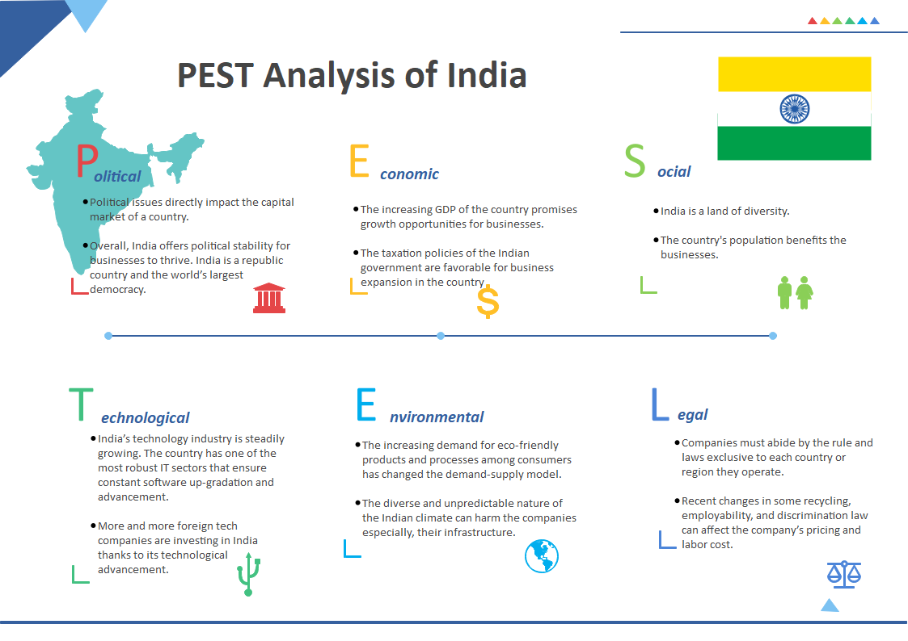
The PESTLE study is a tool for assessing the potential effects of external variables on a country's business climate (HIREMATH & C, 2021). Researching the market's political, economic, sociological, technical, legal, and environmental variables aids in making informed business decisions. India's PESTLE analysis is as follows:
Figure 1 PESTLE Analysis on India (Endrawmax.com, 2021)

Political Factors
India is the largest and most stable democracy in the world. However, it also has problems like bureaucracy and corruption. India's political climate and government policies have significant effects on the country's business climate (Sinha, 2017). India is becoming an increasingly popular place to put money because to the government's efforts to improve its business climate and encourage foreign direct investment (FDI).
Economic Factors
Despite some difficulties brought on by the COVID-19 epidemic, India has remained one of the world's fastest-growing major economies (Sharma & Sachdeva, 2023). Businesses may benefit greatly from the country's enormous consumer market and rising middle class. Growth in Gross Domestic Product, Inflation Rates, Government Spending, Infrastructure Investment, and Monetary Policy from the Reserve Bank of India are all crucial elements of the Indian economy (RBI).
Sociocultural Factors
India is a multicultural melting pot, home to people of many different languages, faiths, and customs. It is essential for companies doing business in India to have an appreciation for local customs and consumer tastes. Consumer behaviour and market demand may be considerably affected by factors such as population demographics, urbanisation, social views, lifestyle shifts, and educational levels.
Technological Factors
India is quickly becoming a leading centre for information technology (IT) services and innovation due to its rapid technological development (Das, 2020). Initiatives like Digital India and Make in India are being pushed by the government because of their emphasis on technical progress and the creation of digital infrastructure. Internet accessibility, mobile phone usage, R&D efforts, and industry-wide uptake of new technologies are all examples of technological influences.
Legal Factors
Several statutes and regulations control commercial activities in India (Samajpati, 2022). Laws and regulations in this category cover matters such as employment, intellectual property, taxes, business practises, and the environment. It is important for businesses to follow these regulations and monitor legislation for any changes that might affect their operations.
Environmental Factors
Air pollution, water shortages, deforestation, and waste management are just a few of India's environmental problems. The government has launched programmes to deal with these problems and promote sustainable behaviour. Consumers' growing environmental consciousness has the potential to shape companies' long-term goals, new product designs, and CSR programmes.

Porter’s Five Forces Model on India
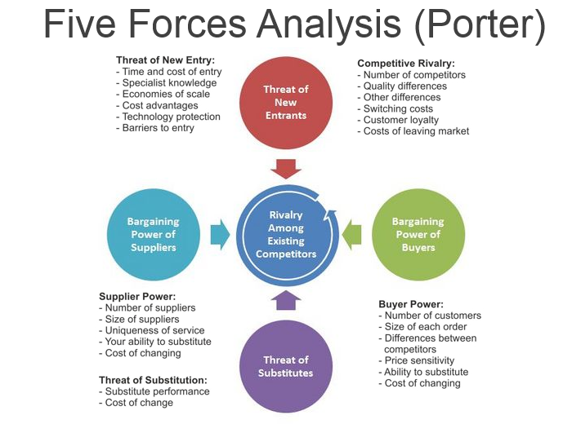
The five forces of Porter's model provide a framework for assessing the attractiveness and competitiveness of a market or sector. Let's analyse India using Porter's five forces:
Figure 2 Porter's Five Forces Model (Bethanyryalls, 2015)

Threat of New Entrants: India's enormous and varied consumer base makes it an attractive location for startups in a wide range of fields. But there are several obstacles to new entrants breaking into the market, including government rules, capital needs, and existing competing companies in various areas (Tiwari, 2023). Also, new entrants may have trouble finding success in India without first learning the ins and outs of the country's culture and market.
Bargaining Power of Suppliers: Indian suppliers negotiate sectorally. Suppliers may have less impact in businesses with abundant raw materials. In enterprises with unique inputs or concentrated supplier bases, suppliers can dictate price and conditions. Government rules and international trade dynamics may impact suppliers' negotiating power.
Bargaining Power of Buyers: India's vast and price-conscious client base gives buyers a lot of influence. They have high criteria for value, quality, and service and may easily switch brands. Replacements and company competition give buyers additional power. In high-switching-cost or brand-loyalty marketplaces, customers may have less influence.
Threat of Substitute Products or Services: Variety and options characterise the Indian market. Most Indian customers have several options. Businesses like mine face tougher competition in India. Technological advancements and changing consumer tastes may also introduce new competitors.
Competitive Rivalry: India's huge population and growing middle class make competition strong. Numerous firms compete in many fields. Price, product differentiation, brand loyalty, and distribution networks impact competitive dynamics (indiatimes.com, 2023). Consolidation has reduced industry leaders.

Challenges and Opportunities in India
Corporate governance, company strategy, and cultural sensitivity are all areas where doing business in India may bring possibilities and problems. Let us take a look at each one separately.

Corporate Governance
Opportunities
Transparency: Companies in India can benefit from a growing public interest in and emphasis on corporate governance by adopting more open policies.
Building Trust: Those who work for and with a company might have more faith in it if it complies with corporate governance standards.
Challenges
Structured complexity of regulations: Businesses in India may have difficulties with compliance and managing bureaucracy due to the country's convoluted legal and regulatory framework (Rajagopalan & Zhang, 2012).
Disregard for the law: There have been some positive developments, but there are also cases of lax enforcement of corporate governance standards that pose threats to businesses.
Example: The corporate governance problems in India were brought to light by the Satyam Computer Services controversy in 2009. The company's chairman had altered financial accounts, which had disastrous effects for the business (Almeida, 2023). The event highlighted the need for improved corporate governance policies and procedures.
Managing Aspect
- To achieve conformity with corporate governance rules, businesses should set up reliable internal control procedures and ethical frameworks.
- Independent board members can add new points of view and a greater sense of objectivity to decision-making.
- Audits and external reviews should be conducted often to assist find and fix compliance issues.

Business Strategy
Opportunities
Massive customer base: Companies may take advantage of the large consumer base and expanding demand in India.
Increase in the middle-class society: The growing disposable income of India's middle class has opened up new opportunities for business growth and the introduction of novel products (Singh & Chaudhuri, 2009).
Challenges
Contrasting market dynamics: India is a multicultural country where people from different areas speak different languages and have different cultural norms and shopping habits. It might be difficult to grasp these subtleties and adjust tactics properly.
High competition: Businesses in India need to set themselves out from the crowd if they want to thrive in the country's cutthroat market.
Example: Due to laws and the dominance of local companies, Walmart's attempt to enter the Indian retail industry was met with several obstacles. To capitalise on its existing position in India, the company shifted its business approach by forming a partnership with the e-commerce site Flipkart (walmart.com, 2020).
Managing Aspect:
- Find out what people in your target market want and need, then give it to them.
- Construct reliable distribution channels for efficient client reach across geographic boundaries.
- Gain insight into the market and break through any regulatory roadblocks by teaming up with local partners or acquiring existing enterprises.

Cultural Sensitivity
Opportunities
Rich cultural heritage: India's diverse culture provides opportunities for companies to incorporate local traditions and values into their products and marketing strategies, increasing their appeal to the target audience (Samanta, 2013).
Skilled workforce: India has a large pool of skilled professionals who can contribute to business growth and innovation.
Challenges
Language and communication barriers: India's linguistic diversity makes it difficult to communicate with a wide range of stakeholders.
Structure in a hierarchy: Businesses in India frequently follow a hierarchical structure, which can affect decision making and calls for familiarity with local customs.
Example: Because of India's large vegetarian population, McDonald's adapted their menu there to include vegetarian alternatives such the McAloo Tikki Burger and the McVeggie Burger (Fulton, 2012). This strategy was essential in giving them a solid foundation in the Indian market.
Managing Aspect
- Help people communicate more easily by spending money on language classes and translation services.
- Align managerial practises with cultural norms to encourage teamwork.
- Recruit natives who are well-versed in the culture of the area and can represent the company as cultural ambassadors.

Barriers for Foreign Companies
- Administrative and legal roadblocks: India's complex and cumbersome regulatory environment may cause problems for foreign enterprises. Obtaining licences and permits and following local requirements may be laborious and time-consuming. Walmart struggled to enter India due of its complex retail laws.
- Lack of infrastructure: Foreign companies operating in India may have hiccups due to the country's insufficient transportation networks, electricity shortages, and lack of access to high-quality services (Jain, 2018). Unreliable electricity, for instance, can halt production and force companies to spend more on expensive backup systems.
- Language and cultural barriers: India's diverse culture and multilingual population may make communication and cultural understanding challenging for foreign enterprises. Familiarity with local customs, dialects, and conventions is vital for business success. Starbucks revamped its menu and stores for Indian customers.
- Restricting access to markets and instituting tariffs: India has historically protected domestic industries through protectionist policies. These include import taxes and foreign direct investment restrictions (FDI). The Indian government restricts foreign investment to protect its e-commerce business.
- IPR issues: Piracy, counterfeiting, and a lack of enforcement of intellectual property laws all pose problems for intellectual property protection in India. This may prevent international firms from engaging in R&D or releasing ground-breaking new goods. For instance, pharmaceutical firms in India have had to deal with patent infringement lawsuits.
- Complicated tax system: India has a tax system that is difficult to navigate for international businesses (Nainwal, 2015). The complexity and cost of complying with various federal, state, and municipal tax requirements. Vodafone and the Indian government have been at odds over taxes for years.
- Lack of Qualified Workers: Multinational firms typically lack expertise despite India's massive workforce. Finding skilled workers may affect a company's operations. Google and Microsoft are two of several IT corporations that have gone to India for their skilled labour.

Recommendations for Businesses in India
Learn about the Indian marketplace: Complete in-depth market research to learn about local customer tastes, purchasing power, cultural subtleties, and the nature of the local competitors. This will allow you to better target your offerings.
Building strong relationships: Relationship-building and networking are essential in India's competitive business environment. Spend effort cultivating relationships with prospective business associates, customers, and vendors. Decisions are heavily influenced by the people involved.
Pricing strategies: The purchasing power of the various segments of the Indian market varies widely. We might want to think about establishing competitive pricing strategies that target different demographics. Increasing your consumer base may be as simple as offering flexible payment alternatives (Riehl, 2019).
Supply chain management: Create reliable supply chain solutions to efficiently manage logistics and distribution. Infrastructure standards in India could differ from one location to another. To simplify logistics, you should talk to logistics companies in your area about forming a relationship.
Following the rules: Learn the Indian rules that apply to your business and act accordingly. Consult a lawyer to make sure your company is in compliance with intellectual property, tax, employment, and licencing rules.
Localization: To better connect with consumers in India, you need modify your offerings, advertising, and methods of contact accordingly. Think about issues like translation, cultural sensitivity, and local laws. Customer involvement and satisfaction can be boosted through localization initiatives.
Digital marketing and online sales: Take advantage of the booming e-commerce market in India by creating a strong online presence (Patil, 2019). Create accessible, mobile-friendly online experiences or applications. Reach out to your audience and keep them interested by employing digital marketing methods.
Local talent acquisition: Hire local talent who have a deep understanding of the Indian market and can navigate cultural nuances. This includes skilled professionals who can assist with market entry strategies, customer relationship management, and local language proficiency.

Conclusion
In conclusion, global business is complicated and dynamic, offering both possibilities and challenges. We've examined global business's economic, technical, geopolitical, social, and cultural dimensions. Economic globalisation ruled. Globalization has expanded markets, exchanged products and services, and enriched companies. Businesses must handle market-specific legislation, cultural norms, and customer behaviour due to interconnection. Technology boosts organisational productivity, innovation, and knowledge. AI, big data, and blockchain have changed business perspectives and created new opportunities. Global competition requires this technology. Trade policy, political stability, and regulations impact global business (Lakshman, 2015). Politics, trade disputes, and protectionist laws may significantly affect cross-border commerce and investment, forcing companies to constantly watch and adjust their strategy. Culture affects global trade. Marketers, product designers, and customers must consider local consumer preferences, social values, and cultural diversity. Global business requires strategic agility, adaptability, and resilience. Competing requires global trends, market dynamics, cross-cultural skills, and new technology. Global enterprises have various opportunities and problems. Globalization, technology, geopolitics, social reasons, and cultural factors may help businesses thrive in this changing world. Awareness, adaptation, and proactivity are needed to navigate the global business climate and achieve sustainable growth.

References
Almeida, A. (2023) Satyam scam - the story of India’s biggest corporate fraud!, Trade Brains. Available at: https://tradebrains.in/satyam-scam/ (Accessed: 28 July 2023).
Das, S. (2020) ‘Disruptive technological change, factor accumulation, and inequality: Evidence from India’, SSRN Electronic Journal [Preprint]. doi:10.2139/ssrn.3826579.
Endrawmax.com (2021) Detailed Pestel Analysis of India: EdrawMax Online, Edrawsoft. Available at: https://www.edrawmax.com/article/india-pestel-analysis.html (Accessed: 28 July 2023).
Fulton, A. (2012) McDonald’s goes vegetarian - in India, NPR. Available at: https://www.npr.org/sections/thesalt/2012/09/04/160543754/mcdonalds-goes-vegetarian-in-india (Accessed: 28 July 2023).
HIREMATH, S. and C, DR.P. (2021) Pestle analysis of organized retailing in India [Preprint]. doi:10.31124/advance.16653532.
indiatimes.com (2023) Enhanced Competitiveness of India’s economy will attract more investments: Phdcci, The Economic Times. Available at: https://economictimes.indiatimes.com/news/economy/policy/enhanced-competitiveness-of-economy-will-attract-more-investments-phdcci/articleshow/100130479.cms?from=mdr (Accessed: 28 July 2023).
Islam, S. and Kharkongor, E. (2012) Business environment. New Delhi: Taxmann.
Jain, P. (2018) ‘Infrastructural Gap in India: The Pension Fund Option’, International Journal of Management Studies, V(Special Issue 2), p. 71. doi:10.18843/ijms/v5is2/09.
Lakshman, C. (2015) ‘Organization and Control Systems for India’, Doing Business in India, pp. 165–179. doi:10.1016/b978-1-84334-774-3.00010-7.
Nainwal, Ms.N. (2015) ‘Tax system in India-evolution and present structure’, PRAGATI : Journal of Indian Economy, 2(1). doi:10.17492/pragati.v2i1.6454.
Patil, Prof.S. (2019) ‘Demonitization and its impact on adoptation of Digital Marketing in India’, International Journal of Trend in Scientific Research and Development, Special Issue(Special Issue-FIIIIPM2019), pp. 174–178. doi:10.31142/ijtsrd23093.
Rajagopalan, N. and Zhang, Y. (2012) ‘Corporate governance in India’, The Convergence of Corporate Governance [Preprint]. doi:10.1057/9781137029560.0009.
Riehl, G. (2019) ‘Pricing to win’, Pricing Strategy Implementation, pp. 111–121. doi:10.4324/9780429446849-12.
Samanta, G. (2013) ‘Rethinking development, welfare and culture in India’, Space and Culture, India, 1(2), pp. 1–2. doi:10.20896/saci.v1i2.24.
Sharma, A. and Sachdeva, P. (2023) ‘Macroeconomic impact of the supply shock during COVID-19 pandemic in India’, Journal of Economic Studies [Preprint]. doi:10.1108/jes-09-2022-0474.
Singh, S.K. and Chaudhuri, A. (2009) ‘The reality of India: Folding Constraints into business strategy’, Journal of Business Strategy, 30(4), pp. 5–16. doi:10.1108/02756660910972604.
Sinha, A. (2017) ‘Political Economy of India’, Political Science [Preprint]. doi:10.1093/obo/9780199756223-0230.
Tiwari, A. (2023) What is the best market entry strategy for India, Enterslice. Available at: https://enterslice.com/learning/what-is-the-best-market-entry-strategy-for-india/ (Accessed: 28 July 2023).
walmart.com (2020) Walmart’s majority-owned Flipkart launches wholesale business to help small businesses in India source directly from manufacturers and producers, Corporate. Available at: https://corporate.walmart.com/newsroom/2020/07/23/walmarts-majority-owned-flipkart-launches-wholesale-business-to-help-small-businesses-in-india-source-directly-from-manufacturers-and-producers (Accessed: 28 July 2023).
Worthington, I. and Britton, C. (2014) The Business Environment, 7th Edition, Pearson
Samajpati, I. (2022) All you need to know about legal environment, iPleaders. Available at: https://blog.ipleaders.in/all-you-need-to-know-about-legal-environment/#:~:text=Competition%20Act%2C%202002-,Legal%20environment%20of%20business,laws%20governing%20the%20business%20ecosystem. (Accessed: 28 July 2023).

