Abby Poulson
BA Photography in the Arts
1702468
Creative Research – Paul Duerinckx

“It is useless and tedious to represent what exists, because nothing that exists satisfies me…. I prefer the monsters of my fantasy to what is positively trivial.”
Baudelaire, Salon Review 1859

Is Baudelaire’s position defensible in light of the case lens-based art-forms make to ‘represent what exists’?
Or, from a contemporary perspective, do the ‘monsters of fantasy’ still allow artists to engage with ‘what exists’ creatively?

Total Word Count:
1834

In Baudelaire’s Salon Review 1859, he famously emphasised that photography was an insignificant mechanical technique used for capturing reality. This was an opinion that was highly held throughout the 19th century during the industrial revolution. Photography’s ‘true duty’ was to be a ‘server of the sciences and arts’. It was to be used for exact actitude, like printing.

Baudelaire also believed that we mustn’t confuse art with industry – if photography were allowed to ‘encroach on the domain of the impalpable and the imaginary,’ then it would be worse for us all. Baudelaire describes that it is a ‘happiness to dream’ and wonders if the painter still knows happiness. Due to the industrialisation of photography, painters were becoming more and more given to painting not what they dream, but what they see. Photography was shaping the art world. Baudelaire’s remarks not only changed how photography was seen in the 19th century but also helped form a new contemporary perspective.
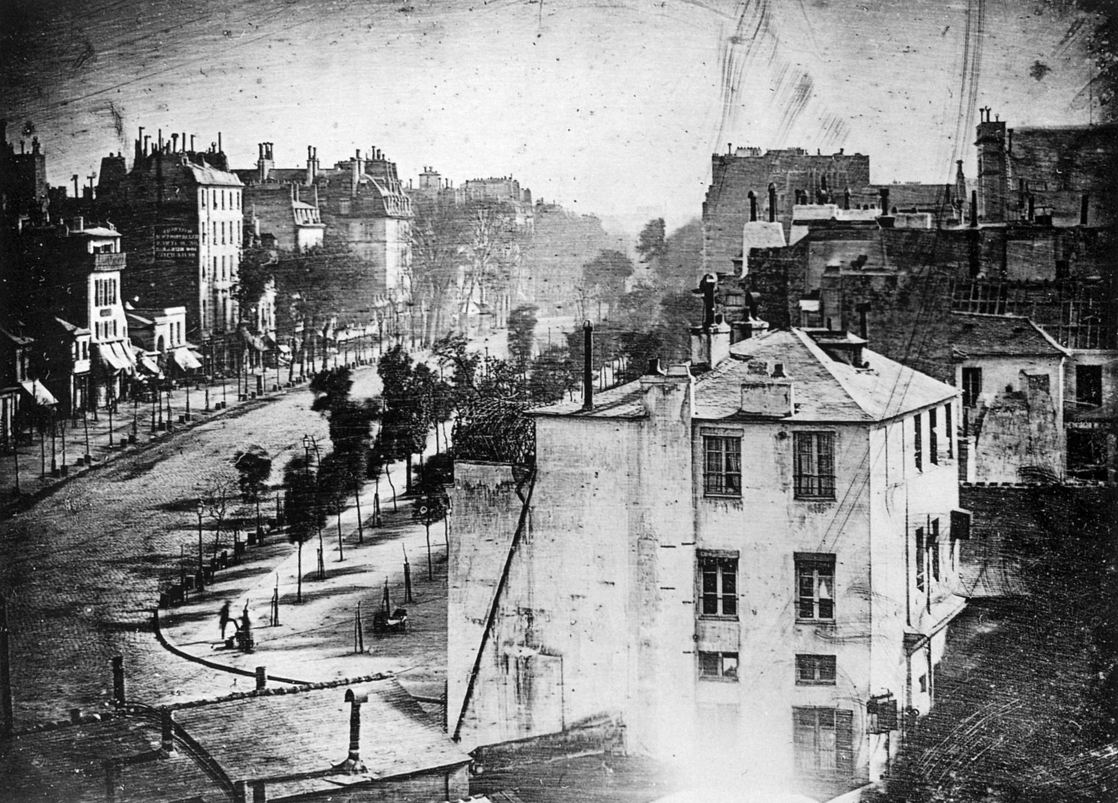

Louis Jacques Mande Daguerre, Two Views of the Boulevard du Temple, 1839.
The invention of the Daguerreotype in 1839 gave photography its first commercially successful photographic process. It was named after its inventor Louis Daguerre, a French artist and photographer. Once commercialised, the Daguerreotype became popular for portraiture amongst those who could afford it. Each daguerreotype had a remarkably detailed, one-of-a-kind photographic image. Its details had a higher resolution than what exists inside digital cameras today. Gustavson, T., 2009. Camera: a history of photography from daguerreotype to digital. Published by Sterling Innovation.

The method of permanently replicating ‘what exists’ had been achieved, this could not be previously achieved by a painting, therefore it became very desirable. This encouraged a new art movement called Realism, which began in France during the 1850s. The movement was inspired by the realism of photography, where even paintings were painted in a photographic way, capturing detail and light.

Following the first mechanized conflict of the First World War, many artists began to experiment with the mechanisms of image making during the development of a new photographic movement, called The New Vision. The 1920s and 1930s was an experimental time for photography, where artists began to approach traditional photographic techniques such as photograms and photomontages to create abstract imagery. This was strongly influenced by the radical teachings in Bauhaus. Hochman, Elaine S., 1st edition 1997. Bauhaus, Crucible of Modernism.

Artist and Bauhaus professor, Laszlo Moholy-Nagy’s interest in photography encouraged his belief that for artists to understand the current state of vision, they must specialise in modernizing their practice, and not restrict their practice to the historical teachings of art.

"The reality of our century is technology: the invention, construction and maintenance of machines. To be a user of machines is to be of the spirit of this century. It has replaced the transcendental spiritualism of past eras.”
“Constructivism and the proletariat” reproduced in Moholy-Nagy’s book “Experiment in Totality”, New York: Harper & Brothers, 1950, p. 19.Laszlo Moholy-Nagy, 1922

Moholy-Nagy encouraged artists to be forward thinking, as the world was progressing rapidly. Artists began to realise that it was important to embrace the new, and to not be restricted by the paint brush. It was teachings like this that encouraged many artists to widen their art practice. He continues to say that, “everyone is equal before the machine.” There were no traditions with technology in contrast to the historical traditionalisms of painting. Moholy-Nagy’s teachings almost proclaim that the machines will not guarantee us the happiness that the ‘spiritualism of past eras’ had given. But the idea that being a ‘user of the machine’ puts you into ‘the spirit of this century’ shows a new socialist ideology which contrasts to Baudelaire’s statements in the Salon Review of 1859 of fearing the mechanical.

Man Ray, a visual artist born in 1890, explored sculpture, painting, filmmaking and photography in his art practice. His exploration within the medium of photography carried him into the centre of the emergent of Surrealism in Paris during the 1920s, and is described as the most ‘versatile and inventive artists of this century’ because of his exploration within different mediums of art. Man Ray Trust 2006. Man Ray had the capability to combine new materials in order to create new meanings. A famous example of this is Le Violon d’Ingres (The Violin of Ingres).

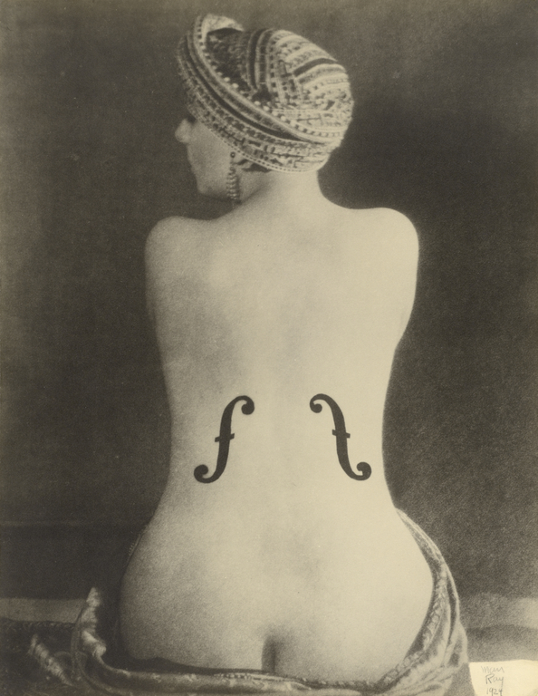

Le Violin d’Ingres, Man Ray 1924.
Gelatine Silver Print.
Here, Man Ray uses the female body as objectification of a musical instrument by painting sound holes onto her back, playing with the ideas of objectification of an animate body as an inanimate object. In this case, Man Ray used photography as a form of documentation to show his sculptural idea. Photography’s main purpose was to replicate what had existed, to document an idea. Although the camera is used quite simply, Man Ray still pushed the medium of photography forward by working against the rules of traditional portraiture where the viewer would usually be able to see the front of the model. Instead Man Ray explores the blankness of the back, and almost uses the model’s body as a canvas, thus still experimenting in new ways and showing photography in a new form.

Man Ray’s Rayographs also changed the way people perceived photography. His ‘Rayographs’ were made without a camera by placing objects directly on to photosensitized paper, then exposing it to light. Although the idea of creating photograms like this had already been invented, Man Ray reinvented the methods, and created something that hadn’t been seen before. These works immediately put the photographer on par with the painters of the day.
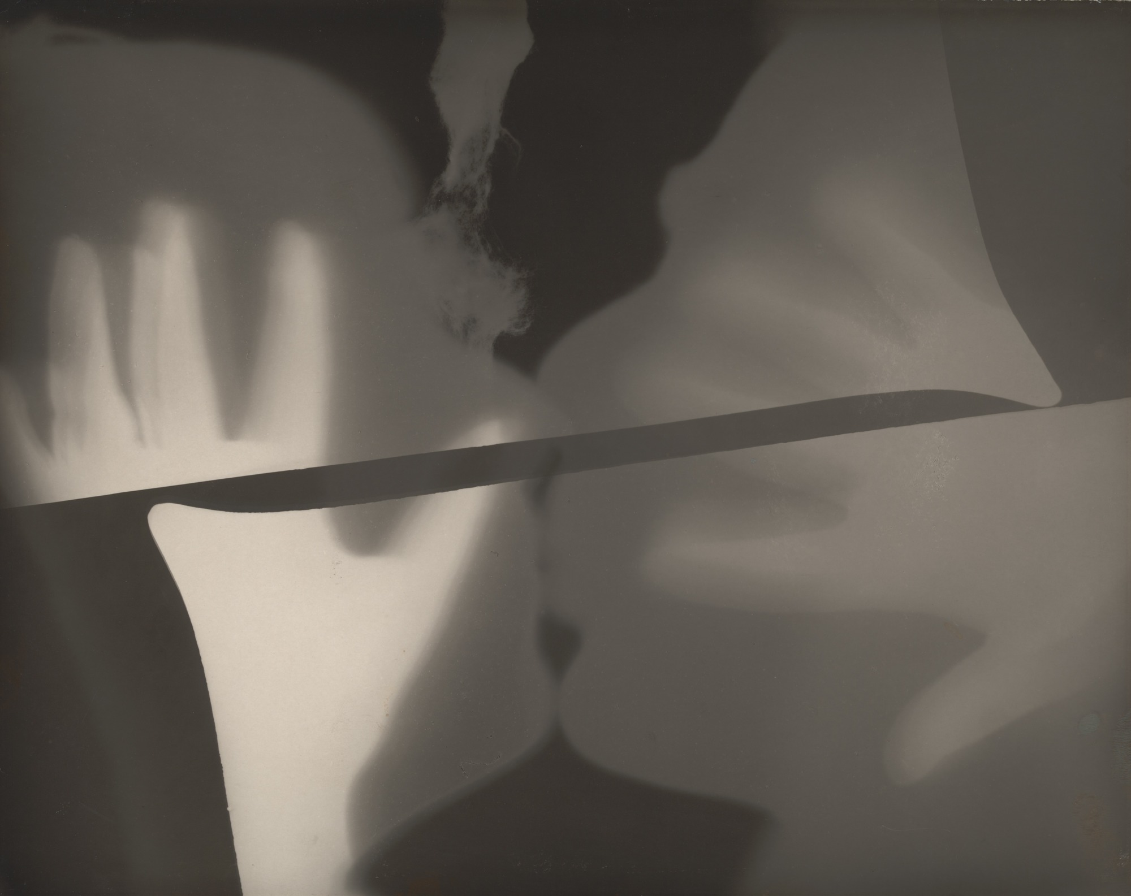
Rayograph, Man Ray 1922.
Gelatine Silver Print (Photogram)
In this Rayograph you can see two heads kissing. The lighter tones show where the hands and heads are closest to the paper, and the darker tones is where the paper wasn’t as masked. The Rayograph shows contact, movement and abstract expressionism. We know that it’s an image of two heads kissing, but only from their shape, form and tonal ranges.
"It is impossible to say which planes of the picture are to be interpreted as existing closer or deeper in space. The picture is a visual invention: an image without a real-life model to which we can compare it,"
Notes from John Szarkowski, curator at the Museum of Modern Arts. (Moma.org, 2018)
Man Ray claimed to have reinvented the photogram in an artistic sense, for in his opinion the photogram was not a mechanical copy, but an unpredictable pictorial adventure. They gave us a new way of seeing, through tones rather than details.

Because of art movements like Surrealism and Dadaism, and a rush of experimental confidence within the field of photography, art was now at a point in history where photography’s identity as a contemporary art had been accepted, for photography’s technical qualities gave visual aspects that were merely impossible to capture from painting. C Cotton The Photograph as Contemporary Art, Third Edition published 2014, P19.

When artists combine their imaginative vision with the mechanic qualities of photographic practice, we are invited to learn a new way of seeing. Ralph Eugene Meatyard described himself as a “dedicated amateur” photographer, and began taking photographs in 1950. Artsy.net. (2018). Ralph Eugene Meatyard - 93 Artworks, Bio & Shows on Artsy. [online] Available at: https://www.artsy.net/artist/ralph-eugene-meatyard [Accessed 11 Dec. 2018]. Meatyard experimented with framing, multiple exposures and blurring to produce quite haunting images which juxtaposed natural and manmade environments. He often used his family in his photographs, but their identities would be hidden by masks which broke the convention of traditional family photo albums.

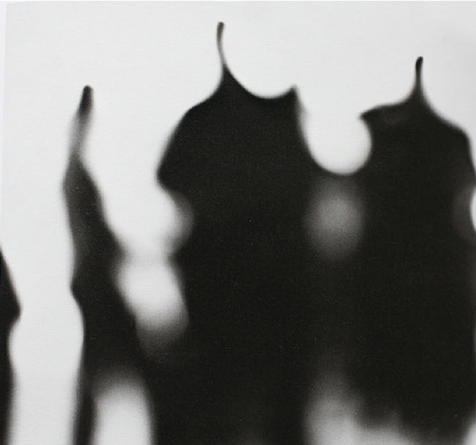

.

No Focus, Ralph Eugene Meatyard. 1959.
Gelatine Silver Print

Meatyard’s image here shows one of the first examples of photography where the conventional rule of focusing the camera had been overlooked. Here the figures in the photograph look almost unrecognisable, are we even sure what the figures are? Similarly, to Man Ray, these series of images and their abstraction stretch the viewer’s vision and questions what we see in the ordinary world.

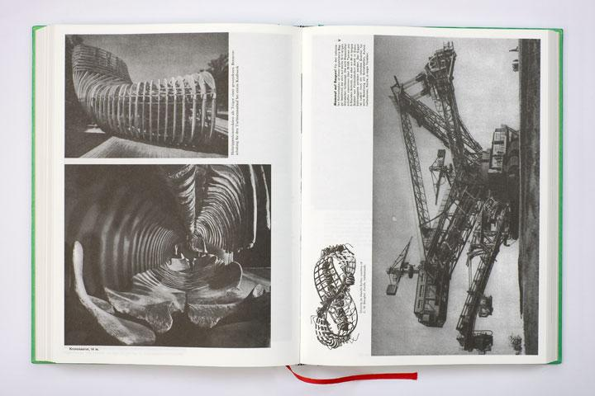
Contemporarily, photographers are still experimenting with what exists in order to create new imaginative ways of seeing. In an age that is overloaded with images and information, Swiss born photographer, Batia Suter, works on photo sequences and collages, primarily using found images. Her publication of Parallel Encyclopaedia contains a large composition of images which explore the diverse resonances of geological landscape and visual surface. The idea of reusing and appropriating found knowledge is a strategy used by many artists, but in Suter’s case her work focuses primarily on the connections between different images, and various narratives and patterns which emerge within the spaces of a single page, and the encyclopaedia.

Parallel Encyplopedia#2 Batia Suter, 2016.

What’s interesting in Suter’s publication is that, although it consists of imagery that the viewer is already familiar with, Suter still encourages us to see in a new way, simply by the order and placement of her images, forcing us to make new connections between what already exists, and our imagination. Art historian, Christel Vesters says that Suter’s Parallel Encyclopaedia “embodies a space in which lack of order creates a space for wonder, for not knowing, for another form of knowledge, or in short, the (non)order of the imagination.” Vesters, C. (2018). The Anti-EncyclopaediaFrom Poetic Disorder to Political Anti-Order (and back again) - Features - Metropolis M. [online] Metropolism.com.

Her explorations give us a new chance to see differently, similar to the way Man Ray and Meatyard’s experiments showed new imagination and creativity. Batia Suter was recently selected for the Deutsche Börse Photography Foundation Prize who award photographers for their significant contribution to the medium during the past year. This year, the prize was criticised for not being photographic enough. The Telegraph described it as a show of “one hit in a sea of misses.” and criticised the lack of engagement the work shown had with photography. Smart, A. (2018). One hit in a sea of misses - Deutsche Börse Photography Prize, review. [online] The Telegraph. Available at: https://www.telegraph.co.uk/photography/what-to-see/one-hit-sea-misses-deutsche-borse-photography-prize-review/ [Accessed 01 Dec. 2018].

Although Baudelaire argued that art mustn’t be confused with industry and that photography should be kept to its ‘true’ purpose of ‘replicating what exists’, it is believed that Baudelaire, in essence, strengthened photography’s place as a fine art as it made artists question photography’s true capability. Professors like Laszlo Moholy-Nagy taught artists to embrace the “reality of our century” and to explore technology, invention, construction and machines. Movements like Dadaism and Surrealism historically showed artists reinventing photography and new, imaginative ideas. This breakthrough meant that photography sat closer to art than it ever had before, and works by photographers like Man Ray and Meatyard have become revolutionary in proving that photography is more than a form of replicating ‘what exists’. Contemporarily, artists still create works that explore “the reality of our century.” Works like Suter’s Parallel Encyclopaedia supports this, and although the work focuses on re-appropriating found imagery, the imaginative “monsters of our fantasy” still force us to imagine more than just the existing photographic image.

References

Arthistoryarchive.com. (2018). The History of Photography as a Fine Art - Fine Art Photography - The Art History Archive. [online] Available at: http://www.arthistoryarchive.com/arthistory/photography/ [Accessed 8 Dec. 2018].

Artsy.net. (2018). Ralph Eugene Meatyard - 93 Artworks, Bio & Shows on Artsy. [online] Available at: https://www.artsy.net/artist/ralph-eugene-meatyard [Accessed 11 Dec. 2018].

Batiasuter.org. (2018). Batia Suter. [online] Available at: https://www.batiasuter.org/ [Accessed 11 Dec. 2018].

Cotton, C. (2006). The photograph as the contemporary art. London: Thames & Hudson

Gustavon, T. (2009). Camera: a history of photography from daguerrotype to digital. Sterling Innovation.

Hochman, Elaine S., 1997. Bauhaus, Crucible of Modernism.

Moholy Nagy, L. (1950). Experiment in Totality. New York: Harper & Brothers, p.19.

Moma.org. (2018). Man Ray (Emmanuel Radnitzky). Rayograph. 1922 | MoMA. [online] Available at: https://www.moma.org/collection/works/46405 [Accessed 9 Dec. 2018].

Smart, A. (2018). One hit in a sea of misses - Deutsche Börse Photography Prize, review. [online] The Telegraph. Available at: https://www.telegraph.co.uk/photography/what-to-see/one-hit-sea-misses-deutsche-borse-photography-prize-review/ [Accessed 01 Dec. 2018].

Tate. (2018). The New Vision – Art Term | Tate. [online] Available at: https://www.tate.org.uk/art/art-terms/t/new vision [Accessed 12 Dec. 2018].

Vesters, C. (2018). The Anti-EncyclopaediaFrom Poetic Disorder to Political Anti-Order (and back again) - Features - Metropolis M. [online] Metropolism.com. Available at: https://www.metropolism.com/en/features/23282_the_anti_encyclopaedia.

Bibliography
Benjamin, W. and Jennings, M. (2006). The writer of modern life. Cambridge, Mass.: Harvard University Press.
Berger, J. (2012). Ways of seeing. London: British Broadcasting Corp.
Cotton, C. (2006). The photograph as the contemporary art. London: Thames & Hudson.
Gustavon, T. (2009). Camera: a history of photography from daguerrotype to digital. Sterling Innovation.
Man Ray (2012). Self-portrait. London: Penguin.
Moholy Nagy, L. (1950). Experiment in Totality. New York: Harper & Brothers, p.19.

