

Assessment Component 2: Marketing Strategies Portfolio
Strategic Marketing Analysis of Apple’s Brand Extension: The Apple Smart Ring
Student Name: Dhruv Jaysukhbhai Pansuriya
Student Number: 2529416
Course Name: Marketing Management (LCMB7024)
Lecturer Name: Dr Muhammad Tariq
Term: February 2026
Word Count: 2714
Submission Deadline: 1st May 2026
Table of Contents
1. Introduction 4
2. Element 1: Brand Extension Poster 4
3. Element 2: STDP Analysis 6
3.1 Market Segmentation 6
3.1.1 Geographic Segmentation 7
3.1.2 Demographic Segmentation 7
3.1.3 Psychographic Segmentation 7
3.1.4 Behavioural Segmentation 8
3.2 Targeting Strategy 8
3.3 Differentiation Strategy 8
3.4 Positioning Strategy 9
4. Element 3: Marketing Mix 9
4.1 Product Strategy 9
4.2 Pricing Strategy 10
4.3 Place (Distribution) Strategy 11
4.4 Promotion Strategy 12
4.5 Integration with Overall Brand Strategy 12
5. Element 4: Reflection 12
5.1 Reflection on Brand Development Process 13
5.2 Skills and Knowledge Gained 13
5.3 Challenges and Learning 13
5.4 Future Improvements and Professional Development 14
6. Conclusion 14
References 15
Appendix 19
Appendix 1: Brand Extension Poster Presentation 19

1. Introduction
The portfolio provides a strategic analysis of a marketing plan based on brand development in the technology industry, with a focus on Apple Inc. The purpose of this report is to develop a brand extension that is viable for the company and will improve its competitive advantage. The major concepts of marketing segmentation, targeting, differentiation, positioning (STDP), and the marketing mix are considered to develop a comprehensive plan.
Apple Inc. is a global technology company that specialises in the design, manufacture, and marketing of smartphones, personal computers, and other electronic devices. Apple is a dominant company in the global technology industry and holds a strong competitive advantage in a highly competitive and dynamic market (Akino, 2025). The purpose of this report is to develop a new brand extension for Apple Inc. The new product is named Apple Smart Health Ring (Apple Ring), which is a wearable device and will improve Apple's presence in the health technology and wearable devices market.

2. Element 1: Brand Extension Poster
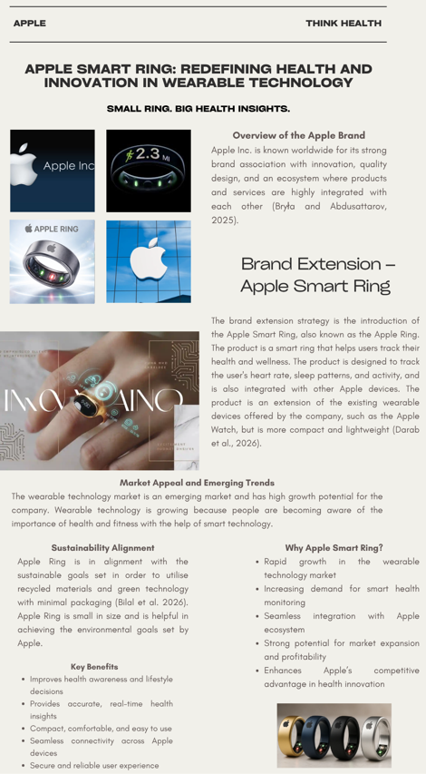
Figure 1: Apple smart ring brand extension poster
(Source: Self-created in Canva)
Figure 1 poster shows the Apple Smart Ring as an extension of the brand, emphasizing the features, market potential, and sustainability considerations. It is be educational and persuasive and be aimed at potential customers and investors by highlighting the value proposition of the product and the growth perspective.

3. Element 2: STDP Analysis

3.1 Market Segmentation
Segmentation is one of the important processes carried out by organisations to segment the larger market into smaller groups of consumers with similar requirements, characteristics, or behaviour (John et al. 2023). Apple Ring is one product that needs to be segmented to identify the relevant groups of consumers to design the marketing strategies accordingly. Apple is working in the global market with different types of consumers, including individuals, businesses, and institutions. Wearable technology is one segment growing rapidly, especially in the health and wellness segment, where consumers want to purchase technology to ensure the ease of usage with the existing technology (Huang et al. 2025).
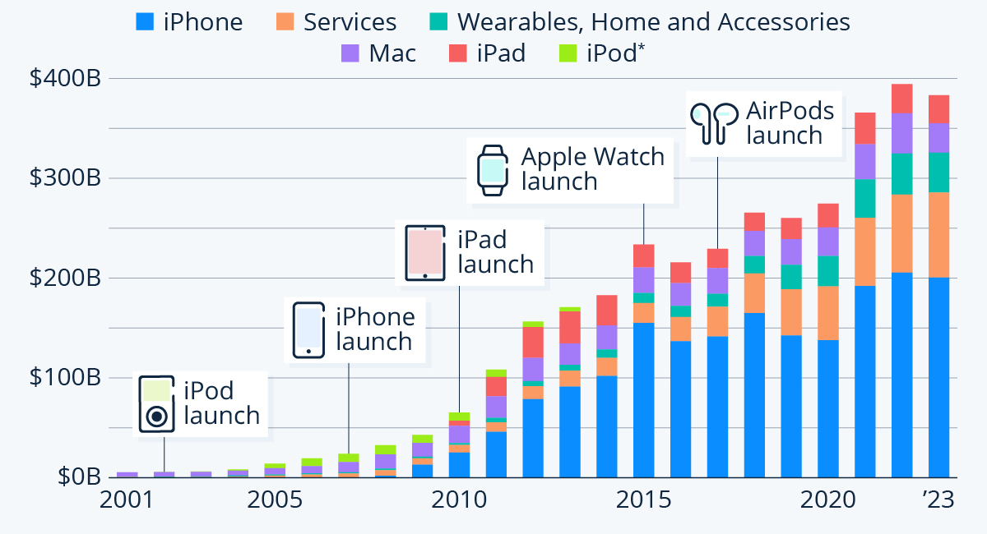
Figure 2: Apple's business performance
(Source: Statista, 2024)
Figure 2 data shows apple business performance based on the different products increases from 2001 to 2023. Although segmentation is a well-known marketing practice that is vital, the views of various writers on the practice differ. As an example, Kotler et al. (2025) highlight the role of demographic and behavioural segmentation as determinants of consumer targeting, and Khan et al. (2025) emphasise the increasing significance of psychographic and lifestyle-driven segmentation in tech markets.

3.1.1 Geographic Segmentation
Geographic segmentation is concerned with the strategy of reaching consumers in the various global markets where the company, Apple, is well established, such as North America, Europe, and the Asia Pacific (Bu & Wu, 2022). This strategy is also aimed at reaching the consumers in the cities where the majority of the population is aware of the technology being provided by the wearable devices and the health and wellness benefits of such devices.

3.1.2 Demographic Segmentation
The demographic segmentation of the Apple Ring is the population between the ages of 20 and 45 years who are aware of the technology and health and wellness benefits of the product (Bhargava & Gupta, 2022). This includes those who are professionals, entrepreneurs, or students and have moderate to high disposable income to spend on high-end products such as the Apple Ring. The demographic segmentation also includes those from both genders who are aware of the convenience and innovation provided by the product. The product is also for those who are fitness enthusiasts and are aware of the health and wellness benefits of the product.

3.1.3 Psychographic Segmentation
Psychographic segmentation is the segmentation of consumers based on their lifestyles, values, and attitudes. Apple Ring targets consumers based on their interest in health, wellness, and optimisation (Khan et al. 2025). The consumers targeted by Apple Ring are technology-savvy, innovative, premium, environmentalists, and believe in sustainable brands. Moreover, such consumers want a seamless digital experience. They are also likely to be Apple users already, who believe in the convenience of Apple products in their daily lives. Psychographic segmentation is suited to wearable market since the consumers behaviour cannot be solely demographic as it is influenced by their health and lifestyle awareness (Alojail and Khan, 2023).

3.1.4 Behavioural Segmentation
Behavioural segmentation targets consumers on the basis of their usage of the brand, benefits, and brand loyalty (Gonen et al. 2024). Apple Ring targets consumers who use wearable technology on a regular basis. Moreover, Apple Ring benefits from brand loyalty. Apple has a huge consumer base of loyal customers. Apple consumers are more likely to use Apple Ring since they are already loyal to the brand.

3.2 Targeting Strategy
The primary segment for the Apple Smart Ring product will be tech-savvy and health-conscious consumers who fall between the age group of 20 to 45 years, living in urban and metropolitan cities. This segment includes professionals, fitness enthusiasts, and existing Apple users who fall in the moderate to high disposable income bracket. This has been evident in the business model of Apple, which targets consumers and professionals alike, offering them hardware, software, and services under one ecosystem, as described in the business model proposed by Kreutzer et al. (2024).

3.3 Differentiation Strategy
The Apple Smart Ring differentiates itself through a combination of innovative features, seamless integration, and premium design. The unique features of Apple Smart Ring include health monitoring, heart rate monitoring, sleep analysis, activity tracking, and more, all in a small and discreet package (Crawford, 2024). The Apple Smart Ring differentiates itself from other wearable devices due to its enhanced comfort and convenience.
Apple Smart Ring offers a greater competitive advantage with its incorporated ecosystem as compared to competitors like Samsung and Oura. Although Samsung wearable devices offer similar health tracking features, it does not offer the same degree of cross-device integration. Likewise, Oura Ring is not the company that can offer the wider benefits of a digital ecosystem that Apple has.

3.4 Positioning Strategy
The positioning strategy for the Apple Smart Ring is primarily aimed at creating a product that is not only innovative but also offers the best experience for the user. The definition of the brand positioning statement is as follows: “For health-conscious and tech-savvy people, the Apple Smart Ring is a premium wearable device that offers seamless, accurate, and convenient health monitoring through the Apple ecosystem”. In terms of the perceptual positioning, the Apple Ring is positioned in the high-quality, high-price segment, which further enhances the product’s position as a luxury product with the best technology available in the market (Richardson, 2024).

4. Element 3: Marketing Mix

4.1 Product Strategy
Apple Smart Ring is developed as a compact and innovative wearable product, building on the Apple product family (Patnaik et al. 2024). Apple Smart Ring features include health monitoring, heart monitoring, sleep monitoring, activity monitoring, and the integration of advanced biometric technology. Apple Smart Ring ensures that the customer is well-informed through accurate information to help manage health and wellness.
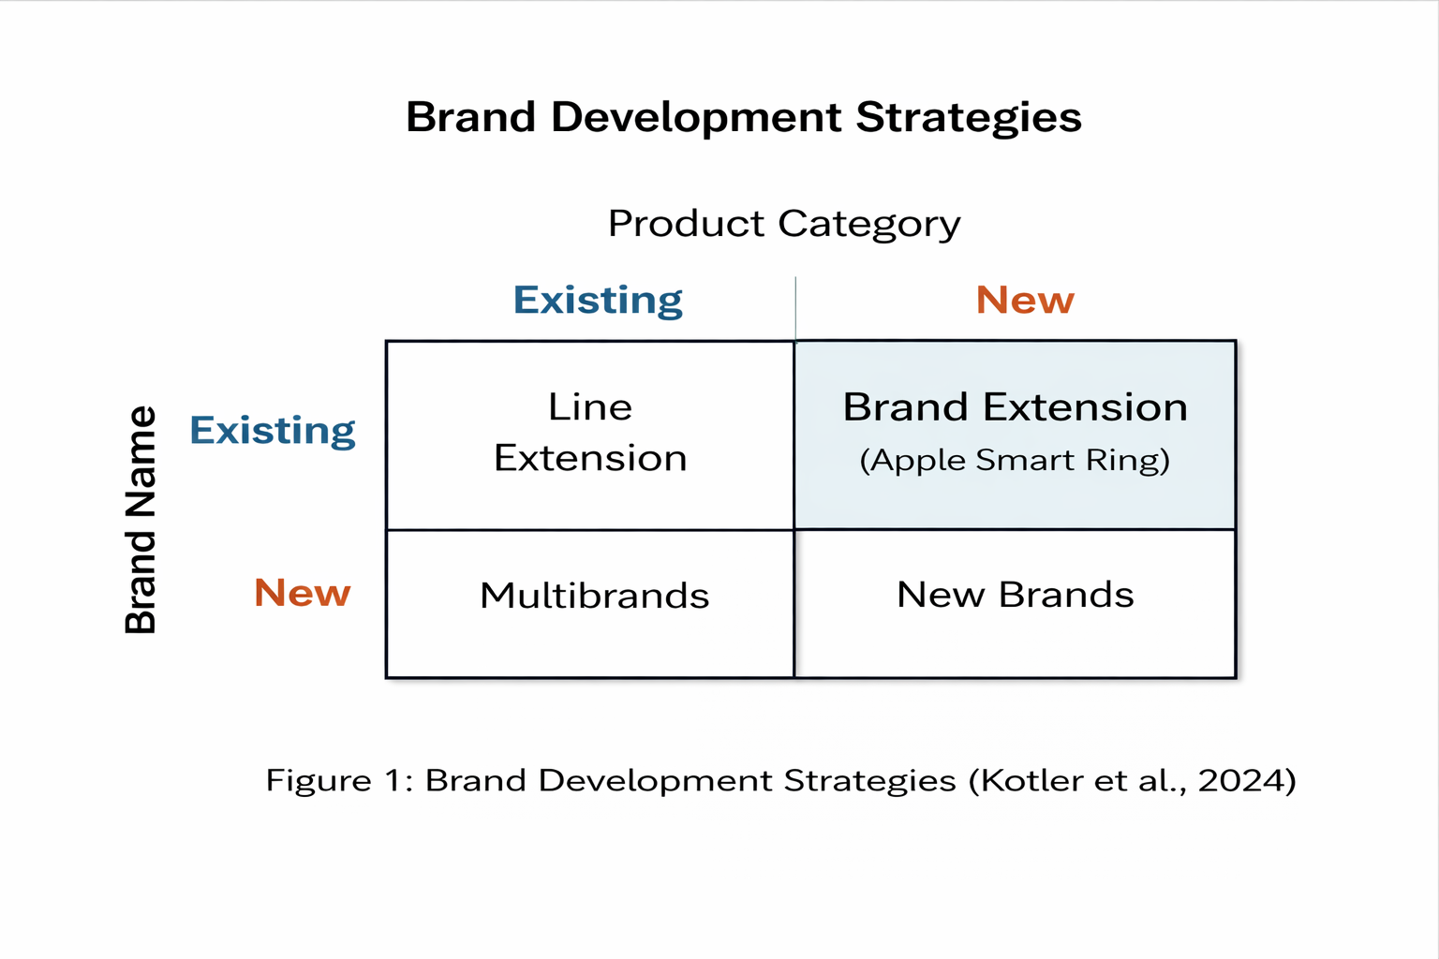
Figure 3: Brand development strategies
(Source: Self-created using reference Kotler et al. 2025)
Apple Ring has a unique design, which is Apple’s trademark. Apple Ring is made of high-quality materials such as recycled aluminium and titanium. Apple Ring is light and compact compared to other wearable technologies. Apple’s minimalist design is in line with Apple’s signature design philosophy. Innovation is the core idea behind Apple Ring, as the product integrates the latest technology with Apple’s software (Malik et al. 2026). Apple Ring integrates with Apple’s Health app and other Apple devices, providing the customer with a seamless experience.
The product plan is also in accordance with the rise of changes in artificial intelligence (AI) and digital health. The Apple Smart Ring can be improved with AI-based analytics, enabling it to give individualised health feedback and forecast health tracking. This indicates the growing need for smart healthcare solutions in the wearable technologies market. Also, sustainability is becoming increasingly important to consumers, and the production of Apple products using recycled materials like aluminium and titanium promotes sustainable production.

4.2 Pricing Strategy
The pricing policy followed by the Apple Smart Ring is the premium pricing policy, which is suitable for the brand as well as the product, as the brand is associated with the premium segment, as mentioned by Frohmann in 2023. The product is priced on the higher side compared to the normal price range of the wearable devices available in the market, which is due to the high-end features available in the product. The value-based pricing policy is followed by the company, where the price is determined on the basis of the value provided to the customer rather than the cost of production of the product (Helmold, 2022). The customers are willing to pay the price for the product as the brand is known for its high-quality products available in the market. The Apple Smart Ring provides value to its customers, which is due to its integration with other Apple devices, providing a high-end experience for its consumers. Apple Smart Ring is priced higher than its competitors, Samsung, etc., in the wearable segment (Park, 2022).
The premium pricing strategy used by Apple may be justified as compared to its similar products in the market. As an illustration, wearable tech like the Oura Ring costs about $300-400, and Samsung wearable tech tends to be cheaper, depending on features. The elevated costs of Apple are attained due to having great brand equity, integration into an ecosystem, and consumer-perceived value.

4.3 Place (Distribution) Strategy
Apple’s distribution plan for Apple Smart Ring relies on the existing global network of Apple retail and distribution channels. Apple Smart Ring will be delivered through Apple's retail stores. Apple retail stores enable customers to have a premium experience within their stores, and apart from that, they enable customers to have a direct interaction with the product (Hagtvedt and Chandukala, 2023).
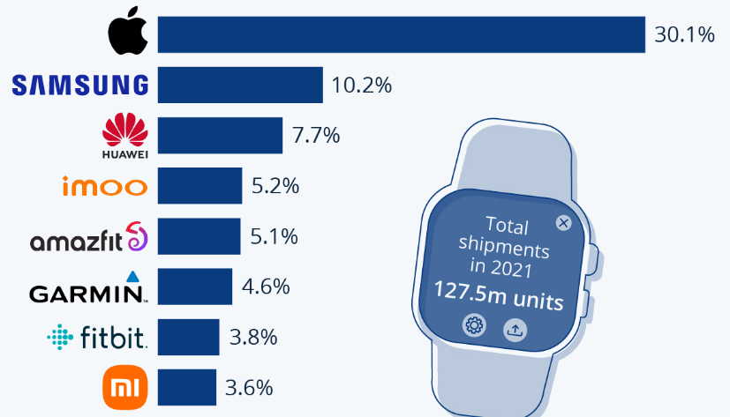
Figure 4: Apple smartwatch market
(Source: Statista, 2022)
Figure 4 data shows Apple is the leading brand in smartwatch market, which is about 30.1%. Apple also relies on indirect distribution methods for delivering the Apple Smart Ring to customers. Apple’s indirect distribution methods include working with third-party retailers and carriers (Helmold, 2022). Apple sells its products via both direct and indirect methods, as indicated in the annual report. The annual report of the company shows that Apple sells its products directly and indirectly to reach a wider customer base. The presence of the company in global markets such as America, Europe, and the Asia Pacific ensures that Apple Ring reaches these markets and reaches its maximum sales potential.

4.4 Promotion Strategy
The Apple Smart Ring promotion strategy is based on creating brand awareness and generating interest among consumers about the product by implementing marketing communication strategies. Apple uses high-impact advertising campaigns to promote its products. The advertising campaigns of Apple are conducted online and on television. Social media is a significant factor in promotion as it helps Apple directly engage with consumers and create brand awareness by highlighting the features of the product in a visually appealing way (Bung et al. 2024). Social media channels like Instagram, YouTube, and X (formerly Twitter) are used by Apple to highlight how the product is used in real-life situations.
The promotional strategy can also be underpinned by the practical examples of successful product releases by Apple, which leave a high degree of consumer involvement and media coverage. As an example, high brand awareness due to the initiatives of storytelling and the marketing of experiences based on experiences has always been developed by Apple with its previous product launches (Nemadet et al. 2025). Combining digital marketing platforms, such as social media and partnering with influencers, only increases consumer interaction.

4.5 Integration with Overall Brand Strategy
Apple’s marketing mix for the Apple Smart Ring is well-integrated with the overall brand strategy, which is evident from the consistency seen in all the factors (Richardson, 2024). Apple's product strategy is also based on innovation, design, and integration, which are exactly what Apple is known for. Apple's pricing strategy, being premium, is also well integrated with the brand, as the brand itself is known to be premium. Apple's distribution strategy is also well integrated with the brand, as the brand itself is known for its premium customer experience.

5. Element 4: Reflection

5.1 Reflection on Brand Development Process
The process involved in the development of the Apple Smart Ring as a brand extension provided an insightful understanding of the process involved in the formation of strategic marketing decisions (Crawford, 2024). Initially, the process involved finding an extension within the existing product line of Apple while ensuring that the extension aligned with the brand’s overall brand identity, which is associated with innovation, simplicity, and high quality. The idea of the smart health ring was found as an extension within the wearable technology segment. The process of designing the extension also involved taking into account the market trends and the increasing demand for health-focused wearable devices (Del-Valle-Soto et al. 2024).

5.2 Skills and Knowledge Gained
The assignment helped me gain a better knowledge of key marketing concepts, especially concerning brand development, segmentation, targeting, positioning, and the marketing mix. The application of these theoretical concepts to a real-world company such as Apple helped me gain a better and practical knowledge of how these concepts are being practically applied in a changing and competitive market environment (Ch'ng et al. 2026). Moreover, I have also developed strong analytical skills by assessing consumer behaviour, market trends, and competitive strategies.

5.3 Challenges and Learning
One of the biggest challenges I faced while working on this assignment was ensuring that every element of the marketing strategy was consistent (Yaiprasert and Hidayanto, 2023). Initially, it was challenging to integrate the brand extension, STDP analysis, and marketing mix into a single strategy. Another challenge I faces selecting the most appropriate target segments and justifying every decision made in the process of creating a marketing strategy. However, I have learned to overcome these challenges by reviewing some of the most important concepts of marketing and ensuring that every decision made is backed by logical reasoning and evidence. The process of dividing the assignment into smaller sections helped me develop strong organisational and presentation skills (Subramanian and Suresh, 2022).
Besides the difficulties in the process of developing the marketing strategy I was also experiencing difficulties with the process of preparing the poster along with the process of presentation. The poster design was a compromise between visual appeal and sparse and informative information, since it entailed simplifying complicated marketing concepts to a clear and attractive format. One of the challenges that involved time management and communicating important ideas in a short period of time came up during the presentation. It took a lot of planning and practicing to ensure that the presentation was both informative as well as persuasive. These obstacles were however overcome with rehearsal and confidence building and enhancement of content to center on main points. This experience increased my presentation, visual design and communication skills.

5.4 Future Improvements and Professional Development
In any future projects, I would look to include even more data and reports to further strengthen the analysis and add depth to the evaluation. I also plan to improve my critical analysis by ensuring I analyse different strategic options before selecting the most suitable approach. The assignment is relevant to my professional development, especially in the fields of marketing and business strategies. The assignment has helped me develop strategic thinking and analysis capabilities, which are essential for working in a constantly changing business environment and will be beneficial for my future career in the field of marketing.

6. Conclusion
This report developed a comprehensive marketing strategy for the Apple Smart Ring as a brand extension. Through the application of the STDP analysis and the marketing mix tool, the strategy identified a clear target market for the Apple Smart Ring, created strong differentiation for the product, and reinforced the premium positioning of the Apple brand. The analysis also emphasised the significance of matching product innovation with the needs of consumers and the brand itself. Furthermore, the integration of sustainability and ecosystem benefits provided a clear demonstration of how Apple could maintain its competitive advantage in the wearable technology market.

References
Akino, S., 2025. The Transformation of the Business Structure of Apple Computer Inc. and Its Dynamic Capabilities. In Strategic Management and Innovation Strategies: From the Perspective of Revisiting Dynamic Capabilities (pp. 319-352). Singapore: Springer Nature Singapore.https://doi.org/10.1007/978-981-96-8437-3_13
Alojail, M. and Khan, S.B., 2023. Impact of digital transformation on sustainable development. Sustainability, 15(20), p.14697.https://doi.org/10.3390/su152014697
Bhargava, S. and Gupta, P., 2022. Boat: the Indian startup scripts a revolutionizing growth strategy. Emerald Emerging Markets Case Studies, pp.1-40.https://doi.org/10.1108/EEMCS-09-2021-0318
Bilal, M., Ali, M., Shaukat, F., Ullah, S., Arslan, M., Li, Z., Xiaobo, Z., Wahab, M., Guo, Y., Sun, X. and Ahmed, Z.F., 2026. Plant‐Based Biopolymer Composites for Smart and Sustainable Food Packaging: Global Insights, Recent Advances, and Future Research Directions. Food Frontiers, 7(2), p.e70229.https://doi.org/10.1002/fft2.70229
Bryła, P. and Abdusattarov, S., 2025. Apple’s Strategy Success Factors and Challenges in Europe: A Case Study of Apple’s Business Model and International Marketing. Annales Universitatis Mariae Curie-Skłodowska, sectio H–Oeconomia, 59(5), pp. 7–30.http://dx.doi.org/10.17951/h.2025.59.5.7-30
Bu, N. and Wu, T., 2022. The Asia-Pacific region: The new centre of gravity for international business. In International business in the New Asia-Pacific: Strategies, opportunities and threats (pp. 3-29). Cham: Springer International Publishing.https://doi.org/10.1007/978-3-030-87621-0_1
Bung, P., Jahan, N.F., Jahnavi, M., Nagasubba Reddy, N. and Shubha, R., 2024, April. Analyzing Twitter and YouTube Posts for Identifying Influencers of Apple Products in the Bangalore Region: A Comprehensive Study with Sentiment Analysis. In International Conference on Business Intelligence and Data Analytics (pp. 445-462). Singapore: Springer Nature Singapore.https://doi.org/10.1007/978-981-97-7717-4_32
Ch'ng, C.B., Lee, S.M.F., Lin, K.W. and Pathan, A.A., 2026. Challenge-based learning: the case of future business events industry leaders in Asia. International Journal of Event and Festival Management, pp.1-22.https://doi.org/10.1108/IJEFM-04-2025-0057
Crawford, C., 2024. TV plus what? Data-capital, brand extension, and lock-in effects in the Apple ecosystem. New Review of Film and Television Studies, 22(4), pp.1061-1082. https://doi.org/10.1080/17400309.2024.2418249
Crawford, C., 2024. TV plus what? Data-capital, brand extension, and lock-in effects in the Apple ecosystem. New Review of Film and Television Studies, 22(4), pp.1061-1082.https://doi.org/10.1080/17400309.2024.2418249
Darab, M., Bakhshayesh, A. and Tajabadi, M., 2026. Introduction to Wearable Electronics. In Perovskites for Next-Generation Wearable Technology (pp. 1-24). Cham: Springer Nature Switzerland.https://doi.org/10.1007/978-3-032-03931-6_1
Del-Valle-Soto, C., López-Pimentel, J.C., Vázquez-Castillo, J., Nolazco-Flores, J.A., Velázquez, R., Varela-Aldás, J. and Visconti, P., 2024. A comprehensive review of behavior change techniques in wearables and IoT: implications for health and well-being. Sensors, 24(8), p.2429.https://doi.org/10.3390/s24082429
Frohmann, F., 2023. Pricing process part 3: Structure (3c: Price optimization). In Digital pricing: A guide to strategic pricing for the digital economy (pp. 217-262). Cham: Springer International Publishing.https://doi.org/10.1007/978-3-031-24591-6_9
Gonen, L.D., Tavor, T. and Spiegel, U., 2024. Unlocking market potential: strategic consumer segmentation and dynamic pricing for balancing loyalty and deal seeking. Mathematics, 12(21), p.3364. https://doi.org/10.3390/math12213364
Hagtvedt, H. and Chandukala, S.R., 2023. Immersive retailing: the in-store experience. Journal of Retailing, 99(4), pp.505-517.https://doi.org/10.1016/j.jretai.2023.10.003
Helmold, M., 2022. Sales Channels and Sales Partners. In Performance Excellence in Marketing, Sales and Pricing: Leveraging Change, Lean and Innovation Management (pp. 147-156). Cham: Springer International Publishing.https://doi.org/10.1007/978-3-031-10097-0_14
Helmold, M., 2022. Value-Based and Cost-Based Pricing Concepts. In Performance Excellence in Marketing, Sales and Pricing: Leveraging Change, Lean and Innovation Management (pp. 75-81). Cham: Springer International Publishing. https://doi.org/10.1007/978-3-031-10097-0_7
Hemzo, M.A., 2023. Defining the Persona: Segmentation and Targeting. In Marketing Luxury Services: Concepts, Strategy, and Practice (pp. 75-94). Cham: Springer International Publishing.https://doi.org/10.1007/978-3-030-86073-8_6
Huang, G., Chen, X. and Liao, C., 2025. AI-driven wearable bioelectronics in digital healthcare. Biosensors, 15(7), p.410.https://doi.org/10.3390/bios15070410
Jennings, L., Sorell, M. and Espinosa, H.G., 2024. The provenance of Apple Health data: A timeline of update history. Forensic Science International: Digital Investigation, 50, p.301804.https://doi.org/10.1016/j.fsidi.2024.301804
John, J.M., Shobayo, O. and Ogunleye, B., 2023. An exploration of clustering algorithms for customer segmentation in the UK retail market. Analytics, 2(4), pp.809-823.https://doi.org/10.3390/analytics2040042
Khan, N., Deshpande, N., Singh, P. and Kadam, P., 2025. A review of AI-based health prediction using apple watch and fitbit data. Discover Applied Sciences, 7(10), p.1217. https://doi.org/10.1007/s42452-025-07783-8
Kotler, P. and Pfoertsch, W., 2025. The B2B Brand-Building Process. In B2B Brand Management: Incorporating Performance Branding, Transformative Marketing and Artificial Intelligence (pp. 221-305). Cham: Springer Nature Switzerland. https://doi.org/10.1007/978-3-031-94665-3_4
Kreutzer, M., Hettich, E. and Neudert, P.K., 2024. Design, setup, and growth of successful ecosystems. In Business Ecosystems: Strategizing in a Connected World (pp. 73-124). Cham: Springer Nature Switzerland.https://doi.org/10.1007/978-3-031-70555-7_4
Malik, P., Mittal, V. and Chaudhary, K., 2026. Engineering Innovation Meets Strategic Excellence: Navigating the Technological Revolution. In Technological Advancements in Engineering and Management Sciences (pp. 169-191). Cham: Springer Nature Switzerland.https://doi.org/10.1007/978-3-032-04606-2_12
Nemade, C.T., Baste, N.S., Bihani, M.M. and Raut, S.S., 2025. Nutraceuticals and cosmeceuticals. Pharmacognosy and Phytochemistry: Principles, Techniques, and Clinical Applications, pp.297-314.https://doi.org/10.1002/9781394203680.ch15
Park, C., 2022. Different determinants affecting first mover advantage and late mover advantage in a smartphone market: a comparative analysis of Apple iPhone and Samsung Galaxy. Technology Analysis & Strategic Management, 34(3), pp.274-289.https://doi.org/10.1080/09537325.2021.1895104
Patnaik, S.K., Medimi, N. and Ariwa, E., 2024. Smart rings: Redefining wearable technology. In Handbook of Artificial Intelligence and Wearables (pp. 217-235). CRC Press.10.1201/9781032686714-14
Richardson, N., 2024. The Marketing Mix. In Sustainable Marketing Planning (pp. 79-136). Routledge.10.4324/9781003434214-5
Richardson, N., 2024. The Marketing Mix. In Sustainable Marketing Planning (pp. 79-136). Routledge.10.4324/9781003434214-5
Statista, 2022. Apple Several Ticks Ahead in the Smartwatch Market. https://www.statista.com/chart/15035/worldwide-smartwatch-shipments/?srsltid=AfmBOorLKqbRBGX8Vz5p3jqXbhZds2veBz_3SNk9UnqltAUXiq6TTDbw
Statista, 2024. Apple's Constant Search for the Next Big Thing. https://www.statista.com/chart/17862/apples-annual-revenue-by-operating-segment/?srsltid=AfmBOopyVufLbLOxAalv3eO7Yiim0zFr7bycr3km0mnXhw3aUQSvAxhM
Subramanian, N. and Suresh, M., 2022. The contribution of organizational learning and green human resource management practices to the circular economy: A relational analysis–evidence from manufacturing SMEs (part II). The Learning Organization, 29(5), pp.443-462.https://doi.org/10.1108/TLO-06-2022-0068
Yaiprasert, C. and Hidayanto, A.N., 2023. AI-driven ensemble three machine learning to enhance digital marketing strategies in the food delivery business. Intelligent Systems with Applications, 18, p.200235.https://doi.org/10.1016/j.iswa.2023.200235

Appendix

Appendix 1: Brand Extension Poster Presentation

