Essay title: Words, Words, Words
Adult literature is often not illustrated. Why is this and how could illustration change an adult reader’s perceptions about literature and allow adults to learn something new from illustrated literature?
Student number: 1404928
BA course title: Illustration
Module number: ADAD6001C
Overall word count: 6497 words
Supervisor: Jonathan Williams

Submitted in partial fulfilment of the requirements for the degree of BA (Hons) Illustration University of Wales Trinity Saint David, Swansea, 11th December 2019.

Table of Contents

Summary of Topic 3
List of Illustrations 3
Introduction 5
Chapter 1, Words Rule, Or Do They? 7
Chapter 2, Modern Media 12
Chapter 3, Too Much Violence? 18
Chapter 4, Images and Words 23
Chapter 5, Illustration’s Future 28
Conclusion 32
References 34

Summary of Topic
This individual investigation explores the relation between children’s picture books and adult literature, making connections between them in order to discover why adult literature is seldom illustrated. It focuses on why we are taught that adults are too mature for picture books, how today’s media may affect this, how violence in adult literature may deter people from illustrating them, how adult and children’s illustration is different and how we can embrace these differences, and finally what the future of adult illustration could be.

List of Illustrations
Fig 1: Kerr, J. (1968) The Tiger Who Came To Tea [book illustration] Available at: https://www.bbc.co.uk/news/magazine-25027090 (Accessed: 6th December 2019)
Fig 2: Hanuka, T. (2016) Battle Royale – Work in Progress [digital drawing] Available at: https://eviltender.com/2013/12/10/interview-the-calm-chaotic-art-of-tomer-hanuka/ (Accessed: 6th December 2019)
Fig 3: The Sun, The Daily Mirror. (2017) Election Day Front Pages [newspaper front pages] Available at: https://www.theguardian.com/media/2017/jun/08/press-gang-up-on-jeremy-corbyn-in-election-day-coverage (Accessed: 8th December 2019)
Fig 4: Sharratt, N. (2010) Little Darlings cover [book cover] Available at: https://www.theworks.co.uk/p/children-s-fiction/little-darlings/9780385614436 (Accessed: 7th December 2019)
Fig 5: Kubrick, S. (1972) The Ludovico Technique [film still] Available at: http://filmuforia.co.uk/a-clockwork-orange-1971/ (Accessed: 8th December 2019)
Fig 6: Ito, J. (1998-1999) Azami Kurotani [ink drawing] Available at: https://carnivorouslreviews.wordpress.com/2018/05/07/spiral-into-madness-uzumaki-review/ (Accessed: 8th December 2019)
Fig 7: Allen, P. (2016) The Usborne Big Book Of The Body [book cover] Available at: https://usborne.com/browse-books/catalogue/product/1/9935/big-book-of-the-body/ (Accessed: 8th December 2019)
Fig 8: Barnett, R. (2015) Surgery to correct strabismus [anatomical studies] Available at: https://hyperallergic.com/257404/gruesome-and-surreal-surgical-illustrations-from-the-15th-19th-centuries/ (Accessed: 8th December 2019)
Fig 9: Uelsmann, J. (2004) Untitled [photograph] Available at: http://www.thedarktower.org/palaver/showthread.php?1183-Salem-s-Lot-(Centipede)-Jerry-Uelsmann (Accessed: 6th December 2019)
Fig 10: Uelsmann, J. (2004) Untitled [photograph] Available at: http://www.thedarktower.org/palaver/showthread.php?1183-Salem-s-Lot-(Centipede)-Jerry-Uelsmann (Accessed: 6th December 2019)
Fig 11: Weber, S. (2019) The Conch [book illustration] Available at: https://www.foliosociety.com/uk/lord-of-the-flies.html (Accessed: 8th December 2019)

Words, Words, Words
Adult literature is often not illustrated. Why is this and how could illustration change an adult reader’s perceptions about literature and allow adults to learn something new from illustrated literature?

Introduction
This independent inquiry explores the concept of illustrating adult novels in order to gain understanding of why they are not often illustrated. This research explores elements of our society that negatively and positively affect illustration within the adult world and also focuses on how these elements can be implemented to improve the use of illustration within literature.
The first chapter explores children’s picture books, focusing on how they aid with learning and development. This research includes a short exploration of children’s illustration including evidence that picture books can teach children about difficult topics, and also how these picture books can help children relate to the world around them. Further, this chapter also explores why adult novels are not illustrated, focusing on the negative effects of this and why it would be beneficial to explore illustration more within adult literature, and why society deems illustrated books too immature for older readers.
The second chapter explores the media of today and how this affects adults’ literacy skills and their ability to enjoy literature. This research focuses on exploring how today’s media can affect us negatively including how social media has changed the way we look at literature and also including a short exploration of the decline in reading times by young and older adults. This chapter also covers an exploration of how social media impacts us and what this means for illustration, focusing on how we can use today’s media as a template in order to regain adult’s interest in reading.
The third chapter focuses on violence within literature, film and video games, exploring how graphic themes can affect our mood. This chapter also focuses on how these negative or positive affects in mood could change how we view adult literature due to the fact that it often contains violent and graphic themes. This also focuses on how adult illustration could affect us in a similar way to other violent media and why.
The fourth chapter explores how illustration is used in the adult world and how it is different to children’s illustration by exploring our use of anatomy reference books and how these have developed and aided adults in their learning. This research includes an exploration of how children’s books are used to help adults with learning and how this could be used with adult picture books in the future. This chapter will also explore how adult illustration could improve adult learning abilities, further exploring how illustrated books may help with reading skills in adults who may be poor readers.
The fifth chapter focuses on the future of illustration and how illustrating adult books is beneficial to illustration as a whole. This chapter explores examples of some books that have already been illustrated, including publishers that have already begun to work on this topic and how this industry could be improved and made more accessible for all.
The overall focus and aim in this independent inquiry is to discover how illustration can be implemented into adult literature in a successful way and how it can be made as common as children’s picture books. This research aims to find solutions for the lack of adult illustration and explore how it could be implemented further into the world of adult literature.

Chapter 1
Words Rule... Or Do They?
Children’s picture books are infinitely popular with both the young and old, and children are often brought up on picture books before they are able to walk. We become accustomed to illustration as children and grow to love gazing at pictures while being read to. Even adults who read these picture books to their children enjoy doing so as “...pictures make us happy... some are lovely and relaxing to look at. The best are gorgeous, mesmerizingly beautiful...” (Elkins, 2004). Children’s picture books “create a bond between the reader’s eyes and ears” (Malu, 2013, pp.10-18) and we grow accustomed to making visual connections between word and image. Most products marketed towards children include pictures in some way in order to catch their eye and picture books are no exception, full of visually appealing content that children are able to use to appreciate the written word. The connection between images and words is particularly useful in a child’s development, as agreed in many studies (Berg-Cross, 1978, pp. 659-663). Illustrations in children’s picture books become universally loved by many as shown in this illustration by Judith Kerr for her story book The Tiger Who Came to Tea (1968). Even today this book is massively popular and reaching its 50th anniversary in 2018 had sold over one million copies. (Cowdrey, 2017)

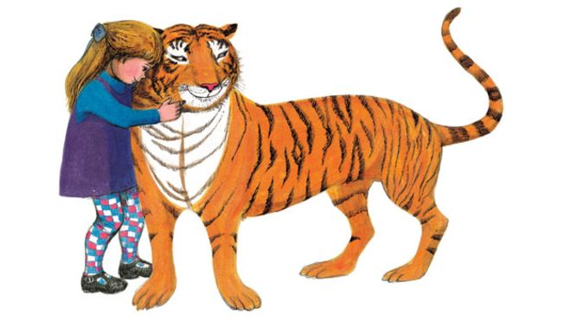
Fig 1: Kerr, J. (1968) The Tiger Who Came to Tea [book illustration]

Relating to this, the popularity of children’s picture books can be partially attributed to aiding in teaching and learning as shown in our use of picture books in schools and nurseries. Difficult concepts can be explored in a simpler way by accompanying words with images to create a pathway between a word and a visual concept (Smith, 2018). This helps children relate themes to the real world and associate words with the world around them while also being taught about challenging issues. For these reasons, illustrations are known to be “...a fundamental feature in children’s picture books and the evidence suggests they are more than simply window dressing to make books look more attractive” (Evans, 2008). Children’s books explore many different themes such as “death... space travel... female main characters...” (Abrahamson, 1980, pp. 167-170) and using images to illustrate these themes may encourage children to develop a deeper “understanding of mind” (Dyer et al, 2000, pp. 17-37). Because children’s picture books are so beneficial to the development of children’s minds, wouldn’t there also be benefits from maintaining this into adulthood? If so, why is illustrated literature considered unsuitable for more mature readers? Miller explains:
“The traditional wisdom is that as the average reading ability level of students increases, the class library and class reading activities need to be limited to reading materials at “instructional level”. For Grade 5 through 8, this tends to mean “no picture books”.” (Miller, 1998, pp. 376-381)
We see here that even children from the ages of ten to fourteen are discouraged from reading picture books. Disappointingly once we reach a more mature age it is shown that our interest in reading may begin to lessen (Ashton, 2019). Large blocks of text can seem difficult to read for many and are often not friendly to adults who may have learning difficulties such as dyslexia. However, as a society we do not consider picture books or illustrated novels to be suitable reading for adults, and instead consider graphic novels and comic books to be one of the only forms of illustrated literature that bridge the gap between adult and children. To many who are unfamiliar with illustration, it may seem as though using cartoons to tell stories is something reserved only for younger minds. Nodelman writes:
“The picture book genre is a paradox. On the one hand it is seen as children’s literature’s one truly original contribution to literature... on the other, it is seen as the province of the young child, and is therefore beneath serious critical notice.” (Nodelman, 1999)
Nodelman’s words explain our society’s issue with illustration and for these reasons we neglect illustration in mature literature which may cause adults to feel they are unable to enjoy literature because they find novels that are purely focused on words difficult or boring (Versaci, 2001). Adult novels are often considered to be an intellectual form of literature and those who do not enjoy this may feel ashamed that they would prefer to read a book that society would deem as childish. Literature in many occasions is held on a pedestal, especially classic titles (for example, Charles Dickens) and as a result, holding literature to such a high standard as this can cause a disconnect between the readers and the work itself, as many may feel inferior if they do not enjoy a book that many consider to be “good” or “important” (Versaci, 2001).
A reason why we believe adult novels should not be illustrated could be due to Emile Durkheim’s theory of collective consciousness which can be outlined as a “...belief that every society displays and requires a sense of continuity with the past...” (Mitzal, 2003, pp. 123-143). We can loosely connect Durkheim’s theory to the societal belief that adults should not engage with illustrated literature as throughout our lives we are taught that illustration belongs solely in picture books for children. This has since become common knowledge in our society and has formed a “determinate system that has its own life” (Lukes, 1973).
Following this, illustrations in picture books are considered to be essential in understanding a story (Tomlinson, Lynch-Brown, 1996) which poses the question: why don’t we implement illustrations more often? We see illustration in the adult world occasionally, for example in the increasing popularity of adult colouring books (Barrett, 2015, pp. 27) and another common theme that is evident with adult novels is illustrated covers. Although they neglect including illustrations alongside the text itself, book covers are commonly designed in visually appealing ways to catch a reader’s eye. An example of an illustrated book cover is a 2016 re-publication of Battle Royale (1999) by Koushun Takami which includes an illustrated cover by artist Tomer Hanuka. Despite the fact that the cover is illustrated so meticulously, the inside of the book resembles any other – large blocks of text accompanied by chapter headings. A disadvantage that comes with illustrating book covers is that a reader may feel misled or confused if the rest of the novel isn’t designed similarly. Tomer Hanuka’s work makes the book cover vivid and colourful and his work is visually impressive, capturing the violence and brutality written in the novel in the perfect way. The cover relates well to the story and complements the written word. It is disappointing that Hanuka’s work was not used throughout the novel as it would have been an opportunity to integrate illustration into a book that is considered incredibly graphic.
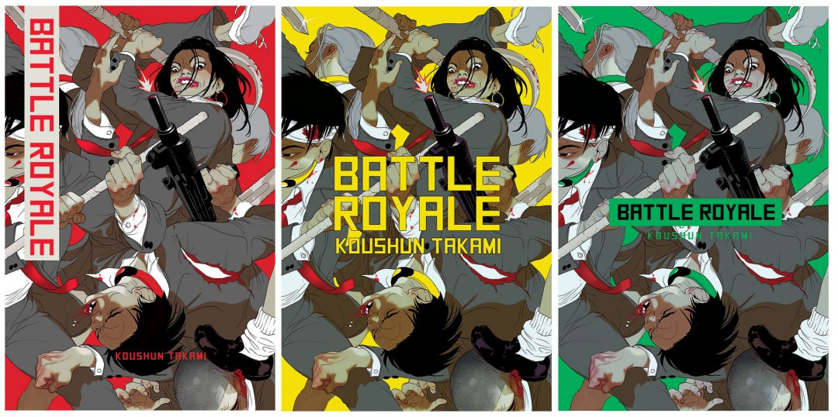
Fig 2: Hanuka, T. (2016) Battle Royale – Work in Progress [digital drawing]

Including illustrations within the novel itself may create less of a disconnect between the novel’s cover and the content inside, and may give a reader more motivation to pick up the book if the text is broken up by images. Seeing large blocks of text can be overwhelming and may feel time consuming to read due to the fact that we are now brought up in a very fast paced world where we are constantly shown information in bite size pieces. We are expected to consume information quickly or in short bursts, but there may be ways to take advantage of this or find ways to make reading more appealing for adults by focusing on modern media and how it affects us in our day to day lives. By doing this we can explore how media alters how we focus on information and we can determine how these alterations could work in illustration’s favour in future.

Chapter 2
Modern Media
In today’s day and age, media is incredibly prevalent in our society in many different forms and we are constantly influenced by the information we see (Khan et al, 2011). Today’s media is known to be very quick and digestible with websites such Instagram focusing on small images that a user can scroll by in seconds. Magazines focus on bold headlines, similarly to tabloid newspapers, drawing a reader’s attention with colloquially written articles to make it as easy as possible for a reader to digest the information. Tabloids contain many pictures and visual content in order to for them to be easier to read (Gossel, 2014). Much of our modern media is created to be consumed quickly and can also cause problems with mental and physical health and can cause high levels of depression and anxiety (Macmillan, 2017). Despite this, much of our time is spent consuming media due to the fact that it is so prevalent in our society. Walker writes:
“Since the mass media are vehicles or channels capable of transmitting pre-existing information, they can transmit examples of culture from any level... via television, a Beethoven symphony, a documentary film or a game show.” (Walker, 1994)
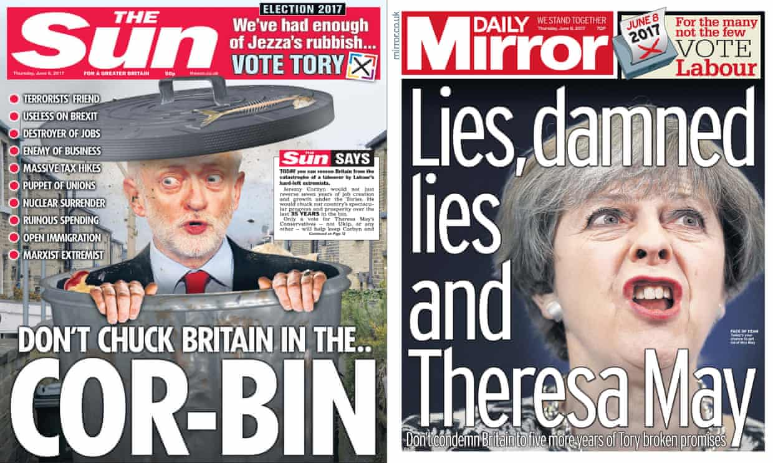
As explained by Walker, today’s media is incredibly widespread and because of this we may begin to stagnate and become overwhelmed with the large amounts of information offered to us but as media is all around us, we grow accustomed to it and learn to live our lives around it. Our minds develop to consume media differently as technology evolves, and we move quickly to keep up with the overwhelming demands of the modern world.
Fig 3: The Sun, The Daily Mirror. (2017) Election Day Front Pages [newspaper front page]
Today’s media is created solely for the purpose of gaining an audience as seen in Walker’s statement: “’success’ is often measured in quantative rather than qualitative terms” (Walker, 1994) and this is shown in many aspects of today’s media. Relating to this, as popularity is categorised by quantity, if the media is easy to consume it will be viewed in greater quantities than media that takes more time to consume. These tabloid newspaper covers demonstrate this point strongly as shown in the use of bold text and large images which look similar to caricatures.
Following this, literature is written in longer forms it can be difficult for people to concentrate for long periods of time. This has been seen in the rapid decline of broadsheet newspaper readers as the circulation of newspapers had declined by 28% in 2016. This is due to the rise in digitally broadcast news as now many wish to see the news quickly and for free rather than purchase a newspaper (Thomas, 2018). Adults are becoming accustomed to media that is short, digestible and accompanied by images to break up text and large blocks of text are exactly what we are not used to. Illustrations could help create less of a disconnect between digital media and adult literature and make a book more appealing to the eye, which would allow a reader to feel less afraid of how large and complicated a book may seem. In relation to this, a report by the United States Department of Labour stated:
“Time spent reading for personal interest varied greatly by age. Individuals age 75 and over averaged 48 minutes of reading per day whereas individuals ages 15-54 read on average 10 minutes or less per day.” (United States Department of Labour, 2019)
This implies that younger generations have been discouraged from reading physical literature due to their heavy involvement with other types of media such as social media. Because of this we can see a clear and sharp decline in the amount of reading young adults and older adults partake in compared to those of an older generation (75 or older) who are not as accustomed to today’s modern media and perhaps spend more time on activities they grew up with. Relating to this review, it is shown that the main demographic for illustrated novels would be young adults and older adults up to the age of 55. This is not to say that this age demographic do not read at all, but most likely fit into the category of digital readers as opposed to those who purchase physical literature. Many adults spend their time reading on social media which has its benefits but also some negative effects which could cause disinterest in reading.
Social media can especially cause us to be less likely to enjoy media that requires a large amount of thought. Long term exposure to social media may increase feelings of depression, a higher chance of episodic heavy drinking and conduct problems (Brunborg, Andreas, 2019, pp. 201-209) however if exposure to social media is lessened, negative effects could be much less prevalent. Social media has also been proven to cause feelings of low self esteem, and young people who spend two hours or more a day using social media often report feelings of psychological distress (Macmillan, 2017). Using illustrated literature to draw people away from social media could be a solution to this and may make adults more likely to read if the long term effects are positive. Including illustration in adult literature would allow the text to become similar to the early ideas of tabloid newspapers where images were used to break up text for easy reading (Gossel, 2014). Without making novels identical to tabloids, using this format loosely may cause adults to feel more drawn to literature that is easier on the eye and more visually appealing. Below is the cover of Little Darlings (2010) written by Jacqueline Wilson and illustrated by Nick Sharratt. The cover of this children’s book is illustrated to have a similar appearance to a tabloid newspaper, due to the fact that the story follows the life of a celebrity family. This children’s book follows this template, making the book colourful and bold which would draw readers in and make them more likely to pick up the book.
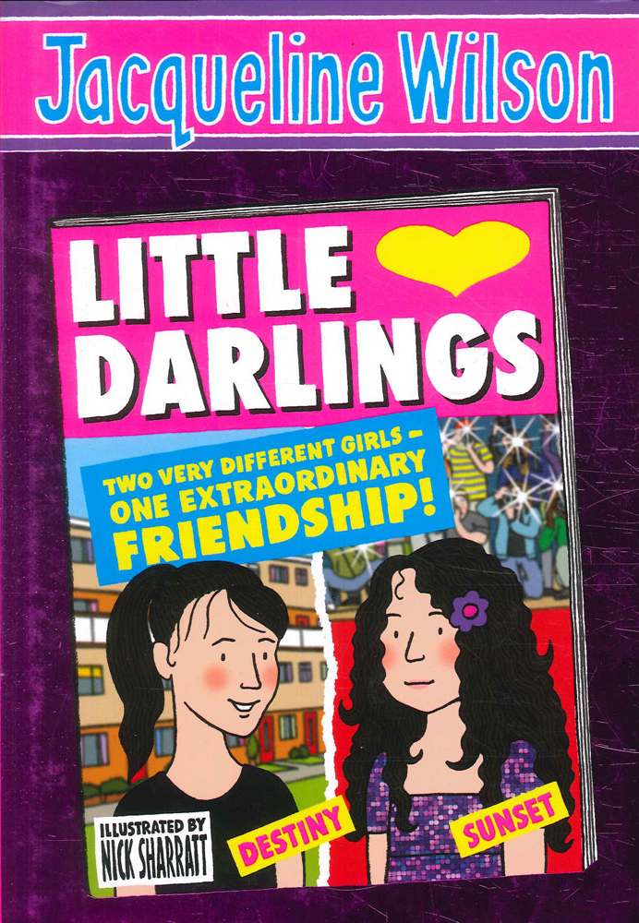

Fig 4: Sharratt, N. (2010) Little Darlings Cover [book cover illustration]

This could also be beneficial for literature and illustration due to the rise in digital reading apparatuses. Reading may now be more accessible to individuals who may not have wanted to purchase a physical copy of a book and therefore illustrations could also be implemented digitally, possibly in the form of moving images or GIFs. This could further evolve the world of illustration to connect to our digital age. Illustrations could also be implemented within learning environments this way, as we are becoming much more digitally focused within workplaces and school (Gohil, 2018). This could aid with illustrated literature becoming more prevalent within higher age groups in schools if teachers feel they can access this literature quickly and easily.
Relating to this, Bloem and Padak ask: “Is there integrity to the practice of using children’s literature in the adult literacy classroom? A growing number of educators and researchers think there is” (Bloem, Padak, 1996, pp. 48-53). This statement proposes the idea that children’s literature could be beneficial to adult’s literacy development. From this it is understood that picture books would help adults improve their learning. Instead of using children’s picture books, using adult texts and including common elements from children’s picture books could create a successfully illustrated adult novel. Further illustrating this point is Sharp, who explains that adult literacy programs could base their learning on reading children’s picture books, improving adult reader’s literacy skills (Sharp, 1991, pp. 216-219). This is further explanation that adults would greatly benefit from more exposure to pictorial literature, however thematically adult novels are known to contain graphic and disturbing themes. This may cause problems with the process of illustrating adult novels as violence has often been a sensitive subject within literature, and especially within film and video games. Exploring how violence affects us and how we react to it would be helpful in determining how graphic illustrations may possibly affect a reader, whether positively or negatively.

Chapter 3
Too Much Violence?
Violence is a popular theme used in adult literature, cinema and television and more often than not an adult novel will contain mature themes. Cinema, television and literature are very different mediums; however they both work hand in hand. Violence is a common part of our everyday lives and in the fiction we consume. Violence is “both produced and consumed... everyday life is transformed in the engagement with violence” (Das, Kleinmann, 2000). We become accustomed to it being a part of our lives and because of this we are less sensitive towards violence within our literature, films, video games and music. Despite this, violence within our media can still be a cause of controversy for some especially after a film or video game has been released that contains large amounts of violence.
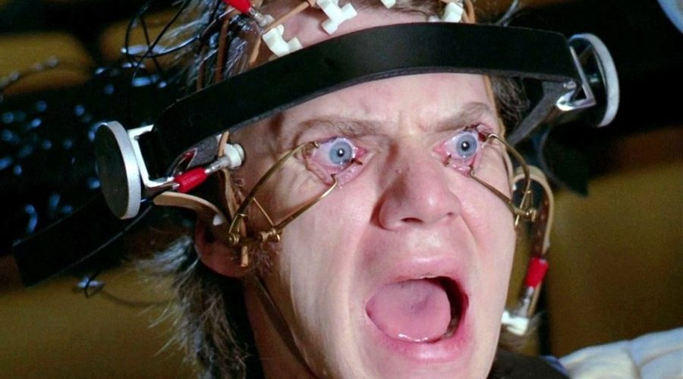
Illustrating adult novels may pose certain problems as they often contain mature concepts and controversial themes. Audiences react differently to certain elements of literature and although nowadays we are partially desensitised to problematic themes, this has mainly occurred in relation to films and video games as opposed to literature. When A Clockwork Orange (1972) was released in cinemas, it received a number of concerns and director Stanley Kubrick banned any showings of the film in the United Kingdom as there were fears of crimes being committed that had connections to the film and its thematic contents. “Several rapes, and murders...” (Travis, 1999) occurred as instances of copycat crimes stemming from the violent scenes shown in the film. Below is a scene from the film showing the main character Alex DeLarge being subject to the Ludovico Technique in A Clockwork Orange (1972).
Fig 5: Kubrick, S. (1972) The Ludovico Technique [film still]

However in relation to this, the novel A Clockwork Orange (1962) written by Anthony Burgess was also heavily criticised upon its publication but not because of its thematic content. The Times considered the novel “...a somewhat clumsy experiment with science fiction... clumsy clichés about juvenile delinquency” and although the novel was incredibly graphic, they described this violence as “unconvincing” (The Times, 1962). This implies that many viewers see film and literature as very differently. Violence on a screen usually appears far more realistic than when it is read, which may be why the film gained much more negative criticism relating to the graphic scenes shown. Relating to this, Anderson writes:
“Violent movies may increase aggression by increasing hostile feelings and the accessibility of aggressive thoughts... participants who viewed a violent movie clip later reported higher levels of state hostility than did those who viewed a non violent clip.” (Anderson, 1997, pp. 161-178)
This proves that viewing violent and aggressive themes within media can cause a negative effect on the viewer. Because of this a connection has to be made between illustration and film as it is important to examine possibly negative impacts. Although both mediums are very different, if violence within film can negatively affect a person, illustration may cause a similar issue especially if the images are particularly graphic or disturbing. This relates back to the issue of copy cat crimes, as these types of crimes are often considered an issue after violent media has been released, an example being Joker (2019) directed by Todd Philips. This film has received many negative responses due to its disturbing and graphic scenes of violence (Zuckerman, 2019).
Literature allows for much greater use of imagination than film, which is the joy that many find in it. Illustrating adult novels with this amount of violence may be a sensitive area to explore, however it is also known that violent media does not always cause aggressive behaviour. Aggressive behaviour triggered by violent media is often determined by a “number of variables, including gender [and] trait hostility” (Kirsh, Olczak, 2002, pp. 1160-1178) therefore the violent media itself may not be a cause for concern. A common belief is that violent media may trigger aggressive behaviours; however these very behaviours are usually triggered in people who exhibit these traits already. This still may be a slight concern; however violent media is already very prevalent in our society. We see violence and disturbing imagery within graphic novels and comic books, which are not entirely different from picture books. An example of this is the seinen horror manga series Uzumaki (1998-1999), written and illustrated by artist Junji Ito.
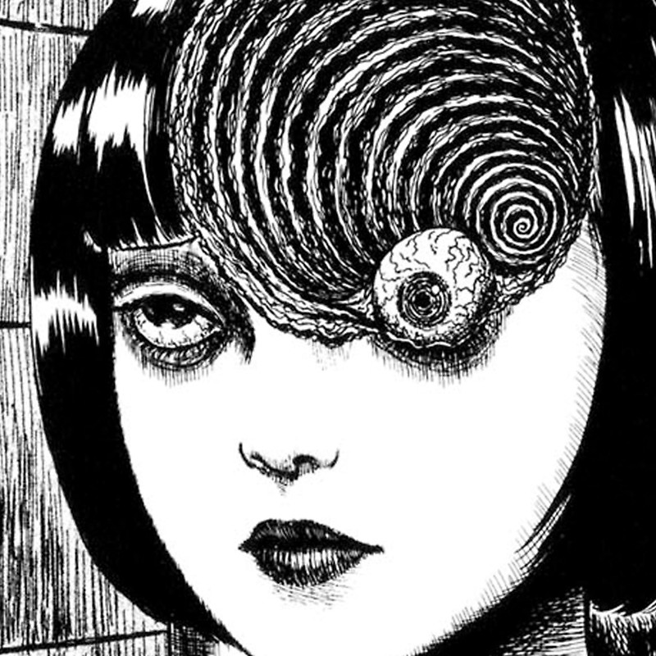

Fig 6: Ito, J. (1998-1999) Azami Kurotani [ink drawing]

The manga is full of graphic imagery but is illustrated beautifully and approaches the themes of horror and distress in a very successful way. This shows that disturbing artwork does not need to be distasteful and can evoke powerful feelings. Ito’s illustrations are also a good example of how adult illustrations can be used successfully. Further exploring the affect of violence on viewers of violent media, Bushman and Huesmann explain that:
“As expected, the short terms effects of violent media were greater for adults than for children, whereas the long-term effects were greater for children than for adults. The results showed that there were overall modest but significant effect sizes for exposure to media violence on aggressive behaviours, aggressive thoughts, angry feelings... and helping behaviour.” (Bushman, Huesmann, 2006, pp. 348-352)
This shows that overall, violent media affects both adults and children negatively in the long term and short term and it may be problematic in terms of illustration. How could we combat this? Comic books and graphic novels are rarely an issue in terms of being a cause of aggressive behaviour, most likely due to the fact that there is a slight disconnect between the images and the reader. A video game or a film may be more immersive due to the fact that they are moving images, thus causing a viewer or player to experience the events shown in a much deeper and personal manner (Stuart, 2010). This is also shown in Ferguson’s discussing that video games may have a tendency to “cause aggressive behaviour among players” (Ferguson, 2007) which further illustrates the point that violent video games are much more physically immersive than a still image or drawing. This is not to say that illustrations cannot be immersive, however they impact the reader in a different way emotionally than a moving image. Another difference is that video games are controlled directly by the player which may cause them to feel more in control of their actions on the screen, whereas with an illustration the viewer acts more like a bystander. Therefore, illustration in adult novels would most likely not cause a rise in violent behaviour and seeing them become more common would be a generally positive experience for many readers, increasing their enjoyment.
Following from this, as children’s picture books are a common item on many bookshelves and bookshops, we grow to believe that illustrations are reserved for children’s picture books only. Although illustrations are found in children’s literature more often than adult literature, it would be incorrect to make the assumption that adults never come in contact with illustration at all. It is much more common in the adult world than we think, however not in the same way it is presented to children.

Chapter 4
Images and Words
Illustration for adults is used in a slightly different way to how it is used for children, however both work similarly in how they educate the reader as seen in anatomy reference books and encyclopaedias. An example of a book that showcases these anatomical drawings is Sick Rose or disease and the art of medical illustration (2014) by Richard Barnett. This book explores the different aspects of anatomical illustration throughout history, and how they were used. These types of books are available for children and adults alike, however the contents is often heavily simplified for children and is less graphic.
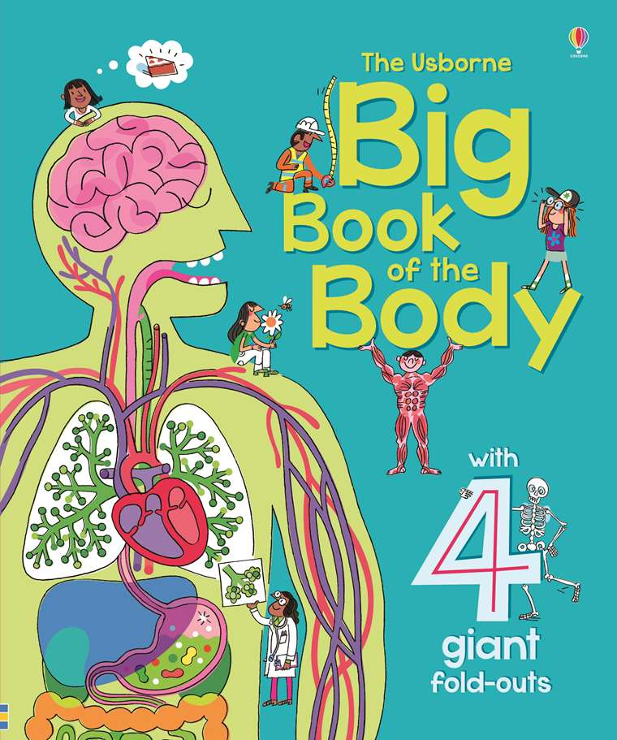

Fig 7: Allen, P. (2016) The Usborne Big Book Of The Body [book cover]

If illustration is so readily available for adults in an educational form, why not use this as an opportunity to focus attention on illustration adult fiction? Although there is a significant difference in fiction and non-fiction writing, the benefits of using images within fiction could be as beneficial as they are in non-fiction. Adults are not unfamiliar with illustration as previously explored therefore adults may already be comfortable with the idea of illustrated books; they simply need to be implemented into society.
Furthermore, illustrations are used in more adult settings than we are aware as shown in The Secret of Drawing, The Line of Enquiry (2005) where a surgeon is seen using the blood of a patient to draw diagrams during an open heart surgery. He intended to use the illustrations and diagrams to help explain his processes to the students who were working with him. This shows that illustration is used more commonly than we may realise in order to teach individuals and illustrations in novels could help teach and help to promote learning and understanding in a digital age especially due to the fact that pictures often enhance the written word. This is explained by Agosto:
“In most picture story books the stories are told twice, once through text and once through illustration. The reader can comprehend such stories either through the words or through the pictures... conversely, there exists a subset of picture story books for which the reader must consider both forms of media concurrently in order to comprehend the book’s stories.” (Agosto, 1999, pp. 267-280)
We see here that illustration has a heavy bearing on a reader’s understanding of writing. Because of this, illustration is also used in an educational sense for adults as images are able to enhance our understanding of words within educational means. Furthermore, the images and illustrations that are used can also work as stand-alone images, which support Agosto’s statement further.
Anatomical illustration has been a forefront in the world of science for a long time, and is “indebted to individuals whose lifetimes span several centuries” (Calkins et al, 1999). Evidently adults have been exposed to illustration a lot more than they realise but in a vastly different way to children. Children are brought up on picture books in order to educate them, whereas adults are taught with pictures in the forms of diagrams, which feel much more formal than picture book illustrations. Some may not even realise that illustration is such a big part of anatomical illustration, as it does not fit the usual vision many have of what illustration is. Anatomical illustration is particularly important in these terms as it was used during a time where cameras only developed in black and white, and when cameras were not yet available. Using illustration would aid surgeons and doctors by giving them the most accurate depictions of a disease, sickness or injury. Despite the fact that anatomical illustrations are not created as often today ever since the evolution of our photographic capabilities, however the illustrations that have been created still continue to educate even today.
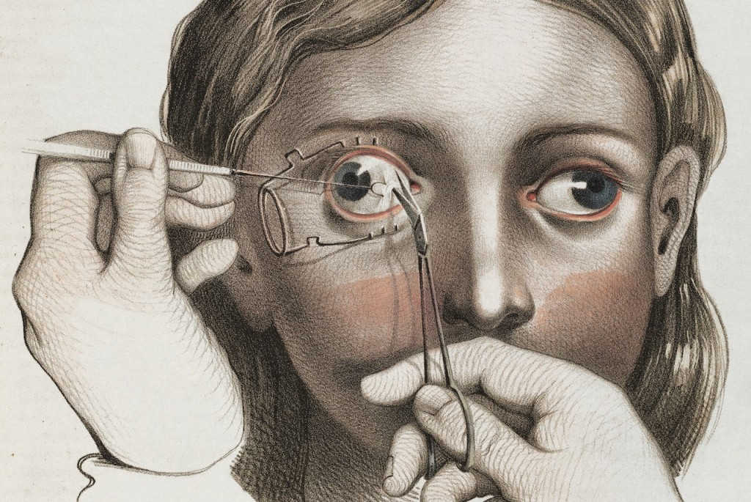

FFig 8: Barnett, R. (2015) Surgery to correct strabismus [anatomical study]

Furthermore, Whillis explains that “anatomical illustrations are now so commonly accepted that little thought is given by the reader to the stages in development of this art” (Whillis, 2009, pp. 54-59). We have since become accustomed to anatomical illustrations and almost take them for granted. The ongoing use of anatomical illustration is useful to the potential rise in illustrated adult fiction as it proves that illustration has a clear bearing on how we understand words, and may allow readers to become more immersed in literature. Using images and words together is a common scientific practice as diagrams support explanations and vice versa and both act as standalone sources of information. This would be beneficial in illustrated fiction as the words and images would not take away from each other and instead complement each other as individual sources of learning.
Relating to this, Crawley explains that illustrated picture books can aid in teaching and could also be used as a learning source for nursing students, in order to grasp difficult themes such as death, loss and grief (Crawley et al, 2012, pp. 45-52). This is interesting because it focuses on the idea that picture books can aid in coping strategies and in teaching difficult subjects. Sometimes approaching an emotional subject with a childlike perspective can help create a better understanding of certain topics by lessening the adult like confusion surrounding it. This could be helpful in using illustration to teach adults about certain topics and issues by creating simplified versions of these issues through images. This also shows that illustrations continue to have an educational benefit to us even after we are no longer developing children.
An experiment conducted on 24 girls aged eleven to twelve “studied text material illustrated with pictures or less informative line drawings.” Contrary to what many believe about pictures aiding learning, this experiment showed “no clear superiority for the pictorial presentation over the non-pictorial” (Vernon, 1954). This could imply that illustrative books do not aid in learning as much as we may believe, however the results of this experiment may be short term. Long term exposure to illustrated literature may prove more beneficial to development as Osborn explains that students who were denying themselves the enjoyment of reading picture books were also categorised as poor readers. These picture books could be used by teachers to develop reading comprehension (Osborn, 2001, pp. 24). This in contrast to Vernon’s statement shows that images and words together can improve reading and comprehension in the long term. In relation to this, Osborn states that reading a picture book is a source of pleasure and enjoyment (Osborn, 2001, pp. 24) which shows that regardless of whether or not picture books greatly benefit learning, the long term enjoyment of an individual may be increased which in turn would improve mood and willingness to learn. Therefore adult illustration may begin becoming more prevalent within our literature in the near future due to the fact that it is already well established within education for adults and children. Illustration for adults may one day be as common as illustration for children, and we can see this development within the illustrated adult literature that is already on the market.

Chapter 5
Illustration’s Future
The future of adult novel illustration could be a bright one, as an example of a publishing company who are already working with adult illustration is The Folio Society which is a publishing company that commission artists and illustrators to create artworks for many classic and popular novels. Some examples of these novels are The Lord of the Flies (1954) by William Golding and Catch-22 (1961) by Joseph Heller. These novels contain up to five illustrations and a cover design, and are illustrated by artists such as Charles van Sandwyk, James E. Ransome and Gary Kelley. A disadvantage with these newly illustrated novels is that they are priced highly, which may mean that literature remains on a pedestal. It would be a goal for adult illustrated literature to be as common as children’s literature in a bookshop in order to make it more accessible. The Folio Society’s publications are very well produced which is why they are more expensive than the average book, but despite this drawback this is proof that illustration is becoming more common. Illustrations becoming commonplace in averagely priced books would be an achievement as more people would be exposed to illustration within novels without the belief that illustration exists only for children’s picture books. Another example of this is a 2007 publication of Salem’s Lot (1975) by Stepn King, which includes photographs by Jerry N. Uelsmann.
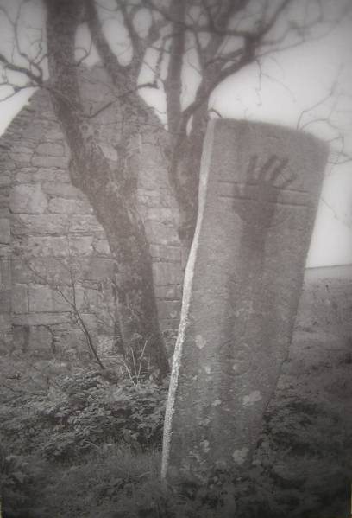
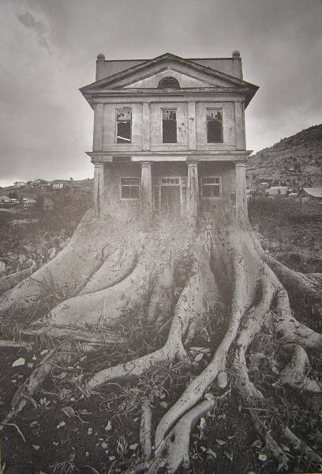
Fig 9 &10: Uelsmann, J.N. (2007) Untitled [photographs]
This novel is marketed as being ‘illustrated’, however it contains photographs instead of hand drawn images and they are spaced few and far between within the writing. Therefore the difference between this and a normal copy of the novel is barely noticeable. However, despite this novel not being the best example of successfully illustrated literature, it shows that the appeal for illustrated adult novels is slowly growing. Because of this, adult illustration may eventually grow to be as common as children’s illustration, especially if there is profit to be made. Children’s picture books have become increasingly more popular over time with many being constantly published and re-published (Hade, Crawford, 2000, pp. 66-80) and this rise in illustrated children’s literature begs the question: where can illustration go from here? Sipe explains:
“According to many writers, the essence of the picture book is the way the text and the illustrations relate to each other; this relationship between two kinds of text – the verbal and visual texts – is complicated and subtle.” (Sipe, 1998, pp. 97-108)
This shows us that using illustration in novels could create a visual harmony within the books. Breaking up blocks of text with bright images gives the brain to absorb the information gathered from text. Although the use of images and text together is described as being “complicated and subtle” (Sipe, 1998, pp. 97-108) an illustration done well would never take away from the text on the page, only enhance it. This does not mean that only illustration could be used since some books have used photography as opposed to drawings as previously shown with Uelsmann’s photographs in Salem’s Lot (2007). Nodelman writes:
“Our heritage of many centuries of great unillustrated literature makes it clear that stories can be told adequately by words on their own. Why, then, add pictures to them? Or why even create a series of pictures that tell stories on their own without accompanying words? Why are there such picture books at all?” (Nodelman, 1988)
To put it simply, illustrations are fun. We enjoy looking at pictures and have always found them fascinating (Elkins, 2004). The world believes that adults must be mature and picture books delve too deep into immaturity for some. However, why is it a necessity for adults to read literature that is deemed mature and what does this truly achieve? Driving adults away from literature is the central problem here and in order to gain their interest, literature must be made fun and accessible for all.
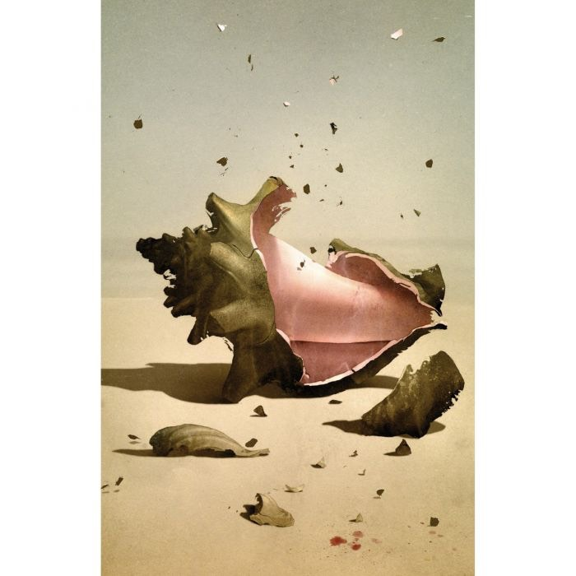

Fig 11: Weber, S. (2019) Lord of the Flies - The Conch [book illustration]
This is not to say that all books should be illustrated as this may be counterproductive. However making illustrated books another option for adults could create less of a drop in reading times and may once again get adults to enjoy reading and boost the credibility of illustrated books in the world. As the future of adult illustration is already on its way to developing itself, over time illustrations may become more integrated into our literature and it may one day be a common occurrence to see an adult delving into a picture book.

Conclusion
In conclusion, this independent inquiry focused on the concept of illustrating adult novels exploring why they are not often illustrated and how we could combat this. The aim of this research was to discover ways that illustration could be implemented into adult literature focusing on media, violence and education as key themes. This research found that illustration is common within the adult world, however not in the sense of traditional picture books. Because of this, engaging adults with literature again relies on how media affects society, and how we can modernise illustration to correspond with our digital age. The exploration of children’s books and adult anatomical illustration allowed for further understanding of the inner workings of an illustrated book, and gave insight into how we could successfully implement illustration into an adult novel successfully.
This topic allowed for the discovery that unillustrated literature is a side effect of discouraging adults from reading. This research focused on how regaining adult’s interest in reading could improve literacy skills and further development in reading, and also improve comprehension and understanding of certain themes. Although violent media may prove to be a challenging issue, this is a common occurrence within today’s society and this research found that there may be no correlation between graphic illustrations and violent behaviours. As adult illustration may become more prevalent, it would be important to continue monitoring how readers react to illustrated literature, in order to understand whether or not the illustrations are benefiting adults in their reading. Furthermore, focusing on adult books that have already been illustrated, it was shown that adult illustration is already slowly becoming more prevalent in our society, which is a step in the right direction for illustration.

References
‘The Line of Enquiry’ (2005) The Secret of Drawing, episode 1, BBC2, 8 October. Available at: https://www.youtube.com/watch?v=9H59cVnnF9Y (Accessed: 23rd November 2019)
A Clockwork Orange (1972) Directed by Stanley Kubrick [DVD] Warner Brothers: United States.
Abrahamson, R.F. (1980) ‘An Analysis of Children’s Favourite Picture Books’, The Reading Teacher, 34(2), pp. 167-170, JSTOR [Online] Available at: https://www.jstor.org/stable/20195201?seq=1 (Accessed: 23rd November 2019)
Agosto, D.E. (1999) ‘One and Inseparable: Interdependent Storytelling in Picture Storybooks’, Children’s Literature in Education, 30(4), pp. 267-280, Springer [Online] Available at: https://link.springer.com/article/10.1023%2FA%3A1022471922077 (Accessed: 23rd November 2019)
Anderson, C. A., Carnagey, N. L and Eubanks, J. (2003) ‘Exposure to violent media: The effects of songs with violent lyrics on aggressive thoughts and feelings’, Journal of Personality and Social Psychology, 84(5), pp. 960-971, APA PsycNET [Online] Available at: https://psycnet.apa.org/record/2003-00420-007 (Accessed: 26th November 2019)
Anderson, C.A. (1997) ‘Effects of violent movies and trait hostility on hostile feelings and aggressive thoughts’, Official Journal of the International Society for Research on Aggression, 23(3), pp. 161-178, Wiley Online Library [Online] Available at: https://onlinelibrary.wiley.com/doi/pdf/10.1002/%28SICI%291098-2337%281997%2923%3A3%3C161%3A%3AAID-AB2%3E3.0.CO%3B2-P (Accessed: 26th November 2019)
Ashton, J. (2019) ‘Reading is in sharp decline – that’s bad news for the future’, Reaction, 8th March. Available at: https://reaction.life/reading-sharp-decline-thats-bad-news-future/ (Accessed: 6th December 2019)
Barnett, R. (2014) The Sick Rose or disease and the art of medical illustration. Thames & Hudson: United Kingdom.
Barnett, R. (2015) Crucial Interventions: An Illustrated Treatise on the Principles and Practice of Nineteenth-Century Surgery. Thames & Hudson: United Kingdom.
Barr, R. (2013) ‘Memory Constraints on Infant Learning From Picture Books, Television, and Touchscreens’, Child Development Perspectives, 7(4), SRCD [Online] Available at: https://srcd.onlinelibrary.wiley.com/doi/abs/10.1111/cdep.12041 (Accessed: 23rd November 2019)
Barrett, C.A. (2015) ‘Adult Colouring Books: Patterns for Stress Relief’, Phi Kappa Phi Forum, 95(4), pp. 27, Gale [Online] Available at: https://go.gale.com/ps/anonymous?id=GALE%7CA439002253&sid=googleScholar&v=2.1&it=r&linkaccess=fulltext&issn=15385914&p=AONE&sw=w (Accessed: 23rd November 2019)
Berg-Cross, L. and Berg-Cross, G. (1978) ‘Listening to stories may change children’s social attitudes’, The Reading Teacher, 31(6), JSTOR [Online] Available at: https://www.jstor.org/stable/20194614 (Accessed: 23rd November 2019)
Bloem, P.L. and Padak, N.D. (1996) ‘Picture books, young adult books, and adult literacy learners’, Journal of Adolescent & Adult Literacy, 40(1), pp. 48-53, JSTOR [Online] Available at: https://www.jstor.org/stable/40012112 (Accessed: 23rd November 2019)
Brunborg, G.S. and Andreas, J.B. (2019) ‘Increase in time spent on social media is associated with modest increase in depression, conduct problems, and episodic heavy drinking’, Journal of Adolescence, 74(1), pp. 201-209, Science Direct [Online] Available at: https://www.sciencedirect.com/science/article/pii/S0140197119301046 (Accessed: 6th December 2019)
Burgess, A. (1962) A Clockwork Orange. William Heinemann: United Kingdom.
Bushman, B. J, Huesmann, L. R. (2006) ‘Short-term and Long-term Effects of Violent Media on Aggression in Children and Adults’, Arch Pediatr Adolesc Med, 160(4), pp. 348–352, JAMA Pediatrics [Online] Available at: https://jamanetwork.com/journals/jamapediatrics/article-abstract/204790 (Accessed: 26th November 2019)
Calkins, C. and Franciosi, J.P. and Kolesari, G.L. (1999) ‘Human anatomical science and illustration: The origins of two inseparable disciplines’, Clinical Anatomy, 12(2), Wiley Online Library [Online] Available at: https://onlinelibrary.wiley.com/doi/abs/10.1002/%28SICI%291098-2353%281999%2912%3A2%3C120%3A%3AAID-CA7%3E3.0.CO%3B2-V (Accessed: 23rd November 2019)
Cavna, M. (2017) ‘Banned Books Week: Why are illustrated books being challenged more than ever?’, The Washington Post, 25th September. Available at: https://www.washingtonpost.com/news/comic-riffs/wp/2017/09/25/banned-books-week-half-of-the-most-challenged-books-including-bill-cosbys-tale-are-illustrated/? (Accessed: 26th November 2019)
Corrigan, R. and Surber, J.R. (2009) ‘The Reading Level Paradox: Why Children’s Picture Books are Less Cohesive Than Adult Books’, Discourse Processes, 47(1), pp. 32-54, Taylor & Francis Group [Online] Available at: https://www.tandfonline.com/doi/abs/10.1080/01638530902728298?needAccess=true (Accessed: 23rd November 2019)
Cowdrey, K. (2017) ‘Tiger Who Came to Tea hits million-copy milestone’, The Bookseller, 30th August. Available at: https://www.thebookseller.com/news/kerrs-tiger-who-came-tea-hits-million-copy-milestone-624426 (Accessed: 6th December 2019)
Crawford, P. and Hade, D.D. (2000) ‘Inside the Picture, Outside the Frame: Semiotics and the Reading of Wordless Picture Books’, Journal of Research in Childhood Education, 15(1), pp. 66-80, Taylor & Francis Group [Online] Available at: https://www.tandfonline.com/doi/abs/10.1080/02568540009594776 (Accessed: 23rd November 2019)
Crawley, J. and Ditzel, L. and Walton, S. (2012) ‘Using children’s picture books for reflective learning in nurse education’, Contemporary Nurse, 42(1), pp. 45-52, Taylor & Francis Group [Online] Available at: https://www.tandfonline.com/doi/abs/10.5172/conu.2012.42.1.45?src=recsys (Accessed: 23rd November 2019)
Das, V. and Kleinman, A. (2000) ‘Introduction’, in Das, V. et al (ed.) Violence and Subjectivity. University of California Press: London.
Dyer, J. and Shatz, M. and Wellman, H.M. (2000) ‘Young children’s storybooks as a source of mental state information’, Cognitive Development, 15(1), pp. 17-37, APA PsycNET [Online] Available at: https://psycnet.apa.org/record/2001-17598-002 (Accessed: 23rd November 2019)
Elkins, J. (2004) Pictures & Tears, A History of People Who Have Cried in Front of Paintings. Routledge: United Kingdom.
Ellis, B.E. (1991) American Psycho. Vintage Books: New York.
Evans, J. (2008) ‘Responding to Illustrations in Picture Story Books’, Reading, 32(2), Wiley Online Library [Online] Available at: https://onlinelibrary.wiley.com/doi/abs/10.1111/1467-9345.00086 (Accessed: 23rd November 2019)
Fang, Z. (1996) ‘Illustrations, Text, and the Child Reader: What are Pictures in Children’s Storybooks for?’, Reading Horizons – Journal of Literacy and Language Arts, 37(2), Scholar Works [Online] Available at: https://scholarworks.wmich.edu/reading_horizons/vol37/iss2/3/ (Accessed: 23rd November 2019)
Ferguson, C.J. (2007) ‘Evidence for publication bias in video game violence effects literature: A meta-analytic review’, Aggression and Violent Behaviour, 12(4), Science Direct [Online] Available at: https://www.sciencedirect.com/science/article/pii/S1359178907000055 (Accessed: 23rd November 2019)
Ganea, P.A. et al. (2008) ‘Transfer between picture books and the real world by very young children’, Journal of Cognition and Development, 9(1), pp. 46-66, Taylor & Francis Group [Online] Available at: https://www.tandfonline.com/doi/abs/10.1080/15248370701836592 (Accessed: 23rd November 2019)
Gohil, N. (2018) ‘Digital schools: a how-to guide’, Education Technology, 19th September. Available at: https://edtechnology.co.uk/Blog/digital-schools-a-how-to-guide/ (Accessed: 6th December 2019)
Gossel, D. (2014) ‘Tabloid journalism’, Britannica, 7th November. Available at: https://www.britannica.com/topic/tabloid-journalism (Accessed: 6th December 2019)
Heilmann, J.J. et al. (2015) ‘Clinical impact of wordless picture storybooks on bilingual narrative language production: A comparison of the ‘Frog’ stories’, International Journal of Language & Communication Disorders, 51(3), Wiley Online Library [Online] Available at: https://onlinelibrary.wiley.com/doi/abs/10.1111/1460-6984.12201 (Accessed: 23rd November 2019)
Heins, E. (1995) Children’s Literature: An illustrated history. Oxford University Press: United Kingdom.
Hildebrand, R. (2004) ‘Alternative images: anatomical illustration and the conflict between art and science’, Interdisciplinary Science Reviews, 29(3), pp. 295-311, Taylor & Francis Group [Online] Available at: https://www.tandfonline.com/doi/abs/10.1179/030801804225018864 (Accessed: 23rd November 2019)
Hoskins, N. (2007) ‘Why the illustrated novel could be a great draw’, The Guardian, 29th June. Available at: https://www.theguardian.com/books/booksblog/2007/jun/29/whytheillustratednovelcoul (Accessed: 26th November 2019)
Houre, C. (2013) ‘Why don’t books for grown-ups have illustrations anymore?’, The Telegraph, 21st November. Available at: https://www.telegraph.co.uk/culture/books/children_sbookreviews/10465326/Why-dont-books-for-grown-ups-have-illustrations-any-more.html (Accessed: 26th November 2019)
Joker (2019) Directed by Todd Phillips [Film], United States of America: Warner Bros. Pictures
Kelley, J.E. (2008) ‘Harmony, Empathy, Loyalty, and Patience in Japanese Children’s Literature’, The Social Studies, 99(2), pp. 61-70, Taylor & Francis Group [Online] Available at: https://www.tandfonline.com/doi/abs/10.3200/TSSS.99.2.61-70 (Accessed: 23rd November 2019)
Khan, N.A. et al. (2011) ‘Impact of today’s media on university student’s body image in Pakistan: a conservative, developing country’s perspective’, BMC Public Health, 11(379), BMC [Online] Available at: https://bmcpublichealth.biomedcentral.com/articles/10.1186/1471-2458-11-379#citeas (Accessed: 6th December 2019)
King, S. (2007) Salem’s Lot Illustrated Edition. London: Hodder & Stroughton.
Kirsh, S.J, Olczak, P.V. (2002) ‘The Effects of Extremely Violent Comic Books on Social Information Processing’, Journal of Interpersonal Violence, 17(11), pp.1160-1178, Sage Journals [Online] Available at: https://journals.sagepub.com/doi/abs/10.1177/088626002237400 (Accessed: 26th November 2019)
Lukes, S. (1973) Emile Durkheim His Life and Work A Historical and Critical Study. Stanford University Press: California.
Macmillan, A. (2017) ‘Why Instagram Is the Worst Social Media for Mental Health’, TIME, 27th May. Available at: https://time.com/4793331/instagram-social-media-mental-health/ (Accessed: 6th December 2019)
Malu, K.F. (2013) ‘Exploring Children’s Picture Storybooks with Adult and Adolescent EFL Learners’, English Teaching Forum, 51(3), pp. 10-18, Eric [Online] Available at: https://eric.ed.gov/?id=EJ1020720 (Accessed: 23rd November 2019)
Mantzicopoulos, P. and Patrick, H. (2011) ‘Reading Picture Books and Learning Science: Engaging Young Children with Informational Text’, Theory into Practice, 50(1), pp. 269-276, Taylor & Francis Group [Online] Available at: https://www.tandfonline.com/doi/abs/10.1080/00405841.2011.607372?journalCode=htip20 (Accessed: 23rd November 2019)
Miller, T. (1998) ‘The Place of Picture Books in Middle Level Classrooms’, Journal of Adolescent & Adult Literacy, 41(5), pp. 376-381, JSTOR [Online] Available at: https://www.jstor.org/stable/40016940 (Accessed: 23rd November 2019)
Mitzal, B.A. (2003) ‘Durkheim on Collective Memory’, Journal of Classical Sociology, 3(2), pp. 123-143, SAGE Journals [Online], Available at: https://journals.sagepub.com/doi/10.1177/1468795X030032002 (Accessed: 27th November 2019)
Nodelman, P. (1988) Words About Pictures – The Narrative Art of Children’s Picture Books. University of Georgia Press: United States of America.
Nodelman, P. (1999) ‘Decoding the Images: Illustration and Picture Books’, in Hunt, P. (ed.) Understanding Children’s Literature. Routledge: USA and Canada.
Osborn, S. (2001) ‘Picture Books for Young Adult Readers’, in Carroll, P.S. (ed.) The Alan Review, 28(3), pp. 24, Available at: https://scholar.lib.vt.edu/ejournals/ALAN/v28n3/ALAN_Review_Spring_2001.pdf (Accessed: 27th November 2019)
Pantaleo, S. (2005) ‘”Reading” Young Children’s Visual Texts’, Early Childhood Research & Practice, 7(1), Eric [Online] Available at: https://eric.ed.gov/?id=EJ1084869 (Accessed: 23rd November 2019)
Pringle, R.M and Lamme, L.L. (2005) ‘Using Picture Storybooks to Support Young Children’s Science Learning, Reading Horizons, 46(1), ScholarWorks [Online] Available at: https://scholarworks.wmich.edu/reading_horizons/vol46/iss1/2/ Accessed: 23rd November 2019)
Rideout, V. (2016) ‘Measuring time spent with media: the Common Sense census of media use by US 8- to 18-year-olds’ Journal of Children and Media, 10(1), pp. 138-144, Taylor & Francis Group [Online] Available at: https://www.tandfonline.com/doi/full/10.1080/17482798.2016.1129808?scroll=top&needAccess=true (Accessed: 6th December 2019)
Rossuck, J. (1997) ‘Banned Books: A Study of Censorship’, The English Journal, 86(2), pp. 67-70, JSTOR [Online] Available at: https://www.jstor.org/stable/819679 (Accessed: 23rd November 2019)
Sacks, S. (2013) ‘Bring back the illustrated book!’, The New Yorker, 22nd February. Available at: https://www.newyorker.com/books/page-turner/bring-back-the-illustrated-book (Accessed: 26th November 2019)
Sharp, P.A. (1991) ‘Picture Books in the Adult Literacy Curriculum’, Journal of Reading, 35(3), pp. 216-219, JSTOR [Online] Available at: https://www.jstor.org/stable/40012112?seq=1 (Accessed: 23rd November 2019)
Sipe, L.R. (1998) ‘How Picture Books Work: A Semiotically Framed Theory of Text-Picture Relationships’, Children’s Literature in Education, 29(2), pp. 97-108, Springer [Online] Available at: https://link.springer.com/article/10.1023%2FA%3A1022459009182 (Accessed: 23rd November 2019)
Smith, S. (2018) ‘Why primary schools need to embrace picture books to boost literacy’, Tes, 13th April. Available at: https://www.tes.com/news/why-primary-schools-need-embrace-picture-books-boost-literacy (Accessed: 6th December 2019)
Stuart, K. (2010) ‘What do we mean when we call a game immersive?’, The Guardian, 11th August. Available at: https://www.theguardian.com/technology/gamesblog/2010/aug/10/games-science-of-immersion (Accessed: 8th December 2019)
Takami, K. Collins, N. (2014) Battle Royale Remastered Edition. Viz Media: United States of America.
The Times. (1962) ‘New Fiction’, The Times, 17th May, p. 16.
Thomas, H. (2018) ‘Newspaper circulation figures decline by up to 28%’, BBC News, 1st March. Available at: https://www.bbc.co.uk/news/uk-wales-43246321 (Accessed: 6th December 2019)
Tomlinson, C.M and Lynch-Brown, C. (1996) Essentials in children’s literature, (2nd ed.) Boston: Allyn & Bacon.
Travis, A. (1999) ‘Retake on Kubrick film ban’ The Guardian [Online], 11 September, Available at: https://www.theguardian.com/uk/1999/sep/11/alantravis (Accessed: 23rd November 2019)
United States Department of Labor, Bureau of Labor Statistics (2019) American Time Use Survey Summary, Available at: https://www.bls.gov/news.release/atus.nr0.htm (Accessed: 6th December 2019)
Vernon, M.D. (1954) ‘The Instruction of Children by Pictoral Illustration’, British Journal of Educational Psychology, 24(3), APA PsycNET [Online], Available at: https://psycnet.apa.org/record/1955-06185-001 (Accessed: 27th November 2019)
Versaci, R. (2001) ‘How Comic Books Can Change the Way Our Students See Literature: One Teacher’s Perspective’, The English Journal, 91(2), pp. 61, JSTOR [Online] Available at: https://www.jstor.org/stable/822347?seq=1#page_scan_tab_contents (Accessed: 23rd November 2019)
Walker, J. (1994) Art In The Age Of Mass Media, Routledge: New York.
Whillis, J. (2009) ‘Anatomical Illustration’, Journal of Audiovisual Media in Medicine, 24(2), pp. 54-59, Taylor & Francis Group [Online] Available at: https://www.tandfonline.com/doi/abs/10.1080/01405110120048977 (Accessed: 23rd November 2019)
Zuckerman, E. (2019) ‘Joker’ Is Already the Most Controversial Movie of Oscar Season’, Thrillist, 4th November. Available at: https://www.thrillist.com/entertainment/nation/joker-movie-controversy-explained (Accessed: 8th December 2019)

