Human Resource Management

Student Name: Vladimir Rebrik
Student Number: (1914780)
Assignment Title: Individual Report
Module Code: LCMB7000
Lecturer: Mohamed Asim

Table of Contents

Table of Contents...................................................................................................2
1. Introduction.......................................................................................................3
2. The current state of the Labour market in the UK.............................................3
3. The current HR strategies in the post-Brexit, post-Covid environment.............9
4. Conclusion and Recommendations....................................................................10
5. References.......................................................................................................11

Introduction
Over the past five years, the UK labour market has met significant changes. First, important changes occurred due to the UK's exit from the European Union's common labour market. The COVID-19 pandemic proved to be the next, following after Brexit significant game-changer in the labour market. It forced employers to reconsider their approach to remote work and adapt their policies accordingly while considering UK government regulations. Moreover, in 2022, Russia's invasion of Ukraine caused more instability in world markets, resulting in increased energy prices, inflation, and other negative consequences for the UK economy, which inevitably impacted the labour market in the UK.
The purpose of this report is to provide an analysis of the current state of the UK labour market, with a particular focus on examining the impact of the above factors, supported by credible and relevant sources and aim to provide a comprehensive understanding of the current landscape of the UK labour market. In the second half of the report, the author will give examples of new HR strategies used by companies to improve the situation of the workforce in their organisations. At the end of the report, the author will make his conclusion and give several recommendations for the HR departments of UK companies.

The current state of the Labour market in the UK
Due to the post-Brexit and post-Covid periods and the impact of the Russian invasion of Ukraine, the UK economy in 2022 has experienced uncertainty and turbulence.
1 Employment
From December (2022). – In February 2023, there were employed 32.95 million people in the UK, and the employment rate (the proportion of people aged 16-64 in work) was 75.8%, see Figure 1. From 2011 the employment rate gradually rose to early 2020 - to the start of the Covid-19 pandemic, when it reached the maximum rate of 76.6%, the highest level since records began in 1971 (Powell & Francis-Devine, 2023).
The COVID-19 pandemic, which began in China in 2019, spread globally and became the most challenging in terms of mortality and impact on all levels of society and the world economy since the H1N1 influenza pandemic in 1918 (Health, 2022).

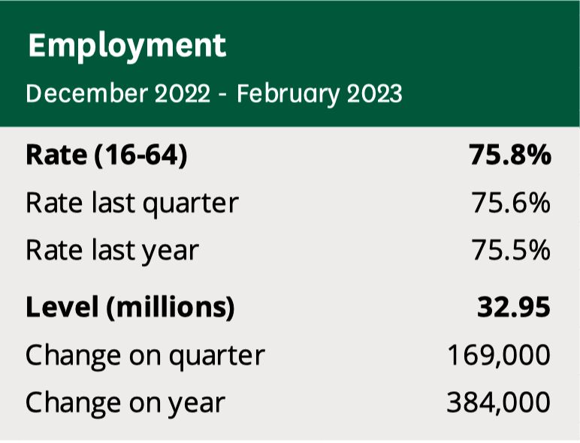
Figure 1. Employment in the UK - (December 2022 – February 2023), (Powell & Francis-Devine, 2023).

Because of the UK-wide coronavirus lockdowns, employment levels fell in March 2020 and began to recover during the first half of 2021, rising in early 2022. The employment rate has remained close to 75.5% compared to a pre-pandemic rate of 76.3%. See Figure 2.
Employment levels rose to December 2022 – February 2023 but remained 34,000 below pre-pandemic levels in 2020.
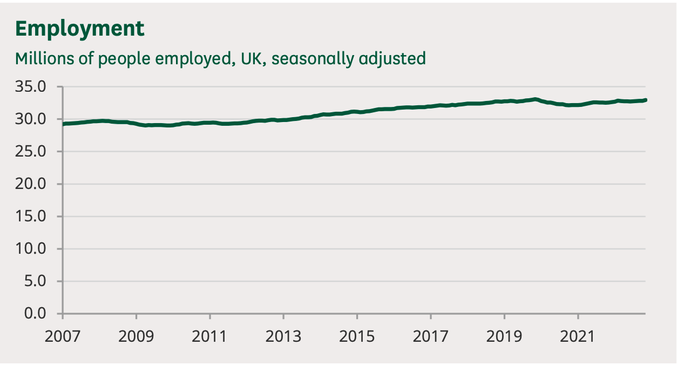
Figure 2. Employment in the UK - (2007 – 2021), (Powell & Francis-Devine, 2023).

2. Unemployment
From December 2022 to February 2023, there were unemployed 1.29 million people in the UK, and the unemployment rate (the percentage of the unemployed economically active population) was 3.8%, see Figure 3.
Before the beginning of the coronavirus pandemic, the unemployment rate was at a historically low level. It rose as a consequence of the Covid - 19 to a high of 5.2% in late 2020, see Figure 4 (Powell & Francis-Devine, 2023).

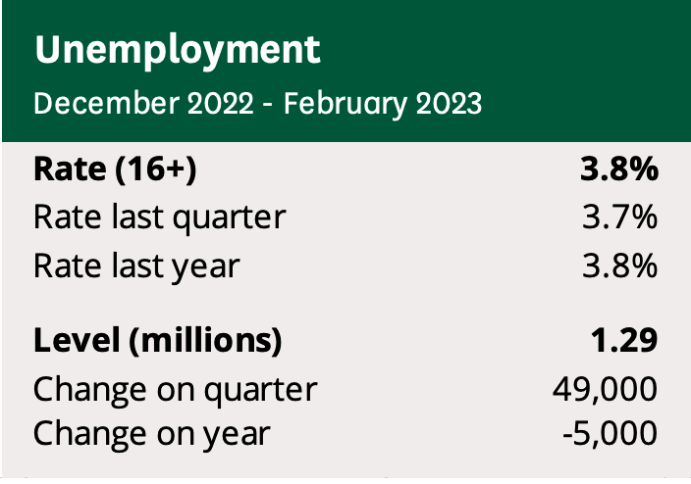
Figure 3. Unemployment in the UK - (December 2022 – February 2023), (Powell & Francis-Devine, 2023).

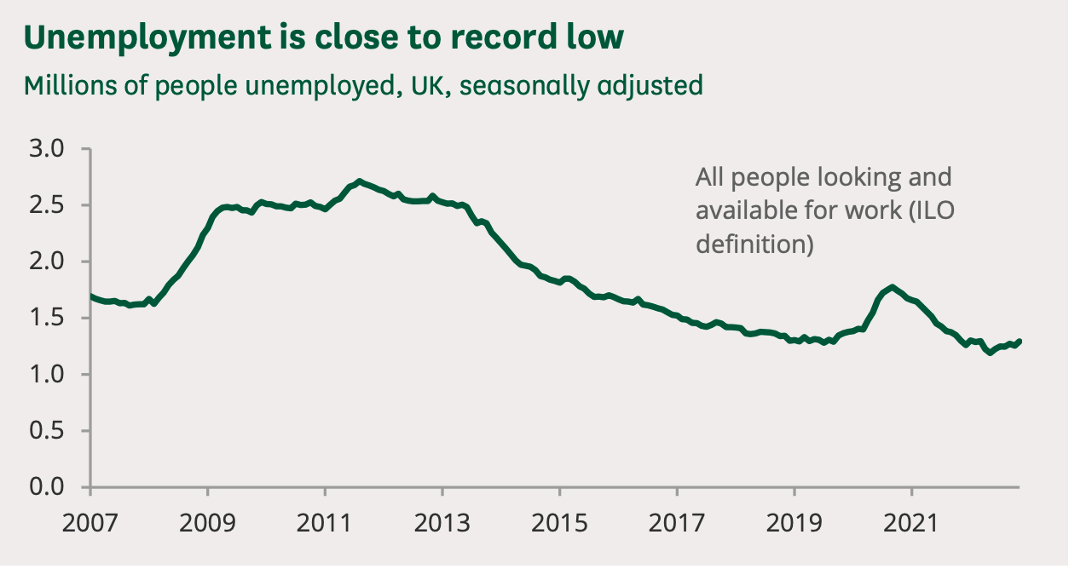
Figure 4. Unemployment in the UK - (2007 – 2021), (Powell & Francis-Devine, 2023).

3. Vacancies
The number of vacancies reduced to 1.11 million in January-March 2023, but were 304,000 higher than the pre-pandemic quarter of January-March 2020, see Figure 5, (Powell & Francis-Devine, 2023). Most sectors of the UK economy had a fall in vacancies at the start of the Covid-19 pandemic. However, vacancies in all industries increased above their pre-pandemic indexes. See Figure 6.
Many sectors have significant vacancies and relatively low unemployment, meaning specific sectors are experiencing workforce shortages.

Figure 5. Vacancies - (January - March 2023), (Powell & Francis-Devine, 2023).

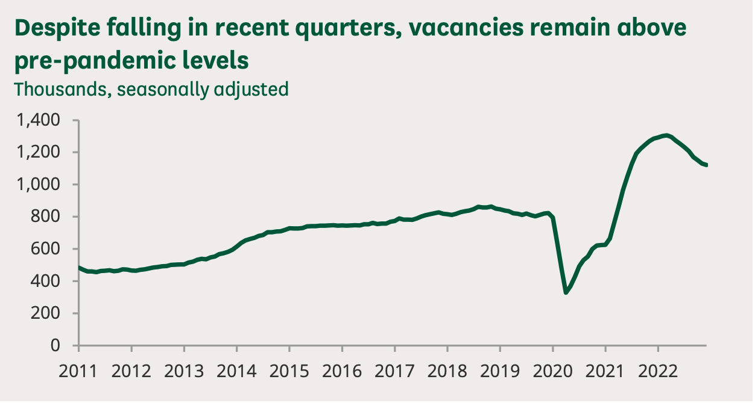
Figure 6. Vacancies in the UK labour market - (2011 - 2022), (Powell & Francis-Devine, 2023).

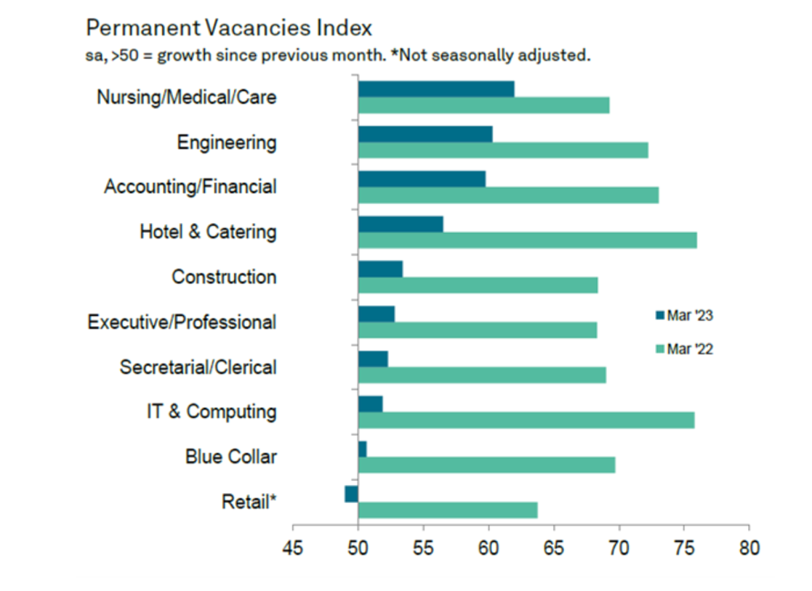
Figure 7. Permanent Vacancies Index (March 2022-March 2023), (Sale, 2023).

The number of permanent job openings rises quicker than for temporary positions. Unlike Retail, most job categories registered improved demand for permanent employees in March. The rapid increase in vacancies was signalled for Nursing/Medical/Care, Engineering, and then Accounting/Financial. See Figure 7.

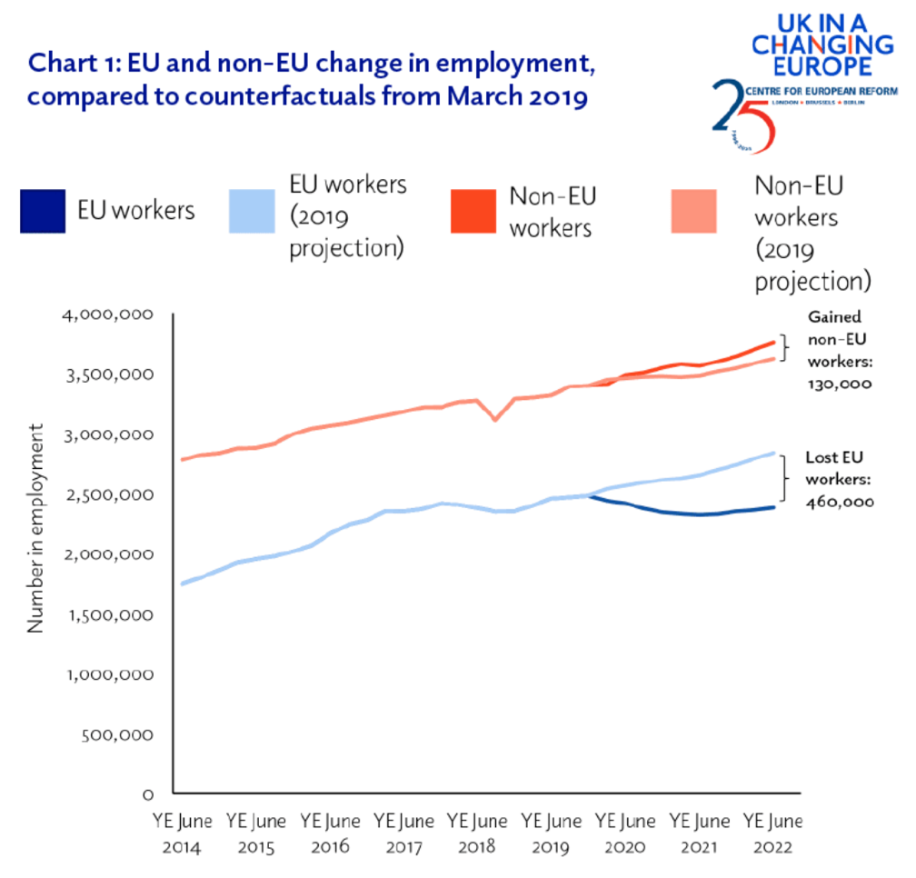

Figure 8. EU and non-EU change in employment, compared to counterfactuals from March 2019, (Walker, 2023).
4. Earnings
A tight labour market and short-term inflation expectations are strengthening underlying nominal wage growth, which is higher than before the Covid-19 pandemic, Figure 10, (Powell & Francis-Devine, 2023). Despite a solid increase in average pay in cash terms from December 2022 to February 2023, there was a fall in real change for earnings because CPI inflation averaged 10.3% in the same period. This trend is seen throughout much of 2022; see Figure 9.

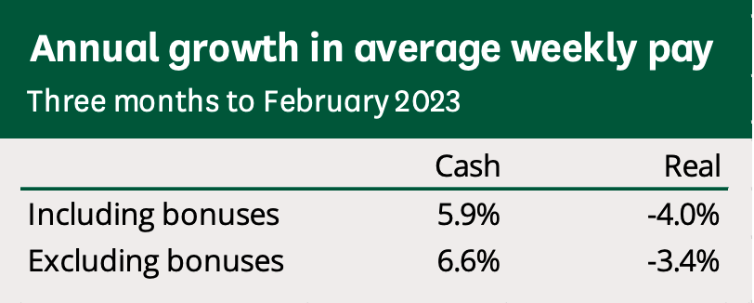
Figure 9. Annual gross in average weekly pay (December 2022 - February 2023), (Powell & Francis-Devine, 2023).

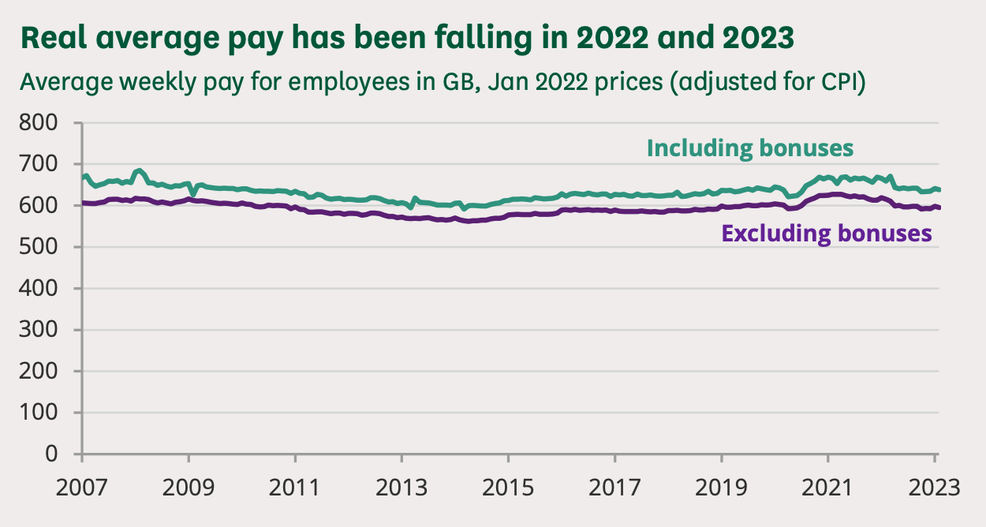
Figure 10. Actual average pay (January 2022 prices adjusted), (Powell & Francis-Devine, 2023).

5. People in the labour market
Women and men
From December (2022). – In February 2023, 15.67 million women were at work, and 17.28 million men were. The female employment rate was - 72.3%; the male employment rate was 79.4%.

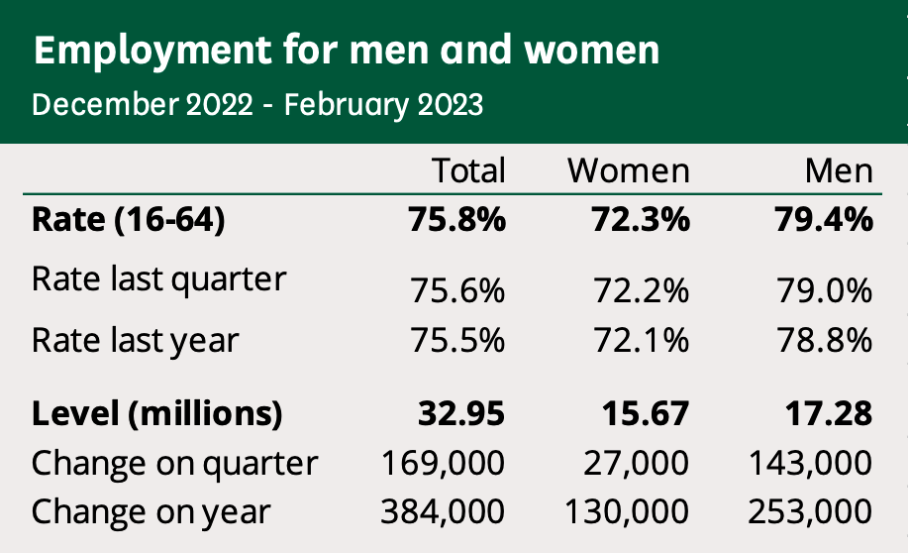
Figure 11. Employment for men and women (December 2022-February 2023), (Powell & Francis-Devine, 2023).

Young people
From December (2022). – In February 2023, 459,000 young people aged (16–24) were unemployed, which by historical records- remains low, with a rate of 10.8%.

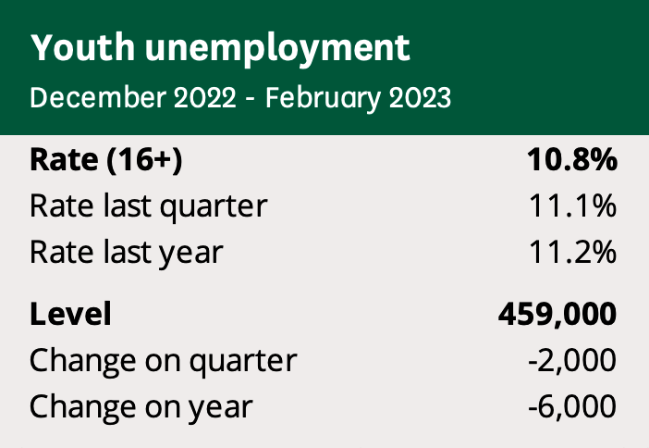
Figure 12. Youth unemployment (December 2022-February 2023), (Powell & Francis-Devine, 2023).
Massive changes in the labour market caused by Brexit and its consequences reached even 2023. The term ‘Brexit’ - combines ‘Britain’ and ‘exit’ and refers to the United Kingdom’s official departure from the European Union. On 23 June 2016, the UK held a referendum regarding its membership in the EU, where 51.89% of voters voted to leave the European Union. The UK officially left the EU on 31 January 2020; however, a transition period continued until and including 31 December 2020. During that transition period, nothing changed, and the UK continued to comply with all rules and laws of the EU. However, negotiations proceeded on the new UK and EU relationship (Government.nl, 2021).
As a direct impact of Brexit, the UK economy sectors such as Transport (HGV drivers), Hotel Catering, construction and others suffer from a labour shortage like never before. Since 31 December 2021, when free movement with the EU ended, the UK has experienced a shortfall of around 330,000 workers. If the migration by non-EU nationals since Brexit increases, more is needed to fill low-skilled vacancies.
The industries most impacted by the reduction of EU workers:
• transport and storage (128,000 reduction /8% total employment in the sector)
• wholesale and retail (103,000 reduction workers /3% total employment in the sector)
• hospitality (67,000 reduction/ 4% total employment).
Since Brexit, construction and manufacturing have also suffered significant labour shortages (Kirby, 2023). The current state of the UK economy displays signs of stagflation, which directly impact labour market trends. Despite all efforts of the Bank of England to reduce inflationary pressures through increased interest rates, the effect on lower levels of economic activity has been gradual and optional, and the final three months of 2022 recorded zero growth, while annual inflation stood above 10%. The post-pandemic has impacted the labour supply, particularly among older age groups who have left the workforce voluntarily or due to long-term illnesses. Despite labour shortages leading to the growth of pay deals for some groups of workers, they are not keeping pace with the rising cost of living. This has resulted in a significant reduction in real incomes, which is a major contributing factor to the current sluggish state of the economy. Public sector employees face an even more substantial impact compared to private, leading to widespread industrial action such as in Tubes trains, NHS, and Airports security employees (Warren, 2023).

The current HR strategies in the post-Brexit, post-Covid environment.
The current state of Labour mar has presented the UK government with a challenge requiring a prompt and effective solution. Meanwhile, UK businesses adapt to the unique circumstances of a Post Brexit and Post Covid world by devising and implementing innovative strategies. These strategies may vary, but they all share a common goal: to navigate the complex and ever-changing business landscape with agility and resilience. The most basic of them are the following:
• Employee Well-being.
With the post-Covid and post-Brexit cost-of-living crisis, recession, and job uncertainty, responsible employers focus on employee well-being to support employee engagement, which also leads to reducing mental health cases.
Nowadays, after Covid - 19 pandemic mental health can cause not only absenteeism but for those who try to deal with it whilst working - It can lead to performance issues and a higher possibility of long-term health issues. Many organisations offer to support employees in this challenging time through their HR departments - an Employee Assistance Programme and having Mental Health First Aiders in the workplace.
• The HR department is interested in championing internal mobility within the organisation by offering fast-track programs to encourage existing employees across other departments to move to the positions needed first.
• Social media recruitment
Nowadays, the ubiquity of social media has prompted HR management in many organisations to develop fully formed social media recruiting tools and include them as a formal part of their human capital management strategies. Social media recruitment uses platforms to identify, engage and vet the users the organisation plans to hire. This HR strategy, also called social hiring or recruiting, uses social media websites and other internet platforms and options, such as blogs, to reach potential job seekers. Employers started using social media recruiting to get a broader and more targeted pool of candidates than traditional recruiting. It can also be more cost-effective than conventional methods, such as workplace events and in-person job interviews, which often require travel expenses and save many work hours for HR managers.
• Flexibility and hybrid working
At a time when organisations continue to rebuild post-COVID-19, flexible working, which also includes 'hybrid working', is the new strategy blended between traditional working from an employee's home and office-based working. It brings many benefits to employees and organisations. The flexible working approach can help increase morale and employee engagement and be an excellent argument for employee retention, productivity, and recruiting young talents. Many prefer to work from home and provide greater diversity and inclusion. It can bring the employee many other benefits, including reducing commute costs.
• Skills-Based Hiring strategy
According to recent research by Remote, there has been an impressive increase of 63% in skills-based hiring within the last year. This shift in focus leads to a greater emphasis on the experience of prospects rather than academic qualifications, expanding the talent pool and eliminating career and salary barriers for a substantial segment of the employees who do not possess a bachelor's degree. This new trend is particularly evident in professions in IT like computer support and software engineering, where a degree is no longer required for performing the job but skills. The Burning Glass Institute analysed millions of online job vacancies and found that the number of jobs requiring a college degree has dropped from 51% in 2017 to 44% in 2021. As skills continue to emerge as the new currency of the labour market, this trend of using a skills-based hiring strategy is expected to accelerate further in 2023 (Meister, 2023).
Increasing investments in HR
Humaans - an employee management platform, released a survey indicating that investing in HR technology will increase and become critical for businesses in 2023. The economic environment has significantly impacted HR, and 59% of teams reported reductions in the past 18 months. As a result, 61% of HR managers think their teams need more staff, and 54% believe their roles have become more complex as they now navigate the very turbulent landscape with smaller units and fewer resources. These findings suggest that investing in HR technology will be crucial for companies striving to succeed, optimising their operations, and navigating the current economic climate. With limited budgets and smaller teams, HR professionals need access to advanced tools to perform their duties effectively. By providing the right technology and investing in a comprehensive HR tech stack - HR professionals can save valuable time on HR tasks; 55% of HR managers recognise that using the right tools can help optimise their workload. By increasing investments in the right resources and tools, businesses can ensure that their HR teams are well-equipped to navigate the challenges of the current economic landscape and continue to drive success (Team, 2023).
Training and development
The current workforce faces a significant skills crisis that is escalating. Recent research by Hays revealed that 93 % of employers faced difficulties recruiting qualified staff in 2022, a considerable increase from 86 % in 2021 to 77 % in 2020. These findings force employers to explore the newest solutions to this pressing issue. Training, coaching, and mentoring can be pivotal in resolving this problem. A strong commitment to employee development can help to upskill the existing workforce, attract new talents, and offer them the necessary tools to perform in new roles. Official statistics in October 2022 indicated that 1.7 million individuals in the UK were willing to work but have yet to be active in the labour market. Proper development initiatives can bring them into the workforce and provide valuable assistance in tackling many employers' challenges. The shortage of skilled labour in 2023 makes staff retention a priority for HR. Research indicates that training can enhance employee commitment and productivity, especially among practical, non-office-based roles. Over two-thirds of workers have stated that development opportunities significantly impact their loyalty towards an organisation. The young people in the workforce have further amplified the need for efficient training and development programs. According to research, Gen Z and Millennials prefer organisations with “opportunities to progress" and "training and development opportunities" and have different expectations regarding their delivery. Gen Zs presently account for 20% of the UK workforce, which is projected to rise; catering to their needs and preferences is critical to securing a sustainable and engaged labour force (Bright and Bright, 2022).

Conclusion and Recommendations
Accordingly, to the report, the UK economy is experiencing a period of weak growth at the start of 2023, with the potential for a recession where the labour market is currently quite tight, characterised by a high number of job opportunities but a limited pool of available skilled workers. The pay raises have increased to the highest level recorded since 2012; however, these pay increases are not keeping up with the rising inflation rates. The shortage of skilled workers is a challenge, surpassing labour scarcity; job seekers possessing a degree or equivalent qualifications are in high demand. Many organisations still face difficulties finding suitable candidates to fill vacancies and predicting even more significant issues in the future. Given these circumstances, organisations must explore and apply new approaches to enhance their HR practices, particularly in recruitment and upskilling, while strengthening the HR department's operational efficiency. The report's second section has insightful recommendations for UK-based organisations' HR departments. In the author's opinion, these recommendations are timely and practical and can be immensely beneficial for both the short and long-term future.

Reference:
• Bright, R. and Bright, R. (2022). Rob Bright: Why training and development will be the key HR trend in 2023 - HRreview. [online] HRreview. Available at: https://www.hrreview.co.uk/analysis/rob-bright-why-training-and-development-will-be-the-key-hr-trend-in-2023/147975 [Accessed 7 May 2023].
• Government.nl. (2021). What is Brexit? [online] Available at: https://www.government.nl/topics/brexit/question-and-answer/what-is-brexit [Accessed 10 Mar. 2023].
‌• Health (2022). Introduction. [online] GOV.UK. Available at: https://www.gov.uk/government/publications/technical-report-on-the-covid-19-pandemic-in-the-uk/introduction [Accessed 12 Mar. 2023].
• Kirby, M. (2023). Labour shortages in the UK and the post-Brexit immigration system. [online] Freeths. Available at: https://www.freeths.co.uk/2023/01/26/labour-shortages-in-the-uk-and-the-post-brexit-immigration-system/ [Accessed 22 Apr. 2023].
• Meister, J. (2023). Top Ten HR Trends For The 2023 Workplace. Forbes. [online] 12 Jan. Available at: https://www.forbes.com/sites/jeannemeister/2023/01/10/top-ten-hr-trends-for-the-2023-workplace/?sh=1934fec95933 [Accessed 7 May 2023].
‌• Powell, A. and Francis-Devine, B. (2023). UK Labour Market Statistics. [online] House of Commons Library. Available at: https://commonslibrary.parliament.uk/research-briefings/cbp-9366/ [Accessed 22 Apr. 2023].
• Sale, C. (2023). April 2023: UK Job market report | Prism Executive Recruitment. [online] Prism Executive Recruitment. Available at: https://prismrecruitment.co.uk/guides/uk-job-market-report/ [Accessed 22 Apr. 2023].
• Team, E. (2023). 76% of HR Managers would like to invest in HR tech in 2023 - HR News. [online] HR News. Available at: https://hrnews.co.uk/76-of-hr-managers-would-like-to-invest-in-hr-tech-in-2023/ [Accessed 7 May 2023]
• Walker, A. (2023). The impact of Brexit on the UK labour market: an early assessment - UK in a changing Europe. [online] UK in a changing Europe. Available at: https://ukandeu.ac.uk/the-impact-of-brexit-on-the-uk-labour-market-an-early-assessment/ [Accessed 22 Apr. 2023].
• Warren, J. (2023). Tube strike: RMT announces London Underground walk out. [online] BBC News. Available at: https://www.bbc.co.uk/news/uk-england-london-64803166 [Accessed 7 May 2023].
‌

‌

‌

‌‌

