Student Name: Gurpreet Kaur Cheema

Student ID: 2026299

Module code: BMSW4004

Assignment section: Problem Solving and Decision Making

Lecturer’s name: Abdi Rahman

Table of Contents
Introduction 3
Define the problem 4
Its scope and impacts 5
Analysis of the organisation and problem 6
Fishbone diagram 8
Propose alternative solutions 9
Evaluation 10
Plan for implementing solutions 11
Conclusion 11
References 12

Introduction
This assessment is about work related stress in the UK, based on the case case study the statista this year has recorded an increase of stress in 2020 compared to the 2019 in a survey of UK organisations.
“Problem solving ,based on the Cambridge dictionary, is the process of finding solutions to problems”, highlight it scope and impacts. To analyse the problem, it will also include the PESTEL analysis.
After that there will be some solution to the problem that will be chosen following seven steps, from these solutions will be chosen one of them, that will be convenient regarding the problem. All the possible solutions will be evaluated to identify the most appropriate option, GRID analysis will be used to choose between the possible solutions.
A plan will be developed for implementing the chosen solution and will also identify and discuss success criteria.
“Decision making, regarding to the Cambridge dictionary, is the process of making choices” after all the analysis there will be a decision to make to choose the appropriate solution.
The conclusion will summaries the discussion and there will also be my personal opinion regarding everything that has been talked about in the report.
At the end of the report there will be the references list of the references that has been used in the assessment.

Define the problem

“Stress has been defined in many ways by many different people. It has been a topic of interest to medical professionals, social scientists, anthropologists, psychologists, and even zoologists.” (What is stress?, Chapter 1).
The problem as already mentioned in the introduction, is a circumstances where there is a gap between the situation as you perceive it and what you believe the situation should be.
The most important skills for business and life are problem solving and decision making, for management and leadership, decision making Is essential and this often involves problem solving as well.
Making decision comes natural to some people and that’s why they should be focusing more on the quality of the decision they are making. On the other hand, people that are not very good in making decision, usually are good at quality assessments but they should be more decisive in acting upon the assessment made.
The first step is finding the problem, some of them can be easily solved by taking decisive action but some of them need more lengthy deliberation.
The process to diagnose the problem could be done by monitoring the performance, listening to subordinates, observing the behaviour and establish the cause of the problem.
The initial analysis is about gathering information, defining the scope, the impact and the consequences. After all this it’s time to make a decision, there are several options such as: decide to do nothing about it and leave it as It is, keep the problem under observation and review it on a later date, contain the problem or find a solution.

Its scope and impacts

In this assignment the main problem that has been identified is the work-related stress, which on the modern world is a common thing as part as day-to-day life. Is this gets worse, the people that has been affected, could lead to health issues as well.
They have also estimated the amount of 14.7 billion U.S dollars, this is cost that UK pays per years in healthcare sector, and the majority of these expenditure is taken by patients that has been diagnosticated with stress condition.
Also, 943 thousand people has been hospitalised due to the stress related illness and the most common physical symptom is the chest pain, circulatory issue and gastrointestinal in females.
This problem, based on the case study, is related to the workers in the Unites Kingdom, the sector that has been affected the most is the customer service, senior management and sales department that is mostly caused by the unsatisfied and angry customers. Other than work related stress, it is also related to politics, monetary or financial stress, family pressure and relationship stress, both genders has been affected, 38 percent of the women and 35 percent of men reported in a survey done by the statista in 2021.

Analysis of the organisation and problem

For this problem has been decided to make a decision and to do so the PESTEL analysis has been evaluated to analyse the problem and what are its impacts.
“The PESTEL analysis is used as tool of situation analysis for business evaluation purpose and is one of the most used models in the evaluation of the external business environment that is highly dynamic.” (Gupta,2013)
The PESTEL analysis is a very useful tool that is used to understand and identify factors involved in change instead of the solutions to any other factors.
This technique include 6 factors and regarding to that identify what the impact will be on the business or organisation.

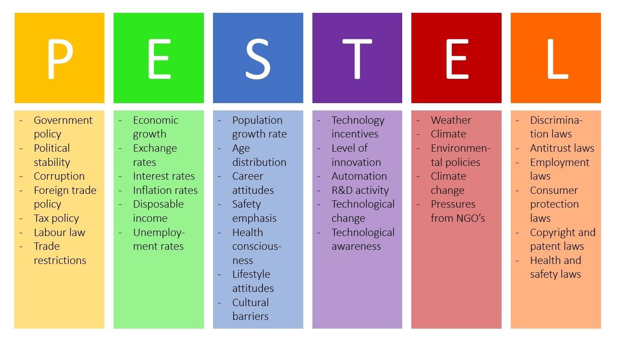

The 6 factors are:
- Political: Stress is caused by many factors, recently the tax rate has been increased from 37% to 39.6%.
The change of government has more impact on business owners, the competition will increase, market orientation and much more.
The instability of the government means, they keep changing laws and making decision real quick.
Changes in the labor laws means change in employee’s wages, if the employment rate decease, the wages of people decrease as well and this cause more stress because everyone will be worried on how they will manage everything
- Economic: Inflation and interest affects a lot on people’s wages.
As we all know about coronavirus, there hasn’t been an economic growth, most of the people were forced to stay at home and close their businesses. In fact some international businesses like GAP and many more had to shutdown permanently all their shops.
Because of this property prices has raised and also the rents.
- Sociological: Family related stress could lead to a low population growth rate, some people decide to not to get married or not have kids for personal reasons.
UK is considered a ”melting pot”, there are more than 270 nationalities and 300 languages. People are most likely to get married or live with someone from a different culture or country.
In the UK there are more young and adults.
- Technological: In the last decade the technology has improved a lot, and most of the family stress is caused by this as well, people spend most of their time on mobile phones and less time with family.
Now days even most of the work is done on computer or mobile phones
- Legal: Work related stress is caused by most of the health and safety laws that workplaces doesn’t follow.
Still some people are discriminated at work for being different or by the colour of their skills or from where they come from.
- Environmental: The business owners has to pay attention to a lot of things, like the position where they intent to open their business, they have ask their selves a lot of question and choose the right option. Does the place has all the resources that I need to open my business? Is the place easily accessible for people? Etc.
For other people, weather changes, natural disasters, climate change has a bad impact on their life style.

Fishbone diagram
The Fishbone diagram (also called the Ishikawa diagram) is a tool for identifying the root causes of quality problems. It was named after Kaoru Ishikawa, a Japanese quality control statistician, the man who pioneered the use of this chart in the 1960's (Juran, 1999).
Cause and effect analysis is a useful tool because its helps focusing on causes, provides a picture of why something is happening, further data gather and action and identify all of the areas that generates a positive effect.
The fishbone diagram include “cause” and “effect” that are connected to each other with a line, clarifies its relationship, graphically displays potential causes and the layout shows causes and effect relationship between the potential causes.
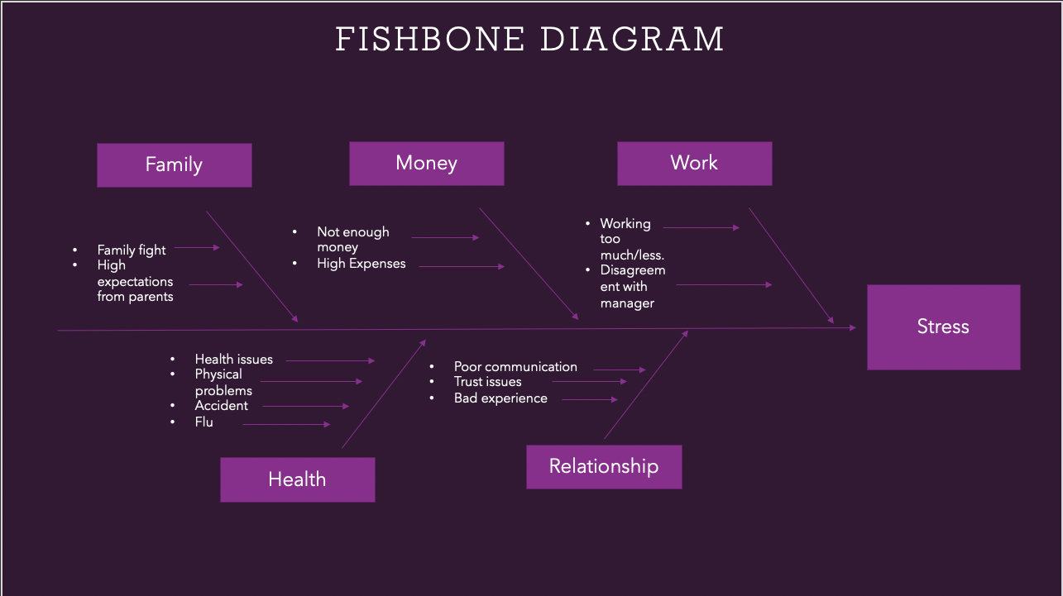

In this case the problem is stress that goes at the end of the line on right hand side, there are 5 factors:
- Work: working too much or too less leads to stress caused by the tiredness, disagreement with managers or with the colleagues also causes stress and angriness.
- Money: having not enough money to get till end of the month and having high expenses
- Family: high expectation from family members and family fights
- Relationship: poor communication with the partner, trust issues and bad experience
- Health: health issues, physical problems, accidents and flu

Propose alternative solutions
This is the stage here is time to list all the possible alternative solution to the problem, but “it is very hard to choose the best solution to the problem when comparing them to each other” (Multi-Criteria decision Making Methods).
To choose the right option, it is very important to study them, compare them to each other, compare the solution to some factors like time, price,, quality and so on.
Its also important to see what are advantages and disadvantages of the alternative solutions.
The make the right decision there are many ways and one of them has 7 steps:
- Identifying the decision: what kind of decision should be taken.
- Gather relevant information: use a secure and the best source of information about your decision, most common are the SWOT analysis for external information and PASTEL for internal information.
- Identify the alternatives: use additional information to construct new alternatives
- Weigh the evidence: visualize the alternative, identify if the need in step 1 would be met or not, in the end priorities the alternatives based on your value system.
- Choose among alternatives: among all the possibilities choose the one that seems the best one for you.
- Take action: a positive action to begin to implement the alternative chosen
- Review your decision & its consequences: consider the result and see if it needs any changes or not.

Evaluation
Alternatives | Time | Cost | Distance | Transport | Total
Weigh | 4 | 5 | 3 | 3
Meditation | 1 x 4= 4 | 2 x 5= 10 | 2 x 3= 6 | 2 x 3= 6 | 26
Stress relief gadgets | 3 x 4= 12 | 2 x 5= 10 | 3 x 3= 9 | 3 x 3= 9 | 40
Talk to experts | 2 x 4= 8 | 1 x 5= 5 | 2 x 3= 6 | 2 x 3= 6 | 25
Medicine | 2 x 4= 8 | 1 x 5= 5 | 2 x 3= 6 | 2 x 3= 6 | 25
Listen to music | 3 x 4= 12 | 3 x 5= 15 | 3 x 3= 9 | 3 x 3= 9 | 45
Sports | 2 x 4= 8 | 2 x 5= 10 | 2 x 3= 6 | 2 x 3= 6 | 30

Some problem are easy to solve and make the decision but soe of them are much more complex and need more attention and thinking. For these kind of problems, like in this case, it has been used an a tool to make decision called grit analysis.
“Benchmarks are an immensely useful tool in performing research since they allow for rapid and clear comparison between different approaches to solving CAD problems.” (Asia and South Pacific Design Automation Conference).
Grid analysis is a table that is more effective when there are a lot of alternatives and factors.
The solution to this case its listening to music, which is the only solution with the highest score.

Plan for implementing solutions
At the end, to see if your decision is having a positive impact or not, the tool that most of the company use the most is the KPI.
“A KPI is a measurement which evaluates how a company executes its strategic vision. The term strategic vision refers to how an interactive1 strategy is integrated into
a company’s strategy as a whole.” (Key Performance Indicators, definition and action, p5).

Conclusion

In this assessment has been identified the problem which is the stress in the UK, the people that that been affected, how they have been affected, what consequences they had on their selves and other people and things around them.
To go in deep of the problem, has been used the PESTEL analysis, fishbone analysis, after that has been decide to make a decision and that was to reduce the stress.
The alternative solution has been written down and after that analysed with grid analysis.
The outcome is, people should listen music more often to reduce stress because it doesn’t cost anything, it doesn’t take much time, you don’t have to travel and dot even need a transport.

References
- https://dictionary.cambridge.org/dictionary/english/problem-solving?q=problem+solving
- https://dictionary.cambridge.org/dictionary/english/decision-making
- http://mrp.ase.ro/no21/f1.pdf
- https://link.springer.com/chapter/10.1007/978-1-4757-3157-6_2
- https://ieeexplore.ieee.org/abstract/document/4483978
- https://www.kwantyx.com/wp-content/uploads/AT_WP_KPI_EN.pdf
- https://www.pacdeff.com/pdfs/What%20is%20Stress.pdf
- https://books.google.co.uk/books?hl=en&lr=&id=ZWpLDwAAQBAJ&oi=fnd&pg=PA2&dq=what+is+pestle+analysis&ots=Dua4uJ0uMw&sig=vKug2_9rEi043-_3ZKIi_j95NrY&redir_esc=y#v=onepage&q=what%20is%20pestle%20analysis&f=false

