

Problem statement for homeless people analyse the impact OF SOCIAL factors

NAME: mihaela geanina oneamoise
student NUMBER: 2232227
module: integrating project [ACHA-4008]
‘This project is submitted in partial fulfilment of the requirements for the Certificate of Higher Education: CertHE Courses (Digital Skills, Skills for Electronics, Skills for Engineering, Professional Skills for Construction), University of Wales Trinity Saint David’.

Declaration
I have read and understood the University Regulations concerning plagiarism and I undertake:
- That all material presented for examination is my own work and has not been written for me, in whole or in part by any other person(s).
- That any quotation or paraphrase from the published or unpublished work of another person has been duly acknowledged in the project [Mihaela Geanina Oneamoise-2232227]

FORM OF CONSENT
I Mihaela Geanina Oneamoise hereby consent that my Project, submitted in candidature for the Certificate of Higher Education: CertHE Digital Skills degree, if successful, may be made available for inter-library loan or photocopying (subject to the law of copyright), and that the title and abstract may be made available to outside organizations.

Acknowledgements
I would like to thank my wonderful family, also a big thank you for my lecturers who have assisted me on this module, and I will say thank you as well for my references, for all their help that has made my research possible.

Table of contents:
- Abstract
- Chapter One: The Problem /Introduction
- Chapter Two: Review of Related Literature
- Chapter Three: Design & Implementation
- Chapter Four: Presentation and Analysis of Results (with screen dumps)
- Chapter Five: Conclusions and Recommendations
- References

abstract
Homelessness is becoming more prevalent in all countries, including the United Kingdom. Although numerous programmes focus on assisting in the resolution of this huge issue today, nations frequently lack the resources required to assist each homeless individual. Homelessness remains one of the world's most pressing social challenges, affecting both men and women, adults and children, single people, and families. [1]
Homelessness is a complicated societal condition characterised by several underlying economic and social factors, including poverty, a lack of affordable housing, unreliable bodily and mental health, addictions, and community and family collapse. These factors, in various combinations, influence the length, frequency, and kind of homelessness. [1] To be completely homeless means to be without shelter; nevertheless, many people suffer partial homelessness, which might involve uncertain, temporary, or inadequate shelter. [1]

Chapter one
Introduction

It is important to begin this project with an understanding of what homelessness is and is not. According to the Canadian Definition of Homelessness:
Homelessness describes the situation of an individual or family without stable, permanent, appropriate housing, or the immediate prospect, means and ability of acquiring it. It is the result of systemic or societal barriers, a lack of affordable and appropriate housing, the individual/household’s financial, mental, cognitive, behavioural, or physical challenges, and/or racism and discrimination. [2] Most people do not choose to be homeless, and the experience is generally negative, unpleasant, stressful, and distressing (CHRN, 2012, Canadian Definition of Homelessness). [2]
Most homeless persons wander through a variety of transient and insecure living conditions, making producing income, preserving health, staying safe, fostering healthy relationships, and getting permanent housing exceedingly difficult. [1]
Homelessness is more than just not having a fixed address. It is a condition that affects a vast and growing number of people in the United States and, most likely, the rest of the world. It involves being cut off from families, social groups, and community organisations, as well as feeling disconnected from society (Brown Casey, 2014). [2]
Homelessness is a long-standing and persistent societal issue in the United States. Health care is a concern for homeless people, who often struggle to receive even the most basic care. Attempts to provide proper care for the homeless under the current healthcare system are frustrating for both patients and providers. [2]

Chapter Two- Review of Related Literature
What exactly is homelessness? This is an essential question to think about. Many of us are quick to judge homeless persons for their own failings and weaknesses. Some of us still feel that people choose to be homeless and like the 'vagrant' lifestyle. [3] However, the feeling of chronic hunger, the increased danger of disease or injury, and the persistent threat of violence casts doubt on these beliefs. Any attempt to solve the issue of homelessness necessitates an understanding of what it is. [3]
Homelessness is both complicated and simple to define. On the one hand, the term "homelessness" refers to a wide range of social and economic issues that contribute to poverty and unstable housing, such as a lack of affordable housing, tenant insecurity, insufficient income, individual crises, health problems, mental health challenges, addictions, trauma, veteran’s issues, child abuse, and involvement with the justice system. [3]
When people lose their homes, they frequently move in with friends or relatives, a practise known as "couch surfing." [3] Many people will stay in temporary emergency shelters or become completely homeless if the option of moving in with friends and/or family is not (or is no longer) available due to a lack of social capital or a lack of consistent income. Emergency shelters are available in medium- and large-sized cities, but not in rural areas or small villages. [3]
Many individuals may argue that homelessness has always existed and that the issue is not new. [3] While it is undeniably true that there have been homeless people throughout history and in many communities, this does not imply that homelessness has always existed. A lot of researchers now agree that our current homelessness problem intensified in the latter half of the twentieth century, and this was not due to an increase in the number of homeless persons. [1] It was a direct effect of rising poverty because of our economy's reorganisation and substantial changes in government policies. As a result, an increasing number of people are finding up on the streets or in emergency shelters due to a lack of safe, affordable accommodation. [3]

Education
Education is a vital part to our understanding of homelessness. First, individuals with lower educational attainment are more likely to be unemployed, underemployed, or poor. [4] One of the consequences of youth homelessness is being forced to withdraw from school. In other situations, the variables that contributed to a young person's homelessness also had an impact on their academic performance. [4] In other words, they were already on the verge of quitting. School may not have been affected in other circumstances. When homelessness forces a person to leave their community, dropping out of school becomes even more likely, regardless of previous academic performance. [4]
It is typically difficult for families suffering homelessness to keep their children in school. [3] Families experiencing homelessness are frequently compelled to relocate to family shelters located far from their neighbourhoods. Children have little choice but to enrol in a new school, and because such families are poor, they are at a disadvantage in acquiring a proper education. While most people agree that all children and youth deserve a good education, the reality of homelessness and poverty makes this difficult, if not impossible. [4]
Some of the barriers to education include:
- Housing instability
- Displacement
- Negative familial relationships including lack of parental support.
- Domestic violence
- Health conditions and learning disabilities.
- School enrolment policies
- Lack of transportation
- Inadequate nutrition
- Lack of inter-agency collaboration
- Discrimination
- Download of school responsibility solely on children and youth

Planning
Creating a plan assists communities in setting goals and conceptualising what they should prioritise. [5]A plan can include objectives, a procedure and schedule for achieving those objectives, and tools for measuring progress. Planning also brings together providers, government officials, Continuum of Care leads, and funders to discuss topics such as identifying population needs, deciding on the structure of coordinated assessment, integrating prevention and shelter diversion resources, mapping out existing assessment and intake processes, and sketching out preliminary needs assessment and screening tools. [5]

Chapter three - Design & Implementation

The Homelessness Reduction Act
The Homelessness Reduction Act has been dubbed the most significant homelessness law change in decades. [6] It reflects a significant shift in strategy towards earlier prevention and the expansion of help to more persons in need. It also strives to establish an approachable and friendly attitude among all local government housing professionals. [6] The Act imposed additional duties on local governments and other public bodies in England, the majority of which went into effect in April 2018:
■ A requirement on local authorities to conduct assessments and develop personalised housing plans (PHPs) with all eligible applicants.
■ An extended prevention duty requiring local authorities to take reasonable steps to prevent homelessness for applicants threatened with homelessness within 56 days regardless of intentionality, priority need and local connection.
■ A relief duty requiring local authorities to take reasonable steps to help homeless applicants secure suitable accommodation over a period of 56 days regardless of intentionality and priority need.
■ A requirement for local authorities to provide homelessness information and advice to anyone in their area (including those not owed a prevention or relief duty).
■ A requirement for local authorities to report more detailed case-level data, using a new HCLIC (Homelessness Case Level Information Classification) system.
■ The Act also introduced a new duty to refer, from October 2018, requiring public authorities to refer people at risk of homelessness to their local authority

Implementing a homelessness solution requires a diverse strategy. This can involve actions such as affordable housing, mental health support, job training programmes, and community engagement. [6] Collaboration between the government and the local communities is essential for successful implementation. [4]
What can I do personally? I can contribute to helping homeless people by volunteering at shelters, donating to local charities, providing essential items like clothing and food, or supporting organization that focus on long-term solutions such as job training and housing assistance. Raising awareness about homelessness and advocating for supportive policies also makes a positive impact.

Chapter Four: Presentation and Analysis of Results
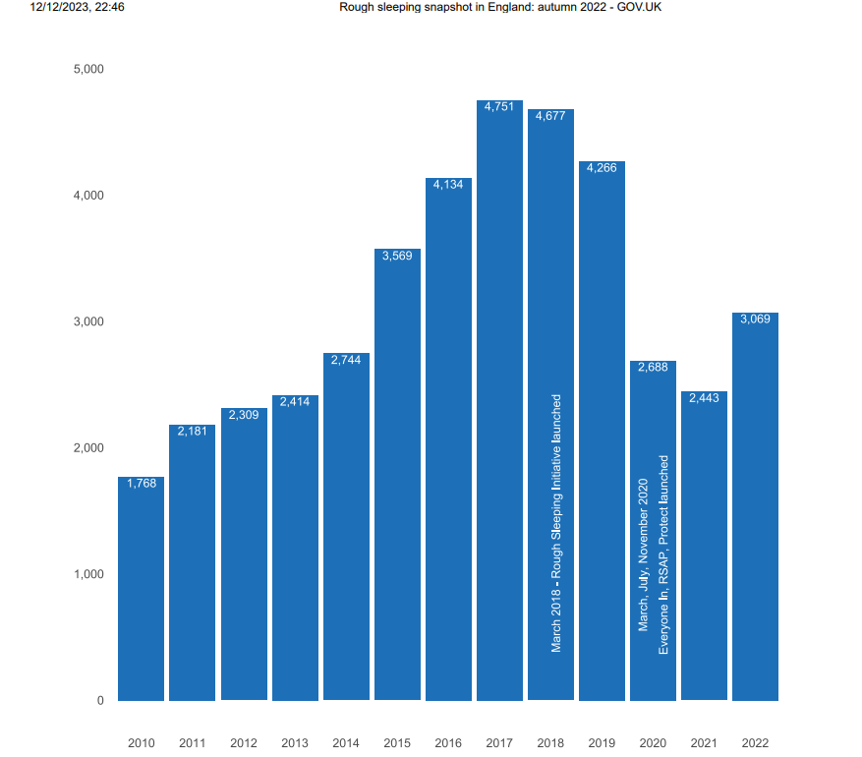
- This article contains estimates of the number of persons sleeping rough on a single night between 1 October and 30 November 2022, as well as some basic demographic information (age, gender, and nationality). [7]These figures can be used to estimate the number of individuals sleeping rough across England on a single night in fall, as well as to track changes over time. The rate of people sleeping rough on a single night in England in 2022 was 5.4 people per 100,000. [7] This has increased since 2021 (4.3 per 100,000) though is lower than in 2017 (8.5 per 100,000) .

Chapter Five: Conclusions and Recommendations
Addressing homelessness is a complex problem that necessitates a varied strategy. It entails not only providing immediate relief through shelters and programmes, but also addressing root problems such as affordable housing, mental health, and career possibilities. [8]Disaster officials and lawmakers should prioritise efforts to prevent new homelessness following a disaster and to give permanent housing solutions to the previously homeless. At its most basic level, shelter should provide the bare requirements of security, hygiene, privacy, and comfort in the least restrictive way possible, with a focus on keeping families together. [8]

Recommendations:
- Holistic solutions
-implement comprehensive solutions that address the diverse needs of homeless individuals, including housing, healthcare, employment support
- Long-Term support
-focus on providing long-term support and sustainability solutions
- Community Engagement
-promote community involvement through awareness campaigns, education programs, and initiatives that reduce stigma associated with homelessness.

References

[1]F. C. M. approach, “Analyzing the impact of social factors on homelessnes,” [Online]. Available: https://www.ncbi.nlm.nih.gov/pmc/articles/PMC3766254/#:~:text=Social%20forces%20such%20as%20addictions,homelessness%20through%20their%20dynamic%20relations.. [Accessed 12 12 2023]. Analyzing the impact of social factors on homelessness: a Fuzzy Cognitive Map approach - PMC (nih.gov)
[2]gov.uk, “gov.uk,” [Online]. Available: https://www.local.gov.uk/sites/default/files/documents/22.7%20HEALTH%20AND%20HOMELESSNESS_v08_WEB_0.PDF. [Accessed 12 12 2023]. 22.7 HEALTH AND HOMELESSNESS_v08_WEB_0.PDF (local.gov.uk)
[3]“homeless hub,” [Online]. Available: https://www.homelesshub.ca/resource/what-homelessness#:~:text=Most%20people%20who%20are%20homeless,obtaining%20permanent%20housing%20extremely%20challenging.. [Accessed 10 12 2023]. What is Homelessness? | The Homeless Hub
[4]“homeless hub,” [Online]. Available: https://www.homelesshub.ca/about-homelessness/education-training-employment/education. [Accessed 10 12 2023]. Education | The Homeless Hub
[5]“National alliance,” [Online]. Available: https://endhomelessness.org/ending-homelessness/solutions/creating-systems-that-work/. [Accessed 12 12 2023]. Creating Systems That Work - National Alliance to End Homelessness
[6]“gov.uk media,” [Online]. Available: https://assets.publishing.service.gov.uk/media/5f68c436d3bf7f723618781c/Evaluation_of_the_Implementation_of_the_Homelessness_Reduction_Act_Final_Report.pdf. [Accessed 12 12 2023]. Evaluation of the Implementation of the Homelessness Reduction Act: Final Report (publishing.service.gov.uk)
[7]“gov.uk 3,” [Online]. Available: https://assets.publishing.service.gov.uk/media/5f68c436d3bf7f723618781c/Evaluation_of_the_Implementation_of_the_Homelessness_Reduction_Act_Final_Report.pdf. [Accessed 10 12 2023]. Rough sleeping snapshot in England: autumn 2022 - GOV.UK (www.gov.uk)
[8]“hudexchange,” [Online]. Available: https://files.hudexchange.info/resources/documents/ESG-Emergency-Shelter-and-Permanent-Housing-Standards.pdf. [Accessed 13 12 2023]. ESG Emergency Shelter and Permanent Housing Standards (hudexchange.info)

