Reflective Review of Learning Journey

Module code: BMSK4005

Name: Claire Edwards
Student number: 1812182

Executive Summary
In this report I will be reflecting on my learning journey, I will be conducting a SWOT analysis on my strengths and weaknesses and look at my opportunities and my threats, I will be looking at conversion strategies to turn my weaknesses into strengths and my threats into opportunities.
I will then go on to do a go mad model on what I want to achieve in the next five years, and how doing my university course will help me to with my end goal. By doing the framework level by level it has shown me that with an action plan I can achieve my end goal with hard work and determination.
I have been looking at different learning styles I found that Honey and Mumford and VARKS learning style questionnaires suited me the best, in this review I have done the questionnaires and inserted my results into this report.

Content Page

Introduction pages 4-5
SWOT Analysis page 6
Go MAD framework pages 7-8
Learning Style Questionnaires pages 9-10
Conclusion/PDP page 11
Reference list page 12-13

Introduction

Considering the situations learnt during my reflective journey has provided an insight into learning. As part of a review, a SWOT analysis provides an assessment to make improvements in order to achieve career aspirations. ‘Typically, we think of SWOT as something done in the world of corporate business. What many don’t realize, completing a self-SWOT will help you analyze your own effectiveness as a leader’ (Fry, 2018)
Using a SWOT analysis which consists of strengths, weaknesses, threats, opportunities and developing an action plan to convert identified internal weaknesses to strengths and external threats to opportunities will increase knowledge and understanding to obtain the five-year goal as set out in a SMART objective manner as explained by (Hussain, 2016). ‘Conversion is the process of switching from something old to new, so, system conversion is the process of switching from an old system to a new system.’ Appropriate conversion strategies will help to do this.
Learning Theories
There are many learning theories that have been useful along the way, one being the Maslow’s hierarchy of needs, this is a pyramid made up of five levels of needs. ‘Maslow’s Hierarchy of Needs (often represented as a pyramid with five levels of needs) is a motivational theory in psychology that argues that while people aim to meet basic needs, they seek to meet successively higher needs in the form of a pyramid.’ (learning theories. 2014).
Learning Style Questionnaires
On doing different learning style questionnaires I have learned that not every person learns the same and we must find a learning style that suits us individually. Having researched and doing the learning style questionnaires I found myself referring to Honey and Mumford as there are four different types of learners by doing this questionnaire, I realized I am more of a hands-on learner and that I could improve my writing skills.
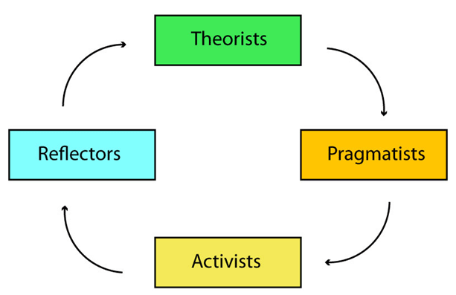(yahoo.com 2019).

Go Mad
By creating a Go Mad frame, I found that it helped me put my goal into perspective, as it gave me a chance to put all the information I need to grow and archive my end goal. The go mad framework is set out in three levels, you must always start at the first level, this is a personal level where you would prioritise family and goals, level two is about checking your reasons and how you are going to achieve your goal and level three is your end goal and achieving this. By doing the go mad framework from step one I felt it helped me gain more information about why and how I was going to achieve this, by using the framework it will help me prioritise what needs to be done to get my result.
Setting goals and targets for yourself is an effective way of planning your direction step by step, if we do not have goals in life then we are not keeping our mind active and motivated. As (Copeland B, 2015) says ‘The trouble with not having a goal is that you can spend your life running up and down the field and never score.’

Swot analysis

By conducting this swot analysis on myself I have learned that there may be some strengths and weaknesses that I did not know about, therefore I could not use my strengths to the best of my ability and could not work on my weaknesses. I have learned that there is always room for improvement and there is always an opportunity that we could take and learn from. My opportunities and threats are essential for my strengths and weaknesses, because without them I will not be able to learn from these, and throughout life learning is important.

Strengths | Weaknesses | Opportunities | Threats
Working with others | Confidence | Learning new skills | Having authority
Time Management | Talking in front of people | Listen more | Doubting myself
Practical work | Spelling | People I know | Competition
Numbery | Overthinking things | Ask for the help I need | Lack of confidence
Helping other | Theory work | Build my confidence | Too trusting
Some IT skills | Writing skills
Working by myself

By looking at my weaknesses and threat I will try to convert them into strengths and opportunities by looking at a conversion strategy, this will help because by noticing my problems it gives a better understanding of the areas that can be improved, and by looking at weaknesses I can learn how to turn them into strengths, by doing more assignments it will help me learn and put more practice to my writing skills and spelling. ‘A list of strengths, weaknesses, opportunities, and threats makes for a handy business guide, but you’ll want to take this exercise one step further to create strategies and plans to improve your business.’ (bplans blog, 2015).
I feel my strengths can then be used to my advantage, as working with others will give me the feedback I need to improve, and I could help others by giving them feedback. I feel that self-confidence is not my strong point and I feel that I do not believe I can achieve something when I can, so by doing the next three years at university it will help me learn and grow into a better person. ‘Self-confidence is extremely important in almost every aspect of our lives, yet so many people struggle to find it.’ (mindtools.com 2019).
On researching Maslow’s pyramid, I felt it helped me put things into perspective, Maslow’s hierarchy of needs which is a pyramid made up of five levels, starting with basic human needs which everyone needs to survive. ‘From the bottom of the hierarchy upwards, the needs are physiological, safety, love and belonging, esteem and self-actualization. Needs lower down in the hierarchy must be satisfied before individuals can attend to needs higher up.’ (McLeod, S 2019).

Go, Mad model

Go Mad model is a framework built to put all your goals together and showed me that if I want to achieve something it is possible. ‘Do you want to stay the same or make a difference? The Go M.A.D.® Results Framework can increase sales, reduce costs, save time, improve performance and help you develop as a leader to engage others in contributing to business success.’ (Gomadthinking.com 2019). Using this framework on my own goals, I found it helped me to understand my goals and builds I bigger picture in my mind of where I want to be and achieve my five-year goal, this way I can set out to achieve each level to the best of your ability.

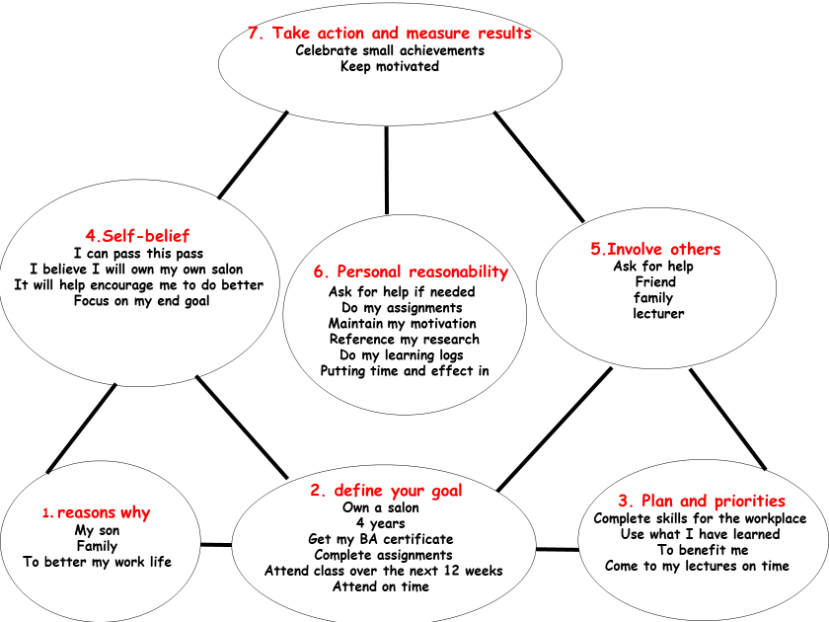

I believe that for a better life for myself and my family, owning my own salon within the next four years is achievable, so for me to achieve this I am going to try my best to complete the next three years in university to get my degree, to have a better understanding. By completing my assignments and attending classes on a weekly basis I will get closer to my end goal and have a better understanding of owning and running my own salon.
I believe I can pass this course to the best of my ability because I am determined and focused on achieving my end goal and setting a good example to my son. Asking for help from my friends and family is important because I will then have feedback on where I am doing good and where I can improve. ‘Once you have planned your project, turn your attention to developing several goals that will enable you to be successful. Goals should be SMART - specific, measurable, agreed upon, realistic and time-based.’ (Haughey, 2019). I feel that doing this course it will encourage me to want to do better in my work environment and in my home life to be more organised with things I do. I feel that each day I am learning something different, not only am I learning in my work skills, I am learning in my everyday life to be more organised and have a plan for the things I do in my day to day life.

Learning style questionnaires
On doing learning style questionnaires I found that not many people learn in the same way, referring to Honey and Mumford I found when I did the questionnaire for my own learning journey it says I was a reflector but I feel I am more of a Pragmatist as I am more of a hands-on learner, but I feel on reflecting on my learning journey in university I have maybe become more of a reflector than I thought.
The four learners of Honey and Mumford are the way that each person would rather learn if you are an Activist Honey and Mumford refer to these learners as individuals who learn by doing the task, these people also have an open mind when it comes to learning, however if you are a theorist it would be believed that the person would review their work before taking action, on being a pragmatist you would need to be shown how things are done rather than reading about the task this way they can see how it works in practice, Honey and Mumford say if you are a reflector then these people need to observe and think by often standing back from situations and observe experiences before they get to work on the task. ‘Learning styles were developed by Peter Honey and Alan Mumford, based upon the work of Kolb, and they identified four distinct learning styles or preferences: Activist, Theorist; Pragmatist and Reflector. These are the learning approaches that individuals naturally prefer.’ (Mobbs R, 2019).
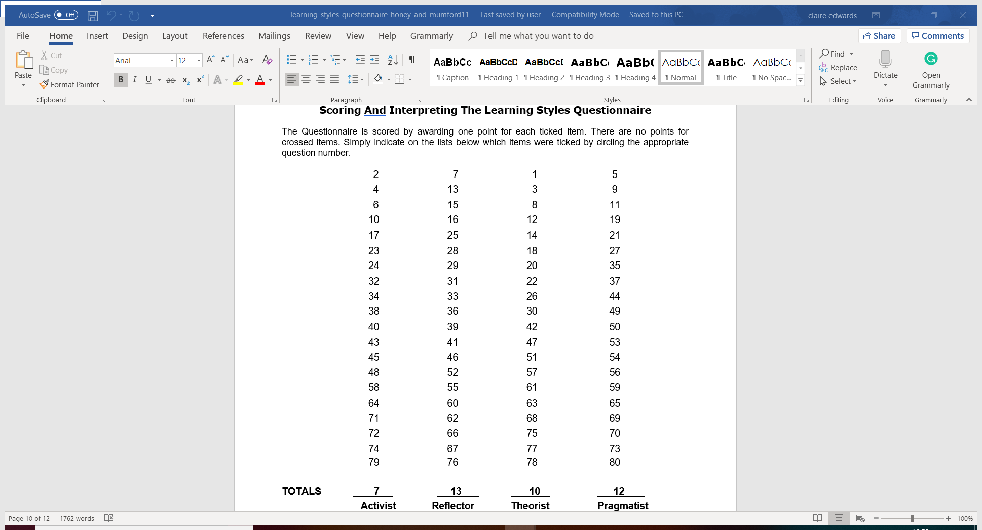
As well as Honey and Mumford, I researched several other questionnaires and how effective they were to me and on doing this the VARKS learning style it showed that I scored the highest and was an auditory learner, this means that ‘Instruction that is spoken or heard facilitates learning for this type of learner. Lectures, recordings, discussions and e-mails are all mechanisms that allow people with this modality to discuss and explore concepts with others and work best for them in learning environments.’ (Hendricks, 2017). 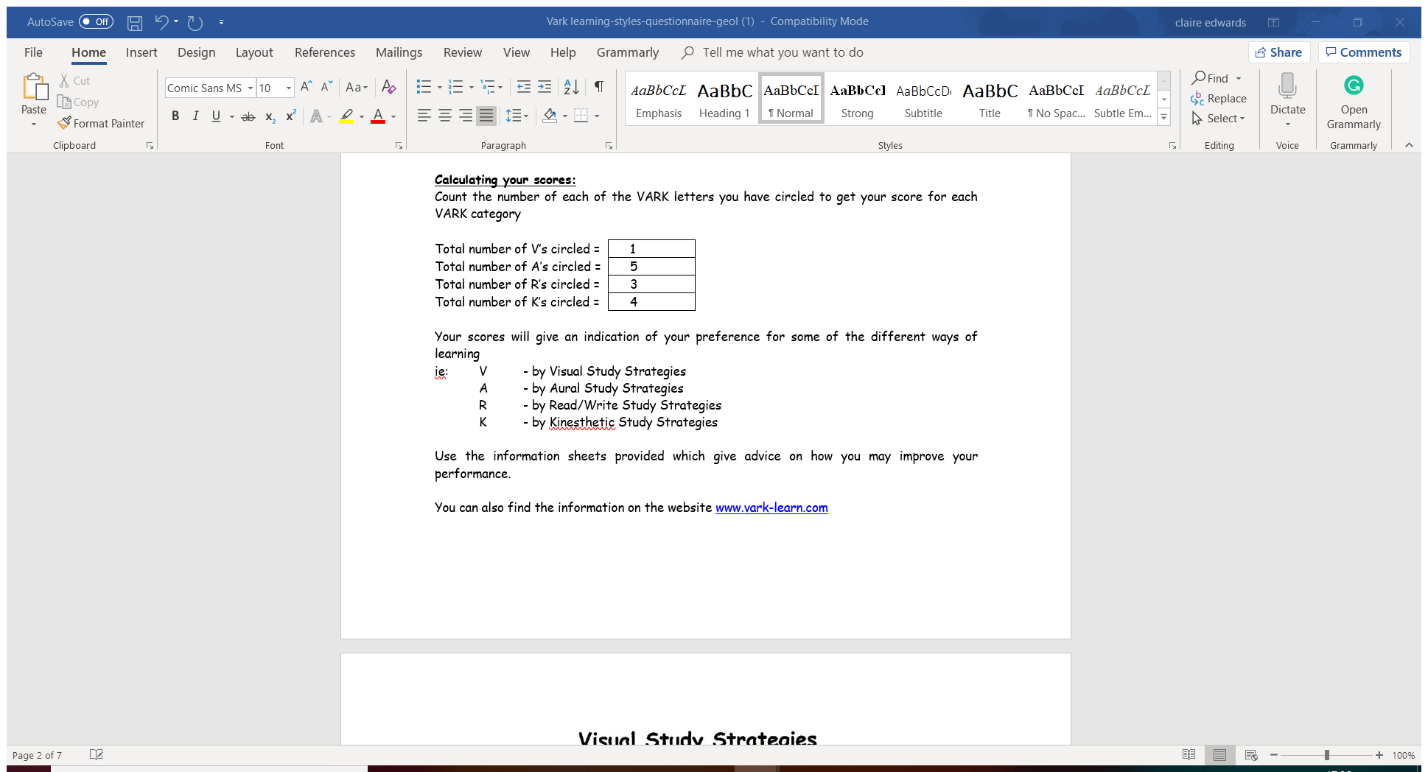

Conclusion
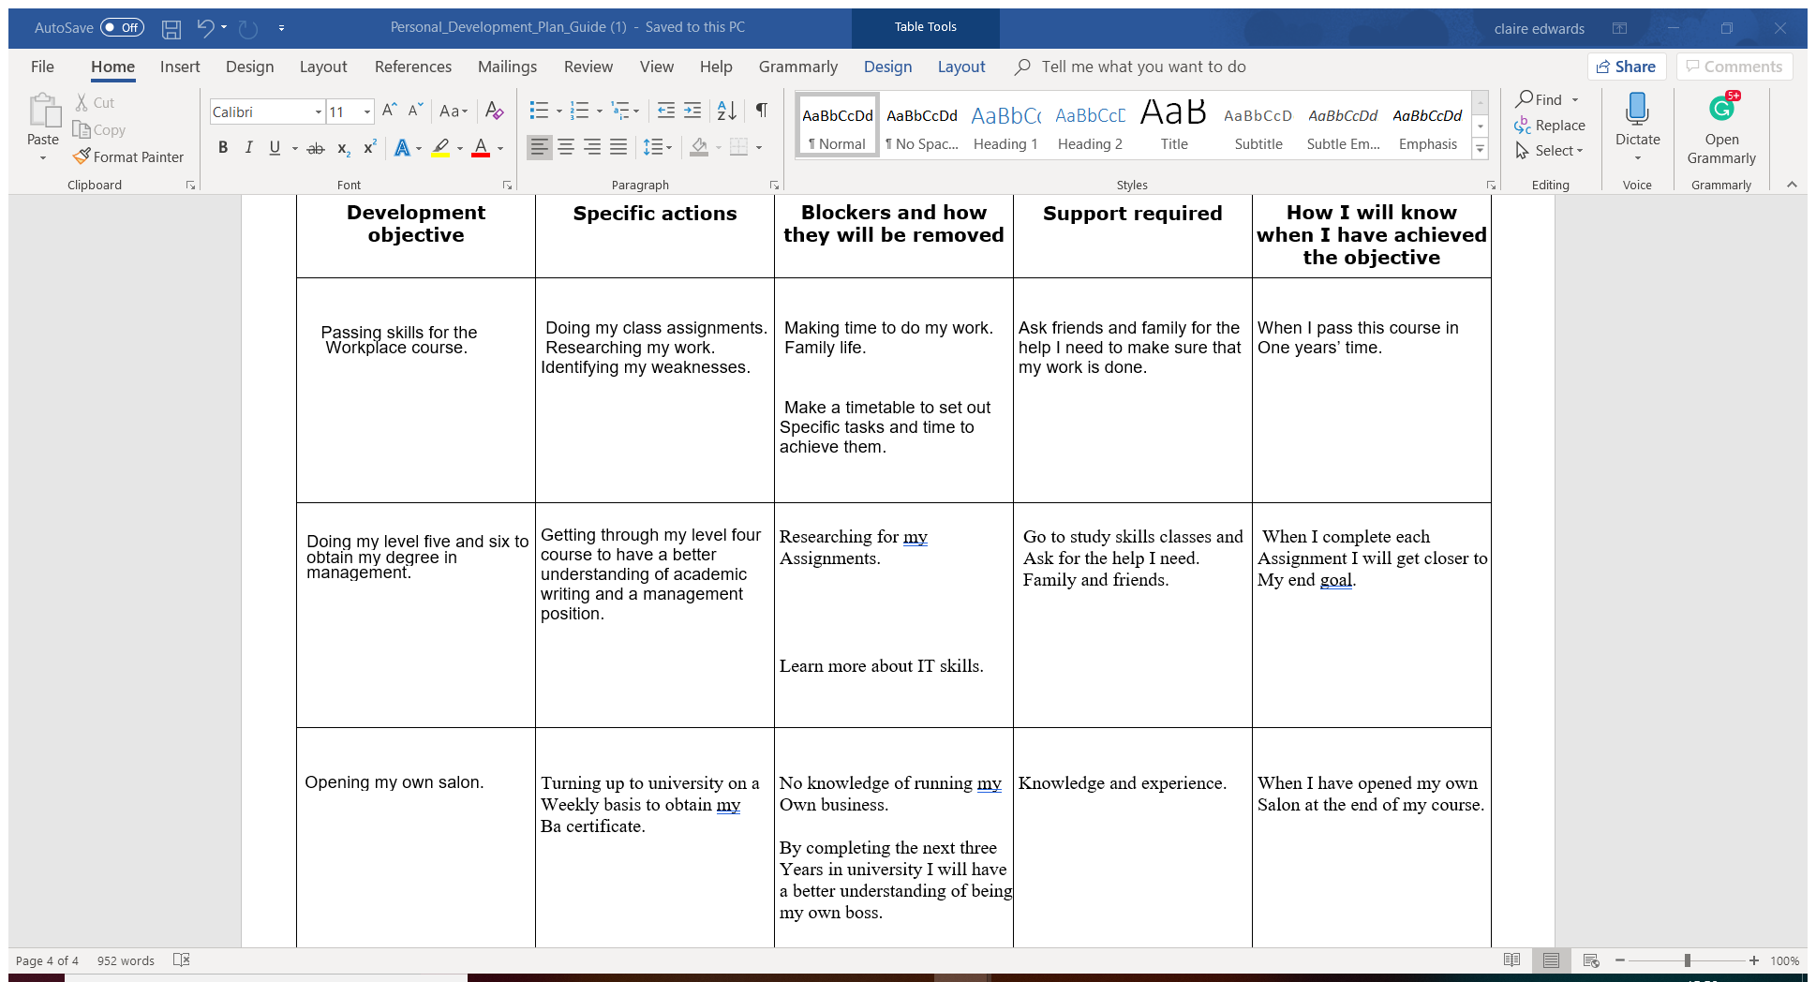
A personal development plan is a process that looks at your goals and where you would like to be, you can do a plan for short- or long-term goals in your career. It will help look at the skills you have and the skills you may need to work on. By identifying development needs and opportunities you will have a final plan to focus on. (mangers.org.uk, 2019).
By doing my own personal development plan it has helped me put an action plan together for where I want to be in five years’ time. In order to own my own salon and be my own boss, I will need to complete my assignments in time to pass and complete my course and obtain my BA certificate, to have a better understanding of running my own business. To achieve this I will get the support I need by going to study skills classes to get help and to make sure I have enough time to do my assignments I will do a timetable each week on the tasks that are ahead then I will plan specific times so that I can achieve everything that is planned.

Reference list

Anon, (2019). VARK Learning Styles. [online] Available at: https://www.ehow.co.uk/info_7978059_vark-learning-styles.html [Accessed 3 Mar. 2019].

Bplans Blog. (2015). Turning Your SWOT Analysis into Actionable Strategies. [online] Available at: https://articles.bplans.com/swot-analysis-challenge-day-5-turning-swot-analysis-actionable-strategies/ [Accessed 26 Feb. 2019].

Fry, E (2018). SWOT Away Doubts and Analyze your Leadership Skills - Centre for Student Achievement Solutions. [online] Available at https://www.csas.co/swot-away-doubts-and-analyze-your-own-leadership-skills/ [Accessed 19 Feb. 2019].

Gomadthinking.com. (2019). Go MAD Thinking. [online] Available at: https://www.gomadthinking.com/ [Accessed 26 Feb. 2019].

Learning Theories. (2014). Maslow's Hierarchy of Needs - Learning Theories. [online] Available at: https://www.learning-theories.com/maslows-hierarchy-of-needs.html [Accessed 21 Feb. 2019].

Managers.org.uk. (2019). Personal Development Planning. [online] Available at: https://www.managers.org.uk/knowledge-bank/personal-development-planning [Accessed 4 Mar. 2019].

McLeod, S. (2019). Maslow's Hierarchy of Needs. [online] Simply Psychology. Available at: https://www.simplypsychology.org/maslow.html [Accessed 28 Feb. 2019].

Mindtools.com. (2019). Building Self-ConfidencePrepare Yourself for Success. [online] Available at: https://www.mindtools.com/selfconf.html [Accessed 28 Feb. 2019].

Mishaal Hussain. (2016). Conversion Strategies - Mishaal Hussain. [online] Available at: http://creativehive.org.uk/mishaalhussain/2016/03/15/conversion-strategies/ [Accessed 25 Feb. 2019].

Project Smart. (2019). SMART Goals. [online] Available at: https://www.projectsmart.co.uk/smart-goals.php [Accessed 27 Feb. 2019].

Seale, Q. (2019). On The Importance Of Goal Setting: 6 Reasons Why You Need To Set Goals. [online] Keepinspiring.me. Available at: https://www.keepinspiring.me/why-you-need-to-set-goals/ [Accessed 4 Mar. 2019].

Uk.images.search.yahoo.com. (2019). Yahoo is now part of Oath. [online] Available at: https: https://uk.images.search.yahoo.com/search/images?p=honey+and+mumford&fr=mcafee&imgurl=http%3A%2F%2F1.bp.blogspot.com%2F-vgHunkdcTEI%2FUYiKN1dYAMI%2FAAAAAAAAEFQ%2F [Accessed 22 Feb. 2019].

Www2.le.ac.uk. (2019). Honey and Mumford — University of Leicester. [online] Available at: https://www2.le.ac.uk/departments/doctoralcollege/training/eresources/teaching/theories/honey-mumford [Accessed 1 Mar. 2019].

