
U W T S D
Author
Hasan Mangov-1815075
Module- Managing Performance (LCMB7013)
Lecturer- Hossein Shokri

Table of Contents
Introduction 3
Performance Management 4
Aims of Performance Management 6
Creating a Strategic Approach 7
Performance Management Tools 8
Characteristics of Performance Management 9
Personal Assessment 9
Assessment of competencies 10
Assessment of Performance 10
Personal Assessment Methods 11
Personal Behaviour 12
Challenges of Work-life Balance 12
Personality can influence perception 12
Self-Confidence equals to Hard Work 13
Bullying results in breaking bonds 13
Performance Appraisal 13
Approaches to Performance Appraisal 14
360- Degree Appraisal 15
Pay and Reward Systems 16
Employee Engagement, Satisfaction, and Involvement 17
Employee Engagement 18
Employee Satisfaction 19
Employee Involvement 21
Training and development 22
Culture 22
Recommendations 23
Short-term Recommendations 23
Long-term Recommendations 24
References 25

Introduction
Modern enterprises are forced to adapt to market conditions and competition. Therefore, the factors that determine success in the market are also factors for the survival of the organization. Each of them is associated with the activities of the company's employees. Critical success factors i.e., those without which it is practically impossible are personnel development, innovation; strong and reliable partners (suppliers, sub-enterprises, alliances, etc.); customer orientation; production cost; fast delivery; logistics and its condition; staff qualification level, etc (Gerrish, 2016). The market is constantly changing. The organizations are forced to be dynamic and able to adapt not only to the changes in the external environment themselves, but also to their speed.
The present study is focused on the performance management of SainCo that is a retail organization having a reputation in the market, as the business exists for a long time. the organization manages its operations from ten different locations and their total employees are 2000. Managing such an organization needs consistency in the management plans; SainCo is a family run business that is autocratic in nature. The Company needs extensive modernization of performance management system that can guide the leadership in a timely manner. SainCo needs a performance management system that can create competitive advantage for the Company in retail market. The present report is aimed to evaluate the performance needs of SainCo Company. The report outlines the performance management system for SainCo and provide recommendations to sustain the business growth with these changes.

Performance Management
Performance management is a systematic process of enhancing organizational performance by effective utilization of workforce and performance of individuals and teams. To get a better performance, it is important for individuals and teams to have clear understanding about the organizational goals and their tasks to perform. The performance management is based on shared understanding of objectives, management of employees or people to improve performance and achieve the defined goals in long or short term. The performance model is the overall evaluation of business performance indicated by the key business indicators set by the management (Amiridis & Costea, 2019). The performance management model provides strategy to individual participant in the management process. The key performance indicators are distributed from higher to lower end in a hierarchy that creates clear indication of individual responsibilities and authority allocated. The business performance management system is developed to seamline the business strategy and management tools applied at each level (Wood, 2020).
Laying out individual and group objectives that are associated with the association's essential objectives, arranging execution to meet the objectives, assessing, and breaking down progress, and developing individuals' information, abilities, and gifts are all important for the course of execution the executives. Line administrators are answerable for overseeing execution, and execution the executives are intended to help them in doing so. Managing the business is the thing that exhibition the board entails. It ought to be a viable device for guaranteeing that the association's essential goals are met. It ought to relate to other center HR tasks, like human resources the executives, ability the board, learning and advancement, and award the board, to help achieve the social transformation. As an outcome, execution the board helps flat reconciliation and the 'packaging' of HR works on, permitting them to be interconnected thus supplement and build up each other. Representative commitment might be helped essentially by utilizing a decent exhibition the board framework. (Armstrong, 2018).
The following diagram demonstrates the process of performance management.

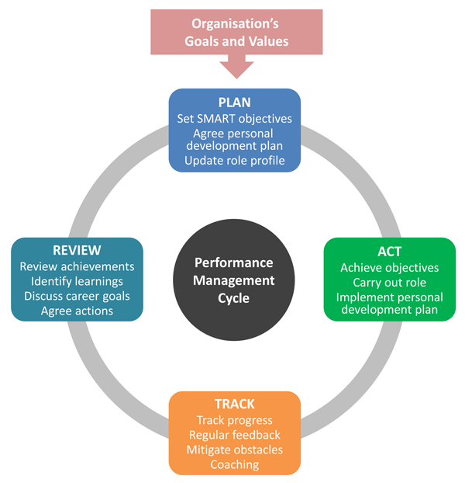
Figure 01: Performance management process cycle (Armstrong, 2020)

Aims of Performance Management
The main goal of performance management is to improve the overall performance of the organization, individuals, and teams. The process of performance management is based on communicating the organizational goals and bring all the workers on the same page to achieve success. Performance management is based on adopting strategic approach to align individual goals with the organizational strategic goals. According to (Amiridis & Costea, 2019), the company’s performance management plays an important role in establishing commitment and results in improved motivation among individuals or teams. SainCo is an organization with autocratic style of leadership and this approach is not performance oriented. The company needs to adopt performance management approach that aimed to accomplish strategic targets, build individual capacity, increase individual performance, establish a culture of continuous development, and integrate individual, team and corporate objectives. Following figure demonstrates the benefits of performance management for organization, managers, and employees.
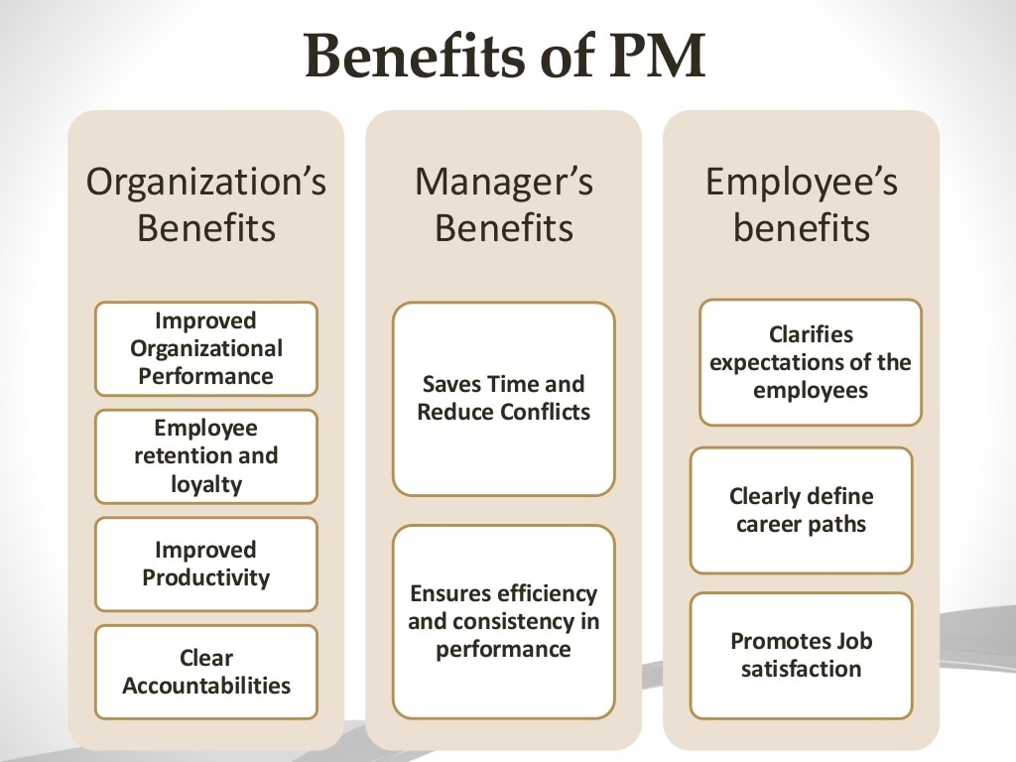
Figure 02: Benefits of Performance management (Virani, 2015)

Creating a Strategic Approach
The performance management process can be considered as a strategic management tool that involve integration of group and individual contributions align them with organizational goals and develop and continuous development strategy for the organization. The process involve integration of HRM methodologies into cascade bundles merging individual and corporate objectives. Following figure demonstrate the creation of performance management strategy for SainCo,.
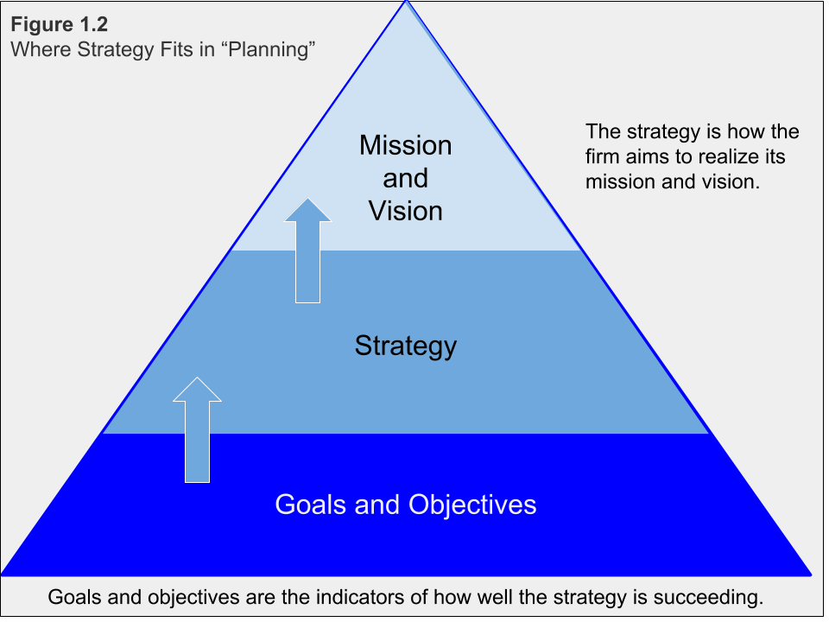
Figure 03: Strategic performance management (Mason Carpenter, 2009)
To understand the strategy development and strategic performance management, it is important to define the term strategy. According to Wood (2020), strategy is the identification of competitive advantage and decision making to compete successfully. The mission and vision statement of the company plays an important role in defining organizational operations and future orientation of the business. Strategy is formulated according to vision and aimed to develop strategic approach for performance improvement (Schleicher, et al., 2018).

Performance Management Tools
At present the economies and businesses are driven by knowledge and the companies heavily rely on intangible assets to develop value. Performance management system is based on implementing measures to improve employee performance. The performance management is the process of identification, management, measuring and developing performance of the human capital within SainCo. The performance management tools help the organization to figure out how effectively the employees are performing and how to improve the performance level (Adams, et al., 2016). There are many performance management tools designed and adopted by SainCo to make the process simple and more effective. The most important tools of performance management include personal assessment, key performance indicators, performance appraisals, personal behavior, 360-degree feedback and management by objectives.

Characteristics of Performance Management
- The process of performance management includes planning, measurement, dialogue, agreement, feedback, and positive reinforcement.
- Performance management is focused on planning and improvement of organizational performance in future (Schleicher, et al., 2018)
- The process of performance management is flexible and continuous that is based on cooperation and consensus rather than coercion or control (Amiridis & Costea, 2019)

Personal Assessment
Personal assessment is a tool for identifying the characteristics of employees that help the leaders to make managerial decisions and improving performance of the organization. at present, the organizations are continuously raising different approaches to personal assessment. There are several methods and techniques are developed to evaluate the personal at work. assessment of an individual is based on assumptions that involve variability in behaviors from other individuals possess personal characteristics (Robinson, et al., 2015). Personal assessment is different from employee appraisal as the appraisal is a continuous process of evaluating employees and providing feedback to improve the performance. The personal assessment is based on the individual capabilities and characteristics including quality of work, loyalty, discipline, adherence to service standards and volume of work. The personal assessment fall into two major groups.

Assessment of competencies
This group is based on assessing the skills and knowledge of the employee, his personal qualities as well as behavior within working environment, and the personal abilities of the employee to practically get the work done. The assessment of competencies is most effective to solve the situational problems and defining the specific position of an employee within organization or plan to take actions (Armstrong, 2018). The competencies of an individual are important to define the role of an employee within organization. with a proper assessment of the competencies the organization is able to place right person at right place that eventually improves the organizational performance.

Assessment of Performance
The assessment of personal performance is based on comparing the performance indicators of an employee with the planned performance for a given piece of work, time, or position. Before starting the personal performing assessment, it is important to set clear objectives and tasks to be done by the employee. The performance effectiveness of an employee can be expressed through different traits like the number of completed projects, numbers of transactions concluded, the volume of sales per month, or the amount of profit generated by the employee. the development of assessment criteria could be different for different employees but there are two main methods of assessing the personal performance including self-report inventories and projective tests (Chopra, 2017). The self-report inventories are based on providing the performance evaluation by employee itself while the projective testing is based on tests to project the desires, feeling and impulses of employee that drive the performance.

Personal Assessment Methods
There are different methods adopted to personal assessment and divided into three groups based on their focus. These three groups include quantitative methods, qualitative methods, and combined methods (John Shields, 2016). SainCo adopted a combination of methods to evaluate the personal capabilities. Qualitative methods of personal assessment are descriptive that describe an employee without use of quantitative data. the qualitative methods of personal assessment include the matrix method, assessing the performance of tasks, the method of the system of arbitrary characteristics, group discussion and the 360-degree method that involve assessment of an employee by managers, colleagues, clients, subordinates, and himself (Cleveland, et al., 2019).
The quantitative methods of personal assessment are the most objective and the results are analyzed on the base of numbers. The quantitative methods of personal assessment include Free Scoring method, ranked method and Scoring method. Scoring method where each staff member receive number of points against each achievement and all the points are summed up and evaluated for a specific period. ranked method involve rating of employees by group of managers and the lowest ranked individual may lose the job or transferred to a low responsible position. Free scoring method involve rating that is based on quality of person assessed by the experts for a certain number of points. Combined methods of personal assessment use both descriptive and quantitative aspects to evaluate the performance of the individual. The grouping system and the method of the sum of estimates are the example of combined methods (Armstrong, 2018). SainCo adopt a combination of qualitative and quantitative personnel assessment tools to evaluate the effectiveness and performance of the employees.

Personal Behaviour
Employee behaviors are closely associated with performance management. it is observed by many researchers that a positive attitude at work not only improves the performance of an individual, but it also influences the morale of other employees. According to the American Psychological Association, there are five important types of behaviors that influence the productivity at workplace including cooperation, interpersonal skills, going above and beyond, dependability and drive. The personal behavior could influence the working performance in both positive and negative manners. The personal behaviors can influence the organizational performance at SainCo as following.

Challenges of Work-life Balance
Separating the work life from personal life is the biggest challenge faced by employees. Employees with personal stress cannot perform well at work and also influence the other workers working around. It is important for the organization to develop a friendly working environment, where employees are encouraged to discuss their needs and guide them through the career path.

Personality can influence perception
Human characteristics are influenced by personal behaviors. According to Meyer Friedman and Ray Rosenman, there are two types of individuals at work including Type A and Type B (Subba, 2011).“Type A employees as driven and Type B employees as laid back. If you’re a Type A person at work, you may be perceived as aggressive, goal-oriented, and solely focused on what you can accomplish. If you’re a Type B person at work, your quiet nature could be interpreted as passive and disengaged” (2011).

Self-Confidence equals to Hard Work
A self-confident employee is more likely to respond positive and work hard to achieve organizational goals. The self-confidence came from the sense of security and acknowledgement of work. A self-Esteemed employee welcome the feedback from seniors and believes that the comments of evaluation will lead to high performance and self-improvement (Chopra, 2017).

Bullying results in breaking bonds
Teamwork is the key success factor for any organization and bullying personal behaviors can debilitate the work environment. The bully behaviors involve targeting a colleague and it ends up with a resistance from other side. Blaming others for low performance or mistake often create a hatred among employees and that results in poor performance of the organization (Fotso, 2011).

Performance Appraisal
Performance appraisals are formulated and designed by the HR department of an organization as the way for workers to develop the career path. The HR department provide feedback to the employees based on their performance at work. The appraisal ensure that employees are meeting expected goals, managing their performance and guidance to employees to reach the targeted objectives. Performance appraisal is a way for organizations to determine the contributions of employees to business success and rewarding the best performing employees accordingly. As the companies have limited budget for the bonuses and frequent raises, performance appraisal is the tool that help an organization to allocate the funds as per requirements (Chopra, 2017). Employee Appraisal is important for SainCo and the organization adopt the appraisal system for well performing employees. The process of employee appraisal involves the evaluation of employees and rewards for the employees who performed extraordinary. This promotes the overall organizational performance of SainCo.
There are five key elements of the appraisal process at SainCo including measurement, feedback, positive reinforcement, exchange of laws and agreement. The measurement includes evaluation of processes to understand the working conditions following by feedback from organization regarding the measurement results. The positive working on feedback reinforces the workplace and provide an opportunity to exchange views (Robinson, et al., 2015) . The last element of appraisal process is agreement, when both employee and employer reach an agreement based on certain terms. Employee performance appraisal involve different form of personal assessment including appraisal by line manager, appraisal by peers, self-appraisal, appraisal by subordinate, customer appraisal and multilevel or 360-degree appraisal.

Approaches to Performance Appraisal
The employee performance appraisal is harder and evaluative under the traditional approach that involve evaluating an employee based on his past performance as compared to predetermined performance (Adams, et al., 2016). This kind of approach is mostly associated with top-down form of management where seniors are more authoritative and judgmental allocations of rewards. The modern approach of employee appraisal is based on development of understanding between employees and the organization. this approach is considered as softer approach that fill the communication gaps in clarifying job objectives, performance expectations, training, and development (Pulakos & Battista, 2020).

360- Degree Appraisal
360-degree appraisal is the best way to make sure that appraisal at SainCo is done by considering all the elements surrounded to employee. The 360-degree approach is complex form of performance appraisal, and it is difficult to implement. The 360-degree approach provide a holistic view of employee performance considering all the important aspect like leadership, teamwork, collaboration, and behaviors (Potočnik & Anderson, 2012).

The following diagram demonstrates the 360-degree appraisal.
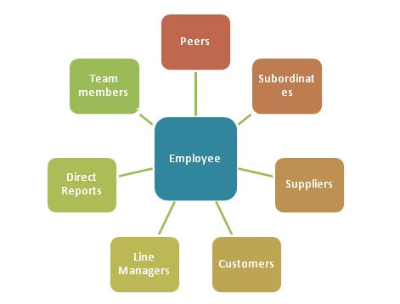
Figure 04: 360-degree appraisal ( MBA Skool Team, 2021; Virani, 2015)

The process of 360-degree appraisal at SainCo involves the feedback from 7 to 12 different persons working with or interacting with the employee including the employee himself. With the increase in global competition and advancement in technologies, 360-degree performance appraisal provide an opportunity to determine the performance of individuals that is more realistic to continue the business operations (Potočnik & Anderson, 2012)

Pay and Reward Systems
The procedure for calculating the wages of employees of the SainCo is determined by the accepted form of remuneration. In the practice of organizing remuneration, two main forms of remuneration are used at- piecework and time-based, as well as their varieties. With a piece-rate form of remuneration, the employee's wages are charged for work performed at predetermined rates (Antoni, 2011). Depending on the method of accounting for production and the types of additional incentives used, the piecework form is subdivided into different types. Time-based wages are of two types - simple and time-bonus. In a simple time-based system, wages depend on the hourly wage rate and hours worked. The hourly wage rate is determined by dividing the monthly wage rate, established in accordance with the wage scale, by the average monthly standard fund of working hours (Ejumudo, 2014). In the case of a time-bonus system, in addition to payment according to the tariff for the hours worked, the payment of bonuses is provided for the achievement of high quantitative and qualitative indicators in labor (Antoni, 2011).
The size of the salary of each person employed at the SainCo is regulated by several important factors, among which it is important to note:
- Employee qualification level.
- Compensation payments that employees who carry out professional activities in conditions other than normal or pose a potential threat to health can count on.
- Specific features of the work performed (including complexity, quality, conditions).
- Other incentive awards for outstanding employees.
- Tariff wage system.
The system of bonuses for employees is based on the broad independence of SainCo in the choice of forms of material incentives for performers. SainCo develop indicators and conditions for bonuses for each category of employees, determine the sources and timing of bonuses. An effective system of motivation and remuneration of labor will allow the company to increase the performance of personnel up to 40%, improve the efficiency of using the wage fund, and increase the validity of the constant and bonus part of wages (Antoni, 2011).
The development of a remuneration system is one of the main tasks that must be addressed by management and HR managers at SainCo. The set of measures is aimed at establishing the optimal budget for the payroll, ensuring transparent and fair remuneration, and determining its size for different specialists. The efficiency of employees, the attractiveness of the company in the labor market, the turnover of personnel and the profit of the SainCo largely depend on this. Therefore, it is important to conduct a competent development of a personnel incentive system to achieve high financial results. Analysis of the personnel motivation system at an enterprise is a rather difficult task that requires knowledge of the specifics of the business and conducting extensive research using modern methods.

Employee Engagement, Satisfaction, and Involvement
Most companies have now realized that their people are their greatest asset. The happier the employees, the higher the productivity of the company, but most companies still view human capital as a problem, namely finding and retaining the right talent that is also in line with the corporate culture. Truly outstanding candidates are rare, and companies have to come up with many ideas to find and retain the best talent. But the matter is more complicated. To manage something, you need to measure it first. In HR practice, there are several indicators that determine the level of employees' belonging to the company: satisfaction, Engagement and involvement (Djoemadi, et al., 2019). It is important for the HR department of SainCo to determine the level of employee satisfaction, involvement and engagement at workplace to improve the organizational performance.
Quite often people confuse employee engagement and employee satisfaction. A satisfied employee is content with his role, but not committed to the company. A satisfied employee can be absolutely satisfied with his position (if the wages are on time), and the involved employee seeks to find opportunities for growth and improvement (Memon, et al., 2021). A fully engaged employee is enthusiastic about work, inspired by the goals and objectives of the company. Such people demonstrate their commitment by completely immersing themselves in their work and suggesting new ideas.

Employee Engagement
Employee Engagement can be defined as “a physical, emotional, and intellectual state that motivates employees to do their best job” (2020).
At present, most of the employees are Generation Z, who have a different worldview and life position. People of this generation are born with an entrepreneurial streak. They want more partnerships from the employer, so that he is not just a leader, but a mentor, mentor. It is important for them to develop in the company and help in realizing their professional and personal goals. In connection with such changes, more and more companies are introducing bonus systems, are more loyal to the wishes of employees, and respond to their needs (Kwon & Kim, 2020).
Employee engagement is largely dependent on the leaders of the company. Since even if the organization has better working conditions, a modern office, new development programs, but the top management lacks faith in a particular employee, there is no reason to hope for his professional development. According to Gallup, “70% of employee engagement depends on the leader. Therefore, the main emphasis in increasing the involvement of personnel is placed precisely on the development of the leader and his interaction with employees” (Bridger, 2018). The employer in this matter provides a springboard - an office, resources for HR-s, so that they can work to improve engagement and create a comfortable working environment.

Employee Satisfaction
Satisfaction is one of the ingredients of engagement. Employees cannot be involved in work if they are dissatisfied with the level of remuneration, working conditions, work content, etc. These factors are also referred to as hygienic - they only affect engagement when the numbers are negative. In turn, with a high level of satisfaction, further improvement of these factors alone does not lead to a noticeable increase in work engagement (Abe, 2021).
Low employee satisfaction leads to low engagement. Thus, the company may face the following problems:
- Loss of customers and decline in revenue. Employees will be indifferent to the needs of customers, they will not delve into the features of the product, its differences from competitors' products.
- Increased production losses. Also, according to statistics, employees in this case are 41% more likely to make mistakes in their work and 48% more likely to become victims of industrial accidents (Sharma, et al., 2016).
In addition to direct financial risks, there are negative effects that are difficult to assess, but affect the company's activities and results:
- Total control. The manager is forced to supervise the dissatisfied subordinates, as they tend to make mistakes in their work. Control takes time that a leader could spend on team development, making important management decisions, etc (Chi & Gursoy, 2009).
- Lack of trust. A lot of the time employees are engaged in sorting out relationships instead of work. As a result, the quality of teamwork decreases (Chi & Gursoy, 2009).
- Bureaucracy. No one in the department is doing process improvement. As a result, there are sluggish processes and an overly complex reporting system (Chi & Gursoy, 2009).
Five factors influence employee satisfaction most strongly.
Salary: The amount of payment is one of the main motivators for work. If a person feels that they are not being paid enough for a job, their productivity will drop, or they will look for a new job (Harter, et al., 2002).
Working conditions: Personnel satisfaction is greatly influenced by the physical parameters of the work environment. For example, the temperature and noise level in the office. Heat, cold or noisy conditions lead to a decrease in concentration and, as a result, to the frequent appearance of errors in work (Abe, 2021).
Content of labor: When employees are interested in filling their work, they enjoy doing it. Interest in work directly affects the level of involvement and satisfaction.
Safety: Neglecting worker safety in the workplace will lead to reduced productivity. It is important for people to feel that they are concerned about their health (Abe, 2021).
Work comfort: Employee satisfaction is influenced by the office itself, the workplace, the tools used. They are capable of boosting morale and increasing productivity.

Employee Involvement
Involvement is a state of emotional and intellectual commitment to the company that encourages the employee to give their best and advise their employer to those around them. In a sense, this is similar to an entrepreneurial model of behavior, because the employee involved treats the company's business as if it were his own. For example, if necessary, the copywriter will stay in the office for urgent material, and the product manager will calculate the important numbers at night. And the most important point is that they will not get angry and feel unhappy. involvement leads to both tangible and intangible benefits for the business and its customers (Heckscher, 2018).
Motivated workers: Motivated employees are energized and can sacrifice their comfort for the good of the company. They will enthusiastically get down to business when an important project comes along, or an emergency occurs (Johnstone & Ackers, 2015).
Higher loyalty: Employees who love their job and their company tend to stay in the team and are more likely to recommend highly effective colleagues or acquaintances for a new role or task (Johnstone & Ackers, 2015).
Higher quality of customer service: A positive attitude is passed on to others. Engaged employees radiate this energy when communicating with customers and give 110% of their best. They are focused, make fewer mistakes, and usually get it right the first time. When people work with maximum dedication, they win the hearts of customers and improve the company's image by showing that the best of the best work for it (Wallace, et al., 2016).

Training and development
Training and development is a continuous process within an organization to achieve higher performance. HR department at SainCo is responsible for human development and learning practices. Learning and development at SainCO include employee training courses, online lecturers, development programs and HR operations to promote a sustainable growth of the business. learning and development enables the employees to be more professional and confident at work. L&D is the process to polish the employee skills and abilities to handle the work more effectively (Sharma, et al., 2016). We learned that the employee behaviors are significantly important to the organizational performance, and it is necessary to develop professional behaviors of employees. The development of professional behaviors involves intensive learning and development.

Culture
The culture of performance is developed and nurtured by the management and the team itself. Each culture of performance includes in itself its own mission, image, and performing the dignity (which, of course, are sustained in one key with a vast theme of service and standards of all business). The organizational culture significantly contributes to the performance and growth of the organization. organizational culture is directly linked with the employee behaviors and attitude to work (Djoemadi, et al., 2019). it is important for SainCo to align the organizational culture with the strategy, goals, and objectives of the organization. The organizational culture that is aligned with the strategy and objectives of the organization, can provide competitive advantage and exponential growth in performance.

Recommendations
It is observed that performance management is more involved in training of staff and managers covering the performance evaluation and constructive feedback. It is recommended to recognize the employees focus and develop the organizational culture to improve the performance. Performance management involve strategic integration of human resource management and work of the human capital. Based on the present study following Short-term and long-term recommendations are proposed for SainCo.

Short-term Recommendations
- Conduct short-term surveys to evaluate the performance of employees at SainCo.
- Managers plays an important role in improving performance of the organization, it is recommended for SainCo to involve managers at all levels in hierarchy to align the operations and goals of the organization.
- Kodak performance model is not recommended for the organization in present case because the organization is already needing a change from autocratic management style.
- It is recommended to adopt and practice Kaizen philosophy for successful implementation of performance management system.
- For the performance evaluation, it is recommended to gather information from different sources and include 360-Degree model.
- It is important to include the staff in decision making process, develop short-term strategy to involve the employees in business development and allow them to make right decisions.

Long-term Recommendations
- Setting goals is basics of performance management, it is important for the company to align the organizational goals with the individual goals of employee to achieve high performance.
- Development of strategy to achieve the long-term goals is very important. With the rapid change in market conditions, the future strategies are more focused on human capital and employee engagement.
- Performance management is an ongoing process that involve performance planning, monitoring, feedback and learning processes that provide an opportunity to meet organizational objectives.
- Strategic performance management is beneficial in decision making process, HR operations, provides information and facilitates the organizational change.

References
MBA Skool Team, 2021. mbaskool. [Online]
Available at: https://www.mbaskool.com/business-concepts/human-resources-hr-terms/1758-360-degree-assessment-or-feedback.html
[Accessed 29 11 2021].
Abe, E. N., 2021. Future of work, work-family satisfaction, and employee well-being in the fourth industrial revolution. KwaZulu-Natal, South Africa: IGI Global.
Adams, W. A., Freeland, M. J. & Anderson, R. J., 2016. Mastering leadership : an integrated framework for breakthrough performance and extraordinary business results. 1 ed. s.l.:Wiley.
Amiridis, K. & Costea, B., 2019. Managerial Appropriations of the Ethos of Democratic Practice: Rating, ‘Policing’, and Performance Management. Journal of business ethics, 164 (4), pp. 701-713.
Antoni, C., 2011. Pay and reward systems in organisations : theoretical approaches and empirical outcomes.. 1 ed. s.l.:Pabst Science Publishers.
Armstrong, M., 2018. Armstrong's handbook of performance management : an evidence-based guide to delivering high performance. 6 ed. s.l.:Kogan Page.
Armstrong, M., 2020. clearreview. [Online]
Available at: https://www.clearreview.com/resources/guides/what-is-effective-performance-management/
[Accessed 01 12 2021].
Bridger, E., 2018. Employee engagement : a practical introduction. 2 ed. s.l.:KoganPage.
Chi, C. & Gursoy, D., 2009. Employee satisfaction, customer satisfaction, and financial performance: An empirical examination. International journal of hospitality management, 28(2), pp. 245-253.
Chopra, R., 2017. 360 Degree Performance Assessments: An Overview. Global journal of enterprise information system, 9 (3), p. 102.
Cleveland, J. N., Hanscom, M. E. & Murphy, K. R., 2019. Performance appraisal and management. s.l.:SAGE Publications, Inc.
Djoemadi, F. R., Setiawan, M., Noermijati, N. & Irawanto, D. W., 2019. The effect of work satisfaction on employee engagement. Polish Journal of Management Studies, 19 (2), p. 101.
Ejumudo, K. B. O., 2014. Pay reward system management and staff performance in Nigeria: a study of the Delta state civil service. Raziskave in razprave (Spletna izd.), 7(3), p. 30.
Fotso, A., 2011. The Implication of Performance Appraisal Systems on Employees Productivity: A Case Study of Searcy Catering Company, London: Thesis (MBA Human Resource Management) - University of Wales Trinity Saint David / .
Gerrish, E., 2016. The Impact of Performance Management on Performance in Public Organizations: A Meta-Analysis. Hoboken, USA: Wiley Subscription Services, Inc.
Harter, J. K., Schmidt, F. L. & Hayes, T. L., 2002. Business-Unit-Level Relationship Between Employee Satisfaction, Employee Engagement, and Business Outcomes: A Meta-Analysis. Journal of applied psychology, 87(2), pp. 268-279.
Heckscher, C. C., 2018. The New Unionism : Employee Involvement in the Changing Corporation with a New Introduction. New York: Cornell University Press.
John Shields, M. B. S. K. C. D.-S. A. N.-S. P. M. R. J. P. O. G. P. J. R., 2016. Managing Employee Performance & Reward: Concepts, Practices, Strategies. 2 ed. Cambridge: Cambridge University Press.
Johnstone, S. & Ackers, P., 2015. Finding a voice at work? : new perspectives on employment relations. 1 ed. Oxford: Oxford University Press.
Kwon, K. & Kim, T., 2020. An integrative literature review of employee engagement and innovative behavior: Revisiting the JD-R model. Human resource management review, 30 (2), p. 100704.
Mason Carpenter, G. S., 2009. Strategic Management: Concepts,. 2nd ed. s.l.:Pearson .
Memon, F. A., Shah, S. & Khoso, I. U., 2021. Improving Employee's Engagement in Change: Reassessing Kurt Lewin's Model. City University Research Journal, 11(1), pp. 144-164.
Potočnik, K. & Anderson, N., 2012. Assessing Innovation: A 360-degree appraisal study. International journal of selection and assessment, 20(4), pp. 497-509.
Pulakos, E. D. & Battista, M., 2020. Performance management transformations : lessons learned and next steps. Oxford: Oxford University Press.
Robinson, J. C., Phillips, J. J., Phillips, P. P. & Robinson, D. G., 2015. Performance Consulting A Strategic Process to Improve, Measure, and Sustain Organizational Results. 3 ed. s.l.:Berrett-Koehler Publishers.
Schleicher, D. J. et al., 2018. Putting the System Into Performance Management Systems: A Review and Agenda for Performance Management Research. Journal of management, 44(6), pp. 2209-2245.
Sharma, P., Kong, T. T. C. & Kingshott, R. P., 2016. Internal service quality as a driver of employee satisfaction, commitment and performance: Exploring the focal role of employee well-being. Journal of service management, 27(5), pp. 773-797.
Subba, M. T., 2011. The Impact of Performance Appraisal on Employee Attitude: With Special Reference to Venus Health Care Group, London: Thesis (MBA Human Resource Management) - University of Wales Trinity Saint David .
Virani, K., 2015. slideshare. [Online]
Available at: https://pt.slideshare.net/kareemveerani/challenges-in-implementing-performance-management-system/3?smtNoRedir=1
[Accessed 29 11 2021].
Wallace, J. C. et al., 2016. A Multilevel Model of Employee Innovation: Understanding the Effects of Regulatory Focus, Thriving, and Employee Involvement Climate. Journal of management, 42 (4), pp. 982-1004.
Wood, S., 2020. Human Resource Management–Performance Research: Is Everyone Really on the Same Page on Employee Involvement?. International journal of management reviews : IJMR, 22 (4), pp. 408-426.

