Module: Research Methods II

Module Code: ECPS5003

Assignment Title: ‘Exploring the effect of emotional intelligence on memory for emotion-induced stimuli’.

Abstract

Previous research has produced various outcomes regarding memory recall, depending on levels of emotional intelligence (EI). This present study examined whether emotional intelligence has an effect on performance when recalling emotionally induced stimuli. A Trait Emotional Intelligence Questionnaire (TEIQue-sf) was used to measure emotional intelligence, and a recall task was created containing positive, negative and neutral words. Although there was no significant interaction found between emotional intelligence and emotionally induced words, means and standard deviations showed that overall, participants with higher emotional intelligence were able to recall positive and negative words more effectively than those with lower emotional intelligence. Therefore, it can be assumed that data sourced in this study does support much of the previous literature done surrounding this topic. Limitations and suggestions for future research will also be explored in this paper.

Introduction

Many previous research studies have examined the link between emotional intelligence and performance in recall-based tasks. Emotional intelligence can be defined as the ability to regulate one’s moods and frustrations, whilst being able to empathise with the feelings of others. (Goleman, 1966. Cited by Morrison, 2006). The concept has also been linked to cognitive functions and successful performance in transactional tasks (Ahmad, 2019). Various researchers have also looked into levels of EI in relation to traits such as memory within an emotionally induced state. Emotional intelligence can be measured through a variety of scales and self-report tests, including the popular Trait Emotional Intelligence Questionnaire TEIQue (Petrides, 2009).
Past literature has indicated a relationship between emotional intelligence and working memory, based on emotionally induced stimuli. Although memory for recalling neutral stimuli has been shown to be positively linked to IQ alone, recall for positive or negative stimuli has been linked to levels of EI (Orzechowski et al, 2020). Therefore, participants with a higher self-tested level of emotional intelligence have been seen to perform better overall in emotionally laden tasks (Gutiérrez-Cobo et al, 2017). Research by Mavrou (2021) for instance, has indicated that positive words in particular are more easily recalled by participants with a higher EI level.
As well as memory, attention is a cognitive function involved in recall tasks. Supporting the idea that positive stimuli is more easily recalled by those with high emotional intelligence is a study carried out by Lea et al (2018). Eye tracking technology used on participants showed that high EI was associated with attention to positive emotional stimuli, in this case happy facial expressions. Other studies have looked into the impact upon emotions such as stress on attention within recall tasks. It has been found that ability to control emotions while under stressful conditions enables participants to recall better. Those who are less affective at controlling their emotions tend to focus their attention on positive stimuli when stressed, and avoid negative stimuli (Mikolajczak et al, 2010), opposing the findings of Mavrou (2021).
With consideration of previous research surrounding this topic, the aim of this study will be to examine the effect of emotional intelligence on memory for emotionally induced stimuli, using a recall task of emotionally induced words. It is hypothesised that participants with higher levels of emotional intelligence will recall more words overall. It is also expected that participants will be able to recall more positive words than negative/neutral words. And finally, it is hypothesised that for this study, participants with higher levels of emotional intelligence will better recall positive words, indicating an interaction between levels of EI and emotionally induced words.

Method

Participants
Thirty participants took part in this study through a Qualtrics link on the Psychology Experimental Management System. Participants were Level four and five students, studying Psychology related courses at University of Wales Trinity Saint David’s Swansea campus. The participants were all recruited to complete the study for a research methods assessment, and their involvement was completely voluntary. There were 11 males, 17 females and 2 non binary/third gender. Participants were aged between 18 and 51 (M=28, SD= 7.5).

Design
This study took on a mixed multi-factorial design. The first independent variable was emotional intelligence. This between subjects’ factor had two levels, these being low levels of EI and high levels of EI. Participants were categorised into low and high groups in relation to the total mean score (148) achieved on the emotional intelligence questionnaire. The second independent variable was the emotion-induced stimuli, in this case, the words used in the recall task. The words were a within-subjects variable with three levels; positive, negative and neutral. The dependant variable was the total number of words correctly recalled by the participant. A mixed ANOVA analysis was used on the data to establish whether there were any effects or interactions between levels of emotional intelligence and ability to recall emotionally induced stimuli.

Materials
Levels of emotional intelligence were measured using a psychological questionnaire via Qualtrics. The scale used was the Trait Emotional Intelligence Questionnaire – Short form (TEQue-SF). The thirty-item questionnaire is used to measure trait emotional intelligence. Participants are asked to choose from a numbered scale ranging from ‘Completely Disagree’ to ‘Completely Agree’ in relation to various statements. For instance, one of the statements is “Expressing my emotions with words is not a problem for me”. The possible scores for each item range from 1-7 and a low score for each item indicates a low level of emotional intelligence. For this reason, there were fifteen items on the questionnaire that were negatively worded and were therefore reverse scored. Past research and reliability analysis has deemed the TEIQue-sf a reliable psychological scale for measuring emotional intelligence. It has been tested in relation to its original long form and other test scales (Hosani et al, 2020). This however has contradicted the reliability analysis conducted on the scale for this study (α = .49).
The task that was used to measure memory and recall ability of emotionally induced stimuli was created using the Superlab programme. Within the task, there were three experimental trails; each containing positive negative and neutral words. The 20 words for each condition were displayed to the participant individually on the screen for 2000ms each. Each word was separated by a blank screen shown for 400ms. At the end of the trail for each condition, participants were told to ‘think of an animal’ or ‘think of a holiday destination’, for one minute before being automatically moved on by the time Superlabs screen. After this minute, participants were asked to recall as many of the words that they could remember, and type these into a box provided on the screen. At the end of the study, debrief information was displayed on the screen. Participants were scored by the number of words correctly recalled out of the 20 words per trail.
All data for this study was collected in a lab setting. A laptop was provided with the Qualtrics questionnaire set up, along with the study information sheet. Participants were then instructed to switch to a computer provided to complete the Superlabs recall task.

Procedure
Participants were recruited via the EMS booking system. Once in the lab setting, participants started on a laptop which had the Qualtrics survey pre-loaded. The information sheet detailing what would be required during the study, as well an information on confidentiality was displayed. After reading this information, participants were then asked to give their informed consent to take part in the study. Once this consent was given, participants were asked for demographic information, such as their age and gender. Then, participants were instructed to begin the Qualtrics questionnaire. Once the EI questionnaire is completed, participants were directed to switch to the computer monitor to complete the memory recall task via Superlabs. Once this was completed, debrief information was shown on the screen, before thanking the participant for taking part in the study.

Results

A 2 x 3 mixed design ANOVA was carried out to examine the effect of levels of emotional intelligence (high/low) on recall of emotionally induced words (positive/negative/neutral). Descriptive statistics for all variables included in this analysis are displayed in Table 1.
Table 1
Means and Standard Deviations: ANOVA Results.

Emotionally induced words | Low EI | High EI
 | M SD | M SD
Positive | 9.61 4.37 | 11.6 3.87
Negative | 9.33 2.89 | 12.2 2.94
Neutral | 8.33 2.77 | 8.9 3.73

Overall, participants were able to recall more positive and negative words rather than neutral words. Those with higher levels of emotional intelligence on average scored higher on recalling positive words than those in the lower emotional intelligence group. This was also the case when recalling negatively charged words.
The two-way interaction between levels of emotional intelligence and emotionally induced words was non-significant, F(2,44) = .003, p > .05 (.98), np² = .00 . The main effect of emotionally induced words also did not display statistical significance in this case, F(2,44) = 1.97, p > 0.5 ( .15), np² = .08. This indicated that there was no significant difference of recall scores between positive, negative and neutral words.
However, the main effect of emotional intelligence was significant, F(1,22,) = 11.01, p < .05 (.003), np² = .33, and also had a large effect size (partial eta squared = .33). This suggests that there was a difference in scores in accordance with levels of emotional intelligence. These findings show that emotional intelligence may have had an effect on the overall performance of the participants, with the high EI group scoring higher on average than the lower EI group (M= 10.9 and M=9.1 respectively). Pairwise comparisons showed that there was a significant difference between positive negative and neutral words (M= 10.32, SD= 4.23; M= 10.36, SD= 3.18; and M= 8.5, SD= 3.12 respectively).

Discussion

The aim of the present study was to examine whether levels of emotional intelligence had an effect on memory for emotionally induced stimuli, particularly emotionally induced words. The results showed that participants with high emotional intelligence were able to recall more words than the those with low emotional intelligence overall. On average, the high EI participants recalled more positive and negative words than the low EI participants. A significant main effect for emotional intelligence was found, correlating with previous literature by Orzechowski et al (2020).
The outcomes of this study did replicate some of the findings of past studies (Mavrou, 2021), which display that those with higher trait EI are able to recall more positive words than those with lower levels of trait EI. However, those with lower levels of emotional intelligence scored similarly on average for both positive and negative words, contradicting research by Mikolajczak et al (2010), that suggests low EI participants tend to focus on the positive stimuli rather than the negative. Therefore, attentional bias is a concept that could be further explored within this topic, should a study of this type be done again.
There a several factors that could have influenced the outcome of this study. For instance, the TEIQue-sf (Petrides, 2009) has been credited as a reliable self-measure of emotional intelligence, however, as it is a self-reporting measure there may have been response biases that would have affected the groupings of high and low EI. As a solution to this, future studies of this kind could use observational methods to measure participants’ emotional intelligence in order to categorise them. Additionally, the study had a limited sample size, with all participants from the same institution. A wider range of participants from different backgrounds may have given a better indication of the general population, and therefore influenced the overall outcome of the study.
To conclude, the present study did find that there was a difference in recall ability between participants with low and high levels of emotional intelligence. The main effect of EI displayed that those with higher emotional intelligence levels were able to recall more emotionally induced words overall. While the two groups scored similarly on the neutral words, the high EI participants were able to recall more positive and negative words than the low EI participants. Future research should aim to look into attentional bias in accordance with levels of emotional intelligence, with a greater and more diverse sample size.

References

Ahmad J, (2019). Aspects of Emotional Intelligence. Cambridge Scholars Publisher.
Goleman D, (1996). Emotional Intelligence: Why It Can Matter More than IQ, London, Bloomsbury
Gutiérrez-Cobo M.J, Cabello R, Fernández-Berrocal P, (2017). ‘Performance-based ability emotional intelligence benefits working memory capacity during performance on hot tasks’. Springer Nature. Available at: https://www.nature.com/articles/s41598-017-12000-7.pdf
Hosani M.A, Lanteri A, Davidson R, (2020). ‘Reliability and Validity Testing of the Trait Emotional Intelligence Questionnaire-Short Form to Predict Nurses' Job Satisfaction’. Journal of Nursing Measurement. Available at: https://pubmed.ncbi.nlm.nih.gov/33067369/
Lea L.G, Qualter P, Davis S.K, Pérez-González J, Bangee M, (2018). ‘Trait emotional intelligence and attentional bias for positive emotion: An eye tracking study’. Personal and Individual Differences, Volume 128. Available at: https://www.sciencedirect.com/science/article/abs/pii/S0191886918300837?via%3Dihub
Mikolajczak M, Roy E, Verstrynge V, Luminet O, (2010). ‘An exploration of the moderating effect of trait emotional intelligence on memory and attention in neutral and stressful conditions’, British Journal of Psychology. The British Psychological Society. Available at: https://bpspsychub.onlinelibrary.wiley.com/doi/full/10.1348/000712608X395522?casa_token=jVcVn1MNBDEAAAAA%3Ac9Kzv2IgFbkCnTu4kgNo0aepLXLwrdh1cB76Si54KLSIKr7yoOn2ZiUvSHDpjdnf3R0K16rC3fq0Fro
Morrison T, (2006). ‘Emotional Intelligence, Emotion and Social Work: Context, Characteristics, Complications and Contribution’. British Journal of Social Work. Available at: https://academic-oup-com.ezproxy.uwtsd.ac.uk/bjsw/article/37/2/245/1705334
Orzechowski J, Smieja M, Lewczuk K, Necka E, (2020). ‘Working memory updating of emotional stimuli predicts emotional intelligence in females’. Springer Nature. Available at: https://www.nature.com/articles/s41598-020-77944-9
Petrides, K. V. (2009). Psychometric properties of the Trait Emotional Intelligence Questionnaire. In C. Stough, D. H. Saklofske, and J. D. Parker, Advances in the assessment of emotional intelligence. New York: Springer. DOI: 10.1007/978-0-387-88370-0_5

Appendices

Appendix 1: List of emotionally induced words used
Appendix 2: Consent form
Appendix 3: Debrief form
Appendix 4: SPSS output

Appendix 1:

Emotionally induced words used:

Positive | Negative | Neutral
Beauty | Ankle | Afraid
Desire | Locker | Blister
Friendly | Kettle | Crisis
Handsome | Paper | Demon
Rainbow | Doctor | Hostile
Secure | Errand | Lonely
Lucky | Banner | Mistake
Wealthy | Headlight | Riot
Success | Iron | Upset
Joyful | Journal | Wicked
Lively | Statue | Trouble
Diamond | Office | Vandal
Grateful | Taxi | Sinful
Honest | Machine | Guilty
Cuddle | Nonsense | Enraged
Sunrise | Patent | Destroy
Pleasure | Reserved | Blackmail
Nature | Wagon | Coward
Laughter | Curtains | Stupid
Kindness | Basket | Toothache

Appendix 2:
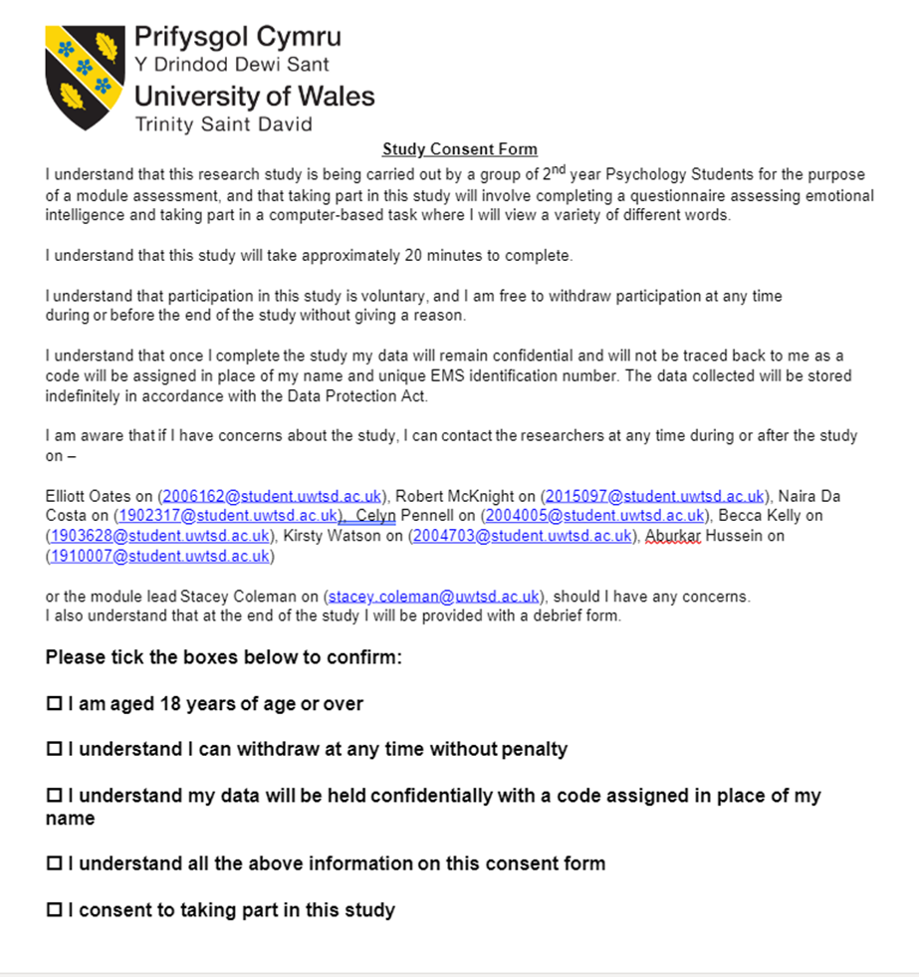

Appendix 3:
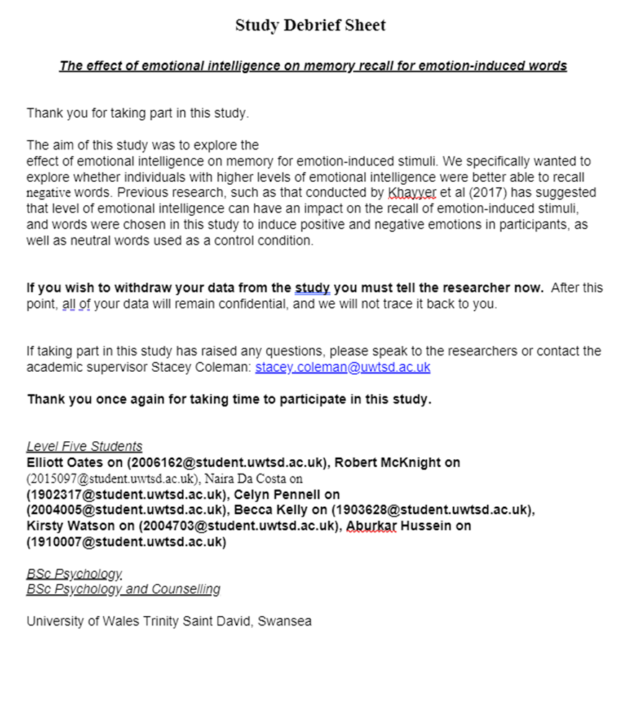

Appendix 4:



