s

Project Management and Research Methods (ACDA5004)
Project Management – Project Initiation Document
Austin Hooper (1700481)

BSc Software Engineering

14/11/2018
Table of Contents

1. Project Definition 1
1.1. Background and Deliverables 1
1.2. Objectives 1
1.3. Scope 1
1.4. Constraints 2
1.5. Authority 2
1.6. Resources 2
2. Business Case 3
2.1. Benefits 3
2.2. Costings 3
2.3. Risks 3
3. Roles and Responsibilities 4
3.1. Project Sponsor 4
3.2. Project Team and Organisation 4
4. Initial Project Plan 5
4.1. Schedule and Milestones 5
4.3. Human Resources 7
4.4. Project and Quality Control 7
4.5. Project and Stakeholders 8
5. Bibliography 9
Appendices 10
Appendix A 10
Appendix B 11

Project Definition

Background and Deliverables

Project Title: SHARD – Subzone Hazard Assistance Recovery Device
The broader idea of the project is that a truck turns up at a disaster scene providing wireless communication, and that portable network towers (nick-named shards) could be placed every few miles. Workers at the disaster scene would be equipped with wrist-mounted devices which all track each other’s locations. The deliverables for the project will be simplified for sake of prototyping:
- Four Android devices acting as the wrist-mounted devices
- A hotspot device – another team member device providing connection to the others
- A server device running a database to store location data
- Each device viewing the location of each other device on a map, in real-time

Objectives

- An Android application on five devices must transmit / save the device’s location in real-time*.
- Each device must be able to view, in real-time*, the mapped location of all other devices connected to a central server
- The system must be always-on and always tracking the device’s location
- The device must be able to be wrist-mounted, i.e. using a strap

*For the prototype, within 10s will be considered close enough to real-time.
The project will need to be completed by the 18th January 2018.

Scope

- An Android application will be developed – only Android will be supported due to the group’s lack of familiarity with iOS development and also due to the Apple Developer cost associated [1].
- A secure strap and mounting system will be developed
- Smartphones will be used for hardware – electronic hardware will not be developed for the sake of this prototype
- The system will connect devices on Wi-Fi on the same local network only, with no GSM, Bluetooth or NFC support
- A map system will not be created from scratch – Google Maps will be used

Constraints

- As mentioned previously, the mapping is limited to Google Maps functionality
- Platform – limited to Android hardware (including sensors) and software
- Time – it must be completed in time for the January 18th, 2018 demo
- Distance – needing to get to campus to work well with the group
- Group collective knowledge and experience

Authority

- Sue Maw, Module lecturer
- Ian Wells, Head of School

Resources

- While contradicting the constraints point, the group’s collective knowledge is also a resource
- University staff – qualified and have experience
- Software / libraries:
  - Google Maps Android API [2]
  - Google Location Services API [3]
  - Android Studio IDE [4]
- Hardware:
  - Android devices
  - Windows 10 / Linux installation on a laptop to act as a test server
- The University library

A selection of notes from initial group planning can be seen in Appendix A.

Business Case

Benefits

The project is intended to improve the effectiveness of emergency / public services staff’s work when on the site of a natural disaster, while also making their jobs easier. As a result, it would also hopefully help people in need at the site of a disaster, possibly even saving lives.
Benefits could be measured by comparing statistics of the impact of natural disasters before and after implementing the system. Surveys and interviews could be conducted with the people using the system to gain an understanding of if and how it helps them.

Costings

Due to the software-based nature of the project, there are no financial implications for the prototype.

Risks

The following are potential risks to the project:
- Absence of a team member due to illness, death, or leaving the course
- Communication difficulties between team members due to network outage
- Team members not cooperating
- A change in law (e.g. due to Brexit) restricting the project idea, or law variance between counties or countries
- University closure, for example due to adverse weather
- Lecturer absence or replacement

Roles and Responsibilities

Project Sponsor

Sue Maw, our module lecturer, is the project sponsor as she is the main authority for the module and approves project ideas.

Project Team and Organisation

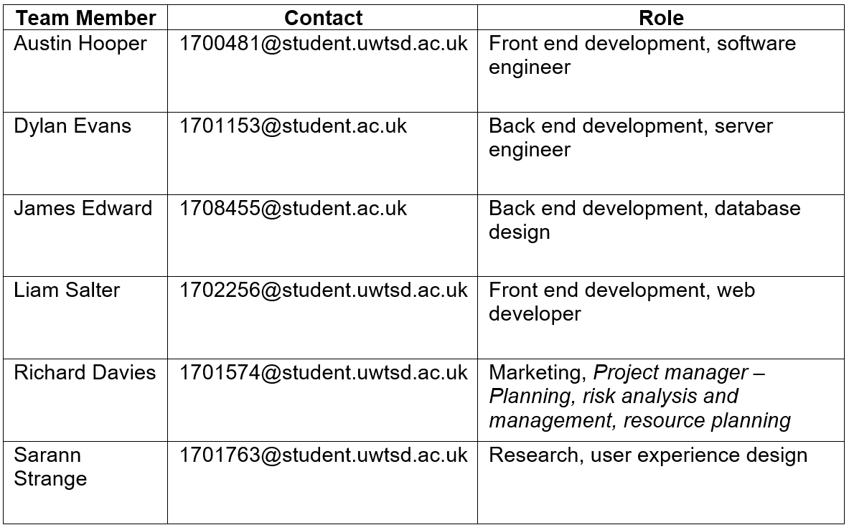
The roles assigned to each team member are as follows:

See the below diagram for lines of authority and reporting:
Table 1 - Team roles
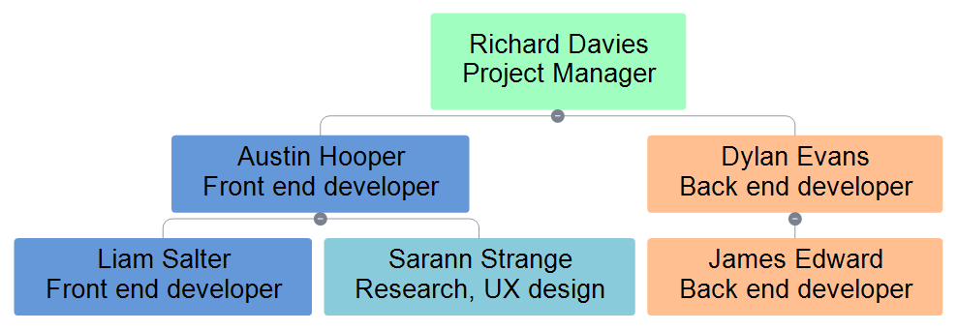
Figure 1 – Authority and reporting

Initial Project Plan

Schedule and Milestones

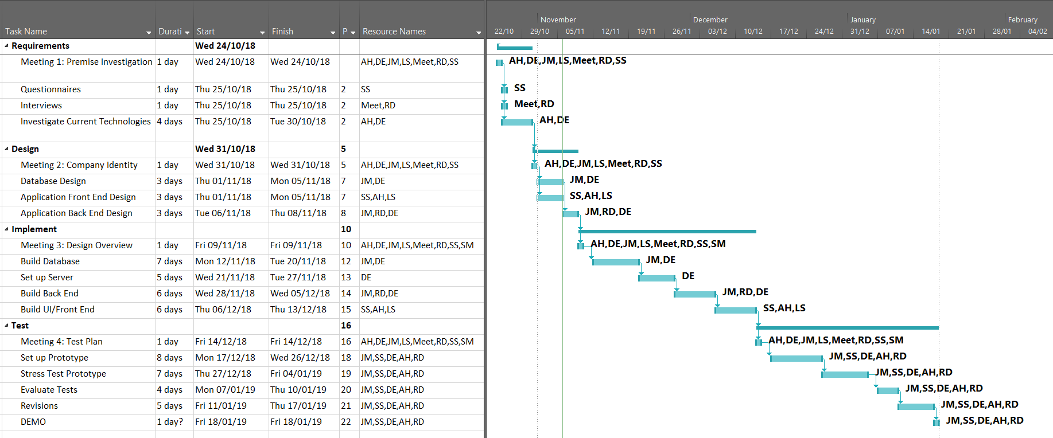
See below Gantt and PERT (Program Evaluation Review Technique) charts for the project’s execution illustrating the project plan and milestones, provided by group members James Millns and Sarann Strange [5]. The main milestones are Requirements, Design, Implementation and Testing. Initial timescale planning can be seen in Appendix B.
Figure 2 - Task list and Gantt chart
PERT chart:
Figure 3 - PERT chart, beginning to end

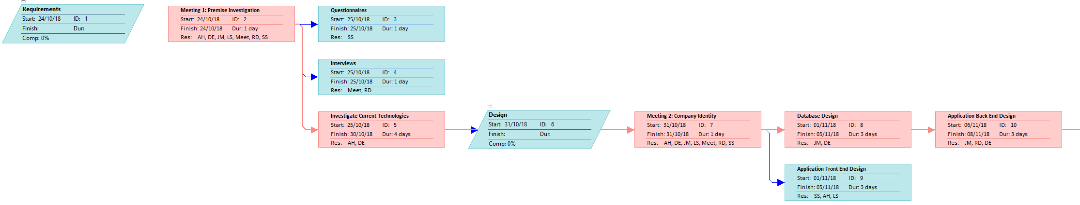
Broken up into lines for readability:

4.3. Human Resources

The estimated total activity time to complete the project is 100-150 hours – which includes only development and testing and excludes project planning.
It is unlikely that there will be a need to bring more people into the project team. The expertise of some of the School of Applied Computing’s lecturers may be useful in completing the project.

4.4. Project and Quality Control

The ISO 25010 software quality metrics (formerly ISO 9126) will be reviewed regularly to ensure that the project deliverables continue to develop in the following areas:
- Functionality
- Reliability
- Usability
- Efficiency
- Maintainability
- Portability
Project progress will be reviewed in regular weekly meetings and compared to the initial plan seen in the Gantt chart.

4.5. Project and Stakeholders

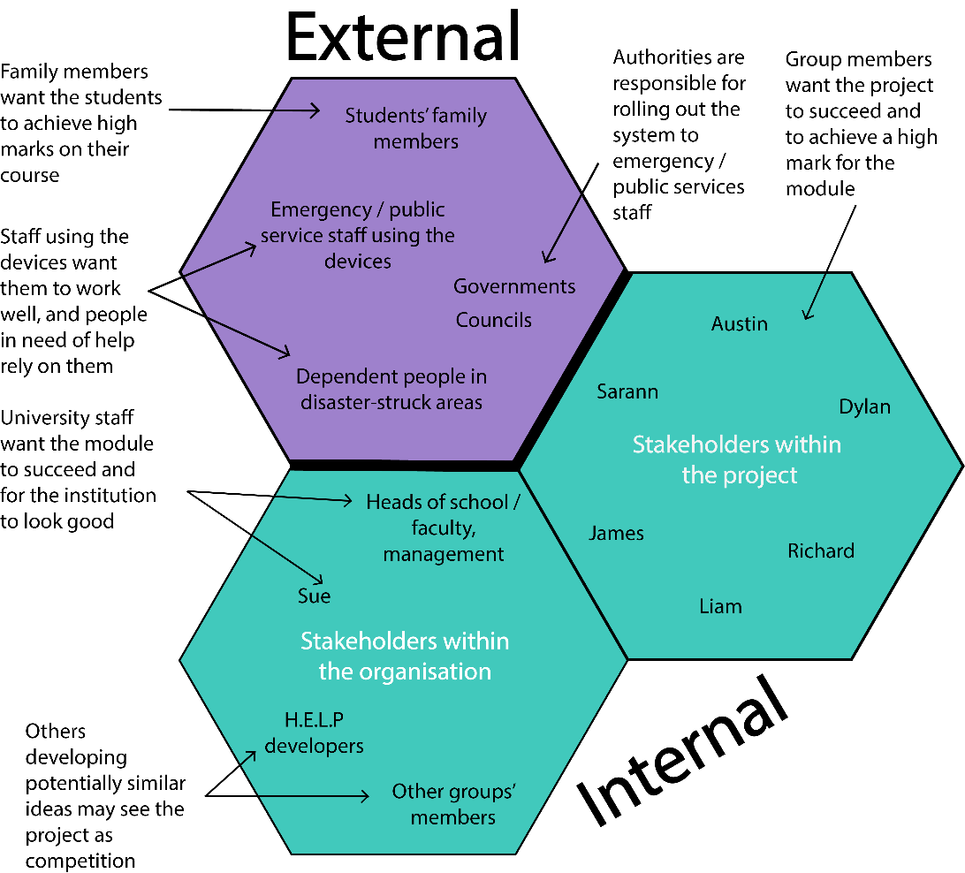
See the below diagram illustrating the project stakeholders:

Bibliography

[1] Apple, “Purchase and Activation - Support - Apple Developer,” 2018. [Online]. Available: https://developer.apple.com/support/purchase-activation/. [Accessed: 07-Nov-2018].
[2] Google Developers, “Google Maps Platform | Google Developers,” 2018. [Online]. Available: https://developers.google.com/maps/documentation/. [Accessed: 07-Nov-2018].
[3] Google Developers, “LocationServices | Google APIs for Android | Google Developers,” 2018. [Online]. Available: https://developers.google.com/android/reference/com/google/android/gms/location/LocationServices#top_of_page. [Accessed: 07-Nov-2018].
[4] Google Developers, “Download Android Studio and SDK tools | Android Developers,” 2018. [Online]. Available: https://developer.android.com/studio/. [Accessed: 07-Nov-2018].
[5] J. Edward and S. Strange, “SHARD Project Plan,” 2018.
[6] Mind Tools Content Team, “Project Initiation Documents - Project Management from MindTools.com.” [Online]. Available: https://www.mindtools.com/pages/article/newPPM_85.htm. [Accessed: 05-Nov-2018].
[7] R. Baxter, C. Rogers, C. Tunnell, and M. Jackson, “SSI/MAUS – Project Initiation Document,” 2011.
[8] J. Carroll, “Network Upgrade Project - Project Initiation Document (PO003),” 2008.

Appendices

Appendix A

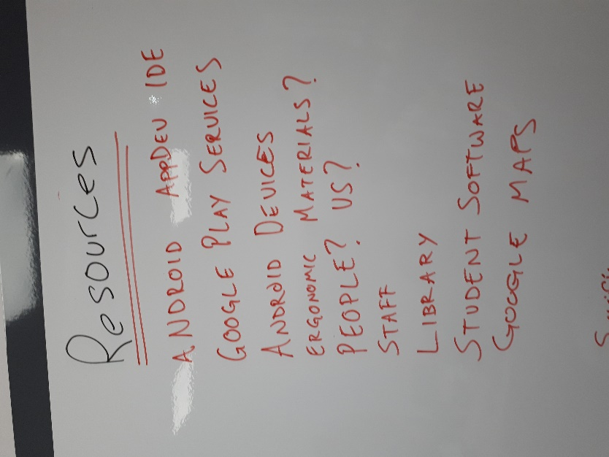
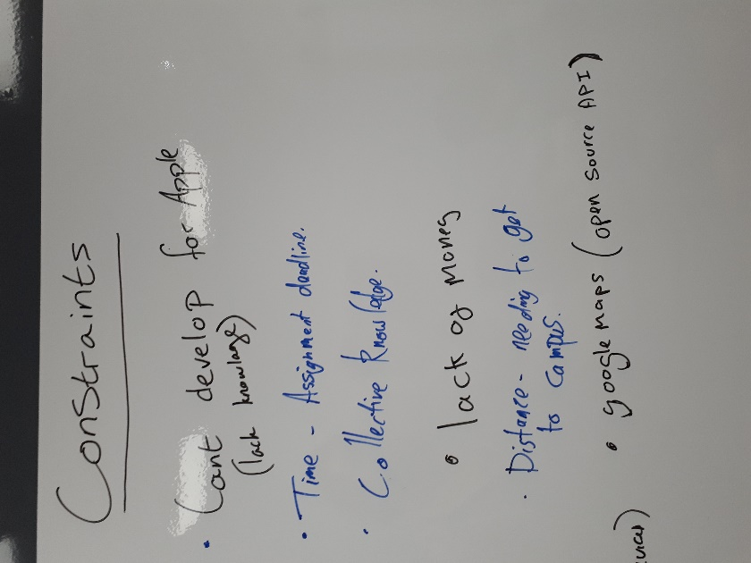
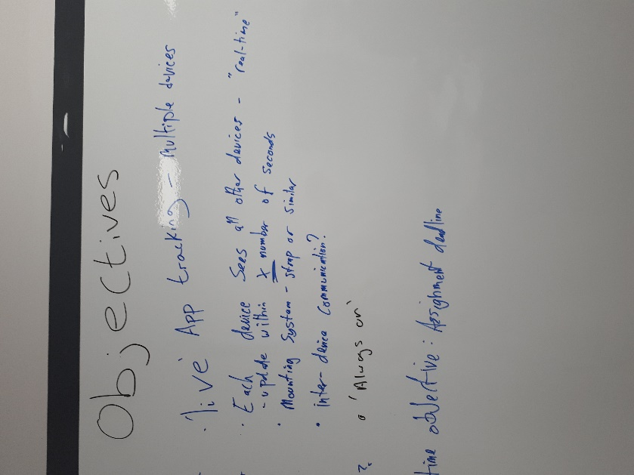
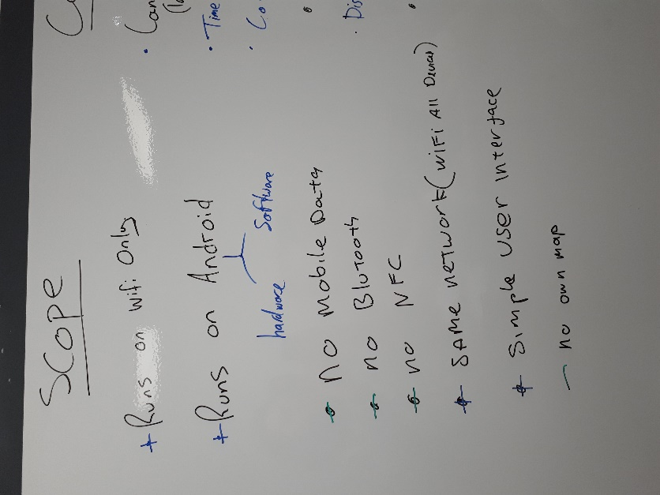
Initial project planning group discussion:

Appendix B

Initial timescale planning:


