Lloyd Mitchell

Fundamentals of construction assignment- semester 1

Describe the differences in these different houses and explain why these changed were made – whether to overcome defects or improve performance ect.

Contents
Contents 1
Introduction 2
Historical context 3
Windows and Doors 3
Wall coverings 4
Roof coverings 5
Social and Technological changes 6
Internal Joinery 6
Eaves Details and Rainwater goods 7
Floor Coverings 8
Conclusion 8
References 9

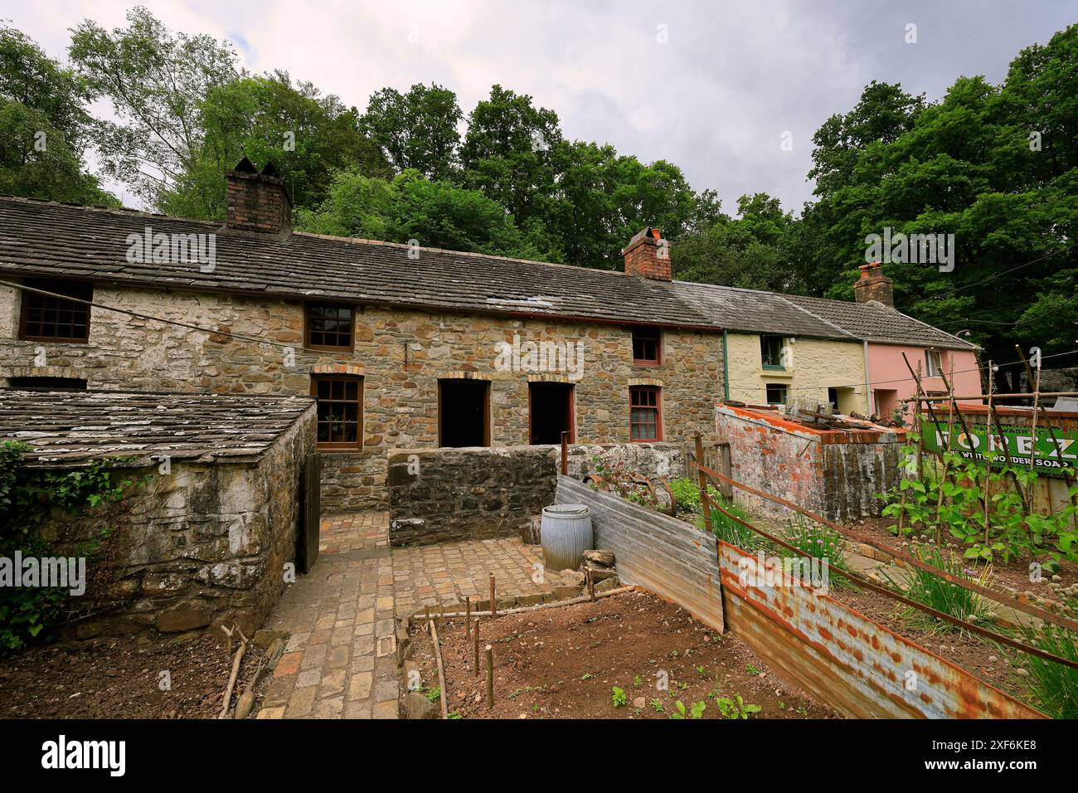

Introduction
The Rhyd-y-Car Terrace houses at St Fagans National Museum provide a valuable insight into the evolution of industrial housing in Wales over nearly two centuries. Originally constructed around 1795 by Richard Crawshay to accommodate ironworkers and their families, the terrace illustrates how working-class housing adapted to changing social, technological and economic conditions. Each restored house represents a different period in history, highlighting improvements made to overcome defects such as dampness, poor insulation and inadequate ventilation while also increasing comfort and functionality. This report examines the changes made to key building elements and explains how these developments improved the overall performance of the houses while reflecting wider changes in society.

Historical context

Ironmaster Richard Crawshay constructed the Rhyd-y-car terrace houses around 1795 to house employees of his iron-ore mining and ironmaking enterprises within South Wales. The expanding industry created a massive increase in the ned for housing that suits the average worker in the mining industry, suddenly thousands of these houses were required to be able to grow the industry. The rapid expansion of the iron industry created a significant demand for affordable worker accommodation. As a result, the houses were designed to be small, simple and economical, providing only the essential living spaces required for working families. From the example in St Fagans the house contained a bedroom, toilet, small living area and an upstairs which most likely contained storage and kitchen supplies. This was because most housing was employer provided which meant that the design was cost driven and efficient. This is also backed with the material that was used predominantly being locally sourced, the walls were solid stone to have reliable stability however little resistance to damp penetration. A combination of lacking technology and cost driven designs meant poor natural lighting and poor ventilation was common in this type of housing. the houses relied on an open fire to heat the entire house; the fire was in the main living space. The fire was also the main ventilation, which was successful in letting air out however, this meant that the heat from the fire was also escaping. The absence of insulation, combined with poor ventilation and damp conditions, created cold living environments that increased the risk of respiratory illnesses and reduced overall living standards. This house design is the foundation on what the terrace houses in St Fagans intend to show, as we see through the 19th century and closing in on the 20th all these flaws are gradually worked at.

Windows and Doors

Windows and doors developed extensively through the 19th and 20th century. Materials and design changes has created multiple purposes and advantages of windows, but this has come from very basic and simple designs that were purely to let daylight in. in 1805 as displayed by Rhyd-y-car terrace, windows were made from crown glass which was the most common type of glass made in that time. Timber frames were used as materials for the house were collected locally which made them cheaper. Smaller planes were used but increased in size from 1855 to improve glazing and have a more stable structure. In 1855 the type of glass also changed moving to cylinder glass, this gave a much clearer view through the window allowing natural light to enter easier. As we are introduced to the 1900s joinery was becoming more standardised especially with doors. As evident in the terrace houses in St Fagans, the wood that was used to make the door had been joined together through coats potentially glue which gives a great improvement to both the structural integrity and the insulation of the house by reducing the gaps between each piece of material used. As well as the joinery, the door lock and knob design changed to a round doorknob which is more aesthetic and functional. 1955 is where we begin to see windows being a part of doors making another advancement in allowing natural light to be apparent inside. By this point in time doors are no longer multiple planks places together side by side but now being practically one piece leaving no room for any air to get in or out.

Wall coverings

In 1805 the wall coverings would most likely be plaster due to it becoming popular in the 18th century for its durability, sound dampening and fire resistance. Plaster would continue to be used in terrace houses until early 20th century (1925 Rhyd-y-car) where the common covering used was wallpaper. Wallpaper was known for its many variant designs and become standard for middle class homes. Wallpaper wasn’t as popular in previous years as hit was meant for upper-class homes. This gave the wall another thin layer of insulation on top of what was already used. Wallpaper also helps discover sources of leaks and reduces the damages.

Roof coverings
Due to the Rhyd-y-car terrace houses being together they all share the same type of roof that being a closed couple roof. The restricted access to the upstairs hides the rafters, however in the earlier made houses the internal loadbearing walls are visible. The main differences between each house is what type of roof covering was used. In the earliest house of 1805, the roof would have been covered with locally sourced stone slates. These were heavy and irregular in size, reflecting the limitations of early quarrying methods. Although durable, this type of roofing placed a large load on the roof structure and was prone to leaks due to inconsistent fixing and uneven overlaps. The choice of material was driven by availability and cost rather than performance or appearance just like the rest of the house. By 1855 and 1895, slate production had become more efficient, and improvements in transport, allowed higher quality slate to be distributed more widely. Roof coverings from this period show thinner slates laid in regular order. This improved weather resistance, reduced the structural load on the building and gave the terrace a more orderly appearance. This changes the earlier defects such as water leakage and frequent maintenance. In both the 1925 and the 1955 houses the slate roofs were being revamped with standard slates but also improved the roof coverings compared to previous years was the use of nails instead of wood pegs to hold them in place, this made more resistance against the wind making the slates stronger and more durable. By 1985 the roof slates had changed shape to maximise efficiency when moving rain to the gutters which the earlier houses would not have considered because gutters would not have been as sufficient to what they are in 1985.

Social and Technological changes
The changes seen in Rhyd-y-car Terrace were not only the result of repairs or fashion, but were strongly influenced by wider social, technological developments. These factors helped shape how worker housing improved over time. During the nineteenth century, industrial growth led to large numbers of people living in poorly built housing. This raised concerns about public health, especially the links between damp, overcrowded housing and disease. As a result, there was greater pressure to improve ventilation, drainage and internal finishes. This influenced the introduction of features such as plastered walls, better floors and rainwater goods. Technological advances also played a key role. Improvements in quarrying, manufacturing and transport made materials such as slate, glass, cast iron more affordable and widely available. Factory-made components improved consistency and performance, allowing houses to be upgraded more easily than before.

Internal Joinery
In the 1805 house, internal joinery was minimal and often roughly made. Doors were simple timber boards or basic framed doors, and there was little detail. Stairs were functional rather than comfortable, and there were no skirting boards. This reflects the need to keep construction costs low. By 1855 and 1895, joinery became more refined. Properly framed and panelled doors were introduced, along with skirting boards and door surrounds. These features helped reduce draughts, protect walls from damage and improve the overall appearance of the rooms. In the 1925 and 1955 houses, joinery became more standardised. Doors and stairs were more consistent in quality and easier to replace or repair. Built-in cupboards and shelving also appeared, improving storage and making better use of space. By 1985, existing joinery was generally repaired rather than replaced. Where new joinery was added, it matched earlier styles. This shows a move towards an appreciation of the original character of the houses while maintaining usability.

Eaves Details and Rainwater goods
On the 1805 house there were no gutters so rainwater would fall straight from the roof to the floor or run down the walls which overtime could cause damage, potentially leading to dampness and leaks within the house. By 1855 cast iron gutters had been added to the house which helped collect the rain and move it so it would no longer cause damage to the walls of the house. The cast iron used was strong and long lasting however, just like the gutters in current time they require maintenance. This gutter system appears to continue through the 1895 house and the next house (1925) is where we see the next development. This is most likely because cast iron was cheap and easy to supply into the Welsh towns. In 1925 and 1955 houses the gutter systems became much more popular with the layouts of the gutters being efficient and durable. The constant development during this period reflected the progressing understanding of what was required of gutters with decades of faults to consider and correct. 1985 proves that the system worked by replicating the same system as the 1955 house. With not much further development possible it is unlikely that gutter systems will be replaced rather than minor maintenance occasionally.

Floor Coverings
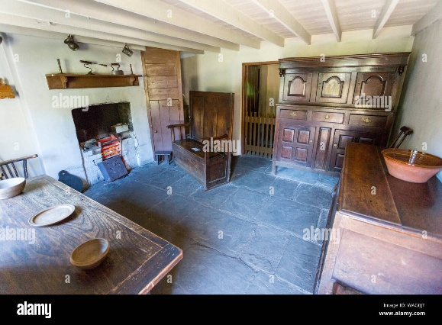
In the 1805 house the flooring appeared to be rough stone which meant the floors were cold, would get damp easily but like the rest of this house the priority was not comfort but rather to be cost effective when making these employers provided houses. By 1855 and 1895 these floors were replaced by timber floorboards, which were more durable and reduced dampness while being able to conduct more heat improving the insulation of the house. The timber floors also was better for comfort as they were smoother and warmer than the previous stone. In the 1925 house you can see the use of carpet as you are walking into the house. This was quite possibly the start of the use of carpets withing these houses which is a massive improvement to the previous cold and discomfort the old flooring caused. And by 1955 the carpets were used to take up most of the living space also getting used in bedrooms. This was the same in the 1985 house only the carpets were used much more intensely bringing more comfort and warmth to the house.

Conclusion

The Rhyd-y-Car Terrace houses clearly demonstrate the gradual development of working-class housing between the late eighteenth and twentieth centuries. Although the basic layout remained largely unchanged, continuous improvements to construction methods, materials and building components significantly enhanced the performance, durability and comfort of the houses. Developments in windows, roofing, flooring, internal joinery and rainwater goods reduced common defects such as dampness, heat loss and structural deterioration. These changes were driven not only by advances in technology and manufacturing but also by improving living standards, public health concerns and changing social expectations. Overall, the terrace provides an excellent example of how incremental improvements to traditional construction techniques resulted in safer, healthier and more comfortable homes while preserving the character of Wales’s industrial heritage.

References
Virtual Tour of Rhyd-y-car: Homes through Time | Museum Wales – virtual tour
Rhyd-y-car: Miner’s Homes Through Time — Google Arts & Culture - background
Rhyd-y-Car cottages - Collections Online | Museum Wales – further information
Bricks & Brass: Bricks and Brickwork – materials of the era

