Edina Szasz
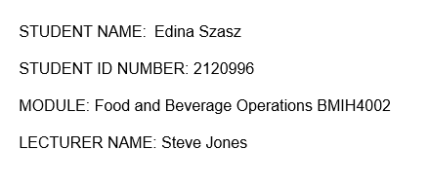

Hotel Trinity takeaway menu
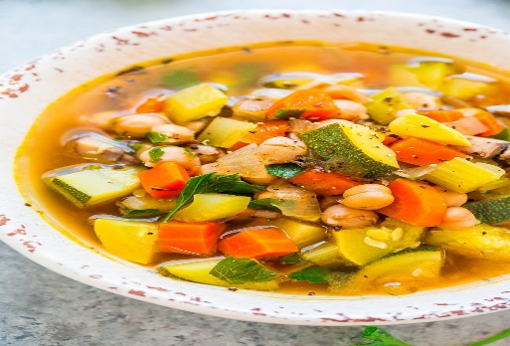
Starters
Vegetable soup with homemade brown bread
Made from vegetables from our organic farm – 7,45
Chicken Caesar salad
With fresh organic lettuce topped with freshly grilled chicken- 7,35
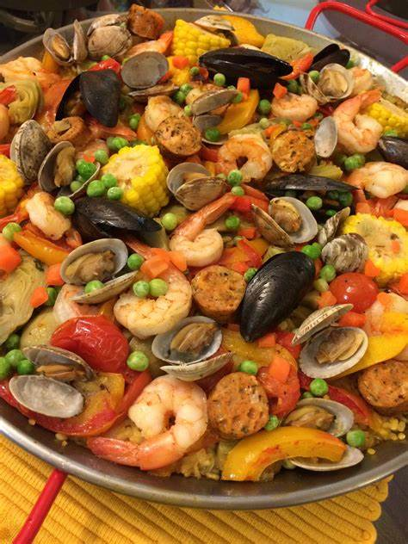
Main course
Seafood and chicken paella
With fresh mussels, free range chicken and extra virgin olive oil – 26,42
Spring carbonara
Made from organic green beans and peas with freshly grated Italian parmesan cheese 17,35
Saffron risotto with forest mushrooms
With Indian saffron and different forest mushrooms carnaroli rice –24,25

Homemade Desserts Kids Favourite
Sicilian watermelon sorbet Chicken nuggets with curly chips – 10,15
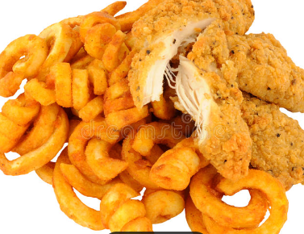
A true taste of Sicily- 7,45 Made from free range chicken and crispy chips
Chocolate brownie
With silky chocolate sauce and vanilla gelato- 8,25
Billionaire’s Cheesecake
White chocolate cheesecake topped with Belgian chocolate ganache -9,
If you need support to match your chosen food with our superior beverages just ask one our expert member of stuff, they are happy to help you.
If you have food allergy or special dietary requirement, please contact a member of our team.


References

- Averie Cooks. 2022. Reset Vegetable Soup. [online] Available at: <https://www.averiecooks.com/reset-vegetable-soup/> [Accessed 11 June 2022].
- BBC Food. 2022. Recipes. [online] Available at: <https://www.bbc.co.uk/food/recipes> [Accessed 11 June 2022].
- https://www.dreamstime.com/stock-photo-fried-breaded-chicken-curly-fries-southern-potato-isolated-white-background-image74856444. 2022. [online] Available at: <https://www.dreamstime.com/stock-photo-fried-breaded-chicken-> [Accessed 11 June 2022].
- The Petite Gourmande. 2022. Seafood Paella - The Petite Gourmande. [online] Available at: <http://www.ruthsinternationalkitchen.com/seafood-paella/> [Accessed 11 June 2022].

