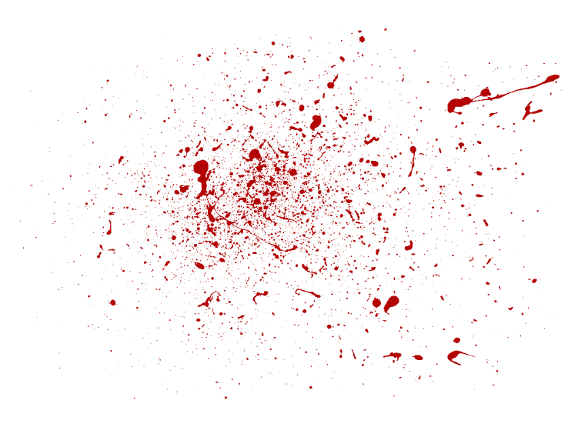


Ashley James Edwards
65 Llandeilo Road, Crosshands, SA14 6RD
07920 013207
ashjedwards88@gmail.com
Youtube
Instagram

Skills Summary
I am conscientious, trustworthy and punctual. I am an experienced and creative scriptwriter and film-maker, specifically comedy. I have also written reviews and news items for several websites. I am proficient in all Microsoft Office and Adobe Creative Cloud software. I have been employed as an office administrator for the past six years, but am also experienced in customer service, finance and retail. I am a fluent Welsh speaker.

Education

I am currently studying for a BA (Hons) in Film and Visual Culture in UWTSD Carmarthen and expect to graduate in June 2020. Other qualifications I hold include:

- NVQ 2 in Business Administration
- NVQ 2 In Hospitality and Quick Service
- NVQ 2 in Food Safety
- First Aid Level 3; Nominated person and Trainer
- IOSH
- 10 GCSEs including Maths (A), IT (A), English Lit (B), English Lang (C) and Science (Triple Award) (C)

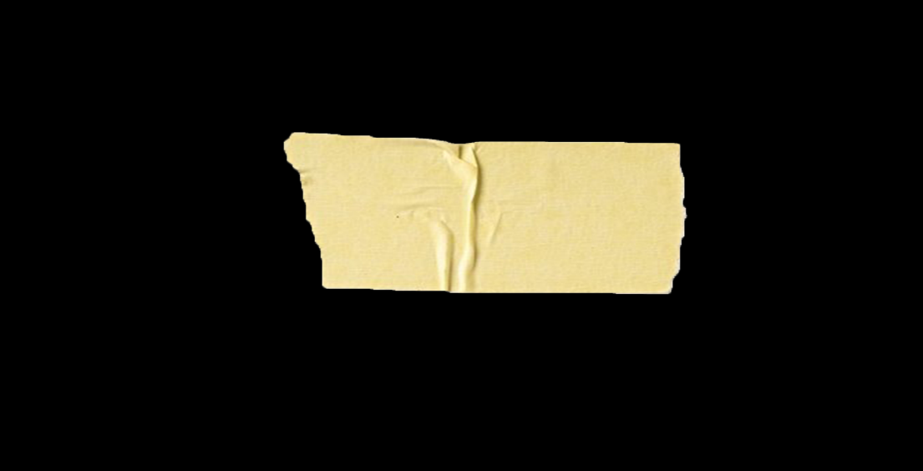
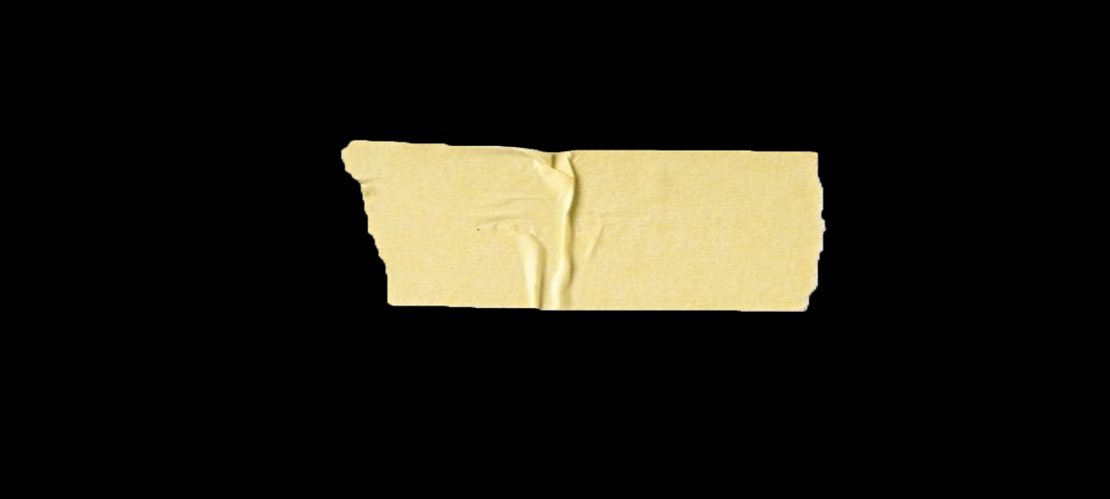
Experience

Business Support Assistant Night Porter
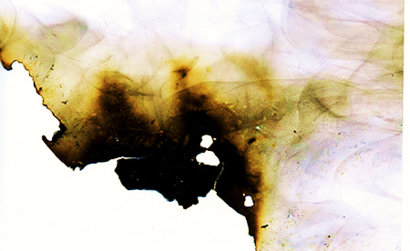
Crosshands Home Services Ltd Crosshands Travelodge
2013 – Current 2008 - 2013

References available on request

